Trowbridge Town Council
  - Invitation to Tender
Trowbridge Town CCTV Enhancement Project
Reference: TTC/CCTV/2026/01
Submission Deadline: 12.00 Midday, 6th March 2026

1. Introduction and Project Overview
Trowbridge Town Council invites tenders for the provision, installation, and commissioning of an upgraded Public Space CCTV system.
The Council is committed to maintaining Trowbridge as a safe and welcoming environment for residents, businesses, and visitors. As part of our ongoing commitment to community safety, we have identified the need to modernize our existing surveillance infrastructure. This project involves the strategic upgrade of several existing cameras to high-definition digital technology, ensuring our network remains fit for purpose in a modern policing and urban management context.

2. Scope of Works
The successful contractor will be required to replace identified legacy analogue/low-resolution units with high-performance hardware. The core scope includes:
- Hardware Replacement: Decommissioning of outdated cameras and installation of 13 new IP-enabled units.
The cameras to be replaced are listed separately in appendix 1 with a map showing locations appendix 2. The removed tandem view cameras (x 5) are to be reused where indicated with *.
- Connectivity: Ensuring seamless integration with the existing Town Council network and monitoring suite which is a HIK system.
- Ongoing Support: Provision of a comprehensive maintenance and service-level agreement (SLA) for a period of 3 years with the possible extension of a further 3 years.

3. Key Objectives
Tenders will be evaluated on their ability to meet the following Council priorities:
- Clarity and Evidence: Superior image quality in all lighting conditions to support Wiltshire Police and local partner agencies.
- Reliability: Robust hardware with high uptime and resistance to vandalism/weather.
- Compliance: Full adherence to the Surveillance Camera Commissioner’s Code of Practice, BS EN 62676 and UK GDPR.
- Value for Money: A solution that balances high performance with long-term cost-efficiency.

4. Submission Requirements
To be considered for this contract, bidders must provide:
- Pricing Schedule: A transparent breakdown of capital costs (hardware/installation) and recurring revenue costs (maintenance) with response times for SLA.
- Technical Proposal: Detailed specifications of the proposed hardware and installation methodology.
- Case Studies: Evidence of similar CCTV upgrades performed for Local Authorities or Public Sector clients.

Trowbridge Town Council require tenderers to submit a tender containing a detailed financial cost statement along with example RAMs, relevant case study examples, insurance details and any other relevant information.
Assessment of Submission
It is the intention of the Town Council to assess the bids through the use of a matrix with a weighting of 50% price and 50% quality. A copy of the quality matrix criteria and weighting available separately.

The Town Council does not bind itself to accept the lowest or any tender, nor will it pay any expenses which may be occurred by any Tenderer in the preparation of this tender.
All recipients of these documents, whether or not they submit a tender, shall treat them as private and confidential. Tenders which do not conform to the foregoing instructions will not be considered. All rates and prices must be, and will deem to have been, tendered exclusive of VAT.

Conditions of Contract
The Town Council will enter into a formal contract with the successful tenderer for the upgrade of cameras and three years maintenance with the possibility of a further three-year extension.

Conditions of Tender

The completed submission, as specified in the schedule of Documents below, are to be returned to the Town Clerk at the offices of Trowbridge Town Council by 12 noon, 6th March 2026. Email address stuart.legg@trowbridge.gov.uk
The tenderer must not contact councillors or staff other than the specified point of contact for the Town Council as identified above for any reason at all.
The tenderer must not contact councillors or staff to encourage or support their tender outside the prescribed process.
The tenderer is to provide an electronic copy of the submission to the email address above. The electronic copy may be via email. Any tenders delivered outside of these times will not be accepted.
Please note, the comprehensiveness and quality of the documents will be used to assess the tender returns.

Schedule of Documents
The documents listed below will be required as part of the submission for assessment.

- A. Financial cost statement
- To include detailed breakdown of costs.

B. Experience
Please submit details of your relevant experience and qualifications including membership of any relevant professional bodies.

- D. Insurances
- Please submit copies of your relevant insurances.

E. Health and Safety
Please submit examples of RAMs or qualifications.

- F. Additional Information
Please submit any additional information that would be beneficial to the assessment of the tender.

Contact Information
For further details and queries, please contact stuart.legg@trowbridge.gov.uk

Appendix 1

Camera No | Location | Current type | Change to
1 | Roundstone street jct church st | analogue PTZ | Tandem view *
6 | Wickerhill | tandem view | 360 Multi
8 | shales lane | analogue PTZ | Tandem view *
10 | Church street/duke street | analogue PTZ | 180 Multi
17 | Union street | analogue PTZ | 360 Multi
18 | Church walk | analogue PTZ | Tandem view *
20 | Train station | analogue PTZ | 180 Multi
22 | Albany palace park street | analogue PTZ | 180 Multi
26 | Skate Park | analogue PTZ | 360 Multi
2 | coffee#1 | tandem view | 360 Multi
3 | market street/castle street | tandem view | 360 Multi
5 | Lloyds bank | tandem view | 360 multi
13 | war memoria/park | tandem view | 360 Multi
 | Tennis courts | 4g PTZ | Tandem view * | Will need to wireless link to camera 13
 | Shires/fore street | analogue PTZ | 180 Multi | Will need to link wirelessly to system.
 | Shires/red hat lane | analogue PTZ | Tandem view | Will need to link wirelessly to system.
 | Bythesea road, the gateway | 0 | Tandem view | Existing fibre in columns will need re connecting
 | Bythesea road snap fitness | 0 | Tandem view * | Existing fibre in columns will need re connecting

Appendix 2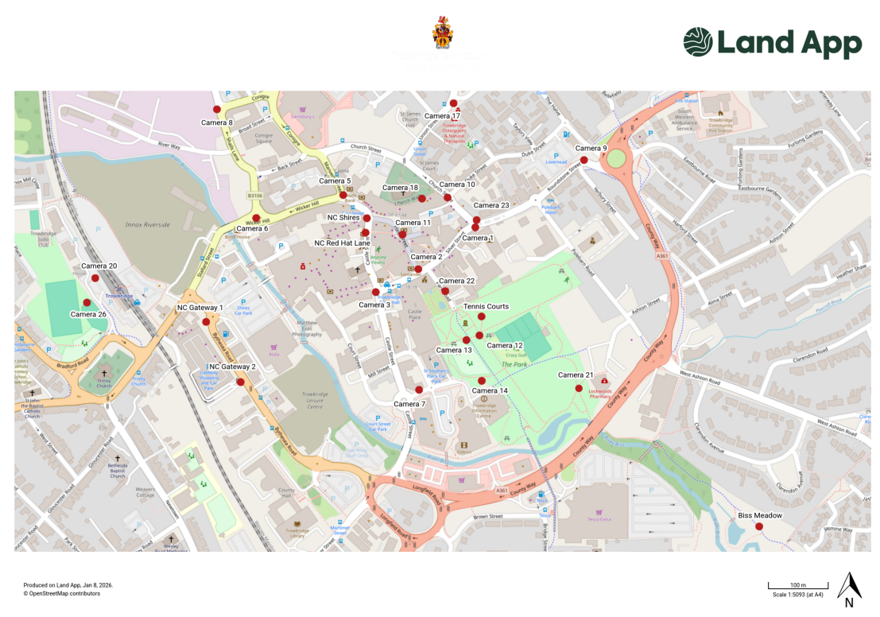

Appendix 3
Scoring Matrix

To ensure Trowbridge Town Council remains transparent and achieves the best "Most Economically Advantageous Tender" (MEAT). A split of 50% Quality/Technical and 50% Price being used.

1. Overall Weighting
Category | Weighting | Description
Technical & Quality | 50% | Hardware specs, methodology, and BS EN 62676 compliance.
Commercial (Price) | 50% | Total cost of ownership (Installation + 3 years maintenance).
Total | 100%

2. Technical & Quality Scored Criteria (50%)
Ref | Criteria | Weighting | What we are looking for
Q1 | Technical Specification | 20% | Compliance with BS EN 62676; low-light performance; 4K/HD clarity; and robust privacy masking capabilities.
Q2 | Project Methodology | 5% | A clear plan for replacing cameras with minimal downtime for the town centre network.
Q3 | Experience & PSS Compliance | 10% | Evidence of working with Local Authorities and operating under the Surveillance Camera Code of Practice.
Q4 | Maintenance & SLA | 15% | Response times for faults, 24/7 support availability, and longevity of the hardware warranty.

3. The Scoring Scale (0–5)
Evaluators will use the following scale to score each Technical and Social Value question:
Score | Rating | Definition
5 | Excellent | Exceptional solution. Exceeds requirements and offers significant added value.
4 | Good | Comprehensive response that meets all requirements with some added value.
3 | Satisfactory | Meets the requirements but without any additional benefits or innovation.
2 | Minor Reservations | Meets most requirements but lacks detail in key areas.
1 | Serious Reservations | Significant gaps in the proposal; does not meet the Council's core needs.
0 | Unacceptable | No response provided or the response fails to address the question.

5. Price Scoring Formula
Price is scored mathematically to ensure fairness. The lowest-priced bid automatically receives the full 50%, and others are scored relative to it:
Score = Lowest Proposed Price divided by Bidder's Price times Weighting (50)
Example: If the lowest bid is £10,000 and a bidder submits £12,000, they receive 41.6% out of the possible 50%.

