Little Chalfont Parish Council

Tender documents for Architectural Design services
For the Westwood Park Rejuvenation Project
(January 2026)

Little Chalfont Parish Council
Little Chalfont Village Hall
Cokes Lane
Little Chalfont
HP8 4UD

Table of Contents
About Us 1
Westwood Park 1
Vision 2
Design Brief 2
New Pavilion 2
Children’s Playground and Exercise Area 3
Car Parking 3
Footpaths 3
Scope of Services 3
Stage 1 (Initiation to Pre-App) 3
Stage 2 (to Planning) 3
Stage 3 (full design) 4
Procurement timetable 4
Required Tender Return 5
Evaluation 6
Costs 6
Experience, Knowledge Question & Team 6
Submission of Tenders 7

About Us

Little Chalfont Parish Council was formed in 2007 as a separate body from what was part of Amersham and Chalfont St Giles. The parish currently has a population of almost 7,000 but this is forecast to significantly increase in the next few years when new developments such as the former Chalfont golf club course and the former GE Healthcare Grove Centre sites are built out.
Little Chalfont was predominantly rural farm land prior to the building of the Metropolitan railway in the late 20th Century. The area only became known as Little Chalfont in 1925 following the railway and landowners selling their land for housing development and a community was formed.
In terms of facilities, the parish council has a Village Hall (built in 1952) which currently houses the parish council’s office. At Westwood Park we have our sports pitches (football and cricket), sports courts, childrens playground, a Pavilion, car park and a house that is leased. Westwood Park provides access for walkers to the Chess Valley.
We are fortunate to have a Nature Park in the Village where residents can enjoy the peace and quiet of nature. This rare meadow land was purchased through funding raised by the local residents and opened to the public in 2016. The village also has a community library that is a valuable community resource.

Westwood Park

Location: Westwood Park, Chenies Avenue, Amersham HP6 6PP
Westwood Park is the parish’s only sports facility and children’s playground. It is within the green belt and the Chiltern Area of Outstanding Natural Beauty.
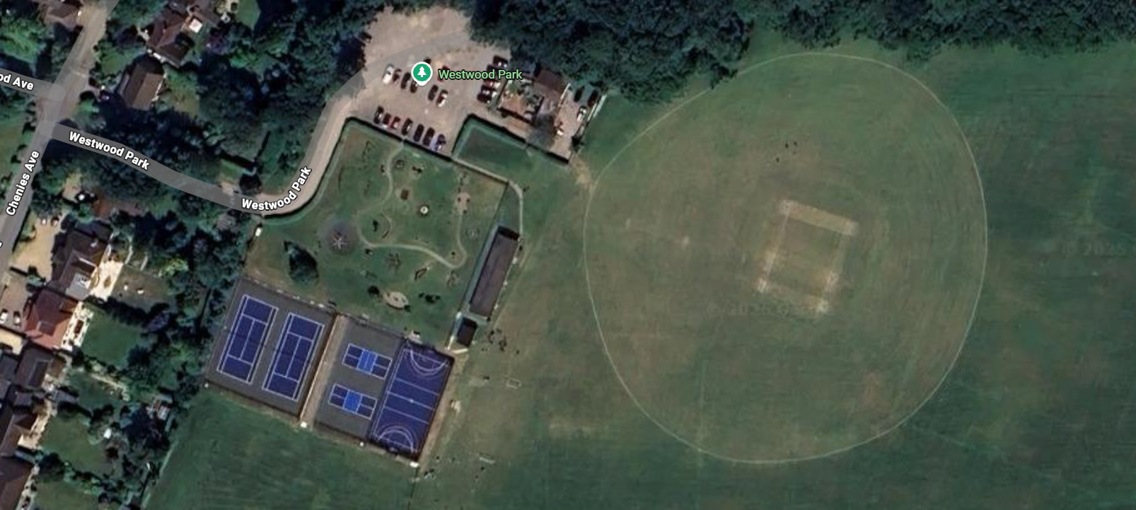
The pitches are predominantly used by a youth football club with circa 30 teams on Saturday mornings and during the summer by a two cricket teams from one local club.
The playground is popular but during the winter months the clay soils retain rainwater in large puddles making some of the play equipment unusable. The play equipment is old and some equipment has had to be removed in recent years on safety grounds.
The Pavilion was built in circa 1975 and, being a timber construction, is now in a poor state of repair. It contains 4 changing rooms, each with a toilet and shower. There is a small activity room with kitchenette which is mainly used by the cricket teams in the summer.
Throughout the year, the park is also used by dog walkers, runners, walkers, sports court users and families. On bi-annual Village Days it is used for a 5k fun run.

Vision

In discussions with current and future users, it was consistently said that the park needed public toilets, a café to meet in and there was a general under investment in the potholed car park and sports facilities.
The parish council is keen to address all of these issues within a rejuvenation project which will also turn Westwood Park into a destination place for the wider community.
In 2024 we started on the refurbishment of the sports courts which were completed in May 2025. We now wish to start Phase 2 for the new Pavilion, car parks, playgrounds, exercise area and footpaths.

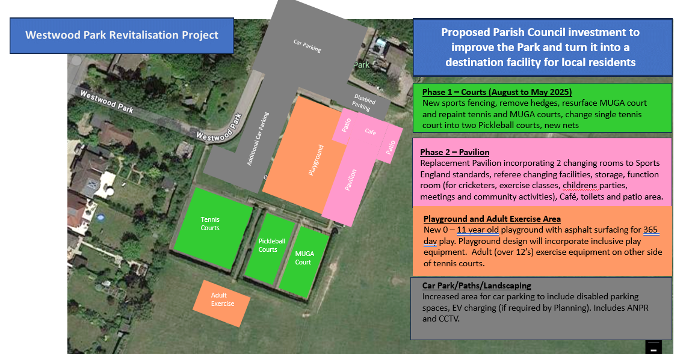

The funding for this project will be from a combination of grants, donations, Levy’s (CIL and Section 106), and parish reserves.

Design Brief

New Pavilion
Approximately 700m² building to include:
- 2 x cricket sized changing rooms, 2 x official changing rooms, 1 x gender neutral changing room
- Football storage with external access
- Multi-purpose activity room (to hire)
- 2 x 20-person meeting rooms (to hire)
- Parish offices with storage
- Café with kitchen and storage, internal FoH and patios facing the playground and sports fields
- Public toilets
The changing rooms must meet Sports England and FA requirements. The Pavilion is not a club-house but a public access facility. The public areas (café, multi-purpose/meeting rooms and toilets) must be designed to feel inclusive to a wide range of users such as children, families, elderly, sporting groups, community groups and be dog friendly.
The Pavilion should be designed for a 50 year lifespan, require minimal maintenance, and be sustainable. The Pavilion should not have a gas supply. All other services (electricity, water, fibre, drainage) to the Pavilion and the house to be completely renewed from the road or utility source point.
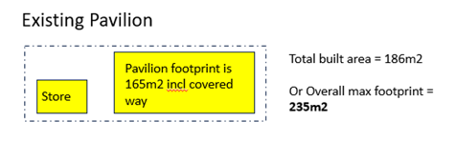
For information, the new Pavilion has a significantly larger footprint than the existing buildings.

Children’s Playground and Exercise Area
This will be designed by others. It is our intention to provide a wide range of play and activity equipment to stimulate play, exercise and be inclusive for children of all abilities. We are assuming it will require 2,000m² of space.

Car Parking
The car park is free to use and is considered to be a significant benefit to the community. However, it lacks a robust surface with good drainage. It should be landscaped to blend in with the natural environment and include disabled parking spaces, bicycle parking, EV charging, lighting, ANPR and CCTV. Subject to there being sufficient space, we would like to include additional car parking alongside the courts and playground.

Footpaths
Footpaths are needed to provide hard surface routes around the site and in particular, around not through the children’s playground. All paths are to be designed to be fully accessible to allow wheelchair users easy access from the car park to all areas. To maintain the current rural aspect of the park, we will need to plan for hedges, planting and trees to soften the areas of hard surfaces.

Scope of Services

Stage 1 (Initiation to Pre-App)
Provision of Architectural Services, Landscaping and Principal Designer services broadly covering RIBA Stages 0 to 2. The Council will separately employ a Planning Consultant. In 2025 we procured a typographical survey of the whole area and an ecology survey which are available to tenderers upon request. Assume that half of the monthly meetings will be held in your offices and the other half at the Village Hall.
The outputs for the Pre-App should include the Pavilion, playground space (space and location only), paths, resurfaced car park, extended car parking area and adult exercise area (space and location only). As the Pavilion will exceed the current floorplate, you should allow for the production of 3 different schemes potentially covering single and two storey options. Include for presentation materials, attending the meeting with the Bucks Council planners and a feedback meeting with the council afterwards.

Stage 2 (to Planning)
Provision of Architectural Services, Landscaping and Principal Designer services broadly covering RIBA Stages 2 to 3 (or often referred to as 2+). The council will separately employ a Planning Consultant, MEPH Engineer, QS and Project Manager. Assume that half of the monthly meetings will be held in your offices and the other half at the Village Hall.
After Stage 1, the Council will review the scope of the works in light of the pre-app and some early cost advice. This may necessitate a remodelling of one of the 3 schemes put to the planners. For the tender costing purposes, the council will build up a provisional sum based on assumed hours and the tenderers hourly rates.
This stage includes a public consultation for residents, incorporating the publics comments into a design to submit for full planning. Include for presentation materials, attendance at the public consultation and planning meeting and a feedback meeting with the council afterwards.

Stage 3 (full design)
It is likely that there will be a period of time to raise the funding before we can proceed with the design after planning. However, it is anticipated that the council would wish to continue with the design team and will negotiate fees through to completion.

Procurement timetable

Stage | Date
Issue tender documents on Find a Tender | w/c 5th January 2026
Deadline to request a site visit | 16th January 2026
Site visits | 19th to 23rd January 2026
Deadline for Clarification questions | 23rd January 2026
Submission deadline | 30th January 2026
Evaluation and Interviews | 2nd to 20th February 2026
Approval to appoint at Parish Council meeting | 11th March 2026
Award of Contract | w/c 16th March 2026

If you would like to visit site, please email clerk@littlechalfont-pc.gov.uk before the above deadline to request a date.
Please note that the Parish Council will not be responsible for any tendering costs.

Required Tender Return

Part 1 | Company background | Provide background information about your company, general experience, date it was incorporated, your head office address and the number of full-time and part-time PAYE staff on payroll. (maximum 3 pages)
 | Main contact details | Provide the contact name, office address, phone number and email address of person who will be responsible for this commission
 | ARB | Confirmation that the company is ARB Registered
 | Insurances | Confirm the level of Professional Indemnity Insurance cover you currently hold
 | Insurances | Confirm the Employers Liability Insurance cover you currently hold
 | Insurances | Confirm the Public Liability Insurance cover you currently hold
Part 2 | Costs | Lump sum for the provision of Stage 1 Services (Initiation to Pre-App) inclusive of travel and expenses. Provide a description of what services you have included for and what has been excluded. Assume that all services will be provided in 2026
 | Costs | Lump sum for the provision of Stage 2 Services (to Planning) inclusive of travel and expenses. Provide a description of what services you have included for and what has been excluded. Assume that all services will be provided up to March 2027
 | Costs | Provide a table of hourly rates for grades of staff up to March 2027
 | Experience – Case Studies | Provide two examples of where your company have undertaken similar work in the past. Identify the client, address of project, the extent of your appointment, dates, value of construction (if not known, your fees), whether the site is in green belt, conservation area or area of outstanding beauty. If you wish to use examples that have been designed by staff whilst employed elsewhere, this should be clearly identified
 | Experience - Specific | Our vision is that the Café, multi-purpose activity room and meeting rooms should be inclusive, welcoming and inspiring to a wide range of sport and community users. Provide examples of your thoughts and ideas on how you would design spaces to achieve this for girl/women sports teams, young children, local groups such as WI or U3A, art classes, dog walkers, vulnerable groups such as dementia or special needs and for wheelchair users
 | Proposed Team | Provide an organisational chart showing the staff members who will be involved with this commission. Provide a one page CV for each staff, identifying their role, which office they are based at, their specific experience relating to this project, when they joined your organisation, whether they are full-time or part-time, whether they are PAYE or a sub-consultant

Evaluation

Part 1 of the return is not scored.
Part 2 of the return is scored in the following proportions:-
Costs 30%
Experience – case studies 30%
Experience – specific 20%
Proposed Team 20%

Costs
In addition to the provision of services cost, we will make an assumption of staffing hours that may be needed to alter the design following the pre-app based on the hourly rates.
After any adjustments to ensure all the tenders are on a like-for-like basis, the following formula will be applied. The lowest tender will be awarded 30 points. Bidders with higher prices will receive a percentage lower than 30, based on the percentage by which their bid is higher than the lowest tender. For example, if a bidder is 10% higher than the lowest bid, 10% of 30 will be deducted giving a score of 27. Results will be rounded up to nearest whole number.

Experience, Knowledge Question & Team
These sections will be scored individually on a graded response scale, based on the bidder’s submission and the interview.

Score | Classification | Characteristics
10 | Excellent | Exemplary response. Comprehensive and relevant information is provided and the response provides the evaluation panel with a very high level of confidence that the bidder will be able to meet the requirements of the project with no reservations or concerns.
8 | Good | Comprehensive and relevant information is provided and the response provides the evaluation panel with a high level of confidence that the bidder will be able to meet the requirements of the project with no more than one limited reservation or concern .
6 | Satisfactory | A broad response with an adequate level of information provided that is relevant and the response provides the evaluation panel with at least a good level of confidence that the bidder will be able to meet the requirements of the project with no more than minor reservations or concerns.
4 | Poor | The response is limited and lacking in relation to a large proportion of material elements and leaves the evaluation panel with significant reservations or concerns,
0 - 2 | Unacceptable | No response or extremely limited response that does not suggest that the bidder has the ability to meet the requirements of the project.

The adjudication panel will consist of the Parish Clerk and a minimum of two Councillors. A minimum of 2 tenderers will be interviewed.

Submission of Tenders

Returns must be returned to the Parish Clerk before the closing date.
They can be submitted by:
Email: clerk@littlechalfont-pc.gov.uk
Post: Parish Clerk, Little Chalfont Parish Council, Little Chalfont Village Hall, Cokes Lane, Little Chalfont, HP8 4UD
Please note that the Parish Office normal hours are Monday to Friday 09:00 to 12:00 and by appointment only.

