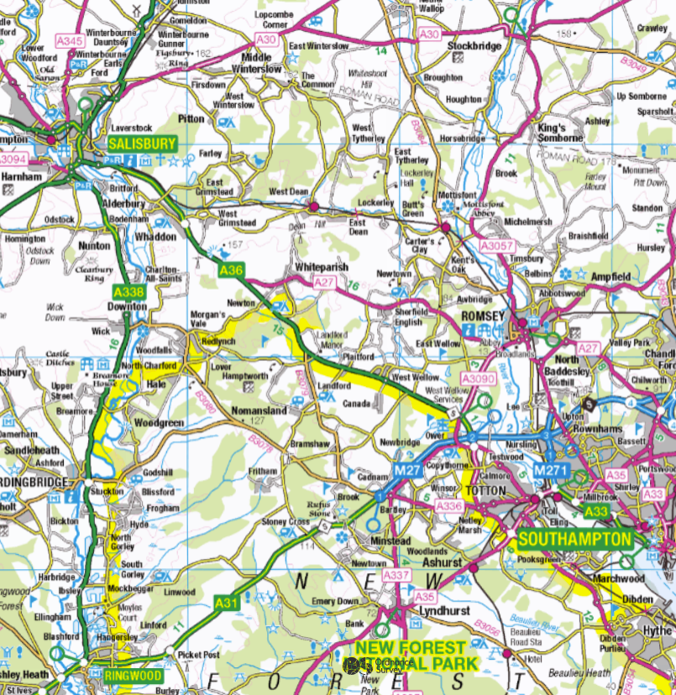
BOUNDARY OF NORTHERN NEW FOREST AND SOUTH EAST WILTSHIRE DEER MANAGEMENT GROUP AREA

