Background to Natural England
Natural England are the government agency for nature conservation. Part of our remit is the management of National Nature Reserves. To undertake this work we require tools, machinery, equipment & services.

National Peatland Action Programme Restoration of S.59 Else’s Fields - Ditch and scrub works at Fenn’s, Whixall and Bettisfield Mosses NNR.
The Marches Mosses BogLIFE project (LIFE15 NAT/UK/000786) was a six-year project started in October 2016 and concluded on 31 December 2022. The project aimed to restore Britain’s 3rd largest lowland raised peat-bog, comprised of the complex of Fenn’s, Whixall & Bettisfield Mosses NNR’s and Wem Moss NNR all located near Whitchurch, Shropshire and Wrexham in Wales, in total approaching 1000ha (see Map, Annex 1.1). The LIFE project was led by Natural England working in partnership with Natural Resources Wales and the Shropshire Wildlife Trust. The project was financially supported by LIFE, a financial instrument of the European Commission and the Heritage Lottery Fund. It is imperative that the control of birch (and scrub) is continued following on from the end of the project in order to aid the continuing restoration process.
- Site/Access:

The work site is at the northern perimeter of Fenn’s, Whixall, Bettisfield Mosses NNR. A small part of the site (0.1 ha) has been designated as part of a Special Area of Conservation (SAC) site, a Ramsar site and SSSI. It does not however, form part of the Fenn’s, Whixall and Bettisfield Mosses NNR, but has been allocated an NNR Section number, Section 59.
- Invitation:
You are invited, to submit a quotation for the requirement described in the specification below.
Please confirm, by email, receipt of these documents and whether you intend to submit a quote.
Your response should be returned to the following email address by:
Email: nathan.brake@naturalengland.org.uk
copied to: peter.bowyer@naturalengland.org.uk
Date: 14th January 2026.
Time: 09:00am
Ensure you state the reference number and ‘Final Submission’ in the subject field to make it clear that it is your response.
NOTE depending on available funding, not all the work may be commissioned.
Contact Details and Timeline
Nathan Brake will be your contact for any questions linked to the content of the quote pack or the process. Please submit any questions by email and note that, unless commercially sensitive, both the question and the response will be circulated to all tenderers.
Action | Date
Date of issue of RFQ | 23rd December 2025
Viewing dates | 7th January 11am 2026
Deadline for receipt of Quotation | 14th January 9am 2026
Intended date of Contract Award | 16th January 2026
Intended Contract Start Date | 19th January 2026
Completion Date | 16th March 2026

- Requirement:

4.1. A contractor is required to coppice all ditch side vegetation necessary to allow the works detailed in point 4.2 to be completed. Note that trees over 8 cm diameter at 1.3m from the ground are to be left. Should it be deemed necessary for a tree above this threshold to be felled, approval should be sought from Reserve Manager Nathan Brake (07880 462288). All track side scrub 4m south of the public right of way up to a height of 6m is to be coppiced and left untreated, see annex 3.2. All brash is to be chipped onto the public right of way and levelled. In section 59 all brash is to be chipped and deposited in a location to be determined by Natural England staff.
4.2. A contractor is required to manage weed/vegetation, scrub growth/root balls and silt in the drains as per the attached map annex 3.1, which is an approximate length of 1137m. The contractor is to remove vegetation, tree roots and silt within the ditch and deposit material on the opposite side of the public right of way once the scrub works have been completed. In section 59 any material excavated from the ditch is to be deposited at least 2m away from the ditch edge but no more than 10m into the field. Where any pipe is located the full extent of the inflow and outflow should be excavated. There is a collapsed bridge (located at SJ 49605 38704) that is also to be extracted as part of the ditch clearance. An ecological clerk of works will be present for this phase of works as Great Crested Newts may be present. All materials extracted from this structure are to be taken to Natural England Manor House base and deposited in area identified by Natural England staff.
- Do not deepen ditches.
- Do not cut into banks or drag material up banks where the channel is open and obvious.
- In areas where hummocks of vegetation have constricted the ditch, edges may be reprofiled in line with the rest of the existing ditch.
See Annex 6: Water Vole best practice guidelines for ditch & habitat management

4.3. A contractor is required to remove all felled pine brash from approximately 25m of ditch line and chip and dispose of offsite. This section of ditch is then to be cleaned as per point 4.2 and is included in the 1137m.
- Contractor obligations:

Where work is alongside tracks open to the public, appropriate signage must be put on the tracks.
The contractor is expected to provide first aid kits and an adequate number of trained first-aiders.
Appropriate PPE to be worn at all times by the contractor and workers. Warning signs to be erected on approach tracks. Copies of First Aid Training Certificates are to be included in the Tender. Training certificates need to be included for any operatives who are to use power tools or machinery stated in the in the methodology - ie chainsaws, clearing saws, chippers, tractors & excavators.
The contractor shall indemnify Natural England & Natural Resources Wales against all reasonable claims arising out of his/her operations and shall insure against all claims made as a result of these operations either by Natural England/Natural Resources Wales or third parties.
All work must comply with HASAW, COSHH, HAVS, Noise and FEPA regulations. Care must be taken because of the presence of ditches/borrow-pits, wet holes, cut stumps, brash, brambles, tree-roots, adders and other animals on site.
No smoking on site.
A list of site hazards is attached below. The contractor must submit their Method Statement and example Risk Assessments in the Tender but full site-specific Risk Assessments before starting the Contract. These must be approved prior to the commencement of work. Natural England examples of operational Risk Assessments are included as examples - ANNEX 4. Risk Assessments.
The contractor must inform the reserve manager by email or text as to when work is being carried out and by whom so that work progress can be inspected and any issues discussed.
No dogs or other animals to be brought onto site.
7. SITE HAZARDS:
a. Disorienting, uneven, and unstable terrain. Uprooted stumps and branches are frequent with bramble in places.
b. Throughout the site it is possible to sink into soft peat but particularly in the borrow pits, machine ruts and old ditches.
c. The area includes drainage ditches and peat cuttings, which may be hidden by vegetation, either empty or filled with deep water and soft peat. Banks may be unstable.
d. Trees on the bog margins can be shallow-rooted and can become unstable in high winds. Mature trees may shed branches, especially in windy weather.
e. Vegetation (particularly bracken and purple-moor grass litter) poses a fire risk in dry and windy conditions all year round. No smoking.
f. Adders, midges, horseflies and other biting insects are present on site.
g. Due regard must be exercised when working near Public Rights of Way for walkers, dogs and horse-riders especially with regard to chemical.

Contract Evaluation:
The contract will be evaluated on the basis of cost 50% and on the basis of quality of the bid 50%.
Quality will be assessed on:
The quality of the bid (50% of the total evaluation score) will be assessed on the below information being provided
40% | Methodology | State method & equipment to be used, fuelling (if applicable), transport, communication, sub-contracting, and measures to minimise damage to bog species. State capacity to get project completed.
25% | Experience | Provide a work force list with relevant qualifications & copies of certificates, together with details of CPD training (continuous professional development) and their employment status (e.g., permanent staff, contractor/temporary, sub-contractor). Detail previous experience on working on peatlands. (This also applies for any sub-contractors being used). Personal information should be removed from any info submitted.
25% | Health & Safety | Provide a site- specific emergency plan including transport, pollution, and fire prevention measures. Provide a Health and Safety Policy & copies of Employees and Public Liability Insurance. Provide relevant examples of Risk assessments & Method statements (RAMS).
10% | Sustainability / environmental / social | Provide detail on how sustainability is embedded in your supply chain. This should include your use of sustainable, environmentally friendly materials and practices. Provision of an environmental Policy. Detail any social value initiatives you would employ on this project.

Score | Justification
For a score of hundred (100): | Excellent - Response is completely relevant and excellent overall. The response is comprehensive, unambiguous and demonstrates a thorough understanding of the requirement and provides details of how the requirement will be met in full.
For a score of seventy (70): | Good - Response is relevant and good. The response demonstrates a good understanding and provides details on how the requirements will be fulfilled.
For a score of fifty (50): | Acceptable - Response is relevant and acceptable. The response provides sufficient evidence to fulfil basic requirements.
For a score of twenty (20): | Poor - Response is partially relevant and/or poor. The response addresses some elements of the requirements but contains insufficient / limited detail or explanation to demonstrate how the requirement will be fulfilled.
For a score of zero (0): | Unacceptable - Nil or inadequate response. Fails to demonstrate an ability to meet the requirement.

Invoicing:
Invoices should be submitted by the end of March 2026 – NO LATER. Contractors shall make no financial investment in the project and, therefore, shall not benefit from any intellectual property rights arising from the project. The Purchase Order number must be included on the invoice or it will be rejected. It should be received before the end of March 2026.
Site Visits
Site visits with reserve manager Nathan Brake will be held on 7th January 2026. Meeting at the lay by at the top of Conery Lane, SY13 3EZ. Unguided return visits are permitted as long as notice is given to the Reserve Manager/s. Instructions will be sent out to those who book.
If you are unable to make any of these dates, please contact the reserve manager to arrange an alternative.
Prices
Prices must be submitted in £ sterling, inclusive of VAT.
It is anticipated that this contract will be awarded for a period of 2 months ending no later than March 16th. Prices will remain fixed for the duration of the contract award period. We may at our sole discretion extend this contract to include related or further work. Any extension shall be agreed in advance of any work commencing and may be subject to further competition.

Pricing schedule:
For works detailed in the specification above. NOTE depending on available funding, not all the work may be commissioned.
Quotation: National Peatland Action Programme Restoration of S.59 Else’s Fields - Ditch and scrub works
S59 Works: |  | Fixed Price (excl. VAT)
Scrub clearance to include chipping of all brash.
Ditch clearance to include removal of collapsed bridge and pine brash.
Total Price excluding VAT
VAT
Total Price including VAT

I can commence work by ………………………………………………………………….
I attach a copy of relevant 4x4, First-aid, clearing-saw/chainsaw, excavator and insurance certificates ………………………………………….………………………………………………
I attach a copy of my method statement and example risk assessment for the job including use of all machinery / vehicles ………………………………………………………………..

I can do all/ part of the work (please specify) …………………………………………….

I envisage that I can complete the work within the required timescale .......................

Signed ……………………………………………………………………………………….

Position ………………………………………………………………………………………

Date ……………………………………………………………………………………

- Sustainability
Natural England protects and improves the environment and is committed to reducing the sustainability impacts of its activities directly and through its supply chains. We expect the Contractor to share this commitment and adopt a sound, proactive sustainable approach in keeping with the 25 yr environmental plan/our commitments compliant with all applicable legislation. This includes understanding and reducing direct and indirect sustainability impacts and realising opportunities, including but not restricted to; resilience to climate change, reducing greenhouse gas emissions, water use and quality, biosecurity, resource efficiency and waste, reducing the risk of pollution, biodiversity, modern slavery and equality, diversity & inclusion, negative community impacts.
As a delivery partner, the successful contractor is expected to pursue sustainability in their operations, thereby ensuring the Contracting Authority is not contracting with a supplier whose operational outputs run contrary to the Contracting Authority’s objectives. The successful contractor will need to approach the project with a focus on the entire life cycle of the project
Annexes:
Annex 1.1 Location map
Annex 1.2 Fenn’s, Whixall & Bettisfield Mosses NNR Management Sections
Annex 2.1 Access to Work Area
Annex 3.1 Ditch line to be cleaned
Annex 3.2 Scrub works
Annex 4 Sample Risk Assessment (for guidance)
Annex 5 Link to terms and conditions
Annex 6 Water Vole ditch & habitat management best practice guidelines

Annex 1.1: Location Map
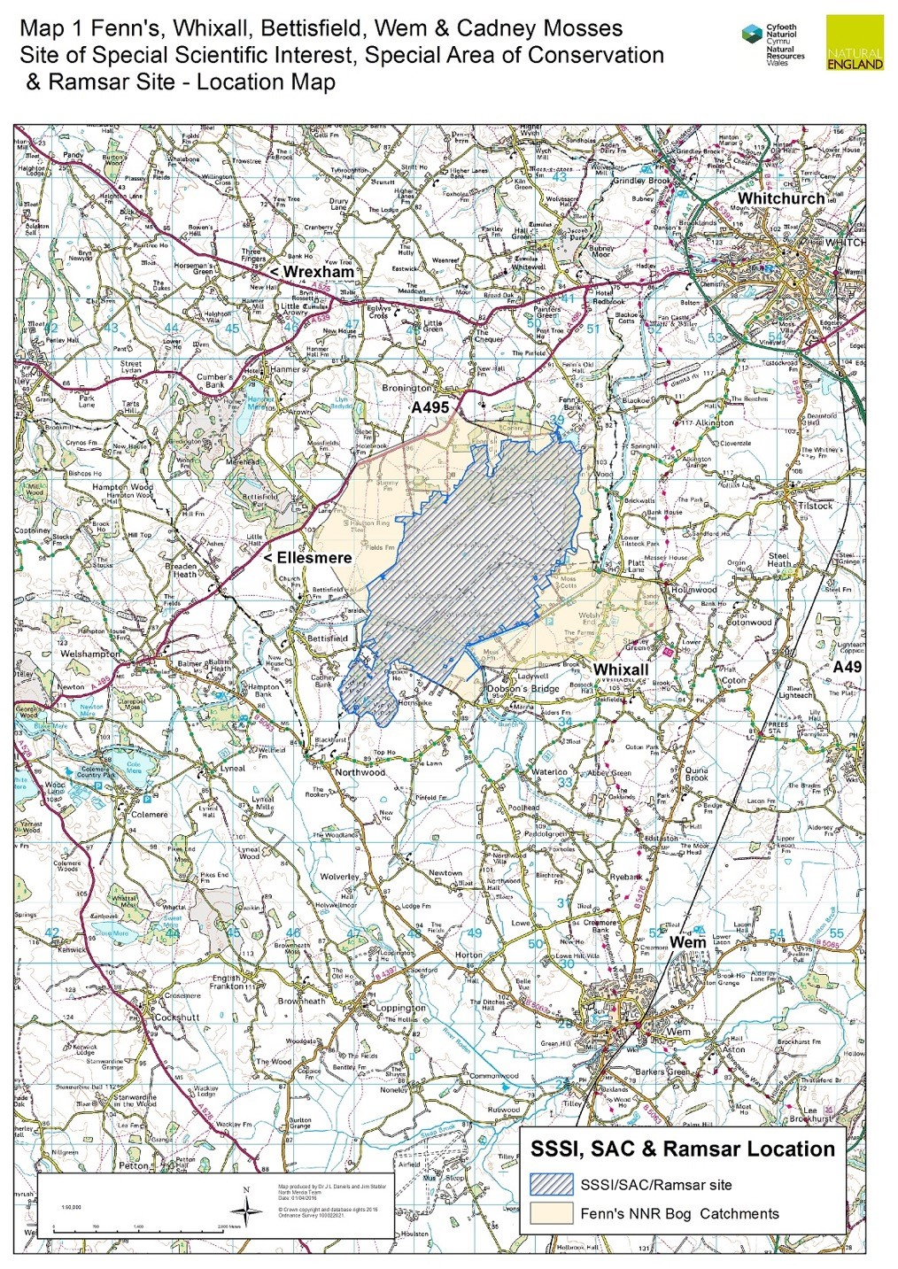

Annex 1.2: NNR Management Sections
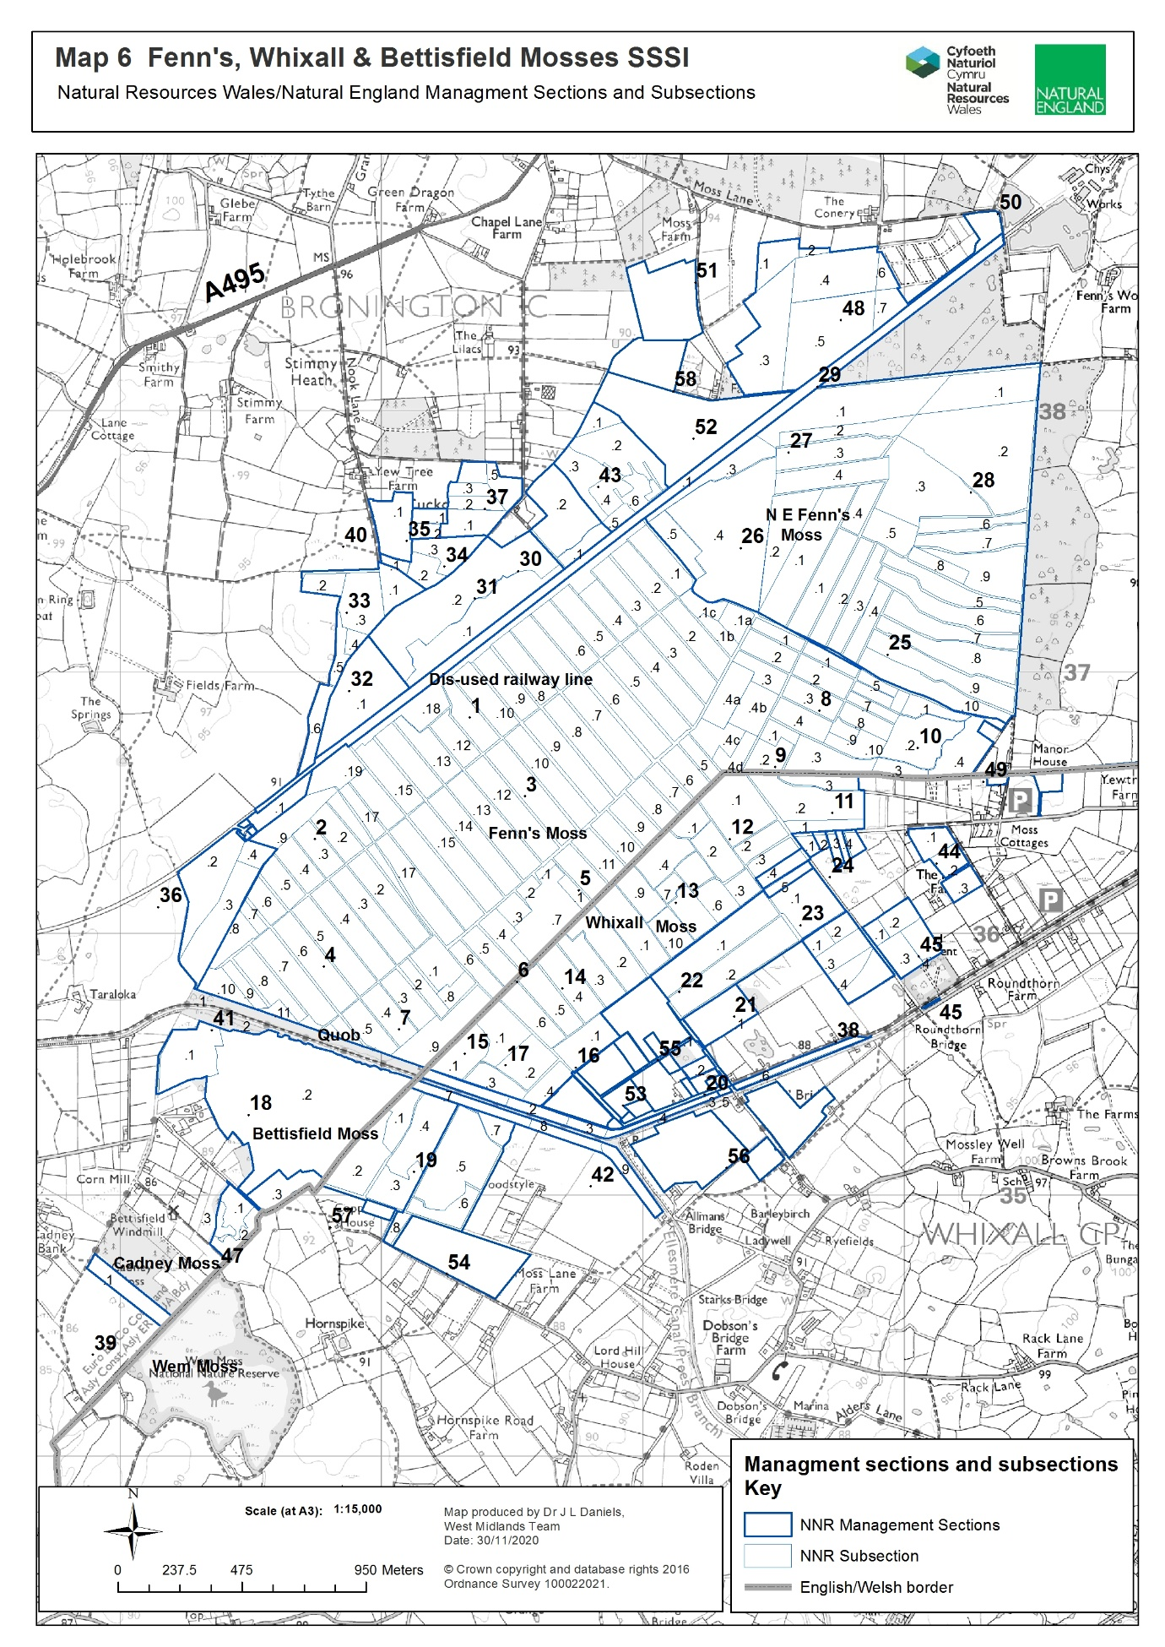

Annex 2.1: Access to work area.
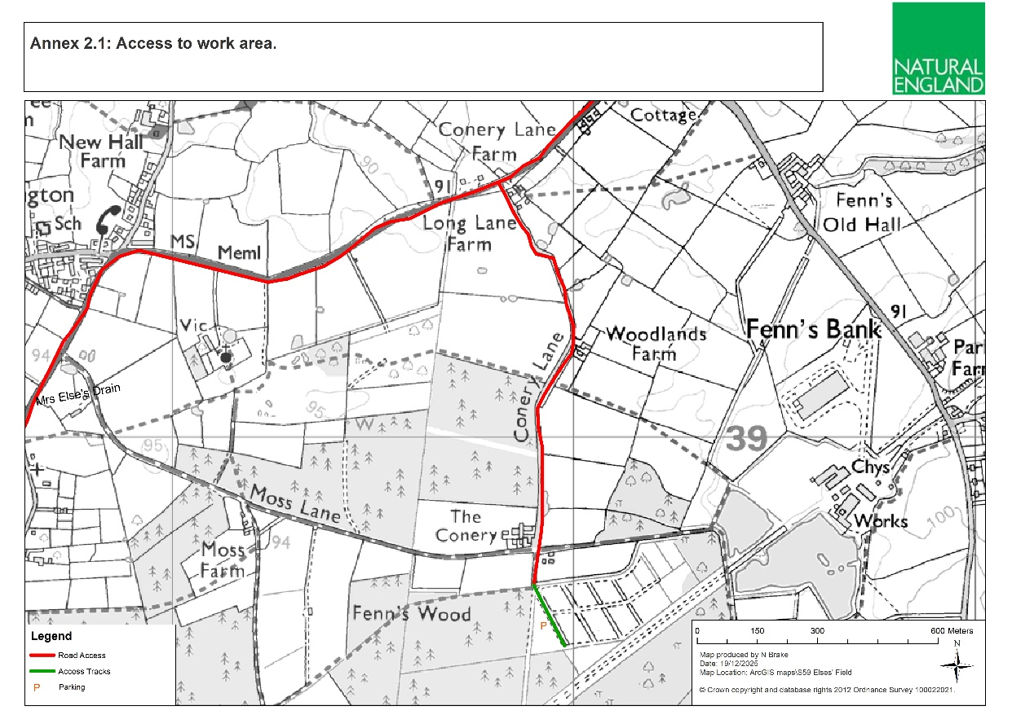

Annex 3.1: Ditch line to be cleaned.
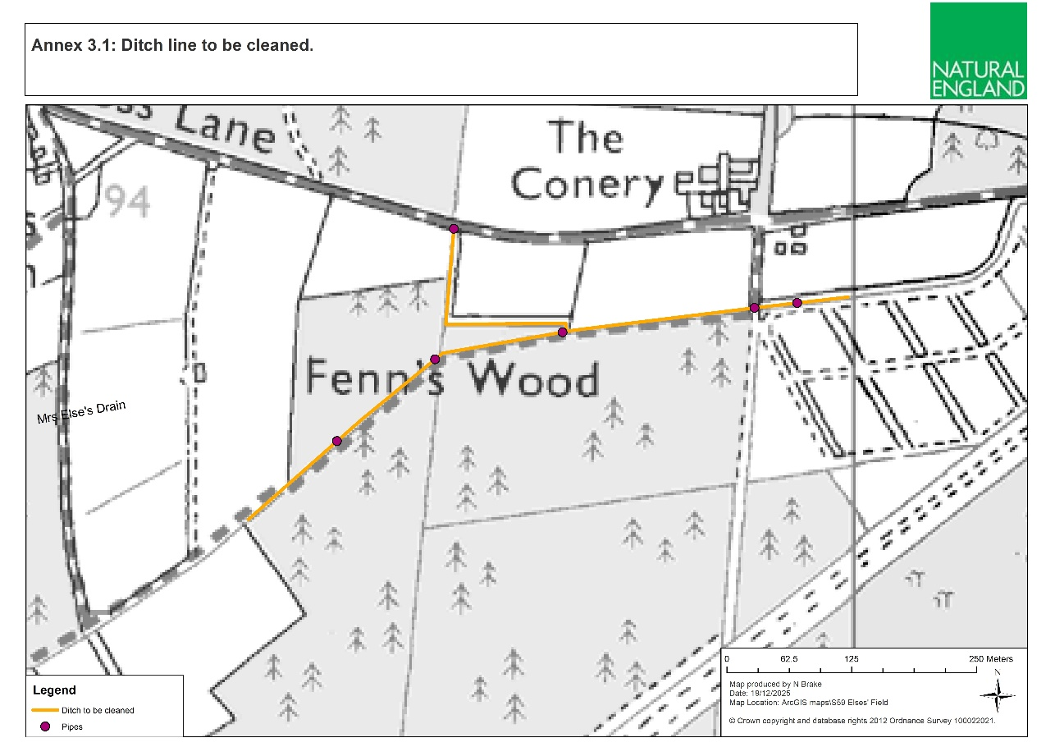

Annex 3.2: Scrub works.

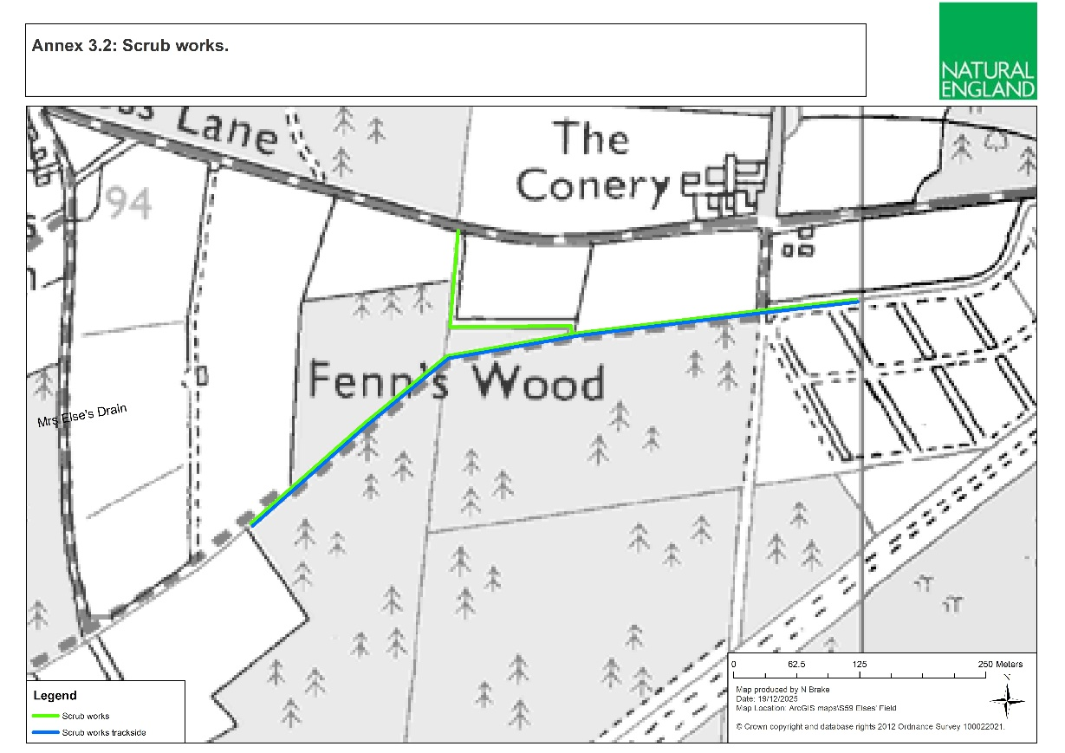

Annex 4: Sample Risk Assessment

Risk Assessment Template (H&S) NNRs
NNRs covered by this risk assessment: | Fenn’s, Whixall and Bettisfield Mosses NNR |  | Date completed: | 21/4/2023
Assessment of (e.g. Activity, Equipment, Individual) | Working on Peatlands |  | Review date (max 1 year): | 21/4/2024
Training required? Tick all that apply |  |  | Signed off by (SRM/ Line Manager): | P Bowyer  SRM
Training course: |  |  | Mandatory/Optional | Applicable?
First Aid at Work |  |  | Mandatory | p
Other (Please specify):
Notes (e.g. mandatory safety precautions) | Site safety maps are kept in all NNR vehicles. This map together with site safety information is emailed to third parties as appropriate.  Vodafone signal on NE Phones is generally good. Third parties to check phone signal whilst on site. Emergency contacts card in all NNR Vehicles & NE first aid kits.  Follow NE lone working policy as appropriate.  Risk assessments are available for all related operations – refer to these as necessary. In particular refer to:  - General safety - Personal  - General safety - Site (Fenn’s, Whixall and Bettisfield Mosses)  First aid kit in all NNR vehicles & each member of staff has a personal NE Kit. Eyewash in all NNR First aid kits & NNR Vehicles.  Note: young persons, new & expectant mothers etc., a separate risk assessment should be recorded.
Minimum PPE/RPE requirements | - Work Gloves  - Rubber gloves and Nitrile Examination Gloves – when working with water  - Steel toe capped high ankle boots/ wellingtons (EN ISO 20345:20011)
What are the hazards common to all? | Who might be harmed and how? | What precautions are you already taking? | What additional local precautions are required?
Uneven, often soft terrain, particularly on rehabilitated cuttings. Old peat pits. | Staff, Volunteers and Contractors  Slips and Trips | Where possible avoid work in the wettest areas over the winter season.  Wear suitable footwear (waterproof if necessary) with a firm grip. | Pre-plan works using site maps to determine where heavily cut areas are in the work area.  Walk over site with caution in-case peat pits are over grown/covered by brash.
Danger of machinery bogging down and overturning. Uneven tracks. Vehicles tip sideways when one pair of wheels is kept on the firm track side and the other is in soft peat. | Staff, Volunteers and Contractors  Cuts, Bruises, Whip Lash, Concussion | Only trained drivers to drive machinery.  Fill track holes with peat/chip.  Protect personnel in vehicles and goods on trailers.  Tractor link-boxes must not be used for personnel carriage.  Cover blades of all sharp tools. All small or sharp-edged tools in trailers/tractor link boxes must should be carried in a tool box.  First Aid kits in every vehicle. | Pick routes to avoid known wet spots on tracks and peat cuttings.
Ditches, bog pools, fire pools, pits Fenn’s Main drain weir, wide U-pipes and other watercourses.  Minor ditches 0.5-1 m deep. Main drains >1 m deep. Overhanging and floating plants, sides unstable. Soft, ‘bottomless’ base to dammed cuttings | Staff, Volunteers and Contractors.  Drowning, Hypothermia | Maintain official crossing places and make personnel and others aware of their positions. | Otherwise cross established peat dams Ensure workers know the drain pattern in the work area.  No lone working on very soft saturated areas, by the main drain & Sect. 14 south and 11.1  Avoid the Fenn’s weir and ensure netting is maintained on large U-pipes.  Maintain safety fencing at the Fenn’s Old Works railway culvert, the Marl Allotment ditch and Bettisfield pond.  Bring throw line when working close to main drains.  Leave the Moss at dusk unless on special monitoring tasks.  One side of fire pools is graded to permit escape. Keep spare set of clothing at NNR Base in case of falling in ditches. Emergency shower at NNR base.  Maintain deep drain, weir, crossing point and fire pool signs and posts.
Deep pools/ borrow pits by dams and bunds | Staff, Volunteers and Contractors  Drowning, Hypothermia |  | Warn users crossing dams or walking on bunds.  Test dams/bunds before crossing.  Don’t step off dams/bunds into water where you can’t see the ground beneath.
Slippery ditch crossings/ ragged mesh covering | Staff, Volunteers and Contractors  Slips, Trips, Cuts and Bruises | Replace rotten sleepers and maintain bridge marker posts and mesh on walkways.  Remove and replace any loose mesh.  Walk over crossings with caution. | Inspect for and clear of peat regularly.
Main Drain - polluted water and deep silt in base, half full downstream of wear so hard to climb out of. | Staff, Volunteers and Contractors  Weil’s disease, Sporotrichosis, Hypothermia and Drowning. | Wear rubber gloves with nitrile examination gloves underneath when working in ditches.  Wash hands before eating or drinking if they have been working in ditch.  Workers to be made aware of their flu like symptoms. | No lone working involving the Main Drain, without regular telephone contact with another worker.  Take throw-line if working by the Main Drain.  Be aware of shallower 100 yd interval side drains.
Unstable shallow-rooted trees prone to windblow. | Staff, Volunteers and Contractors  Crush injuries, Concussion, Cuts and Bruises. | Check the weather forecast prior to work near trees. | Keep out of unstable peat areas.  No lone working and wear waders in unstable carr area on 14.1, 11.1 and along the Quob. Be aware that trees can flip if being winched.  Avoid trees on peat in high winds. If unavoidable wear a hard hat.
Adders | Staff, Volunteers and Contractors  Inflammation, Pain, Bruising, Nausea, Fast Heart Rate, Sweating, Breathing Difficulties, Confusion and Dizziness | Look before touching the ground/sitting down.  Wellingtons/high boots should be worn at all possible times.  Check for adders in areas where work is being carried out.  First aid procedure if bitten:  -Remain calm and keep the part of the body that been bitten as still as possible to prevent the spread of venom around the body.  -Remove jewellery/watches from around the bitten limb.  -Loosen clothing if possible.  -Keep the casualty still and calm.  -Seek immediate medical attention by dialling 999. | Signs on noticeboards explaining the first aid procedure.  Wear gauntlet gloves when lifting brash and rubbish.
Stings and Bites – Insects/Plants | Staff, Volunteers and Contractors  Irritation, Illness and Inflammation | Wear long sleeves/full length trousers.  Use Insect repellent.  Use anti-inflammatory on any effected areas.  Wear work gloves when working with stinging/ thorny plants.
Slippery irregular brash mats. Brash obscuring ditches. Roots can project from tracks. Projecting tree/bush stumps, obscured by vegetation. | Staff, Volunteers and Contractors  Slips and Trips | Warn public to keep off the brash tracks.  Trail routes are to be inspected regularly for projecting roots, overhanging trees etc.  Noting if tree work has previously taken place in that work area.
Projecting metal | Staff, Volunteers and Contractors  Cuts, Bruises, Slips and Trips | Inspect work areas.  Wear work gloves if moving metal.  Wear steel toe capped boots/wellingtons on site, especially if working near known metal.  Inform others wear metal has been found. Mark on annual audit.

What are the hazards specific to your site/ staff/ equipment? E.g. site features such as steep slopes, individual issues such as new starters, equipment features such as known complexities. | Who might be harmed and how? | What precautions are you already taking? | What additional local precautions are required?
Turnover of trainees, volunteers, work placement students | New starters | Ensure new starters to be briefed on safe practices whilst working on the peatland during their induction. New starters should be accompanied by staff during their first few weeks on the reserve. Staff to highlight hazards and safe working practices.
Please add more lines if required.
General comments:

ANNEX 5: Link to Terms and Conditions

Standard goods and services terms and conditions (£10,000 to £50,000) - GOV.UK

ANNEX 6: Water Vole ditch & habitat management best practice guidelines

