National Peatland Action Programme Restoration of S.59 Else’s Fields of Fenn’s, Whixall and Bettisfield Mosses NNR – Rewetting Works.
- Background to Natural England
The Authority is Natural England. The Authority’s priorities are to secure a healthy natural environment; a sustainable, low-carbon economy; a thriving farming sector and a sustainable, healthy and secure food supply. Further information on the Authority can be found at: www.naturalengland.org.uk
- Background to the specific work area relevant to this purchase
  - Else’s Fields, the site for the works, some 2.4 ha in area, lies 7km south-west of Whitchurch and 17km south of Wrexham at OS Grid Ref: 349744 338657. They were part of the lagg (wet woodland, swamp and fen) of Fenn’s Moss at the northern perimeter of the internationally important 949 ha Fenn’s, Whixall, Bettisfield, Wem and Cadney Mosses Site of Special Scientific Interest (SSSI), which is also a Special Area of Conservation (SAC) and forms part of the Midlands Meres and Mosses Ramsar Site.
  - A small part of the site (0.1 ha) has been designated as part of a Special Area of Conservation (SAC) site, a Ramsar site and SSSI. It does not however form part of the Fenn’s, Whixall and Bettisfield Mosses NNR, but has been allocated an NNR Section number, Section 59 on Annex 1.
  - Its present use is as grazing pasture/hay meadow and it has been historically drained and “improved” to allow for this agricultural usage. Approximately half of the total area contains peat that has the potential to be restored.
  - The Marches Mosses BogLIFE Project (LIFE15NAT/UK/000786) finished in March 2023. One of the BogLIFE Project aims was to allow better control of water levels to enable wetland habitat to be restored on land which had been converted from peatland to peaty fields. Section 59 is being funded by NRW’s National Peatland Action Programme (NPAP) money, channelled through the Fenn’s NNR Memorandum of Agreement.
  - The National Peatland Action Programme is a 5 year plan of peatland restoration in Wales. Welsh peatlands need urgent action to address the nature and climate emergencies. Funded by Welsh Government, this programme was set up to coordinate peatland restoration action in Wales.
  - Overall, this Project will rewet approx. 1.65ha of lagg soils in Section 59 plus support water levels in adjacent Section 48 of Fenn’s Moss to the south.
  - It is anticipated that this contract will be awarded for a period of 2 weeks to end no later than 16/3/2026, unless there is substantial disruption from adverse weather. Prices will remain fixed for the duration of the contract award period.
- The Rewetting Project (Annex 1 to 2)
  - Access for the work is available at one point as shown on Annex 1 Location Plan. The access is from an existing hard track (Conery Lane leading to Moss Lane) from the A495 at SJ 349825 339643. Use the existing gate at SJ 349879 338711 and travel along the field to the required start point.
  - Contractor vehicles may park in Section 59 or the hammer head in NNR section 48.6. Disruption to the users of the stretch of Moss Lane along the north of the site during the construction phase must be avoided where possible. This track leads to local dwellings. Additional construction vehicle movements will be limited to delivery of materials for the scheme such as pipes and machinery and delivery and collection of machinery for the construction phase.
  - Soil depths above substrate are only 50 to 80cm. Consequently, the 15m x 15m bunds are to be relatively shallow. The underlying substrate is either sand or clay. If the contractor brings up sand, they should stop and contact Reserve Manager, Nathan Brake (07880 462288) for further instruction.
  - The bunds around the northern and eastern margin of the bunding area should be left open to the maintenance track to allow water to run into them.
  - Two balance pipes are required to allow excess water to escape into the surrounding drains, one at the lowest point in field S.59.1. and one in the lowest point of field 59.2.
  - A 6m dam with balance pipe through it and rock armour facing is needed to divert water flowing down the east of S.59.2 along the south of it to the Bronington Manor Drain
  - The duration of the entire works is expected to be 2-4 weeks, weather conditions permitting.
- The S59 Else’s Fields Rewetting Works (Annex2)
  - Bunds
Bunding should be carried out to create a waterproof core protruding ca 15 - 20cm above ground level, covered by more permeable material/ vegetation so high water can permeate through, without the bunds breaking. Bunding should be carried out as outlined in the extract from the Cumbrian LIFE framework Annex 3.
The bunds should be 15 x 15 m dimensions. The edge ones against the uphill northern and eastern slopes should be left open so water can run down into them.
Ca. 2421m of bunding will be required.
Once sand is encountered, Reserve Manager Nathan Brake must be informed, works should cease and material for the bunds must be obtained by extending the area of scraping wider.
Spills kits must be carried in the tracked excavators / dumpers.
  - Balance pipes
Two balance pipes are required. These will be 300mm Internal Diameter and long enough to cross under the cell bund and 10m wide maintenance track and into the surrounding ditch. One will be at ca SJ 49731 38620 at the SW corner of S59.1 and one at ca SJ 49609 38633 at the SW corner of S59.2. Their upstream collars should be set at 15cm above ground level in these corner cells.
  - Dam
One 6m long dam is required as shown on Map 2 SJ 49589 38623. This should have a 6m-long balance pipe fitted with collar and rock armour at its north end.
- Soils. Ecology and Wildlife
  - The Ecology Report “Water Vole Survey” dated 26th July 2025 has been commissioned by NE from Stuart Edmunds Wildlife Consultants, (document 2.1), which highlighted the lack of value of Else’s Fields for water voles, because of evidence of mink This report is available on request.
  - The habitat and soils report carried out in 2023 by The Environment Partnership “TEP 2023 10101.001 Moss Lane Ext. Phase 1 and Peat Technical Report” found the following habitats on were present within the site:
    - Semi-improved neutral grassland
The grassland is dominated by abundant red fescue Festuca rubra, Yorkshire-fog Holcus lanatus, and smooth meadow-grass Poa pratensis. Rare yarrow Achillea millefolium, oval sedge Carex leporine, compact rush Juncus conglomeratus and bird's-foot trefoil Lotus corniculatus are also present.
    - Tall ruderal vegetation
Species include abundant creeping thistle and nettle Urtica dioica, and frequent cleavers Galium aparine
    - Dense/continuous scrub
This consists of a mix of bramble Rubus fruticosus agg overgrowing the fence lines and occasional scrub species including goat willow Salix caprea, hazel Corylus avellana and hawthorn Crataegus monogyna
    - Scattered broad-leaved trees
Species include English oak Quercus robur and goat willow.
    - Wet ditch/running water
Floating sweet-grass Glyceria fluitans and some great reedmace Typha latifolia are present
    - Dry Ditch
Occasionally species associated with acidic conditions such as bilberry Vaccinium myrtillus and sheep’s sorrel Rumex acetosella are present
So in conclusion no rare plant species are present.
A stand of invasive Japanese knotweed Reynoutria japonica (listed in Schedule 9 of the Wildlife and Countryside Act 1981) is present along the northern boundary adjoining the track. The design of the restoration avoids this area.
    - Fauna
Based on the habitats present and those in the immediate surroundings, the fields may be used by:
      - Amphibians and Reptiles
There is suitable terrestrial habitat for amphibians across the site, particularly in areas with a high sward and high structural diversity such as the areas of dense scrub and tall ruderal.
      - Bats
The site includes a variety of habitats suitable for bat foraging and commuting including numerous trees, ditches, scrub and grassland.
      - Badger
No badger setts or definitive field signs were observed
      - Birds
The habitats on the site offer suitable nesting and foraging habitat for a range of bird species, including foraging habitat for barn owl Tyto alba
      - Invertebrates;
Habitats with high structural diversity, such as scrub, tussocky grassland, and areas of tall ruderal vegetation provide the most optimal habitat for invertebrates
      - Otter/water vole
Unlikely because of shallow overgrown and shaded vegetation along ditches.
      - Brown Hare
The site provides suitable foraging and commuting habitat for brown hare as well as for establishing forms
      - Hedgehog and Polecat
The scrub and tall ruderal habitat on site offer suitable sheltering habitat and the grassland provides foraging and commuting habitat for the species.
    - Soils
A summary of soil types is shown on Annex 2. Peat soils range from 40 cm and clay loam soils range from 28cm before sand will be encountered.
    - The TEP soil survey showed that Section 59 (2.49ha) has 3 soil types:
      - Peat or peaty loam overlying sand. (0.74 ha) (brown stripes on Map 2) Mainly in the centre north and south of section 59.1. These range from 40cm deep to over 80cm
      - Clay or clay loam (0.45ha) (red stripes on Map 2) mainly in the centre and south-west of section 59.2. These range from 49 to 70cm depth and the substrate is generally clay or clay loam
      - Clay loam over sand, (1,56ha) (yellow stripes on Map 2) mainly in the centre of S59.1 and North-west and south-east of S 59.2 These range from 28 to 50cm depth.
- Timing
The work is planned to be carried out in Jan/Feb 2026.
- Site Visit / Prices
It is compulsory to have visited the Site with Nathan Brake, NE Reserve Manager on 7th January 2026 at 9:00 am. Submissions where the Contractor has not visited with the Reserve Manager will be automatically disqualified.
Prices
Prices must be submitted in £ sterling, inclusive of VAT.
It is anticipated that this contract will be awarded for a period of 2 months ending no later than March 16th. Prices will remain fixed for the duration of the contract award period. We may at our sole discretion extend this contract to include related or further work. Any extension shall be agreed in advance of any work commencing and may be subject to further competition.
Pricing schedule:
For works detailed in the specification above. NOTE depending on available funding, not all the work may be commissioned.
Quotation: National Peatland Action Programme Restoration of S.59 Else’s Fields – Rewetting works
S59 Works: |  | Fixed Price (excl. VAT)
Construct 2421m of 15 x 15m cell bunds.
Install 2 balance pipes & 6m dam
As built survey
Total Price excluding VAT
VAT
Total Price including VAT
I can commence work by ………………………………………………………………….
I attach a copy of relevant 4x4, First-aid, clearing-saw/chainsaw, excavator and insurance certificates ………………………………………….………………………………………………
I attach a copy of my method statement and example risk assessment for the job including use of all machinery / vehicles ………………………………………………………………..

I can do all/ part of the work (please specify) …………………………………………….

I envisage that I can complete the work within the required timescale .......................

Signed ……………………………………………………………………………………….

Position ………………………………………………………………………………………

Date ……………………………………………………………………………………

- Work Requirement and Method of the Construction Works
  - Duties under CDM Regulations

- Review Pre-Construction Information

- Prepare a Construction Phase Plan (CPP)

- Ensure that the CPP and RAMS are approved before commencement of the Work.

- Supervise work in terms of accuracy and workmanship.
- Hold weekly meetings with NE and the CDM/Supervising engineer when on-site, to update on progress, and by other communication means as necessary.

- Alert NE as to any major required variations and agree costed written modifications with the CDM/Supervising engineer and NE’s Reserve Manager.

- Provide “As built” information to CDM/Supervising engineer.

- The Contractor will be responsible for immediately reporting any accidents involving either their personnel or the public to the Natural England’s Senior Reserve Manager. All incidents involving the public, however minor, are reportable under RIDDOR.

REVIEW COMPLETION DATES
Site visit for Construction Tenderers – Wednesday 7th January 2026 9:00am
Clarification of questions – Friday 9th January 2026 9.00am
Deadline for submissions – Wednesday 14th January 9:00am
The Construction Contractor is to be appointed in W/c 19th January 2026.
Preconstruction and CDM meeting - TBC
Works to be completed by 16th March 2026.
  - This contract to be completed by 16th March 2026 (subject to any agreed extension in exceptional circumstances).
This contract comprises the following main work elements:
- Create 2421m of 15 x 15 m cell bunds, as Annex 2.
- Construct 2 balance pipes as shown on Annex 2
- Carry out an as built measure map after works completed

Annexes
Residual risk information will be provided to the successful contractor in compliance with CDM requirements.
Annex no. | Title | Availability
Annex 1 | NNR Sections map – location of Sect 59 | Specification
Annex 2 | Sect 59 Else's Fields. | Specification
Annex 3 | Extract from Cumbrian BogLIFE Framework bunding/ damming specification (plus additional comments) | Specification

General
- The works are all permanent works associated with the restoration of the S.59 Else’s Fields Restoration Scheme – rewetting.
- The Employer Natural England, Fenn’s, Whixall & Bettisfield Mosses National Nature Reserve, Manor House, Moss Lane, Whixall, Whitchurch, Shropshire, SY13 2PD.
- Natural England Contact is Reserve Manager Nathan Brake.
- The CDM Co-ordinator/Site Supervisor is Alan Davies of Aegis Ltd.
- A site meeting at the start of works will be held between the contractor, an NE representative, and the CDM co-ordinator, on a date tbc.
Outputs
Key Deliverables
Reference | Deliverable | Responsible Party | Date of completion
a. | Construct 2421m of 15 x 15m cell bunds. | Complete by 16th March unless otherwise agreed by the Reserve Manager
b. | Install 2 balance pipes & 6m dam | Complete by 16th March unless otherwise agreed by the Reserve Manager
c. | As built survey | Complete by 30th March 2026 unless otherwise agreed by the Reserve Manager and passes to the CDM Co-ordinator.

SITE ACCOMMODATION AND WELFARE AND MATERIALS
If required a works welfare unit can be sited in the North-east corner of S59 or the S.48.6 car park. See Annex 1.
All materials are to be supplied by Natural England (Client). Unless otherwise agreed the Contractor will be required to collect and transport the materials from the Fenn’s, Whixall & Bettisfield Mosses National Nature Reserve Base, Manor House, Moss Lane, Whixall, Whitchurch, Shropshire, SY13 2PD to designated temporary stockpile areas on the site, as agreed with the Reserve Manager.
Staff at NE are to be notified in advance of any materials that are to be collected from the NNR Base. Contact Nathan Brake nathan.brake@naturalengland.org.uk 07880 462288 or Pete Bowyer peter.bowyer@naturalengland.org.uk 07974 784795 to arrange collection.
Permitted Site Access routes
During the works, a maximum speed limit of 20 mph will be imposed on Conery Lane, which the Contractor’s plant and transport will adhere to, and they must give way to vehicles of local residents.
A key to locked gates will be provided to the successful contractor.
The Contractor shall carry out whatever temporary works and erect such signs that are necessary to construct and maintain access for the use of vehicles during the Contract period and shall reinstate the accesses to their original condition, unless otherwise directed by the Reserve Manager, on completion of the Works.
The Contractor shall allow for the making good of any surfaces damaged because of their access requirements to the site.
Underground and overhead Services
The location of underground and above ground services, are based on receipt of information returned by the Statutory Undertakers, including Statutory Undertaker and Utility Survey Plans and information from local landowners for private supplies. All services will need to be confirmed by the contractor on site prior to commencing construction works,
Site investigations
The site is owned by Natural Resources Wales (Annex 1) but is managed for them by Natural England.
Weather conditions need to be constantly monitored, and items of work planned in accordance with predicted forecasts. In addition, the choice of tracked plant with low ground pressure is essential when working in the field to avoid becoming “bogged down” and the need for rescue of equipment which is expensive and can be extremely damaging to the property.
Utilities and Apparatus
Prior to commencing works on site, it shall be the responsibility of the contractor to satisfy themselves that all utilities on site have been located, identified, disconnected, and diverted as required, prior to commencing work in the area. Residual risk information will be provided to the successful contractor.
Notable utilities and services identified within the general vicinity of the site work area are as follows:
- Scottish Power Energy Network – underground high and low voltage
- BT Open Reach – overhead and underground
- Severn Trent - underground
Other below ground or overhead services may be present within the extents of the works. It is the Contractor’s responsibility to locate all services and utilities prior to commencing any excavation.
Public access
The Contractor shall ensure that signage of all pedestrian routes and access points on or adjacent to the works are clearly always defined.
Interface with other contractors
No other contractors are known currently.
Pre-construction health and safety information
The employer places great emphasis on the application of the Construction (Design and Management) Regulations 2015 (CDM 2015) to this project. As part of the award process, the tenderer will be required to provide information to Natural England containing evidence of the competency to conform to CDM 2015. The pre-construction Health and Safety Information will be supplied to the successful contractor by the CDM Co-ordinator prior to the commencement of the works.
Provide an Outline Construction Phase Health and Safety Plan.
Limitations of the Plan.
The Health and Safety Plan prepared by the CDM Co-ordinator is based initially on the information provided by the Employer and the Project Manager.
A hazard identification has been prepared and incorporated into the Health and Safety Plan and is based on design assumptions and methods of construction foreseen.
This hazard identification will be provided in the pre-construction Health and Safety plan provided to the successful contractor.
Additional hazards may be identified by the Contractor, and these should be included in a construction phase Health and Safety Plan
Health and Safety Files.
A Health and Safety file available relating to these works will be required to be produced by the CDM Co-ordinator.
Hazards.
Residual risk information will be provided to the successful contractor.
All necessary precautions are to be taken to ensure the safety of the public and the protection of adjacent boundaries during the construction works in respect of:
- Access and egress to the working area along line of public rights of way;
- Overhead and underground services;
- Works adjacent to the public highway;
- Works adjacent to boundary/ retaining walls;
- Works adjacent to property;
- Site clearance;
- Street lighting columns;
- Restrictive working width;
- Noise/ vibration restrictions;
- Materials;
- Use of generators and electrically operated plant;
- Electrical works;
- Weather.
It is anticipated that the contractor will co-operate with the CDM Co-ordinator in identifying and resolving any problem with the design to ensure the safe and appropriate delivery of the works.
Excavation
The Contractor's Health and Safety Plan should include details of how excavation work will be undertaken.
The Contractor shall designate earthmoving areas and require all personnel to wear high visibility clothing in those areas.
Plant
All operators of plant and vehicles shall have been appropriately trained and the Contractor shall provide the Client with such certification or other evidence of such training as part of the quotation.
The Contractor shall supply the Client with documentary evidence to demonstrate that all statutory requirements for certification of plant, machinery and equipment have been implemented. Certification shall be provided for all lifting machines (including excavation) and lifting tackle.
The Contractor will include in their Health and Safety Plan details of their preventative maintenance procedures.
The Contractor must use tracked plant with low ground pressure in recognition of the poor ground conditions within the site.
Vehicular Movement and Pedestrian Safety
The Contractor shall include in their Health and Safety Plan details of the protective and preventative measures to be adopted to ensure that plant and vehicle movements can be safely undertaken.
Temporary Site Welfare Units.
The successful contractor will be responsible for the location, security and safe storage of all temporary site welfare units and well-stocked first aid arrangements.
The successful contractor shall develop and maintain systems for monitoring visitors to the works, and providing for issue of safety helmets, jackets and the like to visitors, and provide written proposals concerning the general Health and safety management of the site.
Health and Safety Legislation.
The Contractor and any works sub-contractors are required to implement the requirements of all current health and safety legislation.
Employer Health and Safety Requirements and Site Rules.
The successful Contractor shall comply with the requirements of the CDM Co-ordinator as set out in this document and diligently observe and apply the provisions of the health and safety plan.
The Client's and CDM Co-ordinator may visit the site at any time and shall be afforded unrestricted access to the works.
If the Contractor fails to take appropriate remedial action to failures or defaults in site operations or methods of site organisation noted verbally or in writing by the CDM Co-ordinator or NNR Reserve Manager, the matter may be reported to the Health and Safety Executive.
The Contractor is to:
- submit names of sub-contractors for approval,
- issue written instructions for sub-contractors to commence works,
- ensure compliance, by any sub-contractor working on the site, with the requirements of the health and safety plan.
None of the matters will relieve the contractors of their statutory duties or obligations.
Risk Assessment.
Risk assessments will be carried out in accordance with current legislation requirements and will be required to substantiate safety method statements.
Method Statements.
The successful contractor and any appointed sub-contractors will prepare detailed and specific method statements (RAMS) where required and before commencing work.
Safety Training.
All persons employed on the project must, irrespective of their status, attend a safety training induction course co-ordinated by the contractor. All contractors will ensure that all personnel are appropriately trained for their allotted tasks.
First Aid.
The contractor will ensure that appropriately stocked first aid facilities together with trained first aiders are available at the site of the Works in accordance with Health and Safety (First Aid) Regulations 1991. Copies of the first aid certification are to be provided by the successful contractor.
Health and Safety Management.
The successful contractor will develop and operate a health and safety management system. Details of the system will be submitted to the CDM Co-ordinator & NNR Reserve Manager.
The information submitted will contain at least the following:
- The methods of monitoring and controlling health and safety;
- A list of health and safety procedures to be included in the Health and Safety Plan;
- Information as detailed in this document;
- An organisation chart showing key health and safety personnel;
- The names and key qualifications of key personnel;
- Duties of key personnel;
- Details of how the requirements of SD 10/95 and SD 11/95 of Volume 6 of the Manual of Contract Document for Highway Works are to be met;
- Emergency procedures i.e. name of first aider, location and telephone number of local doctor and hospital.
Personal Protective Equipment.
Hearing protection must be provided by the Contractor as required by the Noise at Work Regulations 1989.
High visibility garments to BS 6629 Appendix G are to be worn by all personnel on-site.
The whole of the site will be designated a hard-hat site and head protection will be provided by the contractor.
Footwear will have steel toecaps and steel midsoles (steel side studs are not allowed). Protection for eyes, ears and respiration will be provided by the Contractor, where there is a risk of injury or damage to health.
The contractor is to provide a comprehensive store of Personal Protective Equipment (PPE) that will be maintained at suitable levels and will always be readily available to all site staff, for the duration of the works contract.
Pollution.
Disposal of waste on site will not be permitted. It is the contractor’s responsibility to dispose of waste to locations licensed for the specific purpose and will be transported by licensed carriers.
Special care must be taken to avoid pollution of any watercourse. Contractor to provide emergency spill kits and use biodegradable hydraulic oils in plant.
Emergency Procedures.
The successful Contractor is to develop emergency procedures. All contractors will ensure that all personnel are appropriately trained for their allocated tasks.
The successful Contractor shall ensure that a 24-hour emergency contact service is provided and signed / advertised throughout the works.
A list of local medical and emergency services shall be provided by the contractor and should include but not limited to the following;
Accident and Emergency facilities.
Other Restrictions.
The successful contractor shall ensure the works are executed in a safe and proper manner and that the needs for access are fully provided for in the contractor’s methods of working. The contractor is to report to the CDM Co-ordinator NNR Reserve Manager their proposals for dealing with them.
Sustainability
Natural England protects and improves the environment and is committed to reducing the sustainability impacts of its activities directly and through its supply chains. We expect the Contractor to share this commitment and adopt a sound, proactive sustainable approach in keeping with the 25 yr environmental plan/our commitments compliant with all applicable legislation. This includes understanding and reducing direct and indirect sustainability impacts and realising opportunities, including but not restricted to; resilience to climate change, reducing greenhouse gas emissions, water use and quality, biosecurity, resource efficiency and waste, reducing the risk of pollution, biodiversity, modern slavery and equality, diversity & inclusion, negative community impacts.
As a delivery partner, the successful contractor is expected to pursue sustainability in their operations, thereby ensuring the Contracting Authority is not contracting with a supplier whose operational outputs run contrary to the Contracting Authority’s objectives. The successful contractor will need to approach the project with a focus on the entire life cycle of the project
Project Management
Start up meeting between Reserve Manager Nathan Brake, the CDM Co-ordinator and the Contractor. Date TBC
Site meetings as agreed between CDM Co-ordinator Reserve Manager Nathan Brake and the appointed contractor, as appropriate.

Annex 1 Location Map
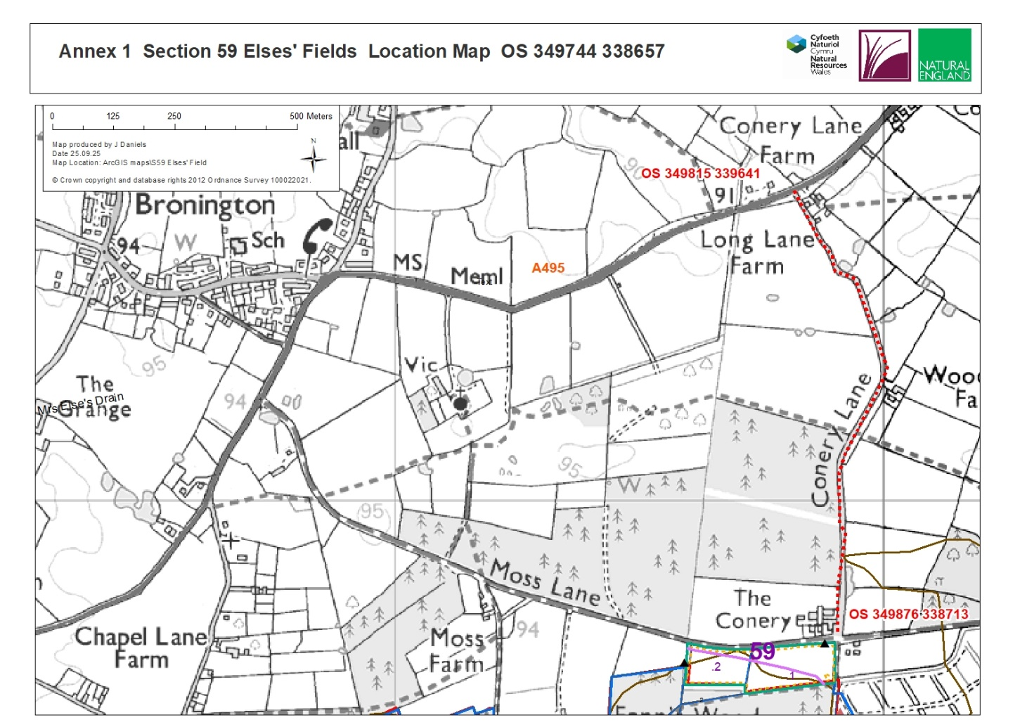

Annex 2 Sect. 59 Else’s Fields – rewetting works.
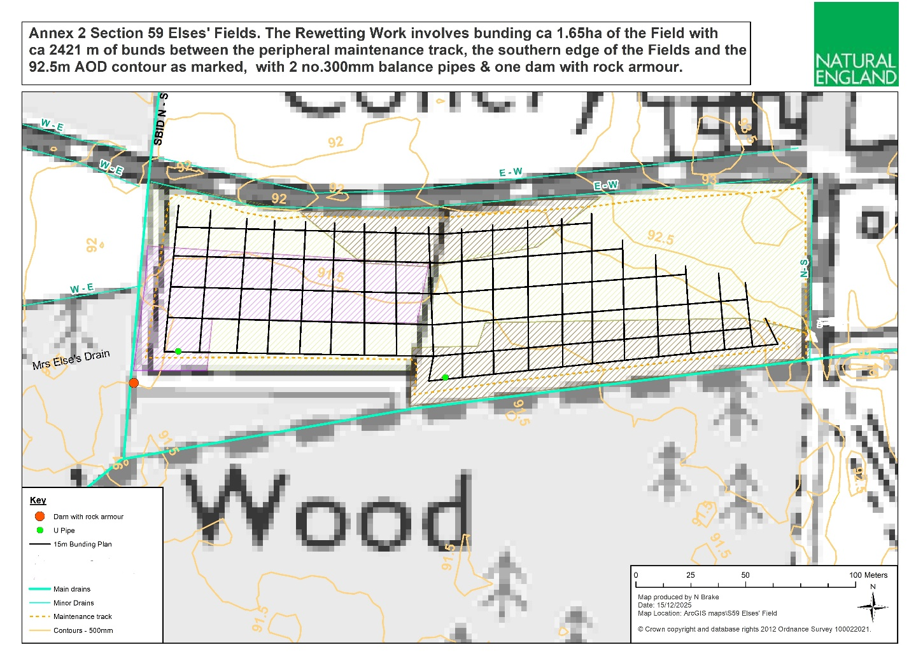

Annex 3. Extract from Cumbrian BogLIFE Framework bunding/ damming specification (plus additional comments) Commercial in confidence.
Lot 2 LOWLAND RAISED BOG – RESTORATION OF DAMAGED BUT VEGETATED BOG AND ANCILLARY WORKS TO FACILITATE THIS WORK.
Overview
Intact lowland raised bog in good condition has two distinct layers: Lowland raised bogs A lowland raised bog consists, in simple terms, of a dome of peat coved in a sphagnum moss dominated vegetated layer - which may be up to 15m deep, sloping sides and the lagg - where the water from the bog mingles with that from the surrounding catchment creating a wet woodland/fen mosaic. Intact lowland raised bog in good condition has two distinct layers: The upper acrotelm layer comprising principally of Sphagnum Moss species with other bog forming plants such as cotton grasses and sedges. This is the growing layer of a peatbog which is biologically active and open to the oxygen in the air which aids humification. This is a process that occurs in soils and peat where organic materials decompose and break down. Whilst this layer can dry out in summer, the bottom parts of the moss plants are sat in cold acidic water and reabsorb water when it rains. Excess rain water flows though these mosses at ground level and excess rain water is shed in all directions into a surrounding stream or area of wet woodland and/or fen situated on the interface between peat and mineral soils. This is called the lagg. Beneath the acrotelm are the layers of accumulated plant fragments saturated in cold acidic water, thereby preventing the peat form breaking down further. This relatively inactive part of the bog is called the catotelm. The degree of humification is largely dependent on how long the plant material that makes up the peat is ‘open to the elements’ in the acrotelm. This boundary between the drier acrotelm and wetter catotelm is the water table, which over time, can be influenced by a number of external factors. Higher water tables result in less humified peat and lower water tables conversely so. The accumulation of peat is slow at an average rate of between 1-2mm per year (in the UK). UK peat bogs have been accumulating peat since the cessation of the last ice age resulting in a peat dome of up to 15m of peat above the underlying mineral drift. Saturated peat in the catotelm is 95% water in a matrix with the original plant cells. It has a very low hydraulic conductivity in contract to the more freely flowing acrotelm. Damaged bogs Many Lowland Raised Bogs have been impacted upon by: domestic and industrial peat cutting afforestation Improvement to agricultural use. Peat cutting leaves a cut over surface of various heights above sea level and cut peat faces which can be up to 3m. Over time, the cut peat face slumps forward leaving cracks on the upper intact peat surface. These cracks act as drains leading to further damage to the bog. Drains vary in size from 0.5m x 0.5m to 1m x 1m on old domestic cuttings and up to 3m x 3m on former industrial cuttings. These drains can also cause parallel cracking. Reclamation to agricultural use can also involve installation of tile- or piped-underdrainage, and application of fertilisers that cause peat to rot. When a bog is damaged by drainage, the active growing layer of Sphagnum moss dries out and dies and is replaced by heather, purple moor grass and eventually trees, all of which increase the rate and effect of peat drying and decomposition through evapotranspiration, interception of rainfall and increased drainage along root lines. The effect of drying and decomposition can extend to a depth of 0.5 - 0.75m, a depth at which water is not available to the acrotelm. This directly affects the ability for sphagnum mosses to grow. Dried (oxidised) peat has different hydraulic properties to ‘wetted’ peat. It cannot hold water and becomes hydroscopic preventing the reabsorption of water. This increases the hydraulic conductivity making it more free draining throughout the affected depth. Restoration of Damaged bogs: In order to restore a degraded but vegetated peat bog all water movement below ground level has to be stopped and a water table between +- 10cm of ground level re-established. This if correctly done will mean that a variety of Sphagnum mosses which will still be in the locality can spread and re-colonise. Ideally water should be at or just below ground level although due to topography and shallow holes left by restoration there will be small areas of open but shallow water. The techniques described below have been developed over the last 20 years and can achieve this. There are three types of damage that will be dealt within this Lot with ancillary works:
1. (Cut Peat Face (Cutting/drainage))
2. Intact but damaged peat surfaces (Cracking/drains/rootplates 1-80 yr old)
3. Cut over and degraded peat surfaces (Drainage, cutting, cracking, tree roots1-80yr old)
4. (Grips/Drains (not covered above)
5. Ancillary works
1 Restoration of Cut Peat
1.1 Remove turf, and re-profile the cut face to approximately 30. (Diagram A)
1.2 Construct a bund of 150mm high (before vegetation added) x 0.75-1m wide. This must be made from ‘good’ peat that is not degraded, i.e. unoxidised, ombrotrophic ‘wetted’ peat. 1.3 Bund construction must be as described below: (Diagram B) a) Remove approximately 0.75m -1m width of turf. Place to one side to reuse for covering the bund. b) Dig out the layer of degraded, oxidised peat, which may extend to 0.5m deep; until ‘good’ peat is reached. c) The ‘good’ peat should not have any cracks. If cracks (or tile-/pipe-drains) are encountered, the peat should be dug down for about 1m or to the bottom of the crack/(under-drainage) to a maximum of 1.5m, then then the peat returned to the void and squashed to seal the cracks. d) Create a borrow pit on the uphill side of the bund and acquire ‘good’ peat. Borrow pits must be separate and not joined up to form a new ditch. e) Use the ‘good’ peat to fill the trench to a height of 150mm above ground level to form the bund. Shape and top with the turf of vegetation previously removed. The turf should be stretched over the bund. f) The degraded peat and/or tree roots removed from the cracked area should be put into the borrow pit and flattened. g) This bund at the top of the cut face will link to further cells that will be constructed on the upper surface. These bunds may link into with other bunds on the intact damaged surface to form bunded cells (Diagram C)
2 Restoration of upper active peat surface damaged by cracks and/or drains and/or root plates: The entire peat surface has been impacted by drainage and agricultural works resulting in tree and scrub encroachment which has resulted in the drying out of the whole surface to a depth of at least 0.5m. Parallel cracking associated with the main and arterial may extend onto the intact surface. These cracks must be treated as active drains. Tree and scrub removal may have taken place in this area so there may be root stock and piles of brash or chip. There may be remaining in situ root plates from small trees and scrub to large root plates from mature trees. The root plates of mature trees are approximately 5-10m apart interspersed by root plates from scrub pine, birch and/or rhododendron. The pricing matrix for this lot allows for different cell sizes Bunded cells (Diagram C) should be between 20x10m on sloping ground and up to 40x40m on flat areas (these will be stated in the mini tender).
2.1 Cells to be constructed as described in paragraph 1.2 2.2 Where a bund cuts through an existing ditch or crack then the degraded material from the edges and bottom of the ditch must be removed before the bund is constructed. Where possible a crack should be dealt with as described in bullet point (c) under paragraph 1.3.
2.3 Where tree root plates are in the line of the bund either construct the bund around them or lift them out. Any root plates lifted out should be inverted and placed in a borrow pit.
5 General considerations
5.1 These repeat much of what has been said above but with some additional information. The ground conditions will vary from dry peat with tree roots offering good support to wide tracked 7-10 tonne excavators, to very soft wet surfaces requiring the use of bog mats. Only very low ground pressure, wide tracked vehicles may be used Peat depth is between 0.6m and 4m There are cracks in the peat associated with peat workings, drains, cut faces, tile & pipe drains and tree growth. These can extend extensively below ground. These must be blocked at depth to prevent them from acting as water flow paths. Bunding/dam building should be carried out using in situ ‘good’ peat, i.e. un-oxidised peat of a low hydraulic conductivity. Disturbance of peat is to be restricted to the minimum area necessary in order to achieve the desired restoration. Prior to bund construction, existing vegetation should be removed and set aside. Degraded peat should be removed to a depth where ‘good’ peat is encountered beneath. Borrow pits should be created adjacent to bund creation areas to obtain ‘good’ peat that will be used to construct the bund. Bund will be constructed to a height of 150mm above ground level before the vegetation is added. ‘Good’ peat must be used to construct bunds. This must connect with ‘good’ peat beneath the newly constructed bunds to prevent water seepage. The bunds will act as water control structures and therefore need to be as level as possible. Cell bunding must be constructed so that water is held at approximately ground level across the cell. Cells should be shaped to fit required areas if irregular. Cells must be built as a descending series to an obvious low point where excess water can escape into adjacent maintained drains. Cells must be built systematically during turf removal to ensure material is available for bund construction. Bunds must be constructed at original ground level. Trees and/or tree roots should be removed from the line of bunds and disposed of in borrow pits. The void from the roots in the peat must be blocked. Where there is not sufficient ‘good’ peat, underlying clay may be used to construct bunds. The clay must be good quality and plastic, and where used, must be worked and squashed to remove air gaps and cracks. In situ vegetation is used to protect the bund surfaces and re-profiled cut faces. Where there is a shortage of vegetation, existing turfs must be stretched to cover the bare peat.
6. Ancillary works Replacement of existing culverts/ installation of through-pipes
Drain maintenance Silt trap cleaning Track maintenance and repair
6.1 Replacement of existing culverts
NOTE: Access across small streams will be required to facilitate future maintenance and access.
6.1.1 Existing metal or concrete culverts must be excavated and the pipe and any associated rubbish (concrete, brick, metal) disposed of in an authorised landfill. Records of disposal must be provided.)
6.1.2 Install a 6m x 300mm or 450mm twin walled corrugated plastic pipe or equivalent (lifetime of 25years +) and reinstate the track way. Construct a small retaining wall on both sides above the new pipe using untreated oak sleepers. Use 3 layers of untreated Oak sleepers 2m x 200mm x120mm. Allow for 5 sleepers per side, each layer approximately 1/3rd longer than the previous The sleeper wall should be supported by four untreated oak sleepers measuring 2m x 200mm x120mm. These should be driven vertically into the ground on the outside of the oak sleeper wall. The sleeper wall and supporting vertical sleepers should be joined using M12 150mm coach screws with a washer. Allow for 2 coach screws per sleeper.
6.1.3 Track should be reinstated to the original level using in situ materials. The edges should be battered to 45 where possible, leaving a minimum of 4m track way.
6.1.4 Where possible original turf should be re-instated on the sides and the track way.
6.2 Drain maintenance NOTE: In some locations drains need to be maintained in an open functioning condition in order to convey excess water off the site and prevent impact from raised water levels on neighbouring land. Drains are 1m x 1m to 3m x 3m in dimension.
6.2.1 Drains should be cleaned of vegetation and silt to existing dimensions. Spoil should be placed on side agreed with Project Officer.
6.3 Silt trap cleaning NOTE: In some locations sediment traps have been dug at the edge of the bog in order to intercept loose material released by restoration and other works. Sediment traps range in size from 5m x 5m up to 20m x 5m
6.4 Sediment traps must be cleaned out prior to and post restoration works.
6.5 Spoil should be placed around sediment ponds leaving a minimum of 2m between spoil and edge of sediment pond
6.6 Gravel Track Maintenance and Re-instatement
NOTE: Access tracks to the sites are usually maintained gravel farm tracks. These will require ongoing maintenance during works and re-instatement to ‘as good’ at the end of works.
6.6.1 Photos must be taken prior to the commencement of works.
6.6.2 General maintenance must be carried out during works to ensure the land user can use the track with minimal inconvenience.
6.6.3 Track must be re-instated using clean, neutral/acidic material. Where possible this is should be either recycled railway ballast or local quarry waste.
6.6.4 Any damage to culverts, fences, gates must be repaired.
6.6.5 Work must be to the satisfaction of Natural England’s Project Officer and will be based on the pre works photos (6.6.1)

