Maternity and Neonatal Voices Partnership – NHS Leicester, Leicestershire and Rutland Integrated Care Board

Service Specification - Management and Administration of the Maternity and Neonatal Voices Partnership

This document is a specification for the management and administration of the Maternity and Neonatal Voices Partnership (MNVP). It has been produced by NHS Leicester, Leicestershire and Rutland Integrated Care Board (LLR ICB) on behalf of the Local Maternity and Neonatal System (LMNS).

Table of Contents
Background 2
Principles of the MNVP 3
Aims and objectives 4
Values 5
MNVP Development and Achievements (2023–2025) 5
What could be improved 6
Aspirations for the MNVP following its Review 7
Membership and Representation 7
Structure and Governance 7
Co-Production and Partnership Working 8
Engagement and Communication 8
Support, Wellbeing and Safeguarding 8
Description of the service required 9
Key Deliverables in 2026/27 9
Coordination and administration 9
Support to Committee 10
Involvement and co-design 10
Statutory and legal requirements 11
Membership recruitment and retention 12
Relationship building with NHS providers of maternity and neonatal care - University Hospitals Leicester (UHL) 12
Attending meetings 12
Awareness raising and communications 13
Achievement outcomes 14
Measuring Success 15

Background
In July 2025, the government published its 10 Year Health Plan for England that outlines the priorities for the NHS within the next 10 years, with a focus on narrowing health inequalities, listening to service users and focusing on neighbourhoods. In 2023 the government published the Three-year delivery plan for maternity and neonatal services, which sets out how the NHS will make maternity and neonatal services safer, more personalised and more equitable for women, birthing people, babies and families. It recognises that listening and responding to all women and families is an essential part of safe and high-quality care.
Listening to women and families with compassion improves the safety and experience of those using maternity and neonatal services and helps address health inequalities. Having a strong MNVP is essential to this, as it ensures that service user voices are at the heart of decision-making in maternity and neonatal services. NHS England has set out clear guidance to LMNS’ to support local MNVPs to ensure they can meet the expectations set by NHS ICBs.
Improving maternity and neonatal care is a key programme for the LLR ICB. It is a statutory requirement for the ICB to commission an MNVP, therefore the MNVP will have a legal obligation to report into ICB governance structures. A meaningful MNVP is critical, as co-production and patient engagement are vital to realise strategic principles and strategic priorities for the health system:

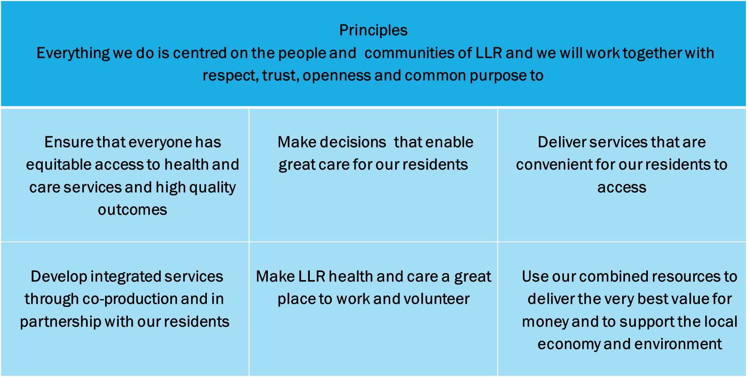
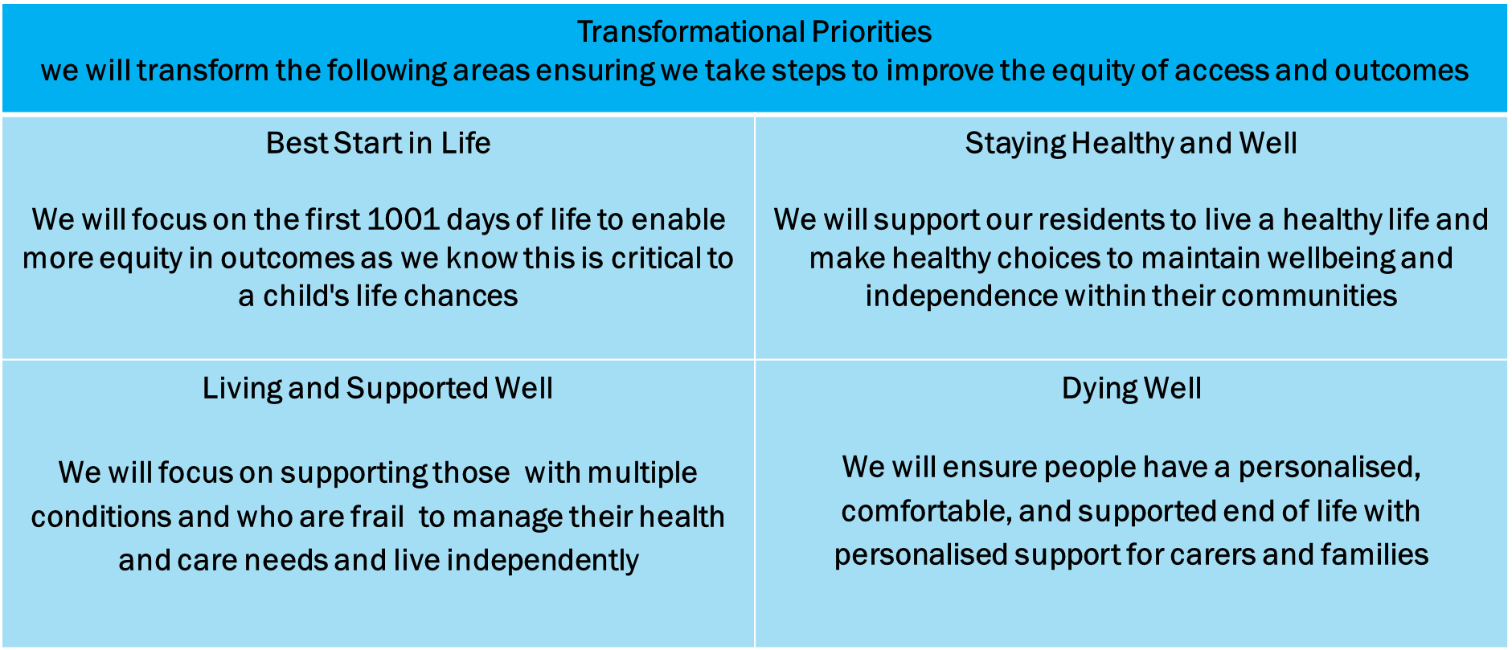

The LLR MNVP should be an independently chaired multi-disciplinary advisory and action forum with service users at the centre. The MNVP should have an appointed Strategic Lead and engagement Leads with lived experience of maternity and neonatal services. They should be independent of NHS organisations and any organisations contracted to manage and administer the Partnership. The model should have the ability to offer strategic senior leadership to influence maternity and neonatal decision makers at senior levels within the NHS as well as direct engagement with communities.

Principles of the MNVP

The MNVP should have a formal committee structure, with written agendas and formal minutes of discussions and decisions, all of which should be published for transparency. It should incorporate the principles and practice of participatory co-design and co-production in order to ensure that the five principles of MNVPs are at the core of the commissioning, monitoring and continuous improvement of maternity services.

The MNVP should operate on the following founding five principles:

- Work creatively, respectfully and collaboratively to co-produce solutions together.
- Work together as equals, promoting and valuing participation. Listen to, and seek out, the voices of women, birthing people, families and carers using maternity and neonatal services, even when that voice is a whisper. Enabling people from diverse communities to have a voice.
- Use experience data and insight as evidence.
- Understand and work with the interdependency that exists between the experience of staff and positive outcomes for women, birthing people, families and carers.
- Aim to achieve continuous quality improvement with a particular focus on closing inequality gaps.

Aims and objectives

The MNVP serves the needs of local women, birthing people and families as well as the Local Maternity Neonatal System (LMNS), which is the part of the Integrated Care Board (ICB) that supports and oversees maternity and neonatal services, including all acute and community services and community hubs. It links with relevant clinical networks to contribute towards and follow regional strategic direction. It links with other MNVPs within the East Midlands and nationally to share good practice.

The MNVP advises the ICB on all aspects of maternity and neonatal services, including:

- Performance indicators and maternity quality requirements.
- Progress on implementing the national policy and evidence-based standards and recommendations.
- Lessons from investigations and reviews of maternity services by the Care Quality Commission or Department of Health.
- Involvement of women, birthing people and their families (patient and public involvement).
- Configuration of services.
- Quality standards for maternity and neonatal services and ways of monitoring standards.
- Clinical governance, audit and guidelines for clinical care.
- The consistency in the delivery of maternity and neonatal services and clinical practice across the district, based on reliable evidence.

The MNVP will listen to and act upon women, birthing people, family and carer feedback at all stages of the commissioning cycle (see appendix 1) – from needs assessment to contract management. All members are committed to working in partnership and to implementing person-centred care. Person-centred care offers women and birthing people information, choice, and care based on best available evidence, always respecting their choices and human rights.

The MNVP are included in the terms of reference of other groups that consult and receive advice from the MNVP including the ICB and Trust boards and will be quorate members in some of these groups.

Values

The MNVP is committed to diversity and equal opportunities and upholds women and birthing people’s human rights in pregnancy and childbirth.

The MNVP is multidisciplinary, so its members will bring with them different beliefs, values and experience. All these perspectives should be valued and respected. Each member should have an equal opportunity to contribute to the MNVP discussion and decision-making process. Care will be taken to enable full participation. For example, it is important to check that the terminology used by NHS staff is understood by all MNVP members and clarified, if necessary. The MNVP goes to places communities already use rather than expecting people to come to the MNVP and travel expenses and care costs are offered to members, when appropriate.

Members are acting in a public service capacity and are expected to adhere to the Nolan principles for conduct in public life.

MNVP Development and Achievements (2023–2025)
Between 2023 and 2025 the MNVP was hosted by Leicester Mammas. Leicester Mammas was founded in 2008 to ensure that parents from underserved communities were valued and were supported to be instrumental in improving services, specifically around breastfeeding, although a conscious decision was made from the outset to be inclusive to all families, irrespective of feeding method.

Leicester Mammas transformed the MNVP in Leicester, Leicestershire and Rutland, increasing the membership of service users from 18 to 128 and engaging in multiple engagement and transformation projects across Leicester. They set up multiple social media platforms and gained a significant following of engaged families.

They engaged with a wide range of partners including Healthwatch representatives from across LLR, Homestart Horizons, Family Hubs, representatives from both University of Leicester and De Montfort University as well as linking with Leads from MNVPs across the region. They built strong relationships with colleagues from University Hospitals Leicester (UHL) maternity and neonatal services, including Heads of Midwifery, the Director of Midwifery, the Safety Champions, the Quality Improvement team, the Neonatal team and Specialist and Consultant midwives. This ensured co-production of a wide range of projects that improved maternity and neonatal services, including partners staying overnight and neonatal parents having free food and parking while their baby was on the neonatal unit. These all happened as a result of listening to the needs of families and influencing at a senior level within maternity and neonatal services.

Leicester Mammas set up the first Neonatal Voices Partnership (NVP) in Leicester, Leicestershire and Rutland and strengthened the neonatal voice in shaping services.
The MNVP Leads and members were essential parts of various working groups with UHL colleagues to make improvements to induction of labour processes, perinatal mental health, pelvic health, bereavement and breastfeeding as well as being part of reviewing guidelines to ensure the pathways of care have the voice of families at their heart.

For more details around the recent work of MNVP in 2024-2025, please see their annual report (double click to open):

Leicester Mammas contract ended in July 2025 and Healthwatch Leicester and Leicestershire/Voluntary Action Leicester have worked in partnership with the ICB to continue the work of the MNVP.

What could be improved
As the Leicester Mammas-hosted MNVP contract ended, two workshops were held to reflect on successes and areas for improvement.
What worked well over the last two years was the engagement within communities, the relationships built across the city and the increased activity of members and leads that led to improvements in maternity services. The relationships built with colleagues and leaders at University Hospitals of Leicester (UHL) that allows a culture of co-production to thrive that was led by the passion, energy and compassion of the MNVP leads and engaged volunteers. The MNVP at LLR has been recognised as an exemplar of excellence by NHS England and has led the way in terms of an MNVP making a positive impact within communities and services.

The key improvement needed for the future MNVP identified in the workshops was that the MNVP needed to be adequately resourced. Over the last two years however, the expectations of the MNVP has increased and the national guidance for the commissioning of MNVP’s outlines the need for MNVP to be strategically influencing perinatal services at a senior level as well as meaningfully engaging with diverse communities.

The MNVP needs to broaden its reach to ensure representation and engagement within Leicester City, County and Rutland. There also needs to be more investment in strengthening our ability to hear diverse and seldom heard voices, including birthing people, with protected characteristics, neonatal and bereaved families.

More recognition is needed around the emotionally challenging nature of the work of listening to birthing people and their families who may have experienced trauma, loss or bereavement. The MNVP is also part of reviewing complaints as well as attending UHL meetings where the loss of babies is discussed. Increased training and support is needed for MNVP Leads and volunteers to enable processing of distressing experiences in a compassionate and restorative way using a trauma informed approach.

The experiences of our previous MNVP have been listened to and additional funds have been allocated to reflect the expectations around these improvements.

Aspirations for the MNVP following its Review

The workshops with the previous Maternity and Neonatal Voices Partnership (MNVP) and key stakeholders highlighted a strong sense of enthusiasm and commitment among participants to further develop and strengthen the current MNVP. Following this, a range of actions and priorities have been identified to help realise the aspirations for the MNVP going forward:

Membership and Representation

- Have a strong MNVP with a variety of service users from different backgrounds and socio-demographic groups working with professionals to improve services for women in the local area.
- Have clinical representation from all service areas, ensuring all areas of the local NHS are included and represented.
- Have a constantly increasing membership base comprising of mums, dads and non-gestational parents.
- Have more involvement from dads, teens, the LGBTQIA+ community, those with disabilities and from diverse communities.
- Recognise the always evolving nature of MNVP membership and continually strive to recruit new members.
- Capitalise on recent births by reaching out to people leaving hospital, bringing them directly into the membership. Encourage and support existing members to continue involvement by ensuring sharing of impact made by their contributions.

Structure and Governance

- Have a hub and spoke structure with strong networks, links to stakeholders, MNVP champions and the voluntary and community sector.
- Have a long-term strategy and individual plans for reaching out to people.
- Have a co-produced workplan with robust measurements for improvement.
- Have a resourced MNVP with a Senior Lead who provides strategic leadership and influence at senior levels of maternity and neonatal leadership in ICB and provider trust organisations.
- Have Strategic and Engagement Leads working closely with communities, with job descriptions aligned to MNVP national guidance.
- Establish strong connections with the ICB, UHL, Leicestershire Partnership Trust (LPT), and wider systems, ensuring access to operational support.
- Have a local service user volunteer expenses policy, which includes out of pocket expenses and childcare costs.
- Have mechanisms to ensure MNVP memberships can be easily transferred back to LMNS or a new provider at the end of the contract, adhering to GDPR.

Co-Production and Partnership Working

- Ensure all new maternity and neonatal services are co-designed and co-produced with the support of the MNVP.
- Work in partnership with UHL and LMNS to facilitate Walking the Patch and 15 Steps to capture experiences of service users currently using the service, as well as being an integral part of Insight Visits.
- Actively influence and participate in key meetings in both UHL and LMNS to ensure the voice of service users is central to decision making and learning for incidents.
- Work in close partnership with UHL colleagues to continue to embed co-production in all areas of quality improvement in maternity and neonatal services.

Engagement and Communication

- Have a culture of going out to and working with communities, engaging in a way that communities can see the value of sharing experiences with the MNVP.
- Establish a programme of promotional activities that reach out using innovative messages via a combination of online and offline tools, including interaction online with live Q&As with health professionals, women’s educational health videos, antenatal and statistical information.
- Have a flexible meeting schedule that fits around people, including supported childcare and other priorities, including evenings and weekends. A balance of online and face-to-face meetings is required, with face-to-face meetings held at appropriate venues with play areas for children.

Support, Wellbeing and Safeguarding
- Ensure MNVP leads and members have the training, restorative supervision and pastoral support needed to thrive within the MNVP, recognising the emotionally challenging nature of the work and the potential for triggering past traumatic experiences.
- Have a trauma-informed approach to listening to experiences and consider how to ensure people are not being retraumatised by sharing experiences, particularly those who had traumatic births, experienced neonatal care and bereaved families.

Description of the service required
The core purpose of any MNVP is to facilitate co-production in the planning, design,
implementation and evaluation of NHS maternity and neonatal services between service users, commissioners and providers working together as equals.

In addition, individual partners would set themselves outcomes-focused goals to help
drive strategy. These may be related to choice and personalisation, improving safety,
and/or improving women’s experience and reducing inequalities, amongst others.

Key Deliverables in 2026/27

The successful service provider will deliver against the following key deliverables through working in partnership with the local health economy and the local system.

The key deliverables are categorised in three categories:

- Co-ordination and administration
- Support to committee
- Involvement and co-design

Coordination and administration

- Recruit a Strategic Lead and Engagement Leads, both with job descriptions aligned to MNVP national guidance and recent lived experience of maternity services at the time of recruitment. Ensure these leads work closely with communities across Leicester, Leicestershire and Rutland (LLR).
- Coordinate MNVP activity across the LMNS, enabling parents to access MNVP alternatives in both the City and County.
- Administer and oversee the LLR Neonatal Voice Partnership (NVP) as a subgroup reporting into the MNVP.
- Establish MNVP Board meetings with members and partners, ensuring minutes and actions are publicly available, alongside regular meetings with providers and the ICB.
- Set up governance processes for robust reporting of insights and experiences, ensuring these are fed into the health system through the LMNS to improve services.
- Ensure appropriate links are made by MNVP leads with regional and national MNVPs for guidance and support, and act as an enabler and administrator to ensure links are in place between MNVP/NVP independent leads, the ICB, and relevant Trusts and partners.
- Develop, deliver, and coordinate an annual programme of work for the MNVP, including the production and publication of the MNVP Annual Report, and provide quarterly and annual reports of activities to the LMNS Board.
- Expand the existing database of interested parties, identify and recruit a socio-demographically representative membership and database, and produce a plan for membership transfer at the end of the contract.
- Attend regular existing groups or events and host health events in accessible locations to support community attendance, including public events (online or face-to-face) at varied times and venues.
- Identify and arrange appropriate individuals to attend meetings with stakeholder groups as requested.
- Work with the research specialist and ICB to set up a process for collecting views and experiences of women, birthing people, and families on an ongoing basis, ensuring all meetings have notes recorded.
- Adhere to data protection rules, including GDPR.
- Ensure appropriate support is in place for volunteers following meetings, being sensitive to the emotional impact of working within perinatal services, and establish a structure for independent members to volunteer for specialist roles and be appropriately rewarded.
- Work with the ICB to establish the MNVP as an area on the VCSE Futures Platform.

Support to Committee
The MNVP provides dedicated support to its core committee, ensuring effective operations, regular reporting, and the wellbeing and development of its members. The MNVP will:
- Recruit to and maintain an MNVP core committee membership in accordance
- Provide regular report activities to the committee
- Provide a quarterly and annual report of activities to the committee LMNS
- Provide regular information to MNVP committee members and identify any training needs or pastoral support needs that members may have
- Support Senior Lead and Engagement Leads of the committee in accordance with the Terms of Reference of the committee
- Facilitate all aspects of the MNVP Committee proceedings
- Support the setting up and facilitating of multi-disciplinary subgroups

Involvement and co-design

The MNVP will liaise with the system communications and engagement teams across the ICB to:
- Collaborate with system communications and engagement teams across the ICB to analyse existing patient experience data (such as CQC reports and complaints), review previous engagement activities, and synthesise the needs of diverse local communities. This shared understanding will help shape services to better reflect local needs.
- Reach out to seldom heard groups, utilising the LLR ICB’s VCSE Alliance, and employ bespoke approaches to ensure the voices of people with particular characteristics are included.
- Provide leadership to ensure the service user voice is central to co-producing LMNS commissioning plans and trust provider operational plans, attending and influencing key meetings within provider and ICB organisations.
- Use experience data and insight as evidence, producing high-quality reports to inform decision making and service provision, and include equality monitoring data in surveys and engagement activities.
- Liaise with key provider organisation leaders, including Chief Nurse, Director and Head of Midwifery, Head of Nursing, governance and quality improvement leads, Obstetricians and Paediatricians, to ensure effective partnership working.
- Create and maintain a database to evidence the number of consultations across LLR, including ethnicity and IMD of participants, and continually monitor representation. Share thematic analysis and recommendations with LMNS and UHL, and work in partnership to implement improvements.
- Coordinate the publication of public meeting minutes on ICB and provider websites.

Statutory and legal requirements

All engagement, involvement, co-design (and if required public consultation) should be in line with the statutory and legal duties required of the ICB.
The Health and Social Care Act (2012) introduced significant amendments to the NHS Act (2006). This guidance supports two legal duties, requiring ICB to enable:
- Patients and carers to participate in planning, managing and making decisions about their care and treatment through the services they commission.
- The effective participation of the public in the commissioning process itself, so that services reflect the needs of local people.

The Equality Act 2010 prohibits unlawful discrimination in the provision of services on the grounds of nine ‘protected characteristics’ which includes pregnancy and maternity as one of those.
The ‘public sector equality duty’ detailed within requires ICBs to have ‘due regard’ to the need to:
- Eliminate discrimination that is unlawful under the Equality Act 2010.
- Advance equality of opportunity between people who share a relevant protected characteristic and people who do not share it and foster good relations between persons who share a relevant protected characteristic and persons who do not share it.

Membership recruitment and retention
The MNVP will liaise with the system communications and engagement teams in the ICB to:

- Recruit new service user members, volunteers and representatives to ensure we are reaching out into every community and involving all cultures, ethnicities and geographies. This will involve a recruitment drive, new leaflets and posters, a social media campaign and advertising through the media.
- Recruit new specialist volunteers with specialised experiences to sit on the any sub groups or workstreams.
- Increase reach and diversity of voices by building relationships with community
- Have a process in place so membership data can be easily transferred at end of the contract to new provider to ensure seamless transition of MNVP at end of contract

Relationship building with NHS providers of maternity and neonatal care - University Hospitals Leicester (UHL)

Strong relationships with UHL are essential to understand their priorities and initiatives they are coordinating. In addition, UHL and other NHS providers have direct daily access to women, birthing people and families, and could therefore promote the MNVP and encourage either membership, a stronger presence on stakeholder databases, or link people into web content on social media to support them pre and post birth.

The MNVP will:

- Have regular meetings with provider organisations and have oversight of quality improvement projects, emerging and ongoing.
- Work in partnership with provider to co-produce action plan in response to CQC Maternity Survey and be an integral part of quality improvement projects that are developed in response to that.
- Understand NHS provider priorities and workplan.
- Integrate relevant NHS provider priorities into workplan of MNVP.
- Support provider with ongoing co- design support through meetings of the MNVP.
- Work with UHL and other NHS providers to establish a direct link to women and birthing people to promote the work of the MNVP.
- Attend key UHL and LMNS governance and oversight meetings to offer service use perspective on guidelines, learning for incidents and data and quality improvement. The MNVP should be a ‘critical friend’ and advocate for women, birthing people and families.

Attending meetings

The MNVP Lead will attend the following meetings as a quorate member

Provider trust:

- Safety Champion meetings
- Maternity quality and safety meetings
- Neonatal quality and safety meetings
- PMRT review meeting
- Patient safety meeting
- Guideline committees

ICB meetings :
- LMNS Board

Awareness raising and communications

Liaise with the system communications and engagement teams across the ICB on:

- The development of a yearly calendar for regular planned local events/meetings to gather feedback from women and their families
- Development of workplan, co-created with ICB that can be regularly monitored and support given to enable the removal of barriers as necessary.
- Creating content for wider engagement with other interested parties through websites, online and social media channels, internally and externally.
- Creating content for articles and press releases for use internally and externally.
- Identification and provision of materials to raise awareness e.g., information for women current using the service on how they can get involved in the MNVP when they are booked in as a maternity user and discharged from the service.
- Identifying specific targeting to raise awareness including but not exclusive to:
- Antenatal check-ups with the midwife and GPs
- Local midwifery units, Obstetric Units and Neonatal Intensive Care Units
- Antenatal classes and support groups (e.g., breast feeding groups)
- Children’s Centres/ family hubs
- Nurseries and nannies/ childminders
- Local mother and baby groups and faith groups
- Online forums such as Instagram, TikTok, Facebook, Twitter, Mumsnet and Net mums etc
- Making all public information accessible, in line with the Accessible Information Standard. The Standard aims to make sure that people who have a disability, impairment or sensory loss are provided with information that they can easily read and understand and with support so they can communicate effectively with health and social care services.
- Promoting all public meetings and public events through a variety of communications channels including websites and through social media.
- Sharing NHS information with MNVP members as requested by the ICB/NHS providers or partners

Achievement outcomes
These outcomes set out what the MNVP aims to achieve, demonstrating the value and impact of service user involvement in shaping and improving maternity and neonatal services:
- Independent MNVP/NVP Leads feel supported and valued.
- Independent MNVP/NVP Leads can raise issues and concerns with provider and ICB colleagues at any level in a timely manner.
- MNVP membership structure is established.
- An evidence base that demonstrates measurable impact of service user experiences and insights in driving improvements is established.
- A local digital platform is developed, in collaboration with the ICB and independent of the provider, which offers innovative ways to engage with service users and gather insights, with a particular focus on including voices that have traditionally been seldom heard.
- Co-production of service transformation is a reality.
- There is increased positive feedback on local maternity services.
- Local themes and issues identified from service user feedback, such as antenatal care, postnatal care, primary care checks, and bereavement support, are routinely recognised and escalated within the system to inform improvements.
Continuous quality improvements occur, with a particular focus on closing inequality gaps.
- There is a statistically representative number of women and birthing people involved from diverse communities who feel empowered, as well as representation from groups with other protected characteristics to ensure inclusion

Measuring Success

Clear measures are in place to monitor the success of the MNVP, ensuring effective representation, meaningful engagement, and ongoing improvements in maternity and neonatal services.

Aims and objectives | Measurement of success
Representation from diverse staff and public of LLR on the MNVP. | All paid roles filled with independent people.  Job descriptions for Strategic and engagement Leads meet national MNVP guidance and leads have recent lived experience of accessing maternity services.  Number of people on MNVP representative of socio-demographics of LLR.  Number of people on MNVP stakeholder database representative of socio-demographics of LLR.  MNVP members list Evidence of engagement activity log  Expenses policy to ensure volunteers are not out of pocket including travel costs and childcare expenses
Ensure demographic reach of MNVP includes Leicester, Leicestershire and Rutland and meets the needs of the diversity of the population across the whole of the area. | MNVP activity log to identify areas of activity  Evidence of attending a wide range of existing groups within the community, across the whole of Leicester, Leicestershire and Rutland.
Clear outputs from MNVP meetings and an established action plan. | Monthly board meetings held with MNVP members with detailed action plan, completed actions and published minutes.
Develop a Neonates Voices Partnership (NVP) to report into the MNVP. | Regular meetings held with detailed action plan, completed actions reported into the MNVP and published minutes.
A representative and significant number of responses from staff and public to questions asked during engagement activity/consultations. | Prior to each activities target will be set.  Themes of feedback and number of people engaged to be included in bi-monthly report
A positive effect on the local NHS reputation, with comments made on NHS Choices, Care Opinion, Twitter and Facebook. | Media evaluation – number of media stories with rating of content.  NHS Friends and Family test scores.  CQC Maternity Survey results
Development of an understanding and positive support for proposals/actions among all stakeholders across systems. | Number of people providing experiences and insights.  Evaluation and analysis and report of findings showing responses and themes to the engagement/consultation.
Engaged women and families. | Numbers engaged online and through other activities.  Demonstration of impact of engagement i.e., quality of published content of ‘you said, we did’ on websites.  Well attended meetings.  Publication of minutes and actions – demonstrate to general public the positive impact of MNVP on maternity and neonatal care.  Use innovative and interactive methods of engagement and data collection.  Co-produced CQC Maternity action plan.  Working with ICB and UHL to be responsive to seeking feedback from members on topics as they arise.  Continued engagement in existing UHL co-production groups with existing members, including guidelines group and Induction of Labour working party.  Undertaking ‘Walk The Patch’ and ‘15 Steps’ in UHL as required but minimum twice a year.  Participate in insight visits in partnership with ICB or other external assurance visits from NHSE or CQC.  Have system to ensure members are renumerated appropriately for input in terms of travel expenses and childcare costs.
Engaged staff. | Number engagement through activities e.g., response to polled staff to assess whether the messages are reaching them.

Appendix 1: The Commissioning Cycle

