If you are interested to participate for the tendering opportunity on our MyProcurement system , you can visit our portal and register through the following link to register in the portal :https://tap.tcsapps.com/tap2/#/bc-supplier-registration
and then login into the portal using the following link : https://tap.tcsapps.com/tap2/#/login-supplier to apply on the opportunity, if you are already registered then login through the following link and follow the below steps https://tap.tcsapps.com/tap2/#/login-supplier .
When you login, please follow the following steps and guides attached for your kind reference :
Source-To-Pay -> Public Notices:

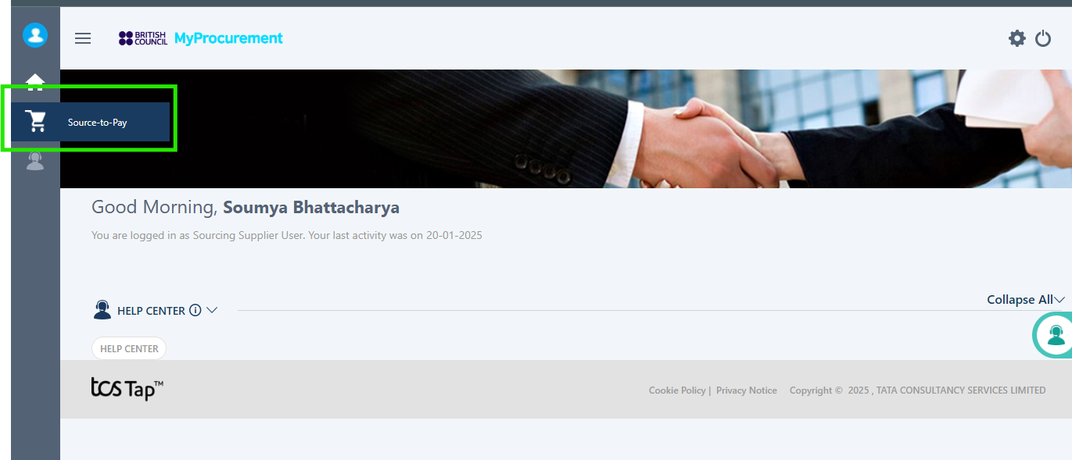
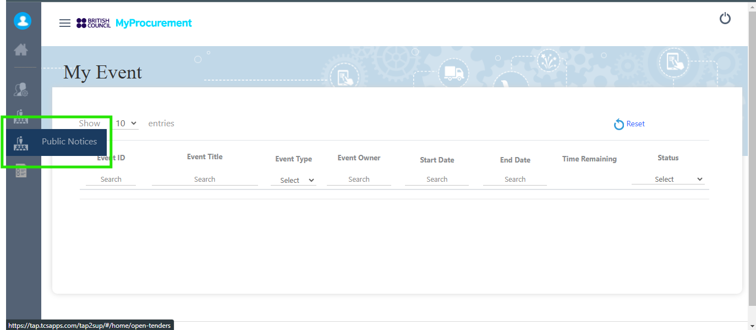
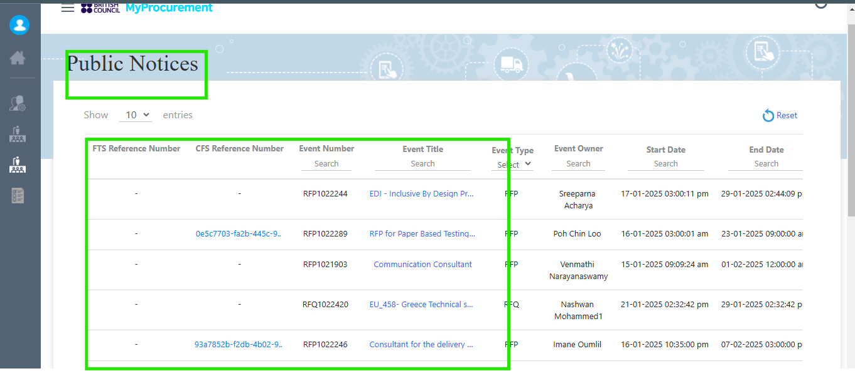

Search for the event Using the following reference number : Framework Agreement of design Management and delivery of capacity building and UK artist residency programmes in Saudi Arabia and Bahrain- ITT1030720

IMPORTANT NOTE : The amount mentioned under the contract value is the threshold amount and is projected to be over GBP214k the proposed contract is a framework agreement and services will be called off on a demand basis or as required with no guarantee of volume or minimum spend

