1. Background & Objectives
The Council seeks a suitably qualified and experienced cleaning contractor to provide reliable, safe, and high-quality cleaning services for the temporary contractor village at the Moorwell Stoneyard. The facility comprises:
- 16 portable single sleeper units (Bunkabin type)
- 2 junior diner units with kitchens
- 1 welfare/laundry unit and shared common room
- Bin store with segregated waste and recycling
The construction village is occupied by Stepnell Ltd, and a designated Stepnell operative will manage weekly schedules, site inductions, and communicate cleaning requirements. The Service Provider must ensure hygienic, presentable accommodation for weekly changeovers and midweek maintenance cleans.

Additional Responsibilities
- Cleaners will also be responsible for weekly water runs for Legionella control in accordance with site procedures.
- Replacement of linen will only occur after authorisation by Stepnell’s designated operative.

2. Site Details
Location: Stoneyard, Moor Well Lane, St Mary’s, Isles of Scilly, TR21 0JY. Site access: Private pedestrian access for keyholders only; no general public access.
Additional Location – Holy Vale Flat
When the Stoneyard is at full occupancy, cleaning will also be required for a two-bedroom flat in Holy Vale (sleeps 4 in two twin rooms). This property will only require a full weekly changeover clean only by request from Stepnell.

3. Contract Scope
The contractor will be responsible for materials, linen supply and labour to deliver:
- Weekly Changeover Clean (Saturday) – full turnaround of all occupied/assigned units.
- Midweek Maintenance Clean – light clean of all units plus shared areas.
- Common Areas – 2 kitchens, common room, welfare/laundry, circulation, external steps/thresholds as practicable.
- Linen Management – supply, collection, laundering, storage, inventory control.
- Linen Replacement -as needed following authorisation by Stepnell
- Consumables – soap, paper products, bin liners, dishwasher tablets, laundry supplies for welfare unit.
- Waste & Recycling Handling – bagging, segregation and placement in bin store (no removal offsite; Council collection applies).
- Legionella weekly water runs
- Periodic Tasks – descaling, deep cleans, upholstery spot-clean, high-touch sanitisation, appliance hygiene.
Additional Location – Holy Vale Flat
When Stoneyard is at full occupancy, cleaning will also be required for a two-bedroom flat in Holy Vale (sleeps 4 in two twin rooms). This property will only require a full weekly changeover clean by request from Stepnell.
- No midweek clean will be required.
- Tasks include: strip and replace linen (after Stepnell authorisation), clean bedrooms, bathroom, kitchen, and living areas to the same standard as Stoneyard units.
- Include pricing for this service as a separate line item in the tender schedule.

4. Service Frequencies & Task Lists

4.1 Saturday Changeover Clean (All Units) as needed by contractor schedule
Bedrooms (single sleeper units & diner units):
- Strip beds; bag used linen; make beds with fresh linen (sheet, pillowcase, duvet cover).
- Dust all surfaces; clean mirrors, ledges, window sills.
- Wipe high-touch points (door handles, switches).
- Vacuum/mop floors; remove scuffs.
- Empty bins; replace liners; remove waste to bin store.
- Check and restock consumables (toilet rolls, soap if applicable).
- Report maintenance issues (fixtures, damp, damage).
Bathrooms (where applicable):
- Clean and disinfect toilets, basins, taps, shower trays/screens.
- Descale taps/shower heads as needed; buff to shine.
- Mop with disinfectant; restock toiletries as specified.
Kitchens (2 shared) & Common Room:
- Kitchens: Clean worktops, sinks, splashbacks; wipe cupboards external; clean hob/oven fronts, microwaves inside/out; fridges inside/out (remove perishables); mop floors; restock consumables (cloths, washing-up liquid, tablets).
- Common Room: Dust/wipe all surfaces; clean tables/chairs; spot-clean upholstery; vacuum/mop; sanitise remotes/switches/handles.
Welfare/Laundry Unit:
- Wipe machines external; clean filters/traps (non-technical); mop floors; restock laundry consumables; maintain linen store order.
External thresholds/steps (as practicable):
- Sweep debris; remove litter.

4.2 Midweek Maintenance Clean (All Units) as needed by contractor schedule
- Light dust and surface wipe; sanitise high-touch points.
- Bathroom quick clean (toilet/basin/shower spot).
- Vacuum/mop floors.
- Empty bins and replace liners.
- Top-up consumables.
- Quick kitchen/common room refresh: clear surfaces, wipe appliances external, mop.

4.3 Periodic Tasks
- Weekly: Appliance hygiene (microwave/fridge internal), shower screen descaling spots.
- Monthly: Full descaling of taps/showers; oven deep clean (as usage dictates); window internal clean; skirting/radiator dusting; mattress rotate/check.
- Quarterly: Deep clean of kitchens/common room; upholstery shampoo (if fabric); high-level dusting (reachable without specialist access).

5. Staffing, Competence & Supervision
- Coordinate with designated Stepnell’s operative for weekly cleaning requirements and inductions
- Provide sufficient trained staff to complete Saturday changeover by agreed times (see §7), plus midweek cleans (typically one scheduled midweek day).
- Named Site Supervisor responsible for checklists, sign-off, quality audits, incident reporting.
- All staff to receive induction covering site rules, safeguarding, lone-working, chemical handling, manual handling, and island logistics.

6. Materials, Equipment & Linen
- Contractor supplies all cleaning chemicals, tools, and equipment suitable for small modular units (non-abrasive, non-caustic on PVCu and coated steel finishes).
- Linen: Contractor to supply hotel-grade single sets; manage laundering to NHS-style thermal disinfection standards (or equivalent), pressed and stored in sealed containers; maintain par stock to support 100% Saturday turnover plus 10% buffer.
- Eco & Surface Compatibility: Avoid products that damage light-grey composite steel panels, PVCu, or membrane flooring noted in unit specs.

7. Working Hours & Access
- Saturday Changeover Window: e.g., 09:00–16:00 (tenderers may propose alternates).
- Midweek Clean: e.g., Wednesday 10:00–14:00.
- Key control via Stepnell procedures; contractor must maintain a key log and secure keys when not in use.

8. Health, Safety & Compliance
- RAMS (Risk Assessments & Method Statements) for all tasks; COSHH for chemicals.
- PAT and maintenance for electrical equipment; safe storage of chemicals.
- Lone-working and slips/trips controls (external steps/thresholds).
- Incident/near-miss reporting within 24 hours.
- Insurance: Public Liability (£5m), Employers’ Liability (£10m), Professional Indemnity (£1m).

9. Environmental & Island Logistics
- Minimise plastic and hazardous chemicals; prefer EN 14476 validated disinfectants for viral hygiene where used.
- Segregate waste and recycling per bin store layout; do not contaminate streams; place in labelled compartments.
- Plan for island transport constraints (ferry/flight delays); maintain buffer stocks; contingency staffing plans.

10. Quality Assurance & KPIs
- AQL (Acceptable Quality Level): ≥95% pass rate in weekly audits.
- Turnaround Timeliness: 100% of units completed within Saturday window.
- Complaint Resolution: Acknowledge in 4 hours; resolve within 24 hours.
- Repeat Defect Rate: <2% per month.
- Stock-out Events: Zero for consumables/linen on changeover days.
- Monthly performance report: checklist scores, issues, rectifications, training completed.

11. Mobilisation & Handover
- Mobilisation period: up to 2 weeks from award.
- Provide: staffing plan, induction schedule, RAMS, COSHH, product data sheets, sample checklists, linen par stock plan, and emergency contacts.

12. Pricing Schedule (to complete by Tenderer)
Please price fixed weekly service and unit rates for flexibility.
Please complete the spread sheet B4_ITT Pricing template
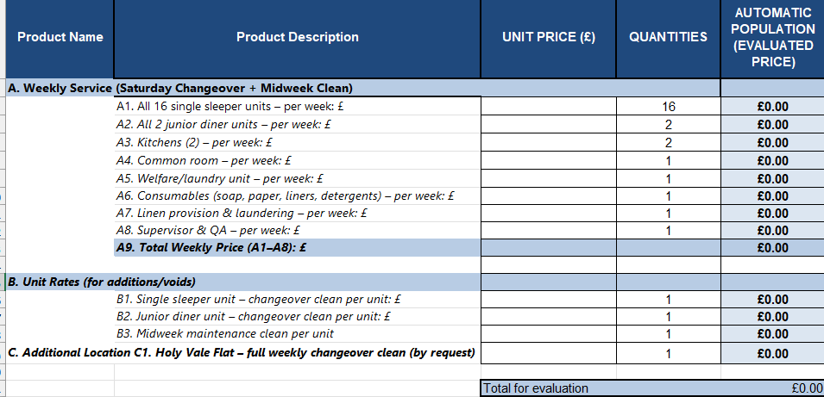

13. Tender Submission Requirements
- Method Statement addressing §4–§11 (how tasks will be delivered on the Isles of Scilly).
- Staffing Plan & Training (including safeguarding and lone-working).
- RAMS & COSHH; product SDS for all chemicals.
- Linen Strategy (procurement, laundering standards, par stock, storage).
- Quality Plan & KPIs (inspection regime, reporting, corrective actions).
- Mobilisation Plan (timeline, risks, mitigations).
- References (2 similar contracts in remote or multi-unit accommodation).
- Insurance & Certifications (see §8).
- Price Schedule (see §12).

14. Evaluation Criteria (example)
- Quality & Methodology – 10%
- Experience & References – 10%
- Environmental Approach & Island Logistics – 10%
- Price – 70%

15. Council Responsibilities managed by Stepnell
- Provide site access and keys for agreed windows.
- Provide bin store with segregated compartments; arrange island waste collection.
- Notify contractor of occupancy changes and special cleaning needs.

16. Points of Contact
- Contract Manager: [Name / Email / Phone]
- Site Supervisor (Contractor): [Name / Phone]
- Emergency Contact: [Name / Phone]

