Background to Environment Agency
The Environment Agency manages flood defence assets to protect people and property. We are designing and constructing improvements to the flood embankment that protects the community of Shardlow in Derbyshire
The project reference is:
ENV0007992C - Shardlow PK2 for Derby FRMS

Background to the specific work area relevant to this purchase
Our Derbyshire Asset Performance and Field Team require a source of cohesive embankment fill to import into the works site from April 2026 for a 10-14week construction programme. We require an estimated 1,550m^3 of fill material to raise and reshape our asset to improve its performance and make it climate resilient. We require a local source of material to reduce cost and carbon impacts. Deliveries also need to be closely coordinated with our Site Manager to control impact on the local community by managing the timing and numbers of daily deliveries to suit construction activity on site. Imports would be required within the months of April and May 2026.
The site is located at:
What3words -///propelled.advances.approach
Address - Wilne Ln, Derby DE72 2HF
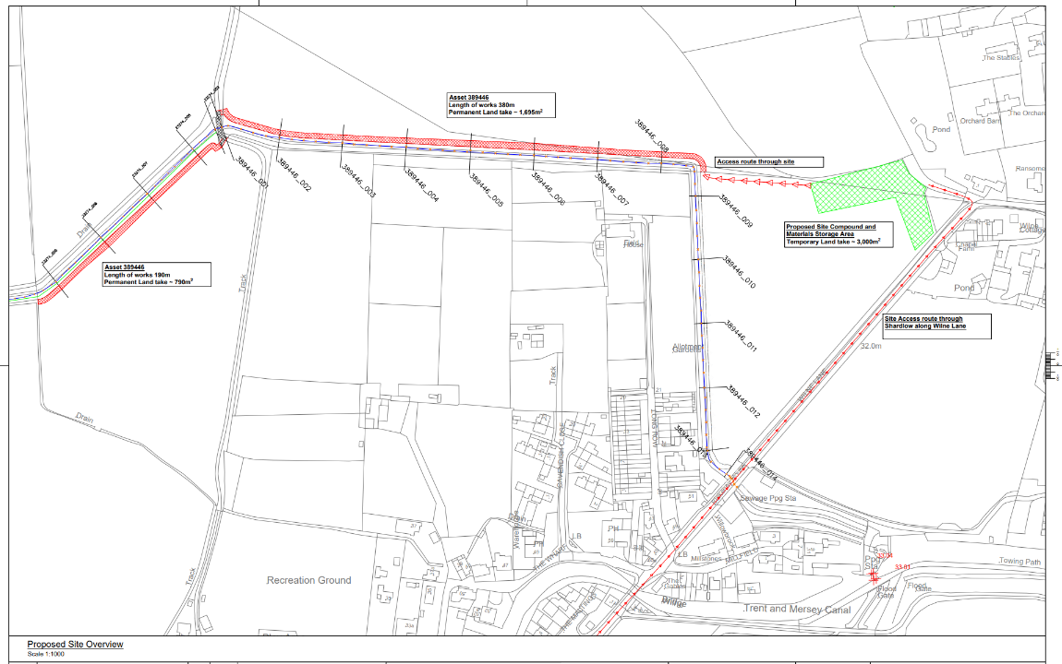
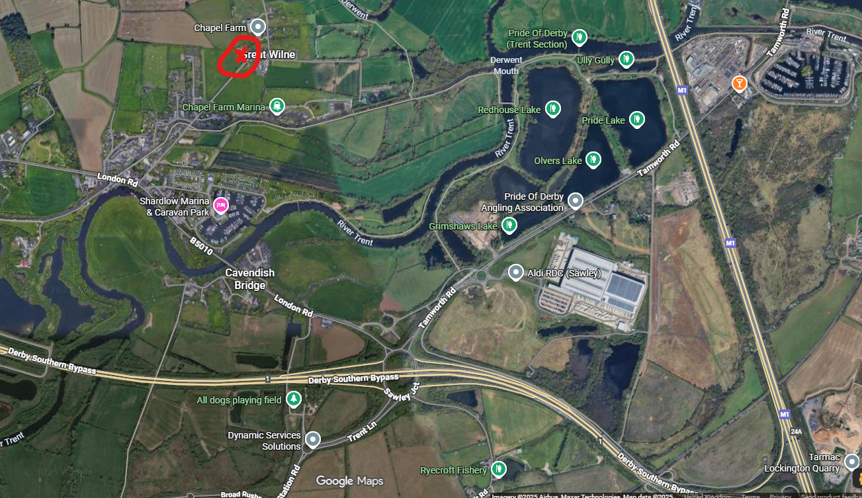

Requirement
The specification of the material we require is as given below. We require records of relevant geotechnical test data to demonstrate the source material meets our requirements and is suitable for our engineering performance needs.
We require supply of wet or dry cohesive fill material type 2A or 2B respectively as defined in Volume 1 – Specification for highway works, Series 600, Table 6/1. This is generally a sandy/silty clay, with properties as shown in the table below. As indicated by the grading, the material shall contain generally not less than 15% or more than 35% clay, with the remainder being well graded sand, silt and gravel. Stones greater than 100mm in size shall not be incorporated in the fill material.
Figure 1 defines the key engineering parameters that are needed for the source material.
Location | Minimum Undrained Shear Strength | Dry Density | Moisture Content | Atterberg limits | Grading
 |  |  |  |  | Particle Size (mm) | % Passing
Imported embankment fill | 60 kN/m² | 95% of Standard 2.5kg Proctor | Optimum -1% to Optimum +3% | LL <80% and/or PI <55% | 100 | 100
 |  |  |  |  | 60 | 95-100
 |  |  |  |  | 2 | 75-100
 |  |  |  |  | 0.06 | 40-80
 |  |  |  |  | .002 | 15-35

The Supplier shall submit results of testing of samples from any of the intended sources to the Client for review and acceptance. Approval of a source of material shall not be construed as constituting approval of material contained therein and approval may be withdrawn by the Employer if the properties of the material are shown to be subsequently outside the specification. A minimum of 2No. individual representative samples shall be tested per site which material is imported from and a copy of the test results provided to the Environment Agency Agent at least 5 working days prior to delivery of material from any new sources. Further to this the source of material shall be available for inspection by the Environment Agency. The Client will give minimum 5 days’ notice prior to an inspection.
All imported materials used in the works shall be free from leachates and other materials which are harmful to the natural environment of the site. Fill materials shall be free from Rhizomania, other diseases and also from propagules e.g. stolons, rhizomes, or other vegetative fragments or seeds of aggressive perennial weeds such as couch grass, docks, Japanese knotweed, and Himalayan balsam. The material shall also be free of sticks, foreign matter, and contaminants and shall be from an approved source. The Supplier shall provide for the Clients perusal, a leachate analysis of all material required for the works. The Supplier shall obtain this analysis from an approved independent UKAS accredited testing laboratory.

Sustainability
The Environment Agency protects and improves the environment and is committed to reducing the sustainability impacts of its activities directly and through its supply chains. We expect the Contractor to share this commitment and adopt a sound, proactive sustainable approach in keeping with the 25 yr environmental plan/our commitments compliant with all applicable legislation. This includes understanding and reducing direct and indirect sustainability impacts and realising opportunities, including but not restricted to; resilience to climate change, reducing greenhouse gas emissions, water use and quality, biosecurity, resource efficiency and waste, reducing the risk of pollution, biodiversity, modern slavery and equality, diversity & inclusion, negative community impacts.
As a delivery partner, the successful contractor is expected to pursue sustainability in their operations, thereby ensuring the Contracting Authority is not contracting with a supplier whose operational outputs run contrary to the Contracting Authority’s objectives. The successful contractor will need to approach the project with a focus on the entire life cycle of the project
A key requirement of this project is that the source material should be within a radius of 30miles of our construction site to reduce the carbon impact of transportation. Local material and other proposed methods to reduce environmental impact of the import will be prioritised in our supplier selection.

Outputs and Contract Management
Prior to acceptance of the contract offer the Environment Agency requires a site visit to inspect the source material to confirm it is suitable for the intended use and meets the required specification and supplied test data. Additionally, a site visit with the supplier to the construction site is required to review access routes and ensure the supplier is satisfied that the required delivery route is suitable for delivery vehicles and to agree the delivery schedule, timings and key contacts. The Environment Agency can incorporate measures such as vegetation management, traffic management and stoning of access routes as agreed with the supplier.

