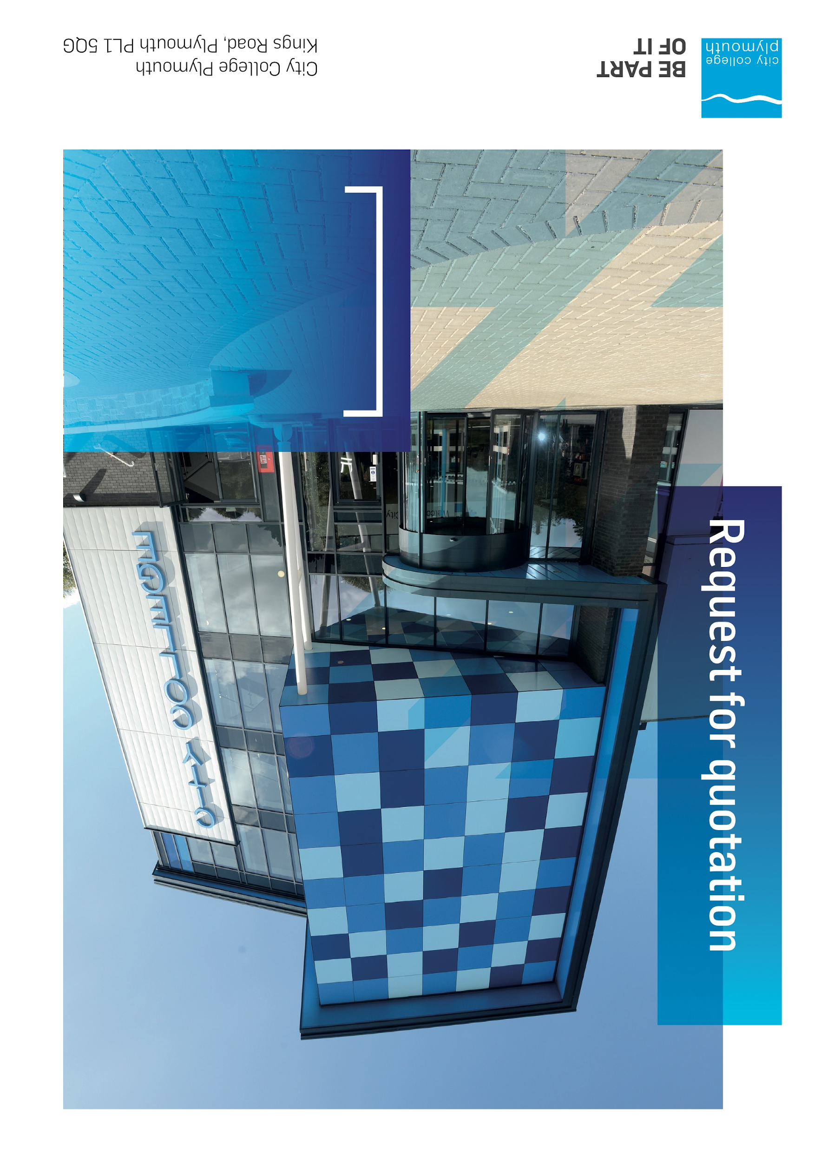

Request for Quotation
RFQ215
Pinpoint Lift Refurbishment 2026

Table of Contents
Table of Contents 2
Confidentiality Statement 3
MINI COMPETITION 4
Submission Details 4
Submission Deadlines 4
Submission Questions and Clarifications 4
Electronic Submissions 5
Introduction and Executive Summary 5
Business Overview & Background 5
Our Guiding principle 6
Our Vision 6
Our CORE VALUES 6
Our CULTURE 6
The Way Forward - our Priorities 7
Detailed Requirement 7
Support/WARRANTY 7
Timescales 8
Written Submission 8
Delivery 8
Pricing 9
Terms and Conditions 9
Validity 9
Selection Criteria 9
Award Price 10
Written submission 10
Assessment of Quotations 11
Freedom of Information Act 2000 11
General Data Protection Regulation (GDPR) 2018 11
Agreement Conditions Acceptance and Declaration 11
Supporting Documentation 12

Confidentiality Statement
This document, and any attachments thereto, regardless of form or medium, is intended only for use by the addressee(s) and may contain legally privileged and/or confidential, copyrighted, trademarked, patented or otherwise restricted information viewable by the intended recipient only. If you are not the intended recipient of this document (or the person responsible for delivering this document to the intended recipient), you are hereby notified that any dissemination, distribution, printing or copying of this document, and any attachment thereto, is strictly prohibited and violation of this condition may infringe upon copyright, trademark, patent, or other laws protecting proprietary and, or, intellectual property. In no event shall this document be delivered to anyone other than the intended recipient or original sender and violation may be considered a breach of law fully punishable by various domestic and international courts. If you have received this document in error, please respond to the originator of this message or email him/her at the address below and permanently delete and/or shred the original and any copies and any electronic form this document, and any attachments thereto and do not disseminate further.
Thank you for your consideration, City College Plymouth.
Where no notice is given, all information contained herein is Copyright 2025 City College Plymouth.

OPEN PROCEDURE
City College Plymouth is carry out an under threshold tender as per the Procurement Act 2023
Any Contractor who directly or indirectly canvasses any Member or Officer of the Institution, or advisor concerning the award of the contract for the provision of the services, or who directly or indirectly obtains or attempts to obtain information from any such member or Officer concerning any Tender or proposed Tender for the service will be disqualified from having his/her Tender considered

Submission Details

Submission Deadlines
All submissions for responding to this Request for Quote must be submitted electronically as stated below, no later than:
19^{h} December 2025
12:00 Noon
Any submissions received after this date will not be considered.

Submission Questions and Clarifications
You may contact the following person if you have any questions or require clarification on any topics covered in this Request for Quotation: by Monday 15th December 2025
Beccy Woods
Estates Operations Manager
Phone: 01752 305734
Email: bwoods@cityplym.ac.uk cc: tenders@cityplym.ac.uk
All correspondence during the Tender should be channeled via the Procurement Officer using the above details only. Bidders found to have gained an unfair advantage shall be disqualified from the current opportunity and future opportunities with the College for a minimum of four (4) years.

Electronic Submissions
Electronic submissions in response to this Request for Quotation are required and must meet the following criteria:
Sent via email to: tenders@cityplym.ac.uk
Document standards:
- Text must be in Microsoft Word format;
- Price tables must be in Microsoft Excel format (using pricing schedule in Appendix A);
- Supportive evidence may additionally be submitted in PDF format;
- Images, Designs, and other supporting evidence may be in either JPEG or PDF format
- Completed Appendix C Suitability Assessment & Selection Questionnaire (Including Mandatory & Discretionary Exclusions) Parts 1, 2 and 3. - Please note this suitability assessment will not be viewed unless you are the winning tenderer. Failure at this stage may prevent the contract from being awarded.
- Signed Agreement Acceptance and Declaration.

Please note that the College is able to accept submissions sent in a compressed or “.zip” file format, so long as the files contained meet the standards described above.

WARRANTY:
By submitting your tender bid, you are warrantying to the College that you have not breached our canvassing or soliciting clause.

If any successful tenderer awarded a contract is found to have provided an inaccurate warranty, then the College reserves the right to terminate the awarded contract with immediate effect and re-tender the contract from which the successful tenderer will be excluded from re-bidding and shall be disqualified from any future opportunities for a period of four years.

Introduction and Executive Summary
City College Plymouth is looking to carry out the installation of a new Platform lift to replace an existing non functioning one at our Pinpoint site.

Business Overview & Background
City College Plymouth has a learning environment and organisational culture that impacts positively on the health, wellbeing and sustainability of our community and enables all of our students and staff to achieve their full potential.
City College Plymouth is one of the largest providers of innovative, technical and professional education in the South West with a national reputation for promoting enterprise, employability and science, technology, engineering and mathematics (STEM). The College plays a central role in the educational, cultural and economic life of the region and works with strategic partners to facilitate growth, raise aspirations and foster wealth creation.
The College was awarded the Teaching Excellence Framework (TEF) Gold award for its university-level provision and its most recent Ofsted inspection confirmed that the College continues to be ‘Good’ with outstanding features (behaviour). The college has also won the prestigious Queen's anniversary medal for our excellence in maritime skills and was elected best place to work at the 2025 Tech South West awards.
City College Plymouth is also one of the first Institutes of technology in the UK Working in collaboration with education providers and employers across the South West to improve the training in science, technology, engineering and maths in order to address skills gaps within these industries and support regional growth.
City College supports the region’s employers with their award-winning Apprenticeship provision, as well as providing a range of courses and bespoke training programmes which enable employees to upskill or retrain to better support their business’ requirements.
The College operates on three main sites within the city, serving 12,000 students and employing over 750 staff. The College operates year round, with opening times from 0800-2100 on some days.

Our Guiding principle
City College Plymouth has a learning environment and organisational culture that impacts positively on the health, wellbeing and sustainability of our community and enables all of our students and staff to achieve their full potential.

Our Vision
We are the learning destination of choice

Our CORE VALUES
Respect, ownership, integrity for all

Our CULTURE
Nurturing a passion for teaching and learning
Enriching our community through knowledge, experience and skills
Enabling every student to be the best that they can be

The Way Forward - our Priorities
• Staff - our most important investment
• Students - our purpose
• Community - making a difference
• Achievement - reputation for success
• Wellbeing - infusing health into every day

Detailed Requirement
City College Plymouth is looking to carry out the replacement of a 3 floor (G, 1 and 2) passenger lift and its pinpoint site.
An outline of the lifts are below;
1 x Chain Drive Platform Lift (500kg) 3 floor
• Single entrance opening doors
• 4G GSM type Auto-dialler providing two-way voice communications
The full specification of requirements can be found in appendix A but the college is happy to accept alternative proposals if you feel there is a more effective solution.
Due to the operational difficulties the lack of the lift will present the college the college is looking to get the works completed as soon as practically possible.

Technical Specification and works plan
Please can you provide in your return a detailed plan of how the works will be undertaken including any technical details. Please provide details on how the work area will be managed in a live college environment, the site management proposals and how the college will be kept informed on the works progress.
Please indicate in your return a Gantt chart showing expected time frames of the works.

Support/WARRANTY

- Please confirm that the lifts will come with a minimum 1 years warranty and this will include 4 service visits

- Please confirm if any additional warranty is available for the works and at what cost

Timescales

Action | Date
Tender Issued | 3rd December 2025
Deadline for Queries | 15th December 2025
Tender Response Date | 19th December 2025
Contract award | w/c 12th January 2025
Works to be undertaken | As soon as practically possible
Works must be completed by | Within 3 week of start date

Written Submission
We require a written document which details your company offer with particular interest to the following areas. This submitted document will be scored as per the table on page 12.
- Support, including warranty agreements
- Quality of Technical Specification including plan of works
- Experience of carrying out a similar project in an educational environment
- Sustainability, the Environment and Corporate Social Responsibility including Modern Slavery
- Potential partnering arrangements with regard to student work experience, apprenticeships and working partnerships.

SITE VISIT

Please contact Dan Williams – Dan Williams: danwilliams@achievementtraining.com to arrange a site visit. The lifts are located at our pinpoint site address below;

Pinpoint
11 Union St,
Plymouth,
PL1 2SR

Pricing
Bidders should provide their pricing for each of the key points in Appendix A.
Please can you also ensure pricing is allowed for the following;
- the removal and disposal of the existing lift using appropriate waste carriers licence
- hoardings for the duration of the project
- supply, installation, commissioning and handover of the lift.
- Cost of initial warranty (if applicable) and any optional extension
- Provision sum for any building or electrical works
- Repositioning of the control unit from classroom PC0.08 into a corridor or another suitable location. (optional)

Prices should be firm and valid for at least the initial contract period (12 months) and not subject to increase or escalation of any kind throughout the contract.

Safeguarding
An enhanced DBS, issued within the last 3 years, preferably cleared under the children's barred list, or a letter of assurance confirming these details, is required before any operatives attend the site. Confirmation that you currently have or will have the required DBS detail prior to the start date of the contract is a prerequisite for this tender, any bids that do not provide this assurance will not be considered

Terms and Conditions
The College’s normal business terms are 1-2 months from the date of invoice. Payment will become due subject to the above upon the College’s full acceptance of the goods/services. This Request for Quotation and any resulting purchase order will be subject to the College’s General Terms and Conditions of Purchase of Goods/Services – see Appendix B.
The college may look to use a JCT contract or similar upon award. Due to the timescales involved the college would look to include guarantee the works will be completed within an agreed timescale with compensation for any avoidable delays.

Validity
Bidder’s offers should be open and valid for acceptance for a period of no less than ninety [90] days from the date of submission.

Selection Criteria
The successful supplier will have provided the Most Advantageous Tender (MAT) to the college. It should be noted that the bidder with the lowest submitted prices will not necessarily be down-selected. All bidders will be notified via email of the results of the outcome no later than 90 days from the date of submission. The date of contract award will be provided within that email.

The marking criteria follows:
Category | Weight
Price | 70%
Quality – Technical Specification and work plan | 10%
Experience of carrying out projects in a live education environment | 10%
Added Value | 5%
Sustainability, the Environment and Social Responsibility | 5%

Please see table below for more details on the scoring method.

Award Price
Lowest quote price divided by quote price multiplied by 100

Written submission
Assessment | Score | Interpretation
Excellent | 4 | Comprehensive response supported by examples  Description fully supported by details that demonstrate the applicant’s ability to provide the required services.
Good | 3 | Broad response supported by relevant examples.  Description well supported by details that demonstrate the applicant’s ability to provide the required services.
Satisfactory | 2 | Reasonable response supported by some evidence.  Description adequately supported by details that demonstrate the applicant’s ability to provide the required services.
Poor | 1 | Limited response not well supported by evidence.  Description inadequately supported by details that demonstrate the applicant’s ability to provide the required services.
Unacceptable | 0 | No response or insufficient information provided.

Assessment of Quotations
Bidders must ensure that their quotation fully addresses all information requested within this RFQ document. Bidders must ensure that any quotation fully meets the specification required. The College reserves the right to discount any quotation which does not fully meet the specification.
The College reserves the right to seek clarification with bidders upon receipt of quotations.

Freedom of Information Act 2000
Under the Freedom of Information Act 2000 the College cannot guarantee that information provided by bidders during the course of this RFQ procedure or any resulting contract will be held a confidential. The College will not routinely release information to interested parties unless required to do so in order to meet our statutory obligations.

General Data Protection Regulation (GDPR) 2018
All bidders must comply with the General Data Protection Regulation (GDPR) 2018 in respect of using and processing personal information. Bidders must have in place technical and organisational safeguards to protect personal data from unauthorised use, disclosure or loss.
The College reserves the right to request a copy of your privacy statement if you are the successful bidder.

Agreement Conditions Acceptance and Declaration
Bidders are required to sign and return the attached Agreement Conditions Acceptance and Declaration. Appendix C

Supporting Documentation
Appendix A: Specification
Appendix B: City College Plymouth Standard Terms & Conditions
Appendix C: Agreement Conditions Acceptance and Declaration
Appendix D: Suitability document
Appendix E: Pricing document

