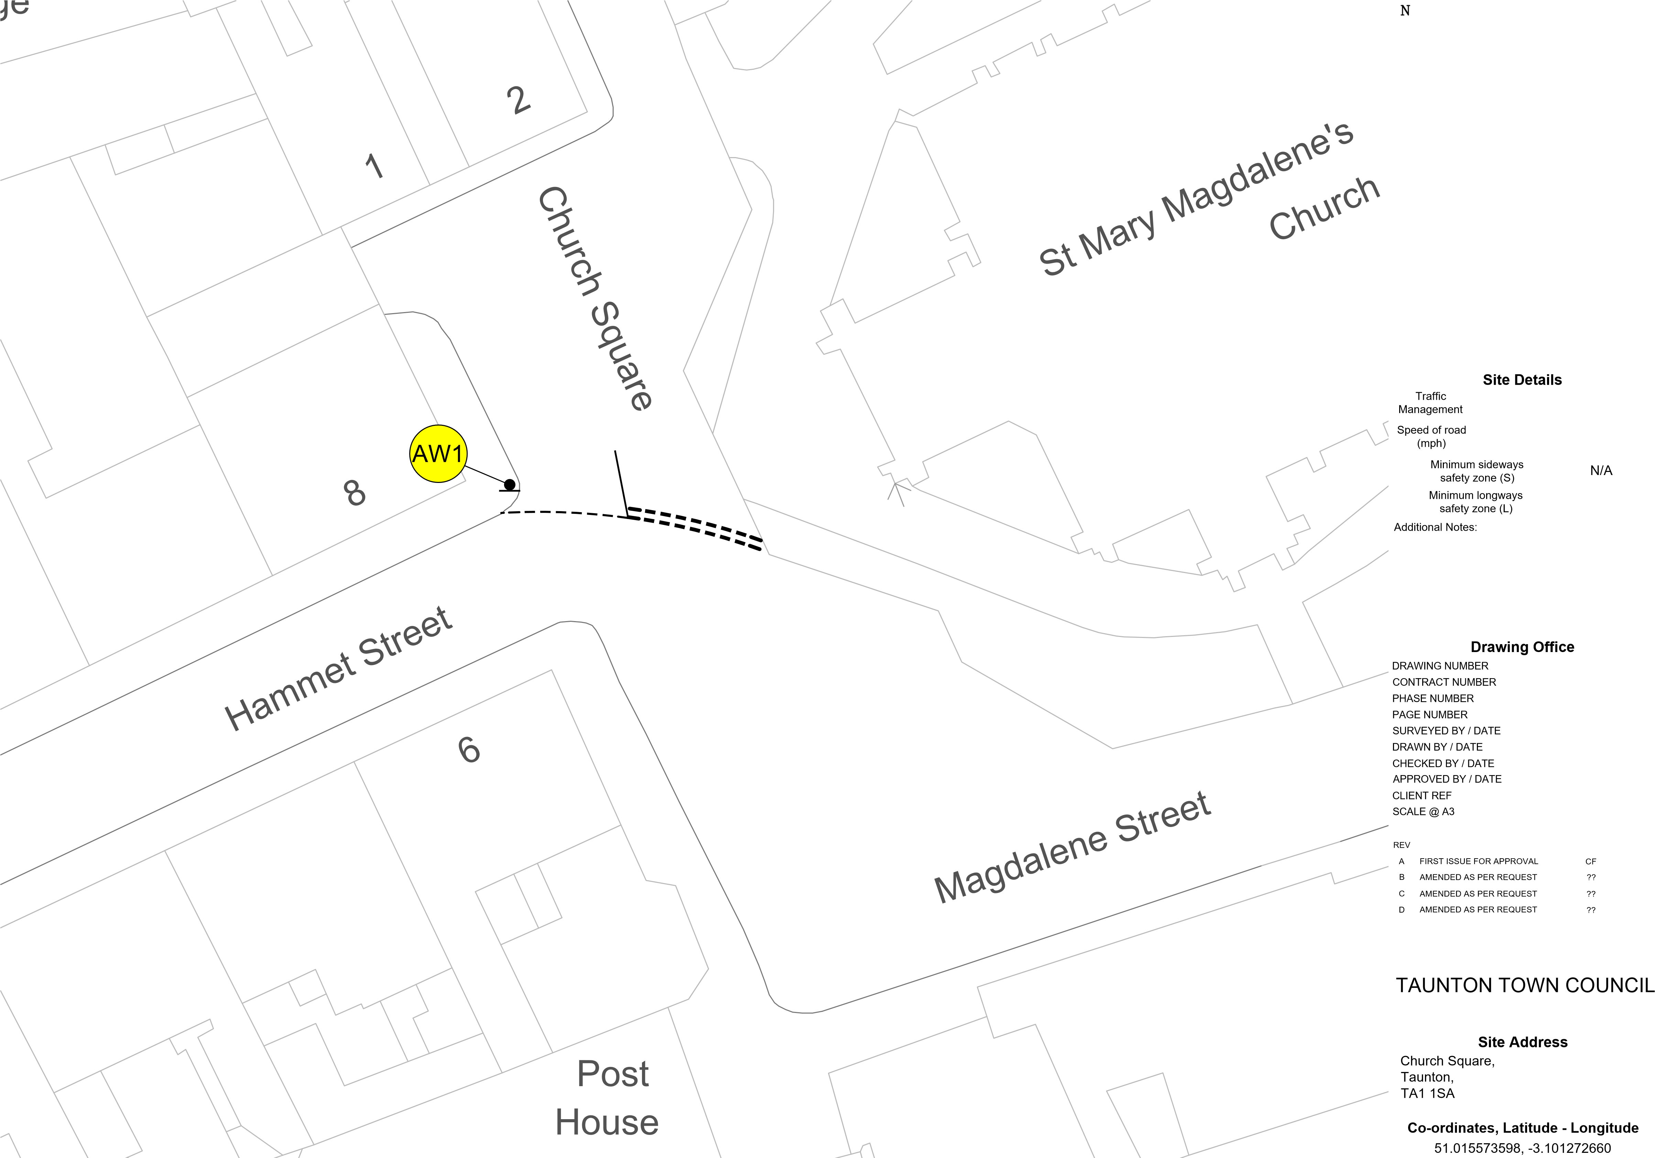
Advance Warning
N/A
CF4001
180141
1 of 1
1 of 20
N/A N/A

CF 01/10/24 CF 01/10/24 CH 01/10/24
N/A
NTS

BY DATE
01/10/24 dd/mm/yy dd/mm/yy dd/mm/yy

Client
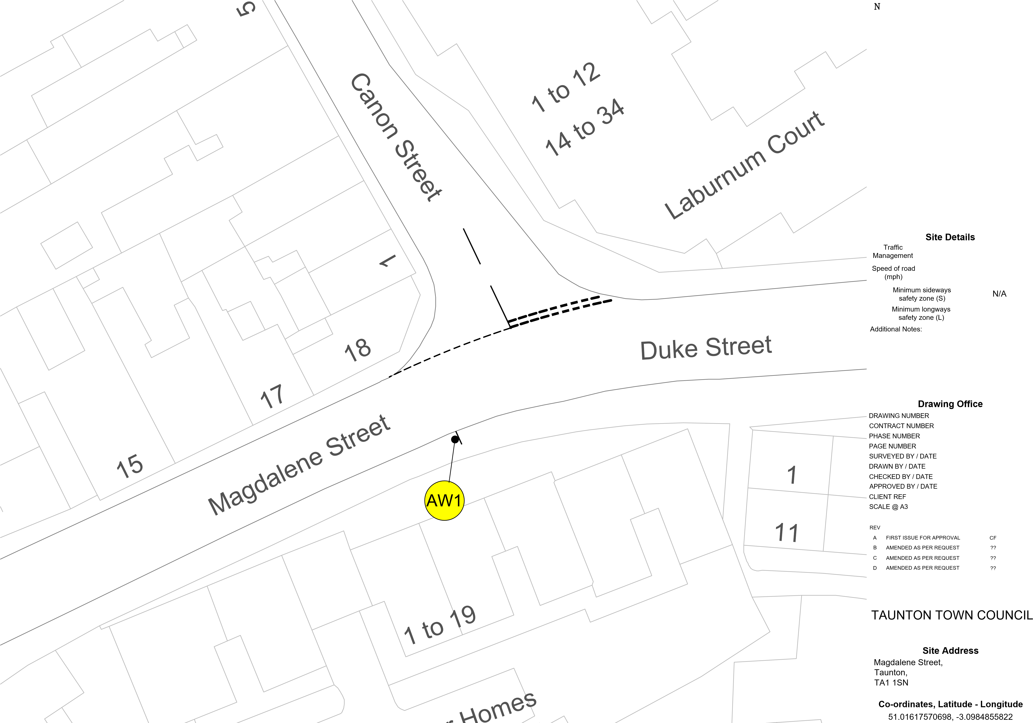
Advance Warning
N/A
CF4002
180141
- of 1
- of 20
N/A N/A

CF 01/10/24 CF 01/10/24 CH 01/10/24
N/A
NTS

BY DATE
01/10/24 dd/mm/yy dd/mm/yy dd/mm/yy

Client
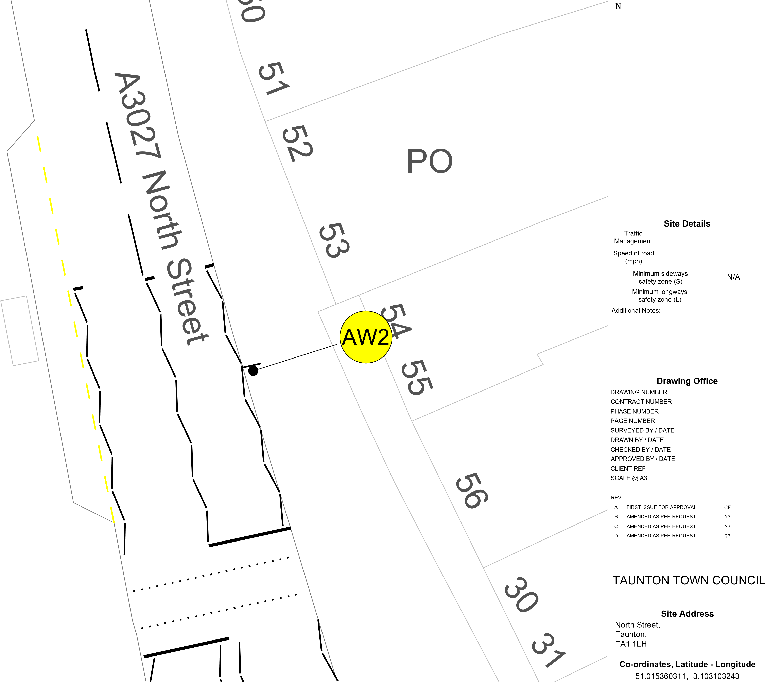
Advance Warning
1
29
N/A
CF4003
180141
1 of 1
3 of 20
N/A N/A

CF 01/10/24 CF 01/10/24 CH 01/10/24
N/A
NTS

BY DATE
01/10/24 dd/mm/yy dd/mm/yy dd/mm/yy

Client
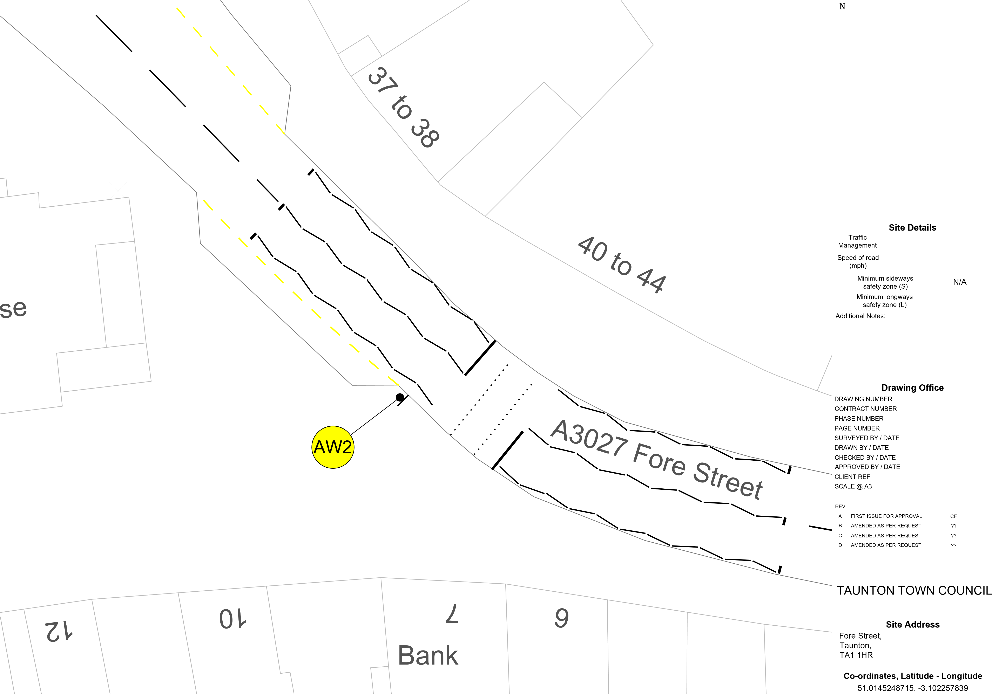
Advance Warning
N/A
CF4004
180141
1 of 1
4 of 20
N/A N/A

CF 01/10/24 CF 01/10/24 CH 01/10/24
N/A
NTS

BY DATE
01/10/24 dd/mm/yy dd/mm/yy dd/mm/yy

Client
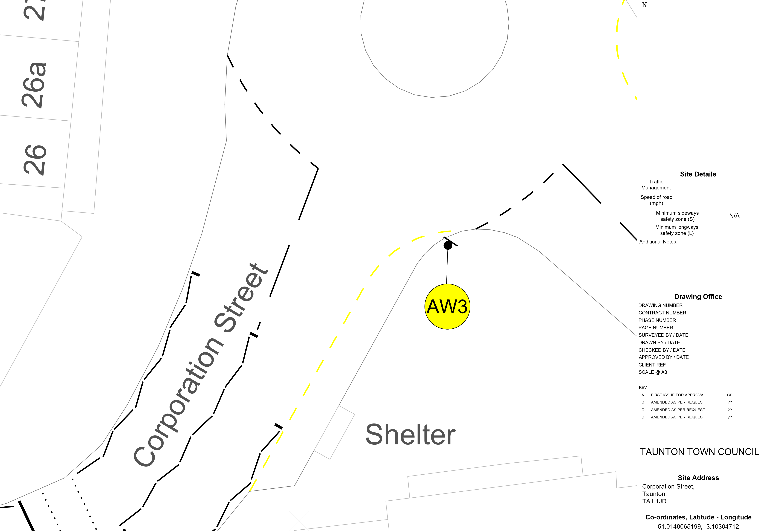
Advance Warning
N/A
CF4005
180141
1 of 1
5 of 20
N/A N/A

CF 01/10/24 CF 01/10/24 CH 01/10/24
N/A
NTS

BY DATE
01/10/24 dd/mm/yy dd/mm/yy dd/mm/yy

Client
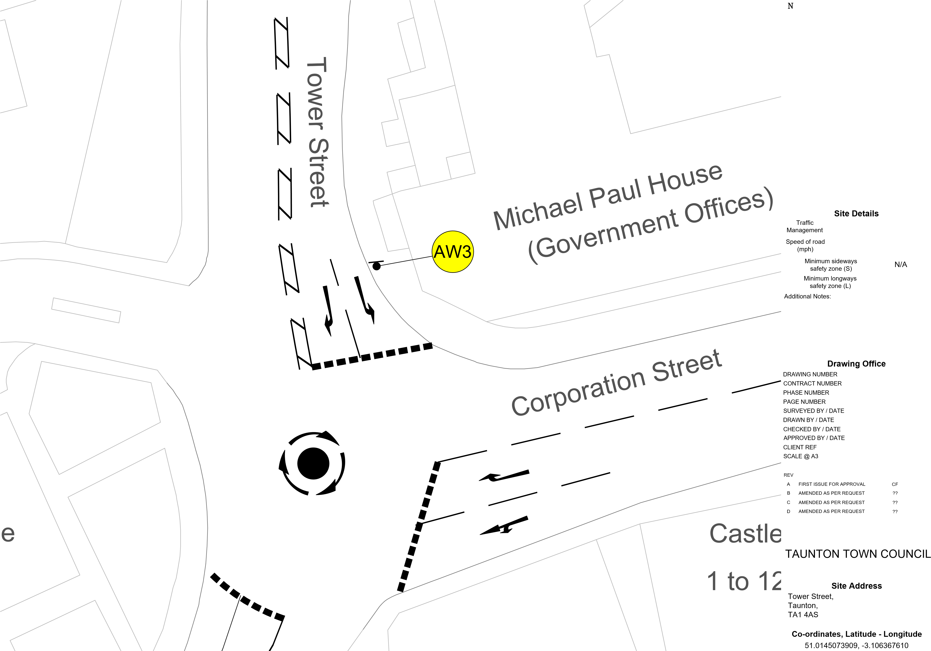
Advance Warning
N/A
CF4006
180141
1 of 1
6 of 20
N/A N/A

CF 01/10/24 CF 01/10/24 CH 01/10/24
N/A
NTS

BY DATE
01/10/24 dd/mm/yy dd/mm/yy dd/mm/yy

Client
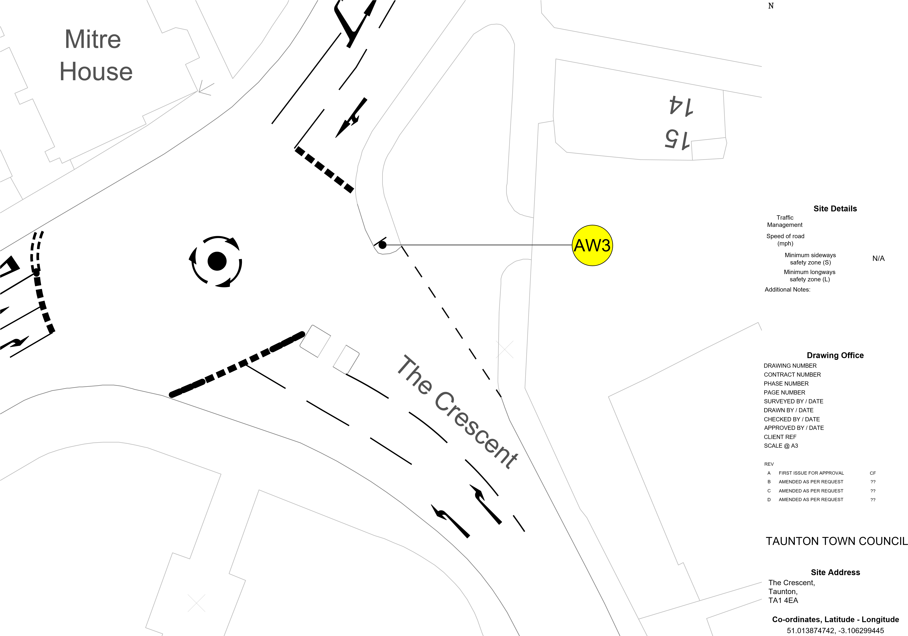
Advance Warning
N/A
CF4007
180141
1 of 1
7 of 20
N/A N/A

CF 01/10/24 CF 01/10/24 CH 01/10/24
N/A
NTS

BY DATE
01/10/24 dd/mm/yy dd/mm/yy dd/mm/yy

Client
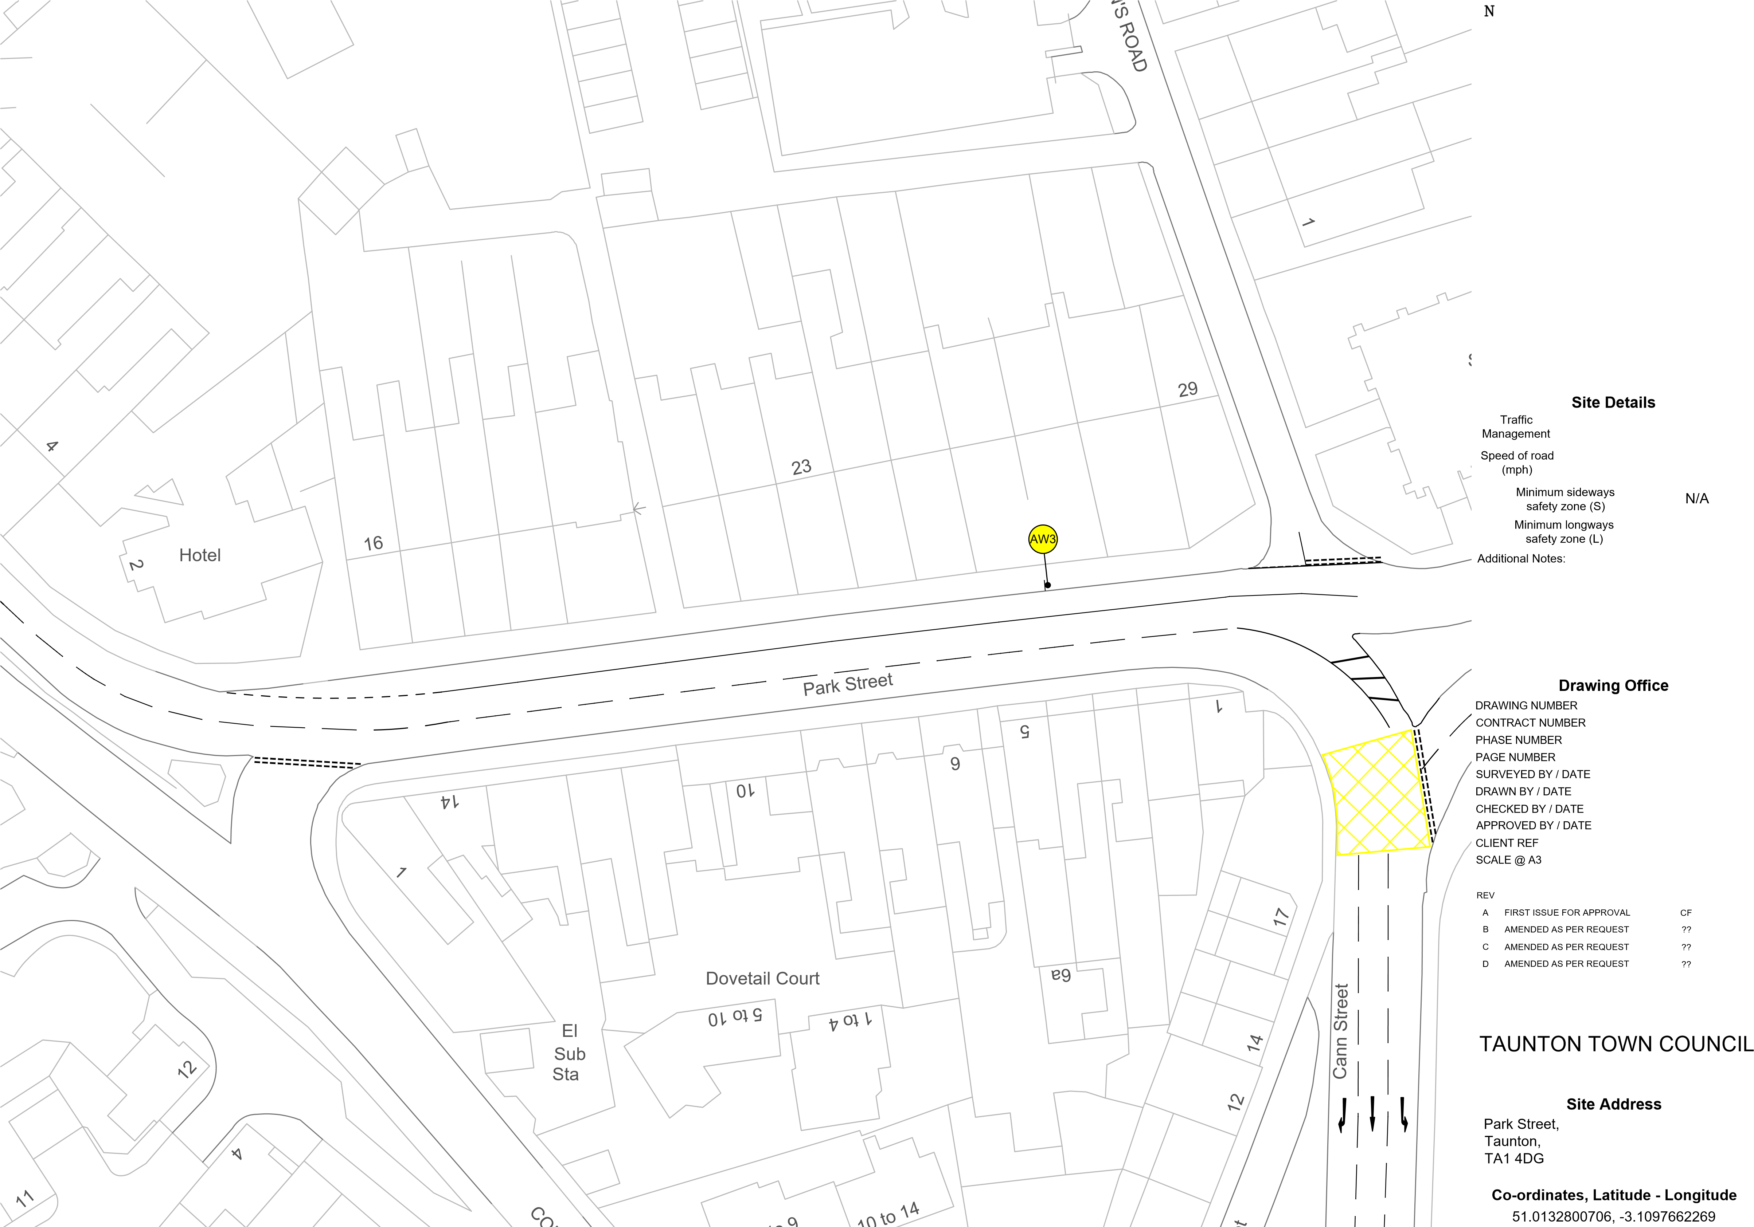
Advance Warning
N/A
CF4008
180141
1 of 1
8 of 20
N/A N/A

CF 01/10/24 CF 01/10/24 CH 01/10/24
N/A
NTS

BY DATE
01/10/24 dd/mm/yy dd/mm/yy dd/mm/yy

Client
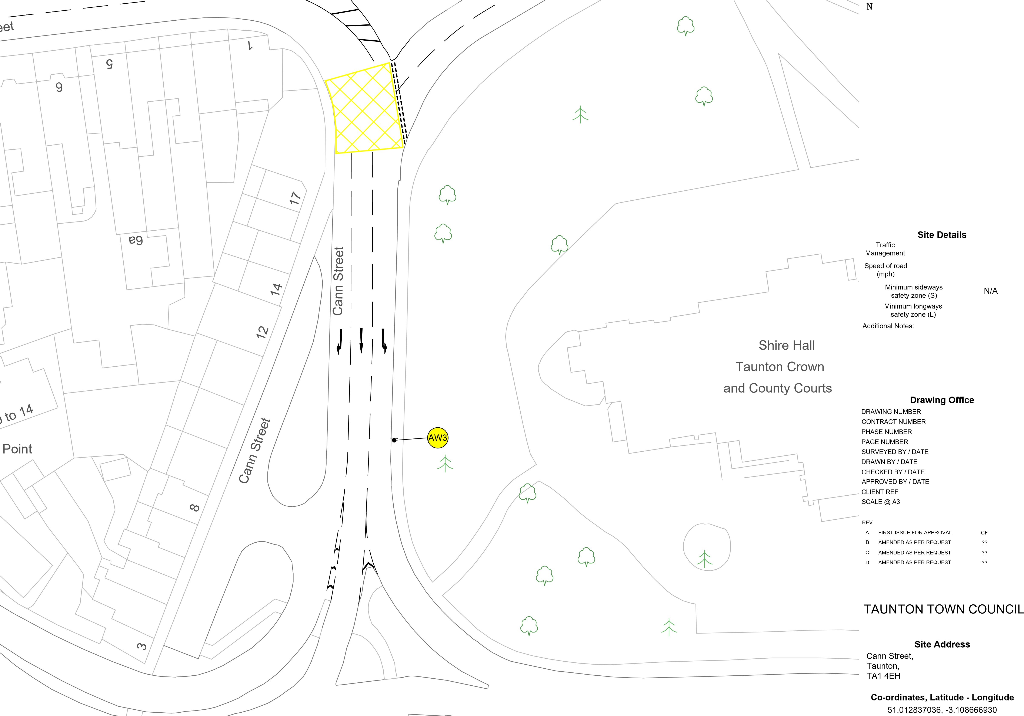
Advance Warning
N/A
CF4009
180141
1 of 1
9 of 20
N/A N/A

CF 01/10/24 CF 01/10/24 CH 01/10/24
N/A
NTS

BY DATE
01/10/24 dd/mm/yy dd/mm/yy dd/mm/yy

Client
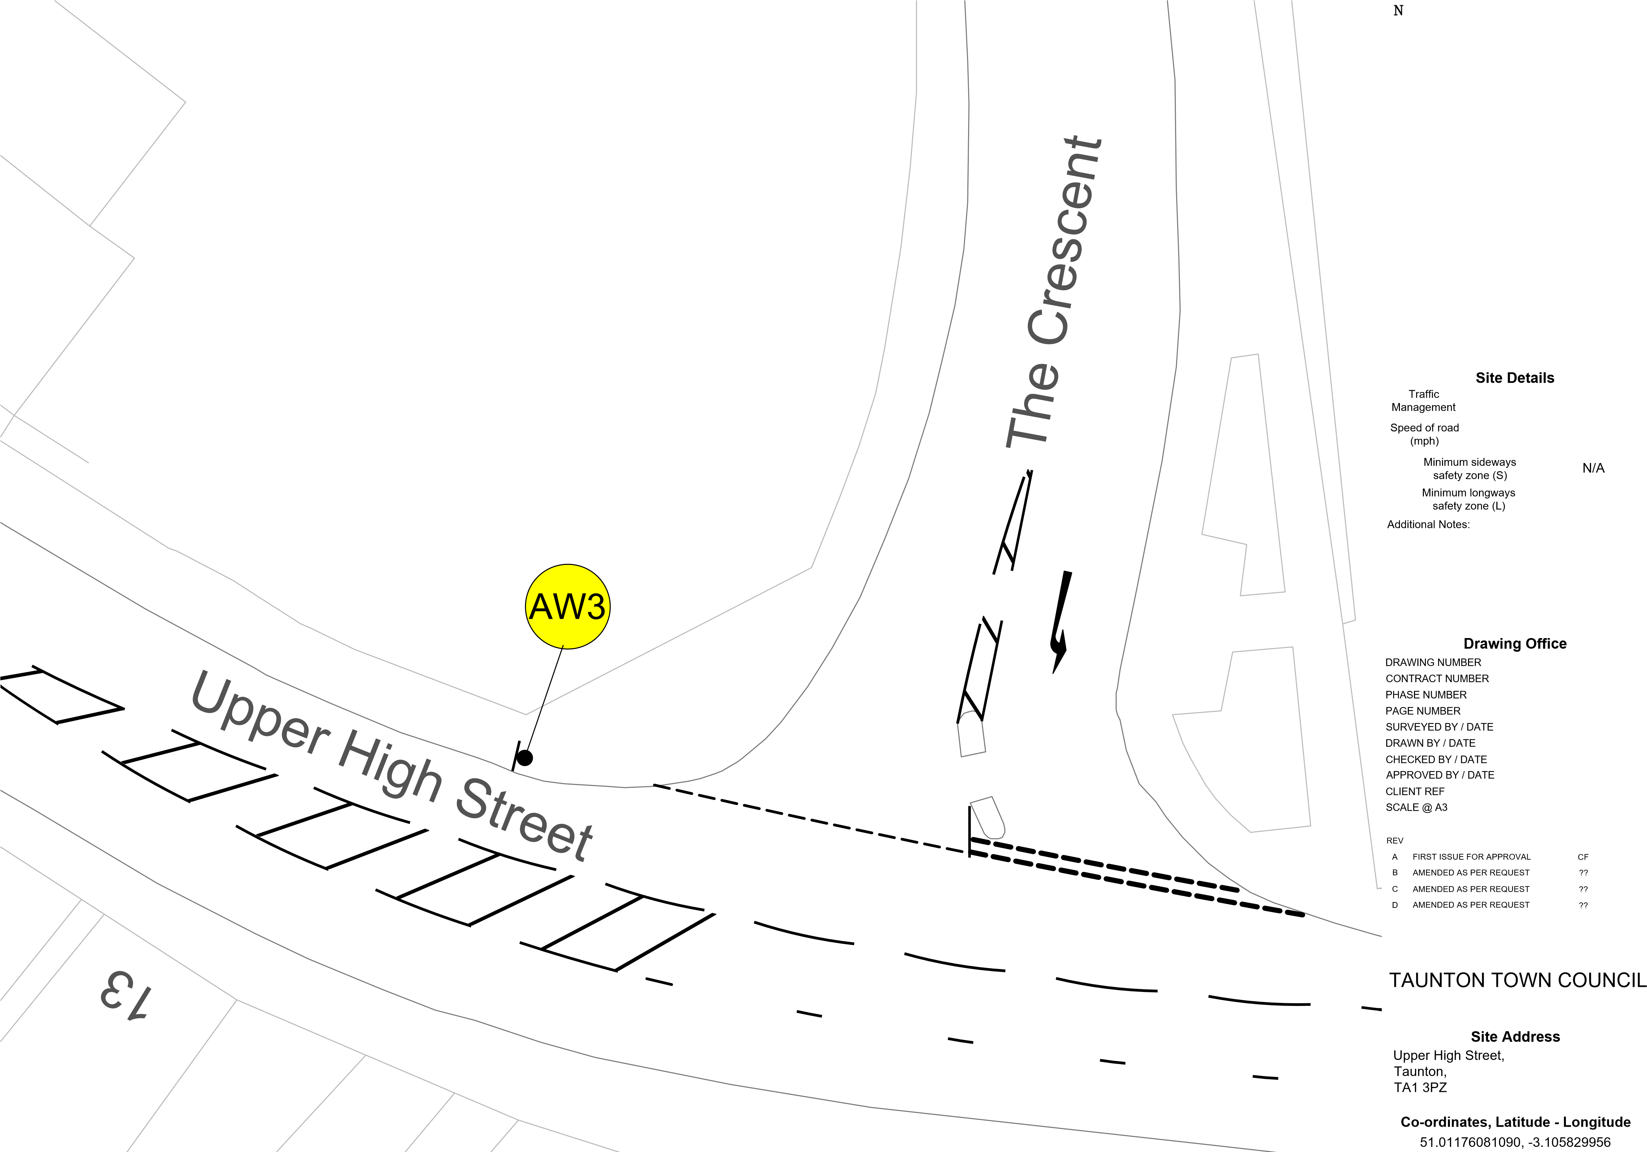
Advance Warning
N/A
CF4010
180141
1 of 1
10 of 20
N/A N/A

CF 01/10/24 CF 01/10/24 CH 01/10/24
N/A
NTS

BY DATE
01/10/24 dd/mm/yy dd/mm/yy dd/mm/yy

Client
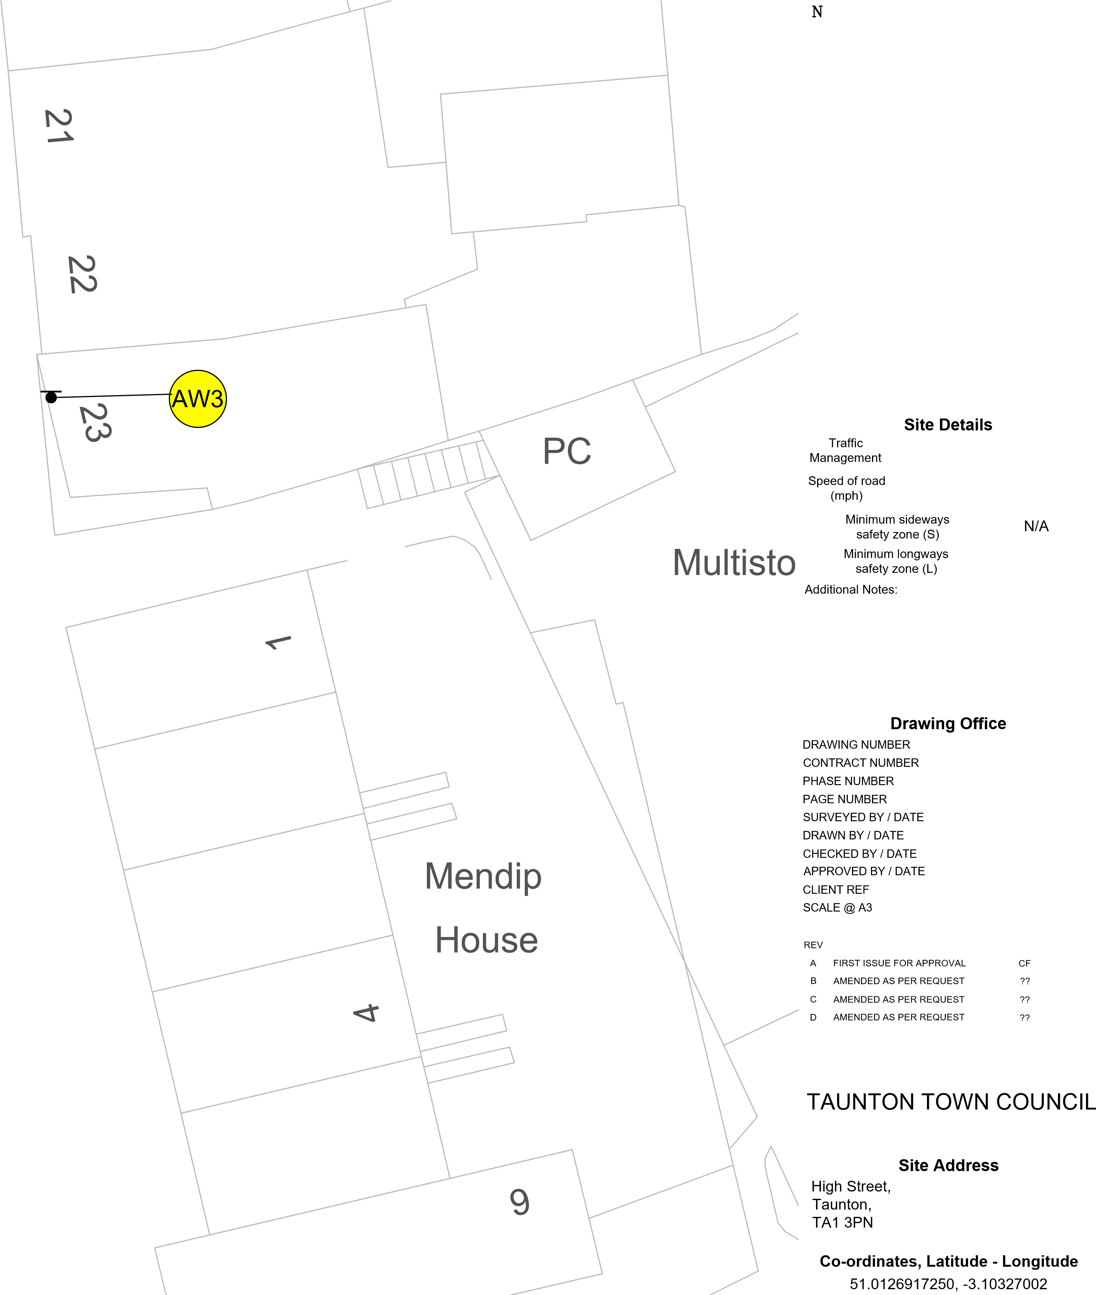
Advance Warning
N/A
CF4011
41
PH
37
38
44
4
39
40
47
Guildford Place
46
45
48
a
45
High Street
180141
1 of 1
11 of 20
N/A N/A

CF 01/10/24 CF 01/10/24 CH 01/10/24
N/A
NTS

BY DATE
01/10/24 dd/mm/yy dd/mm/yy dd/mm/yy

Client

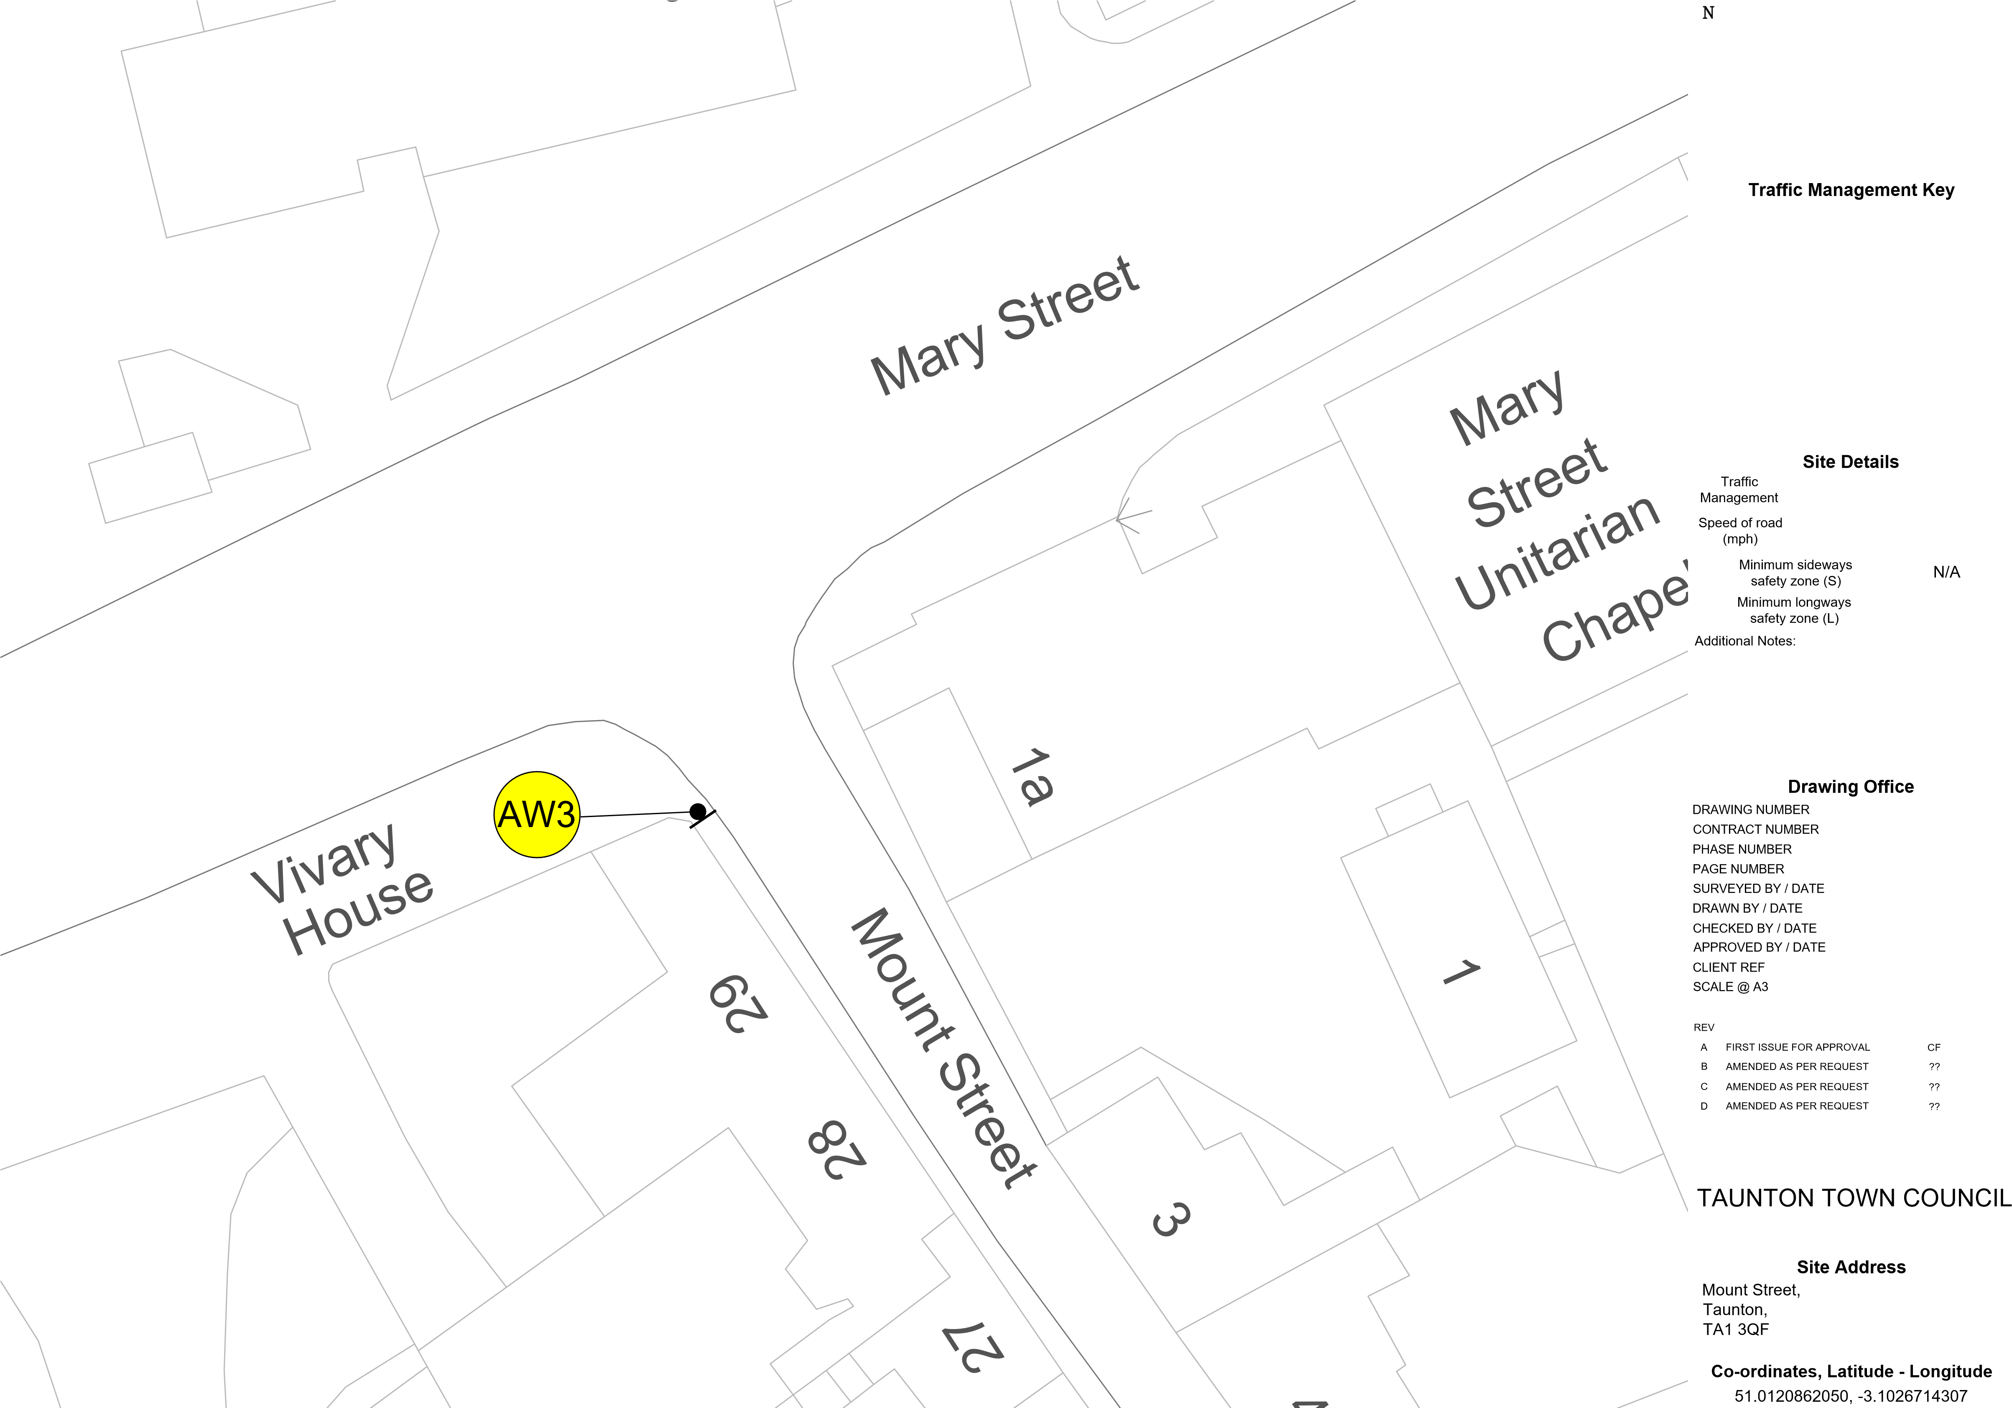
Advance Warning
N/A
CF4012
180141
1 of 1
12 of 20
N/A N/A

CF 01/10/24 CF 01/10/24 CH 01/10/24
N/A
NTS

BY DATE
01/10/24 dd/mm/yy dd/mm/yy dd/mm/yy

Client
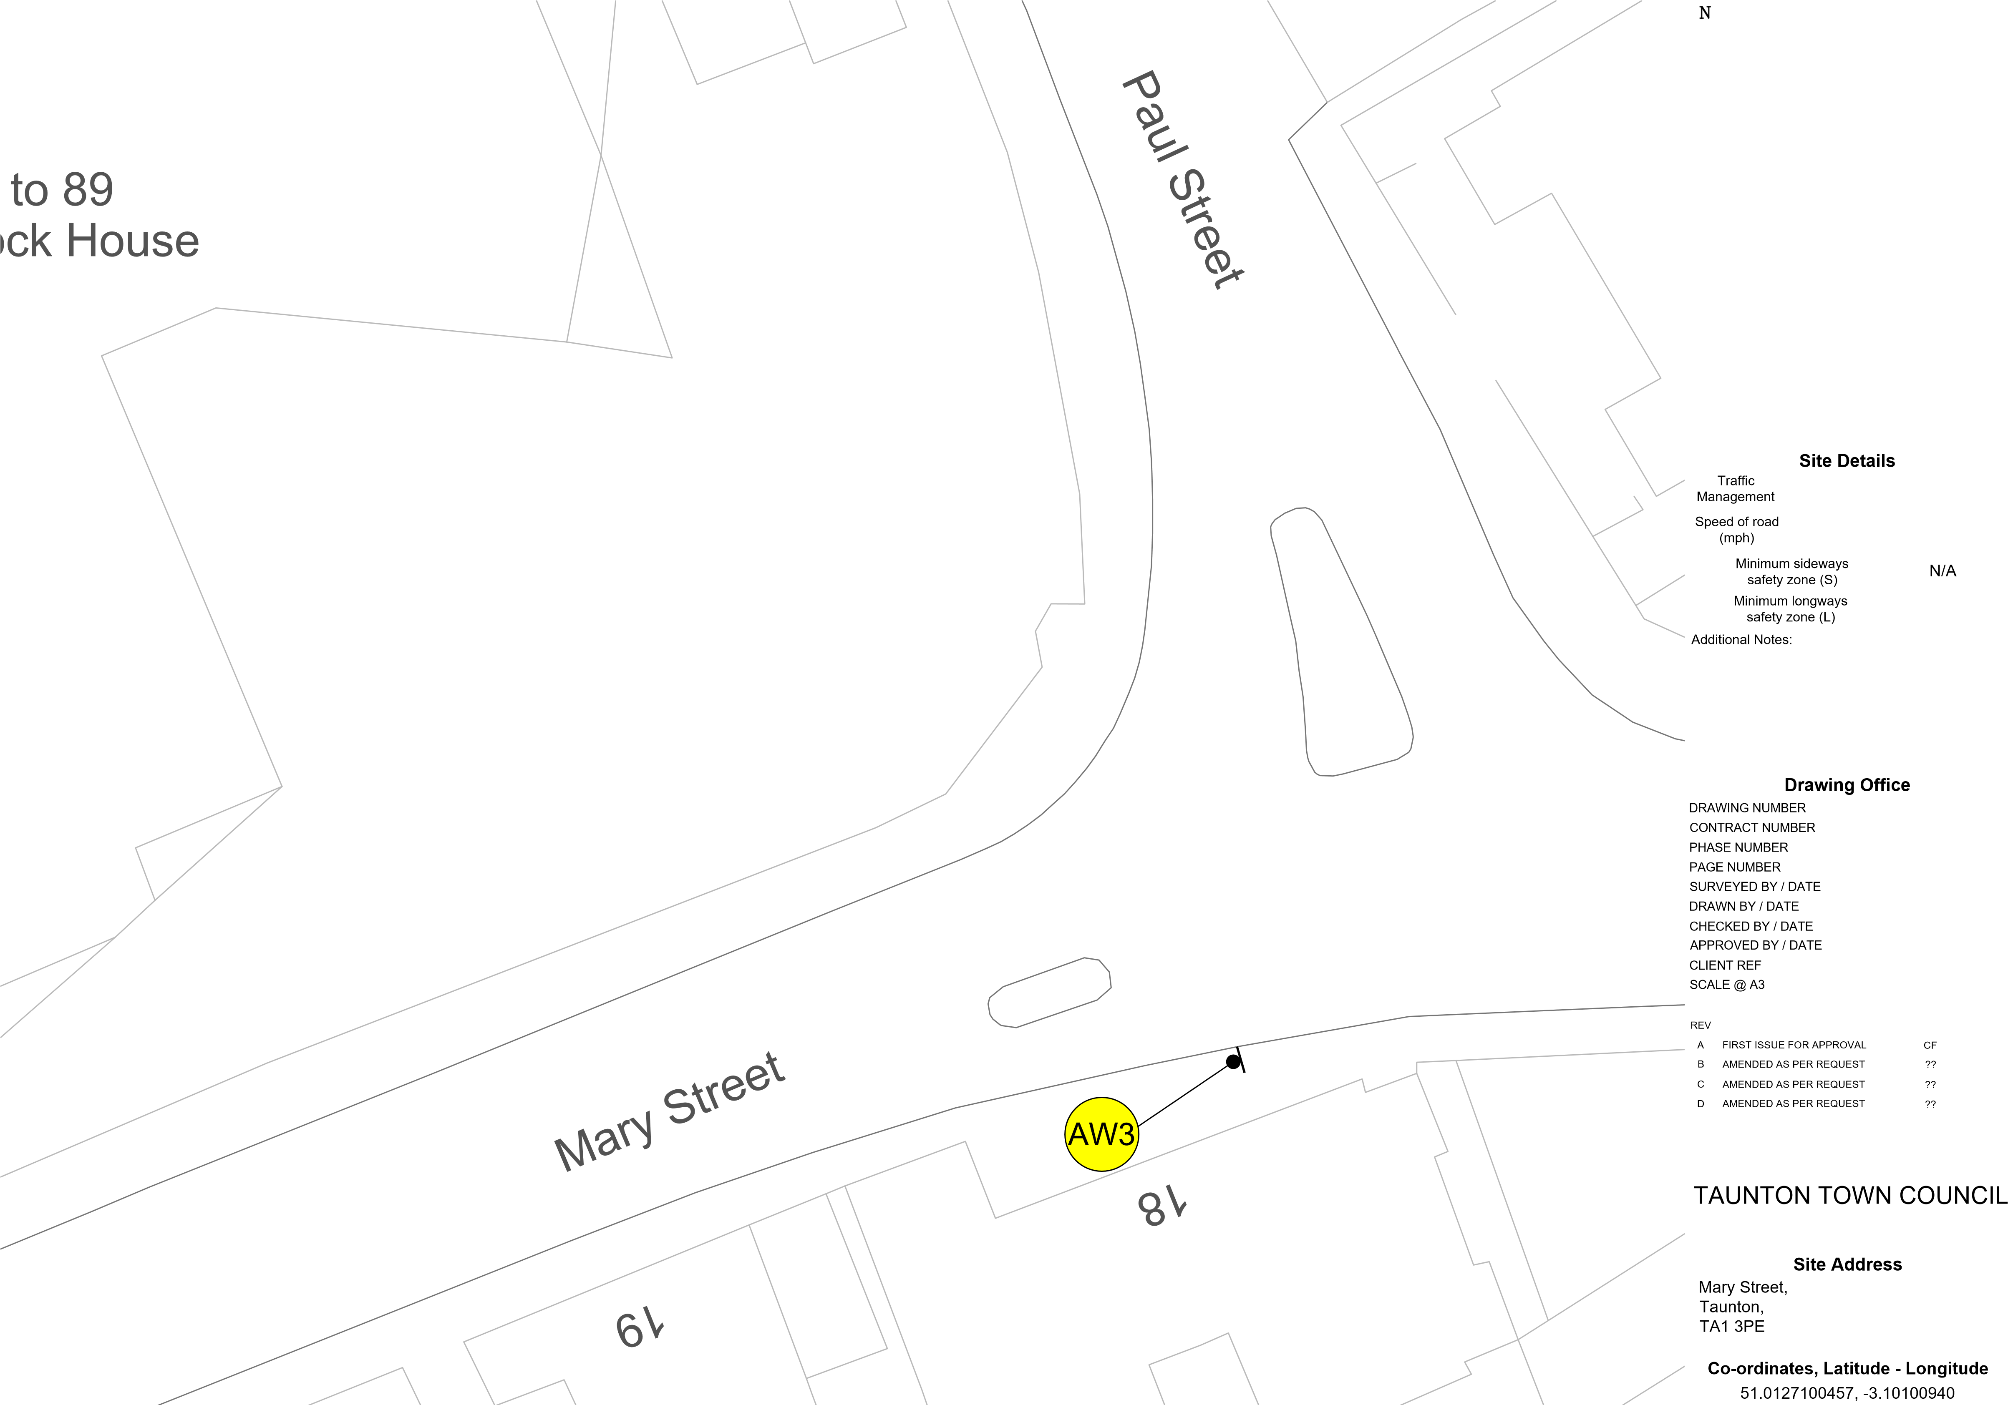
Advance Warning
N/A
CF4013
180141
1 of 1
13 of 20
N/A N/A

CF 01/10/24 CF 01/10/24 CH 01/10/24
N/A
NTS

BY DATE
01/10/24 dd/mm/yy dd/mm/yy dd/mm/yy

Client
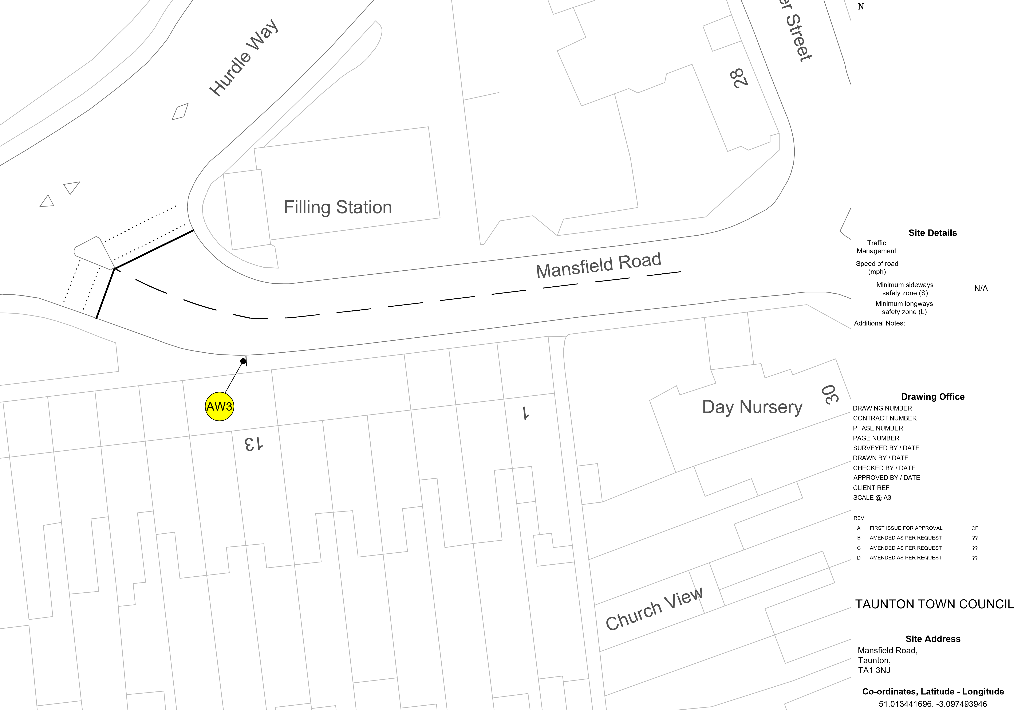
Advance Warning
N/A
CF4014
180141
1 of 1
14 of 20
N/A N/A

CF 01/10/24 CF 01/10/24 CH 01/10/24
N/A
NTS

BY DATE
01/10/24 dd/mm/yy dd/mm/yy dd/mm/yy

Client
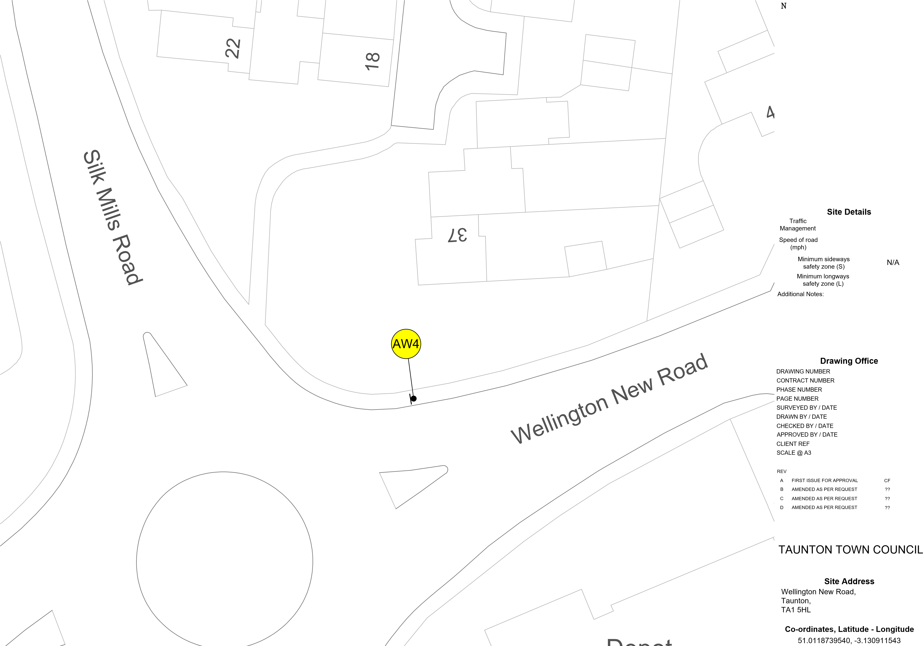
Advance Warning
N/A
CF3987
180141
1 of 1
15 of 20
N/A N/A

CF 30/09/24 CF 30/09/24 CH 30/09/24
N/A
NTS

BY DATE
30/09/24 dd/mm/yy dd/mm/yy dd/mm/yy

Client
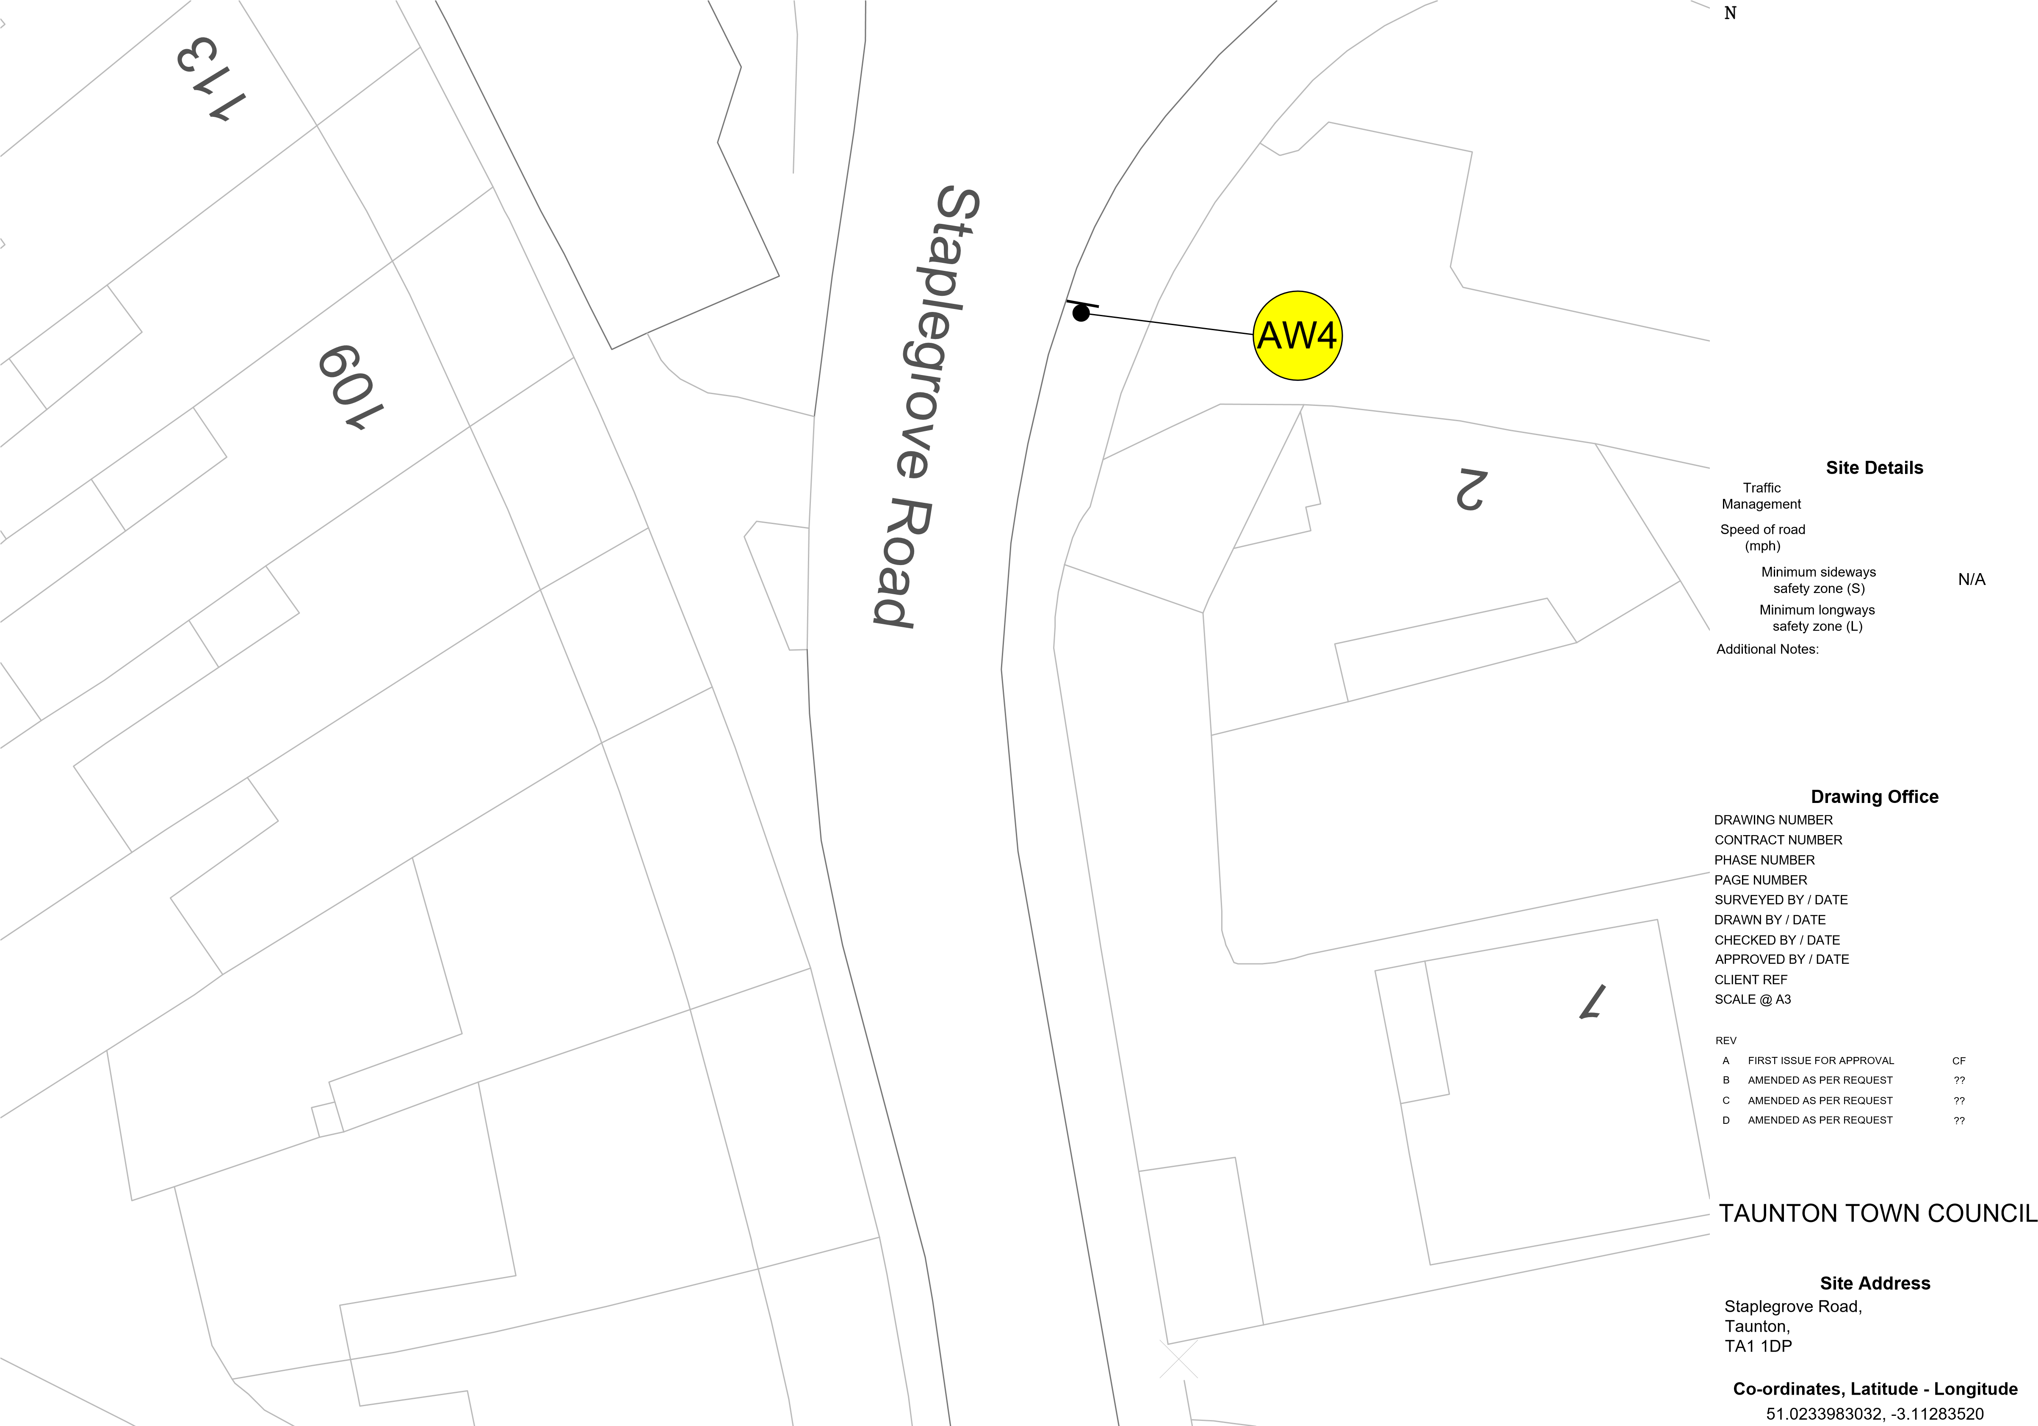
Advance Warning
N/A
CF3988
180141
1 of 1
16 of 20
N/A N/A

CF 30/09/24 CF 30/09/24 CH 30/09/24
N/A
NTS

BY DATE
30/09/24 dd/mm/yy dd/mm/yy dd/mm/yy

Client
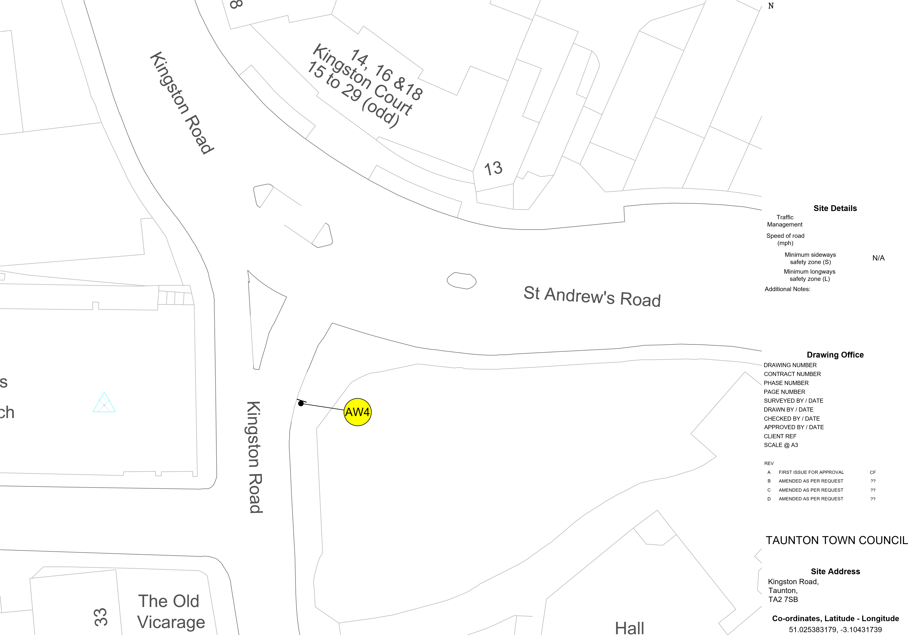
Advance Warning
N/A
CF3989
180141
1 of 1
17 of 20
N/A N/A

CF 30/09/24 CF 30/09/24 CH 30/09/24
N/A
NTS

BY DATE
30/09/24 dd/mm/yy dd/mm/yy dd/mm/yy

Client

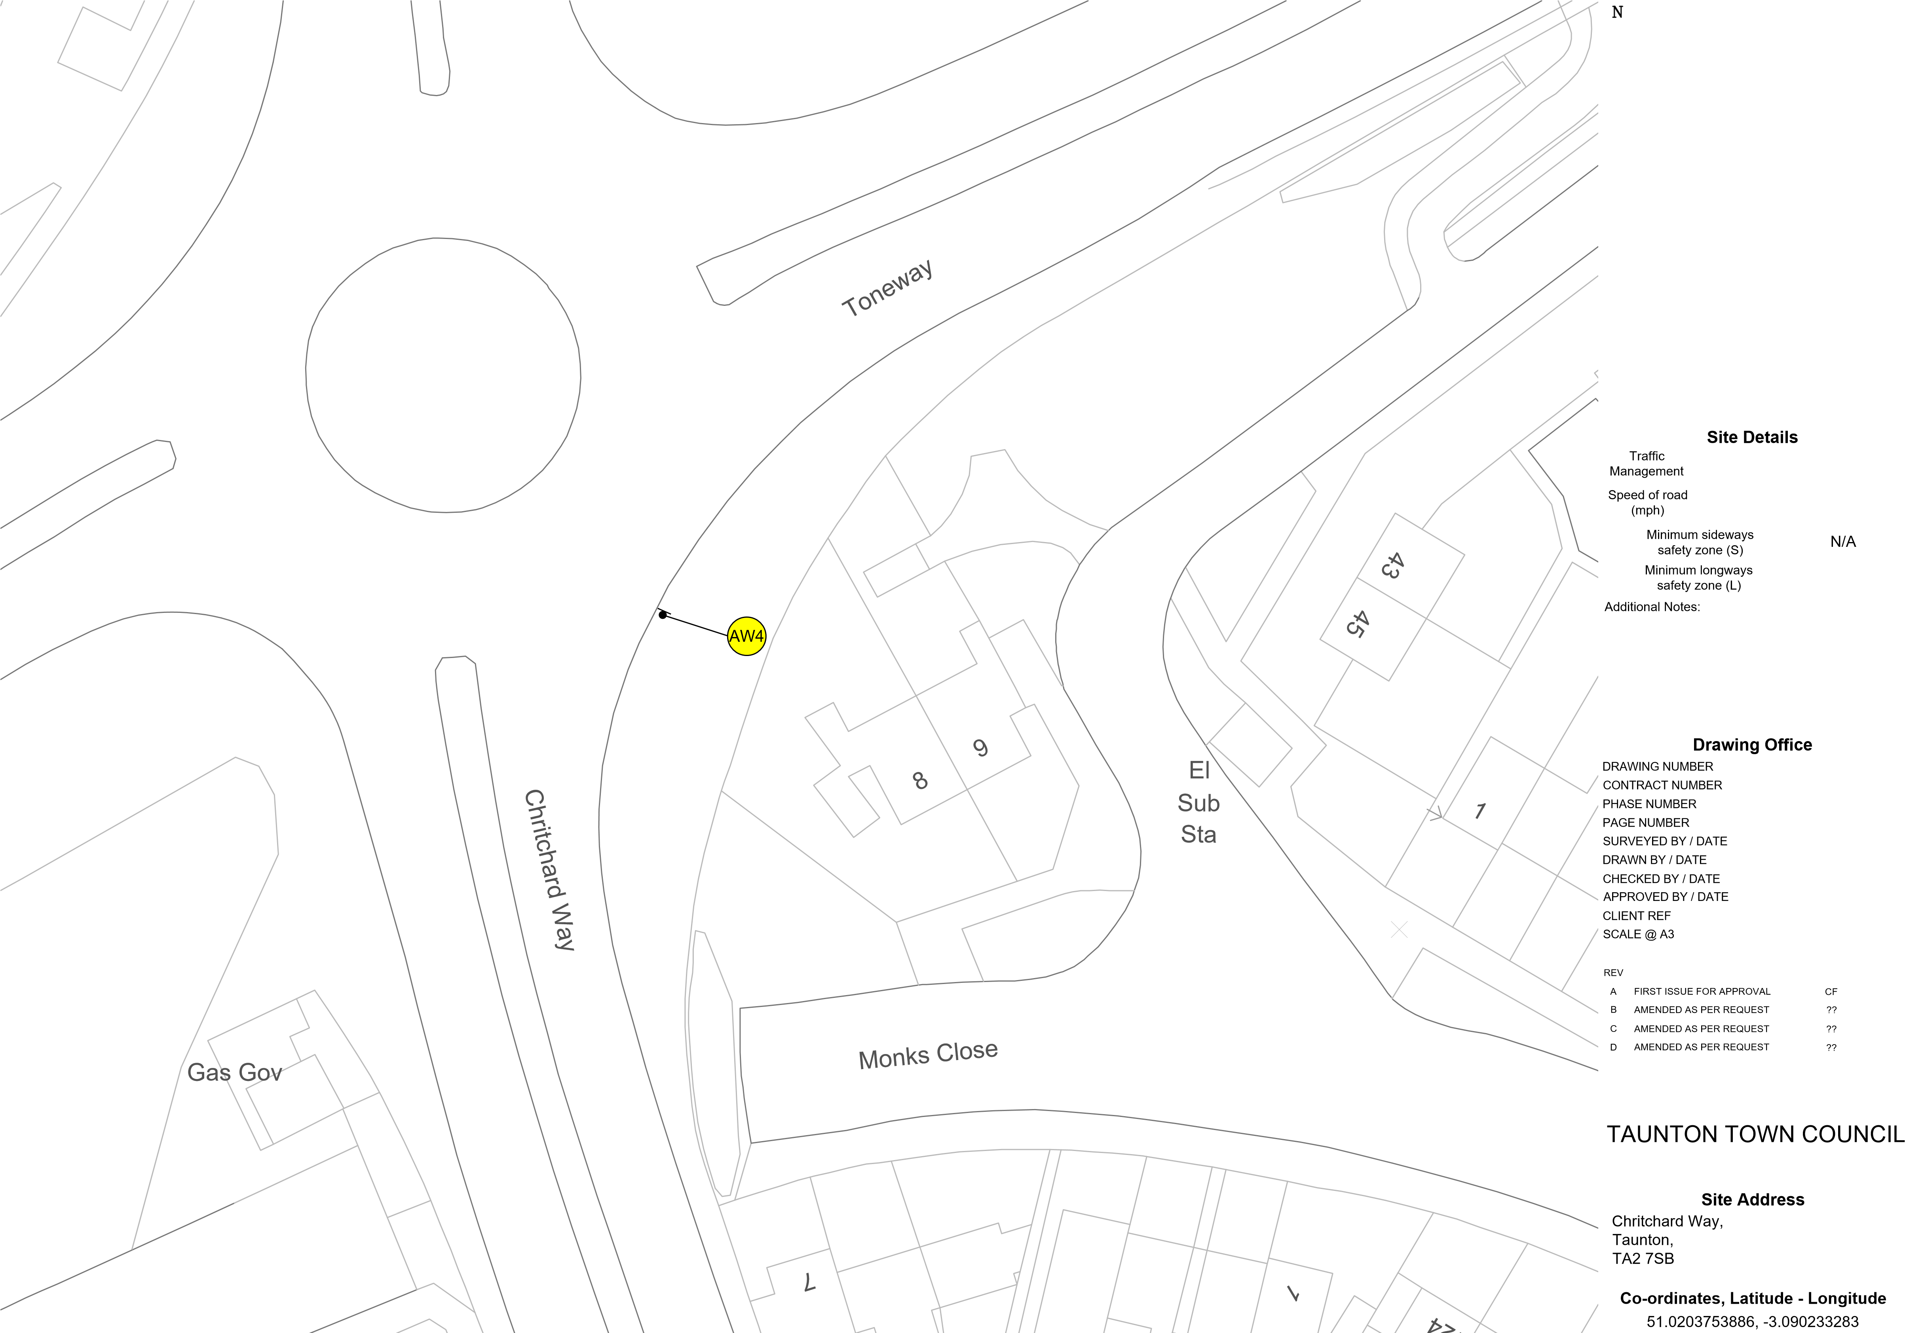
Advance Warning
N/A
CF3990
180141
1 of 1
18 of 20
N/A N/A

CF 30/09/24 CF 30/09/24 CH 30/09/24
N/A
NTS

BY DATE
30/09/24 dd/mm/yy dd/mm/yy dd/mm/yy

Client
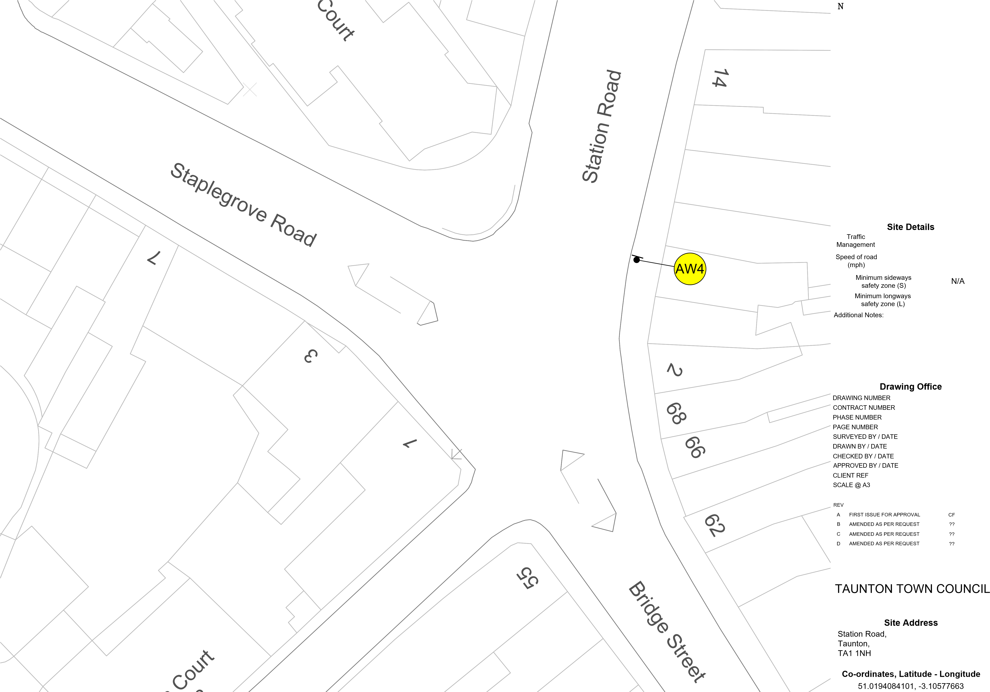
Advance Warning
N/A
CF3991
180141
1 of 1
19 of 20
N/A N/A

CF 30/09/24 CF 30/09/24 CH 30/09/24
N/A
NTS

BY DATE
30/09/24 dd/mm/yy dd/mm/yy dd/mm/yy

Client
Minimum sideways safety zone (S) | N/A
Minimum longways safety zone (L) Additional Notes: | N/A
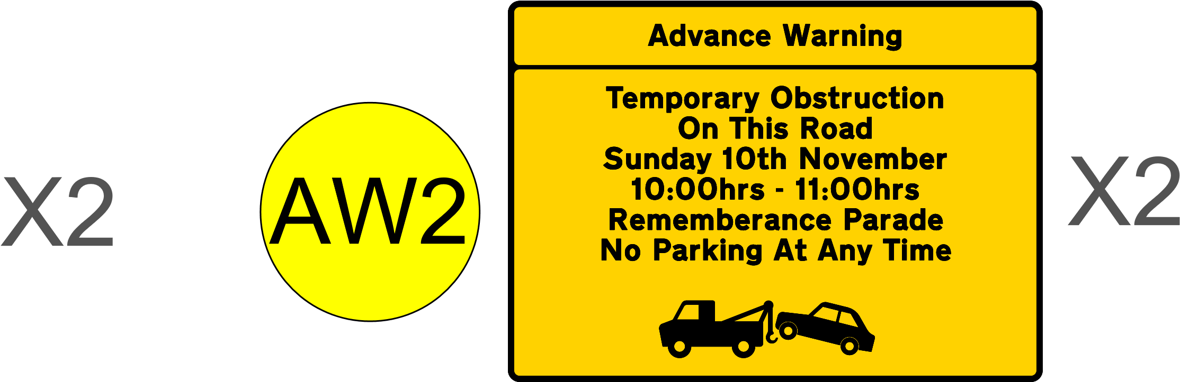
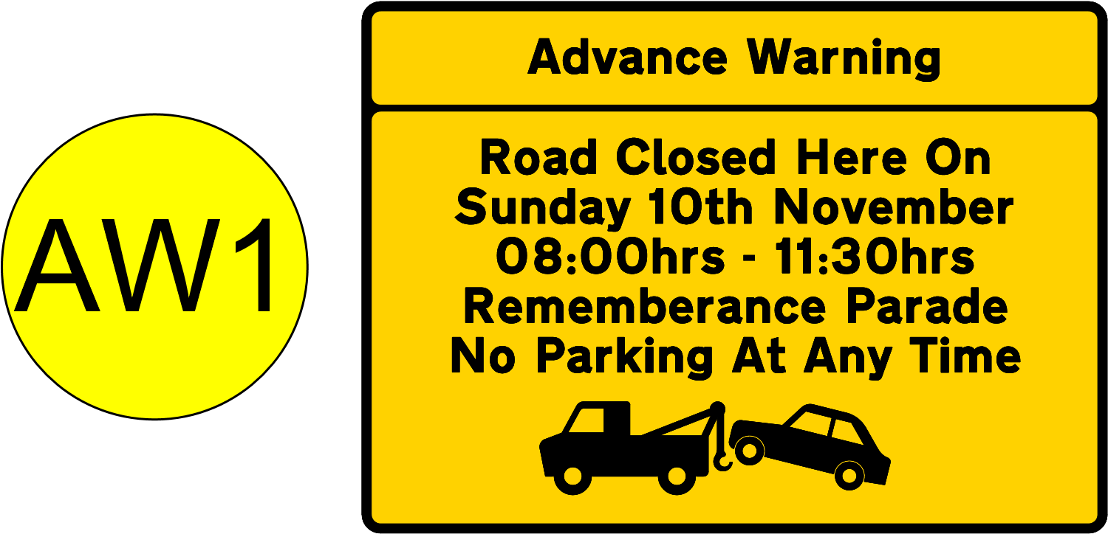
Site Details
Traffic
Management Sign Schedule
Speed of road
(mph)
DRAWING NUMBER  CONTRACT NUMBER  PHASE NUMBER  PAGE NUMBER  SURVEYED BY / DATE  DRAWN BY / DATE  CHECKED BY / DATE  APPROVED BY / DATE  CLIENT REF  SCALE @ A3  REV  A FIRST ISSUE FOR APPROVAL | CF4015  180141  1 of 1  20 of 20
 | N/A  CF  CF  CH | N/A  01/10/24  01/10/24  01/10/24 N/A  NTS  BY DATE  CF 01/10/24
- AMENDED AS PER REQUEST  - AMENDED AS PER REQUEST  - AMENDED AS PER REQUEST |  | ?? dd/mm/yy  ?? dd/mm/yy  ?? dd/mm/yy
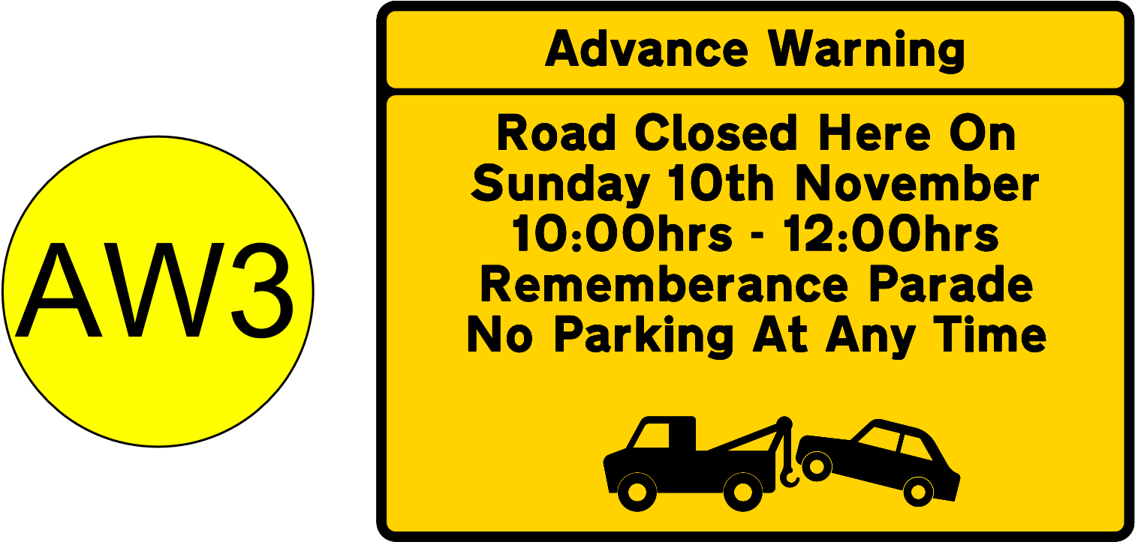  Drawing Office
Client

TAUNTON TOWN COUNCIL
Site Address
Station Road,
Taunton,
TA1 1NH
Co-ordinates, Latitude - Longitude
51.0194084101, -3.1057766

