El Sub Sta

80

77

55

79

81

STAPLEGROVE ROAD

88

86

PH

00

52

44

48

22

46

28

24

58

31,32

35

34

Car Park

49

Belvedere Retail Park

22

88

84

Factory

44 4a

24

11 to 12

(odd)

(odd)

Sloping masonry

DELLER'S WHARF

Wilson Yard

11

66

33

14 to 45

11

44

River Tone

84a

N

Abbey House 11 to 16

66

78

47 to 69

21 to 45

71

Sports Pavilion

54

Laverock Court

11 to 24

14b

14c

16

65

57 59

53

39

33

Sloping masonry

Factory

BLACK

44

36 34

PRIORY BRIDGE ROAD

123

121 119

117

HORSE LANE

14

29

15 23

83e

83d

112

Station Road

El Sub Sta

Health Centre

55 77

10

FRENCH WEIR AVENUE

Northfield Gardens

NORTHFIELD ROAD

Terraces

58

86

46

47

Sloping Masonry

12

39a 41

North Town Mews

100

El Sub Sta

27

22 33

11

44

93

46c

20

77

Kent House

The Coach House

16

17

11

12

29

40 38

41 39

22

aa 48a 48 46

26

Old Flour Loft

22

16

PH

33a

33

ub Sta

33a

33

ub Sta

36

48

52 50 46

42 40 38

Bridge Street

66

62

68

22

11

22

33

35 to 39

55

41

11

44c

Pipes Court

1to8

LANE

Superstore

85

11

22

North Town Community Primary School

51

61

11 to 12

11

39

14 to 66

38

36

16

Oakleigh

Tone Villa

Terraces

11

Terraces

Pegasus Court

Winchester

House

27

Stand

88

Staplegrove Road

Sloping masonry

Terraces

Somerset County Cricket Ground

Priory Barn

88

NORTHTOWN LANE

(Cricket Museum)

11 to 66

48

49a

49

Riverside

PRIORY AVENUE

St Augustine

74

77

Court

77

44

76

11 to 99

77

55

33

Garage

3a

94

77

99

11

Factory

22

23

Cedar Cottages

22

33

86

101

95

14

15

99 11

17

26

25

29

55 66

34

96

77 89

46a

45a

46b

22

Filling St

3b

NORTHFIELD ROAD

27

15

17 23

19

27

51

35

104 108

Drawing Notes

Cone lights spaced minimum 9m, cones to be 750 mm or 1m

All works to be carried out as per safety at streetworks and roadworks "A Code of Practice" October 2013.

CPA conditions apply unless otherwise agreed.

Traffic Management Key

GOODLANDS

Portland Place

66

RIVERSIDE

13

49

NORTHFIELD AVENUE

50

51 50

Glenside

El S

29c29c

22

4

WOOD STREET

TM9 & 10

Hammets Wharf

11 to 44

72

11 to 66

28

27

El Sub Sta

Priory PW

BRIDGE STREET

BRIDGE STREET

9 13 19 21 to 25

Safety Zones

Lodge

31

34

27

34

31

27

1 to 6

UPPER WOOD STREET

11

13

30 to 32

14

Prior's Walk

77 to 12

14 and 15

11 88

33 to 88

11

18

22 20

75

6

El Sub Sta

The Depository

63 57

7 to 12

French Weir Recreation Ground

1

3

ST AUGUSTINE STREET

12 2

76

River Tone

24

Summerfield Court

13

11

1 to 12

10a

A3027 The Bridge

COAL ORCHARD

24

62

51

11

38

Willie Gill Court

44

10

18

67

42

Car Park

Factory

The Wendy House

YARDE PLACE

25

4

8

TM10

20

56

73

11

22

12

13

13 14

63

47

43

4

2

TM9

GYFFARDE STREET

2

69

3

1

Wood Street

26

Brewhouse Theatre and Arts Centre

Car Park

10

16 to 21

22 to 24

65

FRENCH WEIR

TAUNTON

TM1, 2, 3 & 4

Sports Pavilion

14 to 18

Health Centre

7 to 10

St James Close

33

1 to 12

Priory Avenue

TM2

49

3b

The Malthouse

14 to 18

WOOD STREET

8

14 to 15

CRANMER ROAD

WINCHESTER STREET

1 to 23

22

1

53

Thomas More Court

61

6 5 4 3 2 1

25

CLOSE

CLEVELAND STREET

1 to 8

1 7

8

Gyffarde

Court

Milford Place

29a 29b

29a 29b

70

19 21 23

74

Road Signs Road Cones

Pedestrian Barrier

52

PC

61

60

57 59

58

Canon Street

1 to 6

32

St John's

Ambulance HQ

4

23

1

7

19

39

36

PORTLAND STREET

51

POLLARDS WAY

River Tone

St John's Ambulance

HQ

St James Street

St James Church

ESS

13

20

31

Riverside Place

37

17

PRIORY COURT

5

41

27

37

to

7

27

STEPHEN STREET

34

Foundry PH

GREENBROOK TERRACE

4

5

24 23 20 18 12 8 6

22 21 17 15

2

5 4

2 3

SHELDON COURT

Standish

Court

40 to 50

NORTHFIELD COURT

House

14

A3027 The Bridge

Anstey

Cottage

FOUNDRY ROAD

El Sub Sta

1

18

14 11

1

3

4

18

29

14

17

31

16 17

ST JAMES STREET

Garage

20

7 to 15

The Old

Brewery Yard

13

39

42

to

44

24

Middle Street

29

Play Area

Priory Court

1

12

24

El Sub Sta

El Sub Sta

6 4 2

25

18

Middle Street

House

49a

8 to 11

9 4 & 5

Riverain Lodge

6

5

8 9

7

19

to

18 24

24

23

18

18

23

5

2

48 49 50 51

6

16

12 14

37

5 7 9

1

13

13

35

10

25

39

Slipway

41 35 29

18 19 20 22

5 6 7 8 8a

1 2

29 to 36

1 2

Salmon Leaps

Courtyard

LOWER MIDDLE STREET

1 7

CLARENCE STREET

St James Court

28

1 to 74

10

5

52 & 53

16

45

Electricity Distribution Site

Quadrant Court

27

10

11 to 17

19

7

1 to 28

Sloping masonry

15

Sloping masonry

1 to 5

The

8 6 4

13

Raglan Mews

20

STEPHEN WAY

3 1

7

1 to 3

25 to 30 31 to 36

MIDDLE STREET

Canon

Lodge

and 7

The Octagon

21

2

13

7

9

8

4

5

11

8

4c

4a & b

14 15

LABURNUM STREET

12

11

Woodfield House

18

5

1

Laburnum Court

Duke Street

Riverside Chambers

2

abc

abc

Church

20

14

Telephone Exchange

masonry

River Tone

21 27

Sloping

Factory

El Sub Sta

32 33

19 to 26

33

Sunday School

Goodland Gardens

Canon Street

20

The Shed

Place

Slipway

12

Sloping masonry

Sloping masonry

1 13

1

Bank

Bank

MILL LANE

31

abc

9abc to 31abc

Trident Mews

1

22

38

1

11

1

2

1 4

40 to 45

10

El Sub Sta

47

14a

Chapel House

1 to 34

Whirligig Place

Duke Street Duke Street

Somerset House

1 to 2

Congregational

Garden Cottage

Stable

Cottage

North Street

St Mary's Magdalene Vicarage

Whirligig Lane

13 14 15

Car Park

35

37

PC

PH

5

Registry

8

18 to 25

30 to 35

13 14

19

Pentecostal Church

25

27

Harry Broome Annexe

(Probation Service)

5

1 to 12

14 to 34

El Sub Sta

8

12

Traffic Management

Speed of road (mph)

28

35

2a

12

2

28

27

13 17

20

EASTBOURNE TERRACE

Site Details

[Overview](https://www.google.com/maps/%4051.4778151%2C0.3031293%2C62m/data%3D!3m1!1e3?entry=ttu)

34 to 35

17

Tank

4.5m

Gas Gov

El Sub Sta

12 16 to 21

TM11, 12 & 13

TM13

El Sub Sta

Sloping

masonry

TANGIER

Great Hall

Museum

Well

7

1 to 19

Castle

SM

Bank

40 to 44 45 46

El Sub Sta

Car Park

7

Taunton Vineyard Church

8 to 11, 14, 15

Somerset County

The Vicarage

Ina Cottage

War Memorial

WHIRLIGIG LANE

1 2

2a

Magdalene Court

9

11

4

Corfield Hall

1 to 6

15 17 18

Richard Huish

TM4

Bernard Taylor Homes

TM3

3

6

7

Sloping masonry

Magdalene Street

Car Park

1

PH

36

57 to 62

Tancred Street

16 14 12

50

Minimum sideways safety zone (S)

Minimum longways

42

49

EASTBOURNE ROAD

13

N/A

El Sub Sta

Hall

63 to 98

Church

Superstore

38

Hammet Street

TANGIER

37

A3807

5a

TM12

Tangier Way

Tangier Scout and Guide

Centre

Castle Lodge

PC

Castle House

Wyndham

Lecture

Well

Castle Hotel

PO

51 52 53

A3027 North Street

TM6

33

54 55

1

5

St Mary's

The Lodge

TM1

Castle Street

Church Square

50

8

Wrexen House El Sub Sta

3

St Mary Magdalene's

Homes

51

47

Pond

17

24

Eastgate Gardens

28

25

46

43

20

21

The Gatehouse

14 to 24

1 to 6

2 to 12

Tanks

2

1 to 11

15 to 25

Eastbourne Court

56

Maple Court

1 to 6

1 7

2

6 7 and 8

1

4.4m

27 to 37

safety zone (L) N/A

Additional Notes:

TM14, 15 & 16

El Sub Sta

9

42

Car Park

30

32

30 31

56

St Johns House

14

15

Car Park

1 to 7

Winchester Arms (PH)

TM5, 6, 7 & 8

PH

2

28

29

CASTLE GREEN

Bank

3

32

2 to 3

Hammet Street

12

Post House

31

Masons Court

18

11a

10

9 11

12a 12b 13

TM25 & 26

Aroma House

Court

Victoria Mews

29

1 to 8

Tanners

28 26

A3807

House

18

Magdalene Street

17

20

Millstream House

142

9 140

EAST REACH

8

3a 4 5 5a 6 6a 7

PC TM8

1 to 4

Chartfield House

Tower Street

143

143a

143b

26b

26 26a 27 27a

Tower Street

3

1 2

5

TM5

2 2a 3

1 to 5

33

16 17 18

144a

to

144d

144

145 to 147

1

32 to 33

36 to 38

41

East Street

42 1

El Sub Sta

TM15

7 9 11 1

12

144e

9

1

PH

The

Car Park

37 to 38

148 149 150

151

Garage

1 to 49

46

40 to 44

2 4

4

57 58

Inkerman Court

A3807 Castle Street

El

(PW) 2

TOWER

3

1 to 3

54

52

53

48

49 50

14 15

Hall

1 2

LANE

TM11a

Tower Street

55 56

Stream

19

Michael Paul House

(Government Offices)

Corporation Street

Club

TM13a

152

Garage

22 to 23 25 to 30

1

Old Muniicpal Buildings

PH

Castle Way

El Sub Sta

Corporation Street

Shelter

10

4 2

Shelter

25

Corporation Street

Market House

Shelter

TM26a

Magdalene Lane El Sub Sta

156

153

157 160

46 to 47

43 to 45

158

PH

159

PH

1 3

5 7

Drawing Office

45

TM14

8

2

Wellington Road

1

68 69

5

TM15

A3027 Fore Street

Galmington

9

EAST STREET

8

1

El Sub Sta

6

8 to 10

COUNTY WALK

10

61

3

Beech Court

Paul House

28

6 5 4

Castlemoat Place

Tourist

to

13 14

PH Information

21

Centre

33

6

12 13 14 15 17

18

19

Corporation Street

2 to 4

TM7

Bank

64a

10

7

3 2 1 1 & 2

6

7

TM26b

47 to 50

9

13 15 to 17

59

1

Sub Sta

DRAWING NUMBER

4

62 to 64

12

50

27

7

CF3956

TM16

Wellington Road

5

3

28

Stream

74

Galmington

29

St John's

Church

Bath House Court

Taunton Magistrates Court

7

Gaol Stream

Bath House

14

1

1 to 3

8

Parkhaven

House

1

3

Hotel

4

2

TM17

54 to 56

57 58 59

Broadcasting House

12

2

Apsley House

Mitre House

22

TM11b

The Crescent

Silver Street

ST JOHN'S ROAD

Friends'

MANOR ROAD

24

1 to 12 and 14 to 53

Unison House

17 19 19a

The Coach House

1

16

El Sub Sta

33

25 27 29

9

24

23

PH

1

1a

Jarman Court

2 to 4 6 8

1

b

11 12

12a

Orchard Shopping Centre

BILLET STREET

1

23

16

26

Hurdle Way

Park Street

5 to 8

Crown Walk

County Hotel

12

13a

El Sub Sta

1 to 10

El Sub Sta

24

El Sub Sta

7

15

13

El Sub Sta

5

Multistorey Car Park

Meeting House

13

Filling Station

4m

Taunton Baptist Church

60 63

TM26c

7

1

El Sub Sta

20

15

14

66

20

21

Bedford

CONTRACT NUMBER PHASE NUMBER PAGE NUMBER SURVEYED BY / DATE DRAWN BY / DATE

CHECKED BY / DATE

Holy Trinity C of E

(VA) Primary School

38

33

28 26

19

13

68

62

56

ALMA STREET

Mansfield Road

180141

1 of 1

1 of 33

N/A N/A

CF 30/09/24

CF 30/09/24

TM19

6

1

5

2

6

Park Street

Health Centre

9 to 14

80

Multistorey Car Park

Library

Wessex House

1 to 14

11 13

APPROVED BY / DATE

CH 30/09/24

Depot

1

45

1

1

6

10

14

1

30

8

11 13

Car Park

25

El Sub Sta

15 16

7

13

53

TM25

Billet Street

18

HIGH STREET

37

Taunton

United Reformed

Church

ESSs

Day Nursery

El Sub Sta

CLIENT REF

N/A

El Sub Sta

COMPASS HILL

4

11

12

12

11

14

7

Dovetail Court

11

PARKFIELD ROAD

Crescent Way

TM18a

10 to 14

Shire Hall Taunton Crown

County Hall

Cann Street

17

TM19c

12 to 14 15

1 to 4

Ladysmith House

1 to 12

El Sub Sta

Paul Street

14 (Hotel)

9

Harveys Court

TM20, 21, 22, 23 & 24

PH

1 to 89 Quantock House

21 22

High Street

48a

45

46 47

44

45a

Sinks

Chapel

House

St George's

Catholic Church

6a 5 to 10

14

1

15

Memorial

Hall

Church View

SCALE @ A3 NTS

5

1 to 9

Alma Court

1

44

Cedar Gardens

13

1

8

The Point

23

15 to 23

1 to 8

1 to 9

Billetfield

and County Courts

Pond

Cann Street

ESS

5

20

4

Guildford Place

TM20

14 to 76

1

38 39 40 41

PC

Mendip House

6

Multistorey Car Park

TM23

Taunton

Adventist Church

18

19

Cresent House

5

37

TM24

Hughenden House

The Mount

Compass

8

4

9 to 12

Mary Street

Nunsfield Court

House

Rectory

Garage

Coach House

3

57

50

1

REV

A

B AMENDED AS PER REQUEST ?? dd/mm/yy

C AMENDED AS PER REQUEST ?? dd/mm/yy

D AMENDED AS PER REQUEST ?? dd/mm/yy

9

BY DATE

FIRST ISSUE FOR APPROVAL CF 30/09/24

TM17 & 18

16 to 27

WAY

OSBORNE

2

4

OSBORNE RISE

15

19

14 15

1

11

27

COMPASS RISE

1

3

Chapel

Masonic Hall

Terrace

54

32 a 34

14

3

7 to 15 2

ST GEORGE'S

PLACE

M

1

1

1a

Mary Street House

21 22

40

31b

31

1

ST JOSEPHS FIELD

Unitarian

56

57

TM21

1

3 4

Mount Street

1

4 to 12

27 28 29

Vivary

House

50

15

14

Club

British Legion Club

8a

17

Morgan Close

1

3

1 to 6

The Old School House

Phoenix Court

The Royal

20

1

7

2

3

2

1

50

33 33

5

Street

Mary Street

(Government Offices)

Mount House 1 to 5

MOUNTWAY

2

3

Church Hall

6

3

St George's

El Sub Sta

Client

21

15

2 to 8

1

26

8

TAUNTFIELD CLOSE

Old School

Mary

Brendon House

The Brow

4

TM19a

18 20

24

38

Temple Methodist Church

7

1

The Crescent

42 43

Hall

1

10

1 to 12

El Sub Sta

PW

Forde House

21

14

WESTGATE STREET

9 11

13 14

16

22a

23

29

28 30

1 2

Kingdom Hall

of Jehovahs

Witnesses

TM19b El Sub Sta

8

18

Vivary Gate

23

6

Upper High Street

War Memorial

9

8

The Store House

11

St George's Catholic School

(primary)

OSBORNE GROVE

St Georges Mews

6

9

4

25

4

ST GEORGES SQUARE

Annecy Court

Stockwell Stream

2

###### TAUNTON TOWN COUNCIL

Portland Grange

12

5

SOUTH ROAD

11

12

22

24 24a 24b

BURTON PLACE

13 22 to 24

to

15 16 to 21

Shuttern House

5

8

WILTON GROVE

14

15

41

24

2

The Cottage

Jellalabad Court

Shuttern Cottage

4

6

2

Gaol Stream

1 to 16

9

TRULL ROAD

CLOSE

The Keep

43 44

42 45

MOUNTWAY

1 to 3 4 to 9 10 to 12

23

47

The Courtyard

25

21

MANOR DRIVE

65

13

58

8

Mount Terrace

Little Shuttern

11

8

19

49

53

1 to 9

22a

1

56

10

Turkey Court

46

Wilton House

BRUFORD CLOSE

12

65a

48

66

Weir

13

10

22

54

55

57

8

14

Shelter

Sherford Stream

29

19b

2a

Pond

19

53

20

20a

2

40

3 4

Harding House

46

23

22b

10

Jellalabad House

1

7

1

52

WILTON

Play Area

9

18

19a

62

33

12

34

1

**Site Address** Taunton Rembrance Parade, Taunton,

TA1 1SA

47

67

19

6

El Sub Sta

4

14 10

Weir

Mount Street

34

63

39

ORCHARD RISE

MANOR CLOSE

1

11

20

16

51

41

Taunton Bowling Club

5 7

11

24

17

18a

30

TM22

VIVARY ROAD

18

1

Rosemount

**Co-ordinates, Latitude - Longitude**

51.015406878, -3.10170933

Ellisfields Court

1 To 58

44

7

24

2

KINGS SQUARE

Vivary

Court

1 to 8

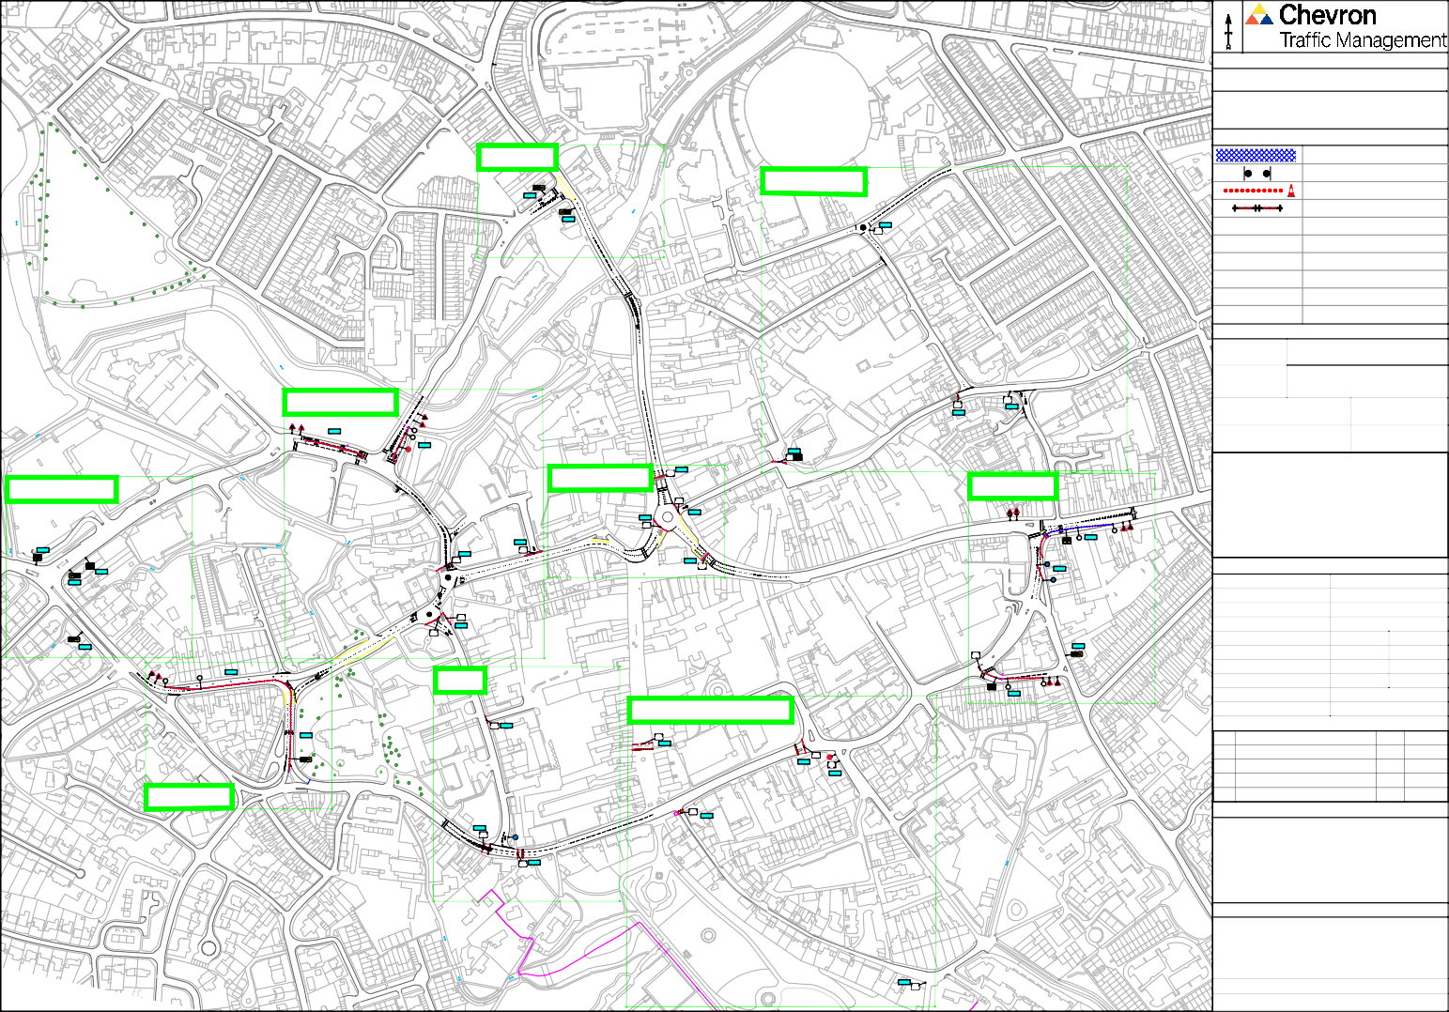Bandstand El Sub Sta

30

|  |  |  |  |  |  |  |  |  |  |  |
| --- | --- | --- | --- | --- | --- | --- | --- | --- | --- | --- |
| TM1 | N | |  | | | | | | | |
| **Drawing Notes** | | | | | | | | | |
| Cone lights spaced minimum 9m, cones to be 750 mm or 1m | | | | | | | | | |
| All works to be carried out as per safety at streetworks and roadworks "A Code of Practice" October 2013.  CPA conditions apply unless otherwise agreed. | | | | | | | | | |
| **Traffic Management Key** | | | | | | | | | |
|  | | | | Road Signs | | | | | |
|  | | | | Road Cones | | | | | |
|  | | | | No Waiting Cones | | | | | |
|  | | | |  | | | | | |
|  | | | |  | | | | | |
|  | | | |  | | | | | |
|  | | | |  | | | | | |
|  | | | |  | | | | | |
|  | | | |  | | | | | |
|  | | | |  | | | | | |
| **Site Details** | | | | | | | | | |
| Traffic Management | | | [TM1](https://www.google.com/maps/%4051.4778151%2C0.3031293%2C62m/data%3D!3m1!1e3?entry=ttu) | | | | | | |
| Speed of road (mph) | | |  | | | | | | |
| Minimum sideways safety zone (S) | | | | | | N/A | | | |
| Minimum longways safety zone (L) | | | | | | N/A | | | |
| Additional Notes: | | | | | | | | | |
| **Drawing Office** | | | | | | | | | |
| DRAWING NUMBER | | | | | CF3957 | | | | |
| CONTRACT NUMBER | | | | | 180141 | | | | |
| PHASE NUMBER | | | | | 1 of 1 | | | | |
| PAGE NUMBER | | | | | 2 of 33 | | | | |
| SURVEYED BY / DATE | | | | | N/A | | | N/A | |
| DRAWN BY / DATE | | | | | CF | | | 30/09/24 | |
| CHECKED BY / DATE | | | | | CF | | | 30/09/24 | |
| APPROVED BY / DATE | | | | | CH | | | 30/09/24 | |
| CLIENT REF | | | | | N/A | | | | |
| SCALE @ A3 | | | | | NTS | | | | |
|  | | | | | | | | | |
| REV |  | | | | | | BY | | DATE |
| A | FIRST ISSUE FOR APPROVAL | | | | | | CF | | 30/09/24 |
|  |  | | | | | |  | |  |
|  |  | | | | | |  | |  |
|  |  | | | | | |  | |  |
| **Client** | | | | | | | | | |
| TAUNTON TOWN COUNCIL | | | | | | | | | |
| **Site Address** | | | | | | | | | |
| Church Square, Taunton,  TA1 1SA | | | | | | | | | |
| **Co-ordinates, Latitude - Longitude** | | | | | | | | | |
| [51.015573598, -3.101272660](https://www.google.com/maps/%4051.0155558%2C-3.1012676%2C43m/data%3D!3m1!1e3?entry=ttu&g_ep=EgoyMDI0MDkyMy4wIKXMDSoASAFQAw%3D%3D) | | | | | | | | | |

B AMENDED AS PER REQUEST ?? dd/mm/yy

C AMENDED AS PER REQUEST ?? dd/mm/yy

D AMENDED AS PER REQUEST ?? dd/mm/yy

Church Square

9

8

1

2

Hammet Street

St Mary Magdalene's

Church

Magdalene Street

|  |  |  |  |  |  |  |  |  |  |  |
| --- | --- | --- | --- | --- | --- | --- | --- | --- | --- | --- |
| 1 to 12  TM2 | N | |  | | | | | | | |
| **Drawing Notes** | | | | | | | | | |
| Cone lights spaced minimum 9m, cones to be 750 mm or 1m | | | | | | | | | |
| All works to be carried out as per safety at streetworks and roadworks "A Code of Practice" October 2013.  CPA conditions apply unless otherwise agreed. | | | | | | | | | |
| **Traffic Management Key** | | | | | | | | | |
|  | | | | Road Signs | | | | | |
|  | | | | Road Cones | | | | | |
|  | | | |  | | | | | |
|  | | | |  | | | | | |
|  | | | |  | | | | | |
|  | | | |  | | | | | |
|  | | | |  | | | | | |
|  | | | |  | | | | | |
|  | | | |  | | | | | |
|  | | | |  | | | | | |
| **Site Details** | | | | | | | | | |
| Traffic Management | | | [TM2](https://www.google.com/maps/%4051.4778151%2C0.3031293%2C62m/data%3D!3m1!1e3?entry=ttu) | | | | | | |
| Speed of road (mph) | | |  | | | | | | |
| Minimum sideways safety zone (S) | | | | | | N/A | | | |
| Minimum longways safety zone (L) | | | | | | N/A | | | |
| Additional Notes: | | | | | | | | | |
| **Drawing Office** | | | | | | | | | |
| DRAWING NUMBER | | | | | CF3958 | | | | |
| CONTRACT NUMBER | | | | | 180141 | | | | |
| PHASE NUMBER | | | | | 1 of 1 | | | | |
| PAGE NUMBER | | | | | 3 of 33 | | | | |
| SURVEYED BY / DATE | | | | | N/A | | | N/A | |
| DRAWN BY / DATE | | | | | CF | | | 30/09/24 | |
| CHECKED BY / DATE | | | | | CF | | | 30/09/24 | |
| APPROVED BY / DATE | | | | | CH | | | 30/09/24 | |
| CLIENT REF | | | | | N/A | | | | |
| SCALE @ A3 | | | | | NTS | | | | |
|  | | | | | | | | | |
| REV |  | | | | | | BY | | DATE |
| A | FIRST ISSUE FOR APPROVAL | | | | | | CF | | 30/09/24 |
|  |  | | | | | |  | |  |
|  |  | | | | | |  | |  |
|  |  | | | | | |  | |  |
| **Client** | | | | | | | | | |
| TAUNTON TOWN COUNCIL | | | | | | | | | |
| **Site Address** | | | | | | | | | |
| Canon Street, Taunton,  TA1 1RU | | | | | | | | | |
| **Co-ordinates, Latitude - Longitude** | | | | | | | | | |
| 51.0177442080, -3.099934678 | | | | | | | | | |

B AMENDED AS PER REQUEST ?? dd/mm/yy

C AMENDED AS PER REQUEST ?? dd/mm/yy

D AMENDED AS PER REQUEST ?? dd/mm/yy

Canon Street

17

5

4

2

3

1

37

Priory Avenue

The Malthous

St James Street

26

24

|  |  |  |  |  |  |  |  |  |  |  |  |
| --- | --- | --- | --- | --- | --- | --- | --- | --- | --- | --- | --- |
|  | Car Par  TM3 | N | |  | | | | | | | |
| **Drawing Notes** | | | | | | | | | |
| Cone lights spaced minimum 9m, cones to be 750 mm or 1m | | | | | | | | | |
| All works to be carried out as per safety at streetworks and roadworks "A Code of Practice" October 2013.  CPA conditions apply unless otherwise agreed. | | | | | | | | | |
| **Traffic Management Key** | | | | | | | | | |
|  | | | | Road Signs | | | | | |
|  | | | | Road Cones | | | | | |
|  | | | |  | | | | | |
|  | | | |  | | | | | |
|  | | | |  | | | | | |
|  | | | |  | | | | | |
|  | | | |  | | | | | |
|  | | | |  | | | | | |
|  | | | |  | | | | | |
|  | | | |  | | | | | |
|  |
| **Site Details** | | | | | | | | | |
| Traffic Management | | | [TM3](https://www.google.com/maps/%4051.4778151%2C0.3031293%2C62m/data%3D!3m1!1e3?entry=ttu) | | | | | | |
| Speed of road (mph) | | |  | | | | | | |
| Minimum sideways safety zone (S) | | | | | | N/A | | | |
| Minimum longways safety zone (L) | | | | | | N/A | | | |
| Additional Notes: | | | | | | | | | |
| **Drawing Office** | | | | | | | | | |
| DRAWING NUMBER | | | | | CF3959 | | | | |
| CONTRACT NUMBER | | | | | 180141 | | | | |
| PHASE NUMBER | | | | | 1 of 1 | | | | |
| PAGE NUMBER | | | | | 4 of 33 | | | | |
| SURVEYED BY / DATE | | | | | N/A | | | N/A | |
| DRAWN BY / DATE | | | | | CF | | | 30/09/24 | |
| CHECKED BY / DATE | | | | | CF | | | 30/09/24 | |
| APPROVED BY / DATE | | | | | CH | | | 30/09/24 | |
| CLIENT REF | | | | | N/A | | | | |
| SCALE @ A3 | | | | | NTS | | | | |
|  | | | | | | | | | |
| REV |  | | | | | | BY | | DATE |
| A | FIRST ISSUE FOR APPROVAL | | | | | | CF | | 30/09/24 |
|  |  | | | | | |  | |  |
|  |  | | | | | |  | |  |
|  |  | | | | | |  | |  |
| **Client** | | | | | | | | | |
| TAUNTON TOWN COUNCIL | | | | | | | | | |
| **Site Address** | | | | | | | | | |
| Duke Street, Taunton, TA1 1LE | | | | | | | | | |
| **Co-ordinates, Latitude - Longitude** | | | | | | | | | |
| [51.01623853175, -3.097657751](https://www.google.com/maps/%4051.01624%2C-3.0977826%2C61m/data%3D!3m1!1e3?entry=ttu&g_ep=EgoyMDI0MDkyMy4wIKXMDSoASAFQAw%3D%3D) | | | | | | | | | |

B AMENDED AS PER REQUEST ?? dd/mm/yy

C AMENDED AS PER REQUEST ?? dd/mm/yy

D AMENDED AS PER REQUEST ?? dd/mm/yy

1

3

11

9

4

6

7

57 to

Tancred Street

aburnum Court

Duke Street

Duke Street

e Street

|  |  |  |  |  |  |  |  |  |  |  |  |
| --- | --- | --- | --- | --- | --- | --- | --- | --- | --- | --- | --- |
| TM4 |  | N | |  | | | | | | | |
| **Drawing Notes** | | | | | | | | | |
| Cone lights spaced minimum 9m, cones to be 750 mm or 1m | | | | | | | | | |
| All works to be carried out as per safety at streetworks and roadworks "A Code of Practice" October 2013.  CPA conditions apply unless otherwise agreed. | | | | | | | | | |
| **Traffic Management Key** | | | | | | | | | |
|  | | | | Road Signs | | | | | |
|  | | | | Road Cones | | | | | |
|  | | | | No Waiting Cones | | | | | |
|  | | | |  | | | | | |
|  | | | |  | | | | | |
|  | | | |  | | | | | |
|  | | | |  | | | | | |
|  | | | |  | | | | | |
|  | | | |  | | | | | |
|  | | | |  | | | | | |
| **Site Details** | | | | | | | | | |
| Traffic Management | | | [TM4](https://www.google.com/maps/%4051.4778151%2C0.3031293%2C62m/data%3D!3m1!1e3?entry=ttu) | | | | | | |
| Speed of road (mph) | | |  | | | | | | |
| Minimum sideways safety zone (S) | | | | | | N/A | | | |
| Minimum longways safety zone (L) | | | | | | N/A | | | |
| Additional Notes: | | | | | | | | | |
| **Drawing Office** | | | | | | | | | |
| DRAWING NUMBER | | | | | CF3960 | | | | |
| CONTRACT NUMBER | | | | | 180141 | | | | |
| PHASE NUMBER | | | | | 1 of 1 | | | | |
|  |
| PAGE NUMBER | | | | | 5 of 33 | | | | |
| SURVEYED BY / DATE | | | | | N/A | | | N/A | |
| DRAWN BY / DATE | | | | | CF | | | 30/09/24 | |
| CHECKED BY / DATE | | | | | CF | | | 30/09/24 | |
| APPROVED BY / DATE | | | | | CH | | | 30/09/24 | |
| CLIENT REF | | | | | N/A | | | | |
| SCALE @ A3 | | | | | NTS | | | | |
|  | | | | | | | | | |
| REV |  | | | | | | BY | | DATE |
| A | FIRST ISSUE FOR APPROVAL | | | | | | CF | | 30/09/24 |
|  |  | | | | | |  | |  |
|  |  | | | | | |  | |  |
|  |  | | | | | |  | |  |
| **Client** | | | | | | | | | |
| TAUNTON TOWN COUNCIL | | | | | | | | | |
| **Site Address** | | | | | | | | | |
| Magdalene Street, Taunton,  TA1 1SN | | | | | | | | | |
| **Co-ordinates, Latitude - Longitude** | | | | | | | | | |
| 51.01617570698, -3.0984855822 | | | | | | | | | |

B AMENDED AS PER REQUEST ?? dd/mm/yy

C AMENDED AS PER REQUEST ?? dd/mm/yy

D AMENDED AS PER REQUEST ?? dd/mm/yy

1

11

Canon Street

5

1

1 to 12

14 to 34

Laburnum Court

18

15

17

Magdalene Street

1 to 19

Homes

Duke Street

|  |  |  |  |  |  |  |  |  |  |  |
| --- | --- | --- | --- | --- | --- | --- | --- | --- | --- | --- |
| Bank  TM5  Shelter | N | |  | | | | | | | |
| **Drawing Notes** | | | | | | | | | |
| Cone lights spaced minimum 9m, cones to be 750 mm or 1m | | | | | | | | | |
| All works to be carried out as per safety at streetworks and roadworks "A Code of Practice" October 2013.  CPA conditions apply unless otherwise agreed. | | | | | | | | | |
| **Traffic Management Key** | | | | | | | | | |
|  | | | | Road Signs | | | | | |
|  | | | | Road Cones | | | | | |
|  | | | | No Waiting Cones | | | | | |
|  | | | |  | | | | | |
|  | | | |  | | | | | |
|  | | | |  | | | | | |
|  | | | |  | | | | | |
|  | | | |  | | | | | |
|  | | | |  | | | | | |
|  | | | |  | | | | | |
| **Site Details** | | | | | | | | | |
| Traffic Management | | | [TM5](https://www.google.com/maps/%4051.4778151%2C0.3031293%2C62m/data%3D!3m1!1e3?entry=ttu) | | | | | | |
| Speed of road (mph) | | |  | | | | | | |
| Minimum sideways safety zone (S) | | | | | | N/A | | | |
| Minimum longways safety zone (L) | | | | | | N/A | | | |
| Additional Notes: | | | | | | | | | |
| **Drawing Office** | | | | | | | | | |
| DRAWING NUMBER | | | | | CF3961 | | | | |
| CONTRACT NUMBER | | | | | 180141 | | | | |
| PHASE NUMBER | | | | | 1 of 1 | | | | |
| PAGE NUMBER | | | | | 6 of 33 | | | | |
| SURVEYED BY / DATE | | | | | N/A | | | N/A | |
| DRAWN BY / DATE | | | | | CF | | | 30/09/24 | |
| CHECKED BY / DATE | | | | | CF | | | 30/09/24 | |
| APPROVED BY / DATE | | | | | CH | | | 30/09/24 | |
| CLIENT REF | | | | | N/A | | | | |
| SCALE @ A3 | | | | | NTS | | | | |
|  | | | | | | | | | |
| REV |  | | | | | | BY | | DATE |
| A | FIRST ISSUE FOR APPROVAL | | | | | | CF | | 30/09/24 |
|  |  | | | | | |  | |  |
|  |  | | | | | |  | |  |
|  |  | | | | | |  | |  |
| **Client** | | | | | | | | | |
| TAUNTON TOWN COUNCIL | | | | | | | | | |
| **Site Address** | | | | | | | | | |
| Hammet Street, Taunton,  TA1 1HP | | | | | | | | | |
| **Co-ordinates, Latitude - Longitude** | | | | | | | | | |
| 51.0150165924, -3.102789380 | | | | | | | | | |

B AMENDED AS PER REQUEST ?? dd/mm/yy

C AMENDED AS PER REQUEST ?? dd/mm/yy

D AMENDED AS PER REQUEST ?? dd/mm/yy

30

31

33

32

16

17

18

2 to 3

Hammet Street

|  |  |  |  |  |  |  |  |  |  |  |  |
| --- | --- | --- | --- | --- | --- | --- | --- | --- | --- | --- | --- |
|  | PO    TM6 | N | |  | | | | | | | |
| **Drawing Notes** | | | | | | | | | |
| Cone lights spaced minimum 9m, cones to be 750 mm or 1m | | | | | | | | | |
| All works to be carried out as per safety at streetworks and roadworks "A Code of Practice" October 2013.  CPA conditions apply unless otherwise agreed. | | | | | | | | | |
| **Traffic Management Key** | | | | | | | | | |
|  | | | | Road Signs | | | | | |
|  | | | | Road Cones | | | | | |
|  | | | |  | | | | | |
|  | | | |  | | | | | |
|  | | | |  | | | | | |
|  | | | |  | | | | | |
|  | | | |  | | | | | |
|  | | | |  | | | | | |
|  | | | |  | | | | | |
|  | | | |  | | | | | |
| **Site Details** | | | | | | | | | |
| Traffic Management | | | [TM6](https://www.google.com/maps/%4051.4778151%2C0.3031293%2C62m/data%3D!3m1!1e3?entry=ttu) | | | | | | |
| Speed of road (mph) | | |  | | | | | | |
| Minimum sideways safety zone (S) | | | | | | N/A | | | |
| Minimum longways safety zone (L) | | | | | | N/A | | | |
| Additional Notes: | | | | | | | | | |
| Bank | |
| **Drawing Office** | | | | | | | | | |
| DRAWING NUMBER | | | | | CF3962 | | | | |
| CONTRACT NUMBER | | | | | 180141 | | | | |
| PHASE NUMBER | | | | | 1 of 1 | | | | |
| PAGE NUMBER | | | | | 7 of 33 | | | | |
| SURVEYED BY / DATE | | | | | N/A | | | N/A | |
| DRAWN BY / DATE | | | | | CF | | | 30/09/24 | |
| CHECKED BY / DATE | | | | | CF | | | 30/09/24 | |
| APPROVED BY / DATE | | | | | CH | | | 30/09/24 | |
| CLIENT REF | | | | | N/A | | | | |
| SCALE @ A3 | | | | | NTS | | | | |
|  | | | | | | | | | |
| REV |  | | | | | | BY | | DATE |
| A | FIRST ISSUE FOR APPROVAL | | | | | | CF | | 30/09/24 |
|  |  | | | | | |  | |  |
|  |  | | | | | |  | |  |
|  |  | | | | | |  | |  |
| **Client** | | | | | | | | | |
| TAUNTON TOWN COUNCIL | | | | | | | | | |
| **Site Address** | | | | | | | | | |
| North Street, Taunton, TA1 1LH | | | | | | | | | |
| **Co-ordinates, Latitude - Longitude** | | | | | | | | | |
| 51.015360311, -3.103103243 | | | | | | | | | |

B AMENDED AS PER REQUEST ?? dd/mm/yy

C AMENDED AS PER REQUEST ?? dd/mm/yy

D AMENDED AS PER REQUEST ?? dd/mm/yy

30

31

56

54

55

51

52

53

A3027 North Street

0

N

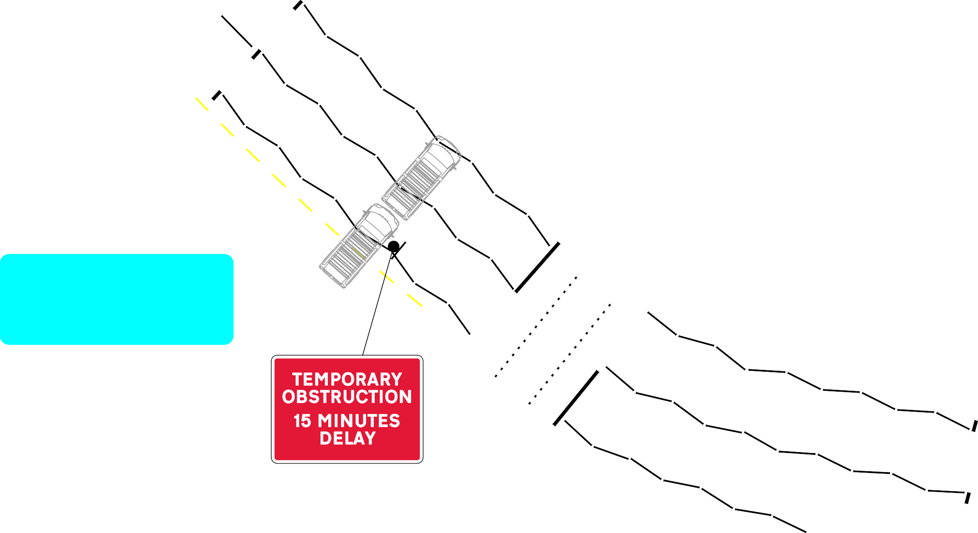

Drawing Notes

Cone lights spaced minimum 9m, cones to be 750 mm or 1m

37 to 38

All works to be carried out as per safety at streetworks and roadworks "A Code of Practice" October 2013.

CPA conditions apply unless otherwise agreed.

Traffic Management Key

Road Signs Road Cones

Traffic Management

Speed of road (mph)

40 to 44

se

Site Details

[TM7](https://www.google.com/maps/%4051.4778151%2C0.3031293%2C62m/data%3D!3m1!1e3?entry=ttu)

TM7

Minimum sideways safety zone (S)

Minimum longways safety zone (L)

Additional Notes:

Drawing Office

|  |  |  |
| --- | --- | --- |
| DRAWING NUMBER |  | CF3963 |
| CONTRACT NUMBER |  | 180141 |
| PHASE NUMBER |  | 1 of 1 |
| PAGE NUMBER |  | 8 of 33 |
| SURVEYED BY / DATE | N/A | N/A |
| DRAWN BY / DATE | CF | 30/09/24 |
| CHECKED BY / DATE | CF | 30/09/24 |
| APPROVED BY / DATE | CH | 30/09/24 |
| CLIENT REF |  | N/A |
| SCALE @ A3 |  | NTS |

N/A

N/A

REV A

B AMENDED AS PER REQUEST ?? dd/mm/yy

C AMENDED AS PER REQUEST ?? dd/mm/yy

D AMENDED AS PER REQUEST ?? dd/mm/yy

A3027 Fore Street

FIRST ISSUE FOR APPROVAL

BY DATE

CF 30/09/24

**Client**

TAUNTON TOWN COUNCIL

10

7

6

### Bank

12

Fore Street, Taunton, TA1 1HR

Site Address

**Co-ordinates, Latitude - Longitude**

51.0145248715, -3.102257839

N

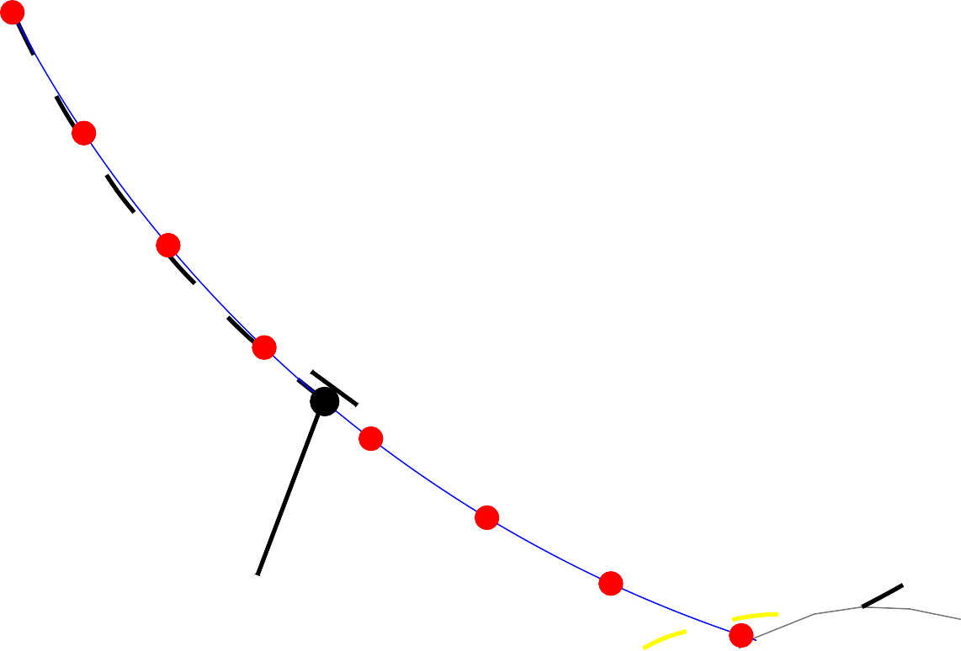

TM8

27

26a

Drawing Notes

Cone lights spaced minimum 9m, cones to be 750 mm or 1m

All works to be carried out as per safety at streetworks and roadworks "A Code of Practice" October 2013.

CPA conditions apply unless otherwise agreed.

Traffic Management Key

Road Signs Road Cones

Traffic Management

26

Speed of road (mph)

Site Details

[TM8](https://www.google.com/maps/%4051.4778151%2C0.3031293%2C62m/data%3D!3m1!1e3?entry=ttu)

Minimum sideways safety zone (S)

Minimum longways safety zone (L)

Additional Notes:

N/A

N/A

Drawing Office

Corporation Street

|  |  |  |
| --- | --- | --- |
| DRAWING NUMBER |  | CF3964 |
| CONTRACT NUMBER |  | 180141 |
| PHASE NUMBER |  | 1 of 1 |
| PAGE NUMBER |  | 9 of 33 |
| SURVEYED BY / DATE | N/A | N/A |
| DRAWN BY / DATE | CF | 30/09/24 |
| CHECKED BY / DATE | CF | 30/09/24 |
| APPROVED BY / DATE | CH | 30/09/24 |
| CLIENT REF |  | N/A |
| SCALE @ A3 |  | NTS |

REV A

B AMENDED AS PER REQUEST ?? dd/mm/yy

C AMENDED AS PER REQUEST ?? dd/mm/yy

D AMENDED AS PER REQUEST ?? dd/mm/yy

25

FIRST ISSUE FOR APPROVAL

BY DATE

CF 30/09/24

**Client**

# Shelter

###### TAUNTON TOWN COUNCIL

**Site Address** Corporation Street, Taunton,

TA1 1JD

**Co-ordinates, Latitude - Longitude**

51.0148065199, -3.10304712

|  |  |  |  |  |  |  |  |  |  |  |
| --- | --- | --- | --- | --- | --- | --- | --- | --- | --- | --- |
| TM9 | N | |  | | | | | | | |
| **Drawing Notes** | | | | | | | | | |
| Cone lights spaced minimum 9m, cones to be 750 mm or 1m | | | | | | | | | |
| All works to be carried out as per safety at streetworks and roadworks "A Code of Practice" October 2013.  CPA conditions apply unless otherwise agreed. | | | | | | | | | |
| **Traffic Management Key** | | | | | | | | | |
|  | | | | Road Signs | | | | | |
|  | | | | Road Cones | | | | | |
|  | | | |  | | | | | |
|  | | | |  | | | | | |
|  | | | |  | | | | | |
|  | | | |  | | | | | |
|  | | | |  | | | | | |
|  | | | |  | | | | | |
|  | | | |  | | | | | |
|  | | | |  | | | | | |
| **Site Details** | | | | | | | | | |
| Traffic Management | | | [TM9](https://www.google.com/maps/%4051.4778151%2C0.3031293%2C62m/data%3D!3m1!1e3?entry=ttu) | | | | | | |
| Speed of road (mph) | | |  | | | | | | |
| Minimum sideways safety zone (S) | | | | | | N/A | | | |
| Minimum longways safety zone (L) | | | | | | N/A | | | |
| Additional Notes: | | | | | | | | | |
| **Drawing Office** | | | | | | | | | |
| DRAWING NUMBER | | | | | CF3965 | | | | |
| CONTRACT NUMBER | | | | | 180141 | | | | |
| PHASE NUMBER | | | | | 1 of 1 | | | | |
| PAGE NUMBER | | | | | 10 of 33 | | | | |
| SURVEYED BY / DATE | | | | | N/A | | | N/A | |
| DRAWN BY / DATE | | | | | CF | | | 30/09/24 | |
| CHECKED BY / DATE | | | | | CF | | | 30/09/24 | |
| APPROVED BY / DATE | | | | | CH | | | 30/09/24 | |
| CLIENT REF | | | | | N/A | | | | |
| SCALE @ A3 | | | | | NTS | | | | |
|  | | | | | | | | | |
| REV |  | | | | | | BY | | DATE |
| A | FIRST ISSUE FOR APPROVAL | | | | | | CF | | 30/09/24 |
|  |  | | | | | |  | |  |
|  |  | | | | | |  | |  |
|  |  | | | | | |  | |  |
| **Client** | | | | | | | | | |
| TAUNTON TOWN COUNCIL | | | | | | | | | |
| **Site Address** | | | | | | | | | |
| The Bridge, Taunton, TA1 1TG | | | | | | | | | |
| **Co-ordinates, Latitude - Longitude** | | | | | | | | | |
| 51.01800878, -3.104439638 | | | | | | | | | |

B AMENDED AS PER REQUEST ?? dd/mm/yy

C AMENDED AS PER REQUEST ?? dd/mm/yy

D AMENDED AS PER REQUEST ?? dd/mm/yy

14 to 18

10a

A3027 The Bridge

12

2

3b

11

3

|  |  |  |  |  |  |  |  |  |  |  |
| --- | --- | --- | --- | --- | --- | --- | --- | --- | --- | --- |
| TM10 | N | |  | | | | | | | |
| **Drawing Notes** | | | | | | | | | |
| Cone lights spaced minimum 9m, cones to be 750 mm or 1m | | | | | | | | | |
| All works to be carried out as per safety at streetworks and roadworks "A Code of Practice" October 2013.  CPA conditions apply unless otherwise agreed. | | | | | | | | | |
| **Traffic Management Key** | | | | | | | | | |
|  | | | | Road Signs | | | | | |
|  | | | | Road Cones | | | | | |
|  | | | |  | | | | | |
|  | | | |  | | | | | |
|  | | | |  | | | | | |
|  | | | |  | | | | | |
|  | | | |  | | | | | |
|  | | | |  | | | | | |
|  | | | |  | | | | | |
|  | | | |  | | | | | |
| **Site Details** | | | | | | | | | |
| Traffic Management | | | [TM10](https://www.google.com/maps/%4051.4778151%2C0.3031293%2C62m/data%3D!3m1!1e3?entry=ttu) | | | | | | |
| Speed of road (mph) | | |  | | | | | | |
| Minimum sideways safety zone (S) | | | | | | N/A | | | |
| Minimum longways safety zone (L) | | | | | | N/A | | | |
| Additional Notes: | | | | | | | | | |
| **Drawing Office** | | | | | | | | | |
| DRAWING NUMBER | | | | | CF3966 | | | | |
| CONTRACT NUMBER | | | | | 180141 | | | | |
| PHASE NUMBER | | | | | 1 of 1 | | | | |
| PAGE NUMBER | | | | | 11 of 33 | | | | |
| SURVEYED BY / DATE | | | | | N/A | | | N/A | |
| DRAWN BY / DATE | | | | | CF | | | 30/09/24 | |
| CHECKED BY / DATE | | | | | CF | | | 30/09/24 | |
| APPROVED BY / DATE | | | | | CH | | | 30/09/24 | |
| CLIENT REF | | | | | N/A | | | | |
| SCALE @ A3 | | | | | NTS | | | | |
|  | | | | | | | | | |
| REV |  | | | | | | BY | | DATE |
| A | FIRST ISSUE FOR APPROVAL | | | | | | CF | | 30/09/24 |
|  |  | | | | | |  | |  |
|  |  | | | | | |  | |  |
|  |  | | | | | |  | |  |
| **Client** | | | | | | | | | |
| TAUNTON TOWN COUNCIL | | | | | | | | | |
| **Site Address** | | | | | | | | | |
| Wood Street, Taunton, TA1 1TG | | | | | | | | | |
| **Co-ordinates, Latitude - Longitude** | | | | | | | | | |
| 51.0180662431, -3.10486358 | | | | | | | | | |

B AMENDED AS PER REQUEST ?? dd/mm/yy

C AMENDED AS PER REQUEST ?? dd/mm/yy

D AMENDED AS PER REQUEST ?? dd/mm/yy

19

4

2

Wood Street

|  |  |  |  |  |  |  |  |  |  |  |
| --- | --- | --- | --- | --- | --- | --- | --- | --- | --- | --- |
| TM11a    Castlemoat P 1 to 12 and 1 | N | |  | | | | | | | |
| **Drawing Notes** | | | | | | | | | |
| Cone lights spaced minimum 9m, cones to be 750 mm or 1m | | | | | | | | | |
| All works to be carried out as per safety at streetworks and roadworks "A Code of Practice" October 2013.  CPA conditions apply unless otherwise agreed. | | | | | | | | | |
| **Traffic Management Key** | | | | | | | | | |
|  | | | | Road Signs | | | | | |
|  | | | | Road Cones | | | | | |
|  | | | | No Waiting Cones | | | | | |
|  | | | |  | | | | | |
|  | | | |  | | | | | |
|  | | | |  | | | | | |
|  | | | |  | | | | | |
|  | | | |  | | | | | |
|  | | | |  | | | | | |
|  | | | |  | | | | | |
| **Site Details** | | | | | | | | | |
| Traffic Management | | | [TM11a](https://www.google.com/maps/%4051.4778151%2C0.3031293%2C62m/data%3D!3m1!1e3?entry=ttu) | | | | | | |
| Speed of road (mph) | | |  | | | | | | |
| Minimum sideways safety zone (S) | | | | | | N/A | | | |
| Minimum longways safety zone (L) | | | | | | N/A | | | |
| Additional Notes: | | | | | | | | | |
| **Drawing Office** | | | | | | | | | |
| DRAWING NUMBER | | | | | CF3967 | | | | |
| CONTRACT NUMBER | | | | | 180141 | | | | |
| PHASE NUMBER | | | | | 1 of 1 | | | | |
| PAGE NUMBER | | | | | 12 of 33 | | | | |
| SURVEYED BY / DATE | | | | | N/A | | | N/A | |
| DRAWN BY / DATE | | | | | CF | | | 30/09/24 | |
| CHECKED BY / DATE | | | | | CF | | | 30/09/24 | |
| APPROVED BY / DATE | | | | | CH | | | 30/09/24 | |
| CLIENT REF | | | | | N/A | | | | |
| SCALE @ A3 | | | | | NTS | | | | |
|  | | | | | | | | | |
| REV |  | | | | | | BY | | DATE |
| A | FIRST ISSUE FOR APPROVAL | | | | | | CF | | 30/09/24 |
|  |  | | | | | |  | |  |
|  |  | | | | | |  | |  |
|  |  | | | | | |  | |  |
| **Client** | | | | | | | | | |
| TAUNTON TOWN COUNCIL | | | | | | | | | |
| **Site Address** | | | | | | | | | |
| Tower Street, Taunton, TA1 4AS | | | | | | | | | |
| **Co-ordinates, Latitude - Longitude** | | | | | | | | | |
| 51.0145073909, -3.106367610 | | | | | | | | | |

B AMENDED AS PER REQUEST ?? dd/mm/yy

C AMENDED AS PER REQUEST ?? dd/mm/yy

D AMENDED AS PER REQUEST ?? dd/mm/yy

Tower Street

Michael Paul House

(Government Offices)

Corporation Street

|  |  |  |  |  |  |  |  |  |  |  |  |
| --- | --- | --- | --- | --- | --- | --- | --- | --- | --- | --- | --- |
|  |  | N | |  | | | | | | | |
| Mitre House            TM11b | |
| **Drawing Notes** | | | | | | | | | |
| Cone lights spaced minimum 9m, cones to be 750 mm or 1m | | | | | | | | | |
| All works to be carried out as per safety at streetworks and roadworks "A Code of Practice" October 2013.  CPA conditions apply unless otherwise agreed. | | | | | | | | | |
| **Traffic Management Key** | | | | | | | | | |
|  | | | | Road Signs | | | | | |
|  | | | | Road Cones | | | | | |
|  | | | | No Waiting Cones | | | | | |
|  | | | |  | | | | | |
|  | | | |  | | | | | |
|  | | | |  | | | | | |
|  | | | |  | | | | | |
|  | | | |  | | | | | |
|  | | | |  | | | | | |
|  | | | |  | | | | | |
| **Site Details** | | | | | | | | | |
| Traffic Management | | | [TM11b](https://www.google.com/maps/%4051.4778151%2C0.3031293%2C62m/data%3D!3m1!1e3?entry=ttu) | | | | | | |
| Speed of road (mph) | | |  | | | | | | |
| Minimum sideways safety zone (S) | | | | | | N/A | | | |
| Minimum longways safety zone (L) | | | | | | N/A | | | |
| Additional Notes: | | | | | | | | | |
| **Drawing Office** | | | | | | | | | |
| DRAWING NUMBER | | | | | CF3968 | | | | |
| CONTRACT NUMBER | | | | | 180141 | | | | |
| PHASE NUMBER | | | | | 1 of 1 | | | | |
| PAGE NUMBER | | | | | 13 of 33 | | | | |
| SURVEYED BY / DATE | | | | | N/A | | | N/A | |
| DRAWN BY / DATE | | | | | CF | | | 30/09/24 | |
| CHECKED BY / DATE | | | | | CF | | | 30/09/24 | |
| APPROVED BY / DATE | | | | | CH | | | 30/09/24 | |
| CLIENT REF | | | | | N/A | | | | |
| SCALE @ A3 | | | | | NTS | | | | |
|  | | | | | | | | | |
| REV |  | | | | | | BY | | DATE |
| A | FIRST ISSUE FOR APPROVAL | | | | | | CF | | 30/09/24 |
|  |  | | | | | |  | |  |
|  |  | | | | | |  | |  |
|  |  | | | | | |  | |  |
| **Client** | | | | | | | | | |
| TAUNTON TOWN COUNCIL | | | | | | | | | |
| **Site Address** | | | | | | | | | |
| The Crescent, Taunton,  TA1 4EA | | | | | | | | | |
| **Co-ordinates, Latitude - Longitude** | | | | | | | | | |
| 51.013874742, -3.106299445 | | | | | | | | | |

B AMENDED AS PER REQUEST ?? dd/mm/yy

C AMENDED AS PER REQUEST ?? dd/mm/yy

D AMENDED AS PER REQUEST ?? dd/mm/yy

The Crescent

15

14

|  |  |  |  |  |  |  |  |  |  |  |
| --- | --- | --- | --- | --- | --- | --- | --- | --- | --- | --- |
| TM12  Tangier Scout and Guide  Centre | N | |  | | | | | | | |
| **Drawing Notes** | | | | | | | | | |
| Cone lights spaced minimum 9m, cones to be 750 mm or 1m | | | | | | | | | |
| All works to be carried out as per safety at streetworks and roadworks "A Code of Practice" October 2013.  CPA conditions apply unless otherwise agreed. | | | | | | | | | |
| **Traffic Management Key** | | | | | | | | | |
|  | | | | Road Signs | | | | | |
|  | | | | Road Cones | | | | | |
|  | | | |  | | | | | |
|  | | | |  | | | | | |
|  | | | |  | | | | | |
|  | | | |  | | | | | |
|  | | | |  | | | | | |
|  | | | |  | | | | | |
|  | | | |  | | | | | |
|  | | | |  | | | | | |
| **Site Details** | | | | | | | | | |
| Traffic Management | | | [TM12](https://www.google.com/maps/%4051.4778151%2C0.3031293%2C62m/data%3D!3m1!1e3?entry=ttu) | | | | | | |
| Speed of road (mph) | | |  | | | | | | |
| Minimum sideways safety zone (S) | | | | | | N/A | | | |
| Minimum longways safety zone (L) | | | | | | N/A | | | |
| Additional Notes: | | | | | | | | | |
| **Drawing Office** | | | | | | | | | |
| DRAWING NUMBER | | | | | CF3969 | | | | |
| CONTRACT NUMBER | | | | | 180141 | | | | |
| PHASE NUMBER | | | | | 1 of 1 | | | | |
| PAGE NUMBER | | | | | 14 of 33 | | | | |
| SURVEYED BY / DATE | | | | | N/A | | | N/A | |
| DRAWN BY / DATE | | | | | CF | | | 30/09/24 | |
| CHECKED BY / DATE | | | | | CF | | | 30/09/24 | |
| APPROVED BY / DATE | | | | | CH | | | 30/09/24 | |
| CLIENT REF | | | | | N/A | | | | |
| SCALE @ A3 | | | | | NTS | | | | |
|  | | | | | | | | | |
| REV |  | | | | | | BY | | DATE |
| A | FIRST ISSUE FOR APPROVAL | | | | | | CF | | 30/09/24 |
|  |  | | | | | |  | |  |
|  |  | | | | | |  | |  |
|  |  | | | | | |  | |  |
| **Client** | | | | | | | | | |
| TAUNTON TOWN COUNCIL | | | | | | | | | |
| **Site Address** | | | | | | | | | |
| Tangier Way, Taunton, TA1 4AS | | | | | | | | | |
| **Co-ordinates, Latitude - Longitude** | | | | | | | | | |
| 51.0155985079, -3.10711958 | | | | | | | | | |

B AMENDED AS PER REQUEST ?? dd/mm/yy

C AMENDED AS PER REQUEST ?? dd/mm/yy

D AMENDED AS PER REQUEST ?? dd/mm/yy

ping masonry

4.5m

Tangier Way

|  |  |  |  |  |  |  |  |  |  |  |  |
| --- | --- | --- | --- | --- | --- | --- | --- | --- | --- | --- | --- |
| TM13 | | N | |  | | | | | | | |
| **Drawing Notes** | | | | | | | | | |
| Cone lights spaced minimum 9m, cones to be 750 mm or 1m | | | | | | | | | |
| All works to be carried out as per safety at streetworks and roadworks "A Code of Practice" October 2013.  CPA conditions apply unless otherwise agreed. | | | | | | | | | |
| **Traffic Management Key** | | | | | | | | | |
|  | | | | Road Signs | | | | | |
|  | | | | Road Cones | | | | | |
|  | | | |  | | | | | |
|  | | | |  | | | | | |
|  | | | |  | | | | | |
|  | | | |  | | | | | |
|  | | | |  | | | | | |
|  | | | |  | | | | | |
|  | | | |  | | | | | |
|  | | | |  | | | | | |
| **Site Details** | | | | | | | | | |
| Traffic Management | | | [TM13](https://www.google.com/maps/%4051.4778151%2C0.3031293%2C62m/data%3D!3m1!1e3?entry=ttu) | | | | | | |
| Speed of road (mph) | | |  | | | | | | |
| Minimum sideways safety zone (S) | | | | | | N/A | | | |
| Minimum longways safety zone (L) | | | | | | N/A | | | |
| Additional Notes: | | | | | | | | | |
| **Drawing Office** | | | | | | | | | |
| DRAWING NUMBER | | | | | CF3970 | | | | |
| CONTRACT NUMBER | | | | | 180141 | | | | |
| PHASE NUMBER | | | | | 1 of 1 | | | | |
| PAGE NUMBER | | | | | 15 of 33 | | | | |
| SURVEYED BY / DATE | | | | | N/A | | | N/A | |
| DRAWN BY / DATE | | | | | CF | | | 30/09/24 | |
| CHECKED BY / DATE | | | | | CF | | | 30/09/24 | |
| APPROVED BY / DATE | | | | | CH | | | 30/09/24 | |
| CLIENT REF | | | | | N/A | | | | |
| SCALE @ A3 | | | | | NTS | | | | |
|  | | | | | | | | | |
| REV |  | | | | | | BY | | DATE |
| A | FIRST ISSUE FOR APPROVAL | | | | | | CF | | 30/09/24 |
|  |  | | | | | |  | |  |
|  |  | | | | | |  | |  |
|  |  | | | | | |  | |  |
| **Client** | | | | | | | | | |
| TAUNTON TOWN COUNCIL | | | | | | | | | |
| **Site Address** | | | | | | | | | |
| Castle Street, Taunton, TA1 4AZ | | | | | | | | | |
|  |  |
| **Co-ordinates, Latitude - Longitude** | | | | | | | | | |
| 51.015628380, -3.10833582 | | | | | | | | | |

B AMENDED AS PER REQUEST ?? dd/mm/yy

C AMENDED AS PER REQUEST ?? dd/mm/yy

D AMENDED AS PER REQUEST ?? dd/mm/yy

Castle Street

4.4m

B AMENDED AS PER REQUEST ?? dd/mm/yy

C AMENDED AS PER REQUEST ?? dd/mm/yy

D AMENDED AS PER REQUEST ?? dd/mm/yy



Corporation Street

|  |  |  |  |  |  |  |  |  |  |  |
| --- | --- | --- | --- | --- | --- | --- | --- | --- | --- | --- |
| ub  TM13a PH | N | |  | | | | | | | |
| **Drawing Notes** | | | | | | | | | |
| Cone lights spaced minimum 9m, cones to be 750 mm or 1m | | | | | | | | | |
| All works to be carried out as per safety at streetworks and roadworks "A Code of Practice" October 2013.  CPA conditions apply unless otherwise agreed. | | | | | | | | | |
| **Traffic Management Key** | | | | | | | | | |
|  | | | | Road Signs | | | | | |
|  | | | | Road Cones | | | | | |
|  | | | |  | | | | | |
|  | | | |  | | | | | |
|  | | | |  | | | | | |
|  | | | |  | | | | | |
|  | | | |  | | | | | |
|  | | | |  | | | | | |
|  | | | |  | | | | | |
|  | | | |  | | | | | |
| **Site Details** | | | | | | | | | |
| Traffic Management | | | [TM13a](https://www.google.com/maps/%4051.4778151%2C0.3031293%2C62m/data%3D!3m1!1e3?entry=ttu) | | | | | | |
| Speed of road (mph) | | |  | | | | | | |
| Minimum sideways safety zone (S) | | | | | | N/A | | | |
| Minimum longways safety zone (L) | | | | | | N/A | | | |
| Additional Notes: | | | | | | | | | |
| **Drawing Office** | | | | | | | | | |
| DRAWING NUMBER | | | | | CF4205 | | | | |
| CONTRACT NUMBER | | | | | 180141 | | | | |
| PHASE NUMBER | | | | | 1 of 1 | | | | |
| PAGE NUMBER | | | | | 16 of 33 | | | | |
| SURVEYED BY / DATE | | | | | N/A | | | N/A | |
| DRAWN BY / DATE | | | | | CF | | | 04/11/24 | |
| CHECKED BY / DATE | | | | | CF | | | 04/11/24 | |
| APPROVED BY / DATE | | | | | CH | | | 04/11/24 | |
| CLIENT REF | | | | | N/A | | | | |
| SCALE @ A3 | | | | | NTS | | | | |
|  | | | | | | | | | |
| REV |  | | | | | | BY | | DATE |
| A | FIRST ISSUE FOR APPROVAL | | | | | | CF | | 04/11/24 |
|  |  | | | | | |  | |  |
|  |  | | | | | |  | |  |
|  |  | | | | | |  | |  |
| **Client** | | | | | | | | | |
| TAUNTON TOWN COUNCIL | | | | | | | | | |
| **Site Address** | | | | | | | | | |
| Tower Street, Taunton, TA1 4AS | | | | | | | | | |
| **Co-ordinates, Latitude - Longitude** | | | | | | | | | |
| 51.0145073909, -3.106367610 | | | | | | | | | |

## l

Castle Way

El Sub Sta

|  |  |  |  |  |  |  |  |  |  |  |  |
| --- | --- | --- | --- | --- | --- | --- | --- | --- | --- | --- | --- |
|  | TM15  TM14 | N | |  | | | | | | | |
| TM15 |
| **Drawing Notes** | | | | | | | | | |
| Cone lights spaced minimum 9m, cones to be 750 mm or 1m | | | | | | | | | |
| All works to be carried out as per safety at streetworks and roadworks "A Code of Practice" October 2013.  CPA conditions apply unless otherwise agreed. | | | | | | | | | |
| **Traffic Management Key** | | | | | | | | | |
|  | | | | Road Signs | | | | | |
|  | | | | Road Cones | | | | | |
|  | | | |  | | | | | |
|  | | | |  | | | | | |
|  | | | |  | | | | | |
|  | | | |  | | | | | |
|  | | | |  | | | | | |
|  | | | |  | | | | | |
|  | | | |  | | | | | |
|  | | | |  | | | | | |
| **Site Details** | | | | | | | | | |
| Traffic Management | | | [TM14](https://www.google.com/maps/%4051.4778151%2C0.3031293%2C62m/data%3D!3m1!1e3?entry=ttu) | | | | | | |
| Speed of road (mph) | | |  | | | | | | |
| Minimum sideways safety zone (S) | | | | | | N/A | | | |
| Minimum longways safety zone (L) | | | | | | N/A | | | |
| Additional Notes: | | | | | | | | | |
| **Drawing Office** | | | | | | | | | |
| DRAWING NUMBER | | | | | CF3971 | | | | |
| CONTRACT NUMBER | | | | | 180141 | | | | |
| PHASE NUMBER | | | | | 1 of 1 | | | | |
| PAGE NUMBER | | | | | 17 of 33 | | | | |
| SURVEYED BY / DATE | | | | | N/A | | | N/A | |
| DRAWN BY / DATE | | | | | CF | | | 30/09/24 | |
| CHECKED BY / DATE | | | | | CF | | | 30/09/24 | |
| APPROVED BY / DATE | | | | | CH | | | 30/09/24 | |
| CLIENT REF | | | | | N/A | | | | |
| SCALE @ A3 | | | | | NTS | | | | |
|  | | | | | | | | | |
| REV |  | | | | | | BY | | DATE |
| A | FIRST ISSUE FOR APPROVAL | | | | | | CF | | 30/09/24 |
|  |  | | | | | |  | |  |
|  |  | | | | | |  | |  |
|  |  | | | | | |  | |  |
| **Client** | | | | | | | | | |
| TAUNTON TOWN COUNCIL | | | | | | | | | |
| **Site Address** | | | | | | | | | |
| Castle Street, Taunton, TA1 4EQ | | | | | | | | | |
| **Co-ordinates, Latitude - Longitude** | | | | | | | | | |
| 51.0144491945, -3.1120645 | | | | | | | | | |

B AMENDED AS PER REQUEST ?? dd/mm/yy

C AMENDED AS PER REQUEST ?? dd/mm/yy

D AMENDED AS PER REQUEST ?? dd/mm/yy

Wellington Road

28

20

A3807 Castle Street

|  |  |  |  |  |  |  |  |  |  |  |
| --- | --- | --- | --- | --- | --- | --- | --- | --- | --- | --- |
| TM15  TM15  TM14 | N | |  | | | | | | | |
| **Drawing Notes** | | | | | | | | | |
| Cone lights spaced minimum 9m, cones to be 750 mm or 1m | | | | | | | | | |
| All works to be carried out as per safety at streetworks and roadworks "A Code of Practice" October 2013.  CPA conditions apply unless otherwise agreed. | | | | | | | | | |
| **Traffic Management Key** | | | | | | | | | |
|  | | | | Road Signs | | | | | |
|  | | | | Road Cones | | | | | |
|  | | | |  | | | | | |
|  | | | |  | | | | | |
|  | | | |  | | | | | |
|  | | | |  | | | | | |
|  | | | |  | | | | | |
|  | | | |  | | | | | |
|  | | | |  | | | | | |
|  | | | |  | | | | | |
| **Site Details** | | | | | | | | | |
| Traffic Management | | | [TM15](https://www.google.com/maps/%4051.4778151%2C0.3031293%2C62m/data%3D!3m1!1e3?entry=ttu) | | | | | | |
| Speed of road (mph) | | |  | | | | | | |
| Minimum sideways safety zone (S) | | | | | | N/A | | | |
| Minimum longways safety zone (L) | | | | | | N/A | | | |
| Additional Notes: | | | | | | | | | |
| **Drawing Office** | | | | | | | | | |
| DRAWING NUMBER | | | | | CF3972 | | | | |
| CONTRACT NUMBER | | | | | 180141 | | | | |
| PHASE NUMBER | | | | | 1 of 1 | | | | |
| PAGE NUMBER | | | | | 18 of 33 | | | | |
| SURVEYED BY / DATE | | | | | N/A | | | N/A | |
| DRAWN BY / DATE | | | | | CF | | | 30/09/24 | |
| CHECKED BY / DATE | | | | | CF | | | 30/09/24 | |
| APPROVED BY / DATE | | | | | CH | | | 30/09/24 | |
| CLIENT REF | | | | | N/A | | | | |
| SCALE @ A3 | | | | | NTS | | | | |
|  | | | | | | | | | |
| REV |  | | | | | | BY | | DATE |
| A | FIRST ISSUE FOR APPROVAL | | | | | | CF | | 30/09/24 |
|  |  | | | | | |  | |  |
|  |  | | | | | |  | |  |
|  |  | | | | | |  | |  |
| **Client** | | | | | | | | | |
| TAUNTON TOWN COUNCIL | | | | | | | | | |
| **Site Address** | | | | | | | | | |
| Castle Street, Taunton, TA1 4EQ | | | | | | | | | |
| **Co-ordinates, Latitude - Longitude** | | | | | | | | | |
| 51.0144491945, -3.1120645 | | | | | | | | | |

B AMENDED AS PER REQUEST ?? dd/mm/yy

C AMENDED AS PER REQUEST ?? dd/mm/yy

D AMENDED AS PER REQUEST ?? dd/mm/yy

Wellington

28

A3807 Castle Street

|  |  |  |  |  |  |  |  |  |  |  |
| --- | --- | --- | --- | --- | --- | --- | --- | --- | --- | --- |
| TM16 | N | |  | | | | | | | |
| **Drawing Notes** | | | | | | | | | |
| Cone lights spaced minimum 9m, cones to be 750 mm or 1m | | | | | | | | | |
| All works to be carried out as per safety at streetworks and roadworks "A Code of Practice" October 2013.  CPA conditions apply unless otherwise agreed. | | | | | | | | | |
| **Traffic Management Key** | | | | | | | | | |
|  | | | | Road Signs | | | | | |
|  | | | | Road Cones | | | | | |
|  | | | |  | | | | | |
|  | | | |  | | | | | |
|  | | | |  | | | | | |
|  | | | |  | | | | | |
|  | | | |  | | | | | |
|  | | | |  | | | | | |
|  | | | |  | | | | | |
|  | | | |  | | | | | |
| **Site Details** | | | | | | | | | |
| Traffic Management | | | [TM16](https://www.google.com/maps/%4051.4778151%2C0.3031293%2C62m/data%3D!3m1!1e3?entry=ttu) | | | | | | |
| Speed of road (mph) | | |  | | | | | | |
| Minimum sideways safety zone (S) | | | | | | N/A | | | |
| Minimum longways safety zone (L) | | | | | | N/A | | | |
| Additional Notes: | | | | | | | | | |
| **Drawing Office** | | | | | | | | | |
| DRAWING NUMBER | | | | | CF3973 | | | | |
| CONTRACT NUMBER | | | | | 180141 | | | | |
| PHASE NUMBER | | | | | 1 of 1 | | | | |
| PAGE NUMBER | | | | | 19 of 33 | | | | |
| SURVEYED BY / DATE | | | | | N/A | | | N/A | |
| DRAWN BY / DATE | | | | | CF | | | 30/09/24 | |
| CHECKED BY / DATE | | | | | CF | | | 30/09/24 | |
| APPROVED BY / DATE | | | | | CH | | | 30/09/24 | |
| CLIENT REF | | | | | N/A | | | | |
| SCALE @ A3 | | | | | NTS | | | | |
|  | | | | | | | | | |
| REV |  | | | | | | BY | | DATE |
| A | FIRST ISSUE FOR APPROVAL | | | | | | CF | | 30/09/24 |
|  |  | | | | | |  | |  |
|  |  | | | | | |  | |  |
|  |  | | | | | |  | |  |
| **Client** | | | | | | | | | |
| TAUNTON TOWN COUNCIL | | | | | | | | | |
| **Site Address** | | | | | | | | | |
| Wellington Road, Taunton,  TA1 4EQ | | | | | | | | | |
| **Co-ordinates, Latitude - Longitude** | | | | | | | | | |
| 51.0136826392, -3.1117706983 | | | | | | | | | |

B AMENDED AS PER REQUEST ?? dd/mm/yy

C AMENDED AS PER REQUEST ?? dd/mm/yy

D AMENDED AS PER REQUEST ?? dd/mm/yy

Wellington Road

3

7

am

N

29

St John's

Church

Hotel

2

16

##### TM17

4

23

Drawing Notes

Cone lights spaced minimum 9m, cones to be 750 mm or 1m

All works to be carried out as per safety at streetworks and roadworks "A Code of Practice" October 2013.

CPA conditions apply unless otherwise agreed.

Traffic Management Key

Road Signs Road Cones

Park Street

Traffic Management

10

6

5

14

1

Speed of road (mph)

Site Details

[TM17 & TM18a](https://www.google.com/maps/%4051.4778151%2C0.3031293%2C62m/data%3D!3m1!1e3?entry=ttu)

Minimum sideways safety zone (S)

1

Minimum longways safety zone (L)

17

Additional Notes:

N/A

N/A

Dovetail Court

1 to 4

5 to 10

6a

Cann Street

El Sub Sta

4

12

12

##### TM18a

COMPASS HILL

1

10 to 14

**Drawing Office**

14

|  |  |  |
| --- | --- | --- |
| DRAWING NUMBER |  | CF3974 |
| CONTRACT NUMBER |  | 180141 |
| PHASE NUMBER |  | 1 of 1 |
| PAGE NUMBER |  | 20 of 33 |
| SURVEYED BY / DATE | N/A | N/A |
| DRAWN BY / DATE | CF | 30/09/24 |
| CHECKED BY / DATE | CF | 30/09/24 |
| APPROVED BY / DATE | CH | 30/09/24 |
| CLIENT REF |  | N/A |
| SCALE @ A3 |  | NTS |

Cedar Gardens

1

1 to 9

The Point

REV A

B AMENDED AS PER REQUEST ?? dd/mm/yy

C AMENDED AS PER REQUEST ?? dd/mm/yy

D AMENDED AS PER REQUEST ?? dd/mm/yy

15 to 23

8

FIRST ISSUE FOR APPROVAL

Cann Street

BY DATE

CF 30/09/24

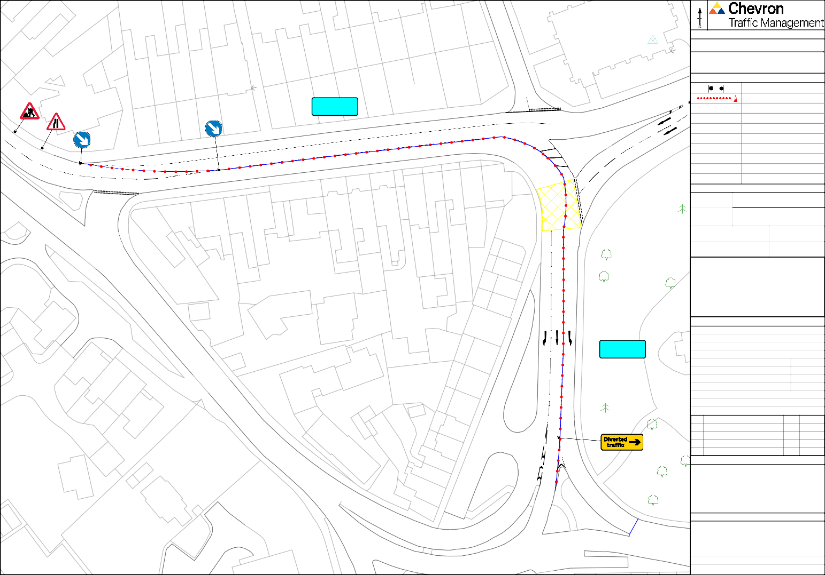

**Client**

5

###### TAUNTON TOWN COUNCIL

Site Address

5

3

Park Street, Taunton, TA1 4DG

**Co-ordinates, Latitude - Longitude**

51.0132800706, -3.1097662269

|  |  |  |  |  |  |  |  |  |  |  |  |
| --- | --- | --- | --- | --- | --- | --- | --- | --- | --- | --- | --- |
|  |  | N | |  | | | | | | | |
| **Drawing Notes** | | | | | | | | | |
| Cone lights spaced minimum 9m, cones to be 750 mm or 1m | | | | | | | | | |
| All works to be carried out as per safety at streetworks and roadworks "A Code of Practice" October 2013.  CPA conditions apply unless otherwise agreed. | | | | | | | | | |
| **Traffic Management Key** | | | | | | | | | |
|  | | | | Road Signs | | | | | |
|  | | | | Road Cones | | | | | |
|  | | | |  | | | | | |
|  | | | |  | | | | | |
|  | | | |  | | | | | |
|  | | | |  | | | | | |
|  | | | |  | | | | | |
|  | | | |  | | | | | |
|  | | | |  | | | | | |
|  | | | |  | | | | | |
| **Site Details** | | | | | | | | | |
| Dovetail Court  Shire Hall  TM18b Taunton Crown  and County Courts  The Point | |
| Traffic Management | | | [TM18b](https://www.google.com/maps/%4051.4778151%2C0.3031293%2C62m/data%3D!3m1!1e3?entry=ttu) | | | | | | |
| Speed of road (mph) | | |  | | | | | | |
| Minimum sideways safety zone (S) | | | | | | N/A | | | |
| Minimum longways safety zone (L) | | | | | | N/A | | | |
| Additional Notes: | | | | | | | | | |
| **Drawing Office** | | | | | | | | | |
| DRAWING NUMBER | | | | | CF3975 | | | | |
| CONTRACT NUMBER | | | | | 180141 | | | | |
| PHASE NUMBER | | | | | 1 of 1 | | | | |
| PAGE NUMBER | | | | | 21 of 33 | | | | |
| SURVEYED BY / DATE | | | | | N/A | | | N/A | |
| DRAWN BY / DATE | | | | | CF | | | 30/09/24 | |
| CHECKED BY / DATE | | | | | CF | | | 30/09/24 | |
| APPROVED BY / DATE | | | | | CH | | | 30/09/24 | |
| CLIENT REF | | | | | N/A | | | | |
| SCALE @ A3 | | | | | NTS | | | | |
|  | | | | | | | | | |
| REV |  | | | | | | BY | | DATE |
| A | FIRST ISSUE FOR APPROVAL | | | | | | CF | | 30/09/24 |
|  |  | | | | | |  | |  |
|  |  | | | | | |  | |  |
|  |  | | | | | |  | |  |
| **Client** | | | | | | | | | |
| TAUNTON TOWN COUNCIL | | | | | | | | | |
| **Site Address** | | | | | | | | | |
| Cann Street, Taunton, TA1 4EH | | | | | | | | | |
| **Co-ordinates, Latitude - Longitude** | | | | | | | | | |
| 51.012837036, -3.108666930 | | | | | | | | | |

B AMENDED AS PER REQUEST ?? dd/mm/yy

C AMENDED AS PER REQUEST ?? dd/mm/yy

D AMENDED AS PER REQUEST ?? dd/mm/yy

1 to 4

5 to 10

6a

10

6

5

1

15 to 23

Cann Street

14

17

12

Cann Street

8

3

1 to 9

10 to 14

Park Street

23

|  |  |  |  |  |  |  |  |  |  |  |
| --- | --- | --- | --- | --- | --- | --- | --- | --- | --- | --- |
| TM19a | N | |  | | | | | | | |
| **Drawing Notes** | | | | | | | | | |
| Cone lights spaced minimum 9m, cones to be 750 mm or 1m | | | | | | | | | |
| All works to be carried out as per safety at streetworks and roadworks "A Code of Practice" October 2013.  CPA conditions apply unless otherwise agreed. | | | | | | | | | |
| **Traffic Management Key** | | | | | | | | | |
|  | | | | Road Signs | | | | | |
|  | | | | Road Cones | | | | | |
|  | | | | No Waiting Cones | | | | | |
|  | | | | HVM Barriers | | | | | |
|  | | | |  | | | | | |
|  | | | |  | | | | | |
|  | | | |  | | | | | |
|  | | | |  | | | | | |
|  | | | |  | | | | | |
|  | | | |  | | | | | |
| **Site Details** | | | | | | | | | |
| Traffic Management | | | [TM19a](https://www.google.com/maps/%4051.4778151%2C0.3031293%2C62m/data%3D!3m1!1e3?entry=ttu) | | | | | | |
| Speed of road (mph) | | |  | | | | | | |
| Minimum sideways safety zone (S) | | | | | | N/A | | | |
| Minimum longways safety zone (L) | | | | | | N/A | | | |
| Additional Notes: | | | | | | | | | |
| **Drawing Office** | | | | | | | | | |
| DRAWING NUMBER | | | | | CF3976 | | | | |
| CONTRACT NUMBER | | | | | 180141 | | | | |
| PHASE NUMBER | | | | | 1 of 1 | | | | |
| PAGE NUMBER | | | | | 22 of 33 | | | | |
| SURVEYED BY / DATE | | | | | N/A | | | N/A | |
| DRAWN BY / DATE | | | | | CF | | | 30/09/24 | |
| CHECKED BY / DATE | | | | | CF | | | 30/09/24 | |
| APPROVED BY / DATE | | | | | CH | | | 30/09/24 | |
| CLIENT REF | | | | | N/A | | | | |
| SCALE @ A3 | | | | | NTS | | | | |
|  | | | | | | | | | |
| REV |  | | | | | | BY | | DATE |
| A | FIRST ISSUE FOR APPROVAL | | | | | | CF | | 30/09/24 |
|  |  | | | | | |  | |  |
|  |  | | | | | |  | |  |
|  |  | | | | | |  | |  |
| **Client** | | | | | | | | | |
| TAUNTON TOWN COUNCIL | | | | | | | | | |
| **Site Address** | | | | | | | | | |
| Upper High Street, Taunton,  TA1 3PZ | | | | | | | | | |
| **Co-ordinates, Latitude - Longitude** | | | | | | | | | |
| 51.01176081090, -3.105829956 | | | | | | | | | |

B AMENDED AS PER REQUEST ?? dd/mm/yy

C AMENDED AS PER REQUEST ?? dd/mm/yy

D AMENDED AS PER REQUEST ?? dd/mm/yy

13

The Crescent

|  |  |  |  |  |  |  |  |  |  |  |
| --- | --- | --- | --- | --- | --- | --- | --- | --- | --- | --- |
| Temple Methodist Church  No Right Turn to be bagged off  TM19b El Sub Sta  ouse  H | N | |  | | | | | | | |
| **Drawing Notes** | | | | | | | | | |
| Cone lights spaced minimum 9m, cones to be 750 mm or 1m | | | | | | | | | |
| All works to be carried out as per safety at streetworks and roadworks "A Code of Practice" October 2013.  CPA conditions apply unless otherwise agreed. | | | | | | | | | |
| **Traffic Management Key** | | | | | | | | | |
|  | | | | Road Signs | | | | | |
|  | | | | Road Cones | | | | | |
|  | | | | HVM Barriers | | | | | |
|  | | | |  | | | | | |
|  | | | |  | | | | | |
|  | | | |  | | | | | |
|  | | | |  | | | | | |
|  | | | |  | | | | | |
|  | | | |  | | | | | |
|  | | | |  | | | | | |
| **Site Details** | | | | | | | | | |
| Traffic Management | | | [TM19b](https://www.google.com/maps/%4051.4778151%2C0.3031293%2C62m/data%3D!3m1!1e3?entry=ttu) | | | | | | |
| Speed of road (mph) | | |  | | | | | | |
| Minimum sideways safety zone (S) | | | | | | N/A | | | |
| Minimum longways safety zone (L) | | | | | | N/A | | | |
| Additional Notes: | | | | | | | | | |
| **Drawing Office** | | | | | | | | | |
| DRAWING NUMBER | | | | | CF3977 | | | | |
| CONTRACT NUMBER | | | | | 180141 | | | | |
| PHASE NUMBER | | | | | 1 of 1 | | | | |
| PAGE NUMBER | | | | | 23 of 33 | | | | |
| SURVEYED BY / DATE | | | | | N/A | | | N/A | |
| DRAWN BY / DATE | | | | | CF | | | 30/09/24 | |
| CHECKED BY / DATE | | | | | CF | | | 30/09/24 | |
| APPROVED BY / DATE | | | | | CH | | | 30/09/24 | |
| CLIENT REF | | | | | N/A | | | | |
| SCALE @ A3 | | | | | NTS | | | | |
|  | | | | | | | | | |
| REV |  | | | | | | BY | | DATE |
| A | FIRST ISSUE FOR APPROVAL | | | | | | CF | | 30/09/24 |
|  |  | | | | | |  | |  |
|  |  | | | | | |  | |  |
|  |  | | | | | |  | |  |
| **Client** | | | | | | | | | |
| TAUNTON TOWN COUNCIL | | | | | | | | | |
| **Site Address** | | | | | | | | | |
| Upper High Street, Taunton,  TA1 3PY | | | | | | | | | |
| **Co-ordinates, Latitude - Longitude** | | | | | | | | | |
| 51.0116521755, -3.1050463831 | | | | | | | | | |

B AMENDED AS PER REQUEST ?? dd/mm/yy

C AMENDED AS PER REQUEST ?? dd/mm/yy

D AMENDED AS PER REQUEST ?? dd/mm/yy

9

The Crescent

42

43

|  |  |  |  |  |  |  |  |  |  |  |
| --- | --- | --- | --- | --- | --- | --- | --- | --- | --- | --- |
| Depot  TM19c  Ladysmith  House | N | |  | | | | | | | |
| **Drawing Notes** | | | | | | | | | |
| Cone lights spaced minimum 9m, cones to be 750 mm or 1m | | | | | | | | | |
| All works to be carried out as per safety at streetworks and roadworks "A Code of Practice" October 2013.  CPA conditions apply unless otherwise agreed. | | | | | | | | | |
| **Traffic Management Key** | | | | | | | | | |
|  | | | | Road Signs | | | | | |
|  | | | | Road Cones | | | | | |
|  | | | |  | | | | | |
|  | | | |  | | | | | |
|  | | | |  | | | | | |
|  | | | |  | | | | | |
|  | | | |  | | | | | |
|  | | | |  | | | | | |
|  | | | |  | | | | | |
|  | | | |  | | | | | |
| **Site Details** | | | | | | | | | |
| Traffic Management | | | [TM19c](https://www.google.com/maps/%4051.4778151%2C0.3031293%2C62m/data%3D!3m1!1e3?entry=ttu) | | | | | | |
| Speed of road (mph) | | |  | | | | | | |
| Minimum sideways safety zone (S) | | | | | | N/A | | | |
| Minimum longways safety zone (L) | | | | | | N/A | | | |
| Additional Notes: | | | | | | | | | |
| **Drawing Office** | | | | | | | | | |
| DRAWING NUMBER | | | | | CF4204 | | | | |
| CONTRACT NUMBER | | | | | 180141 | | | | |
| PHASE NUMBER | | | | | 1 of 1 | | | | |
| PAGE NUMBER | | | | | 24 of 33 | | | | |
| SURVEYED BY / DATE | | | | | N/A | | | N/A | |
| DRAWN BY / DATE | | | | | CF | | | 04/11/24 | |
| CHECKED BY / DATE | | | | | CF | | | 04/11/24 | |
| APPROVED BY / DATE | | | | | CH | | | 04/11/24 | |
| CLIENT REF | | | | | N/A | | | | |
| SCALE @ A3 | | | | | NTS | | | | |
|  | | | | | | | | | |
| REV |  | | | | | | BY | | DATE |
| A | FIRST ISSUE FOR APPROVAL | | | | | | CF | | 04/11/24 |
|  |  | | | | | |  | |  |
|  |  | | | | | |  | |  |
|  |  | | | | | |  | |  |
| **Client** | | | | | | | | | |
| TAUNTON TOWN COUNCIL | | | | | | | | | |
| **Site Address** | | | | | | | | | |
| Crescent Way, Taunton,  TA1 4EA | | | | | | | | | |
| **Co-ordinates, Latitude - Longitude** | | | | | | | | | |
| 51.01297751117, -3.1056396420 | | | | | | | | | |

B AMENDED AS PER REQUEST ?? dd/mm/yy

C AMENDED AS PER REQUEST ?? dd/mm/yy

D AMENDED AS PER REQUEST ?? dd/mm/yy

11

12 to 14

Crescent Way

|  |  |  |  |  |  |  |  |  |  |  |  |
| --- | --- | --- | --- | --- | --- | --- | --- | --- | --- | --- | --- |
| PH |  | N | |  | | | | | | | |
| **Drawing Notes** | | | | | | | | | |
| TM20 PC  Multisto  Mendip House | | Cone lights spaced minimum 9m, cones to be 750 mm or 1m | | | | | | | | | |
| All works to be carried out as per safety at streetworks and roadworks "A Code of Practice" October 2013.  CPA conditions apply unless otherwise agreed. | | | | | | | | | |
| **Traffic Management Key** | | | | | | | | | |
|  | | | | Road Signs | | | | | |
|  | | | | Road Cones | | | | | |
|  | | | | HVM Barriers | | | | | |
|  | | | |  | | | | | |
|  | | | |  | | | | | |
|  | | | |  | | | | | |
|  | | | |  | | | | | |
|  | | | |  | | | | | |
|  | | | |  | | | | | |
|  | | | |  | | | | | |
| **Site Details** | | | | | | | | | |
| Traffic Management | | | [TM20](https://www.google.com/maps/%4051.4778151%2C0.3031293%2C62m/data%3D!3m1!1e3?entry=ttu) | | | | | | |
| Speed of road (mph) | | |  | | | | | | |
| Minimum sideways safety zone (S) | | | | | | N/A | | | |
| Minimum longways safety zone (L) | | | | | | N/A | | | |
| Additional Notes: | | | | | | | | | |
| **Drawing Office** | | | | | | | | | |
| DRAWING NUMBER | | | | | CF3978 | | | | |
| CONTRACT NUMBER | | | | | 180141 | | | | |
| PHASE NUMBER | | | | | 1 of 1 | | | | |
| PAGE NUMBER | | | | | 25 of 33 | | | | |
| SURVEYED BY / DATE | | | | | N/A | | | N/A | |
| DRAWN BY / DATE | | | | | CF | | | 30/09/24 | |
| CHECKED BY / DATE | | | | | CF | | | 30/09/24 | |
| APPROVED BY / DATE | | | | | CH | | | 30/09/24 | |
| CLIENT REF | | | | | N/A | | | | |
| SCALE @ A3 | | | | | NTS | | | | |
|  | | | | | | | | | |
| REV |  | | | | | | BY | | DATE |
| A | FIRST ISSUE FOR APPROVAL | | | | | | CF | | 30/09/24 |
|  |  | | | | | |  | |  |
|  |  | | | | | |  | |  |
|  |  | | | | | |  | |  |
| **Client** | | | | | | | | | |
| TAUNTON TOWN COUNCIL | | | | | | | | | |
| **Site Address** | | | | | | | | | |
| High Street, Taunton, TA1 3PN | | | | | | | | | |
| **Co-ordinates, Latitude - Longitude** | | | | | | | | | |
| 51.0126917250, -3.10327002 | | | | | | | | | |

B AMENDED AS PER REQUEST ?? dd/mm/yy

C AMENDED AS PER REQUEST ?? dd/mm/yy

D AMENDED AS PER REQUEST ?? dd/mm/yy

23

22

21

High Street

6

1

4

4

45

46

47

40

39

44

41

37

38

Guildford Place

45a

|  |  |  |  |  |  |  |  |  |  |  |
| --- | --- | --- | --- | --- | --- | --- | --- | --- | --- | --- |
| M  TM21 | N | |  | | | | | | | |
| **Drawing Notes** | | | | | | | | | |
| Cone lights spaced minimum 9m, cones to be 750 mm or 1m | | | | | | | | | |
| All works to be carried out as per safety at streetworks and roadworks "A Code of Practice" October 2013.  CPA conditions apply unless otherwise agreed. | | | | | | | | | |
| **Traffic Management Key** | | | | | | | | | |
|  | | | | Road Signs | | | | | |
|  | | | | Road Cones | | | | | |
|  | | | | Pedestrian Barrier | | | | | |
| M | | | | Marshal | | | | | |
|  | | | |  | | | | | |
|  | | | |  | | | | | |
|  | | | |  | | | | | |
|  | | | |  | | | | | |
|  | | | |  | | | | | |
|  | | | |  | | | | | |
| **Site Details** | | | | | | | | | |
| Traffic Management | | | [TM21](https://www.google.com/maps/%4051.4778151%2C0.3031293%2C62m/data%3D!3m1!1e3?entry=ttu) | | | | | | |
| Speed of road (mph) | | |  | | | | | | |
| Minimum sideways safety zone (S) | | | | | | N/A | | | |
| Minimum longways safety zone (L) | | | | | | N/A | | | |
| Additional Notes: | | | | | | | | | |
| **Drawing Office** | | | | | | | | | |
| DRAWING NUMBER | | | | | CF3979 | | | | |
| CONTRACT NUMBER | | | | | 180141 | | | | |
| PHASE NUMBER | | | | | 1 of 1 | | | | |
| PAGE NUMBER | | | | | 26 of 33 | | | | |
| SURVEYED BY / DATE | | | | | N/A | | | N/A | |
| DRAWN BY / DATE | | | | | CF | | | 30/09/24 | |
| CHECKED BY / DATE | | | | | CF | | | 30/09/24 | |
| APPROVED BY / DATE | | | | | CH | | | 30/09/24 | |
| CLIENT REF | | | | | N/A | | | | |
| SCALE @ A3 | | | | | NTS | | | | |
|  | | | | | | | | | |
| REV |  | | | | | | BY | | DATE |
| A | FIRST ISSUE FOR APPROVAL | | | | | | CF | | 30/09/24 |
|  |  | | | | | |  | |  |
|  |  | | | | | |  | |  |
|  |  | | | | | |  | |  |
| **Client** | | | | | | | | | |
| TAUNTON TOWN COUNCIL | | | | | | | | | |
| **Site Address** | | | | | | | | | |
| Mount Street, Taunton, TA1 3QF | | | | | | | | | |
| **Co-ordinates, Latitude - Longitude** | | | | | | | | | |
| 51.0120862050, -3.1026714307 | | | | | | | | | |

B AMENDED AS PER REQUEST ?? dd/mm/yy

C AMENDED AS PER REQUEST ?? dd/mm/yy

D AMENDED AS PER REQUEST ?? dd/mm/yy

3

Mount Street

1

1a

29

28

27

Mary

Street

Unitarian

Chape

Mary Street

Vivary

House

|  |  |  |  |  |  |  |  |  |  |  |
| --- | --- | --- | --- | --- | --- | --- | --- | --- | --- | --- |
| TM22  Rosem | N | |  | | | | | | | |
| **Drawing Notes** | | | | | | | | | |
| Cone lights spaced minimum 9m, cones to be 750 mm or 1m | | | | | | | | | |
| All works to be carried out as per safety at streetworks and roadworks "A Code of Practice" October 2013.  CPA conditions apply unless otherwise agreed. | | | | | | | | | |
| **Traffic Management Key** | | | | | | | | | |
|  | | | | Road Signs | | | | | |
|  | | | | Road Cones | | | | | |
|  | | | |  | | | | | |
|  | | | |  | | | | | |
|  | | | |  | | | | | |
|  | | | |  | | | | | |
|  | | | |  | | | | | |
|  | | | |  | | | | | |
|  | | | |  | | | | | |
|  | | | |  | | | | | |
| **Site Details** | | | | | | | | | |
| Traffic Management | | | [TM22](https://www.google.com/maps/%4051.4778151%2C0.3031293%2C62m/data%3D!3m1!1e3?entry=ttu) | | | | | | |
| Speed of road (mph) | | |  | | | | | | |
| Minimum sideways safety zone (S) | | | | | | N/A | | | |
| Minimum longways safety zone (L) | | | | | | N/A | | | |
| Additional Notes: | | | | | | | | | |
| **Drawing Office** | | | | | | | | | |
| DRAWING NUMBER | | | | | CF3980 | | | | |
| CONTRACT NUMBER | | | | | 180141 | | | | |
| PHASE NUMBER | | | | | 1 of 1 | | | | |
| PAGE NUMBER | | | | | 27 of 33 | | | | |
| SURVEYED BY / DATE | | | | | N/A | | | N/A | |
| DRAWN BY / DATE | | | | | CF | | | 30/09/24 | |
| CHECKED BY / DATE | | | | | CF | | | 30/09/24 | |
| APPROVED BY / DATE | | | | | CH | | | 30/09/24 | |
| CLIENT REF | | | | | N/A | | | | |
| SCALE @ A3 | | | | | NTS | | | | |
|  | | | | | | | | | |
| REV |  | | | | | | BY | | DATE |
| A | FIRST ISSUE FOR APPROVAL | | | | | | CF | | 30/09/24 |
|  |  | | | | | |  | |  |
|  |  | | | | | |  | |  |
|  |  | | | | | |  | |  |
| **Client** | | | | | | | | | |
| TAUNTON TOWN COUNCIL | | | | | | | | | |
| **Site Address** | | | | | | | | | |
| Mount Street, Taunton, TA1 3QE | | | | | | | | | |
| **Co-ordinates, Latitude - Longitude** | | | | | | | | | |
| 51.01053641253, -3.0990261782 | | | | | | | | | |

B AMENDED AS PER REQUEST ?? dd/mm/yy

C AMENDED AS PER REQUEST ?? dd/mm/yy

D AMENDED AS PER REQUEST ?? dd/mm/yy

Mount Street

17

18

18a

1

|  |  |  |  |  |  |  |  |  |  |  |
| --- | --- | --- | --- | --- | --- | --- | --- | --- | --- | --- |
| to 89  ck House  TM23 | N | |  | | | | | | | |
| **Drawing Notes** | | | | | | | | | |
| Cone lights spaced minimum 9m, cones to be 750 mm or 1m | | | | | | | | | |
| All works to be carried out as per safety at streetworks and roadworks "A Code of Practice" October 2013.  CPA conditions apply unless otherwise agreed. | | | | | | | | | |
| **Traffic Management Key** | | | | | | | | | |
|  | | | | Road Signs | | | | | |
|  | | | | Road Cones | | | | | |
|  | | | |  | | | | | |
|  | | | |  | | | | | |
|  | | | |  | | | | | |
|  | | | |  | | | | | |
|  | | | |  | | | | | |
|  | | | |  | | | | | |
|  | | | |  | | | | | |
|  | | | |  | | | | | |
| **Site Details** | | | | | | | | | |
| Traffic Management | | | [TM23](https://www.google.com/maps/%4051.4778151%2C0.3031293%2C62m/data%3D!3m1!1e3?entry=ttu) | | | | | | |
| Speed of road (mph) | | |  | | | | | | |
| Minimum sideways safety zone (S) | | | | | | N/A | | | |
| Minimum longways safety zone (L) | | | | | | N/A | | | |
| Additional Notes: | | | | | | | | | |
| **Drawing Office** | | | | | | | | | |
| DRAWING NUMBER | | | | | CF3981 | | | | |
| CONTRACT NUMBER | | | | | 180141 | | | | |
| PHASE NUMBER | | | | | 1 of 1 | | | | |
| PAGE NUMBER | | | | | 28 of 33 | | | | |
| SURVEYED BY / DATE | | | | | N/A | | | N/A | |
| DRAWN BY / DATE | | | | | CF | | | 30/09/24 | |
| CHECKED BY / DATE | | | | | CF | | | 30/09/24 | |
| APPROVED BY / DATE | | | | | CH | | | 30/09/24 | |
| CLIENT REF | | | | | N/A | | | | |
| SCALE @ A3 | | | | | NTS | | | | |
|  | | | | | | | | | |
| REV |  | | | | | | BY | | DATE |
| A | FIRST ISSUE FOR APPROVAL | | | | | | CF | | 30/09/24 |
|  |  | | | | | |  | |  |
|  |  | | | | | |  | |  |
|  |  | | | | | |  | |  |
| **Client** | | | | | | | | | |
| TAUNTON TOWN COUNCIL | | | | | | | | | |
| **Site Address** | | | | | | | | | |
| Mary Street, Taunton, TA1 3PE | | | | | | | | | |
| **Co-ordinates, Latitude - Longitude** | | | | | | | | | |
| 51.0127100457, -3.10100940 | | | | | | | | | |

B AMENDED AS PER REQUEST ?? dd/mm/yy

C AMENDED AS PER REQUEST ?? dd/mm/yy

D AMENDED AS PER REQUEST ?? dd/mm/yy

Paul Street

18

19

Mary Street

N



Drawing Notes

to

Cone lights spaced minimum 9m, cones to be 750 mm or 1m

46

All works to be carried out as per safety at streetworks and roadworks "A Code of Practice" October 2013.

CPA conditions apply unless otherwise agreed.

Traffic Management Key

47 to 50

Ramps

1

Traffic Management

2 to 4

Speed of road (mph)

Site Details

[TM23a](https://www.google.com/maps/%4051.4778151%2C0.3031293%2C62m/data%3D!3m1!1e3?entry=ttu)

Minimum sideways safety zone (S)

Minimum longways safety zone (L)

A3027 Fore Street

Additional Notes:

1 & 2

N/A

N/A

TM23a

4

5

6

3

2

1

Drawing Office

|  |  |  |
| --- | --- | --- |
| DRAWING NUMBER |  | CF4221 |
| CONTRACT NUMBER |  | 180141 |
| PHASE NUMBER |  | 1 of 1 |
| PAGE NUMBER |  | 1 of 1 |
| SURVEYED BY / DATE | N/A | N/A |
| DRAWN BY / DATE | CF | 05/11/24 |
| CHECKED BY / DATE | CF | 05/11/24 |
| APPROVED BY / DATE | CH | 05/11/24 |
| CLIENT REF |  | N/A |
| SCALE @ A3 |  | NTS |

REV A

B AMENDED AS PER REQUEST ?? dd/mm/yy

C AMENDED AS PER REQUEST ?? dd/mm/yy

D AMENDED AS PER REQUEST ?? dd/mm/yy

Paul Street

FIRST ISSUE FOR APPROVAL

BY DATE

CF 05/11/24

**Client**

###### TAUNTON TOWN COUNCIL

66

**Site Address** A3027 Fore Street, Taunton,

TA1 3LQ

**Co-ordinates, Latitude - Longitude**

51.0143414572, -3.1015467003

|  |  |  |  |  |  |  |  |  |  |  |
| --- | --- | --- | --- | --- | --- | --- | --- | --- | --- | --- |
| Cresent House  TM24 | N | |  | | | | | | | |
| **Drawing Notes** | | | | | | | | | |
| Cone lights spaced minimum 9m, cones to be 750 mm or 1m | | | | | | | | | |
| All works to be carried out as per safety at streetworks and roadworks "A Code of Practice" October 2013.  CPA conditions apply unless otherwise agreed. | | | | | | | | | |
| **Traffic Management Key** | | | | | | | | | |
|  | | | | Road Signs | | | | | |
|  | | | | Road Cones | | | | | |
|  | | | |  | | | | | |
|  | | | |  | | | | | |
|  | | | |  | | | | | |
|  | | | |  | | | | | |
|  | | | |  | | | | | |
|  | | | |  | | | | | |
|  | | | |  | | | | | |
|  | | | |  | | | | | |
| **Site Details** | | | | | | | | | |
| Traffic Management | | | [TM24](https://www.google.com/maps/%4051.4778151%2C0.3031293%2C62m/data%3D!3m1!1e3?entry=ttu) | | | | | | |
| Speed of road (mph) | | |  | | | | | | |
| Minimum sideways safety zone (S) | | | | | | N/A | | | |
| Minimum longways safety zone (L) | | | | | | N/A | | | |
| Additional Notes: | | | | | | | | | |
| **Drawing Office** | | | | | | | | | |
| DRAWING NUMBER | | | | | CF3982 | | | | |
| CONTRACT NUMBER | | | | | 180141 | | | | |
| PHASE NUMBER | | | | | 1 of 1 | | | | |
| PAGE NUMBER | | | | | 29 of 33 | | | | |
| SURVEYED BY / DATE | | | | | N/A | | | N/A | |
| DRAWN BY / DATE | | | | | CF | | | 30/09/24 | |
| CHECKED BY / DATE | | | | | CF | | | 30/09/24 | |
| APPROVED BY / DATE | | | | | CH | | | 30/09/24 | |
| CLIENT REF | | | | | N/A | | | | |
| SCALE @ A3 | | | | | NTS | | | | |
|  | | | | | | | | | |
| REV |  | | | | | | BY | | DATE |
| A | FIRST ISSUE FOR APPROVAL | | | | | | CF | | 30/09/24 |
|  |  | | | | | |  | |  |
|  |  | | | | | |  | |  |
|  |  | | | | | |  | |  |
| **Client** | | | | | | | | | |
| TAUNTON TOWN COUNCIL | | | | | | | | | |
| **Site Address** | | | | | | | | | |
| The Mount, Taunton, TA1 3NN | | | | | | | | | |
| **Co-ordinates, Latitude - Longitude** | | | | | | | | | |
| 51.01268093, -3.100176183 | | | | | | | | | |

B AMENDED AS PER REQUEST ?? dd/mm/yy

C AMENDED AS PER REQUEST ?? dd/mm/yy

D AMENDED AS PER REQUEST ?? dd/mm/yy

House

Chapel

House

Compass

The Mount

8

4

1

Memorial

Hall

Billetfield

|  |  |  |  |  |  |  |  |  |  |  |  |  |
| --- | --- | --- | --- | --- | --- | --- | --- | --- | --- | --- | --- | --- |
|  | Filling Station          Day Nursery  TM25 | | N | |  | | | | | | | |
| **Drawing Notes** | | | | | | | | | |
| Cone lights spaced minimum 9m, cones to be 750 mm or 1m | | | | | | | | | |
| All works to be carried out as per safety at streetworks and roadworks "A Code of Practice" October 2013.  CPA conditions apply unless otherwise agreed. | | | | | | | | | |
| **Traffic Management Key** | | | | | | | | | |
|  | | | | Road Signs | | | | | |
|  | | | | Road Cones | | | | | |
|  | | | |  | | | | | |
|  | | | |  | | | | | |
|  | | | |  | | | | | |
|  | | | |  | | | | | |
|  | | | |  | | | | | |
|  | | | |  | | | | | |
|  | | | |  | | | | | |
|  | | | |  | | | | | |
| **Site Details** | | | | | | | | | |
| Traffic Management | | | [TM25](https://www.google.com/maps/%4051.4778151%2C0.3031293%2C62m/data%3D!3m1!1e3?entry=ttu) | | | | | | |
| Speed of road (mph) | | |  | | | | | | |
| Minimum sideways safety zone (S) | | | | | | N/A | | | |
| Minimum longways safety zone (L) | | | | | | N/A | | | |
| Additional Notes: | | | | | | | | | |
| **Drawing Office** | | | | | | | | | |
| DRAWING NUMBER | | | | | CF3983 | | | | |
| CONTRACT NUMBER | | | | | 180141 | | | | |
| PHASE NUMBER | | | | | 1 of 1 | | | | |
| PAGE NUMBER | | | | | 30 of 33 | | | | |
| SURVEYED BY / DATE | | | | | N/A | | | N/A | |
| DRAWN BY / DATE | | | | | CF | | | 30/09/24 | |
| CHECKED BY / DATE | | | | | CF | | | 30/09/24 | |
| APPROVED BY / DATE | | | | | CH | | | 30/09/24 | |
| CLIENT REF | | | | | N/A | | | | |
| SCALE @ A3 | | | | | NTS | | | | |
|  | | | | | | | | | |
| REV |  | | | | | | BY | | DATE |
| A | FIRST ISSUE FOR APPROVAL | | | | | | CF | | 30/09/24 |
|  |  | | | | | |  | |  |
|  |  | | | | | |  | |  |
|  |  | | | | | |  | |  |
| **Client** | | | | | | | | | |
| TAUNTON TOWN COUNCIL | | | | | | | | | |
|  |
| **Site Address** | | | | | | | | | |
| Mansfield Road, Taunton,  TA1 3NJ | | | | | | | | | |
| **Co-ordinates, Latitude - Longitude** | | | | | | | | | |
|  |  |
| 51.013441696, -3.097493946 | | | | | | | | | |

B AMENDED AS PER REQUEST ?? dd/mm/yy

C AMENDED AS PER REQUEST ?? dd/mm/yy

D AMENDED AS PER REQUEST ?? dd/mm/yy

Silver Street

2

23

1

13

25

28

30

26

4m

Hurdle Way

Church View

24

Mansfield Road

N

Drawing Notes

10

11

9

Cone lights spaced minimum 9m, cones to be 750 mm or 1m

8

All works to be carried out as per safety at streetworks and roadworks "A Code of Practice" October 2013.

7

6a

6

CPA conditions apply unless otherwise agreed.

5a

Traffic Management Key

5

4

Road Signs Road Cones

3

3

3a

1

2

5

Site Details

Traffic

#### TM26a

156

153

160

157

159

158

PH

Management [TM26a](https://www.google.com/maps/%4051.4778151%2C0.3031293%2C62m/data%3D!3m1!1e3?entry=ttu)

Speed of road (mph)

148

149

Minimum sideways safety zone (S)

150

N/A

Minimum longways safety zone (L)

N/A

Additional Notes:

152

151

Drawing Office

1

3

|  |  |  |
| --- | --- | --- |
| DRAWING NUMBER |  | CF3984 |
| CONTRACT NUMBER |  | 180141 |
| PHASE NUMBER |  | 1 of 1 |
| PAGE NUMBER |  | 31 of 33 |
| SURVEYED BY / DATE | N/A | N/A |
| DRAWN BY / DATE | CF | 30/09/24 |
| CHECKED BY / DATE | CF | 30/09/24 |
| APPROVED BY / DATE | CH | 30/09/24 |
| CLIENT REF |  | N/A |
| SCALE @ A3 |  | NTS |

REV A

B AMENDED AS PER REQUEST ?? dd/mm/yy

C AMENDED AS PER REQUEST ?? dd/mm/yy

D AMENDED AS PER REQUEST ?? dd/mm/yy

5

7

El

FIRST ISSUE FOR APPROVAL

BY DATE

CF 30/09/24

#### TM26b

9

Sub Sta

**Client**

###### TAUNTON TOWN COUNCIL

East Reach, Taunton, TA1 3HN

Site Address

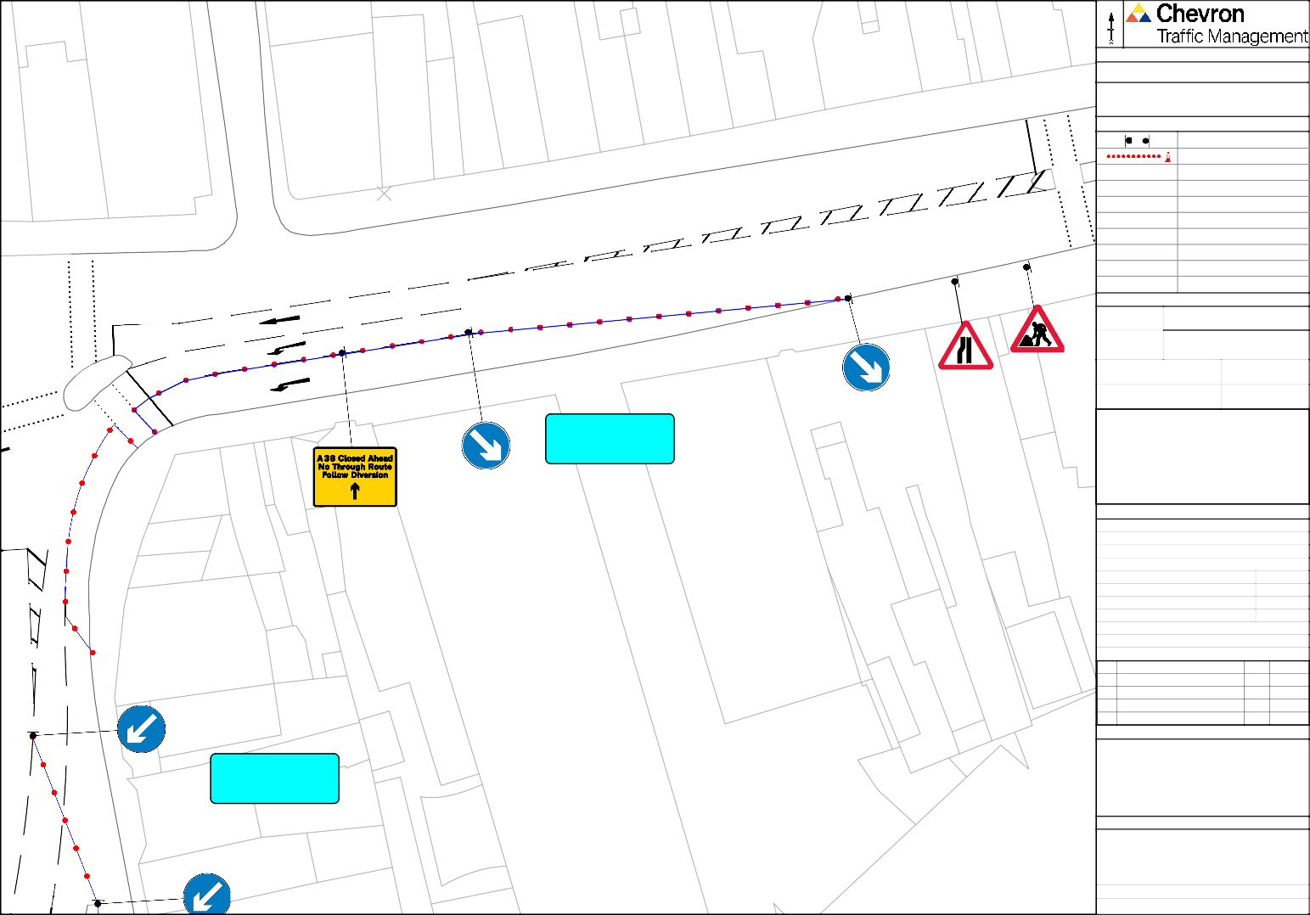

**Co-ordinates, Latitude - Longitude**

51.0148915431, -3.09643781

N

Drawing Notes

10

11

Cone lights spaced minimum 9m, cones to be 750 mm or 1m

9

8

All works to be carried out as per safety at streetworks and roadworks "A Code of Practice" October 2013.

7

6a

6

CPA conditions apply unless otherwise agreed.

5 5a

Traffic Management Key

3

3a

4

Road Signs Road Cones

2

2a

3

1

2

41

42

1

5

TM26a

153

157

43 to 45

Traffic Management

7

148

149

150

Speed of road (mph)

152

151

Site Details

[TM26b](https://www.google.com/maps/%4051.4778151%2C0.3031293%2C62m/data%3D!3m1!1e3?entry=ttu)

East Street

Minimum sideways

156

160

159

158

PH

safety zone (S)

PH Minimum longways

N/A

safety zone (L) N/A

Additional Notes:

1

3

5

TM26b

9

7

El

Sub Sta

Drawing Office

REV A

B AMENDED AS PER REQUEST ?? dd/mm/yy

C AMENDED AS PER REQUEST ?? dd/mm/yy

D AMENDED AS PER REQUEST ?? dd/mm/yy

|  |  |  |
| --- | --- | --- |
| DRAWING NUMBER |  | CF3985 |
| CONTRACT NUMBER |  | 180141 |
| PHASE NUMBER |  | 1 of 1 |
| PAGE NUMBER |  | 32 of 33 |
| SURVEYED BY / DATE | N/A | N/A |
| DRAWN BY / DATE | CF | 30/09/24 |
| CHECKED BY / DATE | CF | 30/09/24 |
| APPROVED BY / DATE | CH | 30/09/24 |
| CLIENT REF |  | N/A |
| SCALE @ A3 |  | NTS |

FIRST ISSUE FOR APPROVAL

BY DATE

CF 30/09/24

**Client**

13

###### TAUNTON TOWN COUNCIL

15 to 17

El Sub Sta

Silver Street, Taunton, TA1 3DH

Site Address

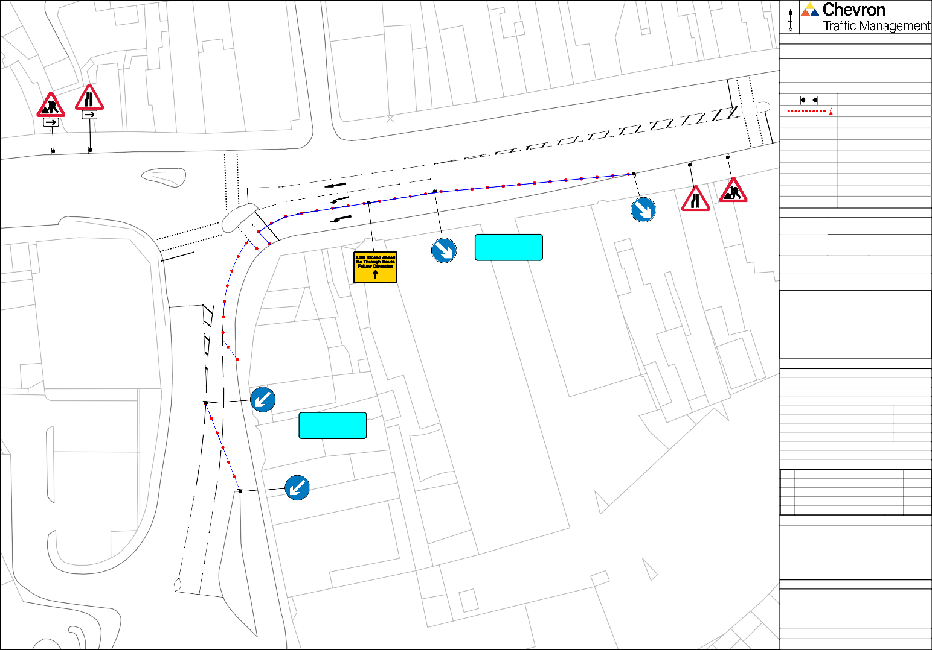

**Co-ordinates, Latitude - Longitude**

51.01452670962, -3.0971854928

|  |  |  |  |  |  |  |  |  |  |  |
| --- | --- | --- | --- | --- | --- | --- | --- | --- | --- | --- |
| TM26c | N | |  | | | | | | | |
| **Drawing Notes** | | | | | | | | | |
| Cone lights spaced minimum 9m, cones to be 750 mm or 1m | | | | | | | | | |
| All works to be carried out as per safety at streetworks and roadworks "A Code of Practice" October 2013.  CPA conditions apply unless otherwise agreed. | | | | | | | | | |
| **Traffic Management Key** | | | | | | | | | |
|  | | | | Road Signs | | | | | |
|  | | | | Road Cones | | | | | |
|  | | | |  | | | | | |
|  | | | |  | | | | | |
|  | | | |  | | | | | |
|  | | | |  | | | | | |
|  | | | |  | | | | | |
|  | | | |  | | | | | |
|  | | | |  | | | | | |
|  | | | |  | | | | | |
| **Site Details** | | | | | | | | | |
| Traffic Management | | | [TM26c](https://www.google.com/maps/%4051.4778151%2C0.3031293%2C62m/data%3D!3m1!1e3?entry=ttu) | | | | | | |
| Speed of road (mph) | | |  | | | | | | |
| Minimum sideways safety zone (S) | | | | | | N/A | | | |
| Minimum longways safety zone (L) | | | | | | N/A | | | |
| Additional Notes: | | | | | | | | | |
| **Drawing Office** | | | | | | | | | |
| DRAWING NUMBER | | | | | CF3986 | | | | |
| CONTRACT NUMBER | | | | | 180141 | | | | |
| PHASE NUMBER | | | | | 1 of 1 | | | | |
| PAGE NUMBER | | | | | 33 of 33 | | | | |
| SURVEYED BY / DATE | | | | | N/A | | | N/A | |
| DRAWN BY / DATE | | | | | CF | | | 30/09/24 | |
| CHECKED BY / DATE | | | | | CF | | | 30/09/24 | |
| APPROVED BY / DATE | | | | | CH | | | 30/09/24 | |
| CLIENT REF | | | | | N/A | | | | |
| SCALE @ A3 | | | | | NTS | | | | |
|  | | | | | | | | | |
| REV |  | | | | | | BY | | DATE |
| A | FIRST ISSUE FOR APPROVAL | | | | | | CF | | 30/09/24 |
|  |  | | | | | |  | |  |
|  |  | | | | | |  | |  |
|  |  | | | | | |  | |  |
| **Client** | | | | | | | | | |
| TAUNTON TOWN COUNCIL | | | | | | | | | |
| **Site Address** | | | | | | | | | |
| Silver Street, Taunton, TA1 3DH | | | | | | | | | |
| **Co-ordinates, Latitude - Longitude** | | | | | | | | | |
| 51.013711348, -3.09683618 | | | | | | | | | |

B AMENDED AS PER REQUEST ?? dd/mm/yy

C AMENDED AS PER REQUEST ?? dd/mm/yy

D AMENDED AS PER REQUEST ?? dd/mm/yy

33

Silver Street

25

27

29

23

28

26

24