INVITATION TO TENDER

To supply a managed service for Street Marshals from
April 2026 to March 2029

Contents
1. Introduction 1
2. Instructions to tenderers 4
3. Submission 4
4. Timetable 4
5. Tenders - assessment and evaluation 4
6. Tender conditions 7
7. Potential for TUPE Responsibility 8
8. Tenderers responsibilities 8
9. Confidentiality 8
10. Specification 8
11. Statistics 10
12. Requirements for personnel of street marshals 12
13. Payment 13
14. Form of Tender 16
15. Certificate of Non-collusion and Non-canvassing 17

Introduction
Taunton is the County Town of Somerset and was one of the first towns in the Southwest to be awarded Garden Town Status and has a population of around 62,000. Taunton Town Council is committed to enhancing security and safety measures to tackle the rise in Anti-Social Behaviour and improve safety and security for members of the public, its community and businesses through engagement, education and problem solving.
The offer must;
Create a safe and welcoming place: by using street ambassadors/marshals to create a friendly and welcoming place for people to shop and spend time in, improving the safety and security of the town centre. Safer towns will lend itself to increased footfall and more potential business for local retailers. The safe streets will entice people to venture out and explore the area, providing a boost to the local economy and improve investment opportunities.
The role of the street marshal will be to assist where possible, approach groups of people to ensure all is well and to be that helping hand, you’ll be required to engage with local businesses and identify hotspots of ASB issues.
Street marshals will look to work with a range of town centre users, this will include businesses, residents, visitors, community groups, street performers, buskers and street traders, the local policing team to ensure that the town maintains a safe and secure environment for all to prosper and grow.
Street marshals could have certification, licenses and training in the following;
- SIA
- Conflict management
- Physical intervention
- Safeguarding children
- Vulnerable adult protection
- Welfare and vulnerability engagement
- “Ask for Angela”
- First Aid
- Prevention of violence against women and girls
- Anti-racism, LGBTQA+
- Handling conflict with teenagers

Supporting Local Business Communications: Street marshals will support the town centre businesses by allowing the businesses to report town centre issues, ranging from verbal abuse, shoplifting and more serious crime where possible, the use of digital platforms or software (such as UKPAC) should be integrated to streamline reporting, enable real-time updates, and facilitate information sharing between marshals, businesses, and authorities. towards businesses via the radio link system.
Street marshals can help in the following ways;
- To provide reassurance by having a physical presence
- Be the eyes and ears on the ground to provide accurate and detailed intelligence.
- Educate members of littering, street drinking and dog fouling and to help preserve the environment.
- Administer the Town Centre Busking Code of Conduct, moving buskers on as appropriate.
- Street Trading to ensure compliance to street trading conditions of their permit
- Deterring conspiracy to commit a crime.
- Act as point of contact for enquiries and help and support visitors when needed.
- Support vulnerable people.
- Act as a professional witness.
- A point of contact for businesses to assist with reporting crime and other ASB issues.
- Carry out any initiatives that derive from the Town Council.
Wardens are not:
- Replacement for policing services
- Emergency response team
- A 24/7 hour service
- Parking or Enforcement Officers.
The town council intends to collaborate with Somerset Council on the implementation of a Public Space Protection Order (PSPO) in the town centre and surrounding areas, and will support the enforcement of its provisions. In the future, street marshals may be assigned responsibilities related to assisting with the enforcement of PSPO conditions.
Taunton Town Centre Patrol Plan (October 2025) – Image 1
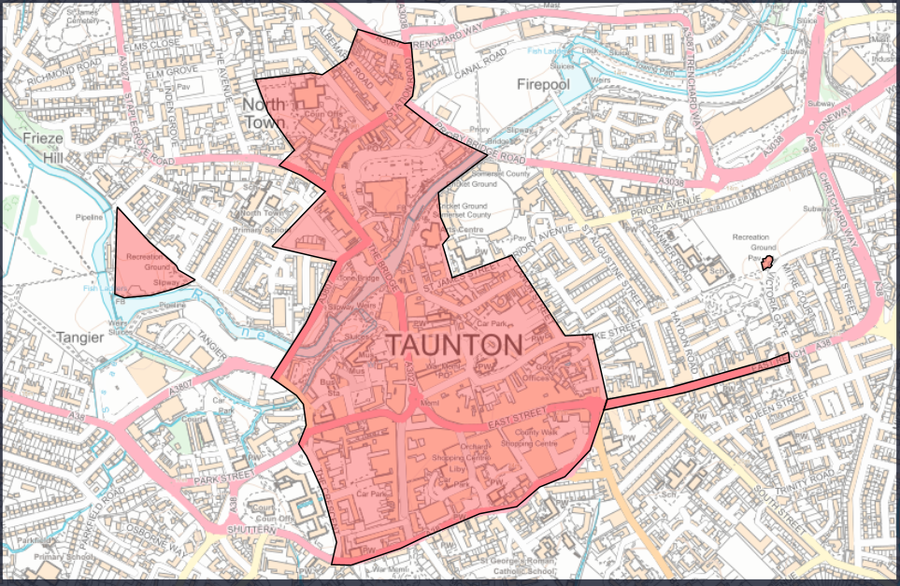
The successful contractor will be suitably experienced and qualified to undertake this tender and be able to provide examples of similar successful projects which they have been involved in.
The street marshals shall be suitably trained and hold:
- SIA Licences
- Certified in Conflict Management
- Adult and Child Protection/ Safeguarding Measures
- WAVE Welfare and Vulnerability Engagement
- First Aid
- Prevention violence against women and girls.
Tender submissions must detail how the business experience and training requirements are met. The successful contractor will deliver this contract with suitably trained personnel.
Sub-contracting by the contractor is not permitted without the consent of Taunton Town Council. Tender submissions must specify whether the intention is to sub-contract.
Taunton Town Council recognise that radios will be required from the Somerset CCTV team

Instructions to tenderers
If there are omissions, discrepancies or enquiries concerning the ITT document these should be emailed to procurement@taunton-tc.gov.uk
Any clarification queries regarding the tender document must be submitted as soon as possible. Any answers to clarifications will be emailed to all known interested tenderers prior to the submission date.
COMPLETED TENDERS MUST BE SUBMITED TO:
marshalstenders@taunton-tc.gov.uk
PRIOR TO THE DEADLINE of 12th JANUARY 2026 12:00 NOON
All tenderers are recommended to visit the town and carry out a site survey with an officer of the Town Council prior to submission of the tender document.
All tenders must be for Anti-social behaviour patrols in the form of Street Marshals as specified in the ITT. If there are omissions or errors in the tender submitted to the Council the tenderer may be required to justify the price/items concerned. Any price adjustments to the tender made by agreement with Taunton Town Council and the tenderer will be confirmed in writing by the tenderer to the Town Council before final acceptance by the Town Council.

Submission
Tenders submitted by email must be received by 12 Noon on Monday 12th January 2026
Tenders received after this time and date may not be considered.

Timetable
Taunton Town Council to award the contract in 2026.
The proposed timescale is as follows:
Activity | Date
Dispatch of ITT | 26th November 2025
Return of ITT | 12th January 2026 12:00 Noon
Evaluation of ITT | 13-30th January 2026
Notification of successful tenderer | 31st January 2026
Service commencement | 1 April 2026

Taunton Town Council reserves the right to change the timetable and will notify tenderers where a change takes place.

Tenders - assessment and evaluation
All tenders will be assessed on the following services:
- Patrol Coverage
  - Assess the approach to patrols for adequate coverage.
- Incident reporting
  - Accuracy and timeliness of incident reporting to track and address issues effectively.
- Community engagement
  - How will interactions and engagements with stakeholders take place.
- Response times
  - Average response times to incidents and requests for assistance within the town centre
- Conflict resolution
  - Assess relevant and suitable qualifications and training.
- Safety measures
  - The safety and security of wardens to ensure the effectiveness tackling ASB issues.
- Collaboration with authorities.
  - Assess the collaboration approach to other authorities to ensure effect and measured approach is taken.
Each compliant tender will be judged against the following criteria:
Description | Sub Weight | Weighting
Experience of successful working with authorities | 20 | 70
Evidence of experience, capability, and training of personnel | 25 | 70
Safety and Security | 35 | 70
Social Value | 10 | 70
Climate and Environment Considerations | 10 | 70
Price | 30
Total |  | 100

Assessing Price
The lowest cost will be awarded the maximum 30% of evaluation marks. All other bids will be evaluated by dividing the lowest cost by the bidder comparison cost and multiplying the proportion by 30% to give the bid their percentage of the total evaluation marks available.
A worked example can be found below:
Bid A is £300 so automatically gets 30 marks.
Bid B is £500 so gets 18 marks.
(The lowest cost divided by the comparison cost multiplied by 30 equals their percentage of the total evaluation marks available. 300/500 x 30 = 18)

Assessment Area | Mapped Evaluation Criteria | Notes
Patrol Coverage | Value for money; Safety and Security | Good coverage = better value and safer town
Incident Reporting | Evidence of experience, capability, and training; Value for money | Accurate, timely reporting shows capability and efficiency
Community Engagement | Evidence of experience, capability, and training | Engagement skills are part of staff capability/training
Response Times | Value for money; Safety and Security | Fast response = better value and improved safety
Conflict Resolution | Evidence of experience, capability, and training; Safety and Security | Training in conflict management is essential for both capability and safety
Safety Measures | Safety and Security | Directly scored under this criteria
Collaboration with Authorities | Experience of successful working with authorities | Directly scored under this criteria
Climate and Environment | Climate and Environment Considerations | Any environmental initiatives or low-impact practices
Cost/Financials | Value for money

The Council will not be bound to accept the lowest priced or any tender submitted and may reject any tender if it is incomplete or vague.
Tenders will be judged by the Communities Committee of Taunton Town Council and may be referred to full Council or delegated to Town Clerk for final approval. If the tenderer is required to attend a meeting to discuss their proposals, this will be at no additional charge to the Town Council.
The Town Council may require additional information as appropriate for each tender. This ITT has been prepared in good faith and Taunton Town Council does not accept any liability or responsibility for the adequacy, accuracy, or completeness of the information.
Each tenderer must make its own independent assessment of the proposed terms after making such investigations and take such professional advice as it deems necessary to determine its interest in the contract.
The tenderer must include in their tender:
a) Information concerning the contractor, including details of experience, training, and staff competencies.
b) A suggested patrol schedule and or programme.
c) Experience of working with other authorities for example the Council and Police.
d) Method statements on minimising safety risk and upholding security measures.
e) A separate document confirming the costs, including payment terms.
Figures quoted must be the total fixed price, excluding VAT, for the works concerned, including all parts of this ITT. This will include uniform, PPE, Equipment and personnel costs. Pricing should be all inclusive of every aspect to deliver and maintain the service for the duration of the contracted 12-month period. The contractor’s submission should also include a breakdown of the total fixed price to deliver all elements of the specification, into the annual cost. Unless otherwise stated by the response in the tender document. Financial arrangements will be agreed with the successful contractor. The contractor should conduct all necessary due diligence in advance of submitting their tender as the Council will not accept liability for additional payments.
f) The names and contact details of three referees who have received a similar service in the past 12/24 months.
Please note that the contractor selected to undertake this contract will have to provide documentary evidence of insurances, health and safety policies, method statements and any relevant personnel training prior to contract award.
In addition, the contractor selected will have to provide a full method statement and risk assessment to demonstrate how the patrols will work and that they are carried out safely.

Tender conditions
The tender shall provide an irrevocable offer to provide the services. The successful tenderer shall conclude a formal contract with Taunton Town Council which shall embody the tenderer’s offer.
It is clearly understood that the ITT and the submission of the tender shall not in any way bind the Town Council to enter a contract with the tenderer or involve the Town Council in any financial commitment whatsoever in this respect.
Any interested organisation who directly or indirectly canvasses any member or official of the Council concerning the evaluation of the tender, or who directly or indirectly obtains, or attempts to obtain, information from a member or official concerning any other tender will be disqualified. If at any stage during the process it is discovered canvassing has taken place, that organisation and its tender may be disqualified from the tender process.

Potential for TUPE Responsibility
It must be noted that the Transfer of Undertakings (Protection of Employment) Regulations 2006 (TUPE) may apply to this contract. The successful tenderer is required to undertake an assessment, in conjunction with the current service provider, to determine whether TUPE applies to the transfer of staff currently delivering the service, and to identify any staff who should transfer under these regulations.
Bidders must factor into their submission all costs associated with compliance with TUPE, including (but not limited to) salaries, pension contributions, and other contractual benefits of employees who may transfer. Further information regarding the current workforce and their terms and conditions will be made available to bidders for this purpose, subject to appropriate data protection provisions.
The successful tenderer will be required to comply with all relevant legal obligations arising as a result of TUPE, including consultation requirements and the protection of transferring employees' terms and conditions. Failure to comply with these obligations may result in liabilities arising for which the contractor will be responsible.

Details of TUPE attached at appendix 1

Tenderers responsibilities
The tenderer is responsible for obtaining all information necessary for the preparation of its tender and all costs, expenses and liabilities incurred by a tenderer in connection with the preparation and submission of a tender shall be borne by the tenderer. Each tenderer should satisfy themselves before submission as to the accuracy of the prices and rates and cover all obligations and all necessary information for risks and contingencies which might affect the tender.

Confidentiality
All information supplied by the Town Council in connection with this ITT shall be treated as confidential by tenderers except that such information may be disclosed so far as is necessary for the purpose of obtaining sureties, guarantees and quotations necessary for the preparation and submission of the Tender.

Specification
Communication and Monitoring
- Equipment
  - Bodycam
  - Mobile phones
  - Data
  - Radios that link to Somerset’s CCTV Team.
It will be the street marshals responsibility to ensure their radio is charged and operational before each shift.
- PPE
  - Covert stab vest
- Remote with Somerset’s local CCTV network system.
The contractor should provide access to, and training in, software systems designed for ASB incident logging, evidence management, and secure communication (e.g., UKPAC or similar). These systems should be GDPR-compliant and support a form of integration with CCTV systems and local police systems where feasible.
Reporting
- To report all security and ASB issues within the boundary area of the town through to Somerset’s CCTV Team via radio.
- Ensure all data protection regulations are followed.
- Data Administrator to collate and report through recording systems.
Uniform
The street marshals must be well presented and comfortable and protected from the UK weather.
- Smart casual appearance with coat/jacket/fleece/t-shirt
- Branded Clothing (Taunton Town Council logo).
- Branded with text as Town Centre Marshals.
- Black/dark trousers and dark boots or shoes
Events
The team will support up to 4 town centre events each year, these will be:
- Christmas Light Switch on
- Remembrance Day Parade
- Taunton Together (Free community Cultural Event)
- Taunton Carnival
Taunton Town Council is tendering with a view to agreeing a contract with a supplier from April 2026. The contract will run for 36 months, up to March 2029.
The areas where the street marshals should concentrate their efforts are within the mains streets in Taunton Town Centre, although can extend accordingly to the geographical area of Image 1
- East Street
- North Street
- The High Street
- Fore Street.
- Station Road
- Victoria Park Pavilion
The street marshals will maintain a high-profile presence in designated areas by undertaking regular patrols on foot. There are currently no public space protection orders in these areas.
The service provider maybe be required to work flexibly day and nighttime hours and adapt their patrolling schedule accordingly based on the data that is captured. The town council would seek to find preventative measures with the aim of reducing ASB across the town.

Statistics
Taunton Town Centre has a number of keys areas where ASB issues are reported these are East Street, North Street, High Street and Taunton Road in Taunton.
Top ASB Locations | Reported Numbers
Taunton outside of town area | 25
East Street | 24
North Street | 22
High Street | 21
Station Road | 20
Total | 112
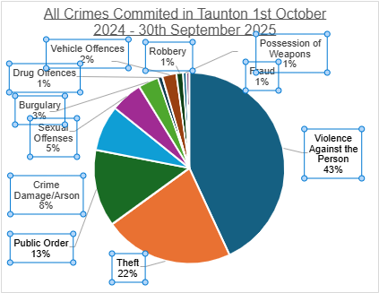
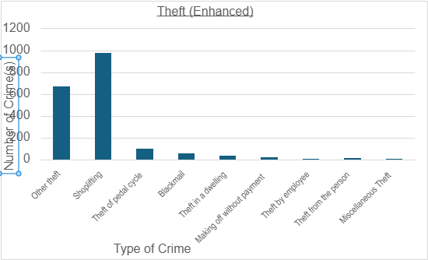

ASB Incidents Over Time (June 2022 – May 2023)
Jun | Jul | Aug | Sep | Oct | Nov | Dec | Jan | Feb | Mar | Apr | May
142 | 144 | 145 | 142 | 147 | 147 | 143 | 140 | 136 | 133 | 132 | 129

Safe working practices must be adhered to and the contractor will need to show evidence of the relevant professional and public liability cover to the value of £10M.

Requirements for personnel of street marshals
Standard to be achieved.
- Public Safety and Security
To achieve a safe and welcoming town centre by patrolling the areas where ASB issues are frequently reported to deter anti-social behaviour and to reduce escalation. Providing assistance on crowd control and emergency procedures. Street marshals to operate in pairs at unsocial hours for safety and security purposes.
Street marshals must comply with all requirements under section 2 (3) of the 1974 Health and Safety at Work Act (HASAW), as far as reasonably practicable, to ensure the health, safety and welfare of all employees.
- Community Engagement an Assistance
Street Marshals will be expected to engage with the local community, aiding visitors and residents and serve as a point of contact for questions or concerns on public safety issues.
- Incident Reporting
Street Marshals will be responsible for the reporting of incidents and issues and will be responsible for identifying trends, hotspots and other concerns in the town centre.
To update the Town Council at reoccurring scheduled meetings on issues and for the Town Council to look further into developing initiatives to reduce ASB.
- Collaboration with Local Authorities.
The street marshals will be required to work closely with the police, local community organisations such as ARC (Taunton’s association for the homeless) and youth providers to identify initiatives to help tackle anti-social behaviour issues across the town.
- Public Health Awareness (Safeguarding and Vulnerable People)
The street marshals will need to show empathy and understanding to those who identify as vulnerable or appear to have mental health concerns.
- Professional Conduct
The street marshals will demonstrate the necessary skills for their duties and conduct themselves in a professional manner that reflects the professionalism of the Town Council
- Communications
The street marshals will have effective communication skills with all stakeholders and have skills to de-escalate situations and keep the Town Council informed of issues and situations by various channels. Somerset’s CCTV control room prevents crime and increases community safety. The cameras are monitored 24/7 and has Police airwave radios and are directly linked to the Police Control Room.
The street marshals who will act as ambassadors for the town centre and will be representing the town council in the heart of the town and community and will require to present a professional and friendly demeanour.
Timings
Taunton Town Council shall provide the contractor with statistical information, which would indicate the days of operation and therefore where the resource shall be allocated. The street marshals can work a flexible shift pattern to address the ASB issues across the town centre. It will be the responsibility of the street marshals to communicate their shifts with the Operations Manager and must not exceed the allowance of 32 hours per week, (16 hrs per street marshal)
Assistance with and provision of documents
The Town Council may ask to see any relevant documentation to support the role of the street marshal should be provided to the Council any requests for documentation / certificates within five working days.
Please note that the contractor is responsible for supplying street marshals to the specification standard.

Additional points and overarching conditions
- The service provider will be responsible for supplying street marshals and all other necessary pieces to cover the duties of street marshals
- The service provider will be responsible for establishing excellent working relationships with a range of key stakeholders and community groups.

- Taunton Town Council to have a direct communication link to the street marshals to share updates and intelligence.
- Street marshals to have a clocking in and clock out system so that hours can be recorded and monitored.
- Tenderers must certify within their tender submissions that they can meet the required timescales.

Payment
Payment for services to the contractor will be made upon the receipt of a satisfactory VAT invoice and may be made in instalments. Full terms are to be agreed once the contract has been awarded.
The total budget for this tender will not exceed the value of;
The contract value is £254,690.16
April 2026 | £82,400
April 2027 | £84,872
April 2028 | £87,418.16
TOTAL | £254,690.16

PROFESSIONAL & BUSINESS STANDING
Has your organisation, at any time during the last 3 years, been in a state of bankruptcy, insolvency, compulsory winding up, administration, receivership, composition with creditors or any analogous state, or subject to relevant proceedings where the proceedings were commenced for valid reasons? YES / NO

Has your organisation, its directors or any other person who has the power of representation, decision or control of the named organisation ever been convicted of a criminal offence related to business or professional conduct, including fraud or conspiracy to defraud? YES / NO

Has your organisation had any judgement made against it in relation to similar contracts in the last three years? YES / NO

Has your organisation been involved in any tribunal hearing in relation to any similar service in the last three years, which has resulted in a judgement being made against it? YES / NO
References:
Please provide details of up to 3 contracts, in any combination from either the public or private sector, voluntary, charity or social enterprise that are relevant. Contracts for supplies or services should have been performed during the past 3 years.
The named contract provided should be able to provide written evidence to confirm the accuracy of the information provided below.
Consortia bids should provide relevant examples of where the consortium has delivered similar requirements. If this is not possible, then 3 separate examples should be provided between the principal members of the proposed consortium.
If you are not able to provide a response, please clarify and describe below how you believe your organisation can meet the requirements of the specification.
Contract title | Details of work carried out | Contact details

Insurance details:
Details of Insurance required:
Public liability insurance | £5,000,000
Employer’s liability insurance | £5,000,000
Professional indemnity insurance | £5,000,000

Please ensure that Sub-Contractors involved in the provision of the Services hold and maintain appropriate cover also
Please confirm that your organisation has the required level of cover or is prepared to obtain the level of cover prior to award.

Form of Tender
Contract for the provision of [Tender Title] to Taunton Council
Ref: [Tender Reference]
I/We hereby tender to enter into a contract with Taunton Town Council to provide the goods and/or services in the Specification in accordance with the Tender Documents and this Invitation to Tender including without limitation the Terms and Conditions of Contract and the prices entered in the Pricing Schedule.
I/We agree the insertion by us of any conditions qualifying this tender shall not affect the Tender Documents and may cause the tender to be rejected. We confirm that we have not made any unauthorised alteration to the Tender Documents.
I/We agree that this tender shall remain open to be accepted and cannot be withdrawn for a period of Ninety Days from the tender return date.
I/We understand that you are not bound to accept the lowest or any tender you may receive.
I/We undertake, in the event of your acceptance, to execute with you any formal agreement which may be deemed necessary, embodying all the conditions and terms contained in this offer, as soon as reasonably practical upon being called to do so.
I/We warrant that we have all requisite authority to sign this Invitation to Tender and confirm that we have complied with all the requirements set out herein.
Signed
Name
Date
On Behalf of
Position

NOTE: THIS CERTIFICATE MUST BE SIGNED AND COMPLETED BY THE TENDERER AND RETURNED WITH THE TENDER. FAILURE TO FULLY COMPLETE AND SIGN THE CERTIFICATES MAY LEAD TO THE REJECTION OF YOUR TENDER.

Certificate of Non-collusion and Non-canvassing

[Description of Services, Works, or Goods (the ’Contract’)

To: Taunton Town Council

Date:
For the attention of: [Procuring Officer]
Note to Organisation: As a public body it is important that the Council receives genuine competitive offers from Tenderers, and that all Tenderers act in a manner that is honest and reflects best practices. Tenderers are therefore required to sign this document to certify that they have not and will not undertake any acts of canvassing or collusion.
Statement of Non-canvassing

I/We certify the following.
I/we hereby certify that I/we have not canvassed any member, director, employee or adviser of the Council in connection with this Tender and the proposed award of the Contract by the Council and that no person employed by me/us or acting on my/our behalf, or advising me/us, has done any such act.
I/we further hereby undertake that I/we will not canvass any member, director, employee or adviser of the Council in connection with this Tender and the proposed award of the Contract and that no person employed by me/us or acting on my behalf, or advising me/us, will do any such act. I/we agree that the Council may, in consideration of this bid, and in any subsequent actions, rely upon the statements made in this Certificate.
Statement of Non-collusion
The essence of the public procurement process for selective tendering for the Contract is that the Council shall receive bona fide competitive Tenders from all Tenderers.

In recognition of this principle, I/we hereby certify that this is a bona fide offer, intended to be competitive, and that I/we have not fixed or adjusted the amount of the offer or the price in accordance with any agreement or arrangement with any person (except any sub-contractor identified in this offer).

I/we also certify that I/we have not done, and undertake that I/we will not do, at any time during the tender process or in the event of my/our Tender being successful while the resulting Contract is in force, any of the following acts:

- enter into any agreement or agreements with any other person that they shall refrain from tendering to the Council or as to the amount of any offer submitted by them; or
- inform any person, other than the Council of the details of the Tender or the amount or the approximate amount of my/our offer except where the disclosure was in confidence and was essential to obtain insurance premium quotations required for the preparation of the Tender; or
- cause or induce any person to enter into such an agreement as is mentioned in paragraph 1 and 2 above or to inform us of the amount or the approximate amount of any rival Tender for the Contract; or
- commit any offence under the Bribery Act 2010 nor under Section 117 of the Local Government Act 1972; or
- offer or agree to pay or give or actually pay or give any sum of money, inducement or valuable consideration directly or indirectly to any person for doing or having done or causing or having caused to be done in relation to any other Tender or proposed Tender for the performance of the Project covered by the Tender any act or omission.
In this Certificate, the word ’person’ includes any person, body or association, corporate or incorporate and ‘agreement’ includes any arrangement whether formal or informal and whether legally binding or not.
I/we agree that the Council may, in its consideration of the offer, and in any subsequent actions, rely upon the statements made in this certificate.

Signed
Name
Position
For and on behalf of [Insert the name of your company here]

