goods & services agreement

27587 –
25T Heavy Goods Vehicle Ramp

CONTRACT

This Contract is entered into as of the 29th day of September 2025

BETWEEN

PLYMOUTH CITY COUNCIL (including its employees and agents) whose office is at Ballard House, Plymouth PL1 3BJ (which, is herein after called the “Council”)

and

STERTIL UK LTD whose registered office is at Stertil House, Unit A, Brackmills Business Park,
Caswell Road, Northampton, NN4 7PW (hereinafter called the “Supplier”)

WHEREAS

the Council requires the Supplier to carry out the following (hereinafter called the ”Goods and Services”)

Provision of 25T Heavy Goods Vehicle Ramp in accordance with the Contract Documents

NOW IT IS HEREBY AGREED that

This Contract shall consist of the following parts (collectively referred to as ‘the Contract Documents’) and in the event of conflict between the Contract Documents they shall take precedence over each other in the order listed.

- Annex 1 - The Contract Requirement
- Annex 2 – Tender Submission
- Annex 3 – Tender Question and Answer Log
- Annex 4 – Supplier Details

The Supplier shall carry out and complete the Services in accordance with the Conditions of Contract and the Special Conditions of Contract and the Council will pay to the Supplier such sums as agreed in the pricing schedule.

The Services shall commence on 29th September 2025.

This Contract shall expire on 25th September 2028. The Council may extend the period of the Contract by up to 2 further periods of 1 year by serving written notice on the Supplier no later than 3 months before the expiry of the Contract.

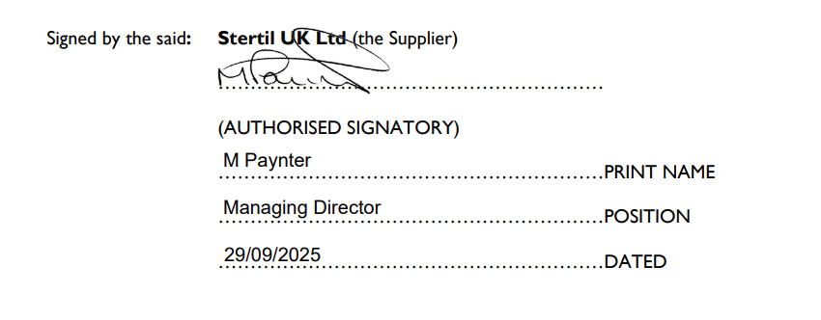
Signed by the said: Plymouth City Council (the Council)
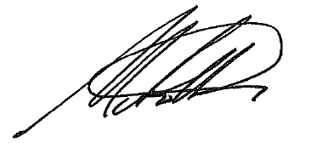
(AUTHORISED SIGNATORY)
……MARTIN HOAR…………………….………PRINT NAME
Interim Head of Environmental Operation………POSITION
…26/09/25………………………………………..DATED

ANNEX 1 – THE CONTRACT REQUIREMENT

- Contract Requirement

  - The documents contained herein, constitute the contract requirement for the supply of 25T Heavy Goods Vehicle Ramp

1.1.1 27587 – 25T HGV Ramp – Instruction Document

1.1.2 27587 – 25T HGV Ramp – Return Document

1.1.3 Appendix A – Specification

1.1.4 Appendix B – PCC Goods and Services Terms and Conditions

1.1.5 Appendix C – Financial Viability Risk Assessment Tool

1.1.6 Appendix D – Pricing Schedule

ANNEX 2 - TENDER SUBMISSION

- Tender Submission
  - The documents contained herein, constitute the contract requirement for the provision of 25T Heavy Goods Vehicle Ramp

    - 27587 – 25T HGV Ramp – Return Document_MBA
    - Appendix C – Financial Viability Risk Assessment Tool
    - Copy of Appendix D – Pricing Schedule
    - Plymouth City Council 1125081801 ST4250-8 18 Aug 2025
    - Stertil UK Limited accounts 31 December 2023
    - Stertil UK Limited 2024 – Final accounts SIGNED

ANNEX 3 – QUESTION AND ANSWER LOG

- Question & Answer (Q & A) Log

The document contained herein, constitutes the contract requirement for the provision of 25T Heavy Goods Vehicle Ramp

3.1.1 – Question and Answer Log

ANNEX 4 – SUPPLIER DETAILS

Supplier Name

Stertil UK Ltd
Supplier Registered Address

Stertil House, Unit A, Brackmills Business Park, Caswell Road, Northampton, NN4 7PW
Company Registration Number

01103855
VAT Registration Number

GB 223 5675 66
Supplier Correspondence Address

As above
Contract Manager Name

David Goddard
Telephone
07771 993873
E-mail

dgoddard@stertil.co.uk

