
NW3023 - Customer Research and Engagement

Scope Document

INTRODUCTION

Northumbrian Water Limited (NWL) is a company registered in England and Wales with company number 02366703 and whose registered office is at Northumbria House, Abbey Road, Pity Me, Durham, DH1 5FJ.

In the northeast of England, NWL trades as ‘Northumbrian Water’ in the supply of potable and raw water and the collection, treatment and disposal of sewage and sewage sludge (it provides only wastewater services in Hartlepool). In the southeast of England, NWL trades as ‘Essex & Suffolk Water’ in the supply of water services only.

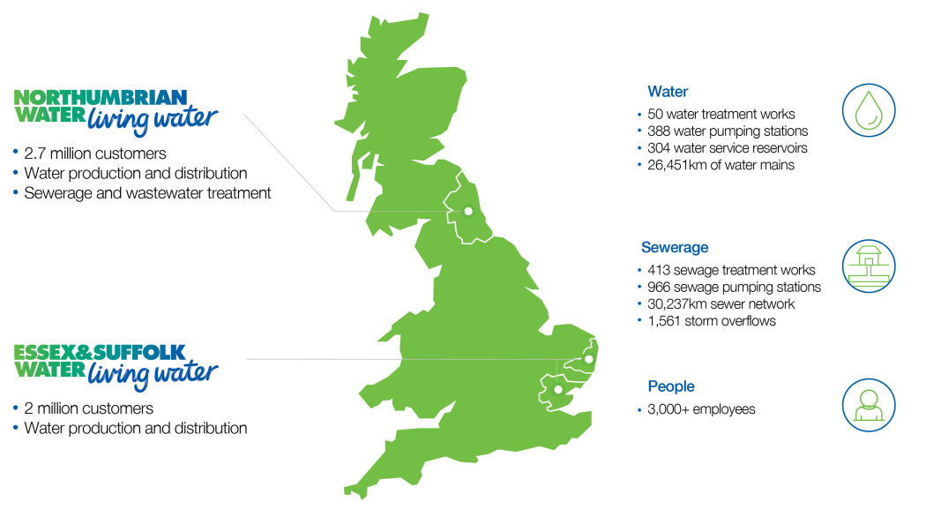

Our purpose is: Caring for the essential needs of our communities and environment, now and for generations to come. We do this by providing reliable and affordable water and wastewater services for our customers. We make a positive difference by operating efficiently and investing prudently, to maintain a sustainable and resilient business.

Purpose is designed to convey why a business exists and guide strategy and behaviours; considering the role business can play to improve society and applying this to services and customer experience. First and foremost, our core role is as a provider of water and wastewater services, which places us at the heart of our communities and our natural environment. Caring for them is always our priority.

Throughout our business, all of our teams are committed to delivering what matters for our customers, communities and environment, and everything we do is focused on achieving the best possible outcomes for them.

Our vision is to be the national leader in the provision of sustainable water and wastewater services, and our values act as guiding principles to help us achieve this vision. These can be seen in the following image.
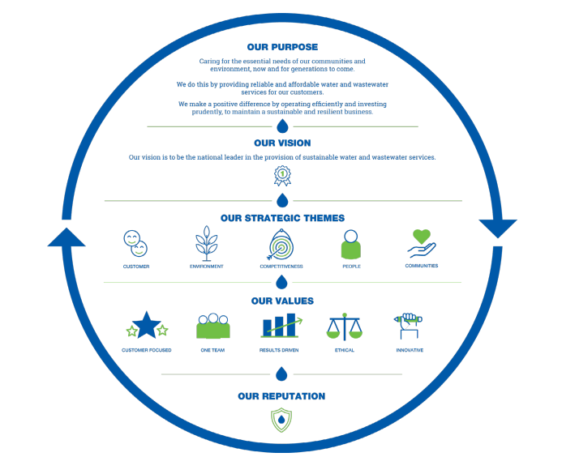
The provision of water and wastewater services in England and Wales is a regulated business, and several organisations including the economic industry regulator, Ofwat, oversee our activities.

Every five years we present a business plan to Ofwat detailing the prices we wish to charge our customers for the services that our customers want us to provide. This process is known as a Price Review (PR).

Customers are at the heart of everything we do and every decision we make. Our plans are co-created with our customers, and other stakeholders, through a robust programme of customer engagement, research and participation. We expect to be fully involved in all customer research and engagement projects and want to be consulted at every stage. We strive to ensure that our customer research and engagement is leading both within the water industry and compared to other sectors.

OUR CUSTOMER RESEARCH AND ENGAGEMENT

We are currently working towards the Price Review that will take place in 2029 (PR29) and require framework partners to work in partnership with us to provide customer research and engagement and supporting consultancy services. PR29 will see us develop and submit our business plan, which will cover the services we will provide from 2030 onwards – the exact period of time is to be confirmed.

To understand the potential scale of customer research and engagement required, you can visit our Research library where we published the findings from the activities undertaken for our PR24 business plan, which covered the period 2025-30.

This area of our website contains our Business Plan 2025-30. Our Long-term strategy (LTS), our Water Resources Management Plans (WRMP) and our Drainage and Wastewater Management Plan (DWMP) can also be found in that area. All those documents will be refreshed and developed further alongside our PR29 Business Plan.

The following Appendices may be of interest to you:
NES02 Appendix A1 - customer affordability and acceptability
NES08 Appendix A7 - customer and stakeholder engagement

The following supporting documents may be of interest to you:
NES42 - A7-01 PR24 Customer Research - Common PCs Insights Summaries
NEs43 - A&-02 PR24 Customer Research - Enhancements and Other Service Area Summaries
NES44 - A&-03 PR24 Customer Research - Prioritisation of Commons PCs
NES45 A&-04 PR24 line of sight

We will undertake both qualitative and quantitative research to understand our customers’ priorities and the value they place on our services. This includes making decisions on the level of services customers can expect to receive and the investment we will make.

Alongside this, we will require other professional services to consult on the use of the information we obtain from research to build suitable models from which we can devise cost effective plans.

We require partners, with excellent professional experience, who can demonstrate a sound understanding of:
- A wide range of customer research methodologies (both qualitative and quantitative)
- A broad range of economic research methodologies
- An in-depth understanding of behavioural economics
- The current regulatory landscape
- Willingness to Pay
- Triangulation methods
- Cost benefit modelling
- Our business and the industry in which we operate
- Innovative practice towards economic research and other customer engagement
- How to make complex information understandable for customers
We welcome submissions from individual companies or consortiums of experts. If you are part of a consortium, please indicate who the lead organisation is.
We want to deliver a robust and innovative research and engagement programme so that our plan reflects our customer priorities and willingness to pay for services.

Our research and engagement must stand up to robust scrutiny by our Executive Leadership Team, Board and regulators.

We will also engage with the Water Forum, (NWL’s Customer Challenge Group). Members of the Water Forum will challenge our research methods, the robustness of the research and engagement and the interpretation of any results. The Water Forum will ensure that our plans adequately reflect the results of our triangulated findings.

Objectives

We need to undertake an innovative, inclusive and leading programme of research and engagement, to understand:
- What our customers and stakeholders believe are the most important areas of service provided by NW and ESW.
- What improvements, if any, our customers and stakeholders would like to see to these services and how they value them.
- How our customers and stakeholders would like to see us incentivised or penalised for our performance against our service commitments.
It is important that, where appropriate, our research is statistically valid and representative of NW and ESW customer bases, both demographically and geographically. The customers in the ESW region will be asked about service attributes relating only to water supply where customers in the NW region will be asked about service attributes relating to both water and sewerage services.

Specific projects will run alongside and be triangulated with our business-as-usual tracking programmes and other customer insight.

FRAMEWORK CONTRACT SPECIFICS

We will take a maximum of 10 vendors through from Conditions of Participation (COP) to Request for Proposal (RFP) subject to scoring a minimum of 60% on the COP questions.

It is then our intention to have 6 vendors on this framework contract, if a spend is anticipated to be £5,000 or more we will send out a request via the Annex A document in the contract for a detailed proposal.

The framework will be in place for 4 years.

The anticipated spend over the 4 years of this framework contract in total is expected to be £1,000,000.

For note - where deemed appropriate there may be occasions where framework partners are expected to work together collaboratively.

Timescales

Our high-level indicative timeline for the tender is outlined below:

Issue of COP
COP Opens 17.11.2025 PQQ Closes 12.12.2025
Issue of RFP
RFP Opens 17.12.2025 RFP Closes 16.01.2026
Interviews
To be conducted between 03.02.26 – 04.02.26 – in Durham (Pity Me Office – DH1 5FJ)
Best and Final Offer (BAFO)
BAFO Opens 06.02.2026 BAFO Closes 11.02.2026
Contract award March 2026
Contract signed March 2026
Contract starts 01.04.2026
service level agreements (SLAs)

We expect the following Service Level Agreements (SLAs) to be in place with the framework partners. By submitting a tender, you agree to deliver on these SLAs:

- You will appoint a senior member of your organisation to act as first point of contact (account manager) for NWL. They will have a nominated deputy.
- There will be an identified senior member of the framework partner’s organisation responsible for receiving and managing confidential documents, such as customer datasets and contractual documents, otherwise known as data control.
- When engaged on a project, regular catch-up meetings will be held. A dedicated project lead, or a nominated deputy, will be present at all catch-up meetings.
- Your organisation must be a member of the Market Research Society and abide by their Code of Conduct.
- Invoice payment terms are 45 days. Invoices will be paid in the following format:
  - 50% upon project commencement,
  - 50% upon completion.
For larger, long-term projects, the schedule of payments may be adjusted by mutual agreement.

KEY PERFORMANCE INDICATORS (KPIs)
KPI - A way to help measure how well companies are performing against goals - allows NWL to see how close we are to achieving objectives.

- All invoices must have a Purchase Order number on them or will be rejected.
- Positive or negative customer feedback should always be referred to the nominated NWL stakeholders within 1 working day.
- For any invoice discrepancies raised we require resolution within 2 working days of the concern being raised.
- When a subcontractor is to be used NWL must be advised before any work is undertaken (for agreement).

