Reedbed Hide refuge
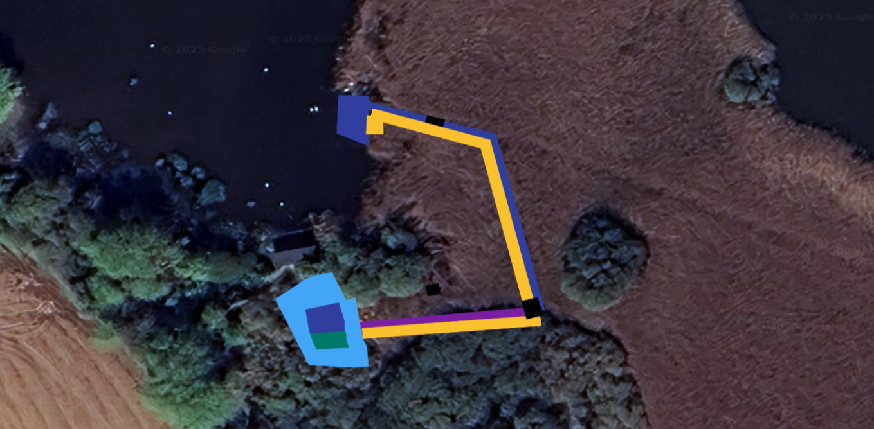
Refuge
Deep Pool
Shallow marsh fringe
New ditch
culvert
Spoil from ditch & pool
Deep Pool
Ditch to restore
Reedbed Hide refuge
Location https://w3w.co/cookie.contain.leaned
Ditch Restoration:
• Length: ~75 m.
• Water depth: 1.5m (when lake level = 1.3 m AOD).
• Open water zone: ≥1.5 m wide.
• Nearside edge: 5 m wide lowered (retain reed rhizome).
• Spoil formed into linear bunds (max side slope 25°).
Deep Pool:
• Water Depth: ≥1.5 m (lake level = 1.3 m AOD).
• Base area: ≥30 m².
• Slopes: 45° except at refuge junction.
• Spoil used for adjacent mounds and refuge creation.
Beaver refuge: as standard beaver refuge specifications.
Shallow Pool Margin:
• As standard beaver refuge specifications.
• Scrub clearance (cut to ground, stumps remain).
Access Ramps:
• As standard beaver refuge specifications.
New Ditch:
• Length: ~50 m.
• Water depth: ≥1.5 m water (when lake level = 1.3 m AOD).
• Marginal zones: 3 m wide.
• Culvert: 600 mm double-walled pipe for bogmaster access.

