Harrisons refuge
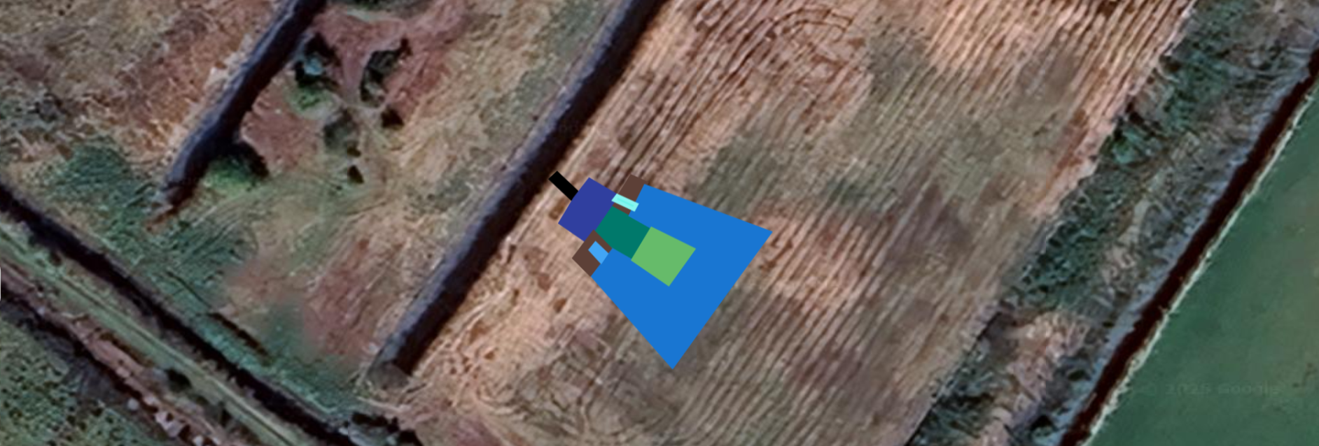
Shallow Marsh zone – extensive as time allows
Access ramp
Culvert + bridge
Deep pool
Dry reedbed zone
Flexi pipe outlet
Overflow rill
Refuge
Harrisons Refuge
Location; https://w3w.co/gracing.gravy.gaps
Linking Ditch Culvert: linking existing ditch to deep pool at bed of pool
• Width: 5 m.
• Pipe: 450 mm straight culvert pipe.
• Culvert slopes (into linking ditch): 20°.
• Length – culvert length only.
Deep Pool:
• Steep sided.
• Flexi pipe to be installed at base of pool, leading to reedbed area at “back” (furthest from existing ditch) of pool.
• Remaining specifications to be as standard beaver refuge specifications.
Beaver refuge: as standard beaver refuge specifications.
Shallow Marsh Zone:
• Surrounding sides and back of refuge but with high, dry reedbed zone (5m) (extending 5m out from refuge base) except deep pool N.B goes round access ramp.
• Water depth: Minimum 500mm at completion.
• Slope: Gentle rise to adjoining areas, minimum 20° (except at refuge).

