Grove Ferry refuge
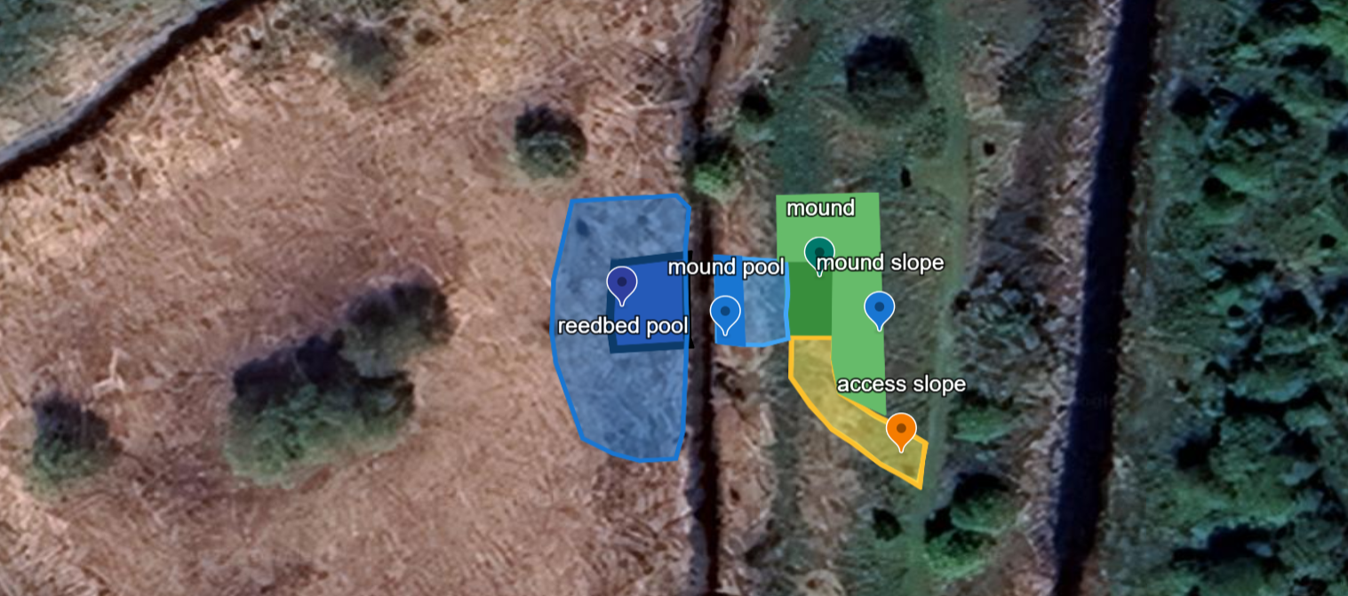

Location; https://w3w.co/offices.linked.tucked

Reedbed Pool:
• Semicircular, open to existing ditch along flat side.
• Pool bed surface area: Equal to the refuge top area.
• Water depth: Minimum 1.5m at completion.
• Side Slopes: Minimum 35°.
• Reedbed/Pool interface (“back” of pool): series of “fingers” (higher formed, using spoil from lower areas).
Refuge Pool:
• Water depth: Minimum 1.5m at completion at ditch interface.
• Deep channel to extend to refuge base
o 1.5m minimum water depth
o 1m wide
o Bridge to span deep channel for future machinery use
• Shallow area at mound base for future machinery access.
• Slopes gentle for safe access.
Viewing Refuge:
• Top Surface Area: Minimum 50m², levelled and smooth.
• Target height: 3.8 m AOD (raise approx. 1.8 m, contractor to confirm).
• An entrance channel to be added where the refuge meets the refuge pool.
o A bridge to be installed over the entrance channel.
Viewing refuge slopes:
• Minimum 1:3 gradient, much steeper on pool-facing edge.
Access Slope:
• From existing path to mound top.
• Gradient: ≤1:12.
Compartment Culvert:
• Lower area to create 400 mm water depth over 5 m length.
• Spoil placed in mound on far side to deter trespass.

