Phase 2 Oxbow
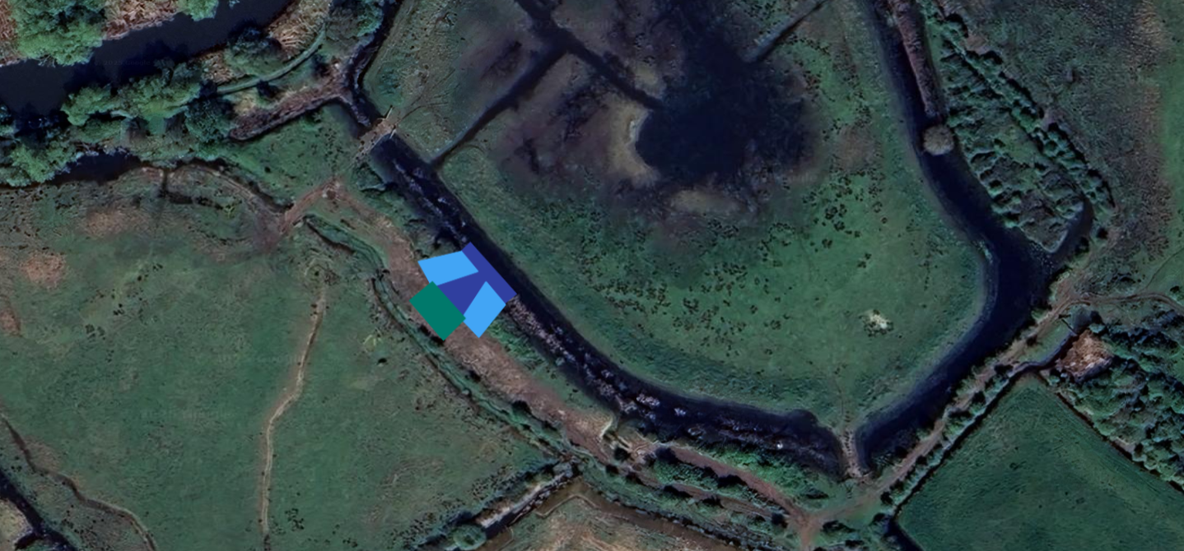
Phase 2 Oxbow

Location - what 3 words; https://w3w.co/pave.knitted.ranked
• Reform existing bund and area leading to existing ditch to meet standard beaver refuge specifications
• Culvert (5m wide) to be created across new linking ditch
o 450mm straight culvert pipe to be supplied and installed by contractor
o Culvert slopes into linking ditch to be 20-degrees

