Middle reedbed

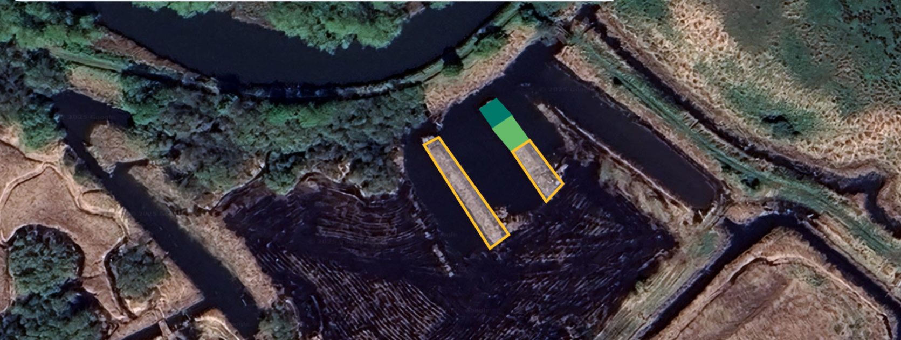
Possible material to use
Access slope
refuge

Location = https://w3w.co/open.pulses.alternate
(See Appendix BR 1 for location and approximate plan view)
• Reform existing bund and pools to meet standard beaver refuge specifications
o NB due to unknown factors in this area this item of works should be priced at a day rate, by 3 days for an excavator suitable for boggy conditions and a wide tracked dumper. Any remaining time, within the 3 day period will be used in the immediate area to create other wildlife features, likely, localised reedbed lowering and small mound creation suitable for water voles.

