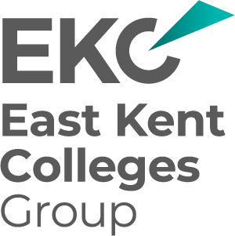
EKC Group –Tender to provide a HR and Payroll System solution (5-year contract)
Tender Clarifications and Guidance 6

The ITT refers to potential LMS functionality under Training and Development
and notes possible integration but does not specify whether an existing LMS is in use.
Please confirm whether EKC Group currently operates a Learning Management System,
and if so, whether you intend to retain it under this contract or would like suppliers to propose
and implement an integrated or new LMS solution as part of this procurement.
We currently use a couple of topic specific LMS systems for mandatory training and Safeguarding
and have some topics on our Moodle for staff.
Our intention would be to see if these could be moved to a single system and this may be something
that suppliers could propose as added value (with costings etc).

Under the 50% weighting for Customer Requirements, will each section (e.g. HR Management, Payroll, etc.)
be scored individually, or will the 15-page response be reviewed and scored as one combined
technical submission

It will be one combined score, but each section attracts points to complete the scoring

_END_

