Background to Natural England
Natural England are the government agency for nature conservation. Part of our remit is the management of National Nature Reserves. To undertake this work we require tools, machinery, equipment & services.
Fenn’s, Whixall and Bettisfield Mosses NNR – Welsh Cut and treat 2025 scrub management.

Background to the specific work area relevant to this purchase:
- Background:

The Marches Mosses BogLIFE project (LIFE15 NAT/UK/000786) was a six-year project started in October 2016 and concluded on 31 December 2022. The project aimed to restore Britain’s 3rd largest lowland raised peat-bog, comprised of the complex of Fenn’s, Whixall & Bettisfield Mosses NNR’s and Wem Moss NNR all located near Whitchurch, Shropshire and Wrexham in Wales, in total approaching 1000ha (see Map, Annex 1.1). The LIFE project was led by Natural England working in partnership with Natural Resources Wales and the Shropshire Wildlife Trust. The project was financially supported by LIFE, a financial instrument of the European Commission and the Heritage Lottery Fund. It is imperative that the control of birch (and scrub) is continued following on from the end of the project in order to aid the continuing restoration process.
- Site/Access:

The sites of work are within the Fenn's Moss area of Fenn’s Whixall & Bettisfield Mosses National Nature Reserve (NNR), designated a Special Area of Conservation, a Site of Special Scientific Interest and listed in the Ramsar Convention, located four miles south-west of Whitchurch (Shropshire). The NNR is split into management sections; the sections relevant to this contract are Sections 6, 7, 31.2 and 32.1 (see Annex 1.2 for NNR management section map).
- Invitation:
You are invited, to submit a quotation for the requirement described in the specification below.
Please confirm, by email, receipt of these documents and whether you intend to submit a quote.
Your response should be returned to the following email address by:
Email: nathan.brake@naturalengland.org.uk
copied to: peter.bowyer@naturalengland.org.uk
Date: 1st December 2025
Time: 9am
Ensure you state the reference number and ‘Final Submission’ in the subject field to make it clear that it is your response.
NOTE depending on available funding, not all the work may be commissioned.
Contact Details and Timeline
Nathan Brake will be your contact for any questions linked to the content of the quote pack or the process. Please submit any questions by email and note that, unless commercially sensitive, both the question and the response will be circulated to all tenderers.
Action | Date
Date of issue of RFQ | 14th November 2025
Viewing dates | 24th November 9am 2025
Deadline for receipt of Quotation | 1st December 9am 2025
Intended date of Contract Award | 2nd December 2025
Intended Contract Start Date | 8th December 2025
Completion Date | 20th February 2026

- Requirement:
The aim of the contract is to herbicide treat (primarily) birch and pine by cut and treat starting 8th December. The target species will be all woody species (Birch, Alder Buckthorn, Oak, Rowan, and Willow) on the bunds and birch, willow & pine only in the cells.

This contract specifically covers areas of the moss where peat restoration work has been carried out using a process called cell/contour bunding. Bunding is a network of impermeable, raised, but low, (approx. 30cm tall) peat-berms (bunds) topped with vegetation that have been created by machine. These bunds have been created in a network of cells to help retain water on the bog. This in turn aids the re-wetting and regeneration of the bog. The identified species are undesirable as they aid the drying out the bog and/or de-stabilise the bunds that have been created.
The work is planned to begin on the 8th December 2025 and should be completed by no later than 20th February 2026. Though depending on when the sap starts to rise within the target species this end date may need to be brought forward. In your methodology, please state your availability and predicted timescale to complete the works.
N.B. ALL SCRUB ON THE BUND WALLS is to be treated.
The scrub varies in height from approximately 1m to 6m tall scrub. The density varies between and within work areas. It is strongly recommended that you visit the site prior to submitting a quote.
The work areas to be treated are shown in Annexes 3.1, 3.2 & 3.3 some areas may be excluded from the contract if costs exceed the available budget. The boundaries of all areas to be treated have been marked out using GPS technology, there will be no physical markers on the ground. Contractors may use their own flags for guidance or to define progress, but these must be removed on completion of each management section.
The maps appended in Annex 3 show the work areas and their specified treatment.
Section 6
Total Area: 4ha (bunds and cells)
Annex 3.1
100% of all scrub (regardless of its height) on Bund walls, birch, pine and willow (1m to 6m tall) within the bunds. Brash is to be cut and left in situ within the cells. Brash cut from the bund walls is to be moved off the bund walls and left within the cells.
This area comprises of a bunded section. There is no public access in this area, but a public footpath does run to the West of the area.
Boundaries:
All boundaries are as per the attached map.
Section 7
Total Area: 12ha (bunds and cells)
Annex 3.1
100% of all scrub (regardless of its height) on Bund walls, birch, pine and willow (1m to 6m tall) within the bunds. Brash is to be cut and left in situ within the cells. Brash cut from the bund walls is to be moved off the bund walls and left within the cells.
This area comprises of a bunded section. There is no public access in this area, but a public footpath does run to the East of the area.
Boundaries:
All boundaries are as per the attached map.
Section 31.2
Total Area: 5ha (bunds and cells)
Annex 3.2
100% of all scrub (regardless of its height) on Bund walls, birch, pine and willow (1m to 6m tall) within the bunds. Brash is to be cut and left in situ within the cells. Brash cut from the bund walls is to be moved off the bund walls and left within the cells.
This area comprises of a bunded section. There is no public access in this area, but a public footpath does run to the East of the area.
Boundaries:
All boundaries are as per the attached map.
Section 32.1
Total Area: 6.4ha (bunds and cells)
Annex 3.3
100% of all scrub (regardless of its height) on Bund walls, birch, pine and willow (1m to 6m tall) within the bunds. Brash is to be cut and left in situ within the cells. Brash cut from the bund walls is to be moved off the bund walls and left within the cells.
This area comprises of a bunded section. There is no public access in this area, but a public footpath does run to the East and West of the area.
Boundaries:
All boundaries are as per the attached map.
- Herbicide (Cut & Treat):

When working in the moss whether bunded or not, caution should be exercised as some areas are very wet with soft bases, especially if there is no vegetation on the peat. Contractors should try to walk on grassy tussocks within the cells and try as far as possible to avoid walking on bog-mosses which are fragile and normally denote very wet areas. Depending on recent rainfall, it may not be possible to treat the very wettest cells and the NE Supervisor should be informed of any areas where this is the case.
The bund-walls are all firm and wide enough to walk on with care but some have a layer of tussocky, uneven vegetation; additionally, there are “borrow pits” where diggers have extracted underlying peat in order to create the bunds. These run directly next to the bund walls and are deeper and wetter than the cell base so should be avoided so concentration is required when working/walking on the bund walls.
Some areas have had previous scrub and tree removal contracts on and may have scrub stumps and brash on the ground; these are trip hazards that can make walking over the area more difficult which can also be very wet and uneven; caution should therefore be exercised when working in or crossing these areas.
The task is to cut all the species identified above to the specified height (see section 4 of the specification) at their base and treat the stumps within 6hrs using an aquatic approved herbicide at the manufacturers recommended application rate. Blue dye must be mixed with the herbicide at manufacturer’s recommended concentration to enable the treated plants to be distinguished. All pines within the work areas are to be cut below the lowest branch and treated, where pines are small, they can be pulled out of the ground instead of being cut if practical to do so. Other woody species such as Rowan, Alder buckthorn and Oak are only to be cut and treated if they are on the top or side wall of a bund.

Care must be taken to minimise run-off onto any non-target plants, particularly rare mire plants such as sphagnum, moss, Common Cotton-grass, Hare’s-tail Cotton-grass, Cross-leaved Heath, Crowberry and Cranberry. Marker canes with flags should be used to ensure that all areas are covered but must be removed after use.
All Herbicide, blue dye, water to be supplied by the contractor. Contractors must specify which Glyphosate they will use in their method statement. The methodology/ equipment must also be specified. The methodology should specify any measures/equipment that will be used to minimise run-off.
Control can commence from 8th December 2025 and must be completed by 20th February 2026 but should not be carried out if rain is forecast within 6 hours of application and allowance for weather interruptions should factored into the contract timings. This contract will commence out of the breeding bird season. However, winter roosts are still possible, if the contractor notices any signs of roosting behaviour, these areas must be avoided, and the NE reserve manager must be notified immediately. The contractor must liaise with the NE reserve manager before commencing works on any of the sections. If any roosting birds are present, exclusion zones/mitigation measures will be put in place.
- Contractor obligations:

Where work is alongside tracks open to the public, appropriate signage must be put on the tracks.
Herbicide is only to be applied by a person holding NPTC PA1 & PA6AW certificates or equivalent. Copies of such certificates should be included in the tender. Any waste/spare herbicide is to be re-wiped on the area treated.
NO LONE WORKING. Contractors/workers are expected to work in pairs as a minimum when working on the bunds and with chemicals for Health and Safety reasons. Workers should carry a mobile ‘phone in case of an emergency and a throw-line must be available should any worker accidentally get “bogged”. The cells in certain areas have got very wet following restoration work and recent wet weather. The contractor is expected to provide first aid/emergency eye-wash provision and an adequate number of trained first-aiders.
Appropriate PPE including spray boots, visors, coveralls and nitrile gloves to be supplied and worn at all times by the contractor and workers. Warning signs to be erected on approach tracks. Copies of First Aid Training Certificates are to be included in the Tender. Any power tools stated in the methodology - ie chainsaws or clearing saws- need appropriate PPE which has to be worn at all times by the contractor and their operatives. Appropriate training certificates need to be included in the tender for any operatives using these power tools.
Sit in ATV’s/ATV’s only to be used on site by persons with current NPTC/LANTRA accredited certificates of training. Copies of such certificates to be included in the tender. 4x4 Vehicles are only to be used off road with prior permission from NE Reserve manager and by person/s with accredited certificates of training. Copies of such certificates to be included in the tender.
Care must be taken not to damage the tracks if using ATVs/ Powered wheelbarrows/ 4x4 vehicles to access the work areas. Parking and access is shown in Annex 2.1 Care should be exercised when using access tracks and when parking to not cause obstruction. Consideration needs to be taken towards other users’. The NNR team reserve the right to limit access if this is not followed or excessive damage is caused by the contractor to any access tracks.
The contractor shall indemnify Natural England & Natural Resources Wales against all reasonable claims arising out of his/her operations and shall insure against all claims made as a result of these operations either by Natural England/Natural Resources Wales or third parties.
All work must comply with HASAW, COSHH, HAVS, Noise and FEPA regulations. Care must be taken because of the presence of ditches/borrow-pits, wet holes, cut stumps, brash, brambles, tree-roots, adders and other animals on site.
No smoking on site.
A list of site hazards is attached below. The contractor must submit their Method Statement and example Risk Assessments in the Tender but full site-specific Risk Assessments before starting the Contract. These must be approved prior to the commencement of work. Natural England examples of operational Risk Assessments are included as examples - ANNEX 5. Risk Assessments.
A record of all herbicide used must be completed on the Herbicide Record sheet attached ANNEX 6. This must be returned to the reserve manager when submitting invoices.
The contractor must inform the reserve manager by email or text as to when work is being carried out and by whom so that work progress can be inspected and any issues discussed.
No dogs or other animals to be brought onto site.
7. SITE HAZARDS:
a. Disorienting, uneven, and unstable terrain. Cut tree & scrub stumps, uprooted stumps and branches are frequent with bramble in places.
b. In places the bund-walls are not always discernibly different from the cells and all bunds have a borrow-pit running along one side of them which is generally deeper and wetter than the bulk of the cell within.
c. Access and the bunded cells can be waterlogged in wet weather.
d. Throughout the site it is possible to sink into soft peat but particularly in the borrow pits, machine ruts and old ditches.
e. The area includes drainage ditches and peat cuttings, which may be hidden by vegetation, either empty or filled with deep water and soft peat. Banks may be unstable.
f. Trees on the bog margins can be shallow-rooted and can become unstable in high winds. Mature trees may shed branches, especially in windy weather.
g. Vegetation (particularly bracken and purple-moor grass litter) poses a fire risk in dry and windy conditions all year round. No smoking.
h. Adders, midges, horseflies and other biting insects are present on site.
i. Due regard must be exercised when working near Public Rights of Way for walkers, dogs and horse-riders especially with regard to chemical.
j. A private syndicate will be shooting released pheasants on the area of the NNR between the disused railway line and English/Welsh border, on the dates shown below.
October: 3, 17, 25
November: 5, 12, 22,
December: 6, 10, 17, 27,
January: 3, 7, 17, 21, 28, 31
- Contract Evaluation:
The contract will be evaluated on the basis of cost 50% and on the basis of quality of the bid 50%.
Quality will be assessed on:
The quality of the bid (50% of the total evaluation score) will be assessed on the below information being provided
40% | Methodology | State method & equipment to be used, fuelling (if applicable), transport, communication, sub-contracting, and measures to minimise damage to bog species. State capacity to get project completed.
25% | Experience | Provide a work force list with relevant qualifications & copies of certificates, together with details of CPD training (continuous professional development) and their employment status (e.g., permanent staff, contractor/temporary, sub-contractor). Detail previous experience on working on peatlands. (This also applies for any sub-contractors being used). Personal information should be removed from any info submitted.
25% | Health & Safety | Provide a site- specific emergency plan including transport, pollution, and fire prevention measures. Provide a Health and Safety Policy & copies of Employees and Public Liability Insurance. Provide relevant examples of Risk assessments & Method statements (RAMS).
10% | Sustainability / environmental / social | Provide detail on how sustainability is embedded in your supply chain. This should include your use of sustainable, environmentally friendly materials and practices. Provision of an environmental Policy. Detail any social value initiatives you would employ on this project.

Score | Justification
For a score of hundred (100): | Excellent - Response is completely relevant and excellent overall. The response is comprehensive, unambiguous and demonstrates a thorough understanding of the requirement and provides details of how the requirement will be met in full.
For a score of seventy (70): | Good - Response is relevant and good. The response demonstrates a good understanding and provides details on how the requirements will be fulfilled.
For a score of fifty (50): | Acceptable - Response is relevant and acceptable. The response provides sufficient evidence to fulfil basic requirements.
For a score of twenty (20): | Poor - Response is partially relevant and/or poor. The response addresses some elements of the requirements but contains insufficient / limited detail or explanation to demonstrate how the requirement will be fulfilled.
For a score of zero (0): | Unacceptable - Nil or inadequate response. Fails to demonstrate an ability to meet the requirement.

Only part of the work may be contracted depending on the availability of funding.
Invoicing:
Invoices should be submitted by the end of February 2026 – NO LATER. Contractors shall make no financial investment in the project and, therefore, shall not benefit from any intellectual property rights arising from the project. The Purchase Order number must be included on the invoice or it will be rejected. It should be received before the end of February 2026 along with completed herbicide records for the work.
Site Visits
Site visits with reserve manager Nathan Brake will be held on 24th November 2025. Meeting at the lay by at the top of Conery Lane, SY13 3EZ. Unguided return visits are permitted as long as notice is given to the Reserve Manager/s. Instructions will be sent out to those who book.
If you are unable to make any of these dates, please contact the reserve manager to arrange an alternative.
Prices
Prices must be submitted in £ sterling, inclusive of VAT.
It is anticipated that this contract will be awarded for a period of 2.5 months ending no later than February 20th. Prices will remain fixed for the duration of the contract award period. We may at our sole discretion extend this contract to include related or further work. Any extension shall be agreed in advance of any work commencing and may be subject to further competition.
Pricing schedule:
For works detailed in the specification above. NOTE depending on available funding, not all the work may be commissioned.

Quotation: Wales Cut and Treat 2025/2026 Scrub Management
NNR Management Section | Cut and Treat treatment | Area (ha) | Fixed Price (excl. VAT)
6 | Bund walls & Cells | 4ha
7 | Bund walls & Cells | 12ha
31.2 | Bund walls & Cells | 5ha
32.1 | Bund walls & Cells | 6.4ha
 | Total Price excluding VAT
 | VAT
 | Total Price including VAT

I can commence work by ………………………………………………………………….

I attach a copy of relevant sit in ATV/sit astride ATV, 4x4, pesticide, First-aid, clearing-saw/chainsaw and insurance certificates ………………………………………….…………………………………………………….

I attach a copy of my method statement and example risk assessment for the job including use of all machinery / vehicles ………………………………………………………………..

I can do all/ part of the work (please specify) …………………………………………….

I envisage that I can complete the work within the required timescale .......................

Signed ……………………………………………………………………………………….

Position ………………………………………………………………………………………

Date ……………………………………………………………………………………

- Sustainability
Natural England protects and improves the environment and is committed to reducing the sustainability impacts of its activities directly and through its supply chains. We expect the Contractor to share this commitment and adopt a sound, proactive sustainable approach in keeping with the 25 yr environmental plan/our commitments compliant with all applicable legislation. This includes understanding and reducing direct and indirect sustainability impacts and realising opportunities, including but not restricted to; resilience to climate change, reducing greenhouse gas emissions, water use and quality, biosecurity, resource efficiency and waste, reducing the risk of pollution, biodiversity, modern slavery and equality, diversity & inclusion, negative community impacts.
As a delivery partner, the successful contractor is expected to pursue sustainability in their operations, thereby ensuring the Contracting Authority is not contracting with a supplier whose operational outputs run contrary to the Contracting Authority’s objectives. The successful contractor will need to approach the project with a focus on the entire life cycle of the project
Annexes:
Annex 1.1 Location map
Annex 1.2 Fenn’s, Whixall & Bettisfield Mosses NNR Management Sections
Annex 2.1 Access to Work Areas
Annex 3.1 Work Area Section 6 & 7
Annex 3.2 Work Area Section 31.2
Annex 3.3 Work Area Section 32.1
Annex 4 Photographic examples
Annex 5 Sample Risk Assessment (for guidance)
Annex 6 Herbicide Record Sheet
Annex 7 Condensed Terms and Conditions Example

Annex 1.1: Location Map
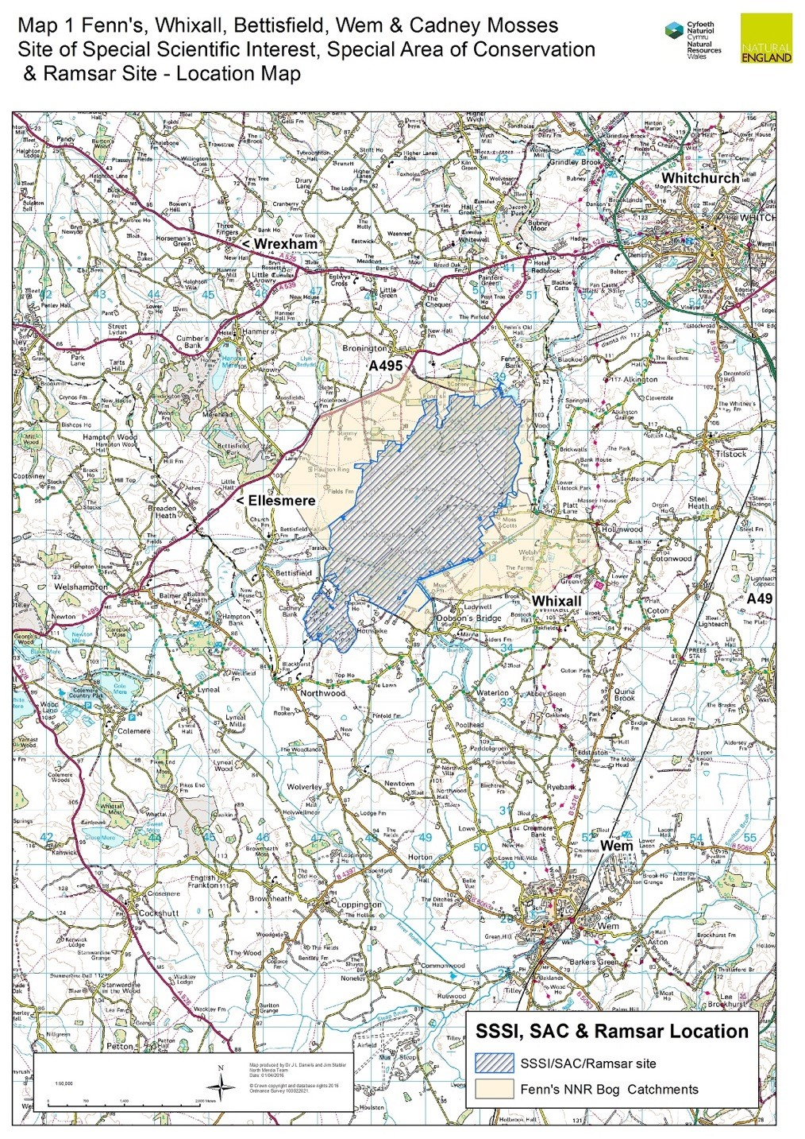

Annex 1.2: NNR Management Sections
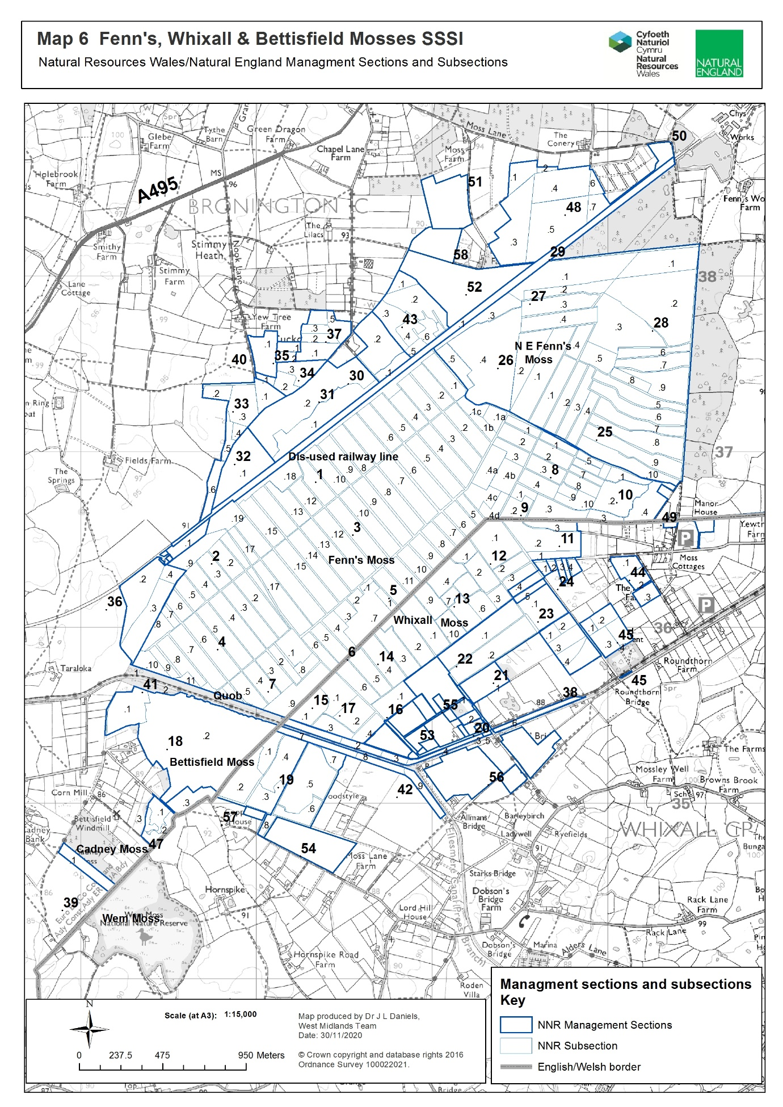
Annex 2.1: Access to Work Areas:

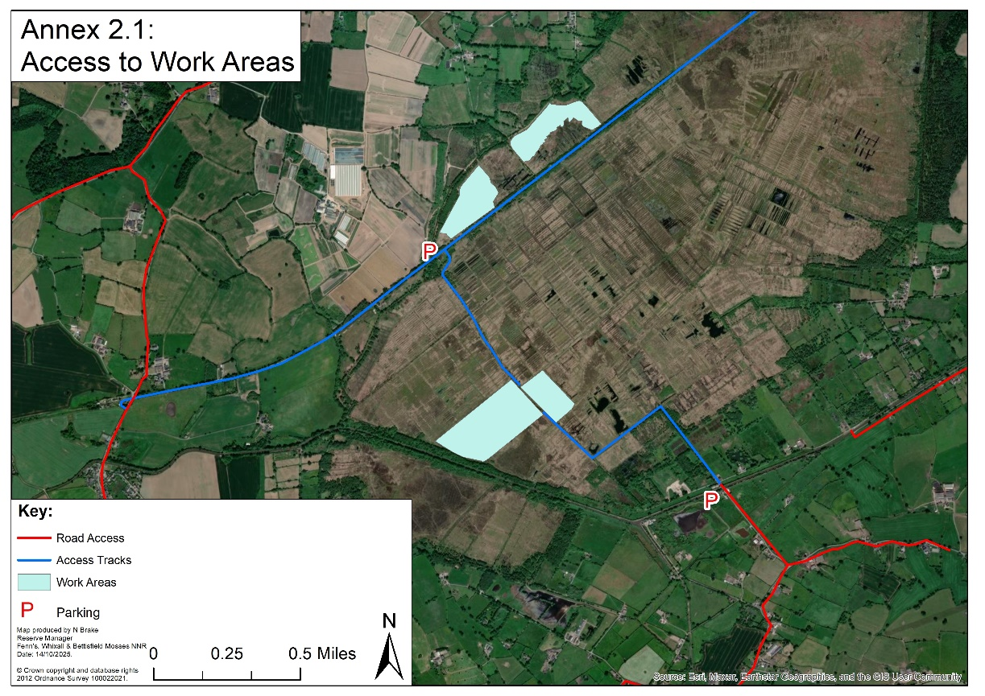
Annex 3.1: Work Areas 6 & 7:
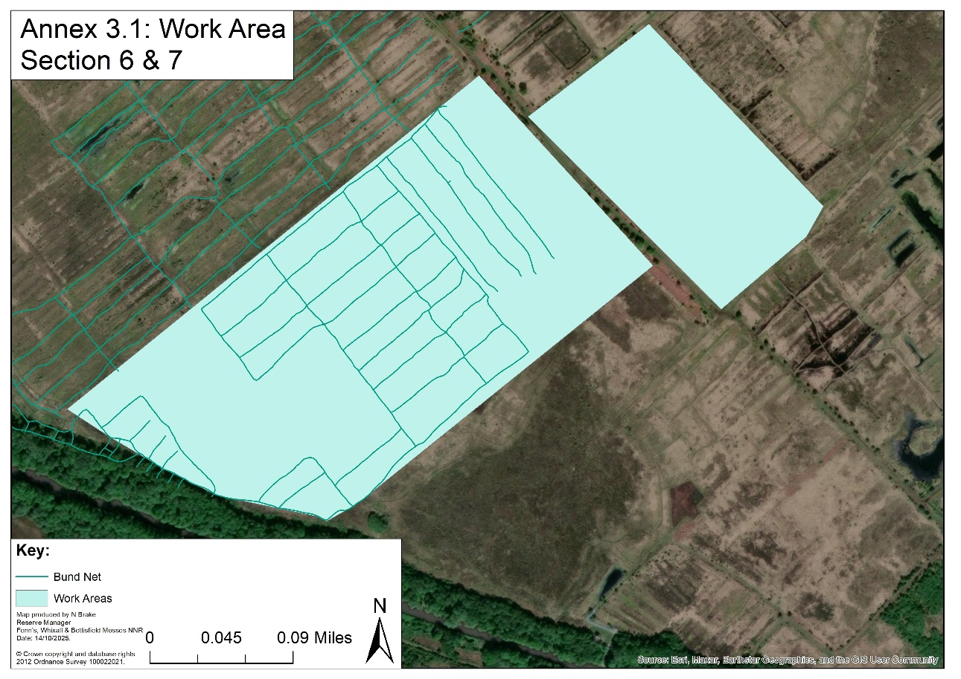
Annex 3.2: Work Area Section 31.2:

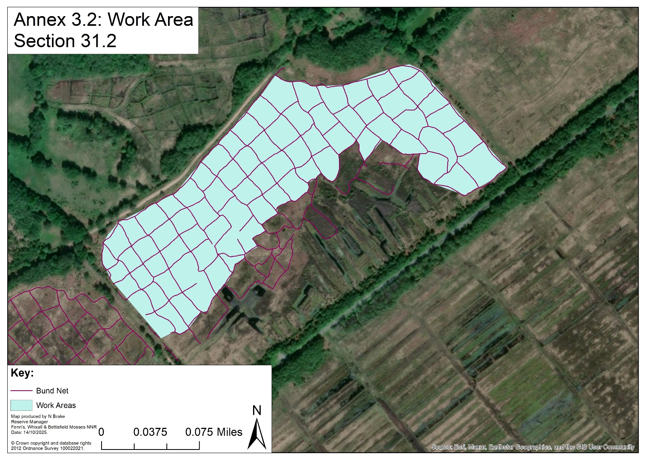

Annex 3.3: Work Area Section 32.1:

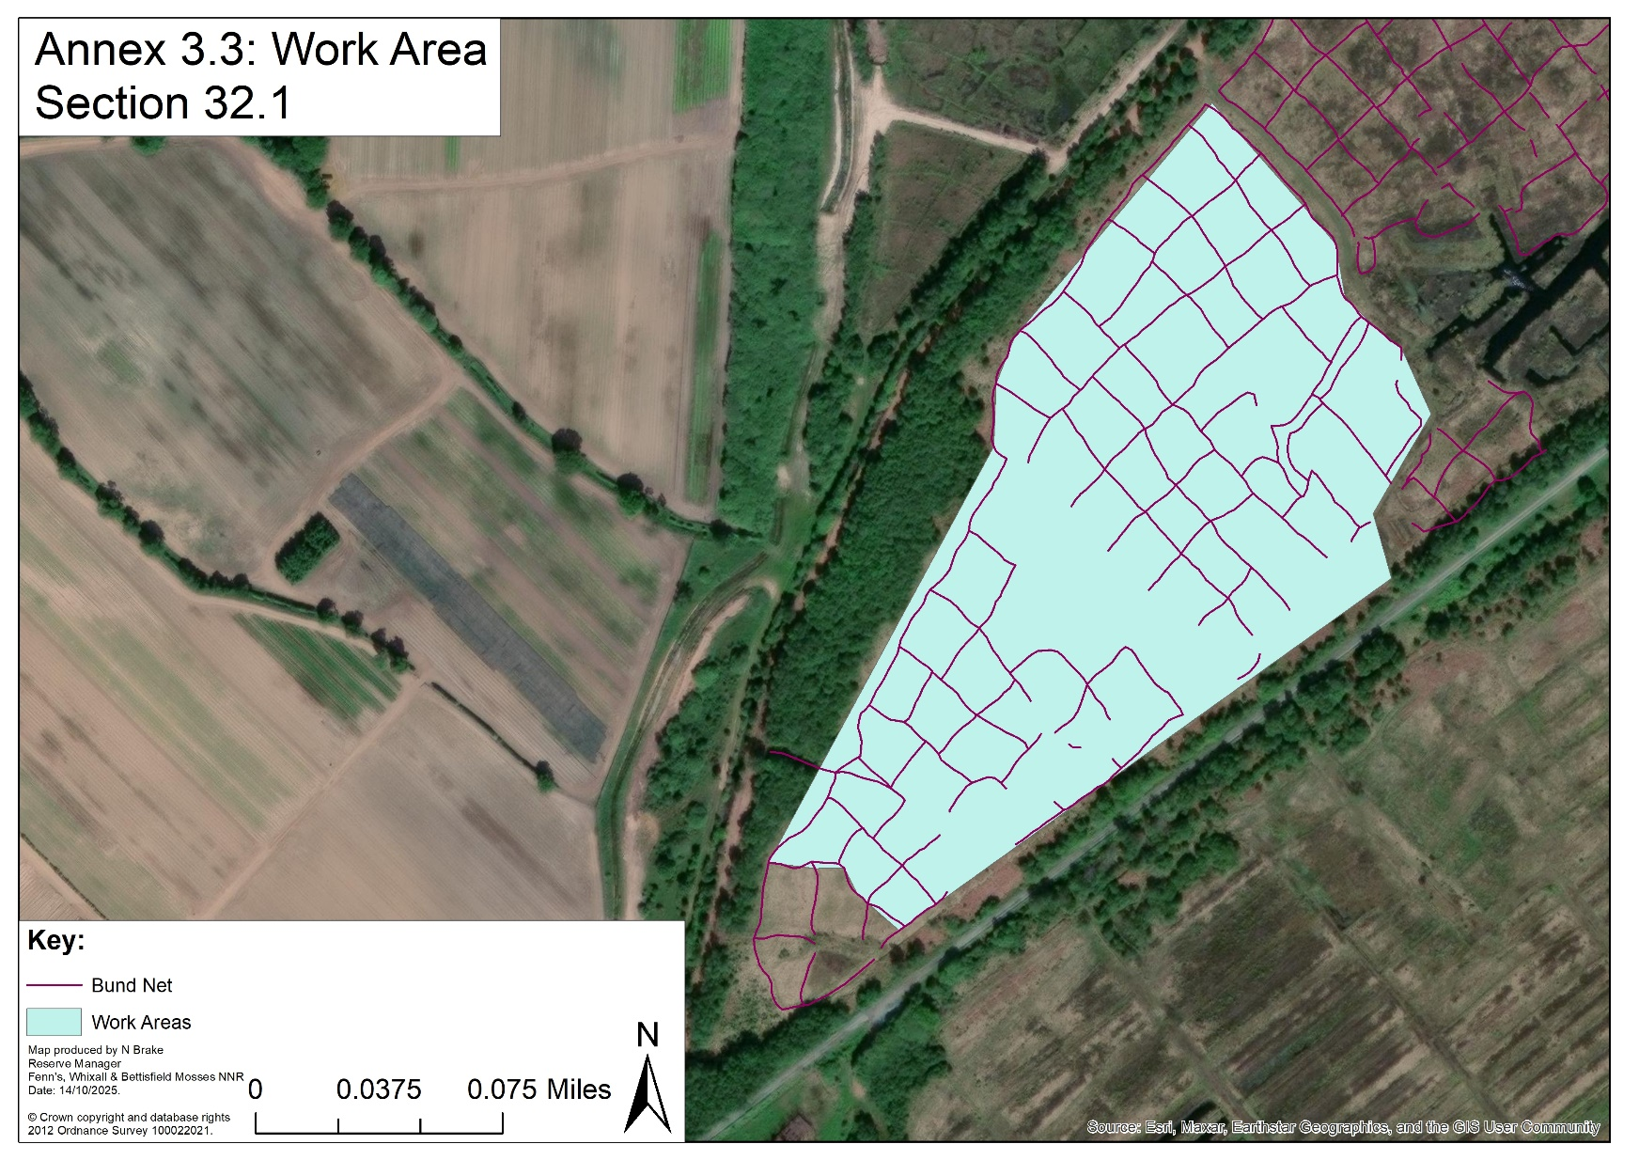
Annex 4: Photo examples of background

Initial Bunding Process (– simply for info)
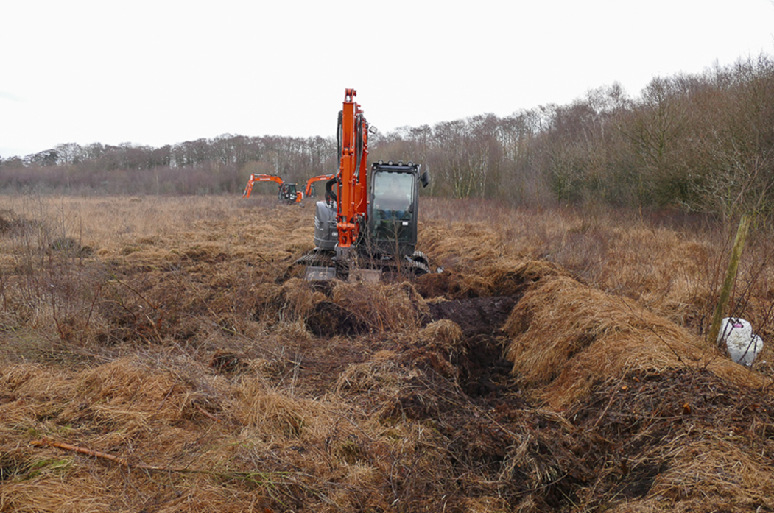
A network of peat banks (bunds) are made and covered with vegetation

Bunded Area 2 years later. The bunds are the green strips and the cells the wetter areas between. In this example, re-wetting has been successful with only sparse Birch re-growth on the bund walls.
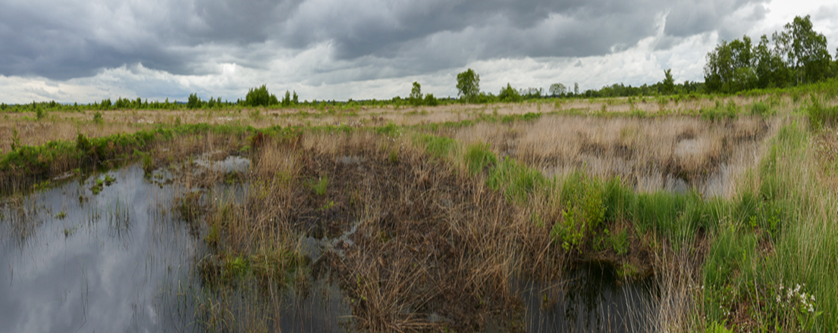

Annex 5: Sample Risk Assessment

Risk Assessment Template (H&S) NNRs
NNRs covered by this risk assessment: | Fenn’s, Whixall and Bettisfield Mosses NNR |  | Date completed: | 21/4/2023
Assessment of (e.g. Activity, Equipment, Individual) | Working on Peatlands |  | Review date (max 1 year): | 21/4/2024
Training required? Tick all that apply |  |  | Signed off by (SRM/ Line Manager): | P Bowyer  SRM
Training course: |  |  | Mandatory/Optional | Applicable?
First Aid at Work |  |  | Mandatory | p
Other (Please specify):
Notes (e.g. mandatory safety precautions) | Site safety maps are kept in all NNR vehicles. This map together with site safety information is emailed to third parties as appropriate.  Vodafone signal on NE Phones is generally good. Third parties to check phone signal whilst on site. Emergency contacts card in all NNR Vehicles & NE first aid kits.  Follow NE lone working policy as appropriate.  Risk assessments are available for all related operations – refer to these as necessary. In particular refer to:  - General safety - Personal  - General safety - Site (Fenn’s, Whixall and Bettisfield Mosses)  First aid kit in all NNR vehicles & each member of staff has a personal NE Kit. Eyewash in all NNR First aid kits & NNR Vehicles.  Note: young persons, new & expectant mothers etc., a separate risk assessment should be recorded.
Minimum PPE/RPE requirements | - Work Gloves  - Rubber gloves and Nitrile Examination Gloves – when working with water  - Steel toe capped high ankle boots/ wellingtons (EN ISO 20345:20011)
What are the hazards common to all? | Who might be harmed and how? | What precautions are you already taking? | What additional local precautions are required?
Uneven, often soft terrain, particularly on rehabilitated cuttings. Old peat pits. | Staff, Volunteers and Contractors  Slips and Trips | Where possible avoid work in the wettest areas over the winter season.  Wear suitable footwear (waterproof if necessary) with a firm grip. | Pre-plan works using site maps to determine where heavily cut areas are in the work area.  Walk over site with caution in-case peat pits are over grown/covered by brash.
Danger of machinery bogging down and overturning. Uneven tracks. Vehicles tip sideways when one pair of wheels is kept on the firm track side and the other is in soft peat. | Staff, Volunteers and Contractors  Cuts, Bruises, Whip Lash, Concussion | Only trained drivers to drive machinery.  Fill track holes with peat/chip.  Protect personnel in vehicles and goods on trailers.  Tractor link-boxes must not be used for personnel carriage.  Cover blades of all sharp tools. All small or sharp-edged tools in trailers/tractor link boxes must should be carried in a tool box.  First Aid kits in every vehicle. | Pick routes to avoid known wet spots on tracks and peat cuttings.
Ditches, bog pools, fire pools, pits Fenn’s Main drain weir, wide U-pipes and other watercourses.  Minor ditches 0.5-1 m deep. Main drains >1 m deep. Overhanging and floating plants, sides unstable. Soft, ‘bottomless’ base to dammed cuttings | Staff, Volunteers and Contractors.  Drowning, Hypothermia | Maintain official crossing places and make personnel and others aware of their positions. | Otherwise cross established peat dams Ensure workers know the drain pattern in the work area.  No lone working on very soft saturated areas, by the main drain & Sect. 14 south and 11.1  Avoid the Fenn’s weir and ensure netting is maintained on large U-pipes.  Maintain safety fencing at the Fenn’s Old Works railway culvert, the Marl Allotment ditch and Bettisfield pond.  Bring throw line when working close to main drains.  Leave the Moss at dusk unless on special monitoring tasks.  One side of fire pools is graded to permit escape. Keep spare set of clothing at NNR Base in case of falling in ditches. Emergency shower at NNR base.  Maintain deep drain, weir, crossing point and fire pool signs and posts.
Deep pools/ borrow pits by dams and bunds | Staff, Volunteers and Contractors  Drowning, Hypothermia |  | Warn users crossing dams or walking on bunds.  Test dams/bunds before crossing.  Don’t step off dams/bunds into water where you can’t see the ground beneath.
Slippery ditch crossings/ ragged mesh covering | Staff, Volunteers and Contractors  Slips, Trips, Cuts and Bruises | Replace rotten sleepers and maintain bridge marker posts and mesh on walkways.  Remove and replace any loose mesh.  Walk over crossings with caution. | Inspect for and clear of peat regularly.
Main Drain - polluted water and deep silt in base, half full downstream of wear so hard to climb out of. | Staff, Volunteers and Contractors  Weil’s disease, Sporotrichosis, Hypothermia and Drowning. | Wear rubber gloves with nitrile examination gloves underneath when working in ditches.  Wash hands before eating or drinking if they have been working in ditch.  Workers to be made aware of their flu like symptoms. | No lone working involving the Main Drain, without regular telephone contact with another worker.  Take throw-line if working by the Main Drain.  Be aware of shallower 100 yd interval side drains.
Unstable shallow-rooted trees prone to windblow. | Staff, Volunteers and Contractors  Crush injuries, Concussion, Cuts and Bruises. | Check the weather forecast prior to work near trees. | Keep out of unstable peat areas.  No lone working and wear waders in unstable carr area on 14.1, 11.1 and along the Quob. Be aware that trees can flip if being winched.  Avoid trees on peat in high winds. If unavoidable wear a hard hat.
Adders | Staff, Volunteers and Contractors  Inflammation, Pain, Bruising, Nausea, Fast Heart Rate, Sweating, Breathing Difficulties, Confusion and Dizziness | Look before touching the ground/sitting down.  Wellingtons/high boots should be worn at all possible times.  Check for adders in areas where work is being carried out.  First aid procedure if bitten:  -Remain calm and keep the part of the body that been bitten as still as possible to prevent the spread of venom around the body.  -Remove jewellery/watches from around the bitten limb.  -Loosen clothing if possible.  -Keep the casualty still and calm.  -Seek immediate medical attention by dialling 999. | Signs on noticeboards explaining the first aid procedure.  Wear gauntlet gloves when lifting brash and rubbish.
Stings and Bites – Insects/Plants | Staff, Volunteers and Contractors  Irritation, Illness and Inflammation | Wear long sleeves/full length trousers.  Use Insect repellent.  Use anti-inflammatory on any effected areas.  Wear work gloves when working with stinging/ thorny plants.
Slippery irregular brash mats. Brash obscuring ditches. Roots can project from tracks. Projecting tree/bush stumps, obscured by vegetation. | Staff, Volunteers and Contractors  Slips and Trips | Warn public to keep off the brash tracks.  Trail routes are to be inspected regularly for projecting roots, overhanging trees etc.  Noting if tree work has previously taken place in that work area.
Projecting metal | Staff, Volunteers and Contractors  Cuts, Bruises, Slips and Trips | Inspect work areas.  Wear work gloves if moving metal.  Wear steel toe capped boots/wellingtons on site, especially if working near known metal.  Inform others wear metal has been found. Mark on annual audit.

What are the hazards specific to your site/ staff/ equipment? E.g. site features such as steep slopes, individual issues such as new starters, equipment features such as known complexities. | Who might be harmed and how? | What precautions are you already taking? | What additional local precautions are required?
Turnover of trainees, volunteers, work placement students | New starters | Ensure new starters to be briefed on safe practices whilst working on the peatland during their induction. New starters should be accompanied by staff during their first few weeks on the reserve. Staff to highlight hazards and safe working practices.
Please add more lines if required.
General comments:

Annex 6: Herbicide Record

Company:

Date | Product | Quantity  undiluted  product  (litres) | Dilution |  | Application |  | Target  Species | NNR name | Section number
Date | Product | Quantity  undiluted  product  (litres) | Diluent | Diluent  Product | Method | Rate

ANNEX 7: Condensed Terms and Conditions Example

Standard goods and services terms and conditions (£10,000 to £50,000) - GOV.UK

