


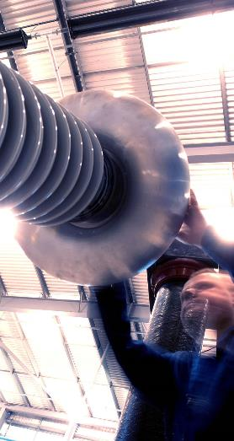

Pre-PROJECT information pack

Module 1 – site general information

Document History

Issue | Prepared by | Revision History
1 | Jason Wise | Original Document
2
3

Contents

1 Introduction 3
2 Health & Safety Goals 3
3 Health & Safety Policy Statement 4
4 Overview of ORE Catapult Aberdeen Facility 5
Description and History of the Site 6
General Layout of the Site 6
5 Existing Site Information 6
Health and Safety Files and supporting O&M Manuals etc 7
Information is available for: 7
Surrounding land uses and related restrictions 7
Access and Traffic Restrictions 7
Existing Hazardous Material 8
• Existing Structures 8
Existing Services 8
Site Rules 9
6 General H&S Coordination and Management 9
General Site Induction 10
Working Hours 10
Site Security 10
Work Authorisation 11
Permit to Work System 11
Risk Assessments & Method Statements 11
Competencies 11
Visitors 12
Smoking 12
Emergency procedures and means of escape 12
Personal Protective Equipment (PPE) 12
Accident and Incident Reporting 12
Ground conditions, underground structures and/ or watercourses 12
Health risks arising from Client Activities 12
Ongoing Catapult Activities 13
7 Accident & Emergency Arrangements 13
Accident & Emergency Hospital 14
7.1 First Aid 14
7.2 Fire Precautions 15
8 General Requirements for Project Working 15
Communication and liaison between Client and others 16
If contact is required Out of Hours 16
Continuing Liaison 16
Co-ordination of ongoing design work and design changes 16
Construction Health and Safety Plan 16
Communication and liaison between Client and others 17
The Construction Site 17
Training and Competence 17
Significant design assumptions and suggested control methods 18
Information on significant risks identified during design 18
9 Format and Content 0f Health and Safety File / O&M’s etc for Handover 19
Standard Health and Safety File / Building Information Format 20
Building Health and Safety File 21

Introduction
This information document has been prepared in accordance with Regulation 11 and Appendix 2 of the Construction (Design and Management) Regulations 2015 (CDM 2015).
This information summary provides information on the health, safety and environmental matters that should be considered during the design and works phases of projects.
Information relates to the routine, ongoing, requirements and arrangements of ORE Catapult that must be considered in addition to project specific activities.
Designers, Project Managers and Principal Contractors shall take account of all items outlined within this plan.
Designers and the Principal Contractor must provide sufficient information on provisions and measures taken to limit or control hazards arising in the realisation of the project during construction / assembly works and the methods they propose or intend to employ to deal with identified hazards.
Designers, Project Managers and Principal Contractors must also consider the project-specific document “Pre-Construction Information Pack Module 2” in addition to this document.
NOTE:
Additional information, or changes to the published information, will continue to be provided as applicable throughout the remainder of the project.

Health & Safety Goals

The health & safety aim of ORE Catapult is to comply with all appropriate legislation by providing a safe and healthy working environment that will minimise workplace hazards and thereby reduce/eliminate potential accidents to personnel and others involved directly or indirectly with the work.
Occupational health issues arising from manual handling, inhalation of dust, noise, hand arm vibration etc. will be identified and appropriate controls applied.
The following aims apply:
- No prosecutions or enforcement notices for H&S issues are received from the Health and Safety Executive (HSE)
- No reportable injuries, diseases or dangerous occurrences (RIDDOR)
- No prosecutions or enforcement notices for environmental issues are received from the Scottish Environmental Protection Agency (SEPA)
- Information relating to design, whether at project commencement or as and when alterations are made, shall be provided in such a timescale as to ensure safe construction.
- Health & Safety File & O&M Manuals to be developed during the project and delivered at practical completion.
- The Principal Contractor shall ensure regular “Toolbox” talks are carried out. These talks will include all their own staff and such staff from the subcontractors as may be appropriate.
- The Principal Contractor shall ensure all persons entering site for the purposes of work are trained and competent to carry out the proposed works.
- The Principal Contractor shall ensure all persons entering site for the purposes of work are in possession of the relevant training certification. (Safety Passport, CSCS or another agreed standard).
- The Principal Contractor shall undertake, at least once weekly, a formal documented site safety inspection to ensure the implementation of agreed control measures throughout the project and make copies of same available to the client or his representative for inspection.

Health & Safety Policy Statement

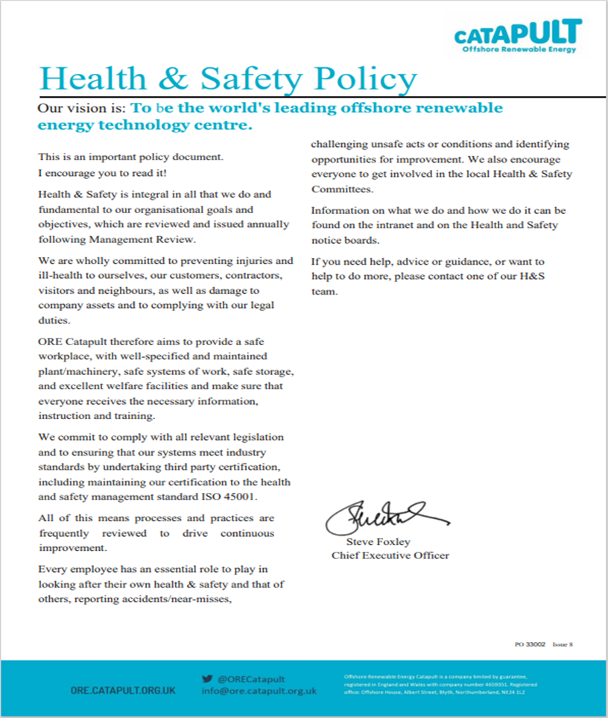

Overview of ORE Catapult Aberdeen Facility

ORE Catapult is the UK's flagship technology innovation and research centre for offshore wind, wave and tidal energy.
Through world-class testing and research programmes, Catapult works for industry, academia and government to improve technology reliability and enhance knowledge, directly impacting upon the cost of offshore renewable energy.

Description and History of the Site
The site comprises a circa 1.4ha plot of land set in between office building called W-Zero-1 (formerly Irvin House) and the eastern extent of Altens Industrial Estate. It is located at the curved eastern section of Harness Road (the B985), before it leads down towards the Coast Road.
The site is currently an undeveloped area of scrubland, allocated for business and industrial use in the Aberdeen Local Development Plan 2023 and is incorporated in the Energy Transition Zone Masterplan.
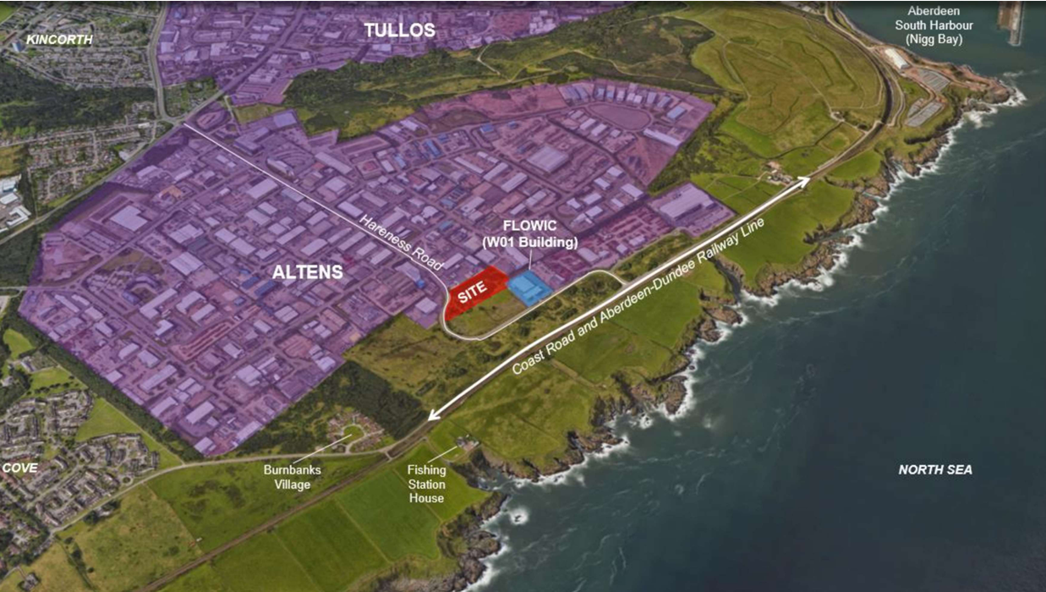
Figure 1 – Site context.

Offshore Renewable Energy Catapult have signed a lease with the Aberdeen Port Authority to develop this area of scrubland into a yard where a Large Mooring Line Test Rig will be installed. The Test Rig will be used to test mooring lines for offshore applications for wind farms. In addition to the test rig, there is planned to be other supporting structures including a standalone electrical substation, a wet storage trough (for soaking of test pieces) and a permanent building comprising of a control room and welfare facility for employees operating the test equipment. ORE Catapult employees will be able to access the W-Zero 1 building via a new stair link which is proposed to be built in the northeast corner of the site.

General Layout of the Site
The view below highlights the location of the site within the Altens Industrial estate. All vehicular access to the site will be from Harness Road.
It should be noted that there is ongoing construction work by Robertsons Construction adjacent to the site where BP and Aberdeen City Council are installing a Hydrogen Hub, however the construction work is not expected to affect the plot of land enablement.

Existing Site Information

Health and Safety Files and supporting O&M Manuals etc

Information is available for:
This Information can be viewed on request to the relevant Catapult Project Manager. Information is available electronically.
Limited information is available for other structures and parts of the site, however due to the age of these are incomplete. Additional surveys will be conducted as necessary.

Surrounding land uses and related restrictions
The surrounding area is predominantly industrial in character, and the site is surrounded on all sides but the east by established parts of Altens Industrial Estate, As mentioned, the W-Zero-1 building lies to the northeast and is associated with the proposed development, being the current base of ORE Catapult and the proposed site of FLOWIC. Beyond the north boundary are various commercial properties lie beyond the west boundary, with the nearest being Compass Print Group’s premises. ENGTEQ’s mixed office and industrial headquarters lie to the south, on the other side of Harness Road.
The only exposed boundary is to the east, which faces a grassy slope that leads downwards to end section of Harness Road, before it passes the W-Zero-1 Building’s main access.
The properties adjoining the site are all commercial in their appearance and use. The nearest residential properties at Burnbanks Village are located a considerable distance away from the site at approximately 400m to the south and beyond an area of dense plantation woodland. The residential property ‘Fishing Station House’ is approximately 400m away to the south southeast.
Works may need to consider noise nuisance and congestion caused by traffic movement in and out of site.

Access and Traffic Restrictions
Access to the ORE Catapult site will be from Harness Road only.
A site access road is to be installed and a wheel wash facility on site to prevent contamination of the road surfaces by loaded vehicles leaving the site prior to any groundworks being undertaken.
On site, traffic must only travel on designated routes and comply with speed limits. These should be always kept free.
- A 10mph speed limit is imposed on site. This applies to all vehicles.
- Access for fire and emergency services must be always kept free from obstruction.
- Footpaths, pedestrian crossings are clearly marked throughout the site and must be adopted.
- Roads and pedestrian routes must always be kept clear of obstructions.
- Materials will not be stored on roadways or paths or in any other area where they may constitute a hazard.

Refer to DWG. No. 221193-000-CAM-DR-C-200 Rev D for further notes on Junction Access and Yard Layout.
Restrictions on deliveries or waste collection or storage

All deliveries and waste removal must be through the Harness Road access.
All waste and/or contaminated materials should be transported by a licenced waste transport company. Any materials to be re-used, recycled are to be stored in a way that does not contribute to contamination of land or water courses or shall be removed from the site and taken for further re-cycling, re-use or transferred to a licenced waste transfer station.
All relevant documentation is to be copied to the client (waste transfer notes, waste carrier's licence/s & waste transfer station licences).
Parking Restrictions
An area is to be designated as a vehicle parking area and screened from the work site activities to enable persons working on the site to park their vehicle out with hazardous areas during the day. No vehicle parking is to be permitted on the street due to the bend in Hareness road which will restrict the movement of traffic passing by the site.

Existing Hazardous Material
ETZ contracted Mason Evans who produced a Geo-technical report following a site investigation survey and is included as part of the tender package.
- Asbestos
No asbestos was recorded within the shallow soils
- Lead Soil
The GQRA identified a contaminant exceedance of lead in the shallow soils, and as such Mason Evans consider there to be a risk to human health from lead impacted soils. Remedial measures including the excavation and removal of this localised lead exceedance, and placement of the contaminated soils within a less sensitive area of the site (i.e beneath hardstanding or car parking area). ￼
- Zinc
A phytotoxic exceedance of zinc was identified within the shallow soils, and as such we consider there to be a risk to the plant life. We would recommend this localised exceedance of zinc is excavated and removed and placed beneath a less sensitive area of the site (i.e., beneath an area of hardstanding or car parking) in order to reduce the risk to plant life on the site.

Existing Structures
It is the understanding of ORE Catapult that no existing structures are evident on the site however this cannot be conclusively assured.

Existing Services
Refer to Site Services Constraint Plan, Dwg No. 221193-000-CAM-DR-C-100 Rev C

Site Rules
The principal contractor will be responsible for initiating the site rules as per their company policy and in accordance with the:
- Health and Safety at Work Act 1974
- Management of Health and Safety at Work Regulations 1999
- CDM Regulations 2015
- Provision and Use of Work Equipment Regulations 1998
And any other relevant acts or regulations provided by Scottish legislation pursuant to building and site work activities.
Key Site Procedures
The Principal Contractor shall be familiar with these key Catapult requirements and ensure that all on site comply with them as applicable.

General H&S Coordination and Management

General Site Induction
All persons working on site must undergo the ORE Catapult General or Building induction before the start of work activities. This does NOT replace the project specific induction.
The general site induction covers:

Working Hours
ORE Catapult normal working hours are: 08:00 – 17:00 Monday to Friday
Work outside these times may be permitted subject to advance notice and approval by ORE Catapult.

Site Security
The construction site is to be maintained in a secure condition for the whole of the perimeter.
No specific requirements have been set however the boundary should be sufficient to prevent unauthorised or inadvertent access by ORE Catapult personnel, members of the public or other contractor operatives on site.
The Principal Contractor shall install, maintain and monitor the site security arrangements and take additional measures as necessary to overcome any failures in such security.

Work Authorisation
Unless otherwise instructed, this will not apply to works carried out in accordance with the Construction (Design Management) Regulations within a separate and clearly defined construction site (see below). It is expected however that an overall WA will be required to authorise the establishment and operation of the construction site.

Permit to Work System
The Principal Contractor will be required to implement its own Permit to Work arrangements within the boundaries of the construction site. Where those works infringe on the ORE Catapult site or are near areas where ORE Catapult employees are working. It is mandatory to liaise and coordinate with ORE Catapult for any safety critical works:
- Isolation of electrical systems
- Hot works
- Live electrical working
- Work with pressurised systems
- Exceptional work at height
- Lifting operations
- Excavations and working in confined spaces

Risk Assessments & Method Statements
The principal contractor is responsible for ensuring that all works carried out within the boundary of the site, whether by their employees or sub-contractors are suitably assessed for risk and that method statements and risk assessments are provided to reduce or mitigate the risk to as low as reasonably practicable.
Risk assessments and method statements must be provided by any personnel wishing to carry out work out with the site boundary but within the facility or ORE Catapult site prior to work authorisations being issued

Competencies
All personnel wishing to carry out work within the ORE Catapult site must be able to provide evidence of competency to carry out that work, such as certificates for operating MEWP, Forklifts etc if required. Training records to be made available upon request.

Visitors
Visitors to the facility, i.e. someone visiting but not carrying out work must be accompanied at all times.

Smoking
The entire site will be a designated “No Smoking” site. A smoking point is to be erected within the site boundary and may be used. If an additional temporary smoking point is required, this must be agreed and approved by Catapult.

Emergency procedures and means of escape
The Principal Contractor must comply with any existing site emergency plan. Muster points for construction works are to be agreed with Catapult.

Personal Protective Equipment (PPE)
Site rules must be strictly enforced by the Principal Contractor with regards to the wearing of Personal Protective Equipment (PPE.) all persons on site must meet the minimum requirements for personal protective equipment immediately upon entering the site.
PPE must be worn in designated areas within Catapult; full PPE is mandatory when entering the yard or test workshops at FLOWIC. The office, welfare areas, and carparks are designated “PPE Free” zones.
In all test halls, engineering spaces, workshops, external yard areas PPE must be worn. This comprises hard hat, hi vis clothing, safety shoes and eye protection and where work is being carried out suitable gloves for the task.
Additional PPE may be a requirement as identified in a particular method statement or process.

Accident and Incident Reporting
The Principal Contractor will be responsible for ensuring that all events are recorded and subsequently reported to ORE Catapult within 24 hours. Details of root cause and subsequent corrective and preventative measures are also to be provided.
This is in addition to their own corporate and legal requirements.

Ground conditions, underground structures and/ or watercourses
Concrete structures from previous site use may be encountered when excavating.

Health risks arising from Client Activities
Noise & Vibration
Noise considered to be a nuisance must be kept to a minimum when working adjacent to neighbouring properties. Where this is unavoidable information on the duration of the noise nuisance must be recorded and where appropriate communicated to those likely to be affected. No excessive noise activities are to be permitted during the hours designated as noise free periods 22:30-07|:00 hrs.
Legionella
Any water stored within holding tanks is to be tested regularly for the presence of Legionella bacteria. Records of the testing are to be held in the site office and provided to the catapult project manager.
Weil’s Disease
The principal contractor is to be aware of the potential for Weils Disease otherwise known as Leptospirosis to be present in the soil or standing water. To ensure that this is adequately managed the principal contractor will ensure that where required animal traps and bait boxes are installed and maintained to prevent rodent infestation of the site and that all food waste is removed from the site at regular intervals to avoid attracting such pests.
Psittacosis
Where applicable the management of wild birds such as pigeons is to be controlled to prevent the likelihood of workers and sub-contractors contracting Psittacosis. Area heavily contaminated with bird faeces is to be cleaned on a regular basis to prevent a buildup of detritus that could contaminate plant, materials or PPE with Psittacosis.

Ongoing Catapult Activities
There are no planned Catapult activities next to the worksite.

Accident & Emergency Arrangements

Accident & Emergency Hospital
Aberdeen Royal Infirmary
Foresterhill Road
Aberdeen
AB25 2ZN
0345 456 6000

First Aid
First aid kits are held in the workshops and offices of ORE Catapult. The principal contractor is responsible for ensuring that a suitable first aid kit, where applicable a bleed control kit and difibrillator are available within the boundary of the construction site.
Details of Catapult First-aiders are listed in the workshops, and this is to be replicated with the first aid trained persons responsible on the construction site
Defibrillation units - a defibrillation unit is available within the communal area of Building W01 and is controlled by ETZ. It will if required be the responsibility of the Principal Contractor to supply a defibrillator within the boundary of the construction site.

Fire Precautions
Fire extinguishers are to be located within the boundary of the construction site and will be the responsibility of the principal contractor to supply, service and maintain such devices.
The Catapult fire assembly point is located at the bottom of the car park adjacent to the electric vehicle charging points. Any person working within the Catapult site or yard will be required to sign in in the Catapult office prior to commencing work and will therefore be accounted for on the register as working within Catapult.
The principal contractor is responsible for ensuring that an assembly point is located within the boundary of the construction site that ensures any persons who assemble there are clear of any access points required by the emergency services.

General Requirements for Project Working

Communication and liaison between Client and others
Pre–Start Meetings shall be held prior to works commencing and Progress Meetings will subsequently be held on a regular basis.
Design and project meetings will all have H&S as an agenda item and attended by the appropriate parties, e.g. Principal Contractor’s site manager; Principal Contractor’s safety representative; sub-contractors as required; client representatives; Catapult Project Manager; Catapult HSE Advisor, designers; etc.
These meetings, together with all agreed actions and closure dates to be met key parties, are to be recorded and the minutes circulated to all relevant parties

If contact is required Out of Hours

Client

Jason Wise – 07748542528 (any enabling works related issues)

Tony Jones - 07471365162 (any HSE issues)

Continuing Liaison
The Principal Contractor shall report the following issues to the Principal Designer and Client as necessary:
- Previously unidentified hazards encountered during the construction phase;
- Methods of construction requiring a variation from existing plans;
- Relevant information to be included within the Health and Safety file;
- Records of all accidents, including any events that result in accidental loss of plant or materials or a “dangerous occurrence” or near miss which could have caused a risk to health and safety.
- Unforeseen eventualities arising during construction which require significant design change or affect the resources required.

Co-ordination of ongoing design work and design changes
Designers and the Principal Contractor are required to advise the Project Team of the names and addresses of all Designers who are employed to carry out these elements.
Designers and the Principal Contractor are required to assess the competency of Designers they appoint.
Designers and the Principal Contractor are to provide to the Principal Designer information regarding design elements to enable the co-ordination of the design with other relevant aspects of the project.
Designers and the Principal Contractor / contractor(s) shall identify to the Principal Designer any significant hazards associated with the contractor designed elements in sufficient time to allow adequate consideration.

Construction Health and Safety Plan
The Principal Contractor shall provide a copy of the Construction Health and Safety Plan at least 5 working days in advance of the planned start of work.
The Client, or representative, shall review the document and confirm its suitability for the project.
The Principal Contractor is to ensure that their senior management are committed to the agreed list of Health & Safety objectives and targets which will be established within the Construction Phase Plan.
The Principal Contractor shall ensure that their sub-contractors implement such actions as are required to meet those objectives and targets. This implementation process will be monitored and reviewed as part of the EHS management process.

Communication and liaison between Client and others
Pre–Start Meetings shall be held prior to works commencing and Progress Meetings will subsequently be held on a regular basis.
Design and project meetings will all have H&S as an agenda item and attended by the appropriate parties, e.g. Principal Contractor’s site manager; Principal Contractor’s safety representative; sub-contractors as required; client representatives; project manager; designers; etc.
These meetings, together with all agreed actions and closure dates to be met key parties, are to be recorded and the minutes circulated to all relevant parties

The Construction Site
Site Establishment
The site is to be maintained in a secure condition by means of 2.0m high mesh fence to enclose the site compound and construction areas. Alternative arrangements must be approved by ORE Catapult.
Vehicle and pedestrian entrances shall be clearly defined and controlled throughout the project to prevent unauthorised access.
The Principal Contractor shall monitor the site security arrangements and take additional measures as necessary to overcome any failures in such security
All fencing is to display appropriate and suitable signage alerting ORE Catapult personnel of hazards.
Welfare facilities to be provided by the contractor
Existing welfare facilities are provided in each building and may be accessible to contractors. This will be agreed prior to appointment or the start of work.
If separate / additional facilities are necessary, the contractor shall provide such in accordance with Schedule 2 of the CDM Regulations 2015. This should include: a mess area, kitchenette with microwave, kettle and sink, toilet with hand washing facilities and power provision.

Training and Competence
Construction Site Induction
All persons working on site MUST undergo a site-specific health and safety induction delivered by the Principal Contractor.
This induction is in addition to that provided by ORE Catapult.
Competency Records
The Principal Contractor shall hold records of training for ALL persons working on site. These records should demonstrate competency and experience for their designated trades and equipment / tools and processes to be used. Records must be current.
This should also include evidence of health and safety training such as CSCS, Safety Passport etc.

Significant design assumptions and suggested control methods
Designers, or Contractors with design responsibility, approved for each project, are to ensure their appointed internal or external architects, mechanical, electrical designers, structural engineers etc. avoid, so far as is reasonably practicable, any foreseeable risks within their designs. Where it is not practical to eliminate the hazard then design solutions should be developed to reduce the overall risk to an acceptable level.
Information must be provided to enable risks within the design to be identified and managed.
Aspects of the design which could create significant risk during the project, future construction work and maintenance, including DDA and security requirements shall be taken into consideration during the design phase.
Risk information, including foreseeable residual risks, shall be provided to the Planning Team for review and comment prior to any work taking place.
All Contractors shall conduct, and record risk assessments appropriate to their work. They shall ensure the control measures identified are implemented, communicated and documented.
Hazards identified which may impact upon any occupiers of the premises, or any maintenance activities related to the premises which will run concurrently with construction, shall be communicated to relevant personnel prior to the commencement of work.
Areas that are under the control of the Principal Contractor shall be agreed and recorded as part of Project Pre-start/ Progress Meetings.
All risk assessments pertinent to works shall be maintained on site. It shall be for the Principal Contractor to ensure compliance with this requirement. It shall also be for the Principal Contractor to ensure information about risks is made available to persons who may encounter the relevant hazard.

Information on significant risks identified during design
Information must be provided to enable risks within the design to be identified and managed.
Aspects of the design which could create significant risk during the project, future construction work and maintenance, including DDA and security requirements shall be taken into consideration during the design phase.
Risk information, including foreseeable residual risks, shall be provided to the Planning Team for review and comment prior to any work taking place.

Format and Content 0f Health and Safety File / O&M’s etc for Handover
The health and safety file should include information where this may be relevant to the health and safety of any future cleaning, construction or maintenance work. The level of detail should be proportionate to the risks likely to be involved in such work.
The Health and Safety File should comply with the requirements of the HSE Guidance to the CDM Regulations 2015 and any further requirement set out in this Guidance. The file should include as appropriate:
- a brief description of the work carried out;
- Any residual hazards which remain and how they have been dealt with (for example surveys or other information concerning asbestos, contaminated land, water bearing strata, buried services etc.);
- key structural principles (e.g., bracing, sources of substantial stored energy – including pre- or post-tensioned members) and safe working loads for floors and roofs;
- hazardous materials used (for example lead paint; pesticides; special coatings);
- information regarding the removal or dismantling of installed plant and equipment (for example any special arrangements for lifting such equipment);
- health and safety information about equipment provided for cleaning or maintaining the structure;
- the nature, location and markings of significant services, including underground cables; gas supply equipment; fire-fighting services etc.;
- Information and as-built drawings of the structure, its plant and equipment (e.g. the means of safe access to and from service voids and fire doors).
The Principal Contractor shall agree at the commencement of the project a programme of H&S File review dates with the Principal Designer to initiate the development of the file and ensure the collection of information and detail as the project proceeds.
The Principal Contractor shall provide both hard and electronic copies of all information required to be included within the H&S File for handover to the Client. :-
- 1-off electronic copy comprising written information files in Microsoft Word and PDF formats and drawing files in both PDF and CAD format.
It is advised that this request is communicated to all Contractors engaged in these works prior to their appointment.

Standard Health and Safety File / Building Information Format
Volume 1 – Project Information
  - Amendment Control
  - Introduction
  - File System
  - General Information
  - Project Directory
Volume 2 – Building Manual (Incorporating the Health and Safety File)

Building Health and Safety File
  - Project Information
  - Residual Hazards
  - Certification, Training and Handover Items
  - Design Statements
  - Hazardous Materials
  - Commissioning and Demolition Statement
  - Cleaning, Access and Maintenance Strategy
Significant Services
Surveys and Reports
Subcontractor / Supplier Literature
As Built Drawings
Volume 3 – Large Mooring Line Test Rig Manual (Incorporating the Health and Safety File)
3.1 Large Mooring Line Test Rig Health and Safety File
3.2 Description of the Project
3.3 Residual Risk
3.4 Design Statements and principals
3.5 Hazardous Materials
3.6 Decommissioning and Dismantling Statement
3.7 Cleaning, Access, and Maintenance Strategy

