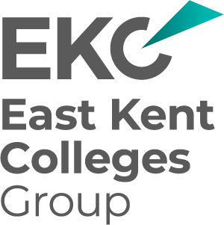
EKC Group –Tender to provide a HR and Payroll System solution (5-year contract)
Tender Clarifications and Guidance 4
Q1 Could you please confirm if you have 2292 employees in total?

Yes

_END_

