Natural England, Moccas Park and Gillians Wood NNR

Specification of Works : 2025

Borehole installation along with Solar pump

Natural England is here to conserve and enhance the natural environment, for its intrinsic value, the well-being and enjoyment of people and the economic prosperity that it brings.

National Nature Reserves are central to the work of Natural England; they safeguard the finest examples of habitat and wildlife and where possible make them available for public enjoyment.

The purpose of this project is to drill a borehole and install a solar-powered pump to provide drinking water for livestock.

- Location : Gillians Wood, Pentre Ln, Hereford HR3 6AX

What3words ///responded.respect.scrap

- Access : Access is only available from Pentre lane

What3words ///order.equity.himself

- Survey :

Contractors are encouraged to arrange a site visit with the Project Officer. Alternatively, they may visit independently to assess the full scope of the project.
- Scope of Work : Please see attached map

The current livestock water system uses a ram pump feeding three header tanks:
- One 10,000L underground tank
- Two 15,000L above-ground tanks
During dry summers, this system fails to meet the daily water requirement of 24 cattle (1,200–2,000L/day).
The header tanks gravity-feed two cattle troughs as marked on the attached map.
The project will disconnect the two above-ground tanks and connect the borehole to the underground tank, retaining the ram pump for winter use.

The contract is to

- Drill borehole ideally at location shown on the map
- install solar-powered pump with automatic tank-level control.
- Connect borehole to the existing 10,000L underground tank.
- Install a second 1,000L concrete trough with associated pipework and stop tap.
- Retain the ram pump for winter use.
- Ensure system delivers a minimum of 2,000L/day.
- Provide one year of system maintenance.

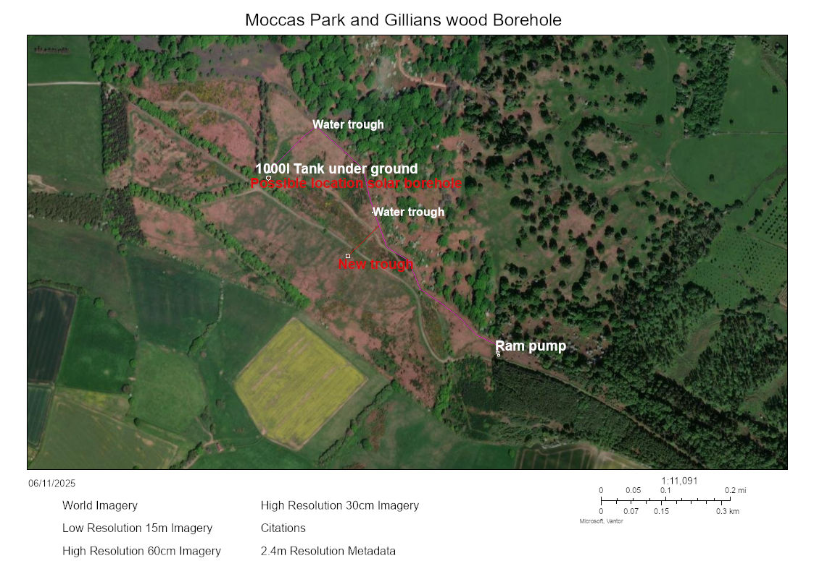

- Period of Contract :

Contract Completion Deadline: All works must be completed and invoiced by 28 February 202

6. Conditions:

Once the works are agreed in writing no variation from quoted prices will take place without written instructions from Natural England’s Project Officer.

The contractor will supply & deliver all labour, materials, necessary plant & spare parts, equipment, tools and fuel to complete the work.
Appropriate protective clothing must be worn by all operators.

A high standard of First Aid and emergency provisions must be available for inspection and in place at the start of operations.

Public safety must be ensured at all times. Warning signs to inform people of potential danger must be erected during any operations.

Copies of the following documents must be supplied before work commences :

- A detailed Method Statement
- A full Risk Assessment
- Copies of Public and Employer Liability Insurance Certificates

On completion of the work the contractor will clear from the site all unused materials and equipment, leaving the site in a clean and tidy condition.

The contractor will make good any damage to access tracks, bridges, gates and fences on completion of the work.

7. Evaluation of Tenders :

Natural England will score tenders on their potential to meet a number of weighted criteria. A decision on the award of the contract will be made subsequent to this scoring process. Criteria for evaluation of tenders will be:

- Value for money
- Previous experience of similar work
- Understanding of the work requirements
- Understanding of the health and safety requirements
- Ability to deliver within agreed timescales

Contractors should be aware that Natural England is looking for quality and will not necessarily take the lowest tender, but rather it will adopt the Most Economically Advantageous Tender approach to letting a tender.

Project Officer : Tom Simpson
Address : Lodge Hill, Dry Mill Lane, Bewdley, Worcestershire, DY12 2LY
E Mail : tom.simpson@naturalengland.org.uk
Tel: 01299 400686
Mob: 07817 957328

