Appendix A2: Lot 2 Scope of Works and Specification

- Site identification

Site name | Jubilee Park Outdoor Multi Use Games Area (MUGA)
Site address | Crouch Lane, Waterlooville | Site postcode | PO8 9SU
What3Words location | ///empty.assume.sparks

Site photographs:

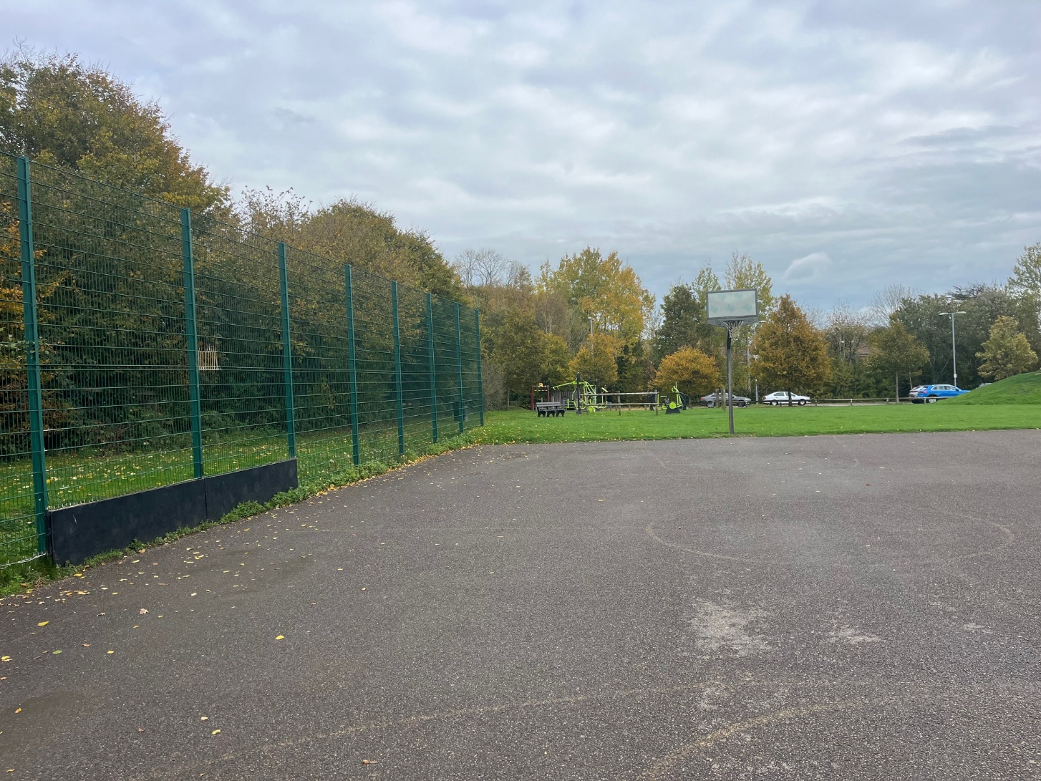

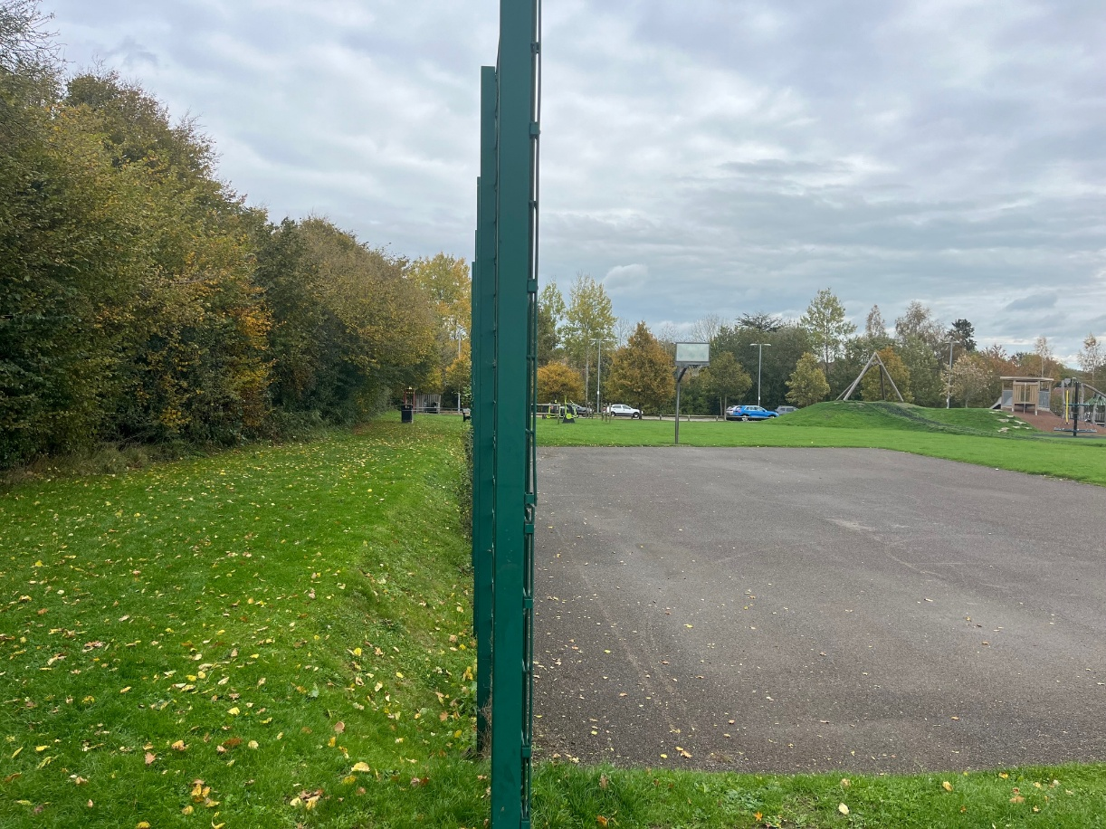
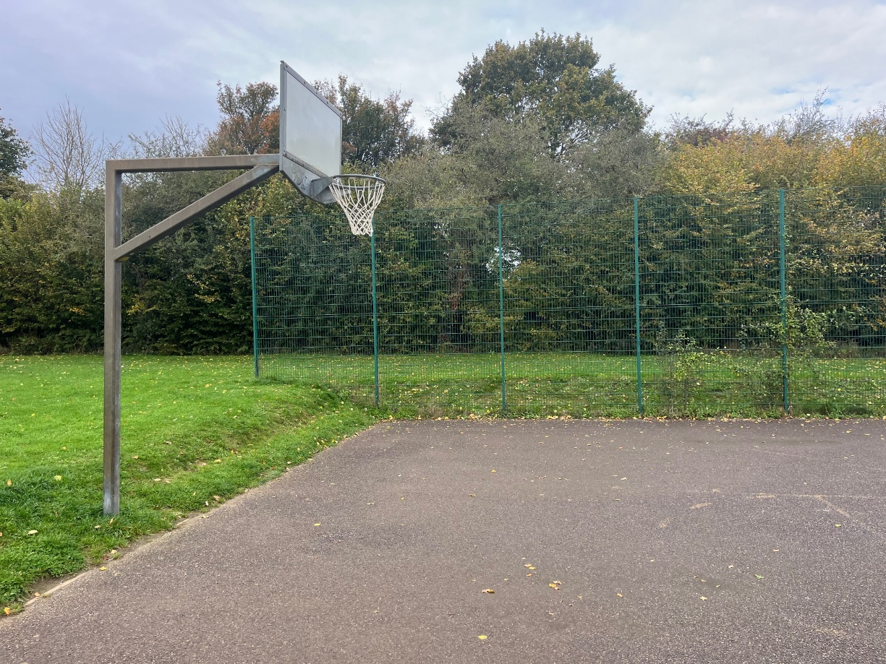
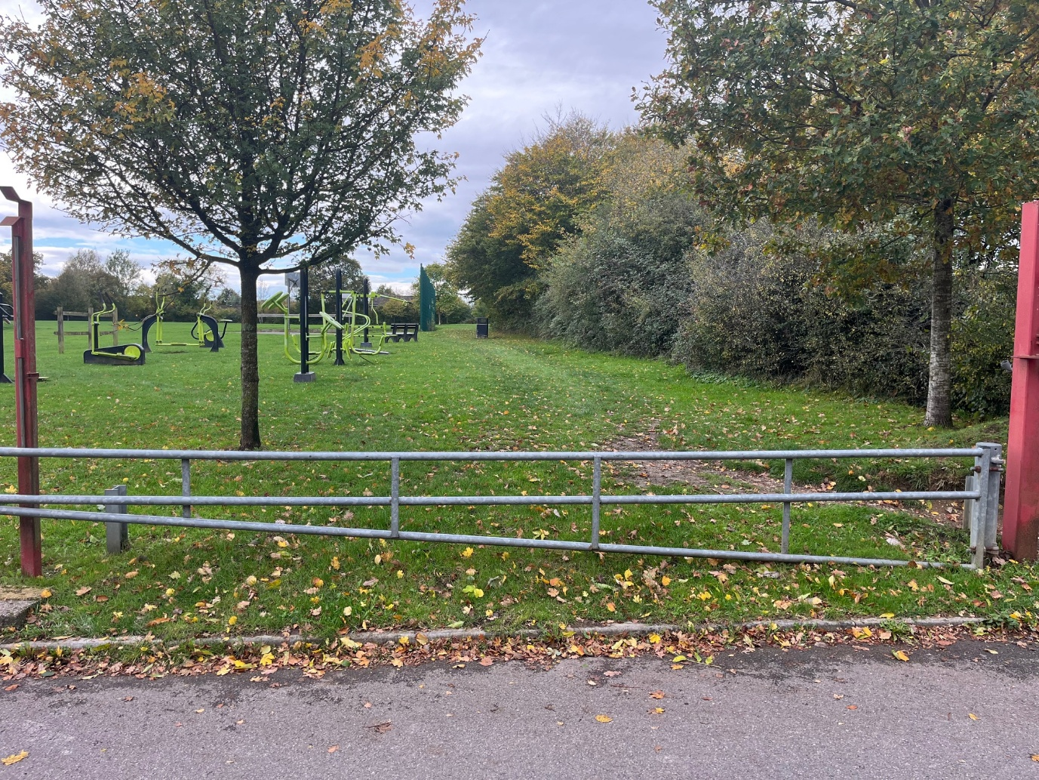

- Lot budget

The budget is approx. £65,000.00 (Ex VAT).

The full budget may be exceeded to meet the minimum brief.
All features included within the design must be included within the budget and quotation, there must be no ‘suggested’ additional works shown in the design outside the tendered price.

- Site requirements & objective

A new multi-use games area that encourages users of all ages and abilities to utilise the facility for its intended purpose. This will be a non-competitive recreational space that will be primarily designed to use for football, basketball and netball.

The current footprint is approx. 25m x 15m (375sqm) of asphalt with 2 x Basketball Backboard and Hoops. The site will require new fencing around the perimeter and a new bitumen overlay with line markings. Access will be via chicanes or the escape routes at the football goal ends.
Site set-up:

Welfare (drinking water and a portable toilet) must be provided for the duration of the Works.
Heras Fencing must be established around the entire site for the duration of the Works, with sufficient CDM signage and double clipped.

Note: there are no TPO (Tree Preservation Orders) on any trees in the vicinity, however contractors must ensure a method of works will mitigate any potential damage such as appropriate use of Heras fencing.

- Specification

  - Multi Use Games Area

Welded steel, highly robust powder coated panels. Twin bar panels are not acceptable. (Colour Chart to be provided).
Football goal recess (white) and basketball backboard and hoop at each end.
Fencing Height: 3.0 metres on 3 x sides and 1.0 metre on 1 x side (field/zip wire side – southern side).
Chicane entrance on both long sides, with consideration of the slope and proposed pathway on the northern side.
Escape routes at each goal recess.
Line Markings: allow for Netball and Basketball line markings in contrasting colours.
Note: Design must conform to BS EN 15312:2007 and suppliers should refer to any guidance detailed in the SAPCA Code of Practice for the Construction of Outdoor Multi Use Games Area, with the design adhering to any relevant guidance.

  - Surfacing

Powerwash existing asphalt surface to ensure removal of any existing debris, moss etc.
Puncture drainage holes into existing asphalt or any other suggested design to ensure adequate drainage.
Open textured 40mm porous asphalt (bitumen) over the existing asphalt footprint of approx. 375sqm. Allow for surfacing within goal recesses and chicane entrance.
Surface should be laser levelled and to a 1:100 fall along the pitch length.

  - Pathways

Optional Pathway: 1.2 metre wide, tarmac pathway with PCC (concrete) edging. Starting point will be next to the maintenance gate at the car park alongside the proposed outdoor fitness facility finishing at the MUGA. Subbase of 100mm Type 1 MOT required.

This only needs to be a budgetary quotation with final details and specifications to be discussed at a later date should the Council wish to proceed with the preferred contractor.

  - Fencing & Gates

No additional fencing or gates will be required as part of this project other than detailed for the MUGA.

  - Furniture

No seating is required as this will be provided by the Council at a later date.

  - Removals and Spoil

All spoil and waste must be removed off site and disposed of in a suitable facility.
All existing fencing panels and basketball backboard and hoops are to be removed and disposed of in a suitable facility ensuring that no protrusions remain that could either affect the quality of the surface or pose a risk to users.

  - Re-Instatement

All damage resulting from removals, vehicle movement, installation, deliveries or any other aspect of the Works, must be repaired or reinstated to at least the condition of that item or items or replaced with the same or similar alternative/s. This includes any ground repair, that either needs soil, grading and grass seed for minor damage, or new turf for any major damage.

  - Post Installation Inspection

A post installation inspection by an independent RPii qualified inspector (i.e. Play Inspection Company, RoSPA or other similar provider) is required to sign off the completed installation. The contractor should allow for this cost within their tender price.

  - MUGA Sign

Signage x 1 (minimum A2 size) affixed to the fencing panels should be provided to indicate: The site name, suitable age use, telephone number to report any incident or damage, number to call in an emergency, Parish Council logo. Final artwork to be agreed by Council.

Ensure the sign is easy and practical to read and understand for a range of users.

