Appendix A1: Lot 1 Scope of Works and Specification

- Site identification

Site name | Jubilee Park Outdoor Fitness Facility
Site address | Crouch Lane, Waterlooville | Site Postcode | PO8 9SU
What3Words location | ///covers.merit.fired

Site photographs:

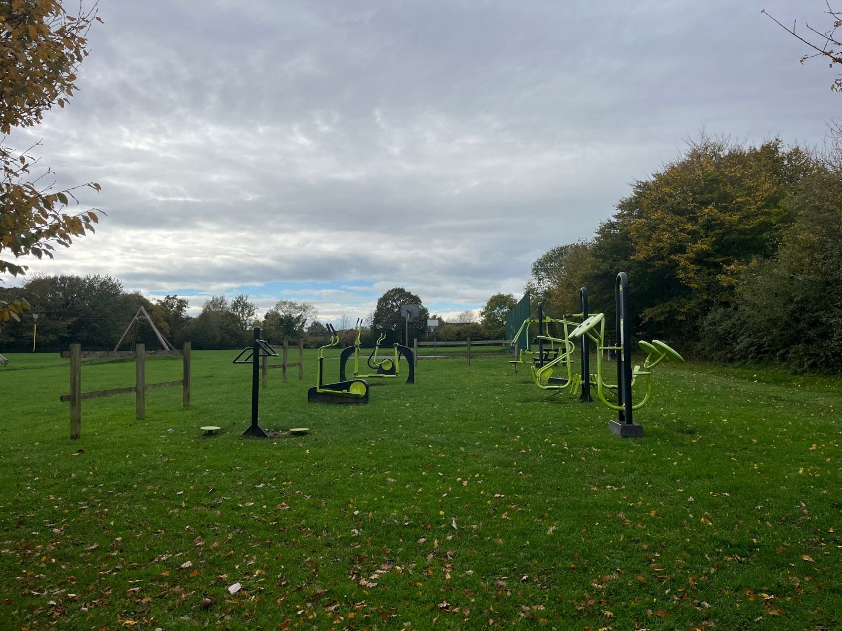
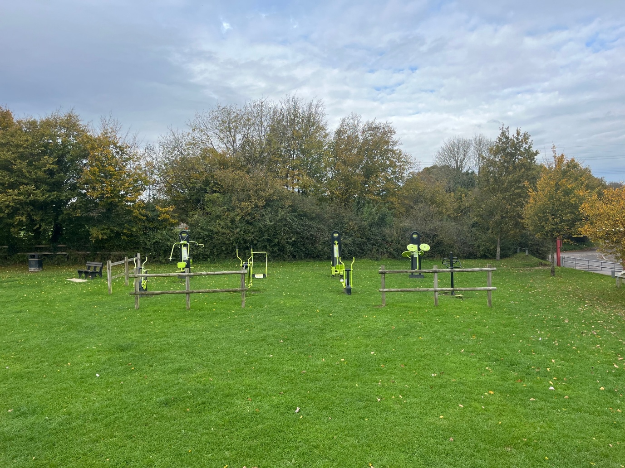

- Lot budget

The budget is £30,000.00 (Ex VAT).

The full budget should be used but not exceeded.
All features included within the design must be included within the budget and quotation, there must be no ‘suggested’ additional works shown in the design outside the tendered price.

- Site requirements & objective

All existing outdoor fitness equipment and associated materials such as grass matting and fence panels are to be removed and disposed of.

A new Calisthenics Frame and surfacing is to be installed on the proposed footprint shown on the Google Map (Main Tender Document) with a connecting surface to the proposed MUGA.

The new frame should offer a variety of health and fitness benefits for a range of users and abilities, with independent evidence to support any claims. The facility should encourage users to return, include user friendly instructions both visually and in writing, and be practical and accessible throughout.

Site set-up:

Welfare (drinking water and a portable toilet) must be provided for the duration of the Works.
Heras Fencing must be established around the entire site for the duration of the Works, with sufficient CDM signage and double clipped.

Note: there are no known TPO (Tree Preservation Orders) on any trees in the vicinity, however contractors must ensure a method of works will mitigate any potential damage such as appropriate use of Heras fencing and traffic management.

- Specification

  - Outdoor Fitness

Equipment must be made of steel, with appropriate anti tamper proof fixings and suitable rubber hand grips where appropriate.

Must Have:
Large Calisthenics Frame

Could Have:
Individual Calisthenic items such as Parallel Bars, Sit Up Bench.

Don’t Have:
Moving Items/Equipment
Equipment that has little to no health or fitness benefits

All product supplied must be certified to or compliant with the relevant safety standard:
BS EN 16630:2015.

  - Surfacing

Wetpour.
Wetpour sub-base works shall be excavated to the depth required for a flush finish with the surrounding area, back filled with 100mm depth of compacted MOT Type 1 stone laid beneath the rubber surface. Colour of wetpour to be black however to include colour splashes to highlight the primary fitness points and to encourage transition around the frame.

Wetpour is to be expanded to connect the fitness facility to the Multi Use Games Area, as suggested on the Google Map (Blue Outline). This is to ensure practical access between the two facilities and should not have any equipment in this space. Surfacing should also be considerate of a future pathway that will likely run parallel to the facility.

Edges should be trench cut into the surrounding grass or fully resin bonded to the pre-cast concrete (PCC) edging if adjoining a pathway. Wetpour shall not be laid during wet weather or in temperatures below 5 degrees Celsius.

  - Pathways

No pathways are required as part of this project, other than the connecting wetpour path to the proposed MUGA.

  - Fencing & Gates

No fencing or gates will be required as part of this project.

  - Furniture

No seating is required as this may be provided by the Council at a later date. The existing bench is to remain in situ, and the design should consider this, however, can be relocated onto a new hardstanding is required. Note: there is a bin near the site which is to remain in situ.

  - Removals and Spoil

All spoil and waste must be removed off site and disposed of in a suitable facility.
All existing fitness equipment and grass matting is to be removed and disposed of in a suitable facility ensuring that no protrusions remain that could either affect the quality of the surface or pose a risk to users. Existing wooden fence panels should also be removed.

  - Re-Instatement

All damage resulting from removals, vehicle movement, installation, deliveries or any other aspect of the Works, must be repaired or reinstated to at least the condition of that item or items or replaced with the same or similar alternative/s. This includes any ground repair, that either needs soil, grading and grass seed for minor damage, or new turf for any major damage.

  - Post Installation Inspection

A post installation inspection by an independent RPii qualified inspector (i.e. Play Inspection Company, RoSPA or other similar provider) is required to sign off the completed installation. The contractor should allow for this cost within their tender price.

  - Fitness Signs

Signage x 1 (minimum A2 size) on steel posts should be provided to indicate: The site name, suitable age use, telephone number to report any incident or damage, number to call in an emergency, Parish Council logo. Final artwork to be agreed by Council.

A 2nd sign (minimum A1 size) should be displayed in relation to the actual equipment including a visual/picture of the equipment, QR Code to link to a video to demonstrate use, area of body to benefit, and any other recommended information.

Ensure the signs are easy and practical to read and understand for a range of users.

