
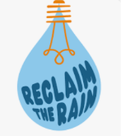

Norfolk and Suffolk Integrated Water Action Plan
Scoping Document

Introduction
Located within the driest region of the UK, East Anglia, Norfolk and Suffolk face significant and growing water related challenges. These include limited water availability, declining water quality, physical changes to water systems, increase in salinity in coastal areas and an increased risk of flooding. These issues are compounded by competing demands for water from public supply, business, agriculture, and the natural environment.
The region is home to a rich mosaic of habitats such as wetlands, heathlands, coastal areas, chalk streams, ancient woodlands, peatlands and grasslands which are supporting rare and critically important species. Norfolk and Suffolk encompass a mix of rural and urban landscapes, and include both nationally and internationally designated environmental sites, many of which intersect the county boundaries.
Climate change is intensifying existing pressures. Winters are becoming wetter, leading to more frequent and severe flooding, while hotter, drier summers increase the risk of drought, heat stress and intense storms. The region's coastline has always been dynamic, but these conditions are increasing the rate of change rapidly.
Agriculture is a cornerstone of Norfolk and Suffolks economy alongside tourism, manufacturing, and energy, is under increasing strain. The Fens contain 50% of England grade 1 agricultural land. Farmers who are key to the region’s food security face increased challenges balancing productivity with environmental and regulatory demands in the shift toward decarbonisation and more sustainable water use.
Water is fundamental to life in Norfolk and Suffolk. It underpins our economy, sustains our natural environment, supports public health and wellbeing, and enhances quality of life. However, water management, whether in terms of quantity or quality, is increasingly complex. It involves multiple layers of legislation, regulation, and a wide array of local, regional, and national stakeholders. Addressing these challenges will require coordinated, cross-sector action to ensure a sustainable and resilient future for the region.

What is causing the challenge?
- Increased housing delivery targets
- Lack of investment in infrastructure
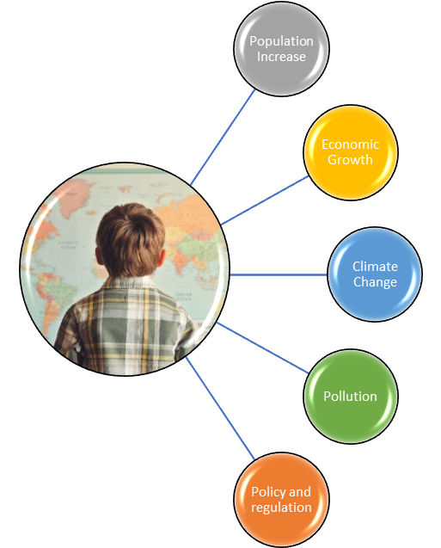

- House build targets
- Business expansion and inward investment

- Flood
- Drought
- Increased Temperatures

- Run offs
- Waste water treatment
- Commercial
- Visitor Economy

- Water Company obligations
- Abstraction licence reform
- Lack of holistic water management
- EA and Natural England regulations/Fear of prosecution

What pressure does this put us under?
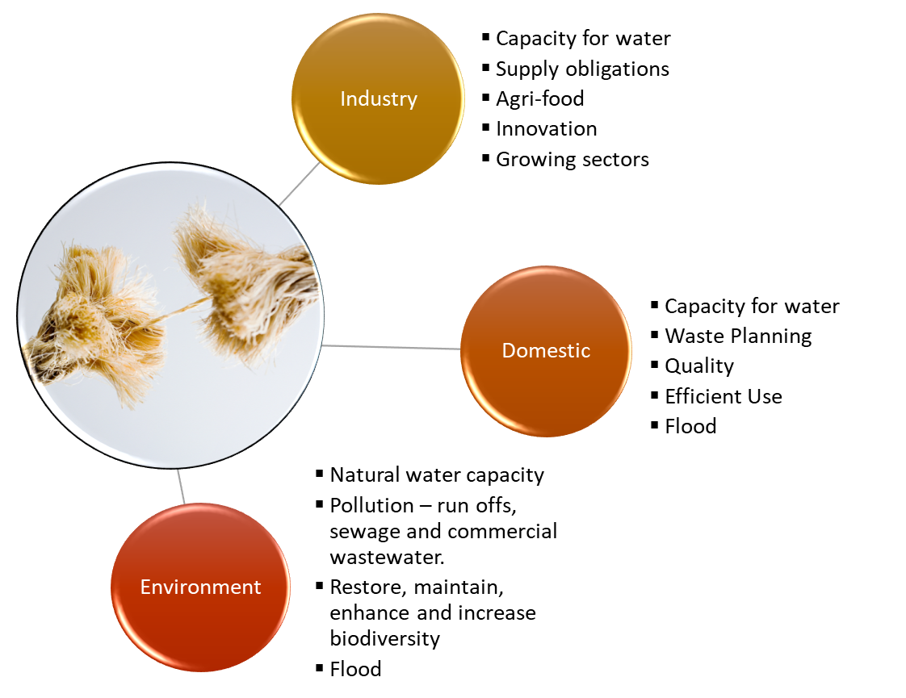

What are the impacts of water scarcity?
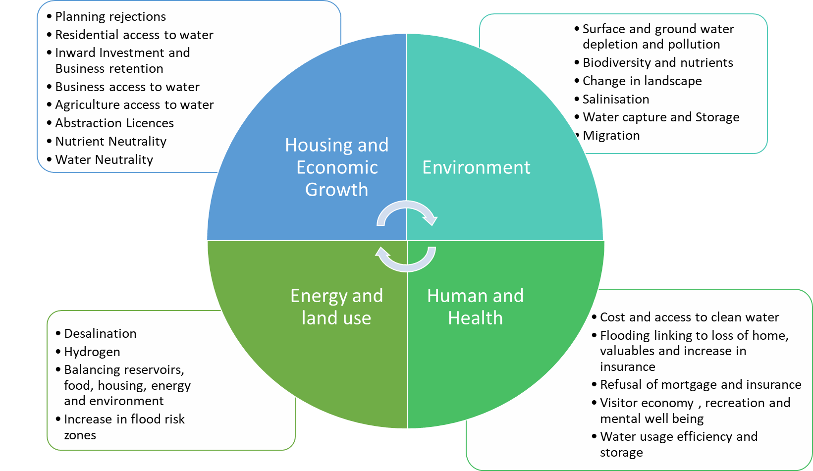

Housing and Economic Growth
Housing and economic growth remain high priorities at both national and local levels, with central government setting ambitious targets for housing delivery. Norfolk and Suffolk aim to attract new inward investment while retaining the businesses that underpin the local economy and labour market. However, water and energy capacity along with connection availability are increasingly influencing investment decisions. Water companies are not obligated to supply water to businesses for commercial or production purposes, other than for sanitation purposes, creating further uncertainty and restrictions to future growth.
While the region is among the driest in the UK, it also faces unique vulnerabilities to flooding. The latest National Flood Risk Assessment (NaFRA) highlights additional areas at risk due to climate change.
The agri-food sector is particularly affected. Wetter winters can flood fields and hinder the sowing, crop growth, harvesting and grazing while increasingly dry springs and summers require increased availability of water for irrigation to maintain certain crop yields and quality. This has implications for both regional food security and economic stability. This situation is exacerbated by abstraction licence restrictions, and inflexibility to capture and store high flows. Without sustainable water access, job losses are likely, and many farmers are already questioning the viability of their businesses. The agricultural sector, facing mounting pressures from decarbonisation, water scarcity, and regulatory change, is experiencing a decline, with one of the highest occupational suicide rates in the UK.
Water related constraints are also beginning to affect housing development. Water companies are advising that some planning applications should be rejected due to insufficient wastewater capacity, compounding the longstanding challenges of nutrient neutrality in affected catchments where building has been paused or severely restricted. A more comprehensive understanding of current and future water demand would enable more targeted infrastructure investment and potentially reduce negative impact on growth.
Norfolk and Suffolk’s coastal position on the North Sea increases the risk of tidal and storm surges. Around 20% of the east of England including Norfolk and Suffolk lies below the current sea level, posing significant risks to infrastructure, communities, and
future housing development as sea levels continue to rise.

Norfolk & Suffolk elevation above sea level
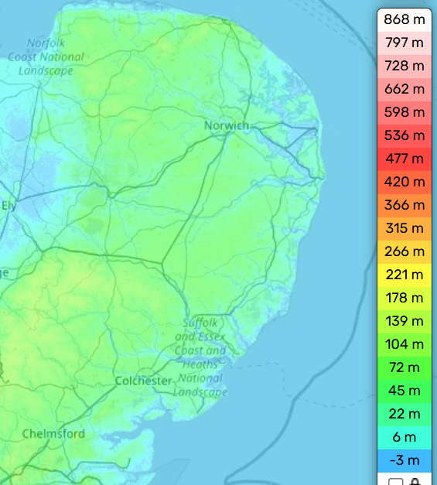

Source: Norfolk topographic map, elevation, terrain

To plan effectively for future economic growth, food security, better flood & drought resilience and climate adaptation, we must develop a clear and detailed understanding of the issues below and the interactions between them:
- Forecasted housing and economic growth
- Sectors most at risk and those projected to grow that require high volumes of water
- Current and future water and wastewater needs
- Areas where infrastructure capacity aligns with growth potential
- Locations most vulnerable to flooding
Equally important is assessing the current and projected economic cost of water scarcity. This insight will strengthen the region’s case for government and private investment in water infrastructure and water storage.
While some businesses are adopting water-efficient technologies, others particularly in the digital and agri-food sectors face significant barriers to doing so. At the same time, a growing number of innovative projects are emerging across the region. However, these efforts to find new solutions and challenge the status quo must be coordinated to avoid unnecessary duplication, maximise funding, and enhance impact.
The challenge of nutrient neutrality rooted in water quality concerns; particularly nutrient loading continues to hinder development. Moving forward requires a better understanding of current mitigation efforts, their effectiveness, and the role local authorities can play. We must also explore alternative approaches, assess the impact of the Nutrient Neutrality Mitigation Fund, and evaluate how emerging mechanisms such as water neutrality and water credits are and could influence or support growth.
By providing a clear and evidence-based picture of Norfolk and Suffolk’s water constraints and opportunities, we can play a proactive role in shaping national conversations, attracting investment, supporting innovation, combined and enabling sustainable growth.
Environment
Water related challenges are deeply interconnected with environmental health and have significant knock-on effects across all our priority themes.
Water pollution from combined sewage overflows (CSOs), agricultural runoff and road surface drainage presents toxicity and nutrient enrichment risk to aquatic ecosystems. This can lead to algal blooms, oxygen depletion, and fish die-offs, which disrupt entire food webs and damage fragile freshwater and marine habitats.
Extensive river engineering has altered natural waterways, reducing habitat for wildlife and diminishing flood resilience. At the same time, coastal erosion is reshaping the landscape, particularly in Norfolk, where around 20% of the land lies below sea level. Rising seas and more frequent storm surges are not only threatening homes and infrastructure but are also salination in rivers, wetlands and aquifers causing further ecological damage, including mass fish mortality in recent years.
Water also plays a vital role in global biodiversity. Norfolk and Suffolk sit on the East Atlantic Flyway, a major migratory route connecting Scandinavia, Russia, and Africa. Migratory birds rely on our freshwater habitats for rest, hydration, thermoregulation, navigation, and breeding. Degraded or disappearing wetlands directly threaten these species and the biodiversity they support.
With wetter winters and drier summers becoming the norm, there is an urgent need to develop smarter approaches to water storage and usage. Capturing and storing high flows throughout the year such as through small, localised reservoirs or managed aquifer recharge could help build resilience against summer droughts, better supporting ecosystems and agriculture alike.
Drought conditions also increase the risk of wildfires, which can be devastating for landscapes and communities. Addressing this requires two key elements: increasing public awareness around prevention and ensuring adequate water availability for firefighting during peak risk periods.
Norfolk and Suffolk's natural environment is also central to the regional economy. Tourism, which depends on clean water, rich biodiversity, and preserved landscapes, was worth £5.5 billion in 2023 and supported 112,200 jobs, 14.6% of the workforce. Sustaining and enhancing the environmental assets that attract visitors is essential for long-term prosperity.
Encouragingly, nature-based solutions and mitigation are possible, and several initiatives are already in progress. However, we face three key challenges:
- Coordination: We must bring together existing projects and stakeholders to ensure collaboration, avoid duplication, and enable efficient use of funding and resources.
- Support Local Decision Making; Greater control over implementation and management of resources that supports innovation and bespoke solutions.
- Gap Analysis: We need to identify areas not currently being addressed and assess where additional focus or investment is needed.
- Strategic Intervention: In some cases, nature-based approaches may need to be complemented with technological innovations or large-scale infrastructure to deliver sustainable outcomes.
By uniting our efforts and understanding the full picture, we can better protect and restore Norfolk and Suffolk’s unique natural environment, preserving it for future generations while also supporting a thriving, resilient economy.

Human and Health
Access to clean, affordable water is essential for life. Without it, communities are at greater risk of waterborne diseases, infections, and the wider health impacts of poor hygiene. Everyone should have the right to safe water not only for drinking and sanitation but also for recreation and quality of life.
We recognise that water is not always used as efficiently as it could be. Clean, treated water is still used for many activities such as watering gardens and golf courses, where alternatives rainwater harvesting and storage would be more sustainable. Encouraging behaviour change remains a key part of the solution. We need to foster a culture of water-saving and waste reduction at both business, individual and community levels.
Flooding is also a growing concern. It can cause serious damage to homes and belongings, affect access to mortgages and insurance, and disrupt everyday life. Flooded roads can prevent people from getting to work, school, or supporting family members who depend on them compounding the social and economic impacts. Studies are showing the impacts of flood risk on mental health and the additional strain they exert on the NHS.
Water also contributes significantly to wellbeing. Our waterways and coastline offer spaces for swimming, paddleboarding, canoeing, and other activities that support physical and mental health. These water assets are a foundation of our thriving visitor economy, contributing both directly and indirectly to local prosperity.
In addition, sufficient water supply is essential for growing nutritious food and ensuring food security. Water stress not only affects crop yield but also impacts the quality and nutritional value of the food we produce and consume.

Water, Energy, and Land Use
Our region not only faces water scarcity but also increasing challenges around energy. Energy production especially in power plants and biofuel facilities requires significant volumes of water, primarily for cooling. At the same time, the water sector depends heavily on energy to power activities such as pumping, desalination, and wastewater treatment and recycling. This interdependence creates a critical feedback loop where shortages or inefficiencies in one system can severely impact the other.
In some cases, water is also a byproduct of energy production. How this water is treated and reused should be considered as part of a wider resource efficiency strategy.
Land use is at the centre of this complex equation. There is growing and often competing demand for housing, economic development, food production, energy infrastructure, nature recovery, and water storage. Balancing these priorities requires careful planning. However, much of this is constrained by land ownership and the willingness of landowners to release or repurpose land.
Without a comprehensive, integrated view of these overlapping challenges water, energy, land, and development it’s difficult to grasp the full scale of the issue or build the robust evidence base needed to influence decision-making and investment at all levels.
County Council’s Role
Water is central to many of the services we deliver, from our responsibilities as the Lead Local Flood Authority’s for Norfolk and Suffolk and our statutory duty to protect and enhance biodiversity, support the local economy, and provide essential services to the people of Norfolk and Suffolk. All these areas are either currently affected by water-related issues or will be in the future.
To ensure the County Council has a clear and coordinated approach, we are working to understand the full extent of our involvement whether through direct service delivery or our wider influence. Our goal is to strengthen resilience across our communities, align our efforts, and establish shared priorities for water in Norfolk and Suffolk so we can speak with one, unified voice.

Integrated Water Action Plan: Project Plan

Purpose
To deliver an integrated water action plan that supports sustainable economic growth, environmental resilience, and climate adaptation in Norfolk and Suffolk, aligning infrastructure, policy, and innovation with future water demands and risks.

Key Themes
- Economic and Housing Growth
- Environment
- Human and Health
- Secondary Impacts

Outcomes

1. Sustainable Economic and Housing Growth
- Understanding the economic value of water scarcity in Norfolk and Suffolk to underpin the importance of developing and delivering solutions.
- Infrastructure planning aligned with water availability to support housing targets.
- Inward investment and business retention improved by addressing water capacity constraints.
- Agricultural sector better supported through sustainable abstraction and irrigation planning.
2. Improved Water Resilience
- Better ability to manage water scarcity, drought, and flood risk.
- Smarter and increased availability of water storage, reuse, and efficient use across sectors.
- More reliable water supply to support agriculture, housing, and industry.

3. Environmental Restoration and Protection
- Enhanced biodiversity through better water quality and wetland resilience.
- Reduced pollution from agricultural and highway runoff and combined sewage overflows.
- Ensure that the impacts of development do not have a detrimental impact on the water environment.
- Strengthened coastal and riverine ecosystems against erosion and salination.

4. Health and Wellbeing Protection
- Reduced exposure to waterborne diseases through improved wastewater management.
- Better flood protection for communities and infrastructure.
- Enhanced public access to clean water for recreation and mental wellbeing.

5. Cross-sector Collaboration and Integration
- Stronger partnerships with water companies, regulators, agriculture, local government and businesses.
- Unified and evidence-based advocacy to government and private funders.
- Streamlined innovation delivery through coordinated project mapping and funding.

6. Climate Adaptation Readiness
- Regionally and locally coordinated response to changing rainfall, sea level rise, and droughts.
- Long-term land use planning that balances housing, agriculture, and conservation needs.

Outputs

1. Comprehensive Water Data and Evidence Base at County and District level
- Water demand and wastewater forecasts.
- Mapping and modelling of water quality, availability, flood risk, and capacity for growth.
- Evidence base to inform district Water Cycle Studies including integrating into I-WAP general stakeholder engagement stakeholder engagement.
- Economic analysis of water scarcity and its financial impact being delivered as a separate workstream by project partner, Reclaim the Rain.

2. Integrated Action Plan for Norfolk and Suffolk
- Prioritized actions across four key themes: economy and housing, environment, human and health, water, energy and land use.
- Defined roles and responsibilities for stakeholders (e.g., councils, water companies, developers, private sector and communities).
- Timeline for implementation and progress monitoring, taking account of the infrastructure planning and investment cycles of key actors and agents.

3. Innovation and Project Pipeline
- Catalogue of current and future water projects (e.g., reuse, storage, technology).
- Coordination of nature-based and engineered solutions.
- Cross-sector innovation opportunities, especially in Agri-tech, tourism, digital and manufacturing.
4. Investment Strategy and Funding Pathways
- Strategies to attract private and government investment into water infrastructure.
- Portfolio of business cases for priority water-related interventions.
- Engagement with emerging mechanisms like nutrient/water credits and neutrality to understand future scalability of mitigations and opportunities for further trading of mitigation credits between providers to enable future growth.
- BNG, Carbon Credits, Natural Capital – interlink
5. Portfolio of Case Studies
- Real-world examples of successful water solutions (e.g., wastewater reuse, fire resilience, seasonal storage).
- Lessons learned and transferable practices.
6. Constraint and Opportunity Mapping
- GIS-based overlays showing where environmental, energy, water, and growth priorities align or conflict.
- Support credible evidence-based planning and influence land use decisions.
7. Stakeholder Engagement Reports
- Documented outcomes of engagement with residents, businesses, water companies, and sectoral experts.
- Communication and education strategies to drive public behaviour change.

8. Project Reports and Action Plan
- Create a deliverable action plan targeted at various audiences from community, water companies, businesses, local authority etc showing clear lead and support roles encouraging collaboration.
- The Council reserves the right to order further work from the winning bidder. This would be an additional requirement for Full Water Cycle study reports for each district in Norfolk and Suffolk. The price for this will be based on the day rates contained in the tender.

What’s already going on?

Reclaim the Rain
Economic Cost of Water Scarcity (excluding flooding and environmental degradation)
Risk & Policy Analysts (RPA) have been commissioned by Reclaim the Rain, a partner in the Integrated Water Action Plan (I-WAP) project, to deliver a dedicated study on the economic cost of water scarcity. This workstream is part of the I-WAP but is being delivered independently by Reclaim the Rain and is funded through an in-kind contribution to the overall I-WAP programme.
The study is structured around seven key tasks:
- Inception and stakeholder engagement
- Data collection
- Scenario storylines
- Future water scarcity model
- Economic impact of water scarcity
  - Business as usual
  - Water use efficiency
  - Coordinated approach to water management
- Synthesis of implications by sector
- Final reporting
These scenarios are not intended to represent a future reality but instead provide the basis for testing what the impacts of water scarcity could be under three different possible futures. This enables the economic effects of business as usual to be compared with sectors taking actions themselves, versus a more coordinated approach led by local planners and the Environment Agency (as the organisation that determines how water is licensed).
A final report summarising the findings and recommendations is scheduled for publication in December 2025 and will feed into the I-WAP.

Governance Structure
Senior Sponsor Norfolk: Wendy Brooks
Senior Sponsor Suffolk: Matt Hullis
Lead: Nicolette Jeffreys
Consultant: TBC
Steering Group: TBC

Timeline Summary
Draft Project Scope Complete: Jun 2025
Final Project Scope Complete: Oct 2025
Procurement: Oct – Dec 2025
Project Start: Jan 2026
Interim I-WAP report for Mayor: May 2026
Finalisation: Aug 2026

