

Background to Natural England
Natural England is the government’s advisor on the natural environment. We provide practical advice, grounded in science, on how best to safeguard England’s natural wealth for the benefit of everyone.
Our remit is to ensure sustainable stewardship of the land and sea so that people and nature can thrive. It is our responsibility to see that England’s rich natural environment can adapt and survive intact for future generations to enjoy.
Natural England are also responsible for the management National Nature Reserves (NNRs). There are currently 225 NNRs in England with a total area of over 98,600 hectares. Natural England manages about two thirds of England's NNRs, the remaining reserves are managed by organisations approved by Natural England, for example, the National Trust, Forestry Commission, RSPB, Wildlife Trusts and local authorities.
National Nature Reserves (NNRs) were established to protect some of our most important habitats, species and geology, and to provide ‘outdoor laboratories’ for research. Natural England’s National Nature Reserves are open to the public, and we welcome all our visitors to connect with nature and be inspired by our fantastic wildlife, habitats, geology and landscapes.
Parsonage Down Bull Pen/ Lower livestock barn repairs
Parsonage Down National Nature Reserve is 480 acres of some of the finest chalk grassland in England and 200 acres of improved farmland. It is a designated SSSI and SAC for its CG2 habitat and vascular plant assemblage.
Parsonage Down is also attached to Cherry Lodge Farm, a working organic farm home to the oldest herd of pedigree English Longhorn cattle; known as the Stoke Herd. Both the cattle and sheep are used for conservation grazing on NNR.
To be able to manage a large herd of cattle, some of the livestock are housed over the winter months. The Lower Livestock Shed normally houses bulls however the barn is not fit for purpose. These are the existing issues:
- There is a major hole in the roof with damaged roof purlins. The roof sheet are also made of asbestos.
- The shed is unable to be mucked out using agricultural machinery because it is lined with a single skin of breeze blocks.
- The barn is also dark and lack ventilation.
- The shed is placed at the bottom of a sloping yard so and feed put out gets wet from rain run off due to the feed barrier being flush with the roof eaves.
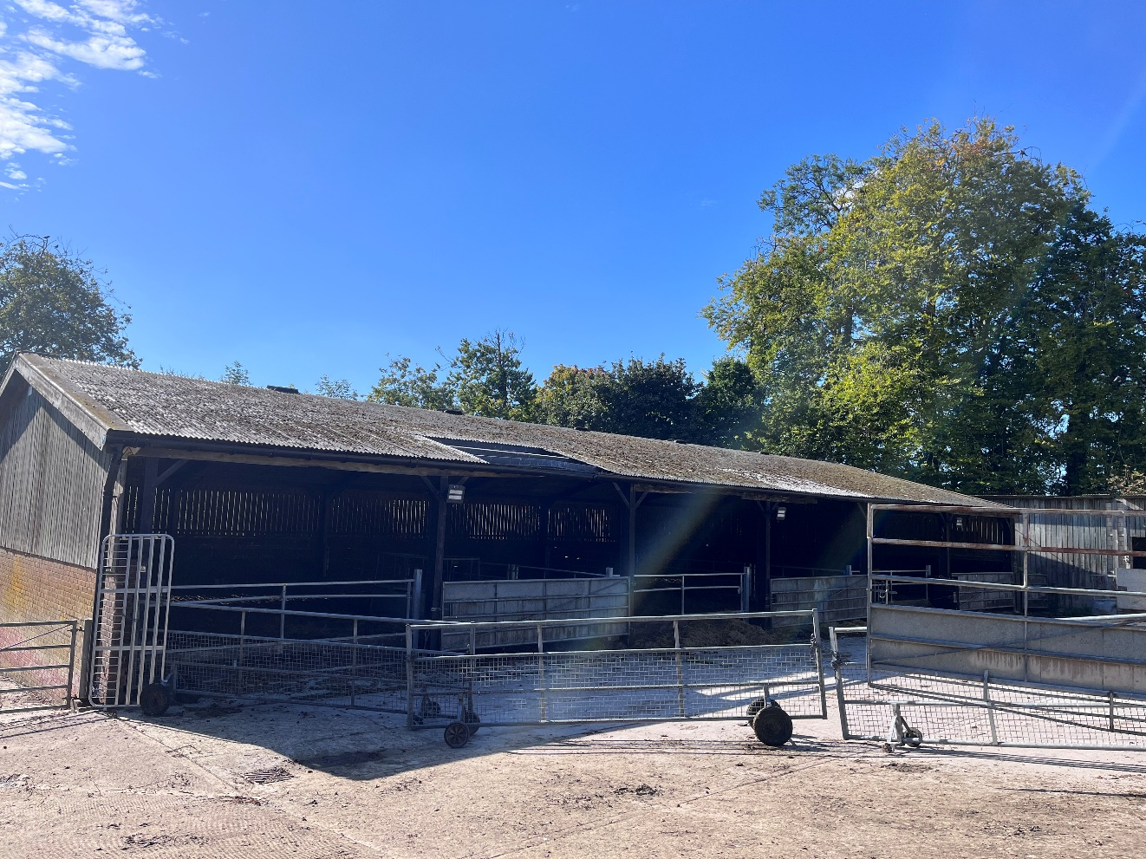
Picture 1 – Lower Livestock Shed

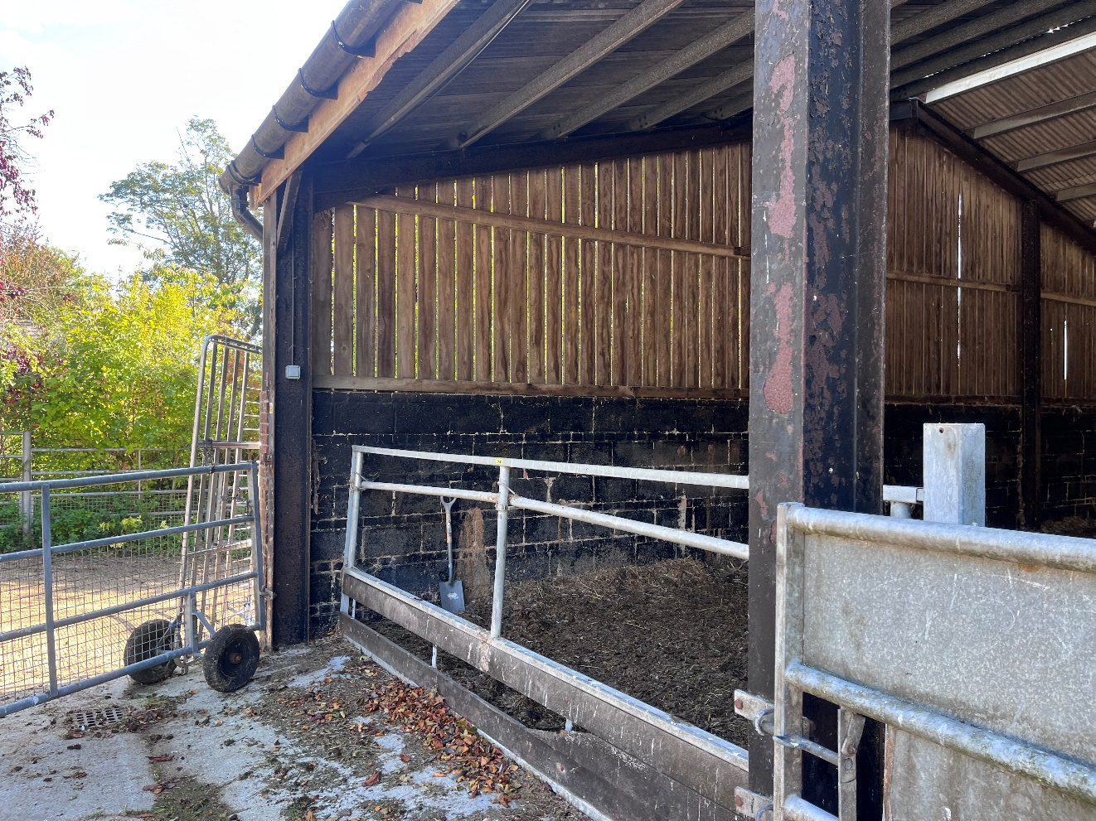

Picture 2 – Feed faces that need setting back and breeze block wall

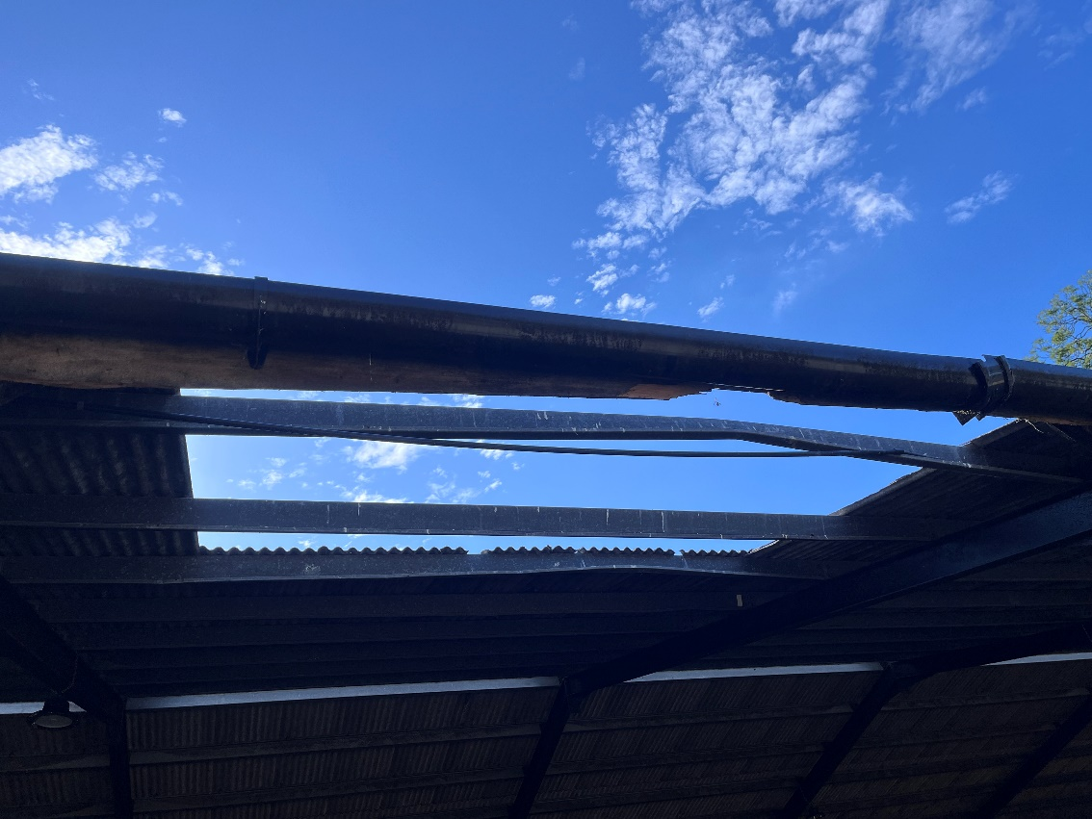

Picture 3 – Whole in the roof
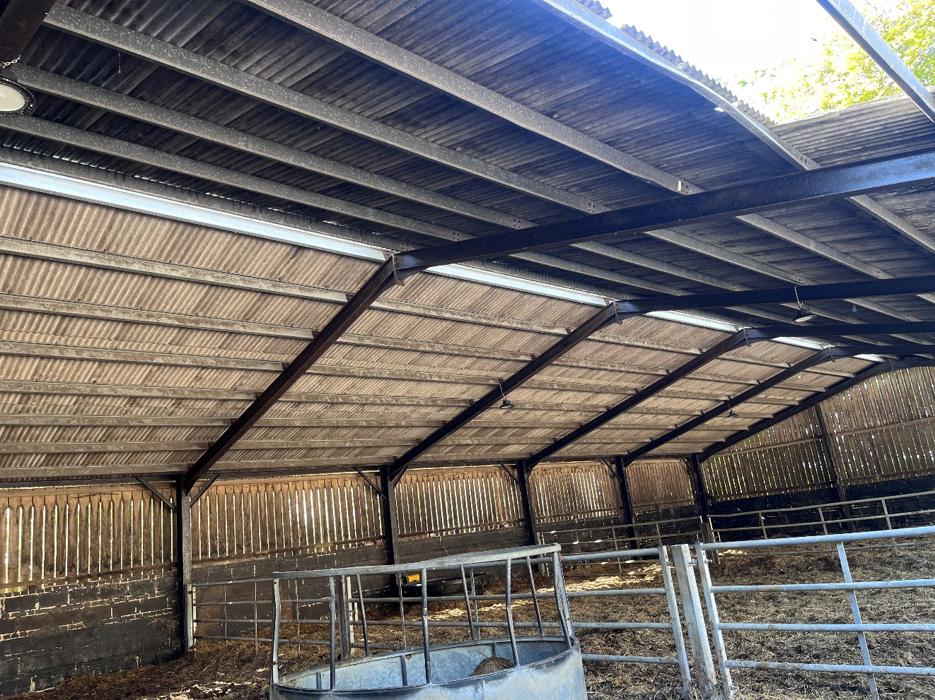
Picture 4 – Yorkshire Boarding on south and west wall that needs removing
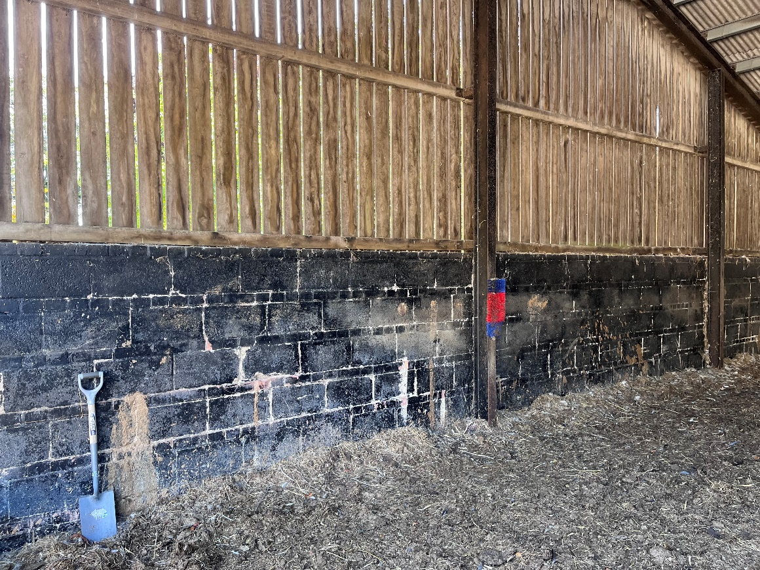
Picture 5 – Breeze Block wall and RSJ the pre-stressed concrete panels are to be fitted to
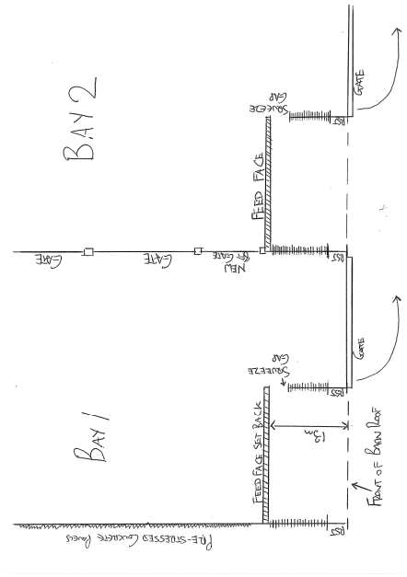
Picture 6 – Basic Barn Design

Requirement - Specification for Bottom Shed

- Roof

- Replace entire roof, repair damaged beams and dispose of old asbestos roof sheets through an approved waste disposal contractor.

- If this is not feasibly possible within the £50,000 (Excl. VAT) budget, we will accept repairs to the roof and the roof patched so it is watertight again.

- Install a raised roof cap to create better ventilation and make the roof watertight again.

- A structural survey has been carried out and found the rood structurally sound. Please see the report from JCP Engineers

- Replace the damaged gutters and soffits.

- Barn Walls

- Install pre-stressed concrete panels by attaching to the RSJs as designed by JCP engineers. Concrete Panels must be thick enough and tall enough to withstand a hit from a telehandler or tractor front loading bucket when mucking out the barn.

- Remove Yorkshire boarding on west wall entirely and every other board on the southern side.

- Feed Face

- Set back the feed faces to a depth off 1.3m and then replace the front gates with 8ft gates and slam post with the addition of a 0.3m squeeze gap with thick rubber lining. See Picture 6, below:

Key Points

- A civil engineering company have been out and assessed stability of the roof and deemed it safe. However please see the report

- The same company have also designed a bracket so the concrete panels can be fitted to the RSJs. Please see the design folder.

- Contractors wishing to quote must have experience and qualifications relating to civil engineering and water management

- Contractors will ideally by part of the CHAS or SMAS scheme however it isn’t mandatory

- Contractors must comply with Construction Design and Management regulations (2015). Its is desirable that contractors have experience in delivering projects that have worked to CDM regulations.

- Any plant machinery all specialist power tools required for the job must have operatives that are trained and certified.

- It will be expected that the contractor will provide a working method statement, risk assessments and evidence of public liability and insurance (level of evidence with depend on whether the contractor is CHAS/SMAS approved)

- Contractors wishing to quote must attend a site visit prior to submitting their tender.

Sustainability
Natural England protects and improves the environment and is committed to reducing the sustainability impacts of its activities directly and through its supply chains. We expect the Contractor to share this commitment and adopt a sound, proactive sustainable approach in keeping with the 25 yr environmental plan/our commitments compliant with all applicable legislation. This includes understanding and reducing direct and indirect sustainability impacts and realising opportunities, including but not restricted to; resilience to climate change, reducing greenhouse gas emissions, water use and quality, biosecurity, resource efficiency and waste, reducing the risk of pollution, biodiversity, modern slavery and equality, diversity & inclusion, negative community impacts.
As a delivery partner, the successful contractor is expected to pursue sustainability in their operations, thereby ensuring the Contracting Authority is not contracting with a supplier whose operational outputs run contrary to the Contracting Authority’s objectives. The successful contractor will need to approach the project with a focus on the entire life cycle of the project

Outputs and Contract Management
Reference | Deliverable
Deadline for submitting quotes | 21st November 2025
Deadline for site visits | 20th November 2025
Award of Contract | 26th November 2025
Start Date | 1st December 2025
Last Date work can be completed | 15th March 2026

