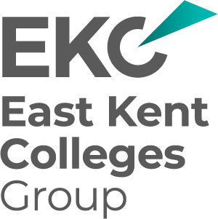
EKC Group – Tender to provide a HR and Payroll System solution (5-year contract)
Tender Appendix
HR System expanded requirements
04 November 2025

Learning and Development requirements

Connections Required:
- Moodle import of Mandatory and internal training
- Self-service certificate upload
- PowerBI (or equivalent reporting dashboard)
- Mandatory training notifications
- Training agreements with penalty fees accessible to payroll

Opportunities to resolve issues:
- Combine Qualification and Training records
- Checklists with uploads (Induction checklists) or equivalent self-service function with built in checklist items.
- Automated Checklist (or equivalent set up)
- Automatic Probation set up and reminders, self-service paperwork uploads.
- Consistency in Role names, descriptions and departments
- Reporting permissions for PowerBI link (or equivalent) so experts can see all staff records
- Training needs – automatically assign mandatory training, development programmes
- Automatic import of previous training and qualifications for new starters
- Training booking system

_END_

