Contents

1. Introduction 2

2. Project Timescales 2

3. Confidentiality 2

4. Response 2

5. Overview of Northumbria Police 2

6. Northumbria Police Geographical Area 3

7. Current CCTV Provision 4

8. Key Attributes of Future CCTV Requirements 4

9. Questions for Suppliers 5

10. Instructions to Respondents 6

11. Supplier Response………………………………………………………………………………………………………………………………….6

# Introduction

Northumbria Police (the ‘force’) invites suppliers to participate in a request for information (RFI). This market engagement is focused on assessing A Video Management Solution (VMS) - Video Analytics and Facial Recognition Software.

The output of the RFI process will help inform the force’s procurement route and the available technology capable of meeting both current and future requirements.

# Project Timescales

The Force is provisionally planning to issue the formal tender pack in July 2025, subject to the relevant approvals and the responses received for the RFI.

This is only an indicative date and likely to change depending on the outcome of this RFI and our internal approval process.

# Confidentiality

The contents of this RFI shall be treated as Commercial-in-Confidence and it is the recipients’ responsibility to ensure the contents are not published or disclosed to any third party without due prior consent of the force.

# Response

All responses to this RFI must be submitted by 12 noon 19/05/2025 via email to [james.thornton@northumbria.police.uk](mailto:james.thornton@northumbria.police.uk).

# Overview of Northumbria Police

The Chief Constable and the Police and Crime Commissioner have developed plans to serve the people of Northumbria, complementing the overall Policing 2025 vision produced by the National Police Chiefs Council (NPCC).

The National Policing Digital Strategy (2020-2030) has now been finalised and published early in 2020, and the high-level ambitions from this have been considered in this review:

The 3 P’s - Purpose, Principles and Priorities – define the ambition of the force and the aims set to achieve this.

Northumbria Police Forces purpose is to keep people safe and fight crime. Their principles are to deliver an outstanding police service, work with communities to prevent crime and disorder and to be there when the public need us.

The force priorities are:

* Be an outstanding force.
* Keep people safe and fight crime.
* Do the right things, in the right way, for the right reason.
* **Courage** - to promote openness, accountability, learning and improvement.
* **Respect and empathy** - to promote a respectful and supportive culture in which everyone can thrive.
* **Public service** - to improve the policing profession and the service we provide to the public.

# Northumbria Police Geographical Area

Northumbria Police (NP) is responsible for policing the administrative counties of Northumberland and Tyne and Wear. This covers an area of more than 2000 square miles with a population of 1.5 million.

The force is approximately 100 kilometres north to south and 80 kilometres east to west. The largest population and conurbation areas are in the Southeast, (Tyne and Wear and Southeast Northumberland), whilst the remainder is largely rural in nature.

The force borders with Durham to the south, Cumbria to the west and Lothian and Borders (Scotland) to the north.

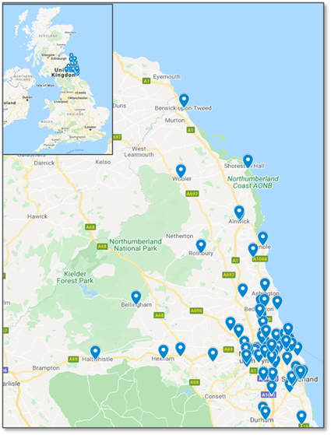

# Current CCTV Provision

## Overview

During the aftermath of the 2024 riots, Bedroq Ltd reached out to several UK Police Force’s to be able to assist with analysing footage which had been provided to the force.

Northumbria Police were one of those forces and benefited from major efficiencies as a result, leading to many arrests that would not have been possible without the product. This highlighted the need for Northumbria Police to procure a long-term VMS contract to ensure these efficiencies remain within the force and the functionality is not lost.

With the Force’s current contract coming to an end in November 2025, the purpose of this RFI is to ascertain what products and solutions are available in the market that can support our requirements and the most effective procurement route for achieving this.

# Key Attributes of the future CCTV requirements

The Force is looking to procure a Video Management Solution which can meet both current and future requirements for Northumbria Police.

Iteration 1:

* Retrospective viewing of CCTV Footage
* Playback imported CCTV footage
* Analysis of CCTV footage
* Importing of video footage
* Facial recognition technology
* Analyse specific objects
* Set time parameters
* Export capabilities/compilations in various formats (PDF etc)

Iteration 2:

* Implement ANPR
* Implement Northumbria Police live camera feeds
* Implement 3rd party live camera feeds
* Live geographical mapping of CCTV
* Live analysis of footfall
* Share footage within Police force
* CCTV demand tracker

Below we have detailed the questions which we would like suppliers to answer as part of the new solution within the force which gives further details to the roadmap which has been detailed above.

# Questions for Suppliers

Northumbria Police would be grateful if suppliers could provide outline answers to the following questions. We respect that some of your answers will be, by necessity, provisional and may change when you receive a formal, more detailed statement of requirements.

We acknowledge that some of the information provided in response to the RFI will be commercially sensitive and can confirm responses will only be accessed by those working on the contract for a new VMS, for the purposes of informing our route to market, the necessary budget required and current market capability.

Q1) Can you provide an overview of your company, including its history, size, and experience in providing video management solutions? (Particularly in similar industries/police forces)

Q2) What is the architecture of your VMS (e.g., cloud-based, on-premises, hybrid?) and how does your solution accommodate growing data and user demands?

Q3) What type of video analytics are included (e.g., motion detection, facial recognition, licence plate recognition)?

Q4) Does your VMS support real-time monitoring and alerts? How are these alerts managed and delivered?

Q5) What features does your user interface offer to enhance usability and efficiency?

Q6) What measures are in place to ensure the security of video data (e.g., encryption, access controls)?

Q7) How does your VMS comply with relevant industry standards and regulations (e.g., GDPR, MoPI)?

Q8) What camera manufacturers do your solution support?

Q9) What formats of CCTV can we import/export?

Q10) What levels of technical support do you offer (e.g., 24/7 support, dedicated account managers)?

Q11) What is your pricing model (e.g., subscription-based, one-time purchase)? Are there any additional costs we should be aware of?

12) Please can you provide indicative, fully inclusive (where reasonably possible) costs for a 4-year contract with two optional 12-month extension periods, broken down into annual costs? We appreciate your response is indicative only and subject to change pending the time of procuring and Northumbria Police’s confirmed requirements, however, this will allow us to ensure the correct budget is signed off before procuring a new contract.

Q13) What are you plans for future development and enhancements of the VMS?

Q14) Can you please advise which requirements noted in Iteration 1 and 2 are current or future capabilities (If future please advise timescales)

Q15) Please advise what national procurement frameworks your organisation is signed up to (if any).

Q16) If Northumbria Police advertised an open tender for this opportunity, would you intend to submit a Tender response?

Q17) There is now a major drive for public sector organisations to consider social value and sustainability during the procurement process. What social value and sustainability benefits could your organisation offer if successful for this contract?

Q18) What accreditations do your organisation hold? (E.G ISO certifications, Cyber Essentials)

# Instructions to Respondents

Please submit responses in any soft copy format that can be read by Microsoft Office.

Respondents are asked to return their responses to:

|  |  |
| --- | --- |
| Contact: | James Thornton |
| Role: | Procurement Business Partner |
| email: | James.thornton@northumbria.police.uk |

# Supplier Response

Q1)

Q2)

Q3)

Q4)

Q5)

Q6)

Q7)

Q8)

Q9)

Q10)

Q11)

Q12)

Q13)

Q14)

Q15)

Q16)

Q17)

Q18)