**Integrated Mediation and Disagreement Resolution**

**For Young People and Parents and Carers of Children**

**with Special Educational Needs and/or Disabilities**

**Needs Assessment**

**2025 – 2028**

# Introduction

The Children and Families Act 2014 [1] requires Mediation and Disagreement Resolution services to be put in place by Local Authorities and Health. They also have a duty to enable parents and young people with SEND aged up to 25 to receive information about the service and how to access it. Health also have a duty to provide and take part in Mediation as identified in the [Children’s and Young People’s Continuing Care National Framework 2016](https://www.google.co.uk/url?sa=t&rct=j&q=&esrc=s&source=web&cd=2&ved=0ahUKEwj1-LXwlMzKAhXM8RQKHRNzCBIQFgghMAE&url=https%3A%2F%2Fwww.gov.uk%2Fgovernment%2Fuploads%2Fsystem%2Fuploads%2Fattachment_data%2Ffile%2F494230%2Fchildren-continuing-care.pdf&usg=AFQjCNHPJINbwiYyiT1SxfIHcf_Yx1qJrg)[2] and [Part 3 of The Children and Families Act 2014](http://www.google.co.uk/url?sa=t&rct=j&q=&esrc=s&source=web&cd=1&cad=rja&uact=8&ved=0ahUKEwiY9eiu34vLAhUL0hoKHV-PABYQFggcMAA&url=http%3A%2F%2Fwww.legislation.gov.uk%2Fukpga%2F2014%2F6%2Fpart%2F3%2Fenacted&usg=AFQjCNF8U3CCK8JsYMfKuPRGVs-MgDJS1g&bvm=bv.114733917,d.ZWU).

The Needs Assessment collates key information which helps to inform the needs of the users of the service in preparation for the procurement of the Mediation and Disagreement Resolution service in September 2025-28.

# Legislation, Strategy, and Policy Background

There are a number of key areas of legislation, strategy and policy which relate to the delivery of Mediation and Disagreement Resolution services, these include:

* Part 3 of the Children and Families Act (2014) and the Children’s and Young People’s Continuing Care National Framework 2016 provide the legislative framework.
* The [SEND Code of Practice](https://www.google.co.uk/url?sa=t&rct=j&q=&esrc=s&source=web&cd=1&cad=rja&uact=8&ved=0ahUKEwjZjtzSpszKAhVLVRQKHQv1DXIQFggcMAA&url=https%3A%2F%2Fwww.gov.uk%2Fgovernment%2Fuploads%2Fsystem%2Fuploads%2Fattachment_data%2Ffile%2F398815%2FSEND_Code_of_Practice_January_2015.pdf&usg=AFQjCNGyyeYYXDzkQxmv6XO7ecoca65oCw&bvm=bv.112766941,d.d24) January 2015
* [Children’s and Young People’s Continuing Care National Framework 2016](https://www.google.co.uk/url?sa=t&rct=j&q=&esrc=s&source=web&cd=2&ved=0ahUKEwj1-LXwlMzKAhXM8RQKHRNzCBIQFgghMAE&url=https%3A%2F%2Fwww.gov.uk%2Fgovernment%2Fuploads%2Fsystem%2Fuploads%2Fattachment_data%2Ffile%2F494230%2Fchildren-continuing-care.pdf&usg=AFQjCNHPJINbwiYyiT1SxfIHcf_Yx1qJrg)
* Legislation and guidance in so far as it pertains to mediation and/or Disagreement Resolution relating to SEND
* The Care Act 2014

SEND Mediation and Disagreement Resolution is a quicker and less formal way to resolve disagreements than going to Tribunal. It can save time and pressure for all involved and it can help re-build relationships that have broken.

**Mediation** focuses on elements of an Education Health and Care Plan (EHCP) in education, social care or health. It’s used at various stages of the process and is specifically linked to decisions about EHCP needs assessments and plans. **Disagreement Resolution** focuses on any element of SEND provision, not just those who are being assessed for (or have) an EHCP.

The service provider must have knowledgeable mediation advisors/facilitators who can provide information and advice about pursuing mediation when discussing the decision on whether to go to mediation with young people, parents and carers. Mediators must be independent of LAs and must be trained and accredited in mediation/disagreement resolution. Mediators must take all reasonable steps to gather the views of the child or young person about the mediation issues.

# Profile of Service Users

Norfolk County Council (NCC), the Local Authority, and Norfolk and Waveney Integrated Care Board (ICB) (representing clinical commissioning for Norfolk and Waveney in Suffolk), also collectively known as ‘the Commissioners’ require a single organisation to provide both Mediation and Disagreement Resolution services for:

* Children and Young People with education, health and care needs (aged 0-25)
* Parents and those with parental responsibility for children and young people (aged 0-25) with special education needs and /or disabilities (SEND)
* Norfolk County Council, the Local Authority (for disputes/mediation services in the Waveney area Suffolk County Council will be the lead Local Authority.)
* Health organisations

A young person is a person over compulsory school age and under 25. Compulsory school age ends on the last Friday of June in the academic year in which they become 16. At the point when a young person reaches the end of compulsory school age all correspondence and discussions should take place, where possible, with the young person themselves with support of the parent and carers as agreed by the young person. Alternatively, if the agreement is received from the young person, correspondence and discussions can be directly with the parents and carers, (the Children’s and Families Act).

Under the Disability & Equality Act 2010, a child or young person is considered to have SEND if they have a learning difficulty or disability which necessitates special educational provision. This includes: if you have a physical or mental impairment that has a ‘substantial’ and ‘long-term’ negative effect on your ability to do normal daily activities.

⦁ ‘substantial’ is more than minor or trivial, eg it takes much longer than it usually would to complete a daily task like getting dressed

⦁ ‘long-term’ means 12 months or more, eg a breathing condition that develops as a result of a lung infection

A progressive condition is one that gets worse over time. People with progressive conditions can be classed as disabled.

However, you automatically meet the disability definition under the Equality Act 2010 from the day you’re diagnosed with HIV infection, cancer or multiple sclerosis.

# Local & National Data

* According to 2024 Education Data, in Norfolk, there were 21,613 school aged children (5-16year olds) identified as having an EHCP or receiving SEN Support. National data shows a steady increase in the number of pupils with special educational needs since 2016. In England, the percentage of pupils with an EHCP or Statement increased from 4.0% in 2022 to 4.3% in 2023; and for SEN Support increased from 12.6% to 13.0%. Norfolk’s rates reflect this increase – but show a greater proportion of pupils with either EHCP or SEN Support compared to regional and national averages. Overall, both nationally and locally, the increase for EHCPs is ‘steeper’ or faster than for SEN Support over time. The ‘real terms’ impact of this increase is shown below – including numbers of children and young people (CYP) aged 0-25 with an EHCP, which has seen an increase of nearly 6,000 in the last 7 years.
* Increases in the proportion of pupils with SEND are evident across the main school stages, and across both EHCPs and SEN Support. Both SEN Support and EHCPs in Secondary Schools in Norfolk reduced between 2017 and 2020 – but have increased since, possibly linked to the pandemic. EHCPs in Primary schools have consistently increased since 2017 and have accelerated since 2020.
* The demographic characteristics of children with SEND are similar to those nationally. Around 72% of children with an EHCP or SEN Support are boys in Norfolk, regionally and nationally. The age profile of children with SEND is also similar across comparator groups, with ages 10, 11 and 12 accounting for the highest proportions of children with EHCPs.

**Data related to delivery of the service:**

There are small numbers of disagreement resolution, the remainder is mediation. The two areas that are most in demand are ‘Contents of plan’ and ‘Refusal to assess’. For ‘Contents of a plan’, it can typically cover any combination of areas across education, health and social care needs. Whereas with ‘Refusal to Assess’ or ‘Refusal to Issue’, the disagreement arises as a result of SEND operational team’s decision making.

* **Demographics:** There were more requests for mediation in relation to males at 64% than females at 36%. In terms of ethnicity, the majority of people considered themselves as White British 69%, 25% declined to answer. The remaining respondents were spread across different ethnic groups in small numbers. Our analysis showed this was representative of the population of Norfolk.

|  |  |
| --- | --- |
| **Main SEND** | Cumulative Total |
| Autistic Spectrum Disorder | 539 |
| Moderate Learning Disability | 44 |
| Specific Learning Disability | 23 |
| Severe Learning Disability | 9 |
| Profound & Multiple Learning Disability | 8 |
| Social Emotional Mental Health | 20 |
| Speech Language Communication Nees | 20 |
| Physical Disability | 22 |
| Hearing Impairment | 8 |
| Visual Impairment | 0 |
| Multi Sensory | 2 |
| Other / Unknown | 18 |

# Service User Voice

The feedback received from all stakeholders is typically positive across most lines of questioning.

In the last 12 months all mediation has been held online with parents and young people offered the option of in person meetings if they would prefer it. Feedback about the method of delivery has been positive.

Other stakeholder feedback has suggested that it would be beneficial for the provider to involve, where possible, all relevant parties when a disagreement concerns Section I of an EHCP – including the parent, LA and any school(s) the parent or LA is seeking to name in an EHCP. The LA view is that is that it can be helpful having potential schools involved to help unpick the reasons why they consider the school unsuitable.

It has also been expressed that it is beneficial for the mediator who will facilitate the meeting to be involved in the pre-meeting preparation and particularly to meet the family prior to the meeting. This helps to ensure the family are well-prepared.

There has been interest from stakeholders about the reasons why a significant proportion of parents or young people change their mind about mediation following a referral and also the extent to which children and young people are engaged to capture their views prior to or during mediation.

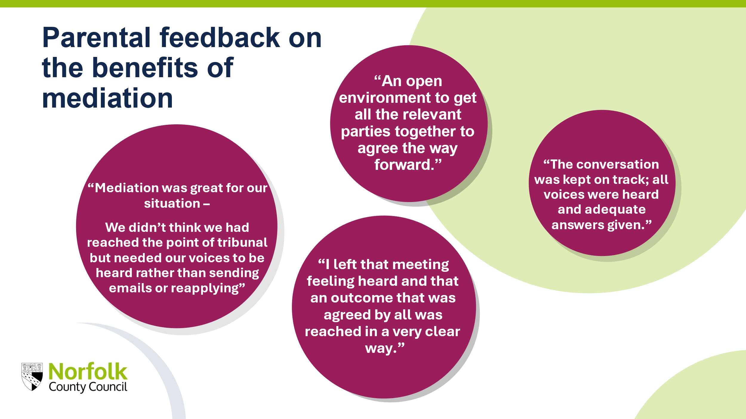

# Design & Benchmarking

The market was offered individual provider meetings with representatives of NCC’s commissioning and procurement on 20th and 25th February 2025. Six experienced providers took up this opportunity and they participated in a conversation about a range of areas of interest including: participation of children and young people, operating models, charging mechanisms, meeting volume of demand and KPIs and data.

**Learning from provider engagement:**

There appears to be variations in the extent to which providers engage children and young people prior to mediation to ensure their views are represented. Some aspects of good practice could be built upon in the service specification and performance management framework.

Providers use various charging structures depending on the requirements of individual local authorities. Use of an hourly rate is considered out-dated and more applicable when meetings were held face to face.

Across the range of providers we met with the Key Performance Indicators tend to be related to the statutory requirements (timescales). There is recognition that in some instances there are factors outside of the providers’ control e.g. availability of the LA and schools during school holidays impacts on being able to provide mediation within 30 days.

# Summary and Recommendations

Legislation sets out clear guidelines for how the service should be delivered. The local authority has long-established processes to ensure the local authority’s responsibilities are met.

Our needs assessment has identified the following recommendations to take forward into the new contract:

* **Pricing** – to reduce administrative burden and potentially achieve improved value for money we will move away from requesting the provider of the service charges the local authority at an hourly rate.
* **Children and Young People’s Views** - the performance section of the specification to be amended to include greater emphasis on how the provider engages with children and young people, following our learning about some existing good practice.
* **Key Performance Indicators** - our key performance indicators to be amended to ensure reporting takes into account some agreed exceptions which limit a provider from fulfilling the requirements within the statutory timescales.
* **The specification to include requirements related to stakeholder feedback** – such as involving school(s), where appropriate, when they have said they cannot meet need, and that families should have the opportunity to meet the mediator prior to the session.

1. [Children and Families Act 2014](http://www.legislation.gov.uk/ukpga/2014/6/contents/enacted) (Part 3)
2. [Children’s and Young People’s Continuing Care National Framework 2016](https://www.gov.uk/government/publications/children-and-young-peoples-continuing-care-national-framework)