Appendix A: Scope of Works and Specification

- Site identification

Site name | Arden Hall Recreation Ground
Site address | Water Orton Road, Castle Bromwich | Site Postcode | B36 9PB
What3Words location | ///dash.sugars.firms

Google Map:

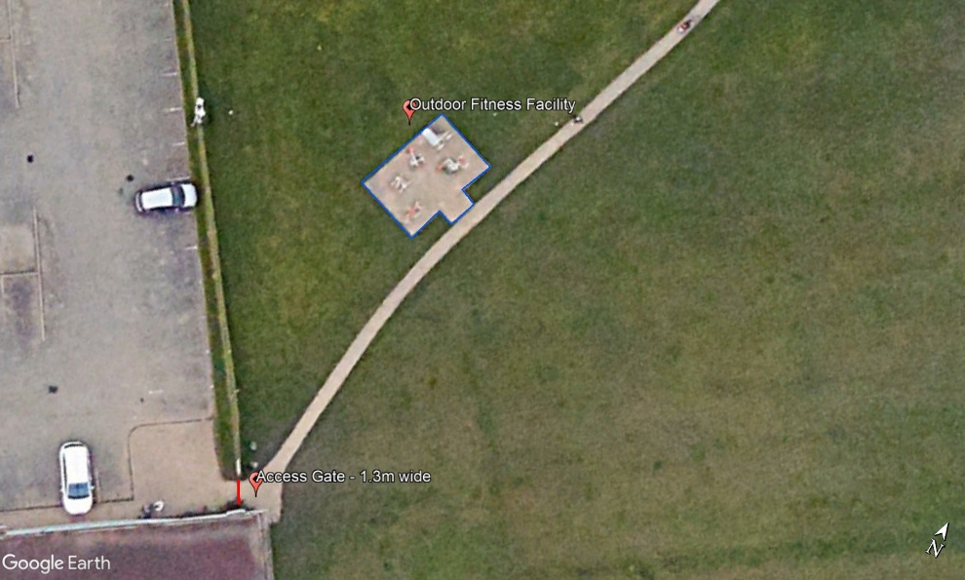

Site photographs:

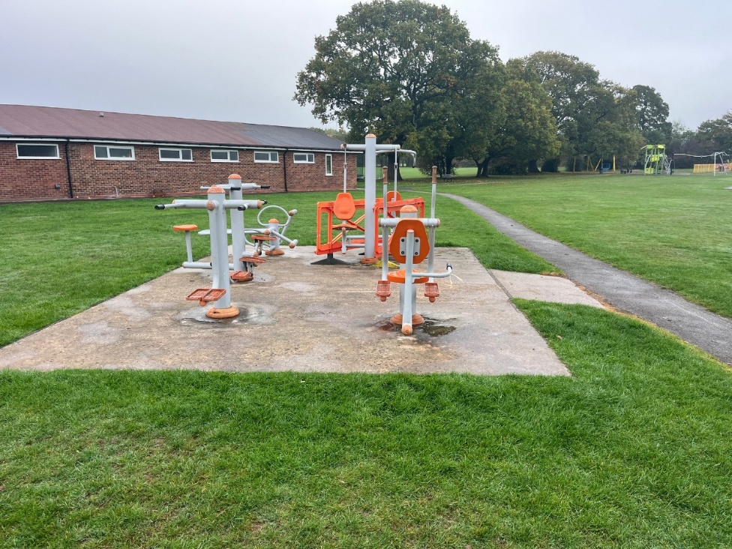
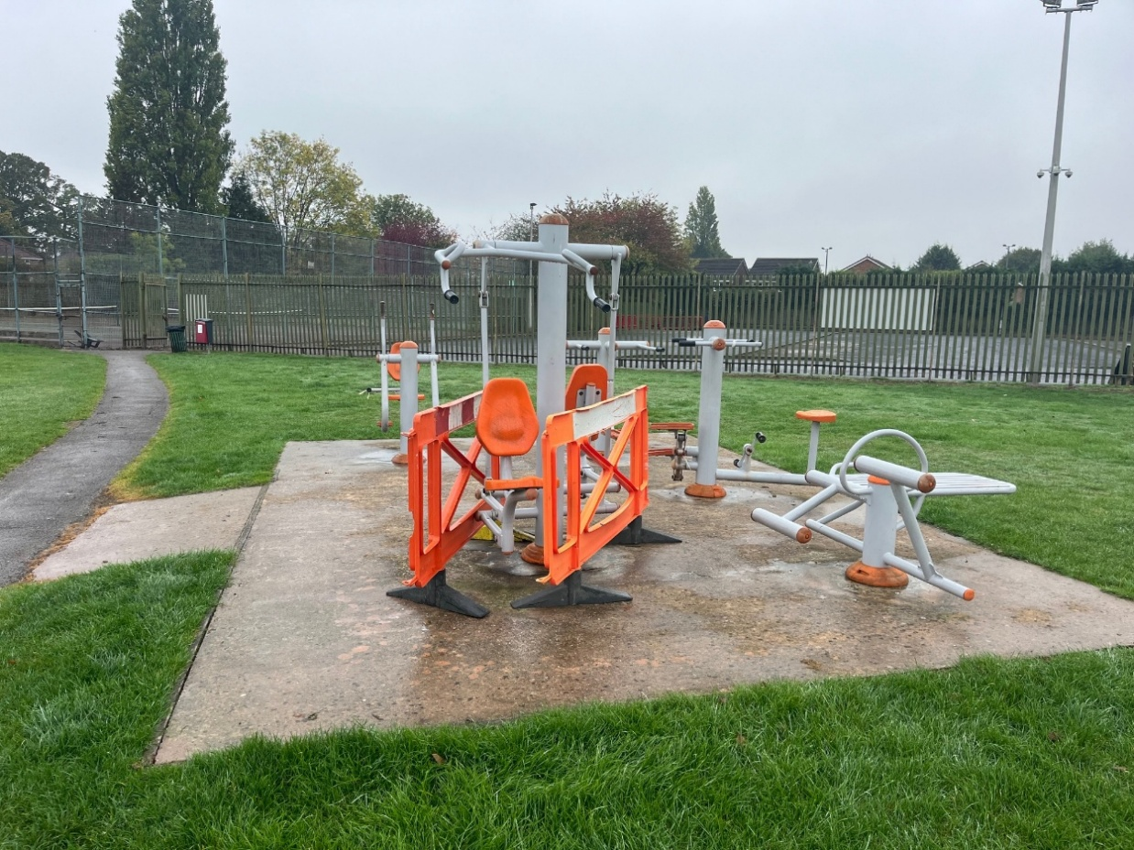
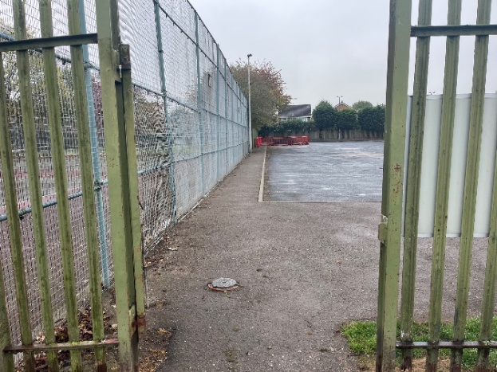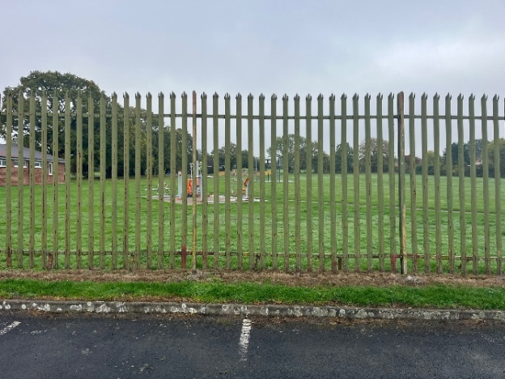

Access to site: either via 1.3m wide pedestrian gate or fence panels may be removed and re-instated on completion using heras fencing to ensure no unauthorised access during the Works.

- Lot budget

The budget is £25,000.00 (Ex VAT).

The full budget should be used but not exceeded.
All features included within the design must be included within the budget and quotation, there must be no ‘suggested’ additional works shown in the design outside the tendered price.

- Site requirements & objective

The current outdoor facility is in poor condition and end of life. The Council would like the footprint to increase to 50sqm from the current 32sqm (plus a 2 sqm access pathway) and offer a range of both static and dynamic items that could be used by a range of ages and abilities. The site should encourage users to re-use the site and ensure suitable access with easy transition around the facility.
Suppliers must provide evidence of how the design and equipment offers continued health and fitness benefits and where possible. Evidence must be independent of supplier and by qualified persons specific to the equipment being proposed.

Site set-up:

Welfare (drinking water and a portable toilet) must be provided for the duration of the Works.
Heras Fencing must be established around the entire site for the duration of the Works, with sufficient CDM signage and double clipped.

Note: there are no TPO (Tree Preservation Orders) on any trees in the vicinity, however contractors must ensure a method of works will mitigate any potential damage such as appropriate use of Heras fencing.

- Specification

  - Outdoor Fitness

Equipment must be made of steel, with appropriate anti tamper proof fixings and suitable rubber hand grips where possible.

Must Have:
Small Calisthenics Frame
Dynamic Moving Equipment for primary target areas of body:
Upper Body, Arms, Legs, Core

Could Have:
Ability to tension or adjust the weight of equipment

Don’t Have:
Sit Up Bench
Equipment that has little to no health or fitness benefits

All product supplied must be certified to or compliant with the relevant safety standard:
BS EN 16630:2015.

  - Surfacing

The Council would like the existing footprint to increase to a total of 50sqm not including any connecting pathways.

Surfacing will be wetpour laid over the existing concrete pad for the existing footprint of approx. 34sqm and extended using a new base to make up the additional 16sqm.
Drainage holes should be drilled into the existing concrete base which also has areas of damage that will need to be prepped for the wetpour to ensure a level surface.

Wetpour sub-base works shall be excavated to the depth required for a flush finish with the surrounding area, back filled with 100mm depth of compacted MOT Type 1 stone laid beneath the rubber surface. Colour of wetpour to be black however to include colour splashes around each item and lines or arrows to encourage transition/movement around each piece.

Edges should be trench cut into the surrounding grass or fully resin bonded to the pre-cast concrete (PCC) edging if adjoining a pathway. Wetpour shall not be laid during wet weather or in temperatures below 5 degrees Celsius. Any damage to the existing tarmac path will need to be satisfactorily repaired with a clean finish to the new wetpour.

  - Pathways

No pathways are required as part of this project, other than the connecting path into the facility.

  - Fencing & Gates

No fencing or gates will be required as part of this project.

  - Furniture

No seating is required as this will be provided by the Council at a later date.

  - Removals and Spoil

All spoil and waste must be removed off site and disposed of in a suitable facility.
All existing fitness equipment is to be removed and disposed of in a suitable facility ensuring that no protrusions remain that could either affect the quality of the surface or pose a risk to users. Existing wooden edging should also be removed.

  - Re-Instatement

All damage resulting from removals, vehicle movement, installation, deliveries or any other aspect of the Works, must be repaired or reinstated to at least the condition of that item or items or replaced with the same or similar alternative/s. This includes any ground repair, that either needs soil, grading and grass seed for minor damage, or new turf for any major damage.

  - Post Installation Inspection

A post installation inspection by an independent RPii qualified inspector (i.e. Play Inspection Company, RoSPA or other similar provider) is required to sign off the completed installation. The contractor should allow for this cost within their tender price.

  - Fitness Signs

Signage x 1 (minimum A2 size) on steel posts should be provided to indicate: The site name, suitable age use, telephone number to report any incident or damage, number to call in an emergency, Parish Council logo. Final artwork to be agreed by Council.

A 2nd sign (minimum A1 size) should be displayed in relation to the actual equipment including a visual/picture of the equipment, QR Code to link to a video to demonstrate use, area of body to benefit, and any other recommended information.

Ensure the signs are easy and practical to read and understand for a range of users.

