
SPECIFICATION

Management and Operation of a two-child Children’s Home in St. Helens WN4 owned by St. Helens Borough Council.

CHEST REFERENCE – DN771608

Children’s Home:
Property WN4
4 Bed (2 child) (incl. 2 x staffing accommodation) property in WN4 St Helens.
Complex needs (ages 11-18)

Tender Instructions

All submissions must be made electronically via ‘The Chest’ (www.the-chest.org.uk)
All queries must be addressed via The Chest’s in-built discussion mechanics at each stage.
Any issues with the Chest relating to functionality or fault should be addressed to The Chest support team procontractsuppliers@proactis.com

Timetable

The tender process will be in accordance with the timetable below. This table is indicative.
Whilst we will make all reasonable efforts to abide by the timescales shown, we cannot guarantee that there will not be delays to any part of the process due to unforeseen circumstances.

Issue of ITT | 14/04/2025
Requests for Site Visits | W/C 28/04/2025
Deadline of Clarification Questions | 20/05/2025 12pm
Submission of Tender Response | 27/05/2025 12pm
Presentation / Interview | 12/06/2025 – 13/06/2025
Evaluation Completed | W/C 16/06/2025
Award Decision Approved | W/C 24/06/2025
Award Decision Communicated and Standstill Period Commences | 08/07/2025
Standstill Period Ends | 17/07/2025 Midnight
Contract Start Date | TBA

NOTE:

This timetable is indicative only.
The Local Authority reserves the right to change the above timetable if required, and Tenderers will be notified accordingly where there is a change in timetable.
Payment shall commence on the Service Commencement date, not Contract Award date.

Executive Summary:

St. Helens Borough Council (SHBC) is issuing this Invitation To Tender (ITT) regarding the management and operation of a two-child children’s home in the borough of St. Helens (WN4).
The contract will be awarded for 3 years with additional extension clauses that provide for a +1yr and a further +1yr extension.
The service provided will be available at all times (including statutory holidays) during the term of the Contact, and will include the provision of an appropriate staffing model with a waking night or sleep-in staff (depending on the children’s needs) in accordance with the Children’s Homes regulations, including quality standards, and National Minimum Standards for Children’s Homes.
Unless formally agreed otherwise, the Notice period for the contract will be 6 months if a child is in placement, or 3 months if no child is in placement, from when the Notice is served.
Tenderers may make submissions to this ITT AND/OR any of the other two ITT’s simultaneously published.

St Helens, Our Borough Strategy 2021-2030
Priority One sets out “We want to make a difference to the lives of children and young people who live in the borough, improve outcomes for all children, whilst tackling deprivation and child poverty and protecting children from vulnerable backgrounds.”
Across St Helens, together we can achieve the following outcomes:
- Children and young people are safe from harm and the lives of children in care improve
- Children and young people’s aspirations, attainment and opportunities are raised
- Children and young people are healthy, resilient, confident, involved and achieve their potential.

Our Placement Sufficiency Strategy 2024/25

We believe in supporting our children and young people to have a safe and stable home where they can live and thrive. We recognise that most children and young people are best brought up within their own families, however, where this is not possible, we find a family or home that best meets their needs and offers access to the support and opportunities needed for success and happiness in later life.

To meet this vision, we need to have the right home, in the right place, at the right time.

Our objectives are to provide:

- The Right Home: To secure high quality provision that meets the individual needs of our Children and Young People.
- The Right Place: To provide St Helens Children and Young People that we look after with the appropriate home in St Helens or the local area. Rarely, and only where it is in the best interest of the child or young person the right place may be outside of our local area
- The Right Time: Emergency moves for children and young people should be an exception, moves should be in the child’s timeframe and well planned.

We wish to achieve outcomes that have been identified based on feedback from children and young people about what is most important to them:
- Being healthy
- Being heard
- Being safe and secure
- Being aspirational and successful

Specific outcomes for the Children’s Homes:

- Fewer Children being placed in inappropriate out-of-borough settings due to lack of appropriate placements in St Helens
- Children in safe and appropriate settings to enable assessment of their needs to enable an appropriate long-term placement or to support a return home
- Acute, Tier 4 service or Secure Welfare able to discharge to an appropriate setting in a timely manner
- Detailed planning which will include identified agencies and services who will work holistically with the child over a specified period to enable permanency or a return home
- Appropriate, efficient and effective use of multi-agency resources.

Detailed Tender Proposal:

- Introduction
As the map shows, there are Children’s homes situated in all wards across the St Helens borough.
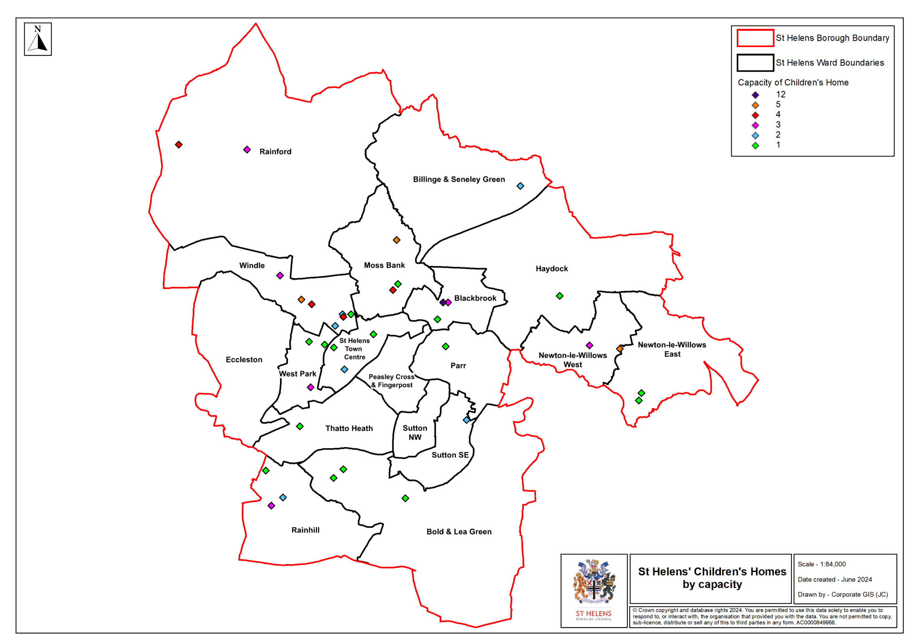
To meet local demand and provide secure stable homes for children, within the borough, the local authority has increased the number of homes owned by the Council. We aim for the majority of our children and young people to live within the local area or close to their home. To achieve this, we want to support the market to be resilient and flexible in meeting the changing needs and challenges of children and young people.

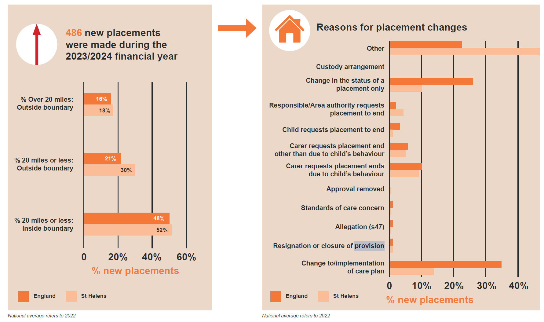
St. Helens Borough Council (SHBC) is issuing this Invitation To Tender (ITT) regarding the management and operation of a two-children children’s home in the borough of St. Helens (WN4).
Looking after children and young people in care is one of the most important responsibilities that the Council fulfils as a corporate parent. ‘Corporate parenting’ is the collective responsibility of the council, elected members, employees, and partner agencies, for providing the best possible care and safeguarding for the children who are cared for by the Council.
When in the best interests of the child or young person, the Council aspires for its children to be able to live in the borough. There are currently 38 registered children’s homes in St Helens run by 19 Providers. Of these 38 homes, 1 is local authority run, 2 are voluntary sector, and 35 fall under private sector provision situated in all wards across the borough.
The Council is currently in the advanced stages of acquiring 3 more homes to provide for 2 children, 2 children, and 1 child (i.e. 5 additional placements in total).
Tenderers may make submissions to this ITT AND/OR any of the other two ITT’s simultaneously published.

- Background and Context

In appraising different options for managing care placements, much work has been undertaken by the Council to understand potential Service Providers’ appetite to working with the Council, on a good quality and sustainable long-term solution to increasing in-borough provision via the three new homes alluded to above.

Our overall guiding principle is to realise a local (i.e. in-borough), quality-focussed, sustainable, best practice-based solution that represents effective and efficient commissioning and value for money.

St Helens Children and Young People Needs Assessment 2024, outlines the challenges faced by St Helens, as the 26th most deprived local authority in England. The report, which can be found in full at Children_and_Young_Peoples_Needs_Assessment_2024.pdf, highlights key statistics and health inequalities in relation to vulnerable groups of children and young people, including:

- The rate of hospital admission for self-harm being the 3rd highest in England and the highest in the North West in 2022-23
- Hospital admissions for alcohol specific conditions amongst under 18s are double the rate in England
- Despite a recent decrease, the rate of substance misuse hospital admissions amongst 15-24 year olds is significantly higher than England and the North West.
- The rate of first-time entrants to the youth justice system has increased between 2021 and 2023 and the rate of youth crime in St Helens is higher compared to the Merseyside average. The most common crime types are violence, stalking and harassment and public order.
- In 2023 almost half (47%) of social care assessments had identified parental mental health as a factor in St Helens, this compares to 37% in the North West and 32% in England.
- The number of children (under 18 years) exposed to domestic abuse (where cases were heard at the Multi Agency Risk Assessment Conference (MARAC)) has increased year on year in St Helens. In 2024, 46.2% of assessments completed by Children’s Social Care Services had domestic abuse as a factor.

Children and young people’s health are subject to a range of factors that form the backbone for health: genetics, the environment, wider societal influences, and emotional support. If any of these factors are compromised, then a child is less likely to achieve optimal health and meet their growth and development potential.

There is a gap between the health and education outcomes between looked after children and young people and the general population, however, research shows that the longer children remain in care and in a stable, nurturing environment, the better they can improve outcomes. Providers of children’s care home services are required to support children and young people to identify and manage risk factors impacting health and development outcomes.

- Requirements and Outputs

  - General Requirements

Central to the requirements set out in the Service Specification is the underpinning vision for all children and young people in St Helens, as set out in the Placement Sufficiency Plan. In particular this plan emphasises the following focuses:

- All children we look after, where appropriate, supported to maintain family contact
- All children we look after will be prepared for independence and a healthy adulthood
- All children we look after will be supported to access quality education services
- All children we look after will be supported to access quality health services
- All children we look after will receive services that are of high quality to secure the specific outcomes identified in their care plans.

By entering into a contract, the Service Provider and the Council commit to working together and with wider partners to help achieve the borough’s vision for a safe, happy, healthy and successful future for children and young people.

In order to safeguard and promote the needs and rights of the child, the specification is directed and underpinned by the following principles, which are considered in the context of their age and level of understanding:

- Welfare – the welfare of a child is paramount and should be held in the highest regard
- Individuality – a child must be treated as an individual
- Their opinion must be listened to, and any decision made should take account of their wishes;
- Though attempts to reconcile the wishes and feelings of parents and child should always be made, it is recognised that a child has individual rights which might take precedence.
- It is the right of every child to be afforded the opportunity to experience security, stability, a sense of permanence as well as a sense of their own identity and positive self-worth.
- A child’s right to privacy must be respected.
- A child’s religion, racial origin, culture, and language should be at the forefront of planning.
- Partnership – all those that work with a child should strive to work in partnership with the child, the parent and all those supporting the family. This includes ensuring activities are coordinated and communicated clearly between all relevant parties.
- Consultation and Engagement – prior to any decision which would affect a child, as well as the parent(s) and other people of significance to the child should be consulted. Decisions should be clear and recorded with opposing views similarly treated. If challenged those making the decision should be able to explain the logic of the decision-making process and ensure that formal procedures are in place to allow complaints to be fully investigated.
- Participation – the child, parent(s), carers, and others of significance, should be given the opportunity to participate actively in the decision-making process. Deviations from this principle should be recorded and open to challenge.
- Accountability – the child and parents should be advised about, and given explanations of the powers, duties, and responsibilities of all those involved with looking after the child and any action which may need to be taken.

The primary focus for those providing care for children is to meet the assessed needs of the child and to fulfil the objectives set out in their Placement/Care Plan.

To achieve this, homes must provide care which:
- Provides a trauma informed model of care that is non-stigmatised, safe, stable, caring, and attractive and safe environment for a young person which may include the delivery of care in accordance with DoLs.
- Provide high quality supervision and clinical oversight, where required, this will ensure that staff are able to deliver care in accordance with the formulation plan, ensure dynamic assessment and consistent delivery of the placement plan.
- Safeguards and promotes the child’s physical, mental and emotional welfare and development by the application of clearly stated operational principles and established standards of practice and care.
- In partnership with the social worker and team around the child, deliver care that is informed by Multi Agency Risk Assessments, clinical formulation (if applicable) and respond dynamically to needs and provides consistent high-quality care, that supports young people to feel safe and secure.
- Provides a flexible service which balances individual needs with communal responsibilities.
- Ensures that children of school age have access to education appropriate to their age, ability and level of attainment and young people over school age are offered an appropriate programme of vocational preparation, training or work experience.
- Ensures a positive and pro-active approach is taken to the child’s health and/or assessment, also ensuring attendance at school examinations and adherence to Personal Education Plans (PEPs).
- Ensure the child has an opportunity to participate in a range of social, recreational and leisure interests.
- Provides an opportunity for the child to feel safe, develop a range of strategies that support and promote emotional health and wellbeing.
- Provides an opportunity for the child to acquire daily living skills.
- Promotes the maintenance of contact with the family and others in line with the Placement/Care Plan.
- Ensures the child is treated as an individual through participation in planning and review procedure and, where the child is of sufficient age and understanding, participation in the decision-making process.
- Allows the child to exercise their right to representation and complaint.

- Is attentive to the child’s individual needs and rights in relation to age, gender, race, sexuality and disability and meets specific cultural and/or religious needs.

  - The Children and Young People to be Supported by the Service

The home will be expected to provide care to children for whom the OFSTED registration will be Emotional and Behavioural Difficulty. The children and young people that may be supported by this service include:
- Children and young people we look after, aged between 11 and 18 who will benefit most from living in a children’s home as opposed to any other home.
- Children and young people with diagnosed and undiagnosed mental health needs
- Children and young people who may be neurodivergent and experience a negative impact on their mental health and wellbeing as a result of the pressure created by behaviours such as stimming, masking or coping with sensory overstimulation
- Children and young people who have been exposed to alcohol or substance use
- Children and young people who are at risk of criminal or sexual exploitation / exploiting others, including by criminal gangs
- Children and young people experiencing severe emotional distress, trauma related attachment issues and behaviours that challenge, disruption and breakdowns of relationships and who are at risk of hospital admission / delayed hospital discharge as a result of presenting behaviour

The service and staff team will need to be appropriately skilled and experienced to provide a sustainable home for this cohort of children and young people. We want to provide children with a stable home where the support can flex and the staff team can adapt to changes in need of the child / children, rather than the child moving to a different placement. Should needs escalate, Service Providers will be expected to work with the Council to maintain a safe and sustainable model of care.
  - The Location

Each property to be brought into use as a children’s home will need to go through the statutory Ofsted registration process by the Provider who is awarded the contract to provide care and support. The Provider will be expected to maintain an overall effectiveness rating of ‘Good’ or better at subsequent inspections by Ofsted. If this is not achieved, the Council will proactively engage with the Provider to develop and implement service improvement plans and complete quality assurance checks to ensure that the Provider is supported to identify and manage any risks and to ensure that the Children we look after receive a good standard of care.

This will include the development of a location assessment that shows that the home is appropriately located, risks have been mitigated, and that it promotes positive opportunities for children. There is non-statutory guidance to assist with this task and must address the issues of safeguarding and accessibility of local services.

The Provider will be required to develop and keep under review a Statement of Purpose for the home, outlining how the home will provide individualised care to meet the quality standards and needs of children in their care. The Statement of Purpose should be appropriate for the above cohort of children and young people to be supported.

The Provider will ensure that the home is:
- A welcoming environment
- A safe and supportive environment
- Provide personal space
- Designed to enable children to develop independent living skills

The home will be owned by St Helens Council and the Provider will be required to enter into a lease agreement with the authority for the duration of the contract. The Provider will be responsible for the day-to-day management and maintenance of the home but must not make alteration or adaptions without the agreement of St Helens Council.

  - Children’s home regulations and standards

Children’s homes provide support and care for some of our most vulnerable children and young people and must comply with Children’s Homes (England) Regulations 2015. The regulations include Quality Standards and underpinning requirements that homes must meet in order to achieve aspirational and positive outcomes. Regulations and standards should be interpreted and applied within the context of the abilities and individual stage of each child. The Service will be dynamic and flexible and be able to respond to individual children’s needs, in line with the below regulations:

- The quality and purpose of care standard
- The children’s views, wishes and feelings standard
- The education standard
- The enjoyment and achievement standard
- The health and well-being standard
- The positive relationships standard
- The protection of children standard
- The leadership and management standard
- The care planning standard

The National Minimum Standards for Children’s Homes require:
- general care and maintenance of the child, including board, food, clothing, pocket money, toiletries, birthday and presents relating to religious festivals and travel costs;
- individual programmes of assistance/work.
- 24-hour staff cover to a level compatible with the home’s purpose and function.
- written reports on individual children for planning and review meetings in compliance with the Children’s Act 1989 and 2004 and the Children and Family Act 2014 and other Legislation relating to the protection of Children and any subsequent amendments.
- Family time (not including travel costs incurred by family and friends) supervised if appropriate.
- transport and/or costs to support the young person in getting to and from school, general leisure activities and transport/travel costs.
- Provide access to or work with health services to provide psychological, psychiatric and other therapeutic services, where required (this includes quality supervision and the delivery of trauma informed care); and
- administration, repair, development and maintenance of the premises to the standard in accordance with the National Minimum Standards for Children’s Homes.

Providers should also have regard to the NICE Quality Standards for the Health and Wellbeing of Looked-after Children and Young People, which apply to all settings, including care homes.

  - Staffing and operational requirements

The home and staff will have the skills, knowledge and experience to provide trauma informed care and a safe nurturing home, for children with a range of complex needs, delivering care in a way that enables young people to grow to be safe, happy and healthy, by putting relational practice at the heart of the delivery model. Children and young people in the home and their lived experience will be at the centre of all aspects of practice delivered in the home. Through trusting relationships, young people will achieve success. The home will believe in the young people living there and be committed to go above and beyond in their care for them each and every day.

The Provider will be required to ensure suitable arrangements for a senior member of staff to be contacted out-of-hours, ensuring a robust escalation process is in place for emergency or serious incidents. The Provider will be expected to take a proactive approach to managing the risk of need for urgent out-of-hours support, identifying individual risks relating to each child and liaising with partners to agree a person centred plan for out-of-hours support.

  - Occupancy and Placement Planning

The Council will support a targeted occupancy rate of 100% for each home. Providers should therefore respond to this tender opportunity on a financial basis according to an 85% occupancy rate.

Placements to the service will be made by St Helens Council. In the event of a placement ending, the Provider will be required to respond immediately to support an effective transition of the child or young person and to commence the planned transition of children or young people who have been matched to the placement.

  - Mobilisation

The Provider will be required to demonstrate a robust mobilisation plan from contract award to the agreed service commencement date. For a 1-child home, the commencement date of the contract will be the date of the child-moving in. For a 2-child home, the full contract may be implemented via a progressive pricing model as determined by the needs of the individual children moving in. Pre-contract implementation costs, such as registration, recruitment, training, property preparation tasks and transition planning tasks will be agreed between the Council and the Provider, in line with the mobilisation plan.

  - Partnership working

The Provider will work with all partners, including social care, education, and health to ensure that the support provided to each individual child, or young person is person-centred, holistic and outcome focussed.

  - Meeting Ethnic, Religious and Individual Needs

Children’s home’s policies, procedures and guidance to staff must be formulated to take account of a child’s religious, racial, cultural, and linguistic background. In accepting a child, the home must be able to clearly specify which of the child’s cultural and religious needs detailed below it is able or unable to meet.

Any Service Provider offering specialist services in this area must clearly identify to whom it is providing a service and what this service is. The particular religious/cultural perspective must be fully integrated into all policies and practices in the following ways:

- the preparation and provision of food is made in accordance with religious/cultural customs.
- children have access to facilities which allow them to practice their religion without undue difficulty or embarrassment, in ways appropriate to their age.
- endeavouring to provide care staff who can speak and understand the child’s main language and dialect are constantly available.
- endeavouring to provide written information in the child’s main language and in a form appropriate to the child’s age and understanding is constantly available.
- care is provided in a culturally/religiously sensitive way.
- there is help and support available for a child learning English as a second language and also to retain and develop the language of their parents.
- a child’s religious/cultural clothing needs are catered for.
- personal hygiene arrangements are culturally/religiously acceptable.
- culturally appropriate social and recreational activities are made available; and
- the composition of the staff reflects the racial religious, cultural and linguistic background of the children and comply with the Equality Standards.

The Provider will be required to provide opportunities for each child or young person to explore and make sense of their identity and promote positive self-identity.

  - Social Value

The Council is committed to obtaining social value through everything we do, particularly throughout our suppliers and supply chains. Social Value is the added community, economic and environmental benefits created through the work we do, and that is undertaken by those working with us. We expect Providers to incorporate an element of social value that is quantifiable, such as the number of apprentices being employed, local job opportunities, or carbon reduction, as well as qualitative case studies that demonstrate the impact of the social value being created. We have aligned our local priorities to the National TOM's (Targets, Objectives and Measures) and will monitor and measure delivery as part of our Contract Management Process.

St Helens Council wants to work with Providers who aspire to develop local partnerships that harness the assets of the local community. Providers may consider the added value that they are able to provide in developing partnerships that offer:
- Mentoring and early intervention
- Well-being
- Vocational / leisure
- Volunteering
- Safe spaces

  - Appropriate Experience and Skills Required

The owner, most senior manager, or person with day-to-day management responsibility for the office location from which services are offered, must be registered as the “fit” person with Ofsted in accordance with Regulation 28.2.

All changes in operational management must be notified to Children’s Services as soon as they occur. The new operational manager(s) must similarly meet the Ofsted requirement for registration.

The operational manager(s) of these services must have expertise and, where appropriate, qualifications which are directly relevant to:

- the types and scale of service(s); and
- the specific needs of the individual children, young people and any young adults who are accommodated at the children’s home as stated in your statement of purpose

All changes of operational manager(s) must be notified to Children’s Services as soon as they occur and without delay. Service Providers must not operate without adequate operational management.

In relation to the services offered, the management structure must be demonstrably:

- of sufficient size to provide management direction and support for care workers.
- organised in such a way to provide management direction and support for care workers.
- supported by administrative systems and any other necessary infrastructure to provide;
- necessary information to enable clear management direction and support for care workers; and
- accessible at all times to all care workers and Children’s Services when services might be provided.

The Service Provider must have a means of adequately managing its financial affairs such that it can demonstrate:

- clear responsibility within the organisation for dealing with financial matters by suitably qualified and experienced personnel;
- invoicing procedures that systematically reconcile work ordered and actual services provided; and
- means of early identification of any cash flow problems and ways of addressing these.

The Service Provider must have in place mechanisms to ensure that information can be passed effectively from senior management to all staff and workers, and vice versa. The effectiveness will be judged by the speed and timeliness of communication; the extent that plain language is used and relevance of the information conveyed without overloading staff; and services for children.

Managers will be expected to have relevant experience and qualifications as set out in regulation 28 (2).

All staff must complete an appropriate induction and satisfactory period of probation. Each staff member must be provided with a job description outlining their responsibilities. All staff must be recruited in accordance with regulation 32 of the Children’s Home (England) Regulations 2015.

The registered person should have a workforce plan which can fulfil the workforce related requirements of the Children’s Home Regulations. Staff in a care role must have the relevant qualifications within the required timeframes specified in regulations 32(4) and 32 (5). The Provider must set out the training requirements of the workforce to meet the needs of each child and young person and the requirement to ensure staff undertake continuing professional development and may include:

- Trauma-informed approaches
- Safeguarding procedures
- How to communicate effectively and sensitively
- Life story work to promote a positive self-identity Identifying problems with, and supporting, good oral health, diet and personal hygiene
- Encouraging positive relationships and sexual identity
- Record keeping, information sharing and confidentiality
- Meeting specific healthcare needs

The training plan must be tailored if there are specific needs related to race, ethnicity and culture. This could include, for example, understanding and respecting cultural and religious identity (including dietary requirements or preferences), and understanding specific hair and skin care needs.

  - Performance Measures and Outcomes

The Provider will be required to develop an effective method for measuring progress of each child or young person towards their agreed outcomes. The Provider will also be required to measure progress against key performance indicators for the home, which will be agreed with the Council and will reflect quality standards and best practice. The below table is an example of performance measures:

Key Performance Indicator | Definition | Target
Occupancy | Occupancy of the home over the past rolling 12-months | 85%
Transition | % of children placed who have moved in as per their transition plan and timescales | 100%
Placements sustainability | Number of placements that the service has given notice on in the past rolling 12 months | 0
Missing incidents | Number of times that a child went missing from the home | TBC
Education | Child attendance in educational provision identified for them | 96%
Utilisation | % of weeks that child engages in key work sessions which are reported to placing social worker | 100%
Health and Wellbeing | Compliance with health plans – attendance to regular health appointments | 100%
Health and Wellbeing | Compliance with leisure / wellbeing activities set out in care plan | 100%
Emotional wellbeing | Completion of SDQ with each child | 100%
Staff qualifications | Compliance with qualification requirements | 100%
Care leaver planning | Progress made on Pathways to Independence training in conjunction with the Futures team | 100%
Care leaver planning | % of care leavers transitioning from the home to suitable accommodation | 100%
Staff Training | Number of staff compliant with their training and development plan | 100%
Staff Supervisions | Number of staff receiving a formal supervision within the past 4 weeks | 100%
Staff retention | Staff turnover for previous rolling 12-months | TBC
Continuity of care | Average % of shifts covered by agency staff over the last rolling 12 months | TBC
Safeguarding / serious incidents | Number of safeguarding concerns / serious incidents reported in the past rolling 12 months | TBC
Police call-out | Number of incidents requiring police to manage behaviour | TBC
Complaints | Number of complaints from Children in the last 12 months | TBC
Social Value | Additional social value delivered through this contract | TBC
Ongoing service improvement | Number of opportunities for children / stakeholders to contribute feedback about the service over the past rolling 12-month | 12
Maintaining the home environment | % of repairs / maintenance issues reported within 24 hours | 100%
Maintaining the home environment | % of repairs completed within 2 weeks of reporting | 100%
Premises | % of health and safety assessments in date (e.g. gas safety, fire risk etc) | 100%

  - Monitoring and Contract Compliance

In order that effective monitoring take place, the Service Provider will:

- permit any person authorised by the Service Purchaser to enter and inspect any premises in which the service is being provided or to visit the child, without prejudice to the child’s right to privacy;
- provide access to such records and produce such information as the Service Purchaser may reasonably request.
- attend regular contract monitoring meetings at the Service Purchaser’s request, and quarterly as a minimum
- comply with all reasonable requests of the Service Purchaser regarding the care of a child.
- inform the Service Purchaser of any complaints, investigations, concerns about staff and major incidents and their outcomes, concerning the service; and
- inform the Service Purchaser immediately of any notice of proposed cancellation of registration or approval received any changes in registration or approval, any convictions under the Legislation specified at 2.5.1, or any other relevant Legislation relating to the home or any employee of the home.

  - Confidentiality

Both parties agree that information made available shall not infringe or prejudice the right of confidentiality of children or their families. However, both parties will be responsible for determining when confidentiality must be broken in the best interests of the child particularly in respect of their safety and welfare.

The Service Provider shall take all reasonable action to ensure that its employees do not, without the express permission of the Service Purchaser, divulge to any third party other than relevant parties normally entitled to information in the course of their duties, e.g., health, court and social workers, any information which comes into its, or their, possession in the course of providing the service.

The Service Purchaser may disclose information relating to the Service Provider to other purchasing, monitoring and inspection agencies.

The Service Purchaser may publish from time to time, statistical information about the purchase of children’s care services and related services, which may identify placements made to particular homes.

Both parties agree to abide by the provisions of the Data Protection Act 2018 and any other relevant and/or subsequent revised Legislation relating to the processing of personal information.

  - Quality Assurance Procedures and Quality Controls

Quality Assurance

As per 3.12, there is an effective system for Quality Assurance based on the outcomes for children and young people, in which standards and indicators to be achieved are clearly defined and monitored on a continuous basis by care and support staff and their line managers.

The Provider will have a model of demonstrating progress towards outcomes and implement a clear set of policies and procedures to support practice and meet the requirements of relevant legislation, which are dated, and monitored, as part of the quality assurance process. The policies and procedures are reviewed and amended annually or more frequently if necessary.

Staff understand and have access to up-to-date copies of all policies, procedures and codes of practice, and children and young people have access to relevant information on the policies and procedures and other documents in appropriate formats.

Regulatory standards and other relevant service standards and indicators, e.g., National Occupational Standards, are incorporated into the quality assurance (QA) system.

There is a process and a procedure for consulting with children and young people and their carers about the care service on a regular basis and assuring quality and monitoring performance including:

- a 6-monthly review to be undertaken by the registered person of the quality of care provided for children
- monthly visit by an independent visitor
- regular supervision meetings between the line manager and care and support workers; and
- annual survey of children and young people, their relatives or representative where appropriate to obtain their views and opinions on the service provided

Care and support workers know the standard of service they are required to provide and monitor and meet the standard on a continuous basis.

The outcome from the Quality Assurance process is published annually, supplied to Ofsted and Children’s Services, and made available to children and young people, their family or representatives, and all stakeholders in the agency.

All Standards and the Quality Assurance process are reviewed and revised as necessary, on at least an annual basis.

The Service Provider must be able to demonstrate that it operates systems by which it satisfactorily and effectively implements its written policies in at least the following areas:
- provision of services, including monitoring methods for checking that tasks are being carried out at times required and with the intended outcomes (this will include involvement of service users).
- Employee/workforce deployment systems.
- Health and safety aspects of work management and delivery.
- Effective recruitment, management, support, induction, and training of care workers.
- Equal opportunities issues.

  - Records

The Service Provider must have a system for maintaining accurate records relating to services provided (in accordance with the Standard 22 of the National Minimum Standards for Children’s Homes).

All records are secure, up to date and in good order and are constructed, maintained, and used in accordance with the Data Protection Act 2018, and other statutory requirements, and are kept securely for the period required by the Providers retention schedules.

Consistent and standard personal data are kept on all service users being cared for by the home.

Children and young people or their representatives have access to their records and information about them held by the home and are facilitated in obtaining access when necessary.

  - Child Protection

The Service Provider must implement policies and procedures to safeguard and protect children living in the home in line with child protection legislation and the procedures adopted by St Helens Borough Council Children’s Services or any subsequent amendments.

The Service Provider must check all staff (including agency and part-time), volunteers and regular visitors with substantial access to children in the home, in accordance with the child protection Legislation and associated guidance. If checks reveal information which would make staff/volunteers/visitors unsuitable for work with children, they must not be employed or have access to children in the home. The Local Authority Designated Officer should also be informed of the findings.

The Service Provider must notify the Service Purchaser immediately of any events defined under Regulation 30(1) of the Care Standards Act National Minimum Standards and Regulations for Children’s Homes or any subsequent amendments.

If a child placed by the Service Purchaser is absent without authority, the Service Provider will be expected to take all reasonable action which would be expected of a good parent, taking proper account of the age, and understanding of the child concerned. In all instances of the child absconding the Service Provider must notify the Service Purchaser immediately.

  - Advocacy

The Provider will ensure that each child or young person is given appropriate advocacy support. Information should be shared with each child about the advocacy support and services that are available in St Helens, how they can be accessed and their entitlement to independent advocacy provision. Details of how a child can access advocacy support or independent advocacy should be detailed in the Children’s guide.

  - Complaints

Children we look after

- All complaints from children made to the Service Provider are responded to within 10 days and a record is kept of all issues raised, or complaints made by children. A copy of all complaints should be forwarded to the Service Purchaser in the end of every quarter.
- If the complainant is dissatisfied with the response, they have received that the complainant should be referred to the Service Purchaser’s Children’s Services Directorate.

Service Commissioner/Purchaser

- All complaints from the Service Purchaser will be made in writing and will be answered by the Service Provider in the time specified, this will be a maximum of 10 working days, or an explanation must be provided as to why a reply may take longer. The Service Provider must acknowledge receipt of the complaint within 5 working days.

Service Provider

- In accordance with St Helens Customer Service Care Standards, all complaints from the Service Provider will be made in writing and will be answered by the Service Purchaser in the time specified, this will be a maximum of 15 working days, or an explanation must be provided why a reply may take longer. The Service Purchaser must acknowledge receipt of the complaint within 5 working days. These timescales may change, should the Customer Service Care Standards be amended.
- If the Service Provider is dissatisfied with the response, they have received then the Service Provider may invoke the procedure for dealing with disputes and breaches of the Agreement.

  - Legislative Requirements

The Service Provider must comply with all relevant current and future Legislation required in the provision of this service.

The Service Provider and any sub-contractor employed by the Service Provider, shall adopt a policy to comply with employers’ statutory obligations under the Race Relations (Amendment) Act 2000 and, accordingly, will not discriminate directly or indirectly against any person because of their colour, race, nationality or national or ethnic origin in decisions to recruit, train, promote, discipline, or dismiss employees.

The Service Provider and any sub-contractor employed by the Service Provider shall perform its obligations under this Contract in accordance with applicable equality Law and not unlawfully discriminate within the meaning and scope of any Law (whether because of race, sex, disability, sexual orientation, religion or belief, age, pregnancy and maternity, marital or civil partnership status, gender re-assignment, trade union membership or activities, part time or fixed term status or otherwise)) including but not limited to the Equality Act 2010 or other relevant or equivalent legislation, or any statutory modification or re-enactment thereof.

The Service Provider will comply as far as possible with the Equality Framework for Local Government which helps local councils to meet their obligations under the Equality Act 2010.

In the event of any finding of unlawful discrimination being made against the Service Provider or any sub-contractor employed by the Service Provider, during the contract period by any court or industrial tribunal, or of an adverse finding in any formal investigation over the same period, the Service Provider shall inform the Service Purchaser of this finding and shall take appropriate steps to prevent repetition of the unlawful discrimination.

The Service Provider shall provide such information as the Service Purchaser may reasonably request for the purpose of assessing the Service Provider’s compliance with the above conditions including, if requested, examples of any instructions, recruitment advertisements or other literature, and details of monitoring applicants and employees.

The Service Provider acknowledges that:

- in performing their obligations under this Contract, it may be regarded as a public authority for the purpose of the Human Rights Act 1998 and
- that it is unlawful to exercise functions deemed to be of a public nature in a way that it is incompatible with the Human Rights Act 1998.
- In providing the Service the Provider shall throughout the Contract Period and at their own cost, be subject to the same duty in respect of Human Rights in the same way as if they were the Local Authority.
- The Service Provider shall undertake or refrain from undertaking such actions as the Local Authority may request so as to enable the Local Authority to discharge its duty under the Human Rights Act 1998.

  - The Contract (Rights of Third Parties) Act 1999

Nothing in this contract confers or purports to confer any benefit or any right to enforce any of the provisions of The Contracts (Rights of Third Parties) Act 1999 on any person who is not a party to it.

  - Transport

The Service Provider must make all reasonable effort to ensure that for any transport provided for children, whether directly or via another agency:

- The operator has a valid licence and current vehicle insurance appropriate to the type of service being provided and operates in full accordance with DVLA licensing rules.
- Any vehicle (and any additional equipment on the vehicle) deployed is maintained and serviced in line with manufacturer’s instructions and must have a current MOT certificate, with full records being kept verifying these.
- Any vehicle used is suitable for the type and condition of users to be carried, including having seat belts or personal restraints which conform to the relevant British Standard and which are used in all instances.
- Any vehicle is always driven safely and with consideration to passengers’ needs. This includes conforming to all road traffic Legislation and never driving whilst under the influence of any amount of alcohol, drugs, or medication.
- The driver is DBS checked and is always properly trained in handling the type of vehicle and the nature of the passengers to be carried. This latter will not apply if a suitable escort is provided.

  - Indemnity and Insurance

The Service Provider shall indemnify and keep indemnified the Service Purchaser against all action, claims, demands, proceedings, damages, costs, charges, and expenses whatsoever in respect of, or in any way arising out of the provision of the service. This will be in respect of:
- injury to or death of any person.
- the loss of, or damage to, any property, including property belonging to the Service Purchaser.

The Service Provider shall effectively maintain the following minimum insurance arrangements, and at the request of the Service Purchaser shall produce evidence in relation to:

- public liability insurance (a minimum of 10 million pounds in respect of any one claim).
- employer’s liability insurance (a minimum of 10 million pounds in respect of any one claim) covering all employees.
- professional indemnity insurance (a minimum of 2 million pounds in respect of any one claim).
- insurance for any vehicle used in the delivery of the service.
- any personal clothing and other personal possessions damaged or lost by the Service Provider must be replaced by the Service Provider at its expense.

- Financial Considerations and Payment Profile

The Council will pay all appropriately evidenced and submitted invoices within 28 days of receipt. Block payment shall commence on the Service Commencement date, not Contract Award date. Appropriate mobilisation / phased implementation costs will be agreed between the Council and Service Provider.
The Council will charge a peppercorn lease to the value of £1/month in relation to the property subject to this ITT.

