InBye Registration

# eTender Registration Information

Mining Remediation Authority tenders are now being undertaken by the Authority’s eTender portal **InBye**, details of how to register are detailed below.

Should you wish to participate in any electronic tender exercise you will need to register your company details, which will require the provision of some company information and agreement to terms and conditions to access the system. Use of the system is free of charge.

In order to register please log on to <https://inbye.coal.gov.uk/s2c/>

Should you have any difficulties with this procedure, please contact XXXXXX – [XXXXX@miningremediation.gov.uk](mailto:XXXXX@miningremediation.gov.uk).

The sending, completion and return of tenders will be undertaken electronically, the Authority will issue a letter to award the contract.

**How to review tender documents and register to participate in the tender:**

**(i) For a supplier not registered on InBye**

From the initial Log in page.

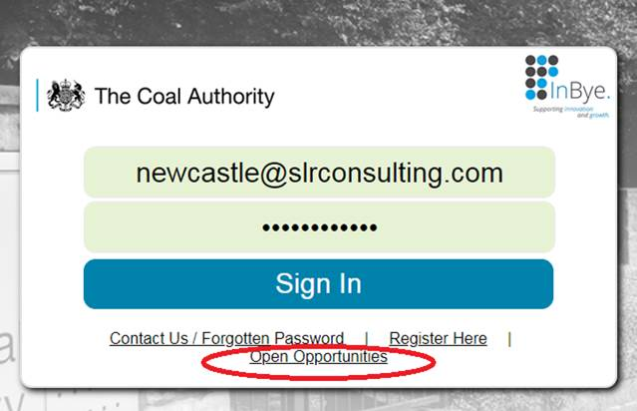

1. Click on the Open Opportunities link.
2. Click View details (system shows base information regarding the opportunity and also attachments). Review the details of the opportunity and if interested;
3. Click on the Register button from the Event Details page, System opens up initial registration page, complete the details and click submit.

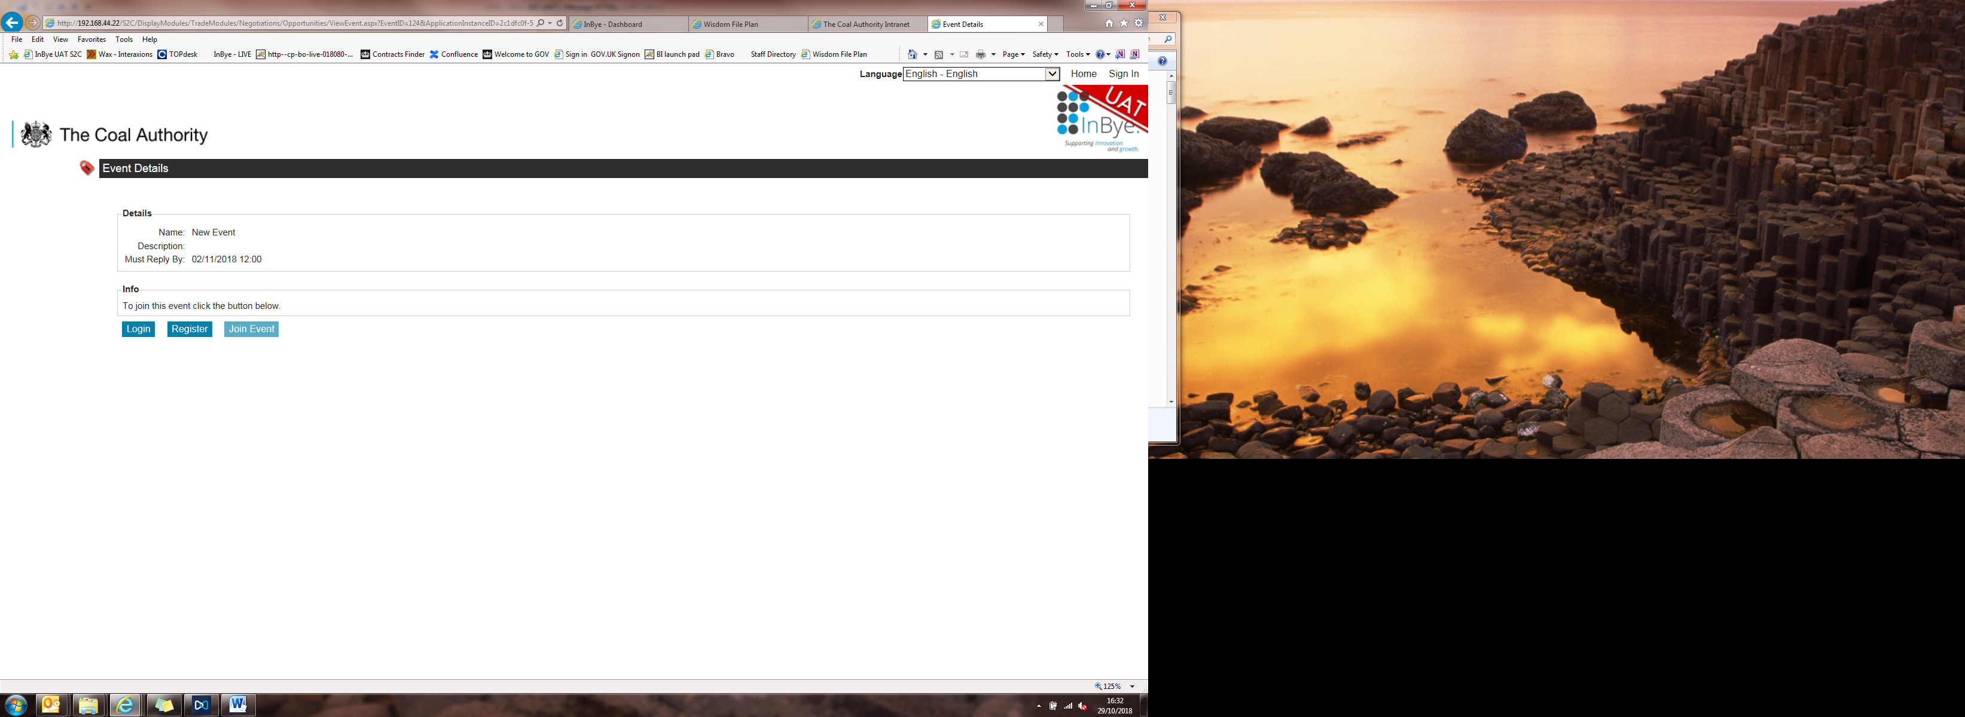

1. System will issue a registration email to you with a link to activate your account.
2. Click on the activation link from the email – system states account activated.
3. Click the Go to Sign In button.
4. Click on the Open Opportunities link
5. Click View details. Shows opportunity details with option to login, register.  
   Click on Log in. Enter login details – username and password.
6. Select Join Event. System states that you have been invited and includes option to Visit Event.
7. Click on visit event and system takes you through to the event in full.

Note: Please be aware that the system does not support Safari web browser.

**(ii) For a supplier already registered on InBye**

**There are two ways to access Open Opportunities, you can either:**

1. View from the initial log in page or
2. Access the details via your dashboard once you have logged in

From the initial Log in page.

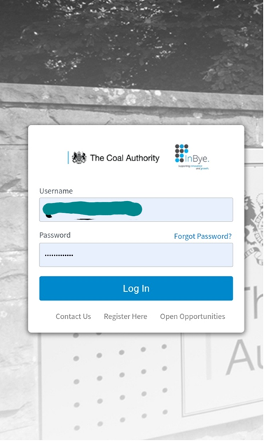

1. Click on the Open Opportunities link, the system will show a list of open access sourcing events.
2. Click the View details button at the side of the event, which is of interest. The system will then show details of the opportunity and any relevant attachments.

Review the details of the opportunity and if interested;  
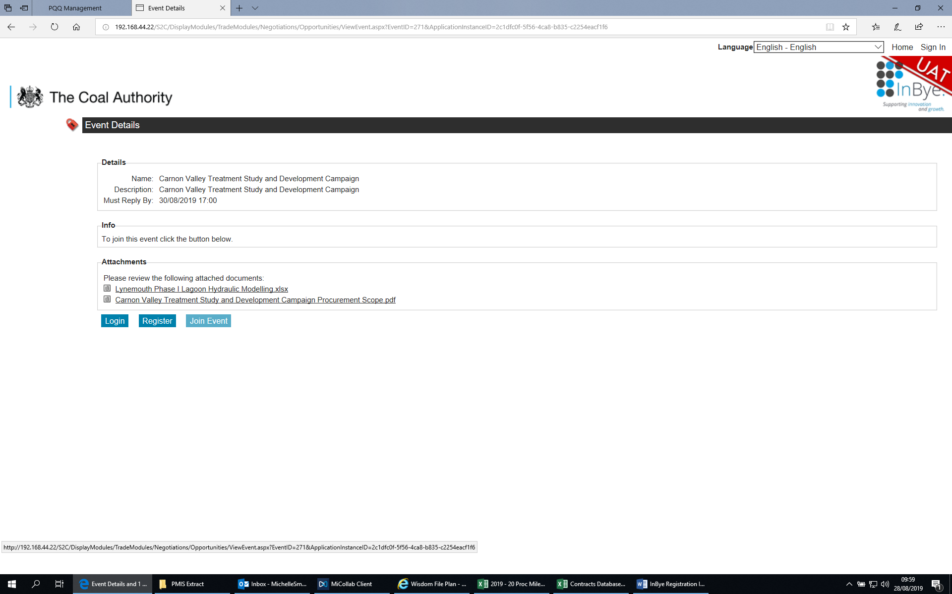

1. Click on Login from the Event Details page and enter username and password:
2. Select Join Event. System states that you have been invited and includes an option to Visit Event
3. Click on visit event and system takes you through to the event in full.

Note: Please be aware that the system does not support Safari web browser.

**Alternatively log into the system**

Once logged in, the dashboard will be shown which provides details your event history plus open opportunities in the widget or quick link as highlighted below.

