TENDERING FOR A CONTRACT WITH THE ROYAL BOROUGH OF GREENWICH

Contents
INTRODUCTION 1
REGISTRATION 1
FINDING OPPORTUNITIES 6

INTRODUCTION
Dear Supplier,

Thank you for your interest in this tendering opportunity. Royal Greenwich utilises the Proactis Rego platform for all our tenders and this document is provided to support you to find the documents, particularly if you are new to the system. To access the system you will need to use the following link:

Proactis - Supplier Network

REGISTRATION
The following screen will appear:

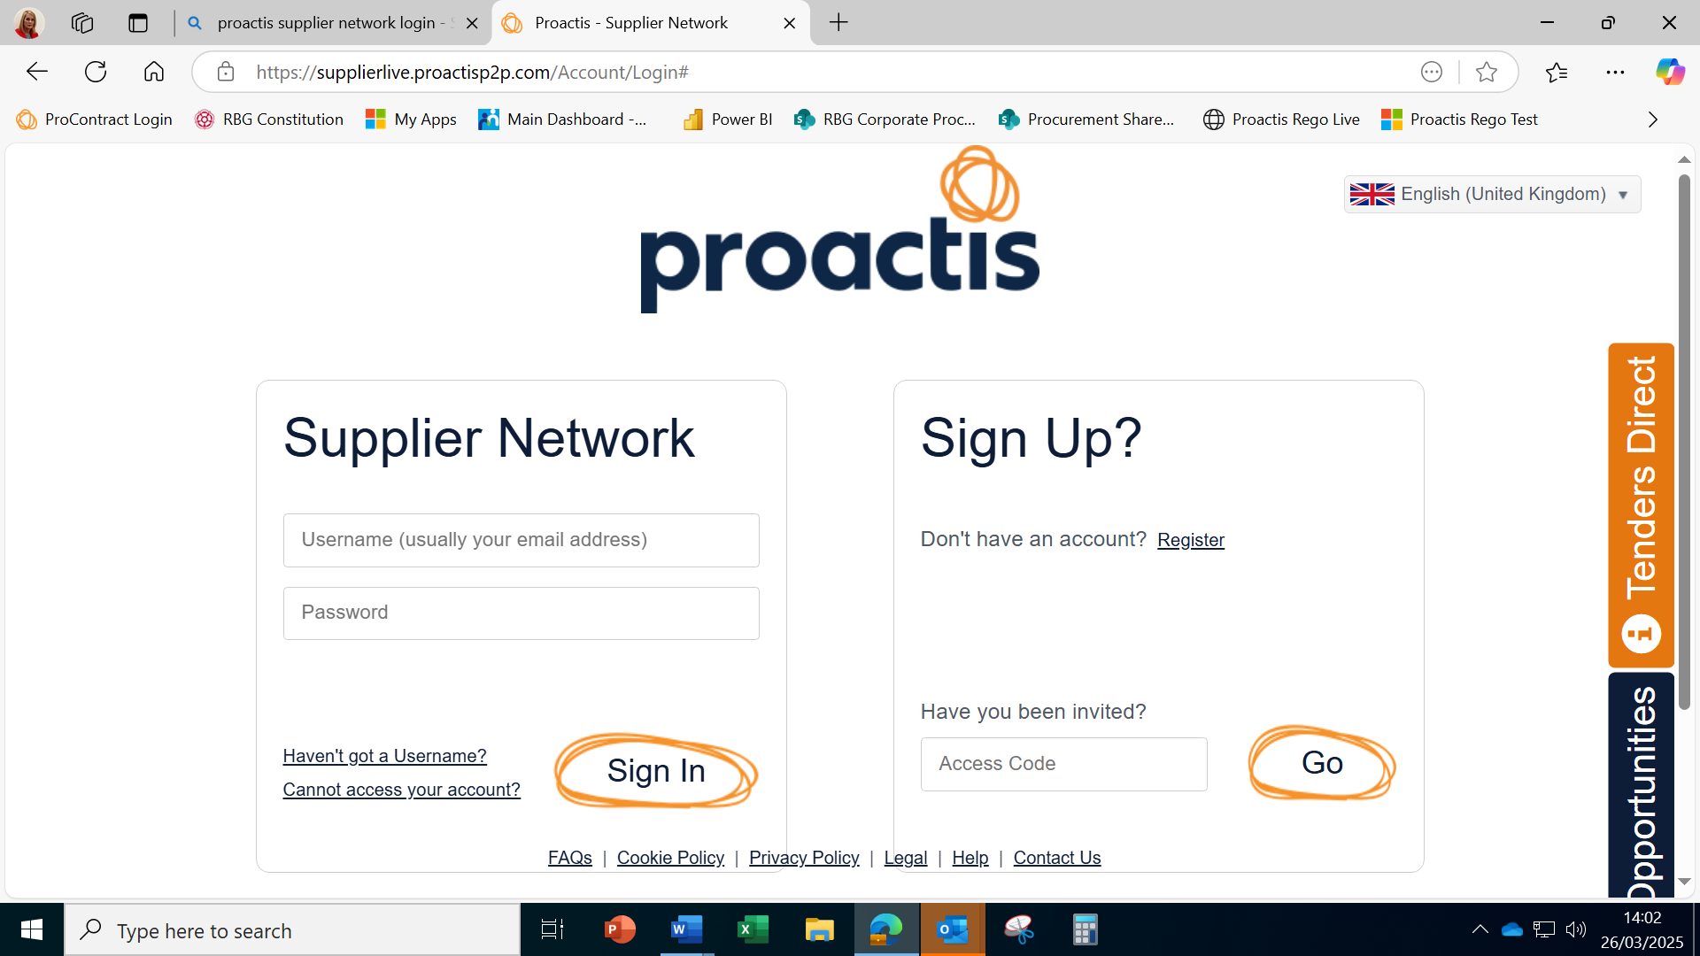

If you are registered you can login - but if not, please use the "Register" link on the right hand side of the screen. If you are already registered, you can jump to the “Finding Opportunities” Section to locate the relevant tender.

You will need to provide and confirm an email address.
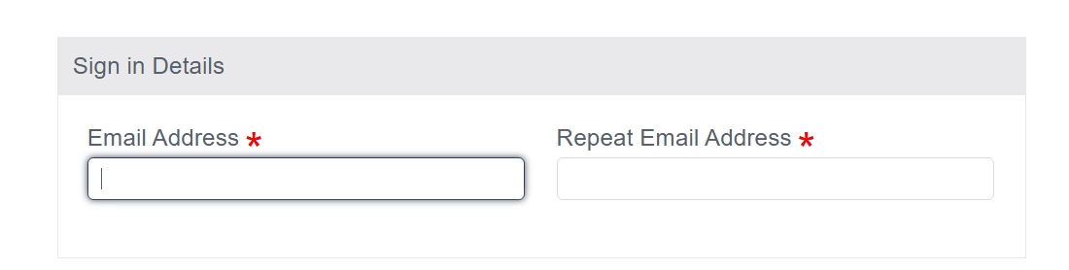

Then your address details:

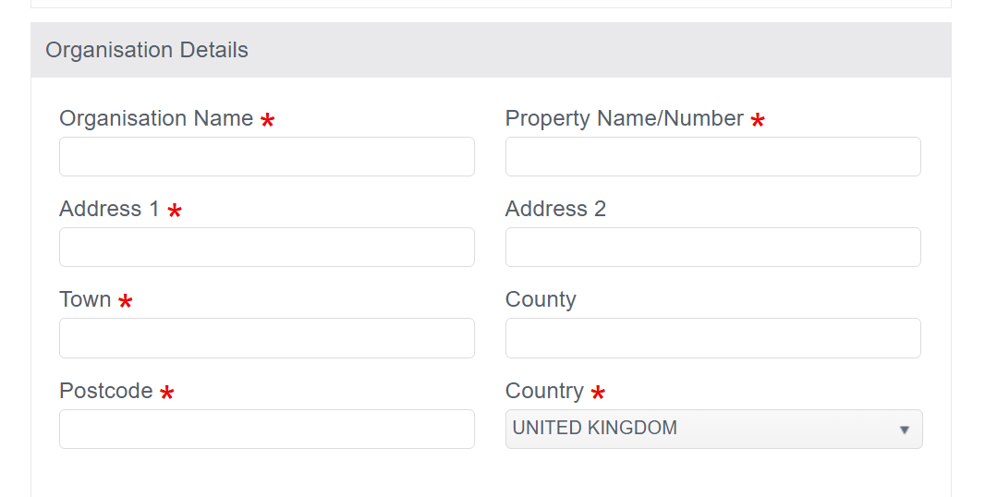

And finally, some contact details before you can click the register button.

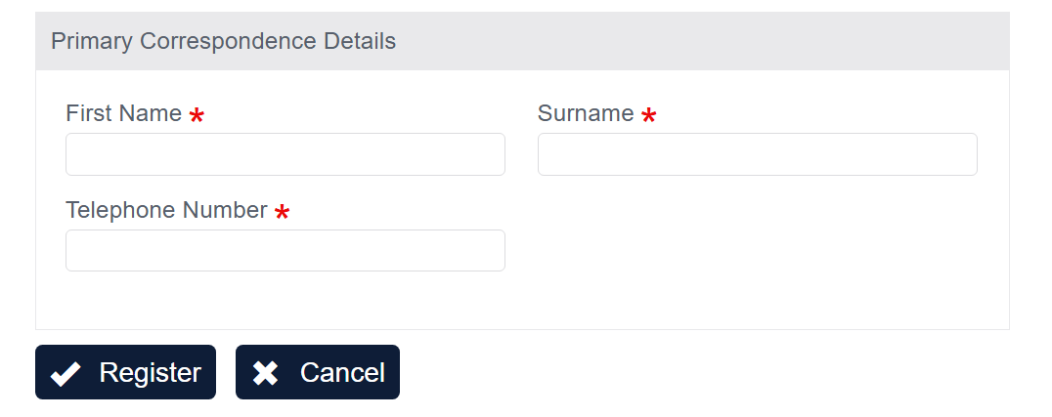

You will then see the following screen:

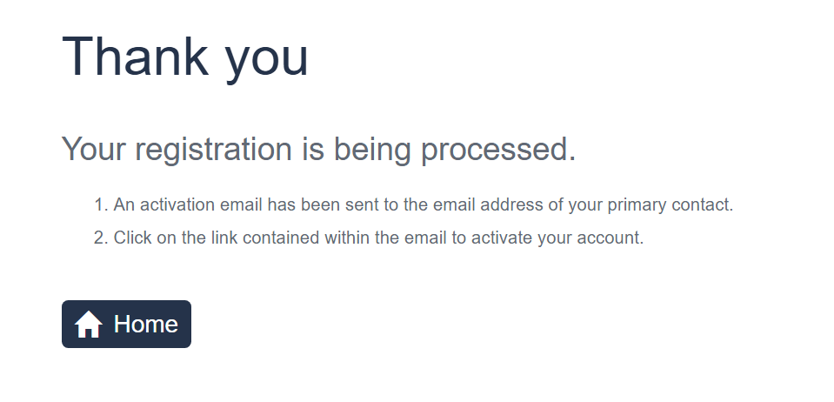

You will then receive an email (if you have Microsoft 365 it may appear in the "Other" inbox) - with the following text:

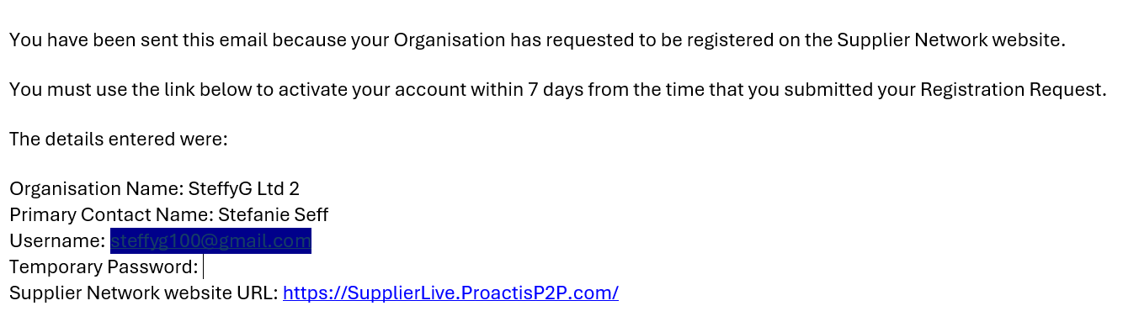
I have blanked the user name - this will normally be your email address. Click on the link to finish the registration process.

Enter the User name and the temporary password that has been provided. You can change the password later.

You will now see the Self Registration screen to complete the process. You will need to work through each section and note that fields with a red * are mandatory.

The first two elements (Organisation details and addresses) are self explanatory.

Product classifications will help identify what services or goods you provide and you will be notified of suitable opportunities that include these classifications. For example, my supplier "Steffyg2 Ltd" is a business consultancy.
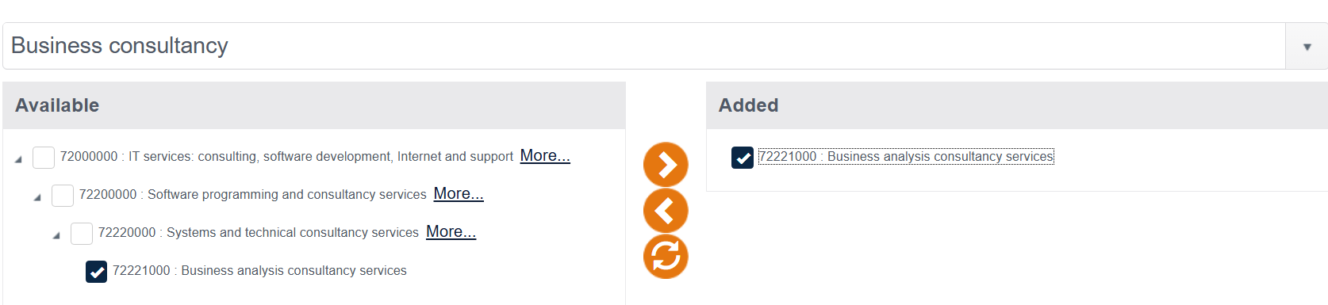

I typed "Business consultancy" into the box, and the options above came up. I chose the most relevant category and clicked the buttonto add it.

The Buyers section is optional. You should finally choose which email notifications you wish to receive. We suggest you select all to start and then you can change this later if you receive too many. Part of the screen is shown below.

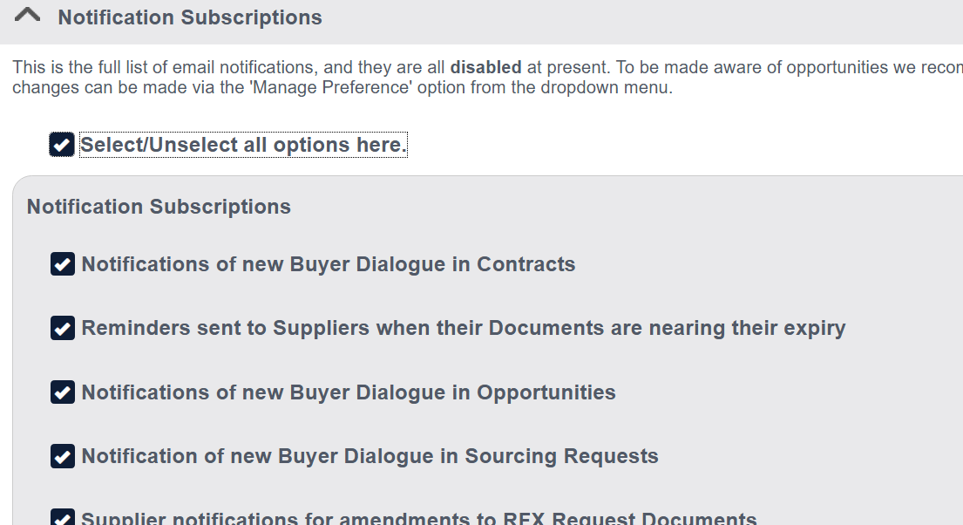

Once you have completed all sections click "Save" and "Finish".

The welcome screen will appear:

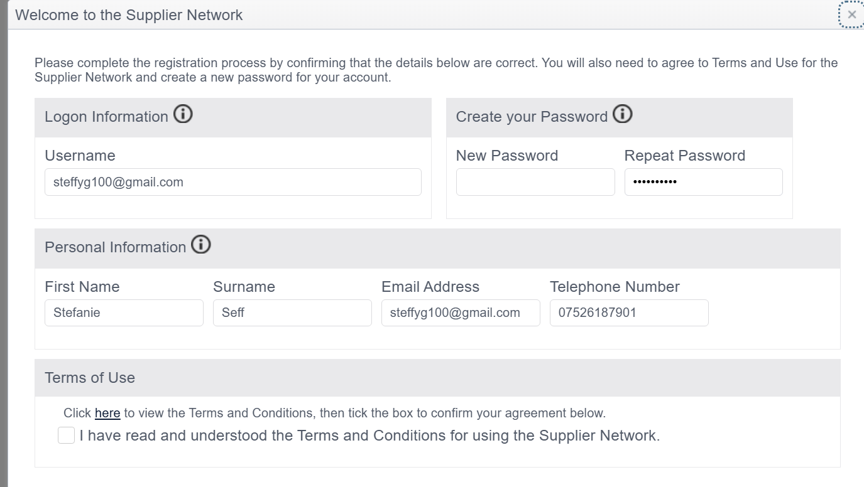

You can now create a more meaningful password that you can remember (and save in your browser too if you prefer).

You will need to check the Terms of Use box to confirm before you can proceed.

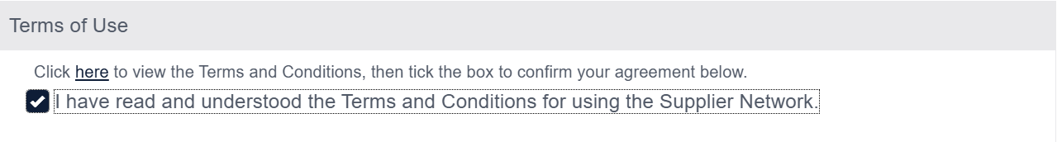

You are now registered on the Supplier Network and will be able to view all open tenders issued by all contracting authorities who use the Proactis Rego system. Individual authorities, including Greenwich, may ask you some further questions at the time we are ready to engage with you further, including if we were to invite you directly to submit a quote, or when we award you a contract.

For now, this is sufficient information to be able to submit a tender for any "advertised" opportunity via the Find a Tender Service or directly on the Proactis network.

FINDING OPPORTUNITIES
To find the specific tender you are looking for, you should log into the Proactis system. You will now be able to see the Supplier Network page:

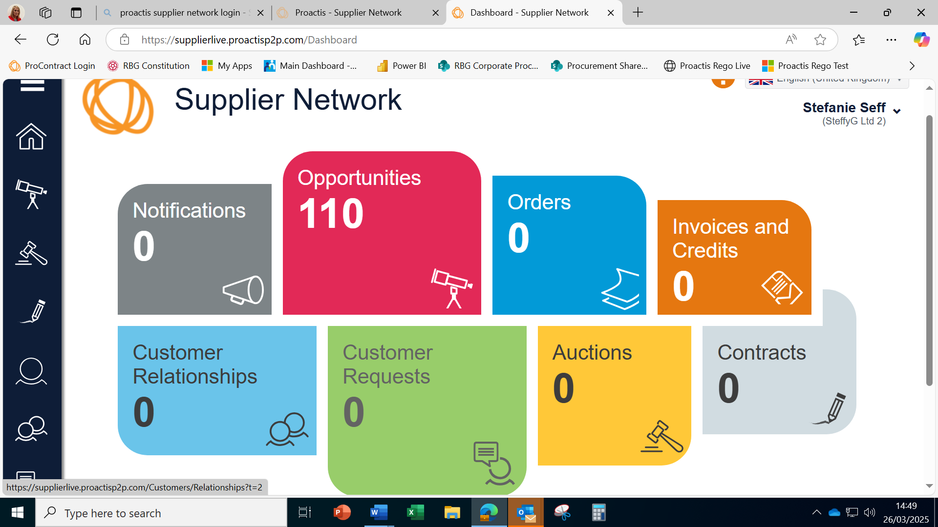

Click on the red "Opportunities" tile to find what opportunities are available.

All current live opportunities will be listed. To narrow these down type Greenwich into the "Search by customer……" box (below).

Now only the live opportunities from Greenwich will be shown. You can also do this for any other contracting authorities in whom you are interested.

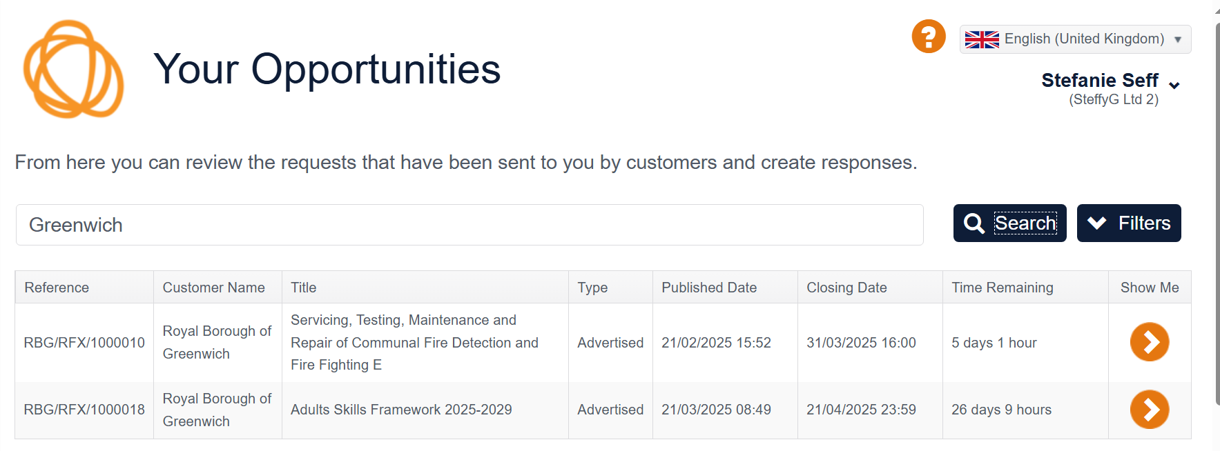

Click on the "show me" button to access the opportunity you are interested in:

You will now see details about the tender and you can click the "Register Interest" button to see further details.

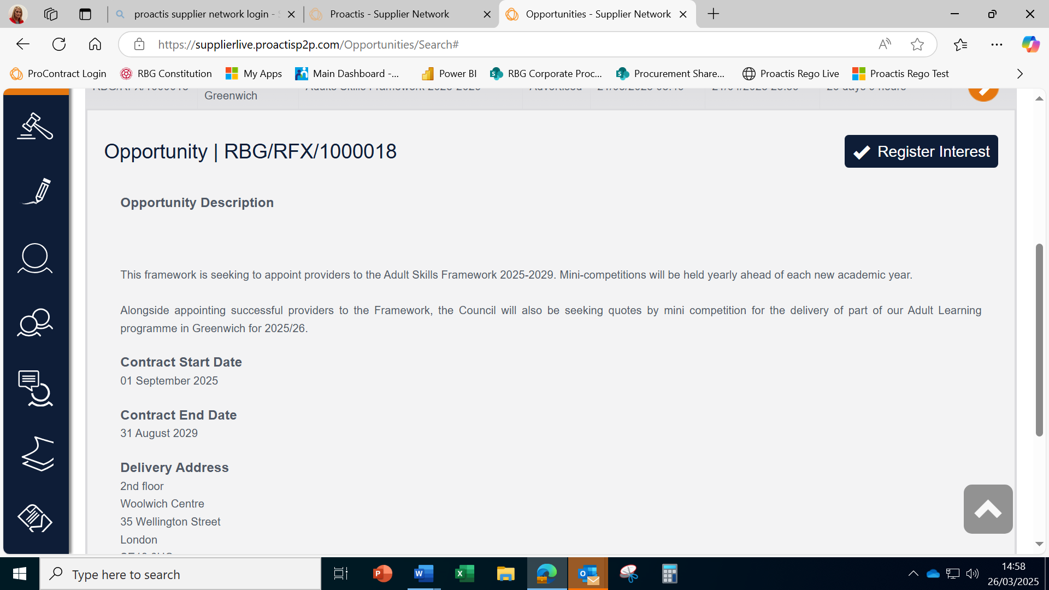

You are now taken to the response screen from which you can download documents, answer questions, provide pricing and submit when you are ready. The messages button is available if you have any questions about the tender opportunity. Please use this if anything is not clear.

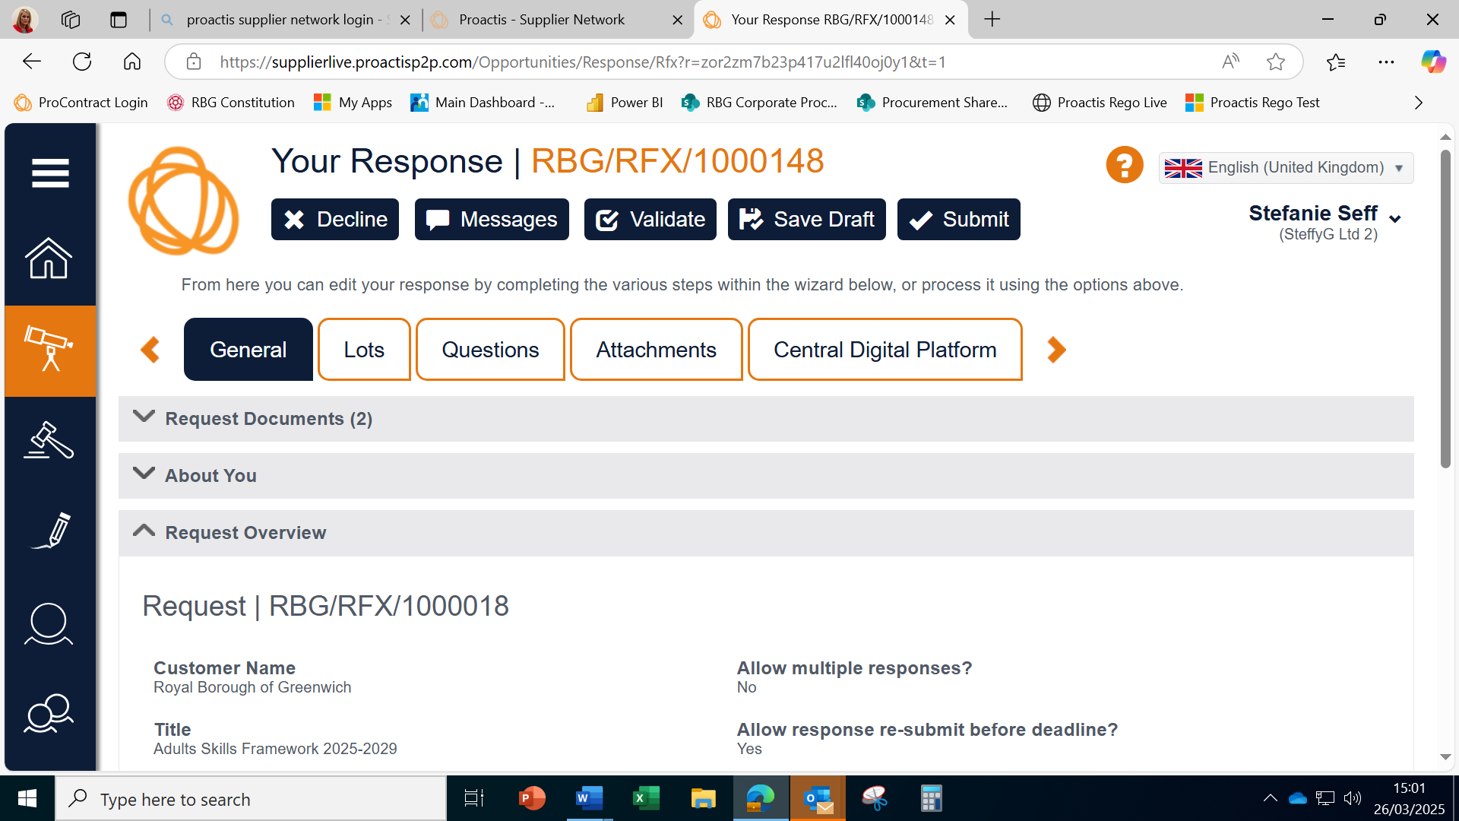

Further guidance to using the system can be provided on request. Just let us know by using the "Messages" button.
RBG Procurement March 2025

