

Youth

Service

Review

Specification for Taunton
Taunton Town Council
5th August 2025

Contents

1. Introduction 3
2. Objectives 4
3. Scope of Work 4
3.1 Geographic and Demographic Analysis 4
3.2 Mapping of Existing Youth Provision 7
3.3 Youth Engagement and Participation 7
3.4 Detached and Targeted Youth Work 7
3.5 Multi-Agency Coordination 7
3.6 Safeguarding and Policy Review 8
3.7 Case Studies and Best Practice 8
3.8 Funding and Sustainability 8
3.9 Technology and Innovation 8
3.10 Final Report and Recommendations 8
4. Consultant Requirements 8
5. Budget 8
6. Timeline 9
7. Additional Considerations 9
8. Submission Instructions 9
9. Conclusion and Expected Deliverables 9

1. Introduction
Taunton Town Council is committed to ensuring that all young people in the town have access to high-quality, inclusive, and responsive youth services. This specification outlines the commissioning of an independent review to assess the current landscape of youth provision in Taunton. The review will inform strategic planning, funding decisions, and service development to ensure young people are supported, engaged, and empowered.
Statistics
As of 2023, Somerset is home to approximately 581,145 residents, with a significant proportion of the population under the age of 25.
Taunton, as the county town, includes a diverse mix of urban and semi-rural communities, with areas such as Priorswood facing higher levels of deprivation. Around 47,800 Somerset residents live in the 20% most deprived areas in England, which has direct implications for youth engagement, access to services, and social mobility.
The review will place a strong emphasis on understanding the needs of young people across different communities, particularly those who are marginalised or at risk of disengagement. It will also explore how socioeconomic factors, accessibility, and service coordination impact youth outcomes.
To ensure a comprehensive and collaborative approach, the consultant will be expected to engage with a range of key local organisations, including but limited to:
- Youth Unlimited – a local youth charity with deep community ties and experience in outreach.
- YMCA Taunton Group – a major provider of youth housing, support, and activities across Somerset.
- Somerset Activity and Sports Partnership (SASP) – a key stakeholder in promoting physical activity and wellbeing among young people.
- Somerset Youth Alliance - a network of youth work organisations in the voluntary, community, faith and social enterprise (VCFSE) youth work sector, facilitated by Spark Somerset.

2. Objectives
This review seeks to provide a comprehensive understanding of youth services in Taunton. It will identify strengths, weaknesses, and opportunities for improvement, with a focus on inclusivity, sustainability, and impact. The work undertaken should look to understand the existing barriers to participation for young people and providers. The findings will guide future investment and policy decisions, ensuring services are responsive to the needs of all young people, particularly those who are vulnerable or marginalised.

3. Scope of Work
The consultant will undertake a series of interrelated tasks designed to build a holistic picture of youth provision in Taunton. Each task is intended to generate actionable insights and support the development of a coordinated, youth-led service ecosystem to support eh delivery a strategic long-term plan that the town council can achieve and deliver on.
The scope of work will primarily focus on engaging young people aged 10 to 24, with flexibility to include older individuals depending on their needs and abilities, to ensure inclusivity and comprehensive representation. The voice of young people should be guiding this review to ensure that the suggested solutions are sustainable and inclusive for all young people in Taunton.

3.1 Geographic and Demographic Analysis
Understanding the local context is essential for effective service planning. This task involves analysing demographic data to identify key trends, needs, and inequalities affecting young people across Taunton. Special attention should be given to areas of deprivation and under-served communities.
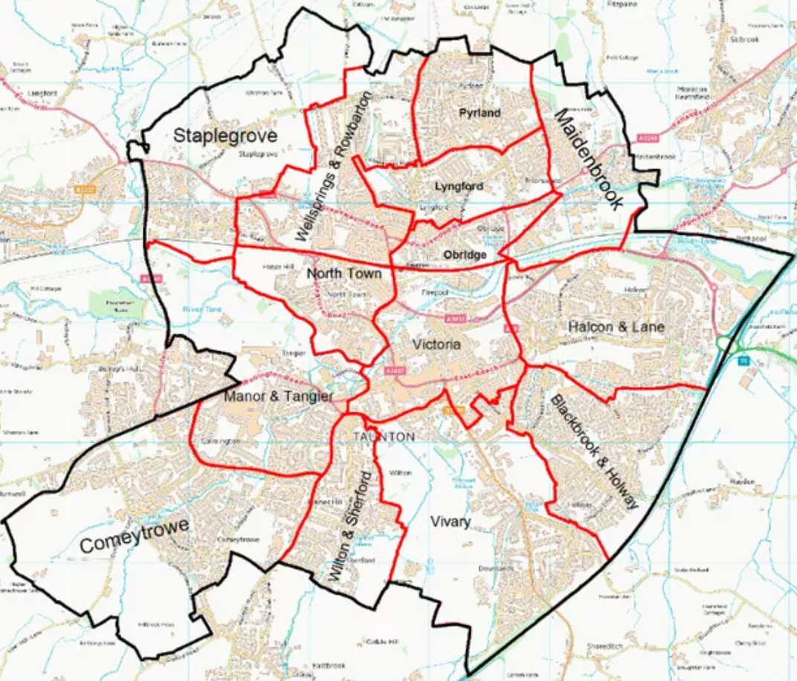

A summary of demographic data for young people in the Taunton area (former Somerset West and Taunton) based on the 2021 Census and other recent sources:
Young People Demographics (2021)
Here’s the breakdown of age groups relevant to young people:
Age Group | % of Population (2011) | % of Population (2021) | Change
0–4 years | 5.3% | 4.7% | ↓
5–9 years | 5.0% | 5.3% | ↑
10–15 years | 6.9% | 6.7% | ↓
16–19 years | 4.9% | 4.1% | ↓
20–24 years | 5.5% | 4.3% | ↓
25–34 years | 10.2% | 11.2% | ↑
Key Trends
- The 0–4 and 10–24 age groups have declined slightly in proportion.
- The 25–34 age group has grown, suggesting a possible influx of young adults, perhaps due to employment or housing opportunities.
Young people demographics in Taunton for the years 2011 and 2021, based on census data:
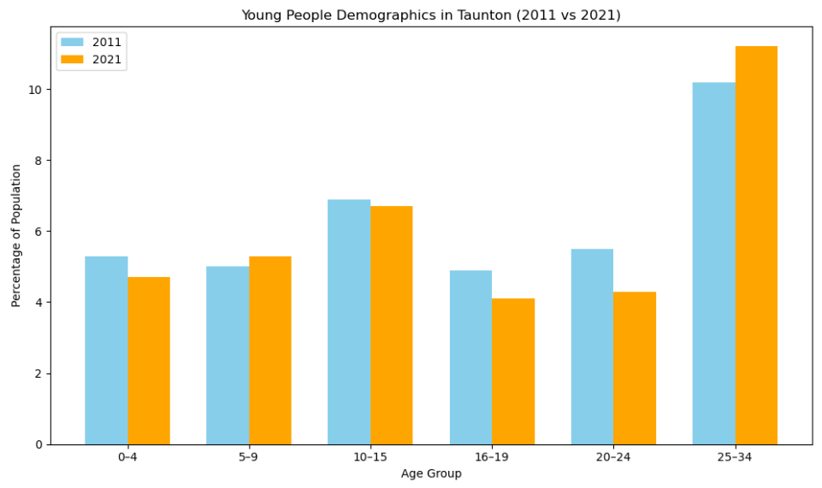
It clearly shows:
- A decline in the 0–4, 10–15, 16–19, and 20–24 age groups.
- A slight increase in the 5–9 and 25–34 age groups.
Data Sources
Office for National Statistics (ONS) Census 2021 [1] [2]
Somerset Intelligence Census Portal [3]
References
[1] Somerset West and Taunton population change, Census 2021 – ONS
[2] How life has changed in Somerset West and Taunton: Census 2021
[3] Census 2021 - Somerset Intelligence - The home of information and ...

3.2 Mapping of Existing Youth Provision
A detailed mapping exercise will identify all current youth services, including statutory, voluntary, and community-led initiatives. This will highlight areas of duplication, service gaps, and opportunities for better coordination and resource allocation.

3.3 Youth Engagement and Participation
Young people must be at the heart of this review. The consultant will need to engage directly with youth through surveys, interviews, and focus groups to understand their experiences, preferences, and aspirations. This will inform recommendations that reflect the voices of those most affected.

3.4 Detached and Targeted Youth Work
Detached youth work plays a vital role in reaching young people who do not engage with traditional services. This task will assess the effectiveness of current detached approaches and explore how targeted interventions can better support specific groups, such as LGBTQIA+ youth, young carers, those at risk of antisocial behaviour as well as 20-24 year olds who face barriers in education, employment or training.

3.5 Multi-Agency Coordination
Effective youth provision requires collaboration across sectors. This task will examine how well youth services are integrated with other agencies, such as education, health, and community safety, and identify ways to strengthen partnership working.

3.6 Safeguarding and Policy Review
Robust safeguarding is a non-negotiable element of youth work. The consultant will review current safeguarding policies and practices across providers to ensure consistency, compliance, and best practice in protecting young people.

3.7 Case Studies and Best Practice
Learning from others is key to innovation. The consultant will identify and present case studies from other localities that demonstrate effective, inclusive, and sustainable youth service models. These examples will inform local recommendations.

3.8 Funding and Sustainability
Sustainable funding is critical to long-term service delivery. This task will explore current funding arrangements, identify challenges, and propose strategies for securing and distributing resources more equitably, including opportunities for match funding and joint bids.

3.9 Technology and Innovation
Digital tools can enhance service planning and delivery. The consultant will consider how technology can support youth engagement, data collection, and service coordination, while ensuring digital inclusion for all young people.

3.10 Final Report and Recommendations
The consultant will produce a comprehensive final report, including a gap analysis and a set of clear, prioritised recommendations. The report will be structured to support decision-making and align with the Council’s budget-setting process for 2026.

4. Consultant Requirements
The Council seeks an experienced, impartial consultant with a strong track record in youth service evaluation. The successful candidate will demonstrate the ability to engage diverse stakeholders, analyse complex data, and deliver high-quality, actionable insights within tight timeframes.

5. Budget
The available budget for this commission is between £10,000 and £50,000.
A mid-range proposal is anticipated, reflecting the scale and complexity of the work.
Value for money and impact will be key considerations in the selection process and will be subject to a fair, transparent and open evaluation.

6. Timeline
The review must be completed in time to inform the 2026 budget-setting process. We would anticipate that the summer break period is ideal for going to Young People where they are, using youth voice to guide the next steps.
Key milestones include:
- Commissioning Date: August 2025
- Interim Findings: November 2025
- Final Report Deadline: February 2026

7. Additional Considerations
To support the review, the Council will provide relevant data, service maps, and contact details for key stakeholders.
The consultant will be encouraged to explore collaborative opportunities with local partners and consider hosting a youth conference to support consultation and engagement.

8. Submission Instructions
Interested suppliers should submit a proposal including:
- A detailed methodology and work plan
- Evidence of relevant experience and qualifications
- A breakdown of costs and timelines
- Two references from similar projects

9. Conclusion and Expected Deliverables
Upon completion of this comprehensive review, the appointed consultant is expected to deliver a clear, evidence-based assessment of youth services in Taunton. The final output should provide Taunton Town Council with:
- A detailed mapping of existing youth provision, including service types, locations, providers, and target demographics and any potential funding timelines.
- A demographic and geographic analysis highlighting areas of need, service gaps, and inequalities in access.
- Insights from direct and non direct engagement with young people and stakeholders, capturing lived experiences, service perceptions and any unmet needs.
- An evaluation of current coordination and safeguarding practices, with recommendations for improvement.
- Case studies and examples of best practice from comparable localities to inform local innovation.
- A comprehensive gap analysis identifying priority areas for investment and development.
- Strategic, actionable recommendations for enhancing youth provision, including short-, medium-, and long-term goals.
- A roadmap for sustainable funding and partnership development, including opportunities for joint bids and match funding from relevant and local funding and grant organisations.
- A final report that is accessible, professional and aligned with the Council’s corporate plan and budget-setting timeline for 2026.

Supplier List:
2BU Somerset
Taunton Brewhouse
Mind in Somerset
National Citizens Service
Scout, Guide Centre, Sea Cadets
Somerset Council – Engagement and Participation Team
TYCA
YMCA, TAUNTON
Young Somerset
Youth Parliament
Connect Somerset
GameChanger
In The Mix
Somerset Youth Theatre
Fuse
Taunton CICCIC
Taunton Minster
Taunton Town FC
Taunton Youth Culture Arts
Taunton Youth for Christ
The Onion Project
Youth Unlimited

