

Request for Quotation

LODGE PARK SPORTS CENTRE REFURBISHMENT of TOILETS, SHOWERS & CHANGING PLACES ROOM

This document has been returned by
Click to enter Organisation name.

Contents
Section 1: Introduction 3
1. General Requirements 3
2. Rights of the Council in Relation to the RfQ 4
3. Procurement Timetable 5
4. Clarification Questions 6
5. Quotation Responses 6
6. Evaluation of Quotations 7
7. Evaluation and Moderation of RfQ Responses 7
8. Evaluation of Price (Award Criteria Questionnaire) 10
9. Presentations and/or Clarifications 11
10. Abnormally Low and/or Unsustainably High RfQ Responses 11
11. Rejection and Disqualification of RfQs 12
Section 2: Specification 14
Section 3: Supporting Information 18
Section 4: Pricing Sheet 24
1. Pricing and Costs 24
*For use at the discretion of the Employer in the potential valuation of any variations 25
Section 5: Freedom of Information 25
Section 6: Declaration 26
Section 7: Due Diligence 27
Section 8: Contract Award 28

Appendix 1: Building Plans………………………………………………………………..29
Appendix 2: Asbestos Management Plan………………………………………………..30
Appendix 3: Photographs of in situ facilities……………………………………………..31
Appendix 4: Conditions of Contract………………………………………………………32

Section 1: Introduction

General Requirements

  - North Northamptonshire Council (hereafter known as the Council) invites quotations to refurbish and upgrade key customer areas to meet Sport England guidance for Accessible and Inclusive Sports Facilities including Part D – Changing and toilet provision at Lodge Park Sports Centre, Shetland Way, Corby, NN17 2SG.

  - The refurbishment will include male, female and disabled toilets; male and female showers; and room alterations with the required fittings to create a Changing Places toilet with shower.

  - The Council’s detailed requirements are defined in Section 2: Specification.

  - Companies are advised to factor in potential price increases to accommodate the contract period (detailed in Table A and 1.5), as quotations cannot be increased once submitted.

  - It is expected that the works will commence from January 2026 and be completed and ready for use at the latest by 20 March 2026.

  - Please take care in reading this document, particularly the Specification. In the event of any questions or queries in relation to this Request for Quotation (hereafter referred to as “RfQ”), please contact the Officer detailed in Table B.

  - The Council reserves the right to:
    - carry out due diligence checks on the awarded Potential Supplier;
    - amend the Conditions of Contract (issued at clarification meeting);
    - abandon the procurement process at any stage without any liability to the Council; and/or
    - require the Potential Supplier to clarify its quotation in writing and if the Potential Supplier fails to respond satisfactorily, this may result in the Potential Supplier being rejected from the process.

  - The Council also reserves the right, at any point and without notice, to discontinue the procurement process without awarding a contract, whether such discontinuance is related to the content of RfQ Responses or otherwise. In such circumstances, the Council will not reimburse any expenses incurred by any person in the consideration of and/or response to this document. You make all quotations, proposals and submissions relating to this RfQ entirely at your own risk.

  - The Council shall not accept liability nor reimburse you for any costs or losses incurred by you in relation to your participation in this procurement process, whether the Council has made changes to the procurement process or not.

  - All documents and materials, which comprise the RfQ Response, must be written in English only.

  - Quotations are to remain open for acceptance for a period of no less than the identified timetable in Section 3 with works expected to be completed by March 2026.

  - Potential Suppliers must be explicit and comprehensive, keeping the information provided specific to and locate within the question asked as this will be the single source of information on which responses will be scored and ranked.

  - For the avoidance of doubt please be aware that following award of contract should the successful Supplier(s) subsequently find that their proposed solution and/or price offer is not accurate and sustainable then the successful Supplier(s) will not be permitted to amend their pricing bid to request any further monies associated with the full provision of the goods/services and/or works.

  - Answer fully all relevant questions and respond in accordance with any specific requests as detailed in the question e.g., maximum word/page limits, etc.
    - Where the Council has identified word limits, Potential Suppliers are strongly requested to adhere as closely to these as possible. Whilst it is not the Council’s intention to count the number of words a Potential Supplier uses in their responses, if the Council reasonably determines that a word limit has been exceeded, it may take that into account when awarding a score for that question; i.e.; words submitted over this limit may not be evaluated;
    - All words in any format (including but not limited to words in diagrams, pictures, maps, tables, and charts) will count towards the word count. Potential Suppliers must state the number of words in any diagram, picture, map, table, or chart directly underneath it. This includes any other method of presentation which is not just text. Potential Suppliers must not attempt to circumnavigate the word limit e.g., by joining up words or using special characters to join words;
    - Submit any attachments requested in an acceptable format to the Council which includes MS Word, MS Excel, MS PowerPoint, JPEGs and PDF files or any file format as specified in the question. Potential Suppliers who wish to submit an attachment in an alternative format must first check with the Council that it will be accepted;
    - When uploading attachments, please state the question number only in the file title; and
    - Submit any zipped files in WinZip format only.

Rights of the Council in Relation to the RfQ

  - The Council reserves the right to:
    - Waive or change the requirements of this RfQ at any time during the procurement process without prior (or any) notice being given by the Council;
    - Make changes to the timetable, structure or content of this RfQ or any other documents associated with this procurement process. Any such changes will be in accordance with the procurement timetable;
    - Abandon the procurement process at any stage without any liability to the Council, or to re-invite responses on the same or any alternative basis;
    - Choose not to award any contract as a result of this procurement process.

Procurement Timetable

  - This RfQ follows a clear, structured and transparent process to ensure a fair and level playing field is maintained at all times, and that all Potential Suppliers are treated equally.

  - All documents, which comprise any RfQ Response, must be received by the Council no later than the Deadline for Submission of Bids, set out in Table A, below.

  - The RfQ process is intended to follow the timetable set out in Table A, below.

Table A – Timetable
Activity |  | Time and Date  (as applicable)
 | Request for Quotation Documents issued | Friday, 10 October 2025
 | Deadline for Questions from Potential Suppliers | Monday, 27 October 2025
 | Deadline to Provide Answers to Questions from Potential Suppliers | Friday, 31 October 2025
 | Deadline for Submission of Bids | 12:00 noon on Friday, 7 November 2025
 | Evaluation of Bids Received* | Wednesday, 12 November 2025
 | Clarification Meetings (if required)* | Thursday, 13 November 2025
 | Contract Award* | Monday, 17 November 2025
 | Pre-Contact Meeting(s)* | Wednesday, 3 December 2025
 | Contract Start* | Monday, 5 January 2026
 | Contract End | Friday, 20 March 2026

  - The Council reserves the right to amend this timetable, and items marked with an asterisk, i.e. *, are provided for guidance only and are subject to change at short notice.

  - Any RfQ received after the Deadline for Submission of Bids identified in Table A, may be rejected. Therefore, it is the Potential Supplier’s responsibility to ensure that the deadline is not breached.

Clarification Questions

  - Any queries about this document, the procurement process, or the proposed contract itself, should be referred via e-mail to the Officer detailed in Table B, below, no later than the Deadline for Questions from Potential Suppliers date set out in Table A.

  - A copy of all requests for clarifications and the responses will be published to all Potential Suppliers, where the clarification and response are not considered confidential.

  - If a Potential Supplier wishes the Council to treat a clarification as confidential and therefore not publish the response to all, they must state this when submitting the clarification. If in the opinion of the Council, the clarification is not confidential, the Council will publish it in an anonymised format.

  - The Deadline for Questions from Potential Suppliers relating to this procurement is set out in Table A. Questions sent to the Council after this deadline may not be responded to.

Quotation Responses

  - Should you wish to take part in the selection process please complete this RfQ and return via e-mail to the Officer detailed in Table B, below, no later than the Deadline for Submission of Bids date in Table A.

Table B – Officer to Contact Regarding the Council’s Requirement
Name | Liz Hudson
Job Title | Leisure Manager for Community Leisure
Telephone number | N/A – All correspondence to be via e-mail
E-Mail address | liz.hudson@northnorthants.gov.uk

  - To enable Potential Suppliers to ensure their Request for Quotation Responses reflect as accurately as possible the Council’s specification and requirements, the Council strongly recommends that Suppliers undertake a site visit so each Potential Supplier can satisfy themself so far as is possible that their proposed quotation price to be submitted in its bid is correct, realistic and sustainable. Such site visits may be arranged by contacting the point of contact for this procurement process, provided in Table B. NB: see Section 2: 1.1 Site Visit.

  - Questions asked by Potential Suppliers during site visits will not be answered. All questions must be submitted in writing, in line with the guidance set out in the supporting documents of this procurement. Thereafter, questions will be made available to all Potential Suppliers, along with the associated answers.

  - Site visits will not be scored or evaluated, but the Council makes available this opportunity to and for Potential Suppliers in accordance with the principles of openness, fairness, transparency and non-discrimination so as to enable each Potential Supplier, so far as is reasonable, to submit its most competitive bid.

Evaluation of Quotations

  - THOSE POTENTIAL SUPPLIERS WHO FAIL ANY PASS/FAIL, MANDATORY, COMPULSORY AND/OR ESSENTIAL QUESTIONS WILL be rejected from the RfQ PROCESS.

  - Any bids which are not compliant or not completed fully will be rejected. If a bid is eliminated for any reason, the price submitted within the quote concerned shall also be excluded from the evaluation. Based on the information provided by Potential Suppliers, each compliant RfQ Response will be evaluated based on the following criteria:

    - Weighted Combination of Questions and Price
- The evaluated score as detailed in Table C, will be divided by 4 and multiplied by the question weighting (within Total) (%), to provide a final score (%) for each question, in accordance with the following example:
- If the question weighting (within Total) is 20% and the Potential Supplier’s response is scored ‘2’, their final score (%) will be:
- 2 / 4 x 20 = 10% for that question.
- The Potential Supplier’s response to each question will be evaluated and scored a maximum of 4 marks as per Table C.

    - Important Note for Question 6
  - Where the Potential Supplier answers in such a way, as to avoid this requirement, but still provides an answer (e.g., “we are unable to offer any benefits as a part of this Contract”), they will be deemed to have not answered the question, which may lead them failing this question and being rejected from the process.

Evaluation and Moderation of RfQ Responses

  - Each RfQ Response will be evaluated by an Evaluation Panel, which may include, but not be limited to, Council officers, members, technical advisors and/or stakeholders (such as members of user groups, focus groups and/or tenant/resident panels).

  - An initial examination may be made to establish the completeness of the RfQ Responses.

  - Any moderation meetings will be attended by the Evaluation Panel and a member of the Procurement Team, who will facilitate the moderation meeting.
  - As the result of any moderation, the Evaluation Panel may choose to revise a Potential Supplier’s score for each response to a Scored Question, either up or down to reach a final score.

  - All responses to the Scored Questions will be assessed against the Criteria set out in Table C, below.

Table C – Criteria for Awarding Score
Score | Criteria for Awarding Score
0 | Considered to be a poor response on the basis that:  - No response is provided; or  - It does not answer the question or is completely irrelevant.
1 | Considered to be a limited response on the basis that:  - Overall, it lacks sufficient detail or is perceived to be unclear, meaning that evaluators are not confident that the criteria will be delivered to an acceptable level.
2 | Considered to be an acceptable response on the basis that:  - It addresses most of the relevant criteria; and/or  - The supporting detail is clear for the most part and provides evaluators with an understanding that the criteria it does address will be met to an acceptable level.
3 | Considered to be a good response on the basis that:  - It addresses all relevant criteria; and/or  - The supporting detail is clear and provides evaluators with confidence that the criteria will be delivered to a good standard.
4 | Considered to be an outstanding response on the basis that:  - It addresses all relevant criteria; and/or  - The supporting detail is clear and robust and provides evaluators with the utmost confidence that all criteria will be delivered to the highest standard.

  - An RfQ Response may be rejected, where the response to any Scored Question fails to achieve a score of 2 or more (as defined in Table C), even if it scores relatively well against all other criteria. This is because the Council requires a minimum quality threshold to ensure an overly low price does not skew an RfQ Response where the quality is fundamentally unacceptable.

  - Should the Evaluation Panel, in its reasonable judgement, identify a fundamental failing or weakness in any RfQ Response then that RfQ Response may, regardless of its other merits, be excluded from further consideration.

  - For the avoidance of doubt, there are no sub-criteria elements in the Scored Questions, which will be scored. The score allocated will be against the total answer submitted and factored against the maximum percentage awarded for that question in accordance with the calculation formula.

  - Where a particular question may list “elements”, Potential Suppliers are informed that no such individual element will be scored, per se; instead, the “elements” as listed are given for information only to assist Potential Suppliers to submit their most comprehensive Response and therefore their most competitive RfQ Response in all the circumstances.

  - The award criteria questions will be evaluated, using the scheme set out in Table D, below.

Table D – Evaluation Criteria Questions and Weighting Scheme

 | Section Headings | Weighting  Within Total
Questions (100%)
Minimum Standard (Answered? Yes/No)
 | Supporting Information | Answered? Yes/No
 | Contact Details and Declaration | Answered? Yes/No
Minimum Standard (Pass/Fail)
 | Insurance | Pass/Fail
 | Modern Slavery Act 2015 | Pass/Fail
 | General Data Protection Regulation (GDPR) | Pass/Fail
 | Social Value | Pass/Fail
Project Specific Questions (45%)
 | Delivery Method Statement, Fixtures and Fittings | 35%
 | Workforce | 10%
Price based on installation in 2026 (55%)
 | Male, female and disabled toilets (first floor)
 | Male and female showers within changing rooms
 | Changing Places Room and fittings
 | Total Cost (A+B+C) | 55%
 | Grand Total | 100%

Evaluation of Price (Award Criteria Questionnaire)

  - Potential Suppliers should satisfy themselves of the accuracy of all fees, rates and prices quoted, since they will be required to hold these or withdraw their RfQ Response in the event of errors being identified after the Deadline for Submission of Bids, set out in Table A.

  - If a Potential Supplier fails to provide fully for the requirements of the RfQ it must either:
    - absorb the costs of meeting the Council’s full requirements within its RfQ price; or
    - withdraw its RfQ.

  - The following criteria will be applied to evaluate price:

    - Weighted Combination of Questions and Price
  - The Potential Supplier with the lowest overall compliant price will be awarded the full Price score, as set out in Example 1. All other RfQ Responses will be scored in accordance with the following calculation:

$$=Price Weighting-\left(\frac{Your submitted price-lowest submitted price}{Your submitted price}\right)x 100$$

    - An example is provided in Example 1, below. This example is based on a 40% price weighting where the lowest compliant price is £100,000.

Example 1
Potential Supplier No. | RfQ Price | Price Calculation | Price Score
 | £100,000.00 | =40%  (lowest compliant price) | 40
 | £110,000.00 | =40-((110,000-100,000)/110,000)*100 | 30.91
 | £500,000.00 | =40-((500,000-100,000)/500,000)*100 | -40
 | £130,000.00 | =40-((130,000-100,000)/130,000)*100 | 16.92

    - If the Potential Supplier receives a minus score, following the Price Calculation provided in Example 1, the Council will amend the Potential Supplier’s Price Score to “0”, for the purposes of the Evaluation, so their Price Score does not adversely affect their overall Score.

Presentations and/or Clarifications

  - Where the Council believes there is an omission, ambiguity or inconsistency in a Potential Supplier’s RfQ Response (including an arithmetical error), the Council reserves the right (but is not obliged) to seek clarification of any aspect of a Potential Supplier’s RfQ Response during the evaluation phase where necessary for the purposes of carrying out a fair evaluation.

  - The Potential Supplier will be required to confirm any appropriate amendments to their RfQ Response.

  - Potential Suppliers are asked to respond to such requests promptly and within any given deadline. Potential Suppliers may be disqualified if they do not satisfactorily respond within the given deadline.

  - Once the submitted RfQ responses have been evaluated, the Council reserves the right to conduct Presentation and/or Clarification meetings as part of the evaluation process with any number of Potential Suppliers, as the Council deems necessary, to complete a full evaluation of the RfQ Responses submitted.

  - The Council may clarify elements of Potential Suppliers' submissions and reserves the right to:
    - re-visit the evaluation scoring; and
    - ask further clarification questions.

Abnormally Low and/or Unsustainably High RfQ Responses

  - RfQ Responses will be reviewed to consider if they appear to be abnormally low or unsustainably high in cost. An initial assessment will be undertaken using a comparative analysis of the price proposal received from all Potential Suppliers.

  - The Council reserves the right to reject any unsustainably high RfQ Responses without further evaluation of the bid submission.

  - If the assessment shows that a Potential Supplier’s price offer may be abnormally low, the Council will request from a written explanation and/or evidence of the Potential Supplier’s price offer and/or RfQ Response, or of those parts of a Potential Supplier’s price offer and/or RfQ Response, which the Council considers contribute to the RfQ Response being abnormally low, to justify the RfQ Response and its price and/or value(s) offered.

  - On receipt of a Potential Supplier’s written explanation, the Council will verify the price offer, RfQ Response or parts of the RfQ Response.

  - If the Council is still of the opinion that the Potential Supplier has submitted an abnormally low offer, the Council will confirm this to the Potential Supplier and will advise either:
    - that the Potential Supplier’s RfQ Response has been rejected; or
    - that, for RfQ evaluation purposes, the Council will make an adjustment to the price proposal to take account of any consequences of accepting an abnormally low RfQ Response.

  - Where the Potential Supplier is unable to prove, within a sufficient time limit, such justification for the low price and/or value, the Council reserve the right to reject the RfQ Response.

Rejection and Disqualification of RfQs

  - The Council reserves the right to reject or disqualify any RfQ Response and or a Potential Supplier, where the Potential Supplier:
    - Fails to submit their RfQ Response by the Deadline for Submission of Bids, set out in the procurement timetable at Table A;
    - contains gaps, omissions, misrepresentations, errors, uncompleted sections, or changes to the format of the RfQ provided;
    - contains handwritten amendments which have not been initialled by the authorised signatory;
    - does not reflect and confirm full and unconditional compliance with all of the documents issued by the Council forming part of this RfQ;
    - contains any caveats or any other statements or assumptions qualifying the RfQ Response that are not capable of evaluation in accordance with the Council’s published evaluation model or requiring changes to any documents issued by the Council in any way;
    - contains any alterations or additions to any documents issued by the Council forming part of this RfQ;
    - cannot commit to achieve any Key Dates for elements and/or milestones etc. as set out in the Council’s Specification;
    - is not submitted in a manner consistent with the provisions set out in this RfQ;
    - fixes or adjusts the amount of its RfQ Response by or in accordance with any Conditions of Contract or arrangement with any other party;
    - communicates to any party other than the Council or, as applicable, relevant participating body, the amount or approximate amount of its proposed RfQ Response or information which would enable the amount or approximate amount to be calculated (except where such disclosure is made in confidence, to obtain quotations necessary for the preparation of a complete and accurate RfQ Response or insurance or any necessary security);
    - enters into any Condition of Contract or arrangement with any other party that such other party shall refrain from submitting an RfQ Response or shall limit or restrict the prices to be shown by any other Potential Supplier in its RfQ Response;
    - offers or agrees to pay or gives or does pay or gives any sum or sums of money, inducement or valuable consideration directly or indirectly to any party for doing or having done or causing or having caused to be done in relation to its RfQ Response or any other proposed RfQ Response;
    - commits an offence under the Bribery Act 2010 or an offence under Section 117(2) of the Local Government Act 1972;
    - directly or indirectly Canvases any officer, member, employee, or agent of the Council or its members or any relevant participating body or any of its officers or members concerning the establishment of the contractual relationship or who directly or indirectly obtains or attempts to obtain information from any such officer, member, employee or agent or concerning any other Potential Supplier, RfQ Response or proposed RfQ Response;
    - fails to declare any conflict of interest or any circumstances that could give rise to a conflict of interest (Potential Suppliers must notify the Council via e-mail);
    - fails to comply fully with the requirements of this RfQ or makes a misrepresentation in any information supplied in their RfQ Response;
    - there is a change in identity, control, financial standing or other factor impacting on the selection and or evaluation process affecting the RfQ Response;
    - submits an RfQ Response which does not comply with any mandatory requirement (where the word “shall” or “must” is used); or fails to comply with the Revised Prevent Duty Guidance: for England and Wales; para. 45 "publicly-owned venues and resources do not provide a platform for extremists to disseminate extremist views"; para 46 "organisations who work with the local authority on Prevent are not engaged in any extremist activity or espouse extremist views"; or contradict para 47 "new contracts for the delivery of their services are being made to ensure that the principles of the duty are written into those contracts in a suitable form";
    - Is submitted by any Potential Supplier (for the purposes of this paragraph, this also includes any company who has control of the legal entity submitting the RfQ Response or a member of the group, if submitting as a group of economic operators) who has longstanding unpaid debts of any value with the Council, which have not been disputed by the Potential Supplier and/or where no payment plan has been agreed with the Council within one-hundred and twenty (120) days of the date the invoice was due to be paid. For the avoidance of doubt, longstanding in this instance, is defined as equal to or greater than one-hundred and twenty (120) days;
    - Fails to declare their organisation or any other person has powers of representation, decision or control in the organisation;
    - Has been involved in any situation or activity which, in the reasonable opinion of the Council, may have a negative impact on the reputation of the Council or may bring the Council or any element of its business in to disrepute; and/or
    - Submits an RfQ Response that is in any other way deemed non-compliant by the Council.

  - By participating in this procurement process, Potential Suppliers accept that the Council shall have no liability to a rejected or disqualified RfQ Response and/or Potential Supplier in these circumstances.

Section 2: Specification

1.0 Lodge Park Sports Centre Works Specification

Lodge Park Sports Centre, Shetland Way, Corby, NN17 2SG was built in 1972 and has a traditional dry side sports centre design.

The Council is seeking to refurbish and upgrade key customer areas to meet Sport England guidance for Accessible and inclusive sports facilities (AISF) specifically including Part D – Changing and toilet provision (see 2.9).

  - Site Visit
Please note we are planning to hold a contractor’s site visit and question session at Lodge Park between 12 noon and 3 PM on Wednesday 22 October 2025. We strongly urge you to attend as it will provide all bidders with a chance to view the site, measure up and talk to us about what we are looking to achieve from this project.

Photographs of all areas are shown in Appendix 3.

2.0 The refurbishment will include:

2.1 First Floor Toilets

2.1.1 Male Toilets (M on First Floor Plan – Appendix 1)
Comprising: 3 toilet cubicles, 3 urinals, 2 sinks plus one lower-level height. Hand dryer will remain. It is expected that the dividing/back panels and sink vanity unit will meet a panel minimum specification of those currently in situ. Colour options for panels should be provided. There should be one ambulant accessible toilet cubicle, one urinal and one wash hand basin within the vanity unit for ambulant disabled users and children. Tiled splashback behind sinks required. Replace radiator with any pipework boxed in. Remove and replace ceiling tiles. Mirrors will need to be removed and replaced with round mirrors at the completion of works.

2.1.2 Female Toilets (F on First Floor Plan – Appendix 1)
Comprising: 4 toilet cubicles, 3 sinks and one lower-level height. Hand dryer will remain. It is expected that the dividing/back panels and sink vanity unit will meet a panel minimum specification of those currently in situ. Colour options for panels should be provided. There should be one ambulant accessible toilet cubicle, and one wash hand basin within the vanity unit for ambulant disabled users and children (remove separate single sink to leave 3 sinks in total). Tiled splashback behind sinks required. Replace radiator with any pipework boxed in. Remove and replace ceiling tiles. Mirrors will need to be removed and replaced with round mirrors at the completion of works.

2.1.3 Disabled Toilet (D on First Floor Plan – Appendix 1)
Comprising: 1 toilet with grab rails, 1 sink. Hand dryer will remain. Tiled splashback behind sinks required. Plastic coated handrails and grab rails should visually contrast from their background colour. Replace radiator with any pipework boxed in. Baby change table to be removed and replace with the Delabie fold down table from the ground floor disabled toilet.

All 3 areas will require new toilet roll holders, redecoration of paintwork on walls (paint colour to be confirmed) suitable for wet areas, and replacement flooring with a minimum specification of that currently in situ.

It is acknowledged that with the inclusion of ambulant accessible toilet cubicles there may be a reduction in the other toilet cubicles currently in situ.

2.2 Ground Floor Male and Female Showers
Located within the male and female changing rooms (Ground Floor Plan – Appendix 1) these will both require individual shower cubicles with dividing panels and lockable doors, back panels and shower fittings. An ambulant accessible shower cubicle provided with a drop-down seat, appropriate grab rails and 2 shower heads at the required heights is required for both areas. The number of showers in the male changing room will ideally be retained unless this contradicts Sport England guidance for the standard space required. Female changing should include 3 standard shower cubicles plus 1 ambulant accessible cubicle (currently 6 in total).

Standard showers should have timed push buttons.

Both areas will require redecoration of paintwork on walls (paint colour to be confirmed) suitable for wet areas and replacement flooring. Floor finishes must be slip resistant even when wet and be laid flush with each other. Remove and replace ceiling tiles.

2.3 Changing Places Toilet with Shower (Ground Floor Plan – Appendix 1)
A Changing Places (CP) toilet facility is an all-gender room with a peninsular WC, fixed track hoist, adult-sized variable height changing bench, washbasin and shower, for use by people with complex and multiple impairments who require the help of up to two assistants.

It is proposed to combine 2 rooms on the ground floor (identified as store rooms on the plan – Appendix 1) to achieve this. Dividing the rooms is a load-bearing wall. NNC Building Control application has been submitted, and officers will need to be involved/informed of the works schedule. The disabled toilet within the first room, has been refurbished within the last 8 months and the Council will seek to retain/reuse such fittings where alterations and Sport England guidance permit.

The space needs to be fitted with a full room cover overhead track hoist system (either ceiling or wall mounted) so that assistants can move the person to the various areas within the room. It should provide a safe working load of at least 200 kg.

All areas will require redecoration of paintwork (paint colour to be confirmed) suitable for wet areas and replacement flooring suitable for wet rooms. Floor finishes must be slip resistant even when wet.

2.4 Access

Lodge Park Sports Centre is open from 6 AM-10 PM Monday-Friday and 8 AM-8 PM Saturday and Sunday. Contractors will need to be mindful that the facility will remain open to members of the public and corridors around the facility and exit routes must always remain clear and free of obstruction.

The sports centre is adjacent to Lodge Park School who use the car park to drop off and collect children at school times. Shetland Way and outside of the school is therefore very busy. Deliveries of equipment and materials should be avoided at these times.

2.5 Project Management

During the refurbishment the contractor will remove and clear from site the in-situ fittings and flooring as identified, protecting corridor flooring, walls etc on route as required.

2.5.1 Safety – the contractor will be responsible for CDM and ensuring safety for all aspects of work. Risk assessments must consider the facility is still open and members of the public (of all ages) will be accessing the building during the works. Relevant building surveys including asbestos are attached in Appendix 2 and contractors will be required to take relevant precautions.

Asbestos has been identified in the Disabled Toilet / Unisex changing, and first floor Disabled toilet. Although not identified in the male/female changing rooms and first floor male/female toilets, this could be due to missed sampling spots. The Council advises contractors to be prudent and to treat materials as if there could be some in these areas when lifting flooring etc. Contractors will need to ensure the relevant HSE guidance for asbestos removal/disposal is followed and reflected in risk assessments.

2.5.2 Welfare – There are toilet facilities on site.

2.5.3 Storage - an area within the overflow car park will be designated in agreement with the site Leisure Manager for a contractor compound where equipment may be stored at your own risk. Contractors should advise how much space is required i.e. number of car park spaces.

2.6 Schedule of Works – subject to building control approval and signed contracts, refurbishment works can start at any time from Monday 5 January 2026 with works being completed no later than 20 March 2026. It is preferred that you do not work after 5 PM weekdays where possible, as this is a peak time for the facility.

It will be important for you to provide us with a definite start date and a clear schedule of works (timeline) for each area so we can inform our customers in advance of the expected disruption.

Ideally the Council’s preferred order of works would be:
- Changing Places Toilet with Shower
- Changing Room Showers (male and female)
- First Floor Toilets (male, female and disabled)

2.7 Warranty - Please provide your Warranty information including Changing Places fittings.

2.8 Additional Works
The Council seek an additional quote to refurbish the toilet area within the female changing room. Comprising: 4 toilet cubicles, 3 sinks.

It is expected that the dividing/back panels will meet a panel minimum specification of those currently in situ. Colour options for panels should be provided. There should be one ambulant accessible toilet cubicle, and one wash hand basin within a vanity unit for ambulant disabled users and children. Tiled splashback behind sinks required. Any pipework should be boxed in. Remove and replace radiator and ceiling tiles. Mirrors will need to be removed and replaced with round mirrors at the completion of works.

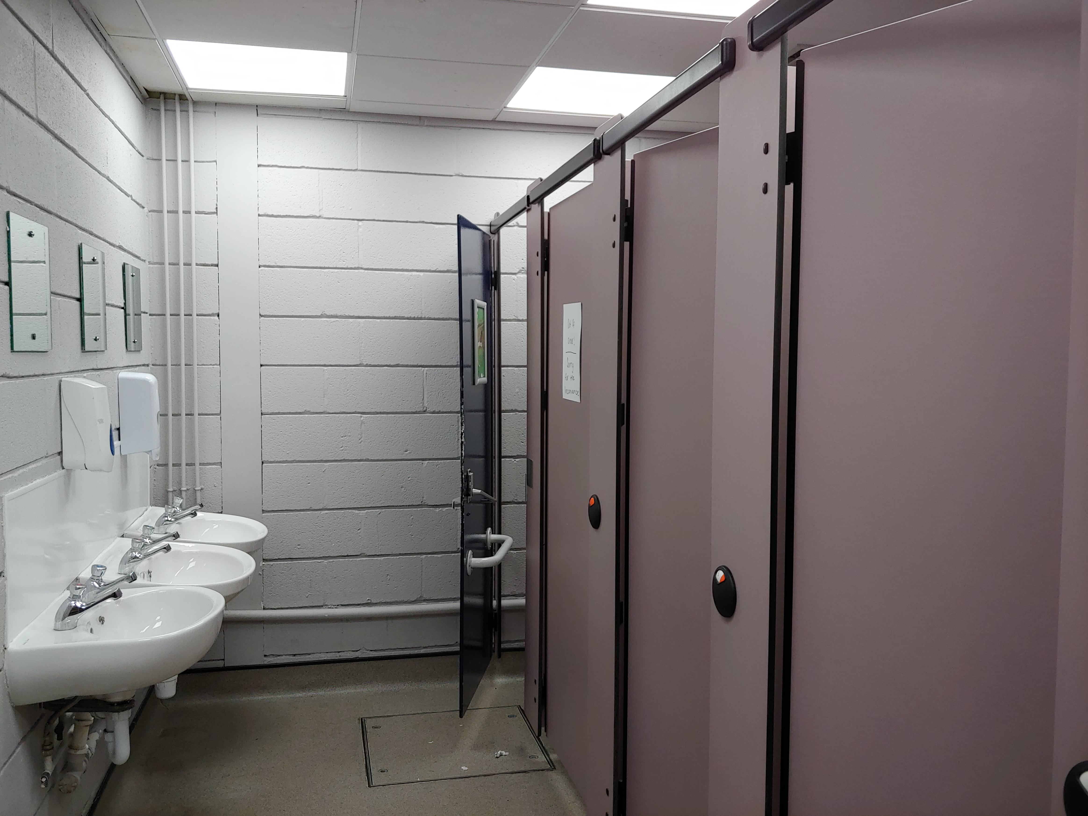
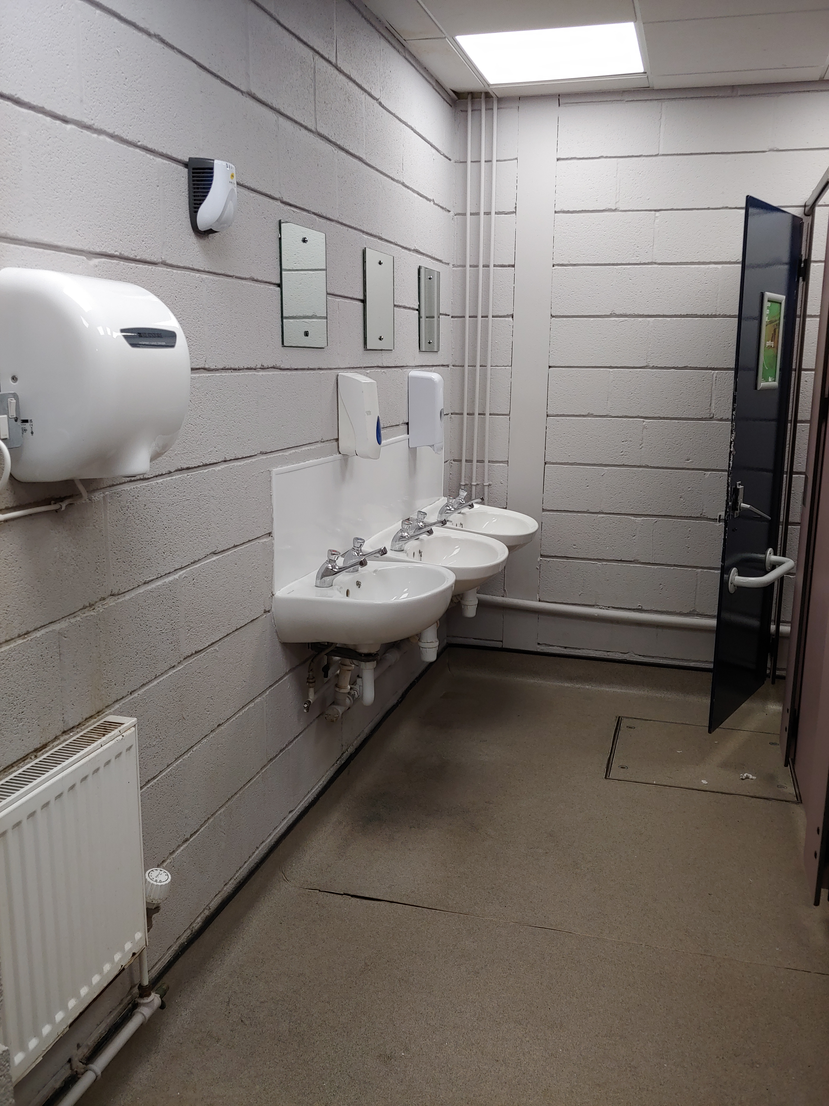

NB: This is listed as a separate item within the pricing schedule

2.9 Sport England AISF Requirements

Accessible and inclusive sports facilities | Sport England

- Completion of Works

  - On completion of all works, all surplus arising shall be removed, and the site left clean and tidy.
  - Repair any damage to the compound area and leave the site in an acceptable and agreed condition.
  - North Northamptonshire Council will not be responsible for any materials or equipment left on site during the refurbishment.
  - Complete all works as to the timeline identified in Table A on page 5.

Section 3: Supporting Information

- Please complete Section 3 below.

General Information
Question 1: |  | Scoring Methodology: | Question Answered? Yes/No
1.1. (a) | Full name of the Potential Supplier completing Information |  |  | Click to enter text.
1.1. (b) (i) | Registered office address |  |  | Click to enter text.
1.1 (b) (ii) | Registered website address |  |  | Click to enter text.
1.1. (c) (i) | Trading Status |  |  | Choose an item.
1.1. (c) (ii) | *If you selected ‘Other*’, please specify |  |  | Click to enter text.
1.1 (d) | Date of registration in country of origin |  |  | Click to enter date.
1.1. (e) | Company registration number |  |  | Click to enter text.
1.1. (f) | Charity registration number |  |  | Click to enter text.
1.1 (g) | Head Officer DUNS number |  |  | Click to enter text.
1.1 (h) | Registered VAT number |  |  | Click to enter text.
1.1 (i) | Trading name(s) that will be used if successful in this procurement. |  |  | Click to enter text.
1.1. (j) | Are you a Small, Medium or Micro Enterprise (SME)? |  |  | Click to enter text.
1.1 (k) | If applicable, details of immediate parent company |  |  | Click to enter text.
1.1 (l) | If applicable, details of ultimate parent company |  |  | Click to enter text.

Please Note: To avoid any unnecessary duplication for the Potential Supplier, by signing the Declaration at Question 2, you are also signing to confirm the following, as included in this RfQ Response, and all associated subsections therein contained:
- Section 5: Freedom of Information; and
- Section 6: Declaration.

Contact Details and Declaration
Question 2: |  | Scoring Methodology: | Question Answered? Yes/No
Potential Supplier contact details for enquiries about this RfQ Response.
2.1. (a) | Contact name
2.1. (b) | Name of organisation
2.1. (c) | Role in organisation
2.1. (d) | Phone number
2.1. (e) | E-mail address
2.1. (f) | Postal address  including postcode
2.1. (g) | Signature  electronic is acceptable
2.1. (h) | Date

Insurance
Question 3: |  | Scoring Methodology: | PASS/FAIL | Word Limit: |  | N/A
Please confirm that your organisation already has or is prepared to obtain the level of insurance cover prior to award of the contract? The levels of insurance cover are indicated below.
Important Note: Potential Suppliers who answer “No” to any of the levels below will be eliminated from this procurement process.
3.1. (a) | Employer’s (Compulsory) Liability Insurance at no less than £5m  It is a legal requirement that all companies hold Employer’s (Compulsory) Liability Insurance of £5 million as a minimum. Please note this requirement is not applicable to Sole Traders. |  |  |  | Choose an item.
3.1. (b) | Public Liability Insurance at no less than £5m |  |  |  | Choose an item.
3.1. (c) | Professional Indemnity Insurance at no less than £5m |  |  |  | Choose an item.
3.1. (d) | Product Liability Insurance at no less than £2m |  |  |  | Choose an item.

Requirements under Modern Slavery Act 2015
Question 4: |  | Scoring Methodology: | PASS/FAIL | Word Limit: |  | N/A
4.1. | The Council wants to ensure that within your business and its supply chain, there is no servitude or forced labour, slavery human trafficking, arranging or facilitating the travel of another person with a view that a person is being exploited or conducting any activities that contain violation of human rights.  Please confirm that your supply chain with regards to this RfQ Response complies with the Modern Slavery Act 2015?  Important Note: Potential Suppliers who answer “No” will be eliminated from this procurement process. |  |  |  | Choose an item.

UK General Data Protection Regulation (UK GDPR)
Question 5: |  | Scoring Methodology: | PASS/FAIL | Word Limit: |  | N/A
5.1. | The Council wants to ensure that within your business and/or in its supply chain, the processing of personal data and processes in relation to this contract are complaint with the requirements of the UK General Data Protection Regulations (UK GDPR) and Data Protection Act.  Please confirm that you and your supply chain with regards to this Mini Competition Response comply with all applicable data protection legislation including but not limited to the UK General Data Protection Regulations (UK GDPR) and Data Protection Act.  Important Note: Potential Suppliers who answer “No” will be eliminated from this procurement process. |  |  |  | Choose an item.

Social Value
Question 6: |  | Scoring Methodology: | PASS/FAIL | Word Limit: | N/A
6.1. | Having read the specification what community benefits, will your organisation provide as part of your proposal? Examples include but not be limited to:  - Sub-contracting locally;  - Improvements to the area covered by North Northamptonshire; and/or  - Use of apprenticeships.  Important Note: Where the Potential Supplier answers in such a way, as to avoid this requirement, but still provides an answer (e.g., “we are unable to offer any benefits as a part of this Contract”), they will be deemed to have not answered the question, which may lead them failing this question and being rejected from the process.
Answer:

Environmental Policy
Question 7: |  | Scoring Methodology: | PASS/FAIL | Word Limit: |  | N/A
7.1. | The Council wants to ensure that within your business and/or in its supply chain, that consideration has been given to the environmental impact of works i.e. whether you have a carbon neutral/net zero agenda for example.  Important Note: Potential Suppliers who answer “No” will be eliminated from this procurement process. |  |  |  | Choose an item.
Answer:

Project Specific Questions
Question 8: | Scoring Methodology: | 35% | Word Limit: | 1200
  - Please demonstrate how you plan to meet the requirements contained within the specification including a detailed Method Statement, describing how the works will be delivered, including a Works Management Plan detailing; site access, customer safety, and material deliver / storage / security. Including a materials specification and details of the products/fittings you propose to use.
  - You will need to include a timetable for the works that achieves completion within the timelines identified in 3.3 Table A and identifies the key stages involved based on the Councils order of preference:
(i) Changing Places Toilet with Shower
(ii) Changing Room Showers (male and female)
(iii) First Floor Toilets (male, female and disabled)
Answer:
Click to enter text.
Word Count: |  |  |  | Enter no.

Project Specific Questions
Question 9: | Scoring Methodology: | 10% | Word Limit: | 500 words
9.1 Please give brief details of the skills, experience, training and qualifications of the workforce and management that will carry out the refurbishment works.
Answer:
Click to enter text.
Word Count: |  |  |  | Enter no.

Durability and Maintenance
Question 10: | Scoring Methodology: | Information to support Question 8 | Word Limit: | 500 words
Please provide further information on the products/materials you plan to use in the refurbishment including service requirements for the Changing Places fittings.
Answer:
Click to enter text.

Section 4: Pricing Sheet

Pricing and Costs

  - Please complete the Pricing Schedule at Table E, below, ensuring that you have provided a fixed and firm cost in each of the relevant boxes.

  - All prices quoted must exclude VAT.

  - Should you be successful, your fixed cost for the contract must be included in your RfQ Response and any costs which are not included will not be met by the Council either before or during the contract.

  - Where the Council considers a price to be abnormally low, it may seek clarification and/or an explanation from the Potential Supplier, and the Council may reject any RfQ Response, at its absolute discretion, if it appears to be unreliable.

Table E – Pricing Schedule
Pricing Schedule
 | Scoring Methodology: 55%
 | Male, female and disabled toilets (first floor) | £
 | Male and female showers within changing rooms | £
 | Changing Places Room and fittings | £
 | Total Cost (A+B+C) | £
 | Female Toilets within changing rooms | £

*For use at the discretion of the Employer in the potential valuation of any variations

Section 5: Freedom of Information

- Information in relation to this RfQ may be made available on demand in accordance with the requirements of the Freedom of Information Act 2000 (“The Act”) and your organisation details will be disclosed and/or published where the expenditure is over £500, as per the Government Transparency agenda.

- Potential Suppliers must state if any of the information supplied by them is confidential and commercially sensitive or should not be disclosed in response for the Information under The Act. Potential Suppliers must state why they consider the information to be confidential or commercially sensitive.

- Note that inclusion below will not guarantee that the information will not be disclosed but will be examined in the light of the exemptions provided in The Act. Note that the Declaration for this Section has been completed and signed at Section 3, Question 2.1 (g) of this document.

Information/Document |  | Reference/Page No. | Reasons for Non-Disclosure | Duration of Confidentiality
 | Click to enter text. | Click to enter text. | Click to enter text. | Click to enter text.
 | Click to enter text. | Click to enter text. | Click to enter text. | Click to enter text.
 | Click to enter text. | Click to enter text. | Click to enter text. | Click to enter text.
 | Click to enter text. | Click to enter text. | Click to enter text. | Click to enter text.
 | Click to enter text. | Click to enter text. | Click to enter text. | Click to enter text.
 | Click to enter text. | Click to enter text. | Click to enter text. | Click to enter text.
 | Click to enter text. | Click to enter text. | Click to enter text. | Click to enter text.

Section 6: Declaration

- By signing Section 3, Question 2.1. (g) I hereby declare that:
  - I am signing on behalf of the Company named at Section 3, Question 1.1 (a) and am duly authorised to do so;
  - to the best of my knowledge, the information provided is complete and accurate;
  - the price in Section 4 is our best offer;
  - no collusion with other organisations has taken place in order to fix the price;
  - that there is no conflict of interest in relation to the Council’s requirement;
  - the requirement be subjected to the terms and conditions set out in Conditions of Contract identified at Appendix 4;
  - that no goods, supplies, services and/or works will be delivered or undertaken until both parties have executed the formal contract documentation and an instruction to proceed has been given by the Council in writing; and
  - I understand that the Council may reject my submission if there is a failure to answer all relevant questions fully or if I provide false and/or misleading information.

Section 7: Due Diligence

      - The Council will undertake its due diligence in advance of any contract award.

      - The preferred Potential Supplier(s) will not be awarded the Contract until the Council is satisfied with any further checks and due diligence it has carried out and these will need to be acceptable to the Council before a contract can be awarded. The Council reserves the right to disqualify any RfQ Response which is incomplete.

      - Due diligence may include credit checks in relation to the preferred Potential Supplier(s) (including each member of any consortium and of any key sub-contractor). This is important to the Council to ensure that any organisation who wishes to enter into a contract with the Council will be in a position to provide the goods, services and/or works on an ongoing basis as agreed within any contract. The Council works with external credit agencies to provide these financial checks.

      - The Council reserves the right to reject a Potential Supplier from the procurement process, where any findings from the Council’s due diligence reveal a serious concern or risk for the Council that cannot be remedied in a reasonable amount of time before award. Potential Suppliers are strongly encouraged to check and manage their financial score within the industry.

      - The Council reserves the right to revisit the responses provided to any questions at any time before award stage, where the Council believes there is a risk that responses might have changed. The Council reserves the right to disqualify any Potential Supplier who no longer meets the minimum criteria if it originally led to them continuing in the procurement process.

Section 8: Contract Award

        - The Council will notify all Potential Suppliers of its intention to award a contract.

        - This will include details of the:
    - Award criteria scores and feedback for the Potential Supplier receiving the notification; and
    - Name of the Successful Supplier(s).

- The following documents shall form part of the contract between the Council and the Successful Supplier(s):
    - Specification including completion timeline;
    - Terms and Conditions plus related Schedules (e.g., service levels, site plans, asset lists, contracts list, relevant policies, etc.);
    - Pricing Schedule (as completed by the Successful Supplier);
    - Response to requirements; and
    - A list of commercially sensitive information.

APPENDIX 1: Building Plans

APPENDIX 2: Asbestos Management Plan

APPENDIX 3: Photographs of in-situ facilities

APPENDIX 4: Conditions of Contract

Prelims to follow

