

**SCHEDULE 2**

**SERVICE SPECIFICATION**

**Proactive Intervention and Prevention Programme**

**Proactive Intervention Offer**

**This service specification applies to all Lots:**

|  |  |
| --- | --- |
| **Lot** | **Health and Wellbeing Partnership Area** |
| **1** | **Breckland** |
| **2** | **Broadland** |
| **3** | **Great Yarmouth** |
| **4** | **Kings Lynn and West Norfolk** |
| **5** | **North Norfolk** |
| **6** | **Norwich** |
| **7** | **South Norfolk** |

Contents

**1.** **Introduction** 3

**2.** **Delivery Model** 5

**3.** **Expected Outcomes** 7

**4.** **Performance Indicators, Monitoring and Evaluation** 11

1. **Introduction**

The Proactive Intervention approach is at the heart of how we are moving from a reactive to proactive approach, that supports residents closer to where they live in their community and prevents, reduces and delays demand for health and care. This approach is re-designing our prevention offer for our residents through three key steps:

1. Step 1: Identifying at risk individuals using different methods, including artificial intelligence technology, to proactively identify people who are at risk or in need of support
2. Step 2: Connecting with residents to understand their needs holistically, and then
3. Step 3: Intervening to mitigate the risk by offering interventions tailored to the person, to reduce that risk. **Step 3 is the focus of this procurement.**

The models below outline our approach to proactive intervention and prevention model, and the pathway an individual will follow through our Proactive Intervention and Prevention Offer

**Figure 1:**

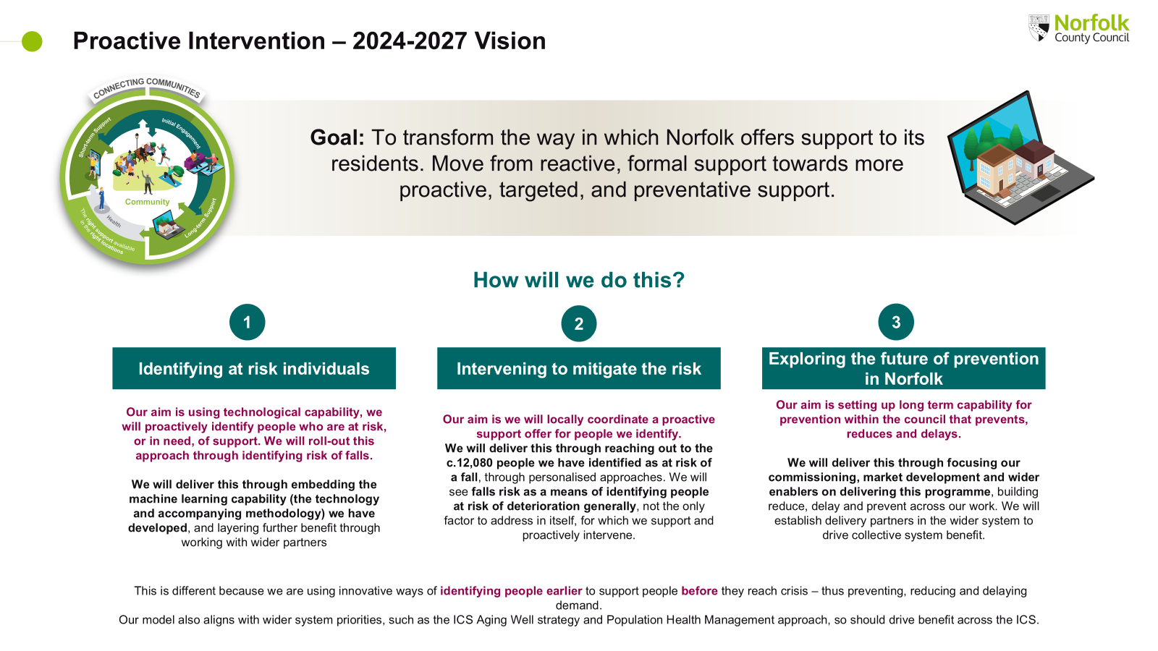

**Figure 2:**

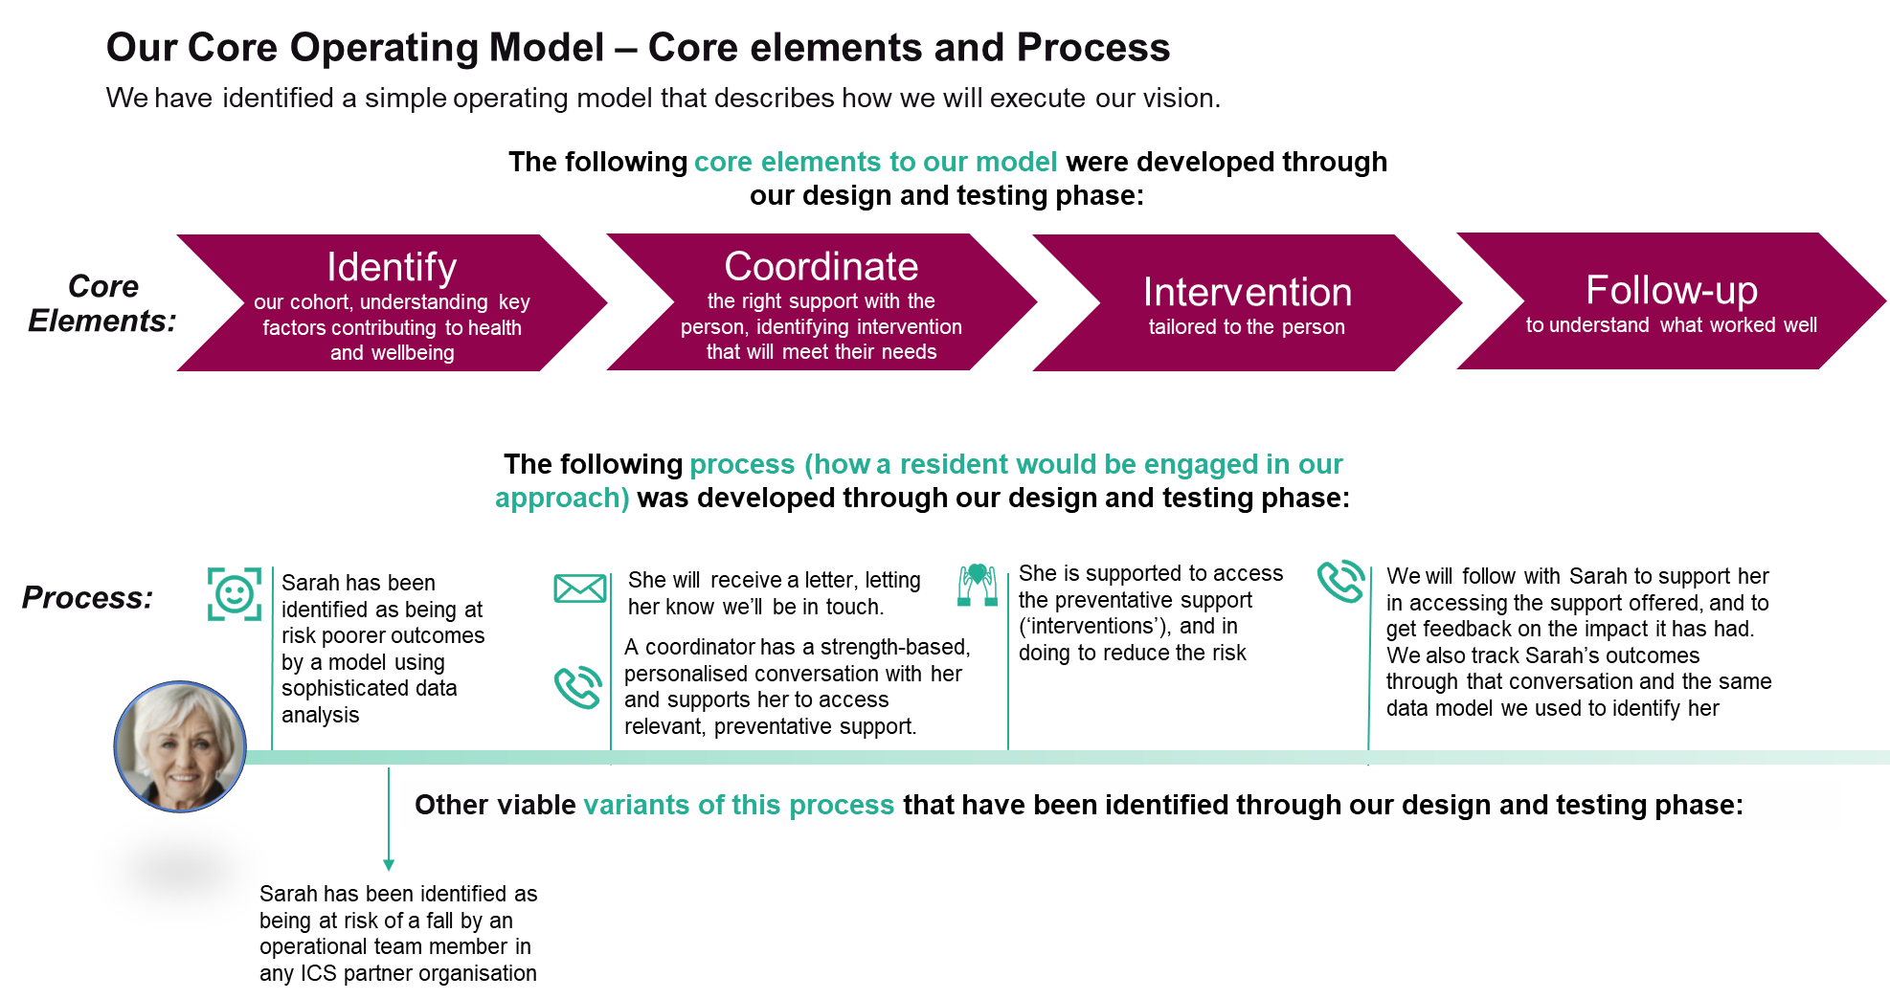

As part of the Proactive Intervention approach, we are seeking to embed a new commissioning approach that delivers the following fundamental shifts:

* From a traditional commissioner and service provider relationship towards a collaborative partnership;
* From system to community, with bespoke offers to be designed and delivered at a place level (within a Health and Wellbeing Partnership area, **see Appendix II for boundaries**);
* From single issue contracts and agreements towards a holistic offer based on the needs of individual people and the outcomes they wish to achieve.

To deliver these shifts, we are looking to work with providers who are:

* Human-focused: where action plans with residents are bespoke to individuals and based on their strengths;
* Learning-focused: where commissioners, providers and other partners work together to develop a culture of continuous learning to identify ways of working that will improve outcomes for residents;
* Community-focused: where providers work with other partners in their Place to maximise the use of assets in the community to deliver a holistic offer to local people that supports them to achieve their outcomes.

One of the core concepts that underpins the Proactive Intervention approach is the need to develop a place offer that enables us to better support people within their own neighbourhoods. It is important to note, one of the key concepts of sustainable, effective and meaningful community development is to build on the community assets that already exist. These might be community buildings, groups, parks and libraries.

We have shared a commissioning information pack to support the understanding of Place as part of the tender alongside the service specification as **Appendix II**.

1. **Delivery Model**

**Types of prevention**

1. **Primary prevention/promoting wellbeing**

* Aimed at individuals with no specific social care needs or symptoms of illness.
* Focuses on maintaining independence, good health, and promoting wellbeing.
* Examples: combating ageism; providing universal access to quality information; supporting safer neighbourhoods; and promoting healthy and active lifestyles.

1. **Secondary prevention**

* Identifies individuals at risk to interrupt or slow down deterioration and improve their current situation.
* Examples: screening and case finding for health conditions (e.g., strokes, falls); or low-level social care needs.

1. **Tertiary prevention**

* Minimises disability or deterioration from established health conditions or complex social care needs.
* Focuses on maximising independence through rehabilitation/reablement services and joint case management.
* Examples: Specialist OT reablement services

**Proactive Intervention approach**

The Proactive Intervention approach is primarily focused on delivering secondary prevention. The aim of this offer is to provide targeted, outcome-focused support to individuals identified as being at risk of falling, where this risk indicates they may benefit from proactive support to remain independent at home. The target group for this intervention includes individuals aged 50+ residing within the specified Health and Wellbeing Partnership area (on occasion younger people may be supported through this offer, where suitable). The Provider should plan to support approximately 800 people per year (per Health and Wellbeing Partnership) and must ensure they have the capacity to enable this.

**Collaboration and entry routes**

Norfolk County Council, the Provider, and local partners will work together to determine entry routes into the service. The expectation is that a holistic conversation will have been completed with people ahead of a referral to the Provider. These conversations are likely to take place through local District, City or Borough Council Hubs and, as such, the Provider will be expected to work closely with partners as part of these infrastructures.

**Intervention plans**

Factors that increase the risk of falls , that interventions should address (to deliver the outcomes) include:

1. Aging Well, including strength and mobility training, physical exercise and movement;
2. Social connection, including participation in local community groups;
3. Information and advice to support aging well, including managing money and accessing services.

The Provider will collaborate with the individual to develop a bespoke Intervention Plan, which includes evidence-based solutions to reduce the risk of falling and support the achievement of wider outcomes meaningful to the individual and their friends, family and carers.

Solutions should be developed based on evidence of impact and tailored to address the person’s specific needs and risk factors. Key evidence bases for intervention design include:

* **Norfolk Joint Strategic Needs Assessments (JSNA)**, particularly relating to social isolation and loneliness and falls prevention:  <https://www.norfolkinsight.org.uk/jsna/>
* **National Institute of Clinical Excellence (NICE) Guidance** on falls prevention:  <https://www.nice.org.uk/guidance/qs86>
* **Human Learning Systems:** [Human Learning Systems](https://www.humanlearning.systems/)

For example, strength and mobility training should be offered in cases where the person has a history of recurrent falls and/or balance and gait deficits.

**Wider interventions**

The Provider is not expected to directly deliver any clinical interventions as part of this offer (such as medical or surgical actions). However, the Provider should work with local District, Borough or City Council Hubs and other partners/structures to facilitate access to Health, Social Care, District Council and other services where support from these partners is identified as key to meeting the outcomes captured as part of the Intervention Plan. Examples of interventions to be provided by partners could include:

* Vision assessment and referral.
* Medication review with modification/withdrawal.

**Community resources and support**

Solutions should be based on awareness of the assets in their community (assets being services, opportunities and wider resources, and skills and experience available to people in their community). The Provider will promote and utilise current and emerging assets, resources, and initiatives to help individuals achieve positive outcomes. Support may cover essential needs such as food, utilities, and emergency expenses, as well as alleviate financial and emotional distress through grants, community programmes, micro-grants, local initiatives, and preventative health measures. Examples include the housing support fund as well as services funded by Public Health: [www.norfolk.gov.uk/article/42480/Healthy-fulfilling-independent-lives](https://www.norfolk.gov.uk/article/42480/Healthy-fulfilling-independent-lives).

Where no suitable services exist, the Provider should work with the person to develop a bespoke offer, and capture learning to inform opportunities for innovation and improvement to address that.

**Service duration and monitoring**

While there is no fixed length of service, interventions should be short-term with the aim of supporting the person to develop the strengths, knowledge, and confidence to access assets within their local community. Providers will help to coordinate support for people, facilitating access to other services, as mentioned above. Outcomes should be monitored regularly through the support process and follow-up sessions (e.g. at 3-, 6- and 12-months) following completion of the Intervention Plan will form a key part of the ongoing learning and evaluation process.

**Compliance and alignment to local strategies**

Local Authorities have several key responsibilities under the Care Act 2014, including promoting wellbeing, preventing the need for care and support, promoting integration, cooperating with other agencies, and safeguarding adults at risk. These responsibilities aim to create a supportive, empowering, and enabling social care system. Any intervention provided as part of this offer should be in accordance with the Care Act 2014. More broadly, the model should align with Norfolk and Waveney Integrated Care System wider priorities, such as:

* Ageing Well Strategic Framework:

[Norfolk and Waveney Integrated Care System (ICS) Ageing Well Strategic Framework (Draft V2.3)](https://improvinglivesnw.org.uk/~documents/route%3A/download/998/)

* The Health Inequalities Strategy Framework:

[Norfolk and Waveney Health Inequalities Strategic Framework](https://improvinglivesnw.org.uk/~documents/route%3A/download/1074/)

* Population Health Management Strategy 2024 – 2029:

[Population Health Management Strategy - final designed version.pdf](https://improvinglivesnw.org.uk/~documents/route%3A/download/1036/)

**Partnerships and engagement**

The Provider should foster positive relationships across the ICS, working in close partnership with the NHS, Local Authorities, and a range of VCFSE and micro providers to deliver accessible and inclusive provision. The Provider will engage with a wide range of communities, including those who are marginalised or face barriers accessing services. To do this effectively, the Provider will develop targeted engagement strategies that are tailored to the specific needs and characteristics of the individuals they are supporting. This should include approaches to continuous learning, which takes partners, communities and peoples experience to deliver a continuous process of learning and adaptation.

**Team skills and training**

The Provider should ensure that their teams (both paid staff and volunteers) have the right skills and experience to complete person-centred planning and support. This should include appreciative enquiry/relational practice techniques to maximise opportunities to understand the needs of an individual.

Access is also available to the Council’s ‘Making Every Conversation Count’ and ‘Appropriate Behaviour Change’ e-learning, and providers should ensure they make provision for their team to take the opportunity offered to engage in this essential training. Details of free training available can be found here: [https://healthydialogues.co.uk/offering/ready-to-change/](https://eur02.safelinks.protection.outlook.com/?url=https%3A%2F%2Fhealthydialogues.co.uk%2Foffering%2Fready-to-change%2F&data=05%7C02%7Ctricia.guinn%40norfolk.gov.uk%7C728914bb5df148fc9ab208dd5b25d4bc%7C1419177e57e04f0faff0fd61b549d10e%7C0%7C0%7C638766940229196587%7CUnknown%7CTWFpbGZsb3d8eyJFbXB0eU1hcGkiOnRydWUsIlYiOiIwLjAuMDAwMCIsIlAiOiJXaW4zMiIsIkFOIjoiTWFpbCIsIldUIjoyfQ%3D%3D%7C0%7C%7C%7C&sdata=%2BIgV34VkdmPudlj%2B4t8IC3ZK%2F4oWJKLvnGkoLhlnrP0%3D&reserved=0)

1. **Expected Outcomes**

**Expected outcomes**

This offer should seek to reduce barriers, instil confidence, and provide toolkits and skills for people, which positively impacts people’s lives, to reduce, delay and prevent the need for social care.

**For the person**

Everyone will have their own specific aspirations to be achieved from this commissioned offer, and this offer should meet those aspirations when other community opportunities cannot. The experience of the offer will be impactful on the person, and we want people to say:

* **“I feel empowered to manage my health and wellbeing, know how to seek help when required, and have the skills to support my decision-making choices that enhance my health and wellbeing”.**
* “**I feel stronger and can move more easily. I now have confidence in getting out and about in the community**”.
* “**I feel enabled to be part of my community, knowing how to access groups that share interests that are important to me**”.
* “**I feel the barriers I had to opportunities to connect with others and build meaningful relationships have reduced**”.
* “**I am confident in how I can seek advice and information if I am struggling with debt, benefits or financial challenges**”.
* **“I have met my goals that I was able to set myself”**

**For the community**

* The Provider is well respected amongst the people in contact with the offer, the wider community and stakeholders.
* The Provider has emersed themselves in the local community assets and infrastructures available to deliver the commissioned offer and support the wider delivering of the operating model.

**For the team (workforce and volunteers)**

* Team members feel valued, motivated and well equipped to deliver the offer.
* Team members feel empowered and valued to shape interventions and service delivery, part of continuous learning that develops and improves the offer.

**For the Integrated Care System**

* The offer is effective: we are delivering what is important to individuals to meet their outcomes
* The offer is efficient: the team can do the right thing to meet a person’s outcomes
* The offer is sustainable: we see sustainable usage that is preventing, reducing or delaying use of health and social care

**How we will do this together.**

1. **Regular learning and review sessions**
   * Regular learning and review sessions with the Provider of the service that explores the impact of the offer at a person- and community-level and potential for change and adaption to improve delivery and outcomes.
2. **Independent feedback and learning cycle**
   * Independent feedback and learning cycle as part of a wider evaluation of the Proactive Intervention Offer.
3. **Positive relationships with community partners and stakeholders**
   * Positive relationships with community partners and stakeholders to help ensure we remain focused on the shared ambition of putting the person first.
4. **Provider integration in community infrastructures**
   * The Provider has integrated themselves in local community assets and infrastructures available to deliver the commissioned offer and support the wider delivery of the operating model.
5. **Relevant memberships and network opportunities**
   * Ensure relevant memberships and network opportunities are established and and meaningful value to the interventions and Proactive Intervention and Prevention Model.

**What good looks like (this will form performance, learning etc.)**

To ensure the success of the Proactive Intervention approach, it is essential to define what good looks like. This will guide our shared approach to learning, performance metrics and continuous improvement efforts. Good outcomes are characterised by people feeling empowered, supported, and connected within their communities. The interventions should lead to measurable improvements in health and wellbeing, social connections, and financial stability. By regularly reviewing and adapting the approach based on feedback and outcomes, the aim is to create a positive and lasting impact on the lives of those served.

**What we think good looks like**

|  |  |
| --- | --- |
| **For the:** | **Success looks like:** |
| **Person** | The person has met the goals as defined by themselves  Outcomes of (all) specific strength and mobility training demonstrates positive impact.  Where applicable, people make their own long-term plan to continue aging well (e.g. join a walking group).   Evidence that people are enabled to access relevant additional support and toolkits to unlock opportunities: e.g. financial enablers like grants, benefits, Public Health and District, Borough and City Council initiatives to support long a long-term plan to continuing aging well. |
| **Community** | Positive relationships with community partners and stakeholders to help ensure we remain focused on the shared ambition of putting the person first.  The Provider is recognised as a key enabler of community resilience within Health and Wellbeing Partnerships. |
| **Team** | Team members have adequate training and guidance.  Team Members feel they have a voice.  Team retention rates are positive.  Volunteer numbers increase. |
| **System** | Everyone referred to this offer will be contacted within 3 working days by the Provider.  A person will only need to provide information once during their intervention plan.  The average length to complete an intervention plan is 12 weeks.  We see a reduction in requests for formal social care services and a move to community first approach. |

Further details of how performance will be monitored, evaluated and reported are provided in Section 4.

1. **Performance Indicators, Monitoring and Evaluation**

It is crucial to develop a trusted, collaborative relationship to deliver this offer and create a ‘commissioning for learning’ environment that embodies this approach. Sharing data and insight regularly is essential to assess how this offer aligns with our model, key principles, and values as an ICS, and how it supports people in achieving their aspirations.

The Proactive Intervention approach is designed to reduce, delay, and prevent the need for adult social care. Whilst achieving these goals, the approach is also expected to enhance broader outcomes for people and contribute to the transformation of collaborative efforts within the ICS.

Working in partnership with place partners, including the Health and Wellbeing Partnerships, we will develop shared, consistent, practical, and robust methods to record and collect information and data. Measures will be proportionate and will utilise a test-and-learn approach to continuously improving the effectiveness of feedback collection.

We will agree on detailed measures with the Provider within the first 8 weeks of mobilisation. Year one measures will be established during this period. The Provider, commissioner, and partners at place (including the Health and Wellbeing Partnerships) will work collaboratively to develop and revise these measures through continuous learning and evaluation throughout the course of the contract, as necessary.

The Provider must demonstrate clear evidence that it has used outcomes, data, and information on user demographics to design and deliver its offer. Additionally, the Provider must evaluate the impact of services to assess their effectiveness and quality, enabling services to evolve and plan for future needs.

**Areas of focus and performance measures**

1. **Area of focus: individual outcomes**

**Why is this important?**

* This offer is designed to deliver outcomes. We need to understand the impact it has at Place and identify areas of learning and change, as necessary.
* We will agree with the Provider the tools to establish this and review and evaluate on a regular basis. Dialogue+ is an example of a nationally recognised means of understanding impact on people: [DIALOG+ | East London NHS Foundation Trust](https://www.elft.nhs.uk/dialog)

We would agree on the tool during mobilisation.

**Suggested measures:**

* 80% of people receive initial contact within 3 working days: we believe the rate of uptake of interventions increases with prompt contact following the holistic conversation.
* 90% of people agree on an Intervention Plan: the model involves a holistic conversation prior to this commissioned offer, so uptake of a plan should be high. If this is not the case, we would need to reassess the model for learning promptly.
* People feel that they have had a prompt response from the Provider.

1. **Area of focus: The journey and model**

**Why is this important?**

* We need a way to evaluate the uptake of this offer and how it is being used to support the principle of ‘commission for learning’. It is also essential to capture relevant demographic information for Equality Impact Assessments (EQIAs) for the contract.
* We are accountable for delivering a Proactive Intervention approach, and this information will support this and our role in adding social value to the community.

**Suggested measures:**

* Service usage and follow-up: number of people supported, duration of service usage, and participation in follow-up conversations.
* Outcomes and referrals: completion and outcomes of plans, and referrals to other interventions and community assets.
* Demographic and community impact: demographic data for EQIA analysis, and community developments resulting from the offer.

1. **Area of focus: cost of delivering service – finance, efficiencies, and social value impact**

**Why is this important?**

* It is important to understand how the funding is spent for any commissioned service. For this offer, this information will be used to indicate how we promote value for money opportunities and support the development of any growth.
* We also need to know that an offer is optimised and as efficient as possible and having a positive impact on the community.

**Suggested measures:**

* Examples of process improvement based on data/feedback on the offer.
* Demonstrable evidence of capacity to support 800 people per year (per Health and Wellbeing Partnership) with interventions.
* Demonstration of adding social value (social, economic and environmental benefits) to the community at Place.

Appendix I sets out in more detail an example of a three-year monitoring, evaluation, and reporting framework, which will guide our performance benchmarks and ensure continuous improvement.

**Consortia arrangements.**

If the Provider is delivering through consortia arrangements, the lead provider will be responsible for the overall delivery of the interventions, agreed performance measures, and implementing agreed improvements. The lead provider should collate all measures as a central point of contact and take responsibility for ensuring each member of the consortium fulfils reporting and monitoring requirements, attends feedback sessions, and meets their legal obligations (e.g., GDPR).

Additionally, the lead provider will oversee the performance management of the consortium, ensuring that all members adhere to agreed standards and contribute to the continuous improvement of the interventions. The lead provider will also ensure that the consortium operates cohesively, with clear communication and collaboration among all parties to achieve the desired outcomes.

1. **Future Development**

We expect the Provider will play a key role in future development of the offer, using their learning from providing interventions and supporting community members, to propose ways the offer can become more impactful, efficient and effective. Regular learning and review sessions with local partners will create an environment of continuous learning and development.

Service design should account for the following changes throughout the contract duration:

1. Funding level adjustments: changes in funding from various partners, which may include any from across the ICS. This could include:
   1. If additional funding becomes available to support admission avoidance and hospital discharge, there could be an increase in funding to support an increase in the numbers of people supported by this intervention and referrals received by teams working in these areas.
   2. To support the ICS prevention agenda funding, may be made available from one or more partners (e.g. ICB, District, Borough or City Council, Adult Social Services) to request general increase in the capacity of the service or focused development to support areas of deprivation and inequality.
2. Referral route modifications: updates to referral pathways into the service, potentially including hospital discharges, social care, district council, VCFSE referrals, and self-referrals.
3. Partner collaboration: enhanced collaboration with partners to ensure the provision of appropriate interventions.
4. Service delivery for other organisations: there may be instances where additional capacity is commissioned on behalf of another ICS partner.
5. The boundaries of the Health and Wellbeing Partnerships may change, and services and funding may need to be revised.
6. To support the service development, continuous learning and reflective practice of this offer and the proactive intervention and prevention model, the way in which the offer and specific services are delivered may be subject to change.

When substantial changes to service policies or functions take place, the Provider is required to perform EQIAs to assess the potential impacts on the community and report the findings to the Local Authority.