**Essex County Council**

**Master Bidder Guidance**

**E005PA Internal Audit Specialists Framework**

**Version PA23 2.2**

**07/10/2025**



**Document Control Page**

|  |  |  |
| --- | --- | --- |
| **Version** | **Date** | **Comments** |
| 0.1 | 20/2/25 | Initial Draft |
| 1.0 | 20/2/25 | Final Draft for Publication |
| 2.0 | 7/3/25 | Reformatting of the Document |
| 2.1 | 11/3/25 | Adding additional cross-references to the PA23 Playbook & making it clearer that all procurement documentation must be published at the start of a sourcing project. |
| 2.2 | 8/4/25 | Minor Updates – Procurement Specific Questionnaire, addition of Standstill to example timetable, typo on scoring tables covering text. |

# PART ONE – GENERAL INSTRUCTIONS AND GUIDANCE

1. Essex County Council (**the Authority**) invites tenders for the provision of the requirement. Bidders should make themselves fully aware of the content of these General Instructions and Guidance, together with any other information/instructions issued by the Authority during this procurement exercise.
2. This procurement is covered by the Procurement Act 2023 and Procurement Regulations 2024 using the Open procedure.
3. The estimated timetable for the award of a contract is as follows:

Invitation to Tender (ITT) Issued 07/10/2025

ITT Clarification Deadline 21/10/2025

ITT Submission Deadline 06/11/2025

Preferred bidders shortlisted 20/11/2025

Standstill 21/11 – 03/12/2025

Contract Preparation 21/11/2025

Contract Signature 05/12/2025

The Authority will not be bound by this timetable if extensive bid clarification is required during evaluation.

1. All communications, enquiries, questions or requests for clarification by Bidders should be addressed in writing using the secure messaging system in the e-Sender Tool. Bidders should note that the Authority will not respond to any enquiry, question or request not submitted in this manner.
2. Bidders should be aware that where a clarification has a fundamental and/or material impact on the procurement, that the clarification and the Authority’s response will be circulated to all bidders. Any bidder who considers their clarification to be confidential must indicate this in writing to the Authority when submitting that clarification. The Authority will consider the Bidder’s written position into consideration when deciding whether to release the clarification and the Authority’s response to all bidders.
3. Any Bidder who directly or indirectly canvasses any member or officer of the Authority concerning this procurement or the award of any contract pursuant to this procurement, or who directly or indirectly obtains or attempts to obtain information from any such member or officer concerning any other public procurement will be disqualified.
4. It is the responsibility of Bidders to obtain for themselves, at their own expense, all information necessary for the preparation of their tenders. Information supplied by the Authority (whether in the PSQ/ITT or otherwise) is supplied for general guidance in the preparation of the tenders. Bidders must satisfy themselves, by their own investigations, regarding the accuracy of any such information and no responsibility is accepted by the Authority for any inaccurate information obtained by Bidders.
5. All information supplied by the Authority in connection with this ITT (including PSQ) shall be regarded as confidential by the Bidder except that such information may be disclosed for the purpose of obtaining sureties and quotations necessary for the preparation of the tender.
6. No servant or agent of the Authority has authority to vary or waive any part of the ITT (including PSQ) other than the Authorised Officer nominated by the Authority who shall only do so in writing.
7. The Bidder shall be deemed to have satisfied themselves before submitting their ITT (including PSQ) as to the correctness of the responses stated by themselves (including rates and prices where relevant) in the submission, which shall (except insofar as is otherwise provided in the Contract) cover all their obligations under the Contract. Please note that where a bidder response is evaluated as a ‘fail’, the Authority reserves the right to exclude the entire bid from the process.
8. All rates and prices quoted must exclude Value Added Tax.
9. All rates and prices quoted must be in sterling.
10. The submission must be fully completed and be accompanied by all requested supporting information. Any submission containing gaps or omissions are likely to be rejected. Any submission containing information which has not been requested is likely to be rejected.
11. Bidders must comply with the limit to the number of words or pages stated. For submissions that exceed the word/page limit the information provided beyond the limit will not be evaluated. Bidders are advised that they should not incorporate embedded documents or URL links in their response unless specifically requested to do so. Inclusion of an embedded document or URL when not requested may result in your submission being rejected.
12. Tenders must be for the supply of the whole of the services upon the terms of the Contract. Tenders for part or parts only of the service or for different standards or frequencies of service or made subject to alternative or additional terms or conditions may be rejected or may be rejected for the reasons of such alterations or additions only.
13. Any document requiring a signature must be signed:
    * 1. where the Bidder is an individual by the individual,
      2. where the Bidder is a partnership, by two duly authorised partners,
      3. Where the Bidder is a company, by two Directors or by a Director and the Secretary of the Company, such persons being duly authorised for that purpose.
14. In addition to any more specific obligations imposed by the terms of the Contract, Bidders must satisfy the Authority of their ability to provide the service set out in the Contract.
15. Every submission received by the Authority shall be deemed to have been made subject to the terms and conditions of the Contract unless the Authority previously, expressly, agreed in writing to the contrary. Any alternative terms or conditions (which must be submitted on a separate form) offered on behalf of the Bidder shall, if inconsistent with the terms and conditions of the Contract, be deemed to have been rejected by the Authority unless expressly accepted in writing.
16. Your ITT (including PSQ) submission must be submitted to the Authority electronically by publishing through this ITT (including PSQ) **DN789700 E005PA Internal Audit Specialist Framework** at <https://procontract.due-north.com/Login>
    * Not later than 16:00 (Noon) hours on 06/11/2025.
    * It is the Authority’s policy to reject any tenders received after the above deadline.
17. Do not attempt to edit your response after the deadline has passed. Should you do this your submission will be considered late and will be rejected.
18. The Authority will not consider individual requests for extensions to the closing date and the time specified in above but may at its own absolute discretion extend generally the closing date and time. Where the Authority extends that deadline it will notify all Bidders in writing via a message in the e-Sender system.
19. The Bidder is expected to keep his ITT (including PSQ) submission valid for acceptance for a period of 120 days from the closing date specified above.
20. The Authority is not bound to accept the lowest or any tender. The tender assessment process will be conducted fairly in accordance with the published assessment criteria to ascertain the most advantageous tender.
21. The Authority reserves the right to amend, modify or withdraw the tender. The Authority reserves the right to accept or reject all or part of the Bidder proposal. Submission of a bid does not create a contract or any expectation by the Bidder of a future business relationship. Rather, by submitting a bid, you are making a firm offer which the Authority may accept to form a contract.

The Authority is not liable for any costs incurred by the Bidder in the preparation, presentation, or any other aspect of the Bidder's bid. The Authority will not reimburse any expense incurred by you in preparing your bid. Bidders take part in this tender entirely at their own risk and cost.

Except to the extent the Authority allows a non-binding bid, all Bids which Bidders submit are legally valid quotations without qualification, except for data entry errors.

1. Not Used
2. Please note that all response attachments must be in Arial 11 font in Microsoft Word, with standard margins (2.54cm top and bottom margins 3.17cm left and right margins) and formatted for printing onto A4 paper. Any submission response not complying with the stated format and specified page limit(s) may be excluded from the tender process. Any internet link included within any responses must comply with the specified response requirements. Bidders are advised that they should not incorporate embedded documents, pictures, diagrams, charts or URL links in their response unless specifically requested to do so. Failure to do so may result in your submission being rejected.
3. Please find below the details regarding the weightings for the assessment of this requirement:

**Invitation To Tender (ITT)**

**ITT Weightings:**

**Technical Response: 70%**

**Commercial Response: 30%**

**Technical Response**

|  |  |  |  |  |
| --- | --- | --- | --- | --- |
| **Question** | **Max Score (0-5)** | **Max**  **Question Weighting**  **(%)** | | **Max Section Weighting**  **(%)** |
| 1. **Internal Audit Charter** | Pass/Fail | | |  |
| 1. **Understanding of an Assignment** | 5 | | 25 | 70 |
| 1. **Relevant Experience** | 5 | | 25 |
| 1. **Resourcing and Availability** | 5 | | 25 |
| 1. **Quality Assurance** | 5 | | 20 |
| 1. **Added Value** | 5 | | 5 |
| **Total question weighting** | 25 | | 100 |

**For example.**

|  |  |  |  |  |
| --- | --- | --- | --- | --- |
| Question | Score | Question Weighting  (%) | | Weighted Score |
| 1. Internal Audit Charter | Pass/Fail | | |  |
| 1. Understanding of an Assignment | 4 | | 25 | 1.0 |
| 1. Relevant Experience | 3 | | 25 | 0.75 |
| 1. Resourcing and Availability | 3 | | 25 | 0.75 |
| 1. Quality Assurance | 4 | | 20 | 0.8 |
| 1. Added Value | 3 | | 5 | 0.15 |
| Total Score | 17 | | - | 3.45 |
| Final Score | | | | | | |
| To allocate a score out of 70, the total weighted score is multiplied by 14.  For example, 3.45 x 14 = 48.3 | | | | | | |

**Commercial**

|  |  |  |  |  |  |  |  |  |  |  |  |  |  |  |  |  |  |  |  |  |  |  |  |  |  |
| --- | --- | --- | --- | --- | --- | --- | --- | --- | --- | --- | --- | --- | --- | --- | --- | --- | --- | --- | --- | --- | --- | --- | --- | --- | --- |
| **Pricing Schedule**  Bidders are required to complete and submit a full Pricing Matrix demonstrating their costs associated with delivering the requirement as set out in the Pricing Matrix.  The Authority states that:   * As set out in the Procurement Act 2023 & Procurement Regulations 2024 an abnormally low bid may be rejected. * The Pricing Schedule provided at ITT must be completed fully. If not completed and returned as part of the tender response the Authority reserves the right to exclude the bid.   The prices and/or rates stated in this commercial section constitute the only reimbursement and profit to the company for providing the services/works which are the subject of this agreement.  The prices are deemed to cover all costs, expenses and profit incurred directly or indirectly by the Supplier in providing the services.  All rates and prices quoted in this section must be in pounds sterling and exclusive of VAT.  **Tied Bids**  In the event of two or more bids attracting the same overall score, the contract will be awarded to the bidder that achieved the highest total score in the technical response following assessment.  Where scores for the technical element of the tender are tied between one or more bidders, the technical questions will be ranked in order of their weighting and the score awarded to each bidder will be compared. The bidder with the highest score on the question at the top of the list will be awarded the contract; where the scores are the same for this question, we will move sequentially down the list comparing scores until a winner is identified.  The order for the assessment of the questions will be decided by the weighted score of the question (highest first), for example:  Question 5.1                    Service Delivery     25%  Question 5.4                    Working Safely       10%  Question 5.5                    Service Demand for Lot 1, 2 and 3 / Methodology Lot 4 15%  Question 5.3                    Outcomes 10%    Worked Example Scoring for Tied Bids:   |  |  |  |  |  | | --- | --- | --- | --- | --- | | Question | Scoring Methodology | Bidder 1 | Bidder 2 | Highest Score | | 5.1 | Table A | 3 | 3 | Tie | | 5.4 | Table A | 4 | 4 | Tie | | 5.5 | Table A | 4 | 3 | Bid 1 | | 5.3 | Table A | 3 | 4 | Bid 2 |   In this case Bid 1 would be awarded the contract as a result of scoring more highly on question 5.5 which was ranked as the third most important question. As the scores remained tied for the first two questions, the third question was then used to break the tie. Whilst Bidder 2 scored higher on question 5.3 this would not have an impact as Bidder 1 has scored more highly on the prior question. |

1. Not Used
2. Not used
3. Please refer to the Assessment Spreadsheet uploaded as part of this tender to see the evaluation criteria and methodology for each PSQ and ITT question.

# PART TWO – PART A BIDDER PSQ GUIDANCE

### Introduction

This Procurement Specific Questionnaire (PSQ) has been issued by the Authority in connection with a competitive procurement conducted under the Procurement Act 2023 & Procurement Regulations 2024.

Please note that the Authority can only accept one bid per organisation/contracting entity.

Should a Bidder have any questions or clarifications regarding the PSQ they must raise them via the messaging facility on the e-Sender Tool. Any questions or clarifications raised, and the response to the same, will be shared with all Bidders unless they are marked as commercially confidential, and the Authority agrees this to be the case.

### Introduction

This Procurement Specific Questionnaire (PSQ) and Invitation to Tender (ITT) have been issued by the Authority in connection with a competitive procurement conducted under the Procurement Act 2023 & Procurement Regulations 2024.

Please note that the Authority can only accept one bid per organisation/contracting entity.

Should a Bidder have any questions or clarifications regarding the PSQ & ITT they must raise them via the messaging facility on the e-Sender Tool. Any questions or clarifications raised, and the response to the same, will be shared with all Bidders unless they are marked as commercially confidential, and the Authority agrees this to be the case.

The last date for questions to be asked is 21/10/2025. Questions asked after this date will be responded to at the discretion of the Authority.

Bidders are required to answer all questions in the format specified.

Please note that where a bidder response is assessed as a ‘fail’, the Authority reserves the right to exclude the entire bid from the process.

### Guidance to completing the PSQ

The Procurement Specific Questionnaire (PSQ) is designed to assess the suitability of a Supplier to deliver the Authority’s contract requirements.

The PSQ is structured in 3 separate parts:

**Part 1** – Preliminary Questions & Supplier Information

**Part 2** -- Exclusions and Debarment, Associated Persons and Sub-Contractors.

**Part 3** – PSQ Questions including Conditions of Participation

### Part 1 – Preliminary Questions & Supplier Information

Bidders must answer the Preliminary Questions and provide a PDF download of their up-to-date Core Supplier Information from the CDP and attach this as part of their submission.

The Preliminary Questions part of this section of the PSQ asks the Bidder to confirm their name, their unique identifier from registering on the Central Digital Platform, if they are on the Debarment List, their bidding model and which Lots they will be bidding for (if applicable). All of these questions are for information and not scored, except for the Debarment question, which is a manual Pass/Fail.

Bidders who are on the Debarment List will Fail.

The Core Supplier Information part of this section of the PSQ requires the Bidder to confirm that they have attached a copy of their up-to-date information from the CDP. This information will be checked by the Buyer to confirm if the Bidder or their Connected Persons are subject to any Exclusions.

**Part 2 - Exclusions and Debarment**, **Associated Persons and Sub-Contractors**

Bidders must provide additional exclusions information for any suppliers that they are relying on to meet the procurement’s Conditions of Participation (Associated Persons).

Bidders must also provide an exhaustive list of all their intended sub-contractors, which will be checked against the Debarment List.

**Part 3 – PSQ Questions including** **Conditions of Participation**

Some of the information requested in this section of the PSQ will be for Conditions of Participation, other information requested may be assessed or for information purposes only.

The questions relating to Conditions of Participation are clearly marked as such, and Bidders must pass these requirements to be able to be awarded the resulting contract.

**Insurance**

The ITT will outline the insurance requirements applicable for the procurement exercise. If a Bidder answers ‘Yes’ or ‘Willing to Obtain’ it is likely that ECC will require evidence of the insurance cover at an appropriate stage during the procurement exercise, and prior to contract award.

Employer’s Liability Insurance is a legal requirement (except for businesses employing only the owner / close family members). If a Bidder believes that they fall into this category they must answer the question and provide further details justifying the exemption.

The questions in this section are mandatory Pass/Fail questions, if a Bidder answers ‘Yes’ or ‘Willing to Obtain’ they will Pass, and if they answer ‘No’ they will fail.

### Modern Slavery Act 2015

The Modern Slavery Act 2015 (the "Act"), aims to eradicate modern slavery, which encompasses human trafficking, slavery, forced labour and servitude.

Organisations with a global turnover of £36 million and over are required to publish a slavery and human trafficking statement for each financial year. The statement must set out the steps an organisation has taken to ensure that slavery and human trafficking is not taking place in its supply chain or in any part of its own organisation**.**

Bidders are required to identify if they are a relevant commercial organisation as defined by Section 54 (Transparency in supply chains etc...) of the Act. Where a Bidder has answered ‘Yes’ then they are to provide an URL to the relevant annual report.

If a Bidder indicates that this is not applicable, they are to provide an explanation.

Further details concerning the Modern Slavery Act can be found at: <https://www.gov.uk/government/uploadTransparency_in_Supply_Chains_etc__A_practical_guide__final_.pdf>

**Equality & Diversity**

The Bidder is to detail if there has been any finding of unlawful discrimination against their organisation by an Employment Tribunal, an Employment Appeal or any other court. A summary of the investigation is to be provided, as well as any remedial action that organisation has undertaken to prevent reoccurrence.

In you are an organisation located outside of UK please refer to equivalent legislation in the country you are based.

The Bidder is to provide details of any complaint upheld by the Equality and Human Rights Commission in the last three year. A summary of the investigation is to be provided, as well as any remedial action that organisation has undertaken to prevent reoccurrence

The Bidder is also required to provide overview of any processes they have in place to check whether any of the above circumstances apply to any of their sub-contractors.

Further information regarding the areas covered in this section can be found at: [www.equalityhumanrights.com](http://www.equalityhumanrights.com) or [www.gov.uk](http://www.gov.uk).

**Environmental Management**

The Authority has a responsibility to the residents of Essex to manage the County’s natural resources, the environment, and reducing the direct environmental impacts of delivering its services. This is why the Authority is committed to managing its own environmental impacts, encouraging and supporting other to do the same, and continuously improving the environment for the benefit of residents and businesses.

The Bidder is to provide details of any breaches of the environmental legislation in the last three years. A summary of any investigation is to be provided, as well as any remedial action that the organisation has undertaken to prevent reoccurrence.

Has your organisation been convicted of breaching environmental legislation, or had any notice served upon it, in the last three years by any environmental regulator or authority (including local authority)?

Please provide details of the conviction or notice and details of any remedial action or changes you have made as a result of conviction or notices served.

The Authority may not select Bidder(s) that have been prosecuted or served notice under environmental legislation in the last 3 years, unless the Authority is satisfied that appropriate remedial action has been taken to prevent future occurrences/breaches.

If you use sub-contractors, do you have processes in place to check whether any of these organisations have been convicted or had a notice served upon them for infringement of environmental legislation?

Further information regarding the areas covered in this section can be found at [www.gov.uk](http://www.gov.uk)

**Health & Safety**

The Bidder is to self-certify that their organisation has a Health and Safety Policy that complies with current legislation.

The Bidder is to provide details of receipts of any enforcement orders in relation to the Health and Safety Executive given to their Directors or Executive Officers in the last three years. A summary of the investigation is to be provided, as well as any remedial action that organisation has undertaken to prevent reoccurrence.

The Bidder is also required to provide an overview of any processes they have in place to check whether any of the above circumstances apply to any of their sub-contractors.

Further information regarding the areas covered in this section can be found at: [www.hse.gov.uk](http://www.hse.gov.uk)

**E-Procurement**

The purpose of this section is to identify your organisation’s current e-Procurement capabilities to ensure that your organisation can meet the Authority’s e-Procurement requirements. E-Procurement refers to electronic methods used to purchase goods, works and services to maximise the benefits to both ECC and suppliers through efficient processes and prompt payment.

If you cannot meet the minimum standards but your organisation is currently developing its IT capabilities which will enable your organisation to meet with the requirements from the date of commencement of the contract please provide details explaining this and detail what action you are taking.

If you have not done so already, you may want to set up a single email account for your organisation. Please note that one single email account must be provided for the organisation, The Authority is unable to accept multiple e-mail addresses for different depots within/across an organisation.

**Licensing and Registration**

The Bidder is to detail if their organisation is registered with the appropriate trade or professional register(s) with the member state or country they are established.

### 

# PART TWO - SECTION B - ITT

### Introduction

This Invitation to Tender (ITT) has been issued by the Authority in connection with a competitive procurement conducted under the Procurement Act 2023 & Procurement Regulations 2024.

Please note that the Authority can only accept one bid per organisation/contracting entity.

Should a Bidder have any questions or clarifications regarding the ITT they must raise them via the messaging facility on the e-Sender Tool. Any questions or clarifications raised, and the response to the same, will be shared with all Bidders unless they are marked as commercially confidential, and the Authority agrees this to be the case.

### Instructions, Key Documents & Declarations

Bidders are required to confirm that they have read, understood, and accept the Instructions, Key Documents, Declaration and Terms & Conditions.

This section includes the Bidder Agreement which must be accepted by the bidder before a response can be submitted.

This section contains key documents such as the Instructions and Guidance to bidders, the Specification and the Terms and Conditions that will be applicable to any resultant contract.

If you have questions concerning the documentation (which are not related to functionality of the system), you will need to submit the question via the Messaging Facility on the E-Sender System. Only questions asked in this manner will be responded to and broadcast.

Bidders are required to answer all questions in the format specified.

Please note that where a bidder response is assessed as a ‘fail’, the Authority reserves the right to exclude the entire bid from the process.

The last date for questions to be asked is 21/10/2025. Questions asked after this date will be responded to at the discretion of the Authority.

Bidders are required to complete all relevant questions and/or complete any documents as required by this tender. Document responses should be uploaded as requested and should state the question with the answer following it. Make sure that your company name appears on each page.

If you fail to answer any question(s) the Authority may consider your tender non-compliant and may exclude your bid from further evaluation.

**Technical Response – 70% of the overall evaluation weighting**

The Bidder is required to complete the attached Quality Questionnaire in the prescribed format in accordance with the instructions set out in this Bidder Guidance and re-attach the completed documentation to this section.

Your responses to the questions in this section will form **70%** of the overall evaluation scoring and will be added to the score in your commercial response.

**Bidder & Supply Chain Information**

This is a mandatory information only question that will not be scored and relates to links to Rusia and Belarus.

**Commercial Response – 30% of the overall evaluation weighting**

Bidders will be required to provide a price for the services/goods that they are tendering for. Their completed pricing model/matrix will need to be uploaded.

The Bidder is required to complete the attached Pricing Matrix in the prescribed format in accordance with the instructions set out in this Bidder Guidance and re-attach the completed documentation to this section.

The price score will be calculated using the following formula:

Lowest compliant bid price = 100% of the price marks (30% of the overall marks).

For compliant bidders that do not achieve the lowest price:

(Lowest Bid Price/Bid Price x 100) = xx%

xx X 30% marks available = their price score

For example.

Lowest Bid = £5,000

Bid Price = £6,000

Score = (5,000 / 6,000 x 100) = 83.3%

Final Score = 83.3 x 30% = 24.99

**Artificial Intelligence** **(AI)**

These questions are mandatory and for information purposes only. They are to establish if AI has been used to assist in your tender submission or used as part of the product/service you will deliver. The Bidders response should also provide assurance of confidentiality in relation to the use of the Authorities’ data with regard to AI.

### Freedom of Information

If a Bidder considers that any information supplied for the purposes of this ITT is either confidential in nature or commercially sensitive and an exemption applies this should be highlighted in the body of the ITT submission and the reasons for its sensitivity given in the table in the form supplied.

Submission of a completed table does not guarantee that the information highlighted will be recognised as an exemption, this will be subject to clarification.

### Form of Tender

The Bidder is to acknowledge they have read and agree to the Form of Tender document.

### Authorised Signatory

The Bidder is to confirm the name, position and contact details of the authorised signatory to the Form of Tender information.

### Proactis Source to Contract

### The Bidder is required to confirm the unique Organisation ID Reference from their Proactis Source To Contract (S2C) User Account, so that the correct Supplier Record can be attached to the resulting contract, should they be successful.

Bidders should ensure that when registering individuals on their S2C account, that a process is in place to deregister users should they leave the organisation (before they leave). At the same time a new individual should be named. Failure to do this could mean that access to your account is blocked and could impact on the system award of contracts.

### Local Government Transparency Code

Bidders are required to answer four mandatory questions to meet Local Government Transparency Code requirements.

### Scoring Methodology

This section confirms the details of the 0 – 5 Scoring Methodology that will be used for all **scored** questions in evaluation.

Each Section or Question in the ITT will confirm the Evaluation Criteria and Scoring Methodology that will be used.

**Scoring Methodology Table A:**

**0 = Wholly Unsatisfactory -** No response or the whole response is irrelevant to all of the question and evaluation criteria**.**

**1 = Unsatisfactory -** The response only covers a minor element of the question and evaluation criteria and lacks relevant evidence regarding competence, capacity and ability to successfully fulfil the requirements of the question.

**2 = Partially Acceptable -** The response covers more than one element of the question and evaluation criteria but lacks relevant evidence regarding competence, capacity and ability to successfully fulfil the requirements of the question.

**3 = Acceptable -** The response addresses most of the question and evaluation criteria but some areas contain limited relevant evidence regarding competence, capacity and ability to successfully fulfil the requirements of the question.

**4 = Very good -** The response fully addresses the question and evaluation criteria and provides relevant evidence regarding competence, capacity and ability to successfully fulfil the requirements of the question.

**5 = Outstanding -** The response fully addresses the question and evaluation criteria and provides relevant evidence regarding competence, capacity and ability to successfully fulfil the requirements of the question and goes beyondexpectations tooffer an outstanding level of performance or an additional benefit which exceeds specified requirements.

### Bidder Feedback

This section provides Bidders with an opportunity to provide feedback or comments regarding the structure or format of this ITT.

We are continuing work to update and improve our standard tender templates and welcome any constructive feedback from Bidders.

**Proactis ProContract**

Proactis, the providers of our eSourcing Tool ProContract can support bidders with technical system issues.

Should the bidder encounter technical problems they must first contact the Proactis Support Desk to try and resolve the issue and **must** obtain a Proactis Ticket Reference for the issue. Please contact [https://www.proactis.com/uk/support-login/.](https://eur02.safelinks.protection.outlook.com/?url=https%3A%2F%2Fwww.proactis.com%2Fuk%2Fsupport-login%2F&data=05%7C02%7CJeanette.Smith%40essex.gov.uk%7C68b19c1cdafb4791b9b508dc4e420279%7Ca8b4324f155c4215a0f17ed8cc9a992f%7C0%7C0%7C638471292616917462%7CUnknown%7CTWFpbGZsb3d8eyJWIjoiMC4wLjAwMDAiLCJQIjoiV2luMzIiLCJBTiI6Ik1haWwiLCJXVCI6Mn0%3D%7C0%7C%7C%7C&sdata=psYMOcOfnNp7LMU%2FuZuvQPdOH3sWJ9lw4YiNFLJ%2BGuk%3D&reserved=0) to log a ticket for ProContract Supplier Support. If this is urgent please call 0330 005 0352 - please note that for access issues you will be asked to email [suppliersupport@proactisservicedesk.com](mailto:suppliersupport@proactisservicedesk.com) to log a ticket so Proactis Support can verify your identity.

If the technical problem is not resolved with Proactis and/or is preventing the Bidder from bidding on time, and the Bidder wants to request a bid deadline extension or late bid, they **must** provide the details of the issue and the Proactis Ticket Reference to the ECC buyer.

A request for a bid deadline extension or late bid for technical reasons can only be approved where Proactis has confirmed that there is a technical issue with the e-Sender Tool that is preventing the Bidder from submitting their bid, and it is not the fault of the Bidder.

**Appendix 1 – ProContract System**

Bidders please note that when uploading requested documents to ProContract they should ensure that the filename is kept as short as possible, whilst incorporating any specific requirements outlined by the Buyer. This is to assist the Buyer with downloading your bid documents.

When naming your documents to upload, please ensure that no special characters are used, as ProContract does not accept that majority of special characters in document titles, and this may result in the system rejecting your document.

Bidders should also be aware that Proactis has updated ProContract to include a requirement for bidders to complete a Central Digital Platform Section, before they are able to submit their response.

Please see the screenshot below showing the new requirement in the checklist on the right-hand side of the screen:

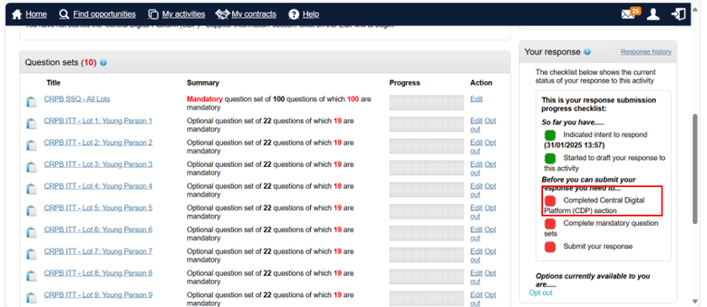

Bidders will need to click on the Central Digital Platform (CDP) – Supplier Information Edit link:

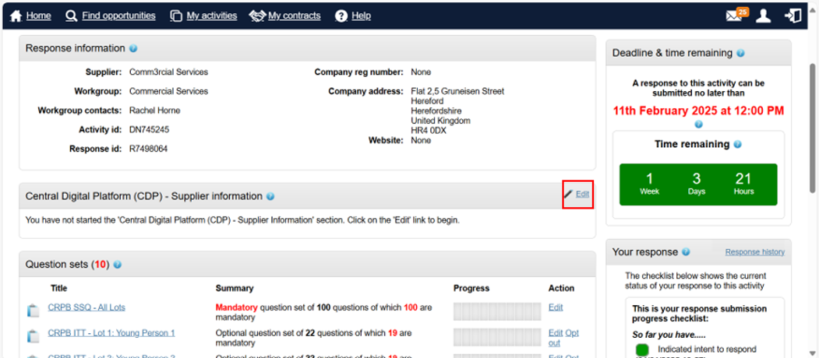

Which will take the Bidder to the following screen. Bidders will need to click on the green Save button:

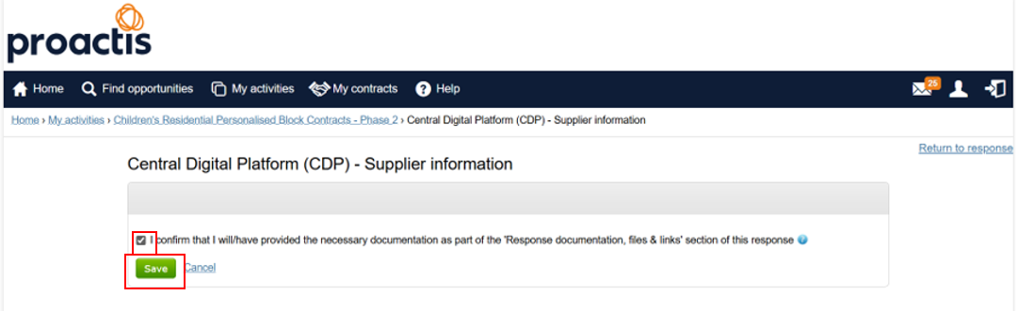

This will then turn the Completed Central Digital Platform (CDP) Section from red to green:

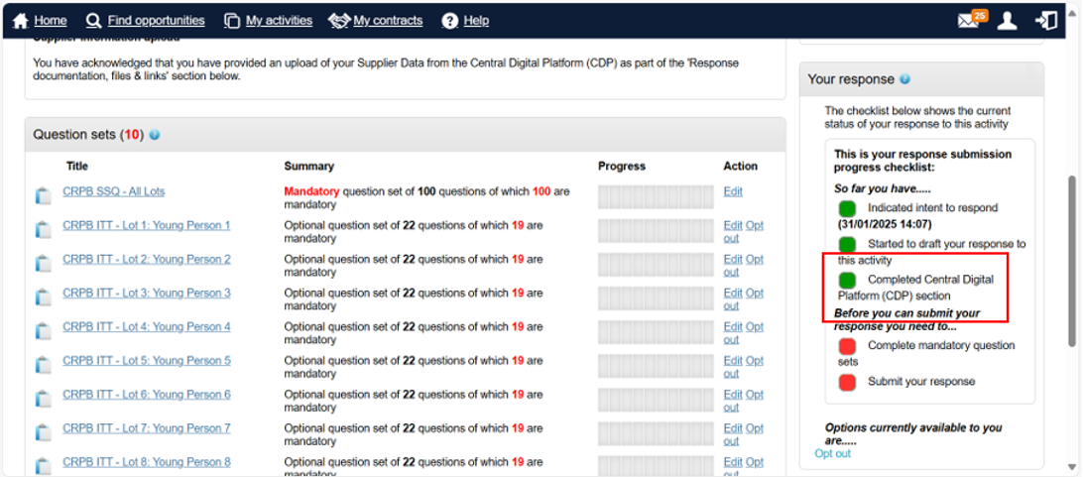

If Bidders experience any issues with this functionality they must contact the Proactis Supplier Helpdesk.