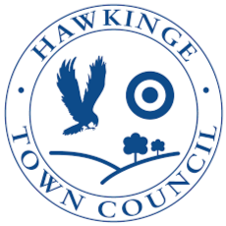

Hawkinge Town Council
Hawkinge Play Parks Upgrade
Brief Document – Parks Information

Introduction
Hawkinge Town Council are responsible for several play parks around the town. As part of investing in the health and well-being of the residents of Hawkinge a budget has been made available to upgrade three of these parks.
The following has been proposed.
Park | Proposed budget
Pannell Drive | £70,000.00
Corbett Road | £6,000.00
Uphill | £30,000.00
Total proposed budget | £106,000.00

The council are looking to maximise the play equipment and play opportunities at each site through this project. We are seeking a contractor with experience in play parks to partner with the council to make this work.
This document should be read in conjunction with the following as part of the tender pack:
- 3323- Hawkinge Play Parks Refurbishment Preliminaries -2025-09-22
- ITQ Instructions Document - Main Contractor – Hawkinge Play Parks 3323 180925
- ITQ Response Document - Main Contractor - Hawkinge Play Parks 3323 180925
- CDM Pre-Construction Information Pack
In addition, there are sets of photos for each park that can be found on this link.
Where possible the council would like to minimise waste across the works and recycle as much as possible. There may be opportunities to move serviceable equipment from one park to another where for example equipment has been installed for the wrong age group.
Parks Information
The following sections give information specific to each park. Please consider these in the light of the overall aims of the project.

Park: Pannell Drive
Address: Hawkinge, Folkestone
Proposed budget: £70,000
Photo
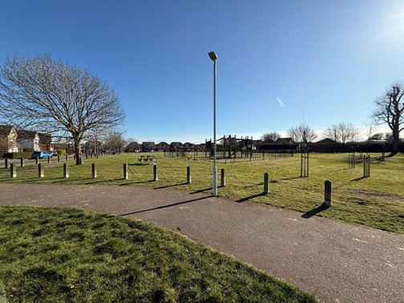
Context
Pannell Drive is currently an open space multi-user sports area with a small children’s play area
Map
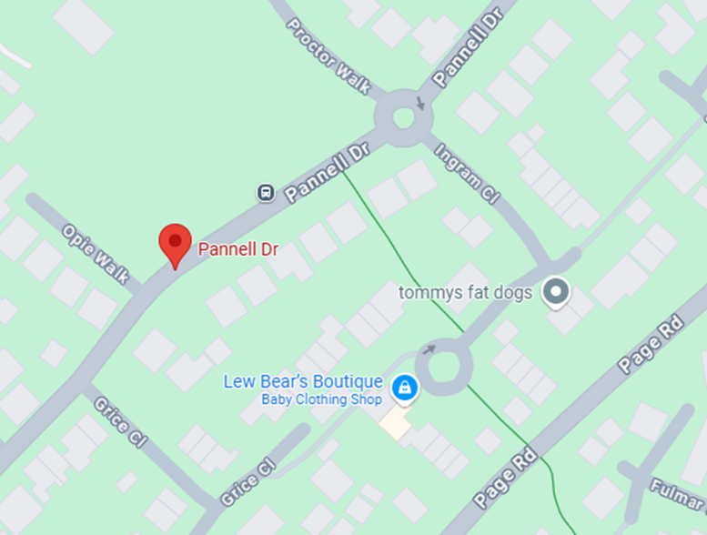
Proposed Works
- Replace existing play park with new to cover school age children (5-12 years) and possibly older children.
- New play park with fencing for babies and toddlers (0-3 years) and pre-schoolers (3-5 years).
- The rationale behind providing two play parks was that it is a central location, the residents generally are some distance away and therefore should not be affected by noise.
Public feedback
How do you use the Park?
Play | 55%
Picnic | 15%
Dog Walking | 16%
What facilities would you like to see developed or improved at Pannell Drive?
Swings 56%
Slides 40%
Adventure 50%
Toddlers 36%
Sensory 27%
Inclusive 16%
Picnic 44%

Contractors are encouraged to suggest furniture that is robust, attractive and will enhance the visitor experience in this park. Consideration should be given to provision of litter and poo bins. Where there aren’t any these should be provided.

Park: Corbett Road
Address: Hawkinge, Folkestone
Proposed budget: £6,000
Photo
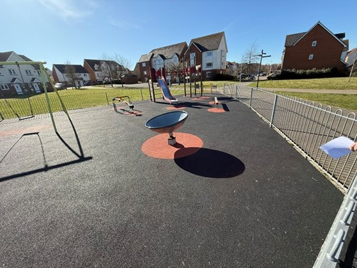
Context
Corbett Road is a park within a new residential area

Map
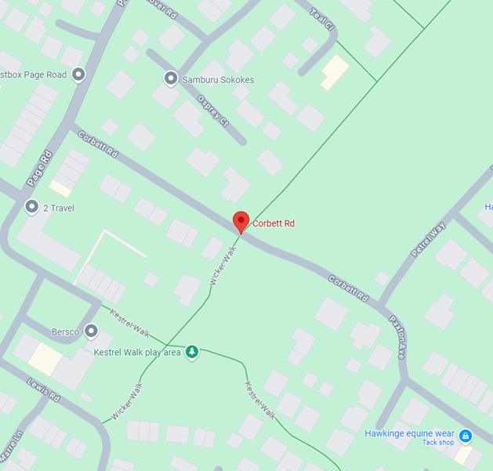
Proposed Works
- Spinner to be replaced with a roundabout potentially to be disabled compliant

Public feedback
How do you use the Park?
Play | 45%
Picnic | 10%
Dog Walking | 7%
What facilities would you like to see developed or improved at Corbett Road?
Swings 34%
Slides 34%
Adventure 40%
Toddlers 31%
Sensory 28%
Inclusive 16%
Picnic 24%

Contractors are encouraged to suggest furniture that is robust, attractive and will enhance the visitor experience in this park. Consideration should be given to provision of litter and poo bins. Where there aren’t any these should be provided.

Park: Uphill
Address: Hawkinge, Folkestone
Proposed budget: £30,000
Photo
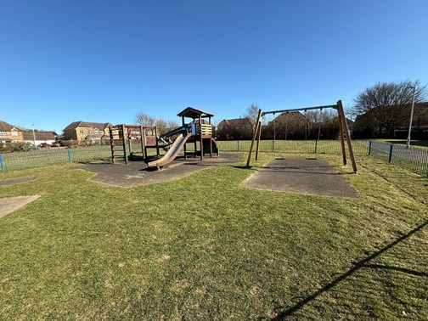
Context
Uphill park is currently a playpark for children aged 4-7 and 6-12 years old. It is a large facility for children, with both cradle and seat swings, rockers and a large play unit with a slide.
Map
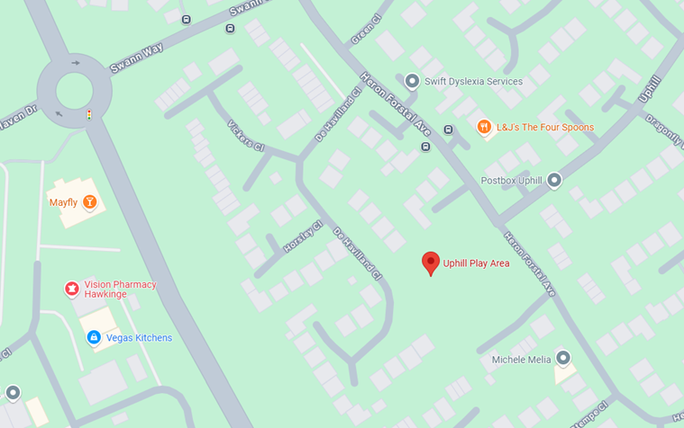
Proposed Works
- A new toddler’s adventure play park should replace the existing. Two new springers that have been recently installed to be retained.
Public feedback
How do you use the Park?
Play | 60%
Picnic | 12%
Dog Walking | 12%
What facilities would you like to see developed or improved at Uphill?
Swings 47%
Slides 43%
Adventure 51%
Toddlers 37%
Sensory 33%
Inclusive 28%
Picnic 36%

Contractors are encouraged to suggest furniture that is robust, attractive and will enhance the visitor experience in this park. Consideration should be given to provision of litter and poo bins. Where there aren’t any these should be provided.

