Site information
Woolwell
- Site location – Woolwell Park Darklake Lane, Woolwell PL6 7TR
https://w3w.co/rising.jelly.fixed
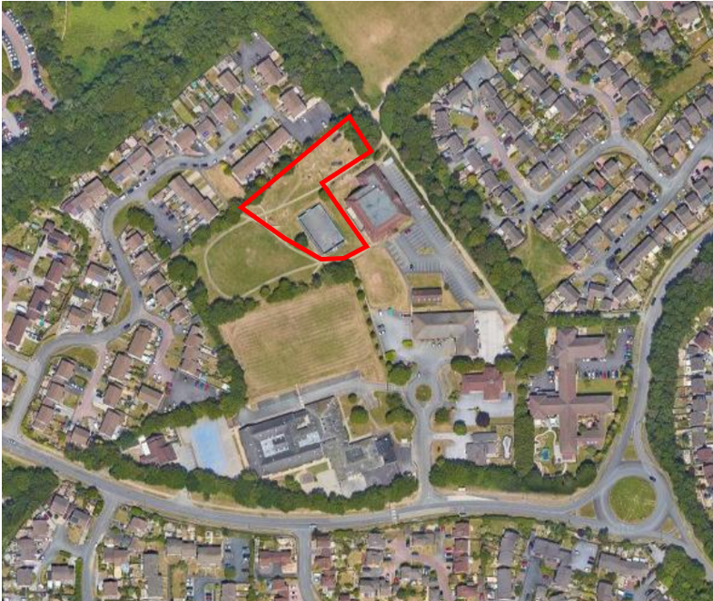
- Land ownership
Land ownership is denoted by blue shading with the play area edged in red. The site contains a range of play equipment catering for all ages and includes a MUGA.

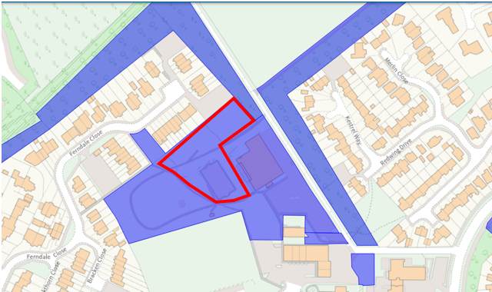

- Photographs of the site and access points

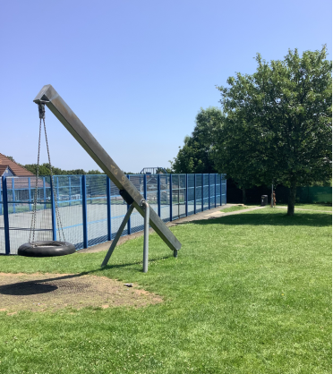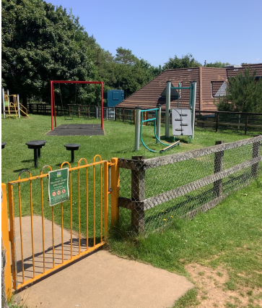
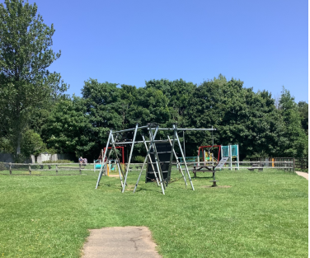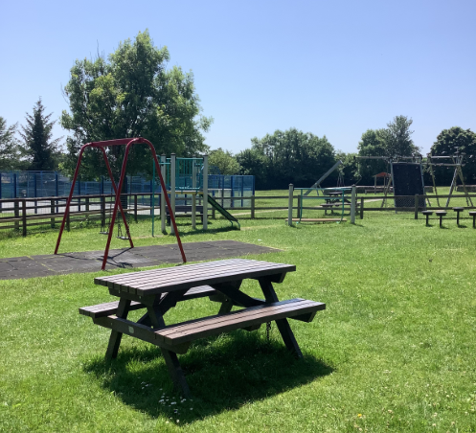
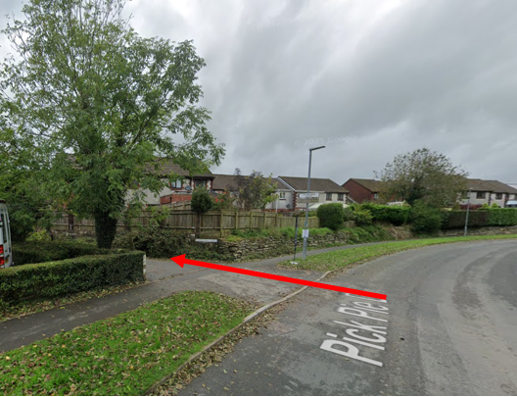

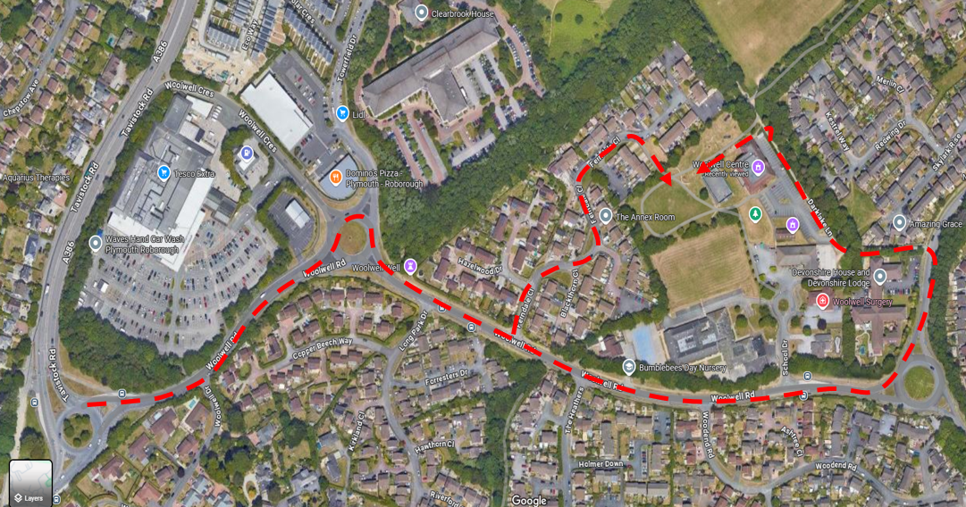
- Site description and known constraints
The site is located to the rear of Woolwell Community Centre. Woolwell lies to the North of Plymouth and can be accessed off the A386 Plymouth to Tavistock Road. The entrance to the Community Centre and play area is via Darklake Lane, a restricted access road off Pick Pie Drive. An alternative route is via Ferndale Close but is restricted by overhanging trees at the entrance to the park.
5. Service plans
Service plans have been attached where they have indicated services on or adjacent to the site. Where plans from other companies have indicated no services, the plans have not been attached. The main area subject to the tendering process is free of utilities however the MUGA has drainage associated with it which may impact on the proposed inclusion of a zipwire.
Please note: these are standard service enquiries and that the contractor must dial before they dig to ensure the services are where they are shown. It remains the contractor’s responsibility for not damaging services and the contractor is required to be covered for any repairs to the services should they drill through one.

