Site Information
Rush Way
- Site Location – Rush Way, Bridgetown, Totnes TQ9 5YH https://w3w.co/fidelity.bake.flamed

The site lies at the top of Bridgetown, Totnes with access off Furze Road and Dukes Road which can be reached via the A385 Totnes to Paignton Road.

Entrance to the site is across a private resident’s car park which is owned and maintained by a housing association (via Rush Way at the southern end adjacent to the existing toddler play area, and via Elm Walk at the northern end closer to the proposed location for the new toddler play area). Because neither car park is part of the HMPE, before and after photographs must be taken of the condition of the car park, and the Contractor will be liable for proper and timely repair of any damage caused by their works vehicles. This is of course necessary to defend the Contractor against unreasonable claims of damage of the car park by adjacent residents.

The existing toddler play area is shown edged in solid red. It sits within a larger Council owned parcel of land which also contains play equipment for older children, a set of goal posts, basketball court and a youth shelter. These do not form part of the contract tendering process.

The approximate location proposed for the new toddler play is edged by a dashed red line, and will require fencing.

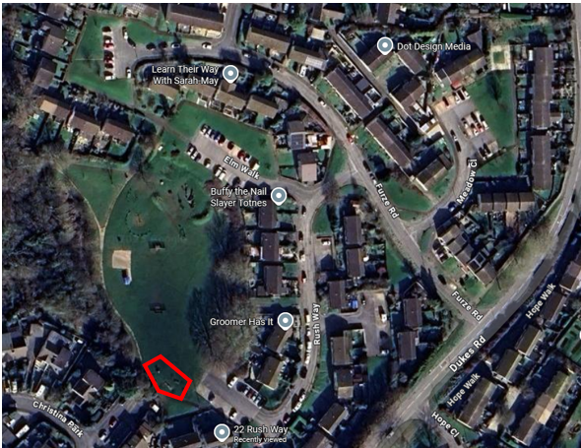

- Land ownership
Land ownership denoted by blue shading with the area of the existing toddler play area edged in solid red. The approximate location proposed for the new toddler play is edged by a dashed red line, and will require fencing.
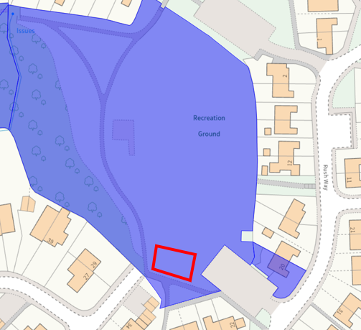

- Photographs of the site access point across the resident’s carpark.
Southern end from Rush Way
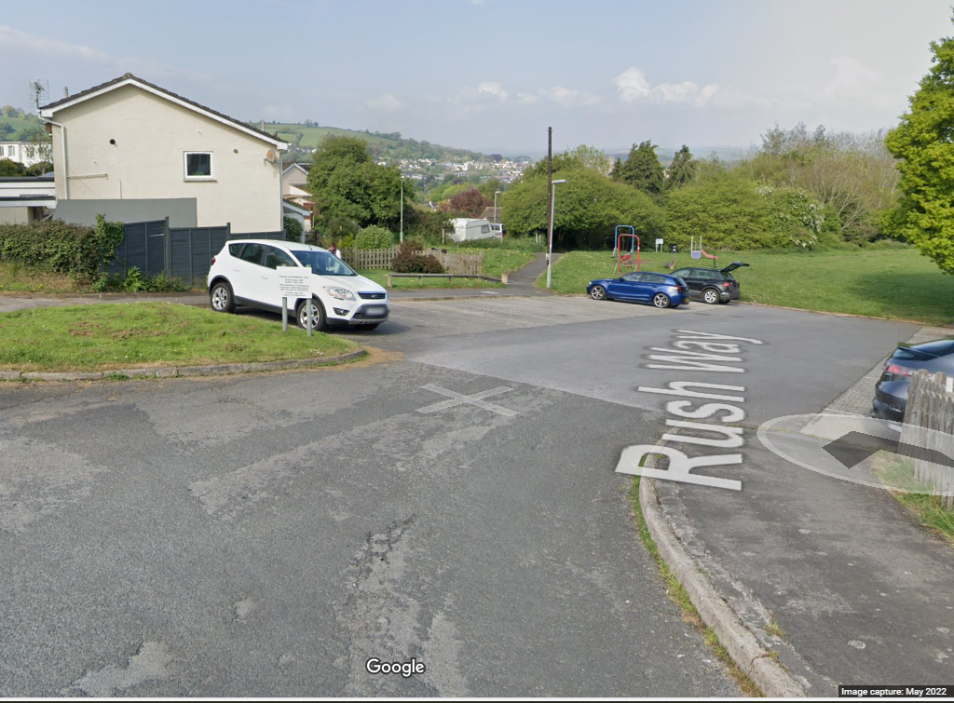
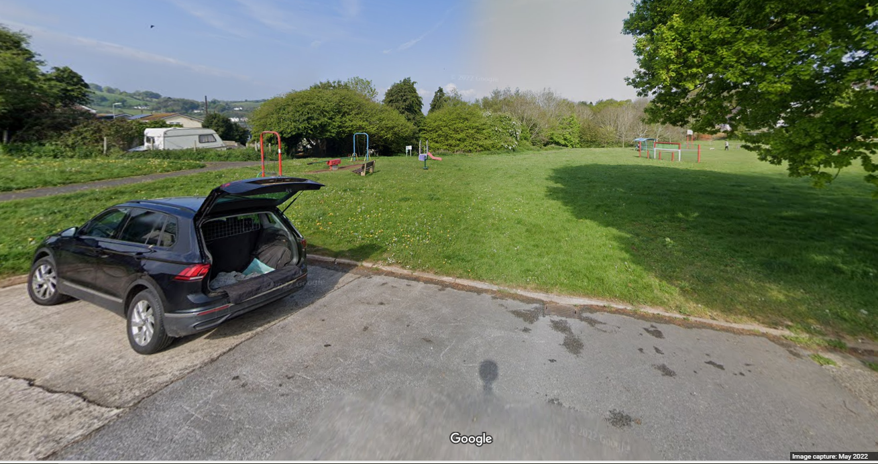

Northern end from Elm Walk
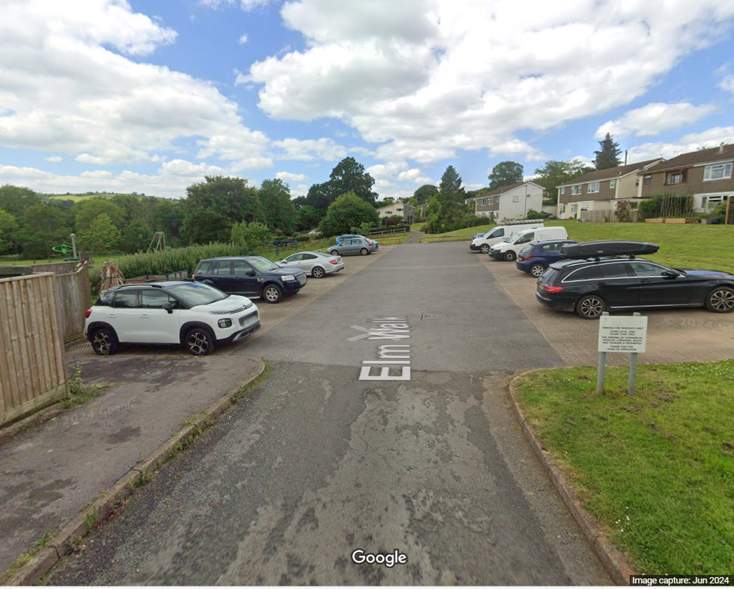
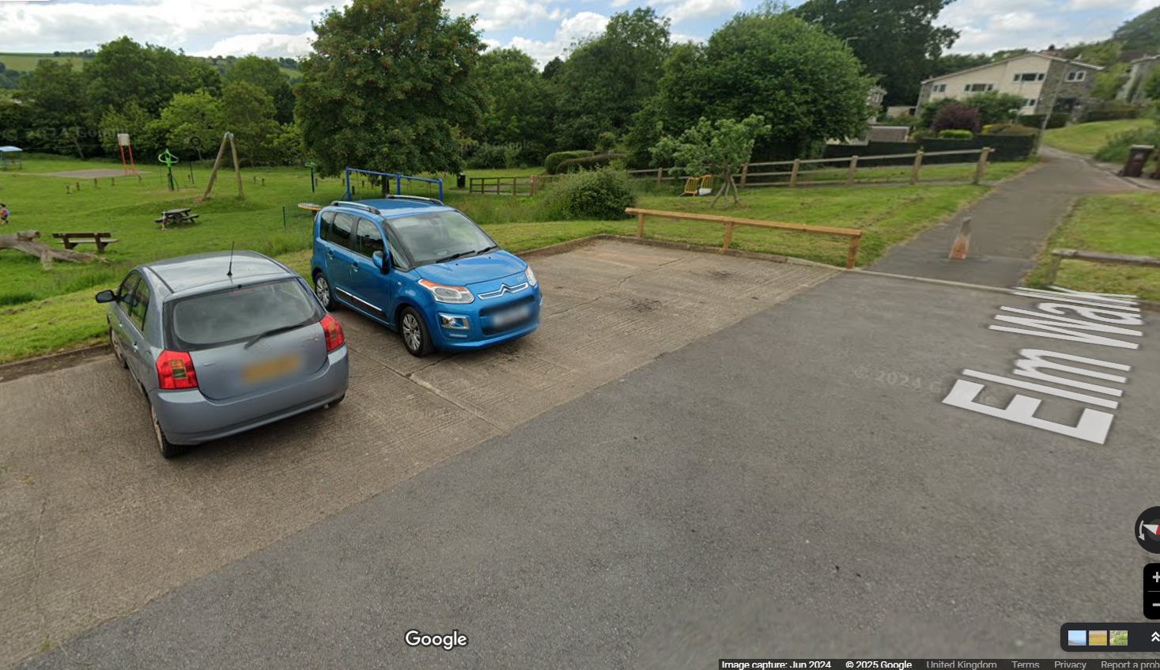
- Site description and known constraints
This site sits within a much larger open greenspace which contains a range of play equipment catering for all ages. It lies within a mixed residential area at the top of Bridgetown with access through a private residents carpark.

- Service plans
Service plans have been attached where they have indicated services onsite. Where plans from other companies have indicated no services, the plans have not been attached.
Please note: these are standard service enquiries and that the contractor must dial before they dig to ensure the services are where they are shown. It remains the contractor’s responsibility for not damaging services and the contractor is required to be covered for any repairs to the services should they drill through one.
South West Water – there are two SWW pipes running across the private carpark adjacent to the southern end of the site

