Site information
Gidleys Meadow
- Site location - Gidleys Meadow , Staple, Dartington TQ9 6JZ
https://w3w.co/mountains.gossiping.rectangular
The site sits at the end of Gidleys Meadow which is accessed off the A385 (A38 to Totnes). This will be the main access point for the site.
Sitting at the corner of Gidleys Meadow and Brimay Gardens the site lies below the road and is adjacent to a popular nursery which has a pick up and drop off lay by adjacent to the play area
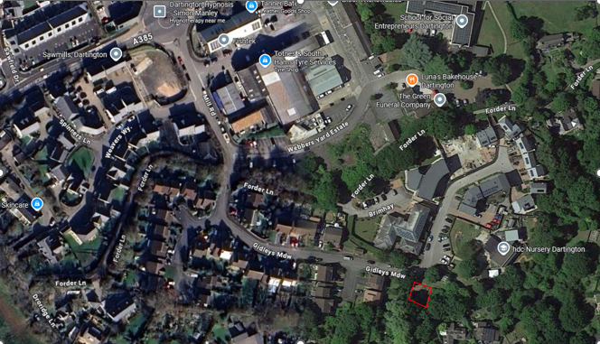
- Land ownership
Land ownership indicated by blue shaded area. Fenced play area boundary edged in red. There are four mature trees indicates by circles on the map

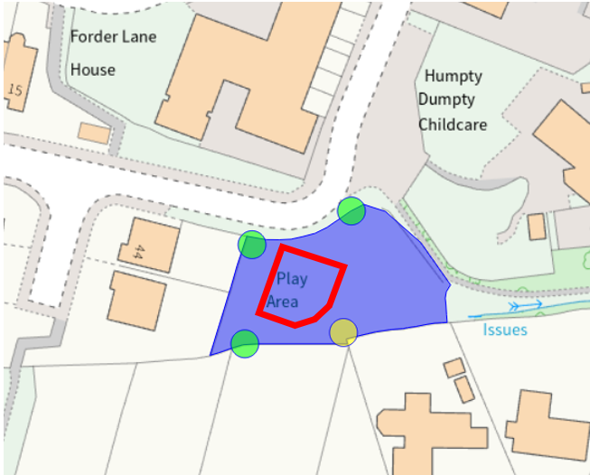
- Photographs of the site
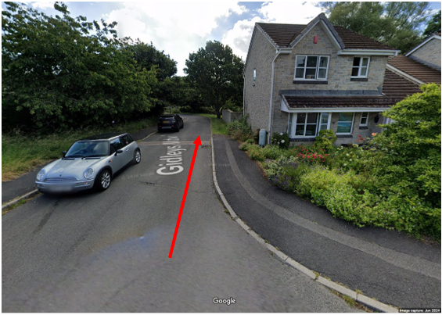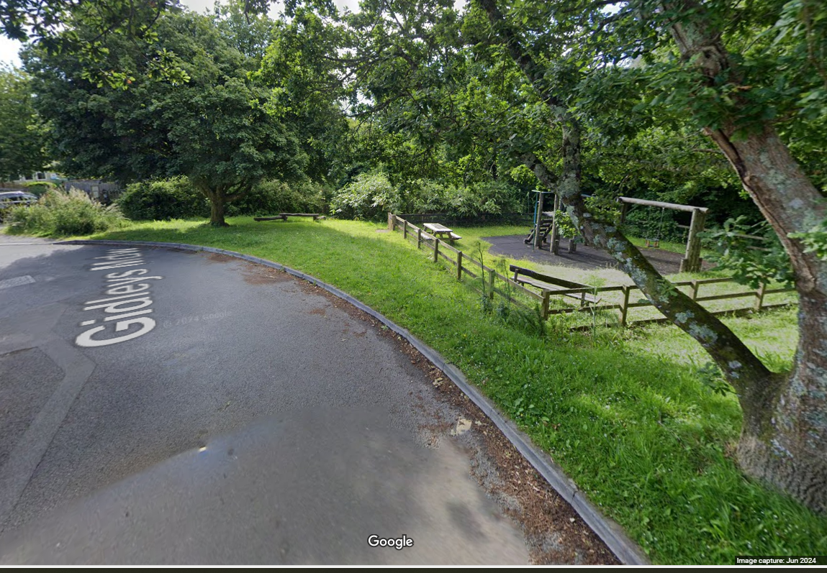
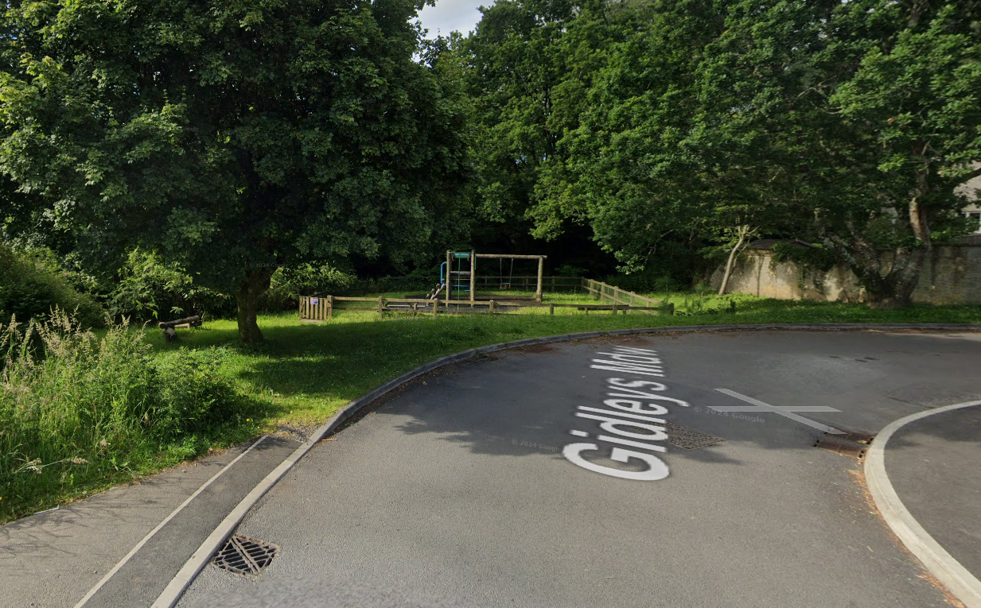
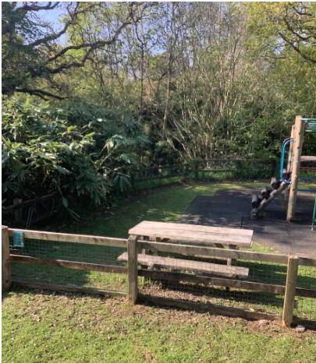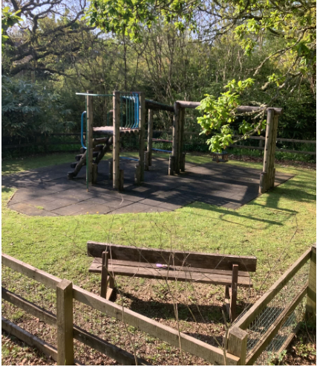

- Site description and any known constraints
The red line area denotes a fenced play area – post and rail with galvanised chain link fence. Whilst there is a works access gate, fencing can be removed for access subject to post works reinstatement.
The site sits within a busy residential area and adjacent to a nursery with regular access. The road is a cul de sac and properties along Brimhay Gardens require access via Gidleys Meadow at all times
- Service plans
Service plans have been attached where they have indicated services on or close to the site. Where plans from other companies have indicated no services, the plans have not been attached.
Please note: these are standard service enquiries and that the contractor must dial before they dig to ensure the services are where they are shown. It remains the contractors responsibility for not damaging services and the contractor is required to be covered for any repairs to the services should they drill through one.
South West Water – there is a public surface sewerage pipe (blue dash) running adjacent to the site
