Site Information
South Brent
- Site location – Crowder Meadow, South Brent TQ10 9DB https://w3w.co/assure.offer.ourselves
The site is located at Crowder Meadow, a residential area of South Brent. Access is via the B3372 Exeter Road and Kerries Road. This will be the main access point for the site.
The site is located next to a residents carparking area and is surrounded by a large hedge and with several mature trees around the site
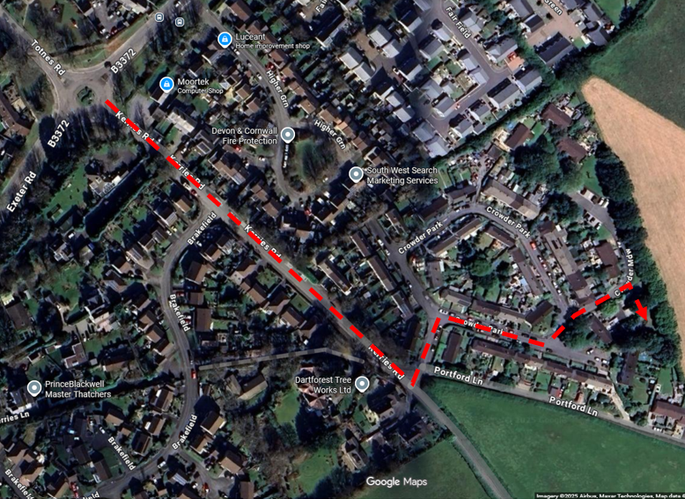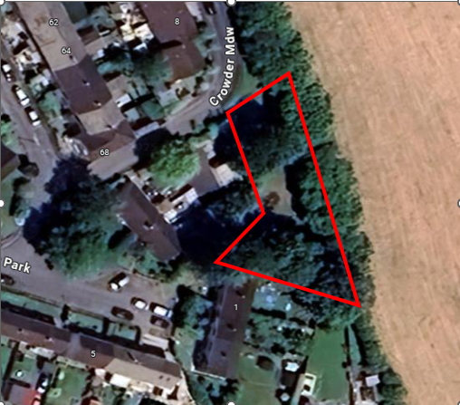
- Land ownership
Land ownership indicated by blue shaded area
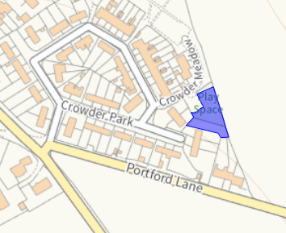

- Photographs of the site
Site access via red arrow. Pedestrian access circled, via residents carparking area
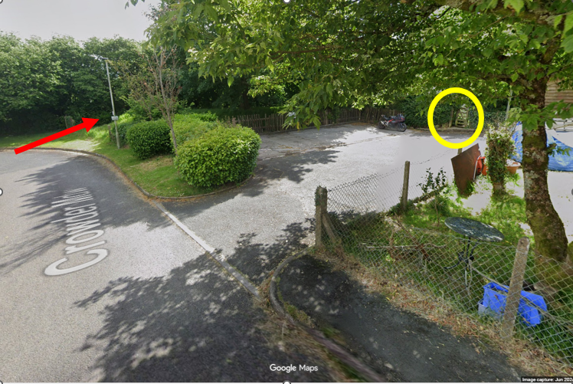
Access via field gate
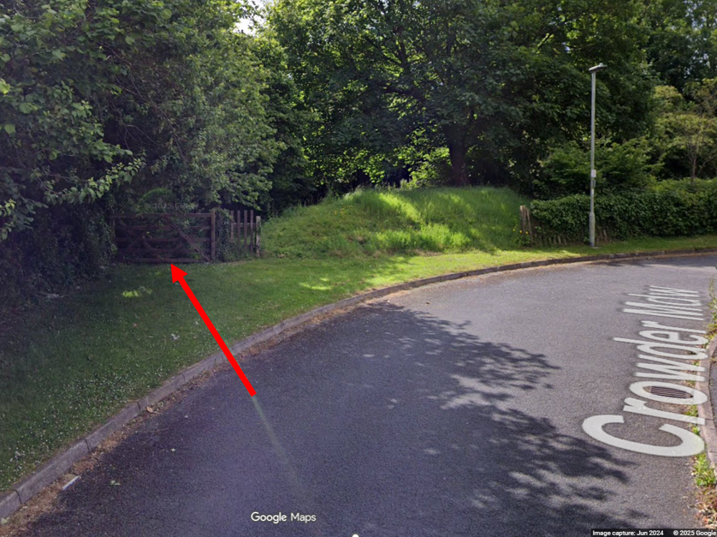
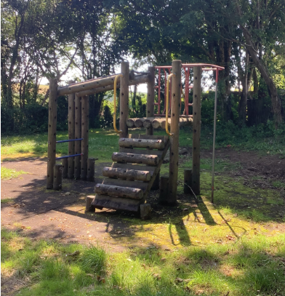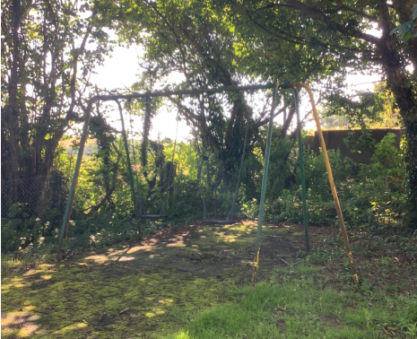
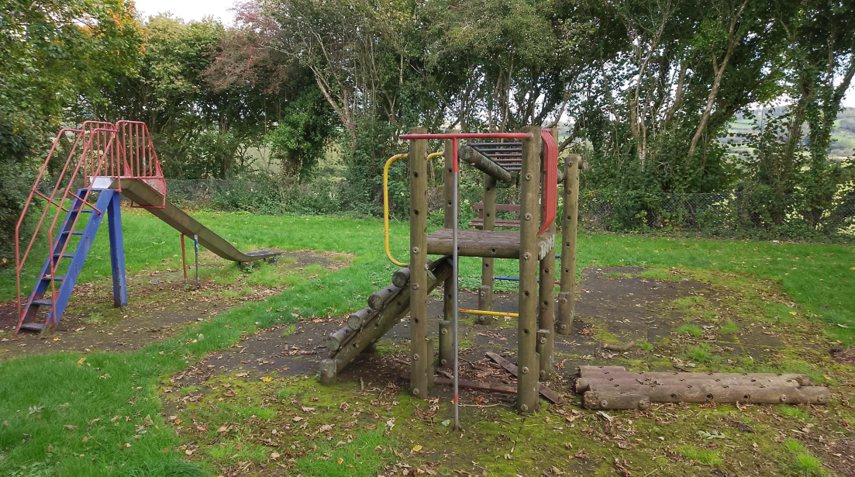
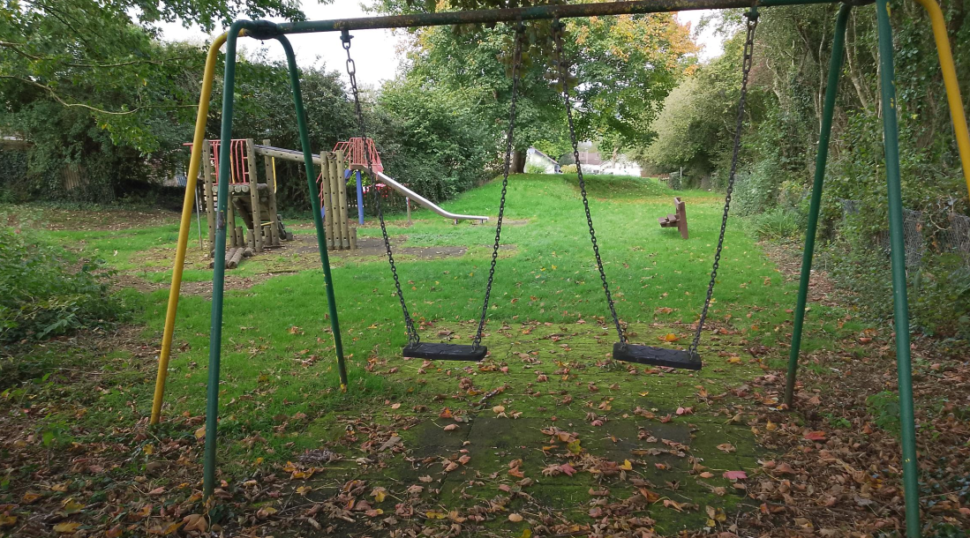
- Service plans
Service plans have been attached where they have indicated services on or close to the site. Where plans from other companies have indicated no services, the plans have not been attached.
Please note these are standard service enquiries and that the contractor must dial before they dig to ensure the services are where they are shown. It remains the contractor’s responsibility for not damaging services and the contractor is required to be covered for any repairs to the services should they drill through one.
Southwest Water – there is a main distribution pipe (blue line) running adjacent to the site entrance
Wales & West Utilities – there is a low-pressure gas pipe running adjacent to the site entrance and parallel with the field boundary within the enclosed play area
National Grid – there is a lighting column adjacent to the site entrance with a cable running parallel with the entrance
