Proactive Intervention Offer
Appendix II

Knowing the Community at Place
To plan effective interventions, providers delivering interventions will need to take a strength-based approach to the population, knowing the challenges and opportunities of the population and community, combined with up to date knowledge and expertise of effective prevention interventions. This appendix provides some information to help formulate this, but is not exhaustive.

- Risk of Falls as an Indicator

We know that several interventions received at the right time can have an impact on a person’s wellbeing and their risk of falls.

NICE guidance outlines several approaches to the interventions that have demonstratable benefits to a person: Overview | Falls in older people: assessing risk and prevention | Guidance | NICE

Our Proactive Intervention and Prevention Operating Model actively seeks individuals to contact and discuss opportunities to reduce their risk of fall and prevent, reduce or delay the use of statutory services including social care.

To inform your planning for supporting individual outcomes it is important to consider that the context of this offer is that an individual will feel that as a result of the intervention they have a lower risk of fall, and they feel that they are less likely to have a fall – and that over time the data we monitor will show this through a reduction in needs and fall rates decreasing.

Below is a heat map to demonstrate where the higher rates of risk of fall are in Norfolk:
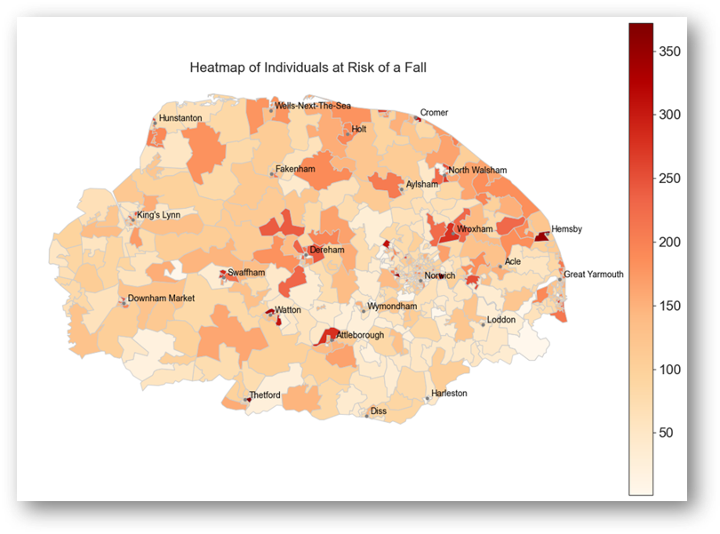

- Place Demographics

For the purpose of this contract, Place is by Health and Wellbeing Partnership boundaries:
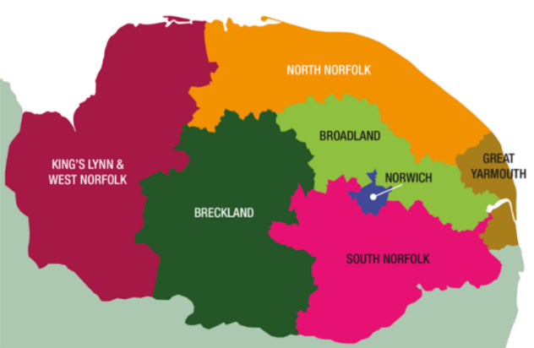

One of the core concepts that underpin the proactive intervention programme is the need to develop a place offer that enables us to better support people within their own neighbourhoods It is important to note that one of the key concepts of sustainable, effective and meaningful community development is to build on the community assets that already exist at place. These might be community buildings, groups, parks and libraries.

Norfolk Insight: Is a locality-focused information system providing data and analysis for neighbourhoods within Norfolk and Waveney. By empowering those who are seeking information with up-to-date knowledge of local communities Norfolk Insight provides the evidence-base needed to make better informed decisions to improve services and localities. This resource includes Joint Strategic Needs Assessments (JSNA) to assist in understanding Place and Needs:

https://www.norfolkinsight.org.uk/
Map | Local Insight
Social Isolation and Loneliness Needs Assessment - Norfolk Insight

- Norfolk Demographics

  - Norfolk’s population is an estimated 931,900 (ONS mid-2023). Compared with the England average, Norfolk has a higher proportion of population of those aged 55 and over, with corresponding lower levels in the younger age bands. Estimates for mid-2023 show 24.8% of Norfolk’s population is aged 65 and over, compared with 18.7% in England. Children and young people (aged 0 to 15) make up 16.2% of Norfolk’s population (compared with 18.5% nationally) and working age adults (aged 16 to 64) make up 59.1% (compared with 62.9% nationally).

  - Norfolk’s ethnic make-up in the Census 2021 is characterised by a predominantly white (aggregated ethnic group) population of 94.7%, compared with 81.0% for England. The proportion of people from all other ethnic groups combined is 5.3%, compared with 19.0% for England.

  - In terms of national identity, the Census 2021 shows that 93.5% of Norfolk people are associated in some way with a UK identity, compared with 90.0% for England. In the Census 2021, English is the main language for 95.0% of Norfolk usual residents aged 3 years and over (compared with 90.8% for England). In our county the other most widely spoken main languages are Polish, Lithuanian, and Portuguese.

  - Around 135,000 Norfolk residents live in areas which have been classified as being among the 20% most deprived in England. The most deprived areas in Norfolk are largely centred in and around urban areas such as Norwich, Great Yarmouth, and King’s Lynn, as well as some market towns such as Thetford, Dereham, and Watton.

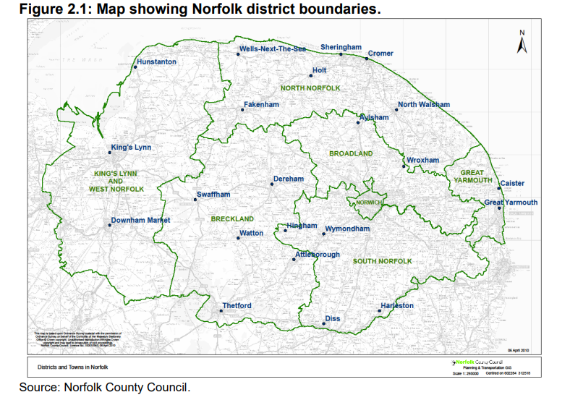

It is increasingly common for people to have multiple long-term health conditions, especially as they age. Norfolk's population is growing, particularly amongst our older age groups. However, life expectancy is stagnating, at the same time healthy life expectancy is decreasing, this means that our residents are spending more years in poor or declining health. Here are some key points to consider:

Living Longer in Poor Health: Many people are living longer, but not necessarily in good health. This can lead to prolonged periods of disability and increased dependence on healthcare services.

Disability and Falls: Chronic conditions often lead to disabilities, which can increase the risk of falls, especially within the older adult population. Falls are a major cause of injury and can significantly impact quality of life and can lead to people dying earlier

Social Isolation: Social isolation is a significant issue for those with long-term health conditions. It can exacerbate mental health problems and potentially lead to substance abuse, such as drugs (prescribed or illegal) and alcohol as a coping mechanism.

Substance Use: There is a strong link between social isolation and inappropriate substance use disorders. Addressing social isolation can be a crucial step in preventing and managing substance abuse.
We know that a number of interventions received at the right time can have an impact on a person’s wellbeing and their risk of falls.

Our Proactive Intervention and Prevention Operating Model actively seeks individuals to contact and discuss opportunities to reduce their risk of fall and prevent, reduce or delay the use of statutory services including social care.

We are keen the approach takes into account Core20Plus5 health inequalities: Core20Plus5 - Norfolk & Waveney Integrated Care System (ICS

- Additional Information

Additional Information about each Place can be found in our Commissioning Data Pack:

