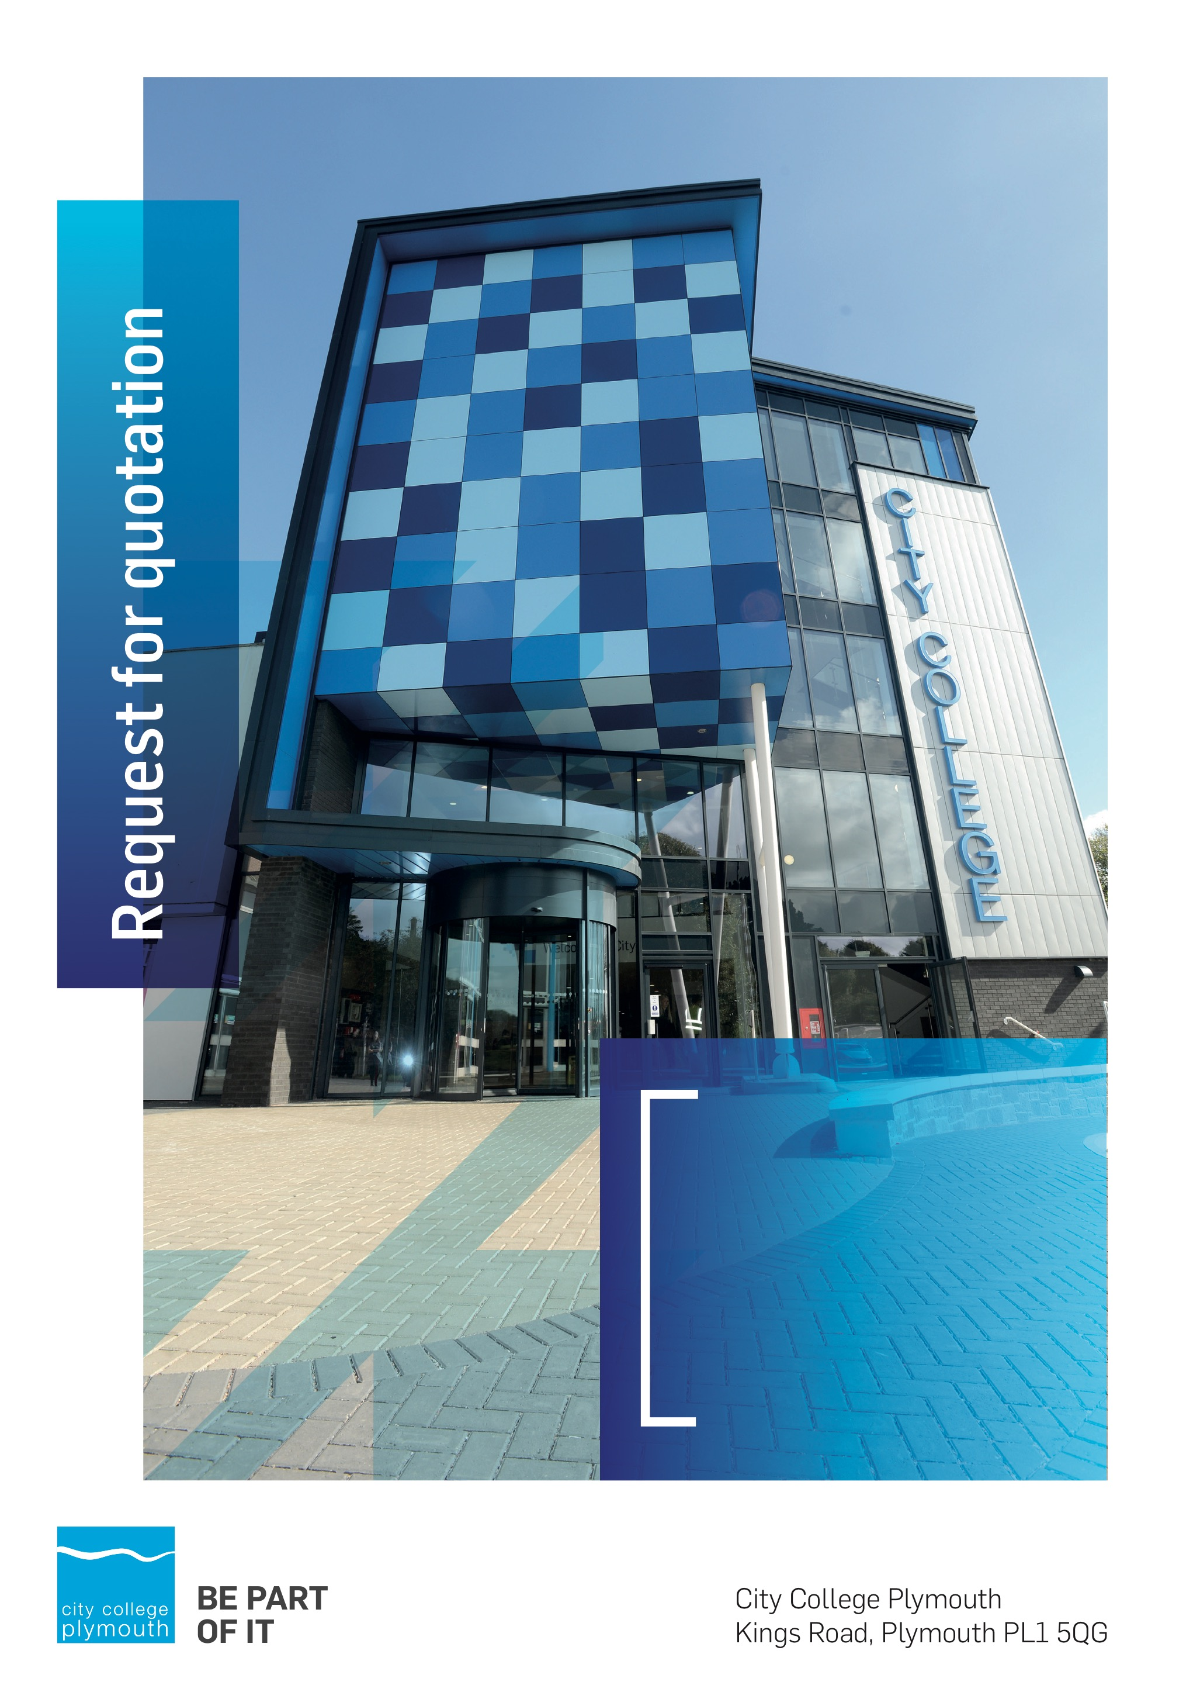

**Request for Quotation**

**RFQ214**

**Lift Refurbishment 2025**

**Issued 12th June 2024**

# Table of Contents

Table of Contents 2

Confidentiality Statement 3

MINI COMPETITION 4

Submission Details 4

Submission Deadlines 4

Submission Questions and Clarifications 4

Electronic Submissions 5

Introduction and Executive Summary 5

Business Overview & Background 5

Our Guiding principle 6

Our Vision 6

Our CORE VALUES 6

Our CULTURE 6

The Way Forward - our Priorities 7

Detailed Requirement 7

Support/WARRANTY 7

Timescales 8

Written Submission 8

Delivery 8

Pricing 9

Terms and Conditions 9

Validity 9

Selection Criteria 9

Award Price 10

Written submission 10

Assessment of Quotations 11

Freedom of Information Act 2000 11

General Data Protection Regulation (GDPR) 2018 11

Agreement Conditions Acceptance and Declaration 11

Supporting Documentation 12

# Confidentiality Statement

This document, and any attachments thereto, regardless of form or medium, is intended only for use by the addressee(s) and may contain legally privileged and/or confidential, copyrighted, trademarked, patented or otherwise restricted information viewable by the intended recipient only. If you are not the intended recipient of this document (or the person responsible for delivering this document to the intended recipient), you are hereby notified that any dissemination, distribution, printing or copying of this document, and any attachment thereto, is strictly prohibited and violation of this condition may infringe upon copyright, trademark, patent, or other laws protecting proprietary and, or, intellectual property. In no event shall this document be delivered to anyone other than the intended recipient or original sender and violation may be considered a breach of law fully punishable by various domestic and international courts. If you have received this document in error, please respond to the originator of this message or email him/her at the address below and permanently delete and/or shred the original and any copies and any electronic form this document, and any attachments thereto and do not disseminate further.

Thank you for your consideration, City College Plymouth.

Where no notice is given, all information contained herein is Copyright 2025 City College Plymouth.

# OPEN PROCEDURE

City College Plymouth is carry out an under threshold tender as per the Procurement Act 2023

Any Contractor who directly or indirectly canvasses any Member or Officer of the Institution, or advisor concerning the award of the contract for the provision of the services, or who directly or indirectly obtains or attempts to obtain information from any such member or Officer concerning any Tender or proposed Tender for the service will be disqualified from having his/her Tender considered

# Submission Details

## Submission Deadlines

All submissions for responding to this Request for Quote must be submitted electronically as stated below, no later than:

**17h April 2025**

**12:00 Noon**

Any submissions received after this date will not be considered.

## Submission Questions and Clarifications

You may contact the following person if you have any questions or require clarification on any topics covered in this Request for Quotation: by **Tuesday 15th April 2025**

**Beccy Woods**

Site Manager

Phone: 01752 305734

Email: [bwoods@cityplym.ac.uk](mailto:bwoods@cityplym.ac.uk) cc: tenders@cityplym.ac.uk

All correspondence during the Tender should be channeled via the Procurement Officer using the above details only. Bidders found to have gained an unfair advantage shall be disqualified from the current opportunity and future opportunities with the College for a minimum of four (4) years.

## Electronic Submissions

Electronic submissions in response to this Request for Quotation are required and must meet the following criteria:

Sent via email to: [tenders@cityplym.ac.uk](mailto:tenders@cityplym.ac.uk)

Document standards:

* Text must be in Microsoft Word format;
* Price tables must be in Microsoft Excel format (using pricing schedule in Appendix A);
* Supportive evidence may additionally be submitted in PDF format;
* Images, Designs, and other supporting evidence may be in either JPEG or PDF format
* Completed Appendix C Suitability Assessment & Selection Questionnaire (Including Mandatory & Discretionary Exclusions) Parts 1, 2 and 3. - *Please note this suitability assessment will not be viewed unless you are the winning tenderer. Failure at this stage may prevent the contract from being awarded.*
* Signed Agreement Acceptance and Declaration.

*Please note that the College is able to accept submissions sent in a compressed or “.zip” file format, so long as the files contained meet the standards described above.*

**WARRANTY**:

By submitting your tender bid, you are warrantying to the College that you have not breached our canvassing or soliciting clause.

If any successful tenderer awarded a contract is found to have provided an inaccurate warranty, then the College reserves the right to terminate the awarded contract with immediate effect and re-tender the contract from which the successful tenderer will be excluded from re-bidding and shall be disqualified from any future opportunities for a period of four years.

# Introduction and Executive Summary

City College Plymouth is looking to carry out either a partial or Full refurbishment of its two tower block lifts.

Due to the age and the lack of availability of replacement parts the college is looking to carry out a refurbishment to extend the life of the lifts.

# Business Overview & Background

City College Plymouth has a learning environment and organisational culture that impacts positively on the health, wellbeing and sustainability of our community and enables all of our students and staff to achieve their full potential.

City College Plymouth is one of the largest providers of innovative, technical and professional education in the South West with a national reputation for promoting enterprise, employability and science, technology, engineering and mathematics (STEM). The College plays a central role in the educational, cultural and economic life of the region and works with strategic partners to facilitate growth, raise aspirations and foster wealth creation.

The College was awarded the Teaching Excellence Framework (TEF) Gold award for its university-level provision and its most recent Ofsted inspection confirmed that the College continues to be ‘Good’ with outstanding features (behaviour). The college has also won the prestigious Queen's anniversary medal for our excellence in maritime skills.

City College Plymouth is also one of the first Institutes of technology in the UK Working in collaboration with education providers and employers across the South West to improve the training in science, technology, engineering and maths in order to address skills gaps within these industries and support regional growth.

City College supports the region’s employers with their award-winning Apprenticeship provision, as well as providing a range of courses and bespoke training programmes which enable employees to upskill or retrain to better support their business’ requirements.

The College operates on two main sites within the city, serving 12,000 students and employing over 700 staff. The College operates year round, with opening times from 0800-2100 on some days.

## Our Guiding principle

City College Plymouth has a learning environment and organisational culture that impacts positively on the health, wellbeing and sustainability of our community and enables all of our students and staff to achieve their full potential.

## Our Vision

To be the learning destination of choice

## Our CORE VALUES

Respect, ownership, integrity for all

## Our CULTURE

Nurturing a passion for teaching and learning

Enriching our community through knowledge, experience and skills

Enabling every student to be the best that they can be

## The Way Forward - our Priorities

• Staff - our most important investment

• Students - our purpose

• Community - making a difference

• Achievement - reputation for success

• Wellbeing - infusing health into every day

# Detailed Requirement

City College Plymouth is looking to carry out either a full or partial refurbishment of its 2 tower block Lifts

An outline of the lifts are below;

2 x Electric traction lifts, 20 person (1365kg), serving 8 storeys

• Variable speed AC electric motor drives

• Leicester control panels, 1 x per lift, duplexing.

• Single entrance centre opening doors

• Windcrest lift car autodiallers for emergency communication use

The college has therefore split the tender into two lots,

* Lot 1: Full Refurbishment of the two lifts as per appendix D
* Lot 2 – Partial refurbishment as per appendix E

The college is looking to assess based on the returns their preferred option.

Due to the operational difficulties the lack of lifts will present the college the college is looking to get the works completed as soon as practically possible.

## Technical Specification and works plan

Please can you provide in your return a detailed plan of how the works will be undertaken including any technical details. Please provide details on how the work area will be managed in a live college environment, the site management proposals and how the college will be kept informed on the works progress.

Please indicate in your return when you would have availability to carry out the works.

## Support/WARRANTY

* Please state what the basic warranty is with the purchase.
* Please confirm if any additional warranty is available for the works

## Timescales

|  |  |
| --- | --- |
| **Action** | **Date** |
| Tender Issued | 9th April 2025 |
| Deadline for Queries | 15th April 2025 |
| Tender Response Date | 17th April 2025 |
| Contract award | w/c 22nd April 2025 |
| Works to be undertaken | To be confirmed |

## Written Submission

We require a written document which details your company offer with particular interest to the following areas. This submitted document will be scored as per the table on page 12.

* Support, including warranty agreements
* Quality of Technical Specification including plan of works
* Experience of carrying out a similar project in an educational environment
* Sustainability, the Environment and Corporate Social Responsibility including Modern Slavery
* Potential partnering arrangements with regard to student work experience, apprenticeships and working partnerships.

## SITE VISIT

Please contact Estates Operations Manager, Beccy Woods – [bwoods@cityplym.ac.uk](mailto:bwoods@cityplym.ac.uk) to arrange a site visit and to clarify any details in relation to the technical specifications.

# Pricing

Bidders should provide their pricing for each of the key products in Appendix A.

Prices should be firm and valid for at least the initial contract period (12 months) and not subject to increase or escalation of any kind throughout the contract.

# Terms and Conditions

The College’s normal business terms are 1-2 months from the date of invoice. Payment will become due subject to the above upon the College’s full acceptance of the goods/services. This Request for Quotation and any resulting purchase order will be subject to the College’s General Terms and Conditions of Purchase of Goods/Services – see Appendix B.

# Validity

Bidder’s offers should be open and valid for acceptance for a period of no less than ninety [90] days from the date of submission.

# Selection Criteria

The successful supplier will have provided the Most Advantageous Tender (MAT) to the college. It should be noted that the bidder with the lowest submitted prices will not necessarily be down-selected. All bidders will be notified via email of the results of the outcome no later than 90 days from the date of submission. The date of contract award will be provided within that email.

The marking criteria follows:

|  |  |
| --- | --- |
| Category | Weight |
| Price | 70% |
| Quality – Technical Specification and work plan | 10% |
| Experience in education | 10% |
| Added Value | 5% |
| Sustainability, the Environment and Social Responsibility | 5% |

Please see table below for more details on the scoring method.

## Award Price

Lowest quote price divided by quote price multiplied by 100

## Written submission

|  |  |  |
| --- | --- | --- |
| **Assessment** | **Score** | **Interpretation** |
| **Excellent** | 4 | *Comprehensive response supported by examples*  *Description fully supported by details that demonstrate the applicant’s ability to provide the required services.* |
| **Good** | 3 | *Broad response supported by relevant examples.*  *Description well supported by details that demonstrate the applicant’s ability to provide the required services.* |
| **Satisfactory** | 2 | *Reasonable response supported by some evidence.*  *Description adequately supported by details that demonstrate the applicant’s ability to provide the required services.* |
| **Poor** | 1 | *Limited response not well supported by evidence.*  *Description inadequately supported by details that demonstrate the applicant’s ability to provide the required services.* |
| **Unacceptable** | 0 | *No response or insufficient information provided.* |

# Assessment of Quotations

Bidders must ensure that their quotation fully addresses all information requested within this RFQ document. Bidders must ensure that any quotation fully meets the specification required. The College reserves the right to discount any quotation which does not fully meet the specification.

The College reserves the right to seek clarification with bidders upon receipt of quotations.

# Freedom of Information Act 2000

Under the Freedom of Information Act 2000 the College cannot guarantee that information provided by bidders during the course of this RFQ procedure or any resulting contract will be held a confidential. The College will not routinely release information to interested parties unless required to do so in order to meet our statutory obligations.

# General Data Protection Regulation (GDPR) 2018

All bidders must comply with the General Data Protection Regulation (GDPR) 2018 in respect of using and processing personal information. Bidders must have in place technical and organisational safeguards to protect personal data from unauthorised use, disclosure or loss.

The College reserves the right to request a copy of your privacy statement if you are the successful bidder.

# Agreement Conditions Acceptance and Declaration

Bidders are required to sign and return the attached Agreement Conditions Acceptance and Declaration. Appendix C

# Supporting Documentation

Appendix A: Pricing Schedule

Appendix B: City College Plymouth Standard Terms & Conditions

Appendix C: Agreement Conditions Acceptance and Declaration

Appendix D: Full refurbishment specification

Appendix E: Partial refurbishment specification