**Quotes are invited to Improve our Pond and**

**Wildlife Area – AQNV 066**

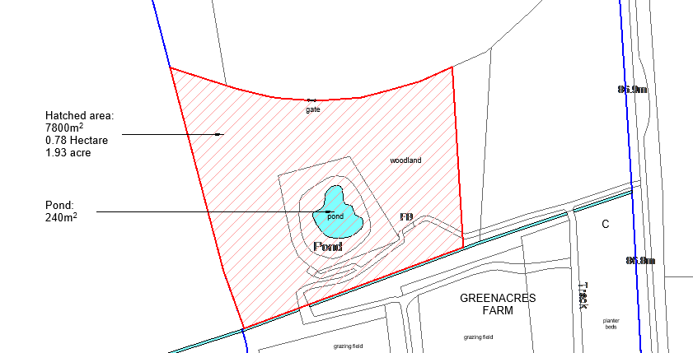

We are a Shropshire Council run Day Service for Adults with Learning Disabilities and have been fortunate to gain some funding from the UK Government through the UK Shared Prosperity Fund and would like an area of our site to be revitalised and improved. This would involve pond clearing, ground clearance to incorporate a pathway around the area. Anyone considering quoting would be asked to include the involvement of the individuals who attend the service in the project when safe to do so. All individual’s involvement would be supported by staff members.

This is a great opportunity to improve our wildlife area and for everyone who visits to enjoy the space and take pride it.

For all prospective quotes we would ask that you attend site, for which an appointment will be required – please contact Julie Cartwright to arrange [Julie.cartwright@shropshire.gov.uk](mailto:Julie.cartwright@shropshire.gov.uk)

All works will need to be completed and payment made by 31st March 2026.

Please note a maximum of £24,000 is available to complete these works.

**Your quotation should include the following:**

1. **A breakdown of costs including the pond clearance cost and the pathway cost.**
2. **A description of how you propose to undertake the work, including how long you anticipate the work will take and how you would involve the individuals at the farm.**
3. **Your business details**
4. **Insurance details – including employer’s & public liability insurance held and the value of cover.**
5. **Details of relevant experience – please attach photos of previous work if available.**

**Evaluation Criteria**

Proposals will be assessed on the basis of the following quality criteria. In reaching this judgement, the following will be considered:

* A combination of your quotation price, experience and how you propose to undertake the work.

Shropshire Council reserves the right:

* To determine whether an appointment is made (using the criteria above) based on the proposal submissions alone, or through further competitive interviews if necessary to further inform the decision.
* To not make an appointment.

**Conditions of Contract**

The contract will be between Shropshire Council and the successful provider and will cover the terms for undertaking the service. This contract must be agreed by both parties before any payments are made.

Your quote should be returned by **Friday 10th October 2025** to:

[Julie.cartwright@shropshire.gov.uk](mailto:Julie.cartwright@shropshire.gov.uk) or to Greenacres Farm, Fenemere Lane, Walford Heath. Baschurch. Shropshire. SY4 2JA.

A copy of the Shropshire Council General Terms and Conditions for the supply of goods, services and works is available to download from the Shropshire Council website:

<https://www.shropshire.gov.uk/doing-business-with-shropshire-council/>

If you require any further information please telephone: 01939 291109 or email (as above)

**This project has been funded by UK Government through the UK Shared Prosperity Fund**