**Taunton’s Native Wildflower Recovery Strategy:**

**Project Brief**

**Budget:** Up to£25,000 exc VAT

**Background**

In 2023 Taunton Town Council declared a climate and ecological emergency, committing to reaching Net Zero by 2030. As part of the Council’s strategy to address the climate crisis, there is an ambition to expand pollinator networks in Taunton by establishing native wildflower corridors to help with local recovery.

The Council recognises the importance of native species recovery in tackling the climate crisis. The council hopes that by supporting native species recovery, not only will it increase Taunton's local resilience to climatic fluctuations but will also act as an educational point for residents to engage with green spaces, as well as improve green space accessibility disparities.

**Proposed Locations**

3 Green Flag Parks:

* TT25 Flood Alleviation Scheme Area (French Weir). Area 1 and Area 2.
* French Weir Park
* Comeytrowe Park
* Victoria Park

**Flexible Locations**

The Council recognises the environmental conditions in the chosen locations may not be suitable for wildflower planting, due to lack of soil analysis on site. We are therefore open to working with the supplier to identify other more suitable locations if our current suggestions are not viable.

**Past Efforts and Existing Initiatives**

Taunton Town Council newly acquired local parks from Somerset Council on April 1st 2025. Though the Council in its infancy worked with Somerset Wildlife Trust to create a Grassland Management Strategy to help increase the diversity of the sward, this has not yet been implemented by the newly established Open Spaces team but is set to initiate from 2026 onwards.

Across the parks, we have no knowledge of previous efforts to recover local wildflower population by previous councils who operated in the area.

We are aware of friends of groups, who have varying levels of activity, with the friends of Comeytrowe previously being very active but have now closed due to lack of volunteers. Below are some of wildflower/floral planting activities of the friends of groups and our current target locations.

1. **TT25 Flood Alleviation Scheme Area (French Weir)**

**Postcode Location:** Taunton TA1 1XF

Discussions have been had with Somerset Council to determine restoration potential to succeed their flood alleviation scheme along the River Tone, with a projected timeline of 12-18 months from July 2025.

Somerset Council have agreed as part of this, to work with us in leaving the area ready for wildflower sowing, however they require confirmation from the project as to how the land should be left specifically, in the areas they are disturbing during the process. Our strategy will need to align it’s timeline for these locations with the culmination of the flood alleviation project. They will additionally, be replanting trees within the boundary of **Area 1** in alignment with Taunton Town Council’s Climate Officer species selection which we are looking to populate with fruiting/flowering native species.

**1a) Area 1**

Proposed wildflower planting areas within pink boundary markers. This area is at risk of flooding in relation to the 100-year climate change flood risk projections, however it has not historically flooded in recent years. We are investigating the potential of returning the remaining green into allotments as it was historically used for this purpose, however there are other regenerative avenues we are exploring. The allotment proposal would specify the condition of organic growing and permaculture principles to support the local biodiversity and the Councils ecological restoration projects and would encompass the wildflower strips within its boundary. If an allotment proposal does not go forward, we would still like to progress with enhancing the borders with wildflowers, as an extended amenity area for the park.

**1b) Area 2**

1. **French Weir Park**

**Postcode Location:** Taunton TA1 1XF

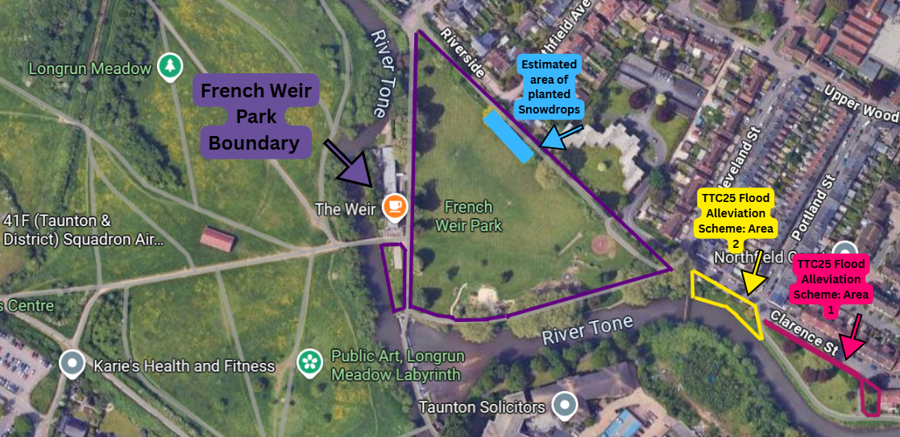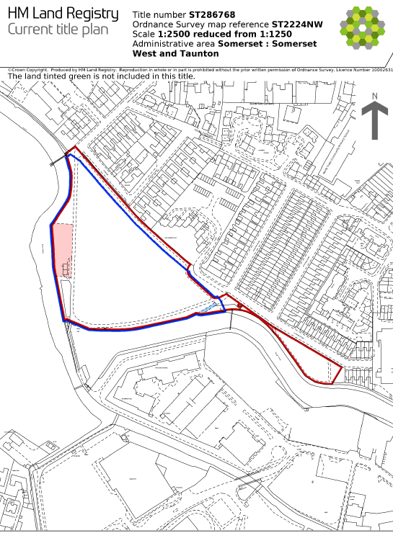

French Weir has had no previous efforts to wildflower restoration, though the Friends Of are aware of some gorilla gardening that took place along one of the verges, where a successful wildflower crop bloomed one year but has yet to return.

There have been around 2000 snowdrops planted one edge of the park, by a local resident in memory of her late son. These are condensed into one small location however and we have assured the resident that we will not disturb the bulbs during our project.

1. **Comeytrowe**

**Postcode Location:** Taunton, TA1 4YG

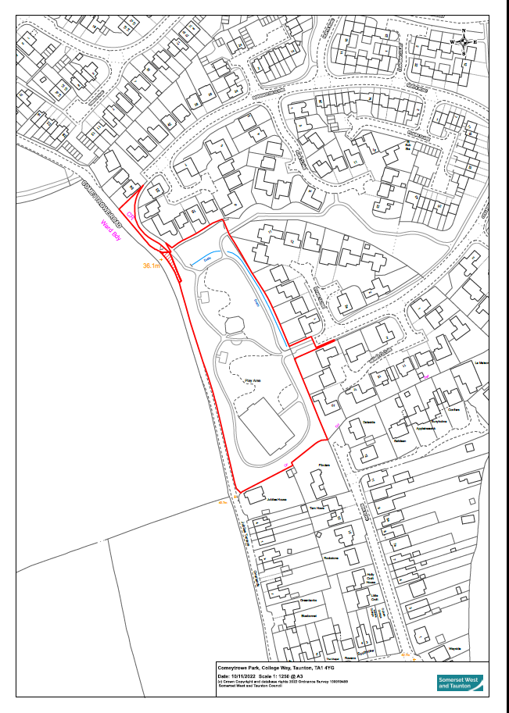

Few hundred daffodils, snowdrops and bluebell bulbs around the park and on the Pope Close/Fivash green space. Wildflowers including ox-eye daisies, knapweed, foxgloves and red campion were planted along a ditch area and in Pope Close but these were less successful and disappeared once the previous managing Council strimmed them. The species were chosen due to their potential to thrive in clay soil, perennial nature and ability to self-seed. During lockdown due to withdrawal of cutting, bulbous buttercups and varied grasses were seen to appear however disappeared once cutting resumed.

1. **Victoria Park**

**Postcode Location:** Taunton, TA1 1YE

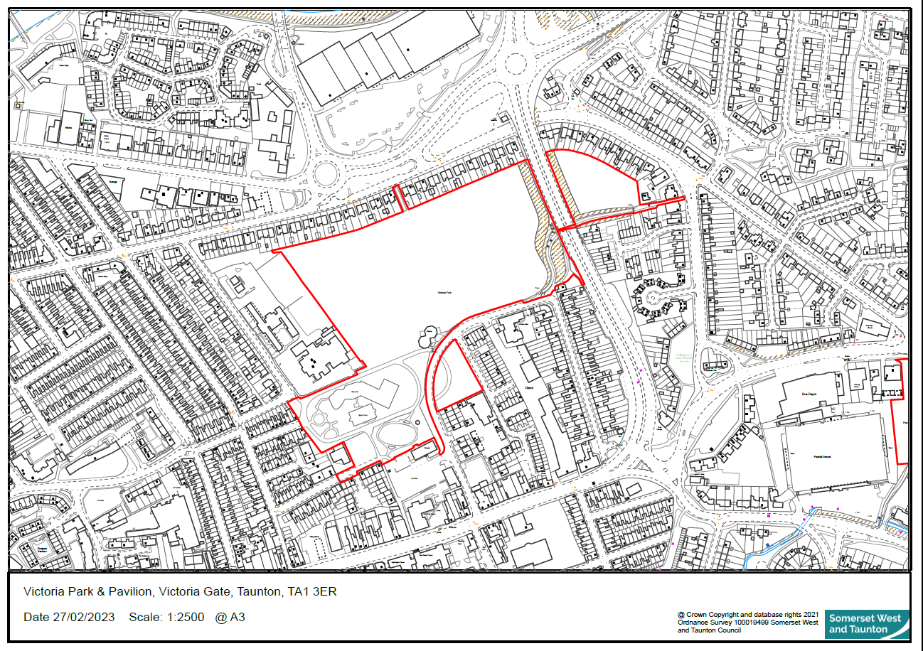

Managed by an active Friends Of group there have been a variety of attempts to create wildflowers however it seems historically these have all been damaged through poor cutting maintenance and lack of communication with the previous managing council. Below are some resources of information offered by the friends of concerning the section of the park managed by them. The contractor will be expected to communicate with the Friends of Victoria Park during their site visit, to identify where previous planting attempts have been created and to keep the group informed of the project plans so they feel involved from the preliminary stages.

The Council has identified the listed potential areas where work could take place, however we are open to discussing identifying other areas that may be more suitable across our parks and open spaces, If the soil suitability does not meet the criteria needed at the proposed sites.

**Ecology Surveys**

Surveys have been contracted for the three sites ‘Comeytrowe, French Weir, Victoria Park’ You will find our received surveys attached in the accompanying email. Surveys for Comeytrowe and French Weir park are not expected to be received until end of August/beginning of September. The Council can share these results once received. Results of the town wide desk study and Victoria Park survey will demonstrate the type of information that will be captured at the remaining sites. We are seeking a project proposal that will be complimentary, progressing us onto the next phases of implementation and delivery.

**Potential Additional/Alternative Locations**

Furthermore, we have contracted ecological surveys for the parks of:

* **Hawthorn:** Hawthorn Park, Taunton, Somerset, TA1 2QN
* **Taunton Green:** Taunton Green, Taunton, Somerset, TA2 7NU
* **Galmington Way:** Galmington Playing Fields, Taunton, Somerset, TA1 5LB
* **Greenway:** Leslie Ave, Taunton, Somerset, TA2 6HU
* **Hamilton:** Hamilton Gault Park, Taunton, Somerset, TA1 2ER

Locations of which, might be deemed more suitable upon the suppliers research. Many of these parks however are in the process of undergoing project proposals for large pitch development for various amenity resources. Discussions with the Operations and Assets team would be required to identify where restoration could take place. It has already been identified that some projects may require restoration afterwards, due to the disruption and changes to land use that would ensue, to align with our environmental commitments. Project timelines are currently uncertain for these aspects however, though we can enter discussions to get a clearer understanding of proposed plans.

Furthermore, please find a full list of our managed parks here: [Taunton Town Council - Parks and Play Areas](https://www.taunton-tc.gov.uk/taunton-community/parks-open-spaces/). Though we do not currently have an ecological survey for the additional parks listed.

Through discussions with a newly reformed Friends Of Group at [Frieze Hill Community Orchard](https://www.taunton-tc.gov.uk/frieze-hill-community-orchard/), there is the potential that this location might work for wildflower restoration. The group is keen to incorporate scything into their management, due to the layout of the orchard and the inability for ride on mowers to cut the grass around the trees. This could be another potentially more suitable site, with an existing Friends of to support work.

**Desk Study Results**

Below are some current results of interest pulled from the desk study. We are still awaiting

* **Soilscape Map**
  + A soil scape map has been produced via the ecology survey however no on site soil sampling has not taken place.
* **Flood Risk Map**
  + This has identified French Weir Park as a medium flood risk zone, therefore suitable flood tolerant species may need to be explored here.
* **Proximity to Statutory Designated Sites** 
  + Victoria Park is located approximately 1 mile from a nature reserve managed by Somerset Wildlife Trust called ‘Childrens Wood’.
  + Though not a formally designated nature reserve, French Weir is adjacent to Longrun Meadow, managed by Somerset Council and an active Friends Of group which are focusing on meadow and floodplain recovery.
  + Comeytrowe is not located near any statutory designated sites.
* **B-Line**
  + A B-Line (Buglife) runs through Taunton, making it a prime location for in terms of connectivity potential for local pollinator recovery - [Benefits-of-B-Lines-for-Local-Authorities-in-England-08.pdf](https://cdn.buglife.org.uk/2023/12/Benefits-of-B-Lines-for-Local-Authorities-in-England-08.pdf)

**Justifications**

* **Climate and Ecological Emergency Plan –** The council have committed to make space for nature as part of their emergency plan across a variety of ways, including a native wildflower recovery strategy to help local pollinators.
* **Biodiversity Policy –** We are adopting a biodiversity policy which stipulates protecting and actively recovering local nature in the way we manage our open spaces.
* **Somersets LNRS** first draft will be released expected summer 2025. We would like the pollinator corridors to contribute towards Somersets aim of 30% of land managed for nature by 2030. We are working with Somersets climate team who would like to be kept informed of our nature-based projects.
* **Grassland Management Strategy –** The council worked with Somerset Wildlife Trust to create a grassland management strategy to improve diversity of the grass sward through maintenance changes. These will come into effect from 2026. The hope is to provide a more extensive supporting project for pollinator recovery to compliment these initial efforts.
* **B Line –** Taunton is situated on a B-Line (Buglife) making it a prime location for restoring landscape connectivity for pollinators, including the benefits of providing habitat within the urban space.

**Challenges**

The Council is still in its infancy with our Open Spaces team and management of 13 parks establishing from April 1st 2025.

Currently, our Open Spaces team is limited on resource due to small team size whilst meeting high demand. We need to identify an approach that will allow wildflower restoration whilst not increasing the pressure on our teams. We will need a clear understanding of the management expectations needed to maintain the wildflower areas long term, and we would seek to incorporate a minimal management approach in the design, whilst retaining the quality of biodiversity recovery. The Council would like to explore community engagement around this with the successful supplier and is currently exploring incorporating skills training days for Scything to recruit volunteers for cut and collect days, including engagement to make residents feel they are a part of the project from its infancy to help increase a sense of stewardship amongst residents for the areas regenerated.

We would hope the contractor will help us identify potential solutions to these challenges through discussions to ensure the project is successful long term.

The Open Spaces team do not currently possess cut and collect machinery, such as a flail mower collector.

**Community Engagement**

The Council recognises the crucial importance of engaging our town in the projects we undertake, specifically for those related to visible land changes in areas of the town they are familiar with.

We would like a proposal to incorporate a creative community engagement element, helping make our residents feel a part of the creation and implementation process, helping raise awareness and education whilst facilitating a sense of ownership over their local spaces.

The engagement approach will need to ensure an inclusive and accessible approach and we encourage collaboration with charities that may work with underrepresented groups, such as those with long term disabilities and ethnic minorities. We would request a long term thinking approach, that designs accessibility into potential future volunteering days to help with delivery and long term maintenance of the practical elements of the project delivery regarding wildflower corridor creation.

It has been advised by Natural Englands, Senior Office for Urban Nature and Inclusion that all community engagement should offer refreshments and paid for travel to the location, if vehicular/public transport is required for attendance whether for workshop or volunteering.

We would request surveys to be completed to collect data on the success and impact of the engagement, so we can understand residents responses to the work which will be valuable to identify our social impact. These again, should be considered in an accessible and inclusive format by providing different collection methods including both digitally and physically.

Taunton Town Council is also exploring the delivery of botany and scything training to local residents, in the hope they may take interest in helping manage any future spaces given over to wildflower restoration. We can discuss how this may complement any community engagement strategy provided by the successful contractor.

**Project Objectives**

**Objective 1: Town Centre Planters and Hanging Baskets**

* Advise on a native planting strategy that can be implemented by the open spaces each year, with emphasis on seed provenance and resilience for minimal maintenance in urban spaces. There are no on-site facilities currently for growing plants, such as a nursery or large storage areas.
* Utilise locations of existing planters to make recommendations for where new planters would be best situated for pollinator movement through the urban center, identifying areas for strategic enhancement to create more structured green corridors.
* To ensure accessibility is considered if looking at on the ground planters to ensure adequate wheelchair access is maintained. If a suggested approach to engage volunteers in planting and upkeep for town planters is created, ensuring that planters are incorporating accessibility elements such as ‘raised planters’.

**Objective 2: Parks and Open Spaces**

* Design a suitable wildflower mix and management plan for the Flood Alleviation TTC25 French Weir area creating a pollinator corridor resilient to local conditions and minimal maintenance whilst maintaining native biodiversity and the town’s aesthetic as the South West's first 'Garden Town'.
* Identify further suitable locations within the 3 green flag parks, or other more suitable park locations within our 15 parks and open spaces managed by the Council, designing site specific pollinator corridors that are resilient to local conditions. Emphasis should be placed on minimal long-term maintenance, whilst maintaining native biodiversity and the town’s aesthetic as the South West's first 'Garden Town'.
* Provide a clear outline for future maintenance of the corridors for the open spaces team to follow and an outline for engaging a volunteering force, post community engagement, to assist with maintenance, ensuring accessibility and inclusion is factored into the volunteering approach to ensure representation for underrepresented groups of protected characteristics, including hard to reach groups, such as those who may experience language or cultural barriers in involvement. to include projected future costings of maintenance for the next 5 years i.e. hiring of maintenance equipment etc.
* To produce a clear and creative community engagement plan to engage our residents with the project from the offset, helping them to feel a part of the creation process to improve buy in and hopefully identify volunteers to assist with future cut and collects in their local area. We expect the contractor to look at local demographics, identifying accessibility and inclusion elements for local residents to remove barriers and foster involvement and inclusion In the project opportunity. Due to the threshold of the budget, we will be conducting a ‘Theory of Change’ to measure the social impact of the project on our communities which will include elements on accessibility and inclusion.
* To work with Taunton Town Councils Communications team to develop informative signage that encompasses accessibility features, such as the use of large print, high contrast signage.

**Objective 3: Potential Expansion**

* The Council are currently bidding for a National Lottery Heritage Grant for Nature. If successful, the project budget will increase up to £45,000 providing further expansion of scope. We would invite all suppliers who submit a project proposal to undertake our tender process should we be successful.
* The Council is additionally interested in the investigation of potential ‘Buzz Stops’ within the town. Though the Council does not directly caretake the bus stops within the town, the Council is interested in entering conversations with the relevant authorities to see if there are some key ones that we could work collaboratively to regenerate.

**Proposed Project Timeline**

The Council seeks for the project to begin before the end of the financial year of 24/25, requesting work to start February 2026 to ensure enough time for our relevant financial procedures to take place so the budget from the financial year of 24/25 can be utilised.

Though we are open to working with the supplier to identify a suitable timeline, we would like the project to completed in a relatively focused timescale to galvanise public involvement and begin making ambitious movement towards ‘making space for nature’.

The Council seeks for the project design period to begin Winter 2025, ready for implementation during the planting season of 2026. The Council is open to suggestions of when the most appropriate time would be to begin any community engagement process.

Due to the Flood Alleviation Work by Somerset Council (TTC25) having a projected timeline of 12-18 months, this location will have to have wildflower restoration align with the culmination of these works. We are currently receiving requests from Somerset Council advice on how we wish the land to be left, ready for wildflower sowing so they can factor this into their planning process, therefore we would seek to have this advice finalised early on after selecting a supplier.

**Project Deliverables**

* Provide a clearly laid out, costed action plan encompassing Objectives 1-3 within the relevant timeline, ensuring accessibility and inclusion awareness is factored into project design and delivery
* Once contracted, Identify suitable planting locations and deliver successful pollinator corridors of native wildflowers across the proposed sites specified or other suitable council owned sites, prioritising functional strategic pollinator corridors, seed provenance and native biodiversity, including where improved green spaces will be the most beneficial for promoting accessibility to nature for our residents.
* Provide within the scope technical advice and an ongoing long term maintenance programme with minimal intervention after the project finishes that can be used by our open spaces team and any volunteering forces.
* Establish a simple long-term monitoring and evaluation framework that our Open Spaces team and Climate Officer can implement to monitor success rates for the first few years after the project. There are potentials to work with external stakeholders, such as Somerset Wildlife Trust with this.
* Deliver an advised planting regime of seasonal wildflower blooms for our floral displays in the town centre, helping to create functional networks of pollinator networks whilst prioritising seed provenance and native biodiversity.
* To advise on additional locations of future planters to enhance functional pollinator networks
* Produce an Inception report within 2 weeks of the projects start date.
* Deliver a final strategy and implementation plan to be approved by the Council prior to on-site activities beginning.
* Liase regularly with the Climate Officer and Open Spaces Lead to coordinate on site activities to prevent disruption with the open spaces teams activities or other public activities taking place within the parks.
* Ensure the relevant contacts at the Council are kept up to date on project progression.
* Ensure appropriate health and safety measures on site are continuously followed due to the locations open public access, communicating with our Health and Safety Lead to ensure compliance.
* Liase with the Open Spaces Lead and Climate Officer at the beginning of the project to determine where support from the open spaces team may be offered during.
* Provide require regular updates via email to Climate Officer and Open Spaces Lead, ensuring they are kept up to date and informed on the next steps of each phase.
* Prioritise seed provenance and ensure corridors host a variety of native wildflower species, fit for the functioning of the location and local climate conditions.
* Produce a final report outlining the outcomes, successes and challenges of the project encountered to provide a case study the Council can utilise.
* Provide an updated, informative planting map that can be stored by the Council for future reference.

**Extension of Scope: Grant Funding**

We are currently in the process of applying for an additional £20,000 from the National Lottery Heritage Grant for Nature. If successful, we will invite all interested parties to undertake our tender process which we will aim to have concluded by February 2026, allowing work to begin with the successful contractor Feburary 2026. If unsuccessful, we will choose a selected supplier from our three quotes process as per our policies.

Please keep this in mind when formulating your project proposal.

**Responding To The Bid**

Thank you for reading our project proposal and expressing interest in being a part of our wildflower strategy delivery.

Please use the information provided to create a project proposal which answer the following questions:

1. Providing a detailed breakdown, please describe how you will meet the project deliverables listed including your best estimations on; breakdown of project costs, site visits, design approaches, officer time covered in meetings, costing of workshops deliveries and or other community engagement and all other listed aspects.

2. Provide a final and fixed quote based on your project proposal.

3. Expression of interest to partake in the tender process, should Taunton Town Council be successful in extending the projects scope from £25,000 exc VAT, to up to £45,000.