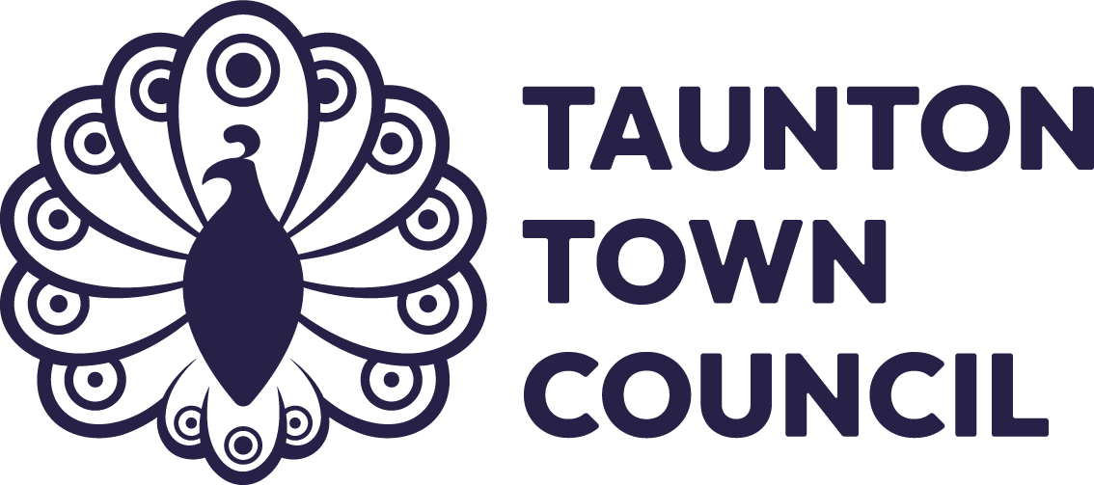

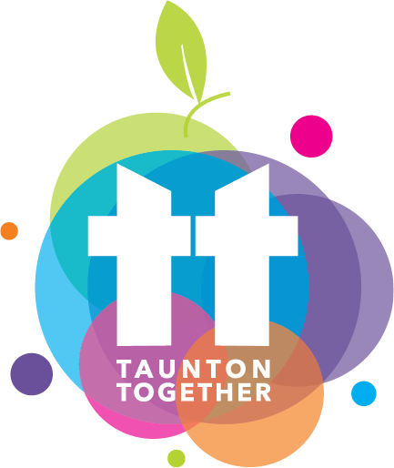
Taunton Together
Specification for Tender

Produced by
Community and Place Team
Taunton Town Council
June 2025

This page has deliberately been left blank

Contents
1. Overview 4
2. Contract Duration and Value 5
3. Key Deliverables 5
a. Event Management 5
b. Programming and Themes 5
c. Stakeholder Engagement 6
d. Governance and Decision-Making 7
e. Marketing and Communications 7
f. Volunteer and Workforce Management 8
4. Sustainability Requirements 8
a. Environmental Sustainability 8
b. Financial Sustainability 9
5. Monitoring and Evaluation 9
6. Governance and Collaboration 10
Evaluation Matrix: Taunton Together Tender Specification (2026–2030) 10

Tender Specification Scope:
Management and Delivery of Taunton Together (2026–2030)

1. Overview
Taunton Together is a flagship annual community event celebrating the cultural richness, creativity, and diversity of Taunton. It is held on the last Saturday of September (subject to change) and is free for all to attend. The event is designed to bring together residents, visitors, the culture sector and businesses, and community groups in a vibrant, inclusive, and safe environment in the heart of the town.
Taunton Together was first held in 2024 and proved to be a resounding success, drawing widespread praise from attendees and participants alike. This milestone event set the stage for what is now to become a celebrated annual tradition, showcasing the unparalleled energy and unity of Taunton’s community. Building on this strong foundation, Taunton Town Council aim to enhance and expand the event in future years, ensuring it continues to flourish as a cornerstone of local cultural celebration, diversity and community spirit.
Taunton Together aims to showcase the town at its very best, celebrating its vibrant spirit and cultural wealth. By leveraging partnerships with local cultural organisations, the event provides a unique opportunity for these entities to highlight their offerings, from artistic performances to community support and initiatives. It serves as an important reminder of the rich tapestry of ethnicities and backgrounds that form the foundation of Taunton's community. The event underscores the strength and unity of coming together, fostering a sense of belonging and mutual respect among residents and visitors.
To ensure the seamless delivery of Taunton Together, that is recognised as regional festival, the appointed organiser will be responsible for creating a comprehensive event management plan that incorporates risk assessments to identify potential hazards. In addition, the plan must address the acquisition of adequate public liability insurance to safeguard against unforeseen circumstances, ensuring the safety and well-being of all attendees, participants, and staff. The document will serve as a critical tool in coordinating logistics, safety protocols, and resource allocation for the event.
The event footprint of the event includes:
- Hammet Street (with road closure)
- Taunton Minster
- Castle Green
- Somerset Square
- Goodland Gardens
- Fore Street and High Street
A premises licence is in place for up to 5,000 attendees across designated areas.

2. Contract Duration and Value
Term: 4 years (2026–2030)
Total Contract Value over four years: £120,000
This financial grant, will be paid within a single financial year and will be broken down into split payments to aid the planning of such a large-scale event.
- First Payment from April – July (£15,000)
- Second Payment from August – November (£10,000)
- Third Payment from – December – March. (£5,000)
Annual Budget: £30,000 (inclusive of VAT and all delivery costs)
Additional Funding: The successful provider will be eligible, supported and encouraged to apply for match funding (e.g. Arts Council, National Lottery, sponsorships) to enhance the event’s scale and impact.

3. Key Deliverables

a. Event Management
Develop and deliver a comprehensive event plan each year, including timelines, risk assessments based on the purple guide standards, and contingency planning.
Secure and manage all necessary permits, licences, and insurances. Please note, a premises licence has been obtained for this event for Goodland Gardens, Somerset Square and High Street.
Ensure compliance with the Event Management Plan, Traffic Management Plan, and Premises Licence conditions.
Coordinate site infrastructure, including staging, power, waste, signage (including way finding signage), and accessibility features.

b. Programming and Themes
Curate a thematic programme each year, aligned with community values and agreed with the Town Council.
Programme to include:
- Live music, dance, and spoken word
- Cultural and heritage showcases
- Interactive workshops and family activities
- Community and charity stalls
- Food and drink vendors
- Quiet and reflective spaces (e.g. Taunton Minster)

c. Stakeholder Engagement
For the success of any community-focused event, working with stakeholders and partners is essential. By fostering meaningful collaborations, the event can reflect the diverse needs and aspirations of the local population. These partnerships create opportunities to amplify voices that might otherwise be overlooked, enriching the event’s programming and ensuring inclusivity.
Engaging stakeholders not only brings a wealth of expertise and resources to the table but also builds trust and a sense of ownership within the community. This cooperation supports the alignment of goals, enhances the quality of delivery, and ensures the event resonates deeply with its audience. Furthermore, a robust stakeholder network can pave the way for innovative ideas and sustainable practices, forming the foundation for a truly impactful and memorable experience.
Taunton stands as a thriving hub of cultural richness, with offerings that capture the essence of its vibrant community. Among the town’s top attractions are:
- The Brewhouse Theatre and Arts Centre. A cornerstone of Taunton’s cultural landscape, this venue hosts an array of performances, from live theatre and music to film screenings and art exhibitions, fostering creativity and community spirit.
- Somerset Museum: Located in the historic Taunton Castle, the museum celebrates the region’s heritage, offering engaging displays that delve into the county’s fascinating past, from prehistoric times to the present day.
- The Creative Innovation Centre: in Taunton is a vibrant, not-for-profit arts and cultural hub dedicated to fostering creativity, community, and enterprise. Housed in a beautifully restored early Victorian hall, CICCIC offers a diverse range of events
- Taunton Minster (St Mary Magdalene): This historic church not only provides a quiet, reflective space but also hosts concerts, exhibitions, and community events, making it a vital part of the town’s cultural fabric.
Integrating these cultural gems into the annual programme will ensure that the event remains deeply rooted in Taunton’s identity while offering diverse experiences for attendees.
You may also wish to engage with:
- Local creative and active community groups and charities
- Cultural and faith organisations through the Community Council for Somerset
- Local businesses and traders through the Chamber of Commerce
- Town Council and statutory partners (e.g. police, fire, highways) for safety and advisory notes and keep up to date with regulation and good practice.
Ensure cultural organisations are central to the event’s design and delivery, with their participation forming a key measure of success.

d. Governance and Decision-Making
The Town Council will act as the strategic decision-making body for the event.
The provider must:
- Attend regular community and place committee meetings to support planning and governance.
- Present proposals and updates for Council approval
- Collaborate transparently and responsively with Council officers and elected members

e. Marketing and Communications
To improve event awareness and encourage participation with the support of the council’s communications function, employing a multifaceted marketing approach rooted in proven theories. One effective technique is leveraging the AIDA model—Attention, Interest, Desire, Action. This framework can guide the messaging strategy, ensuring communications captivate the audience, stir curiosity, foster emotional engagement, and ultimately drive action, such as signing up for participation.
Content marketing will play a pivotal role, with the creation of compelling narratives that highlight the event's unique benefits and community impact. Designing stories around the event’s cultural significance, sustainability efforts, and local engagement will resonate deeply with target audiences.
In addition, the Social Identity Theory can be used to craft messages that tap into the community’s shared identity and values. By emphasising how the event strengthens belonging and pride in the local culture, you can inspire collective participation.
Technologically, utilising tools like geo-targeted social media ads and email campaigns personalised to the recipient's interests ensures the message reaches the right audience at the right time. Furthermore, incentivising early registrations through exclusive perks can boost sign-ups.
Lastly, conducting pre-event surveys or polls can involve the community and business in shaping the event, creating a sense of ownership that encourages both awareness and active participation.
Deliver a multi-channel marketing strategy including:
- Social media campaigns
- Press releases and media engagement
- Printed materials and signage
- Inclusive and accessible communications
- Maintain a dedicated event webpage and/or social media presence.

f. Volunteer and Workforce Management
Collaborating with the local community and key organisations such as the Community Council for Somerset, SPARK Somerset, and Taunton’s Rotary Clubs can amplify the impact of the event. Working hand-in-hand with these organisations opens opportunities to promote inclusivity, coordinate volunteering efforts, and align with local values and aspirations. These stakeholders can also assist in amplifying marketing efforts through their established channels, fostering a sense of unity and shared purpose.
By leveraging the expertise and enthusiasm of SPARK Somerset and Taunton’s Rotary Clubs, the event can further strengthen ties within the community, highlight local talent, and ensure that the event becomes a reflection of collective pride and collaboration. For example, SPARK Somerset’s experience in community development can guide initiatives that involve local businesses, while Taunton’s Rotary Clubs can facilitate connections with volunteers who are eager to contribute. These relationships not only enhance the event’s logistical efficiency but also anchor its success in the shared efforts and spirit of the community.
Recruit, train, and manage a team of volunteers and event staff (This can include Council staff).
Ensure safeguarding, welfare, and clear roles/responsibilities.

4. Sustainability Requirements
The council’s ambitious target to achieve carbon neutrality by 2030 is a guiding principle that underscores all aspects of event planning and delivery. This vision reflects a commitment not just to an environmentally sustainable future but also to the collective responsibility we all bear in mitigating climate change.
Carbon neutrality and aligning our actions with this aim ensures that we contribute meaningfully to reducing carbon emissions, protecting our ecosystems, and creating a legacy of sustainability for future generations. By embedding this goal into our operations, we reinforce the importance of prioritising practices that reduce waste, and encourage active participation from the community in achieving a greener and more sustainable future.

a. Environmental Sustainability
Commit to a low-impact delivery model, including:
- Use of reusable or compostable materials
- Plastic-free event.
- Provision of recycling and waste separation
- Promotion of active travel and public transport
- Minimising energy use and emissions
- Provide an annual environmental impact report.
- Work with local environmental groups to embed sustainability into all aspects of the event.

b. Financial Sustainability
Demonstrate ability to:
- Secure match funding and sponsorships
- Deliver value for money
- Maintain transparent financial records
- Submit an annual financial report including income, expenditure, and funding leveraged.
- Build partnerships that support long-term financial resilience of the event.

5. Monitoring and Evaluation
Monitoring and evaluation play a crucial role in ensuring the continuous improvement and sustainability of the event. By collecting and analysing data on attendance, audience demographics, stakeholder feedback, and social value measures, organisers can identify strengths, address areas for growth, and demonstrate the event's tangible impact on the community. Comprehensive evaluation not only fosters transparency and accountability but also significantly enhances the event’s credibility in grant funding applications. Measuring social value—such as the event’s contributions to cultural enrichment, community cohesion, and economic benefits—provides compelling evidence to stakeholders and sponsors, showcasing the broader benefits and long-term value of supporting the initiative.
Collect and report on:
- Attendance figures and demographics
- Stakeholder and audience feedback
- Media and social media reach
- Environmental and financial performance
- Level and diversity of cultural organisation participation
- Provide a post-event evaluation report each year with recommendations for improvement and social impact and lasting relationships.

6. Governance and Collaboration
Councillors play a pivotal role in shaping the event’s vision and direction, ensuring it aligns with the town’s broader objectives and community needs. Their involvement in decision-making is paramount for transparency and accountability while providing valuable insight and clarity on strategic matters. By integrating councillors into the planning process, organiser(s) can benefit from their local knowledge, advocacy, and governance expertise, creating a cohesive approach that reflects the community's values and aspirations. Regular consultations with councillors will ensure the event evolves as a collaborative effort, building trust and reinforcing its significance within the town's cultural framework and aligned to the Council’s Arts and Culture Strategy and Corporate Plan, which can be viewed here.
Arts and Culture Strategy: https://www.taunton-tc.gov.uk/wp-content/uploads/sites/98/2024/04/Taunton-Town-Council-Arts-and-Culture-Strategy-final.pdf
Council’s Corporate Plan: https://www.taunton-tc.gov.uk/wp-content/uploads/sites/98/2024/08/Taunton-Town-Council-Corporate-Plan-24-28.pdf
Work closely with the Council’s Events Officer and relevant departments.
Attend Safety Advisory Group (SAG) meetings and planning sessions.
Collaborate with other town centre events to ensure coordination and avoid clashes.
If you have any questions or wish to discuss the opportunity further, please contact the Community Lead on community@taunton-tc.gov.uk or the Community and Place Manager on place@taunton-tc.gov.uk

Evaluation Matrix: Taunton Together Tender Specification (2026–2030)
This evaluation matrix is to assess the proposals for the management and delivery of Taunton Together from 2026 to 2030.
Each criterion is aligned with the key deliverables and requirements outlined in the tender specification.
Evaluators will use the scoring guidance to rate each proposal on a scale of 1 to 10, with 10 being the highest score. The weighting column indicates the importance of each criterion in the overall evaluation. Move to next page…

Evaluation Criteria | Weighting (out of 100) | Scoring Guidance (1-10) | Notes for Evaluators
Event Management & Health and Safety. | 30 |  | Assess the comprehensiveness of the event plan, risk assessments, reference to purple guide and contingency planning.
Programming & Stakeholder Engagement | 20 |  | Evaluate the creativity and alignment of the thematic programme with community values and impact. Consider the approach to engaging local community groups, cultural organisations, and statutory partners.
Marketing and Comms | 10 |  | Assess the effectiveness of the proposed marketing strategy across multiple channels and collaboration with Council.
Volunteer and Workforce Management | 10 |  | Evaluate the recruitment, training, and management plan for volunteers and event staff.
Environmental Sustainability | 10 |  | Consider the commitment to a carbon low-impact delivery model and environmental reporting.
Financial Sustainability | 10 |  | Review the ability to secure match funding, deliver value for money, and maintain transparent financial records.
Monitoring and Evaluation | 5 |  | Assess the plan for collecting and reporting on attendance, feedback, and performance metrics.
Collaboration, Decision and Governance | 5 |  | Evaluate the approach to working with the Council’s Events Officer and attending planning and Council decision meetings.

